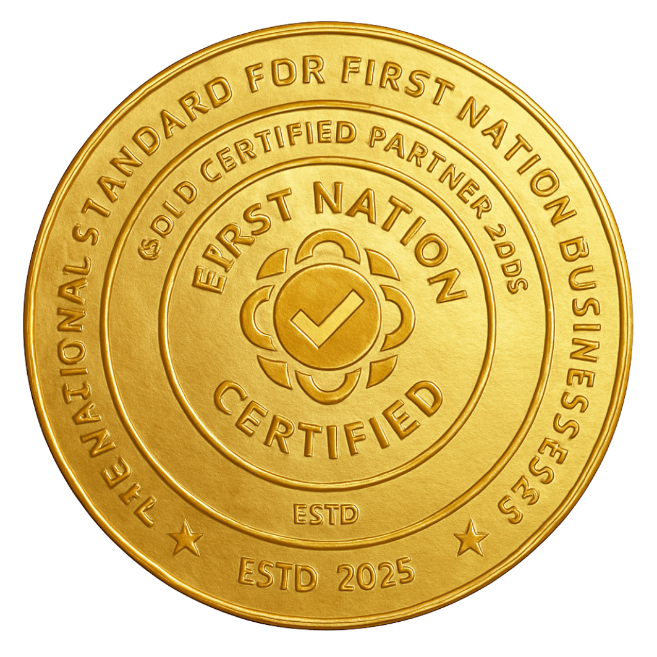

First Nation Certified — Intake & Verification Form
Please complete this form and attach the requested documentation and send to enquiry@firstnationcertified.com.au. A 30-minute Teams/phone yarn will be arranged to confirm cultural connection and ownership.

1. Primary Contact / Business Representative
Full name: _________________________________________
Role / Position: __________________________________________
Business name: __________________________________________
Trading name (if different): __________________________________________

2. Business Address & Contact Details
Business address: __________________________________________
Postal address (if different): __________________________________________
Phone: __________________ Email: __________________________________________

3. Business Registration
ABN / ACN: __________________________________________
Business structure (select): □ Sole Trader □ Partnership □ Company □ Trust □ Other
If Other, please specify: __________________________________________

4. Proof of Ownership / Share Structure
Attach evidence that First Nations people own at least 50% of the business (e.g. share certificates, partnership agreement, trust deed):
□ Share certificates attached
□ Partnership agreement / deed attached
□ Trust deed attached
□ Other ownership documents attached (please list below)
If "Other" - describe: ________________________________

5. Business Registration Documents
Please attach a copy of your registration certificate or equivalent legal documents (ASIC/State registration, incorporation papers):
□ Registration certificate attached
□ ASIC/ABR printout attached
□ Other (please list below)
If "Other" - describe: ________________________________

6. Cultural Connection Yarn
Please tell us about your cultural connection — which Nation/Community/Language group you belong to? (briefly describe):

Note: After submitting this form we will organise a 30-minute Teams / phone yarn to discuss cultural connection and ownership verification.

7. Contact Details for Verification
Authorised contact for verification (name): ________________________________
Preferred contact method: □ Teams □ Phone □ Email
Suggested availability for 30-minute yarn (days/times): ________________________________

8. Document checklist (please tick what you will attach)
□ ABN / ACN proof
□ Share structure / ownership docs
□ Business registration certificate
□ Proof of ID for authorised contact
□ Other supporting documents

9. Consent & Declaration
I declare that the information provided is true and correct to the best of my knowledge. I consent to First Nation Certified verifying my ABN/ACN and business registration details through government registries (ABR/ASIC) and contacting the authorised representative for a 30-minute yarn. I understand this information will be used for verification purposes only.
Signature: ________________________________ Date: ___________________
Privacy: First Nation Certified collects this information to verify First Nations ownership and business registration. We will only use this information for verification and to contact you about your registration. By signing above you consent to these checks.
Return this form and attachments to: enquiry@firstnationcertified.com.au



