15 rhythm strips on Precourse Self-Assessment with the following matching choices:
Agonal Rhythm/Asystole  Atrial Fibrillation (AF)  Atrial Flutter  Monomorphic Ventricular Tachycardia  Normal Sinus Rhythm  Premature Ventricular Contraction (PVC)  Polymorphic Ventricular Tachycardia  Pulseless Electrical Activity (PEA) | Second-Degree Atrioventricular Block (Mobitz I, Wenckebach)  Second-Degree Atrioventricular Block (Mobitz II)  Sinus Bradycardia  Sinus Tachycardia  Supraventricular Tachycardia (SVT)  Third-Degree Atrioventricular Block  Ventricular Fibrillation (VF)
Rhythm Identification

RHYTHM &  ETIOLOGY | CRITERIA OVERVIEW | UNIQUE CRITERIA | SAMPLE STRIPS

Agonal Rhythm/ Asystole  - Dying heart  - Drugs used in cardiac arrest provide some electrical waves | RHY – Regular  R – Slow  P – None  PRI – None  QRS – Very, very wide | Slow wide bizarre stretched out waves  No Pulse | 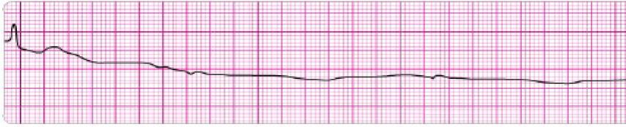

Atrial Fibrillation (AF)  - Ischemic heart disease  - Digoxin toxicity  - CHF  - MI  - Mitral or Tricuspid valve disease | RHY – Irregular  R – Atrial 350-600 Vent. –  Below 100 controlled  Above 100 uncontrolled  P – No Fs  PRI – None  QRS – 0.04-0.10 | Irregular, no  No Ps (called Fs) | 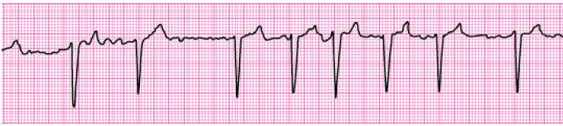

RHYTHM &  ETIOLOGY | CRITERIA OVERVIEW | UNIQUE CRITERIA | SAMPLE STRIPS

Atrial Flutter  - Ischemic heart disease  - MI  - Digoxin toxicity  - Mitral, Tricuspid valve disease  - Stress  - PE  - Hyperthyroid  - Often temperature | RHY – Regular or Irregular  R – Atrial 250-400  Vent: 70 - 150  P – None, Fs  PRI – None  QRS – 0.04-0.10 | Regular or Irregular  No Ps (called Fs)  Saw tooth | 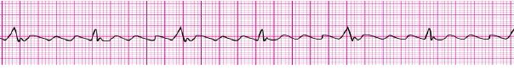

Monomorphic Ventricular Tachycardia  - All complexes are the same shape and look the same  - Wide Complex Tachycardia | RHY – Regular  R – Above 100  P – None  PRI – None  QRS – Wide, bizarre | R over 100  All Vent beats | 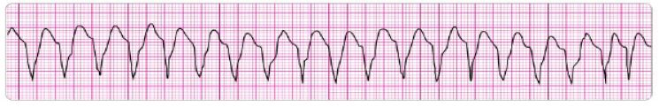

Normal Sinus Rhythm  - Normal, None | RHY – Regular  R – 60-100  P – Upright  PRI – 0.12-0.20  QRS – 0.04-0.10 | None, normal rhythm | 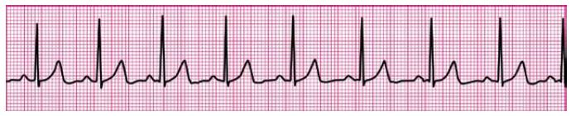

RHYTHM &  ETIOLOGY | CRITERIA OVERVIEW | UNIQUE CRITERIA | SAMPLE STRIPS

Premature Ventricular Contraction/  Premature Ventricular Depolarization  (PVC/PVD)  - Hypoxia  - Hypotension  - Anemia  - Ischemic heart disease  - Electrolytes  - M.I.  - Myocarditis, pericarditis  - CHF  - Stress, fatigue, smoking  - Overeating, caffeine  - Hypoglycemia  - Sepsis  - Cyclic anti-depressants  - Acidosis | AN ECTOPIC BEAT  RHY – Irregular  R – 60-100  P – Upright  PRI – 0.12-0.20  QRS – 0.04-0.10 | SR, early beat has Vent beat (wide & bizarre) | 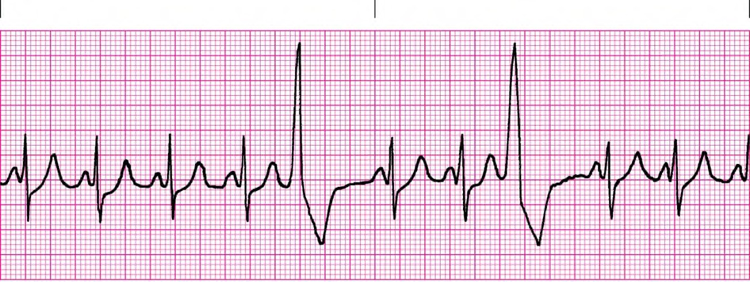

Polymorphic Ventricular Tachycardia  AKA Torsades de Pointes | RHY – Chaotic waves  R – None  P – None  PRI – None  QRS – Points twist | Amplitude of QRS changes  No pulse  Points twist | 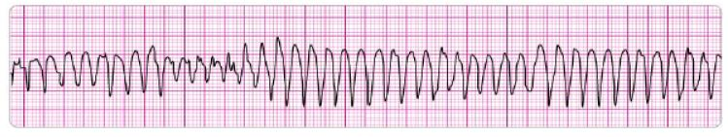

RHYTHM &  ETIOLOGY | CRITERIA OVERVIEW | UNIQUE CRITERIA | SAMPLE STRIPS

Pulseless Electrical Activity  (PEA)  - Looks like any rhythm that should have a pulse but does not |  | No Pulse | 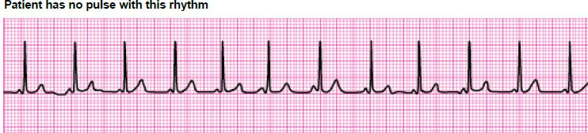

Second Degree AV Block Type I Mobitz I Wenckebach | RHY – Irregular  R – >60  P – Extra Ps  PRI – Vary  QRS – 0.04-0.10 | Irregular  PRI longer & longer  Dropped QRS | 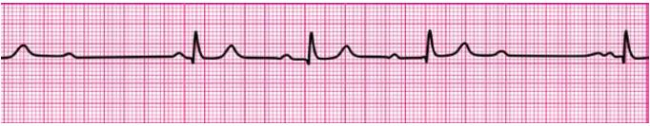

Second Degree AV Block Type II Mobitz II | RHY – Regular or Irregular  R – >60  P – Extra Ps  PRI – Constant  QRS – Normal or wide | Regular or Irregular  EXTRA Ps  PR interval normal with dropped QRS | 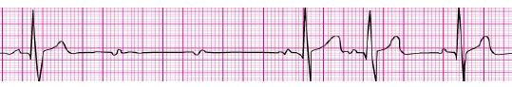

RHYTHM &  ETIOLOGY | CRITERIA OVERVIEW | UNIQUE CRITERIA | SAMPLE STRIPS

Sinus Bradycardia  - Damage SA  - Normal sleep athletes  - Vagal stimulation  - Glaucoma  - Hypothermia  - Inferior MI  - Drugs – MS, digoxin, Inderal  - IICP | RHY – Regular  R – Below 60  P – Upright  PRI – 0.12-0.20  QRS – 0.04-0.10 | Rate below 60 | 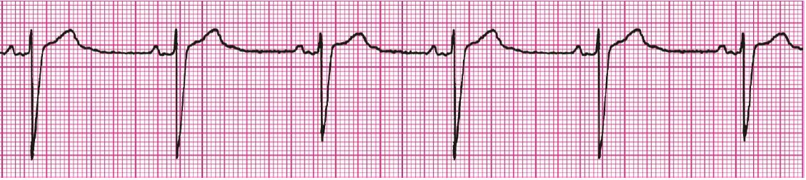  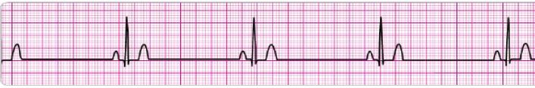

Sinus Tachycardia  - Exercise  - Anxiety  - Caffeine  - Nicotine  - Fever  - Shock  - CHF  - Hypotension  - Pain  - Hypoxemia  - Anterior MI | RHY – Regular  R – 100-160  P – Upright  PRI – 0.12-0.20  QRS – 0.04-0.10 | Rate 100-160 | 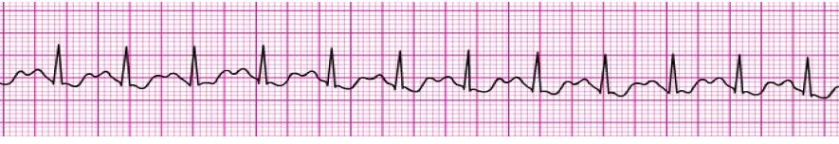

Supraventricular Tachycardia (SVT)  - Not visible sudden start or stop | RHY – Regular  R – 160 - 250  P – Upright  PRI – 0.12-0.20  QRS – 0.04 – 0.10 | Rate above 150-250 | 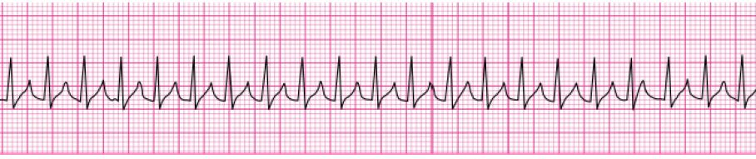

RHYTHM &  ETIOLOGY | CRITERIA OVERVIEW | UNIQUE CRITERIA | SAMPLE STRIPS

Third Degree AV Block  - Same as 1st degree  - Electrolyte imbalance | RHY – Regular  R – >60  P – Extra Ps  PRI – Vary  QRS – Usually wide | Regular  P waves march out  QRS march out | 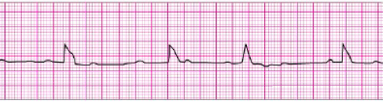

Ventricular Fibrillation (VF)  - Following V-Tach  - Acute MI  - Electrolyte imbalance | RHY – Chaotic  R – None  P – None  PRI – None  QRS – None, fibrillatory line | Chaotic wavy line  No pulse | 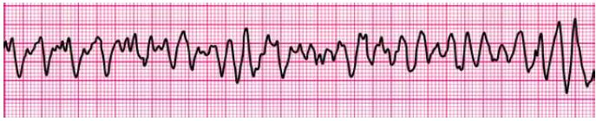  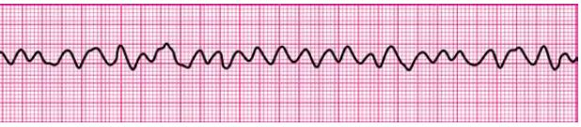
High-Quality CPR
- Rate-at least 100-120 per minute  - Compression depth at least 2 inches, not more than 2.4 inches or 6cm  - Minimize interruptions to less than 10 seconds  - Switch compressors every 2 minutes or 5 cycles  - Chest recoil allows maximum blood return to the heart | - After defibrillation resume CPR, starting with chest compressions  - Rescue breathing for patient not responsive, not breathing with pulse  - Air in stomach -- ventilating too quickly  - Ventilate 1 breath every 6 seconds (10/min)

