
Porsche Cayenne 958 (2011-2018)
Ditch Light Bracket Kit Instructions

Thank you for choosing Maddogs Motor Sports.
Please read all instructions completely before beginning installation.
Important Safety Information
This installation guide is provided for informational purposes only. Always follow proper safety procedures when working on your vehicle. Maddogs Motor Sports is not responsible for any injury, damage, or loss resulting from improper installation or use of this product.
Professional installation is recommended if you are unfamiliar with vehicle modifications or mechanical work.

Kit Contents
Your Ditch Light Bracket Kit includes:
- (1) Driver-side bracket
- (1) Passenger-side bracket
- Spacer washers (for 958.1 models only)
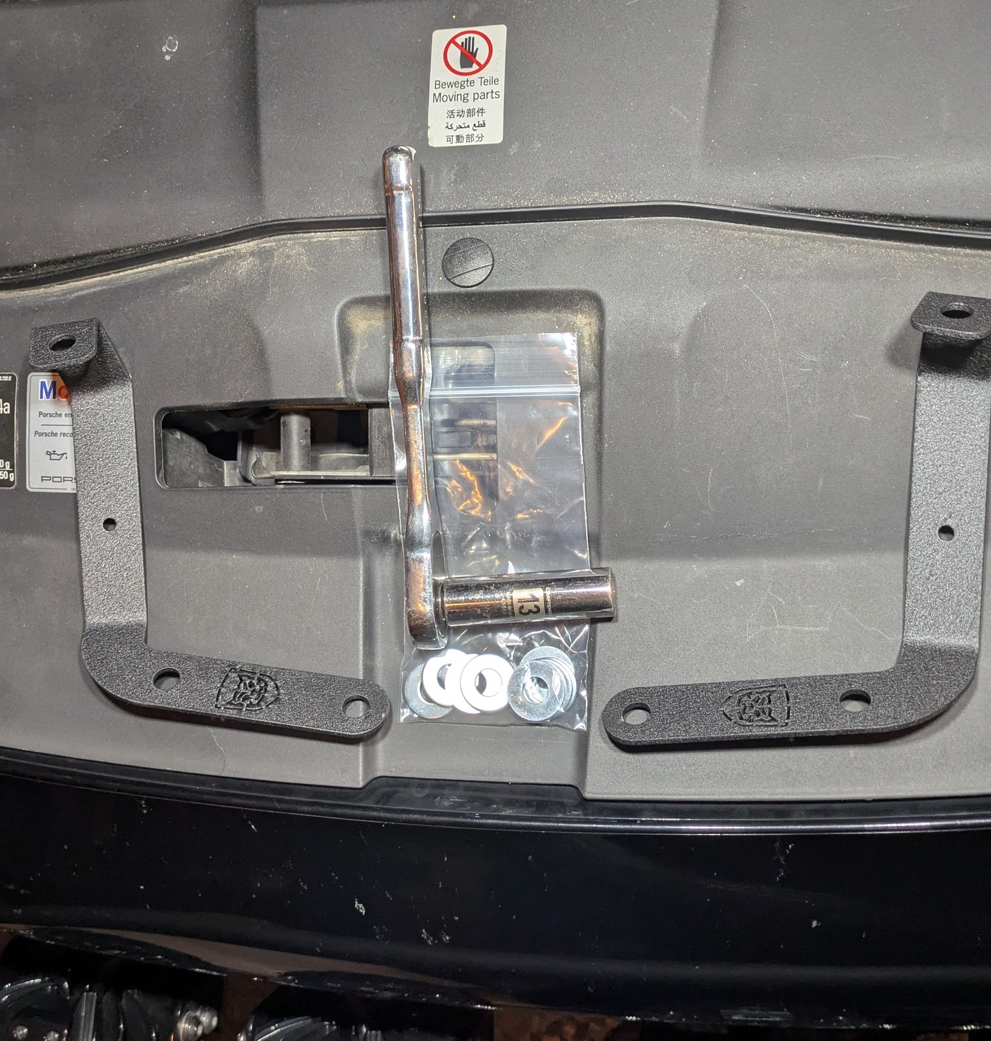

Tools Required
- 13mm socket or wrench

Installation Notes
- Installation can be completed by one person; however, having a second person assist by supporting the hood is strongly recommended.
- Spacer washers are only required for Porsche Cayenne 958.1 models (2011-2014).

Installation Instructions

Step 1 — Remove Hood Hinge Nuts
- Open the hood and locate the hood hinge mounting points on one side of the vehicle.
- Using a 13mm socket or wrench, remove the two factory nuts securing the hood hinge.
Tip: Having a second person support the hood during this step can make installation easier and help maintain hood alignment.
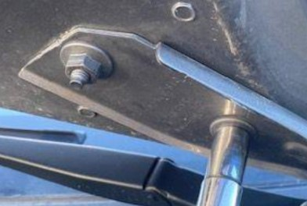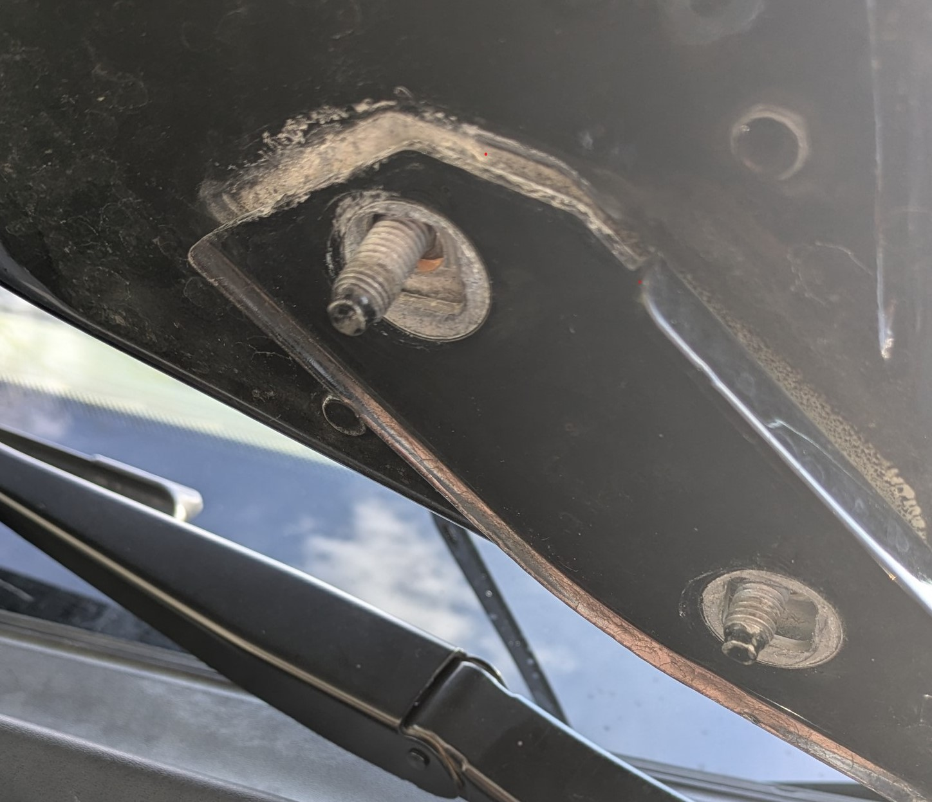

Step 2 — Install the Bracket
- Position the appropriate ditch light bracket onto the hood hinge studs.
- For 958.1 models, install the supplied spacer washers between the bracket and mounting surface as required.
- Reinstall the factory nuts and tighten securely.
Passenger Side Note:
The passenger-side installation area contains a wiring loom. Carefully position the bracket around the wiring while ensuring nothing is pinched or strained.
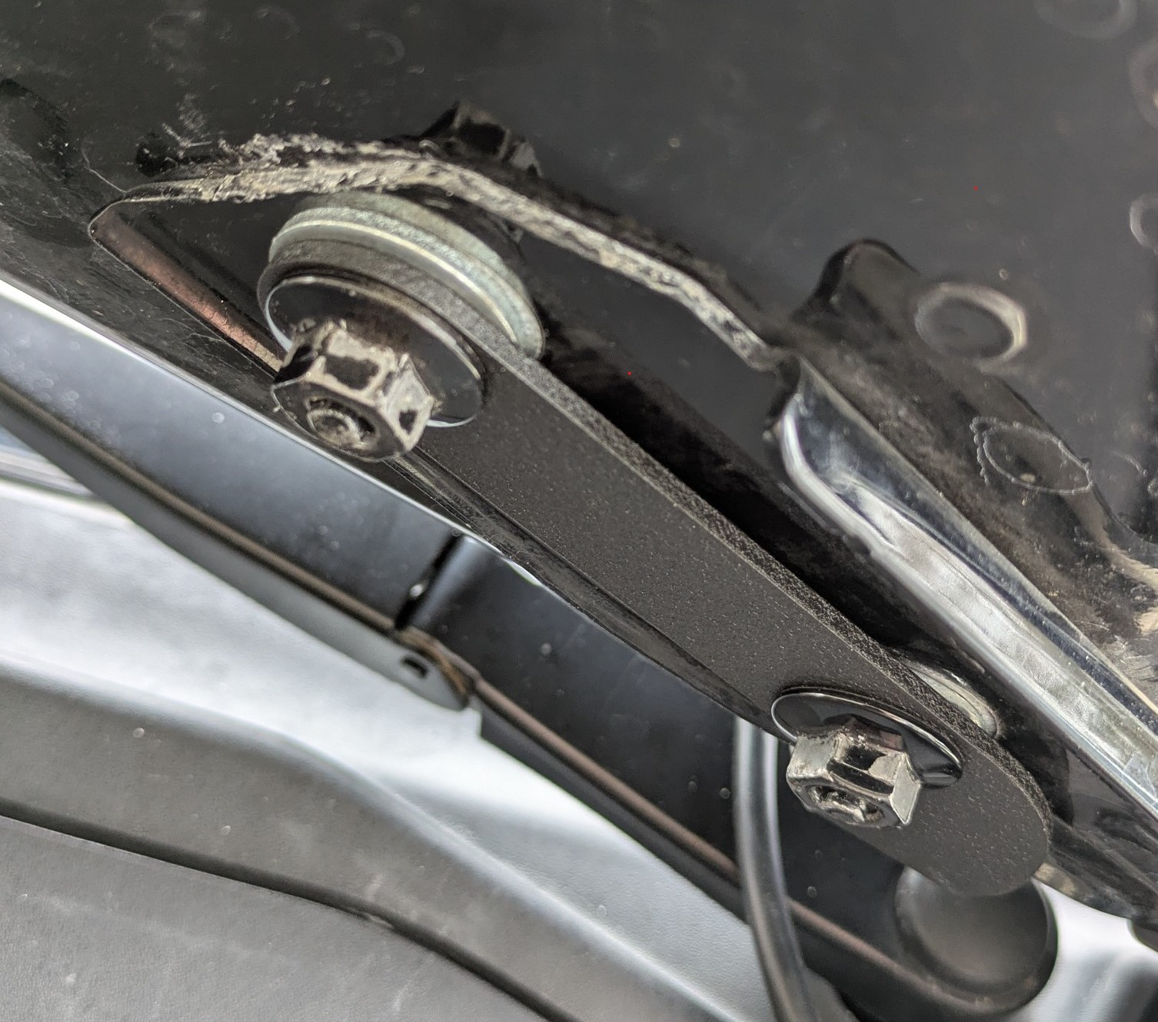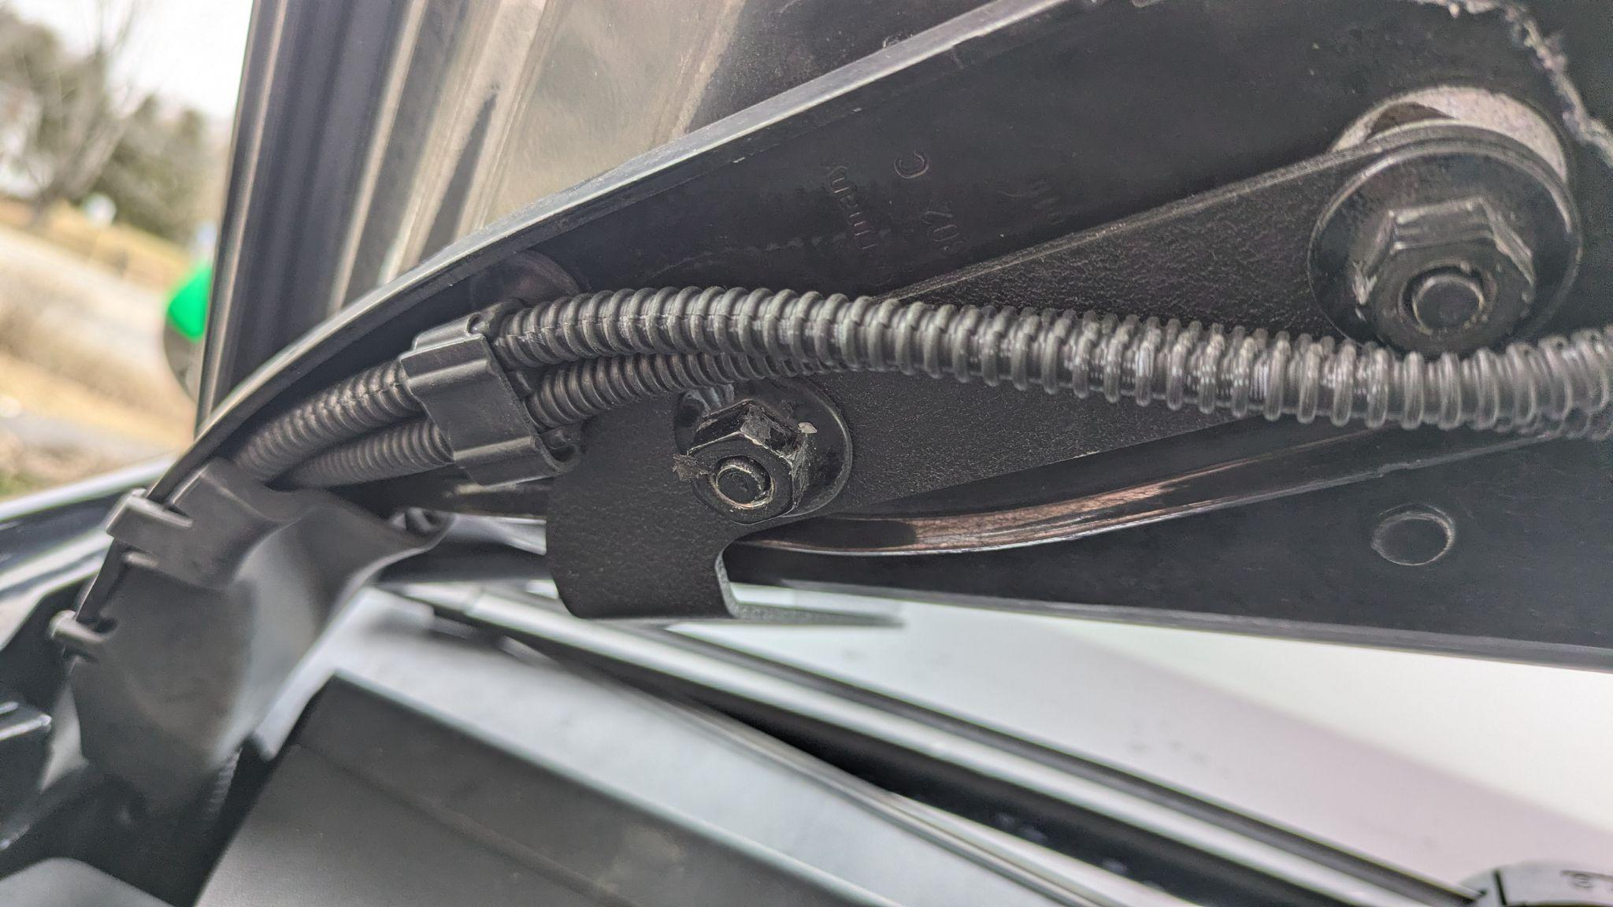

Step 3 — Verify Hood Alignment
- Close the hood carefully and inspect the hood alignment.
- If adjustment is needed, loosen the bracket hardware slightly, reposition the bracket, and retighten the nuts.
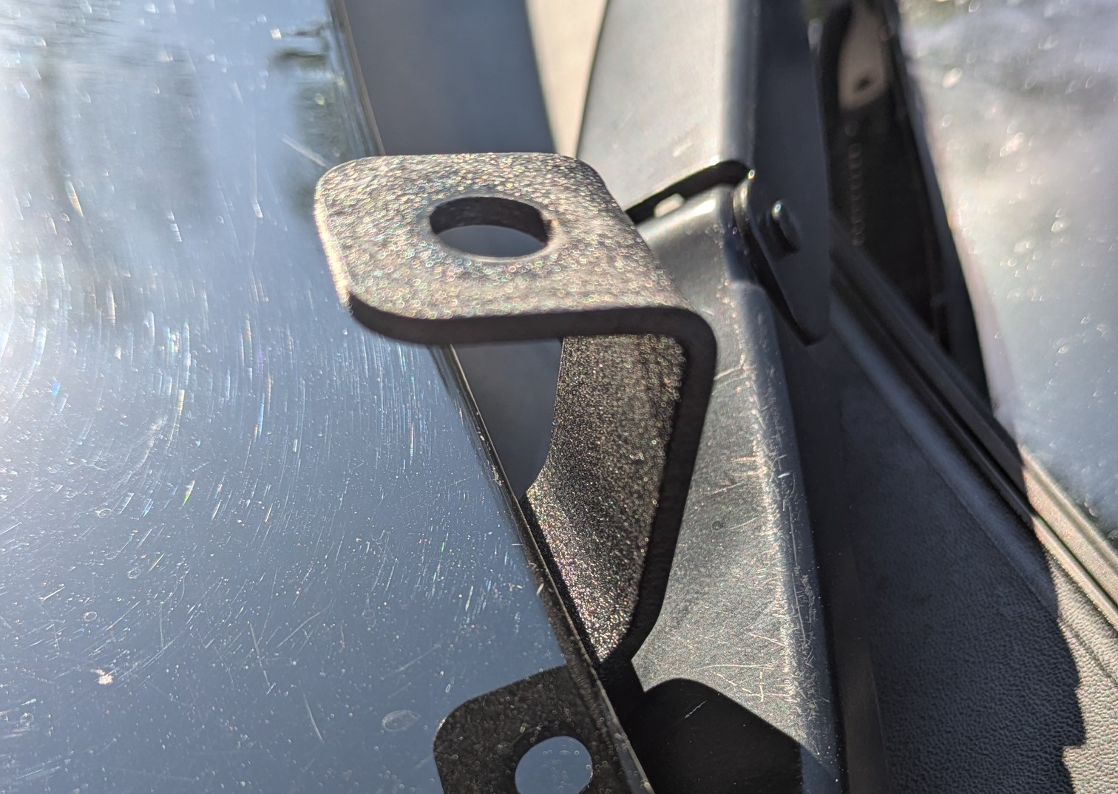

Installation Complete
Your Ditch Light Bracket Kit is now installed and ready for light mounting.
Thank you for your support!


Maddogs Motor Sports

Grand Rapids, Michigan
www.maddogsmotorsports.com

