

Community Compliments and Complaints
Date of sign off and adoption by Committee: April 2026
Review date: August 2026

Purpose

This policy applies to Live Well in Braunton service users, organisations with whom we work and the public, the principles and processes for complimenting Live Well in Braunton as an organisation or an individual on their work, or for making a Complaint.

Policy Statement

Live Well in Braunton aims to provide an excellent service to the community. In order to do this, it is important that those who work on behalf of Live Well in Braunton know when our work is of high quality and appreciated and when we could do better.

Being thanked and complimented is vital for the morale and well-being of those who work on behalf Live Well in Braunton, and for Live Well in Braunton to know when we are providing excellent service.

Equally, we need to know when things aren’t working well. Live Well in Braunton treats all complaints seriously and handles them in a way that is seen to be open and fair. We will do our best to ensure that complaints receive a full and timely response.

We want to empower those who work on behalf of Live Well in Braunton to take sensitive, proportionate and early action to solve complaints. It is also important that employees and volunteers understand the relevant procedures when managing complaints.

Policy Application

Live Well in Braunton may engage people through a variety of employment and/ or self-employment models. Where a member of staff is employed through a host organisation they will adhere to the host organisation’s policy. Where a member of staff is directly employed by Live Well in Braunton they will comply with the Live Well in Braunton Community Compliments and Complaints Policy. Where Live Well in Braunton engage the services of individuals or an organisation through a contract the person or organisation will comply with The Live Well in Braunton policy and practice.

All self-employees, contractors and volunteers should adhere to the Live Well in Braunton’s Community Compliments and Complaints Policy and practice.

Definitions

Advocate
An individual identified by the service user or requested by the Complaint investigator to support the service user through the complaints process.

Compliment
An expression of thanks or recognition of the quality of service to an individual or to Live Well in Braunton as an organisation.

Complaint
An expression of dissatisfaction with something Live well in Braunton, or someone acting on our behalf has done. The complaint may be at differing levels of complexity and/or seriousness:
Minor Complaint (e.g. day to day operational issues, missed/late pickups etc.)
Serious Complaint (e.g. Safeguarding issues, personal injury, allegations of misconduct, inappropriate or illegal activity or an unsatisfactory conclusion to a minor complaint)

Complainant
An individual or group raising a complaint.

Investigator
Person or committee of persons tasked with investigating a complaint. This individual or committee may be independent of the organisation.

Criticism
Criticism and complaint are not necessarily the same thing. Criticism may, for example, reflect a different viewpoint. Any criticism, if the complainant defines it as such, will be dealt with through the Live Well in Braunton complaints process

Principles

Live Well in Braunton aims to provide excellent standards of Service to its users.
Many of our service users are vulnerable and it is vital we provide consistent standards of service suitable to their needs and within the capabilities of our organisation.

All feedback is welcomed.
An effective compliments and complaints system helps Live Well in Braunton to:
- Identify areas of excellent practice to be built on and individuals whose work needs particular recognition.
- Identify areas for improvement in the delivery of our service
- Avoid repetition of the issue
- Identify training needs
- Highlight where we may be working beyond our capabilities
- Understand when we may not act consistently or within the law
- Provide evidence of need and/or identify gaps in provision of services

Compliments can be shared in a manner outlined in the Policy into Practice Section of this document and agreed with the relevant individual working on behalf of Live Well in Braunton.

All issues related to a complaint should be addressed through the complaints procedure and not be disclosed to parties other than those outlined in that procedure

Circumstances under which Live Well in Braunton will not be able to consider a complaint.

- Where the complaint is not about our organisation. In this instance we will refer the complainant to that organisation. We reserve however the right, where we consider it appropriate, to record the complaint and details relating to it.
- Where all steps have been taken to respond to the complaint previously.
- Where the complainant has failed to identify themselves or provide their contact details.
- Where inadequate information is provided by the complainant.
- When the complaint has been received by us and other organisations as a bulk mailing.

In such cases it will still be appropriate where possible to acknowledge the communication, provide an explanation as to why the points raised will not be addressed and state how any further correspondence will be managed

If a complaint is accompanied by obscene language or behaviour then we reserve the right not to deal with the complaint.

Responsibilities

Directors should:
- Receive compliments and complaints, ensure that all feedback is acknowledged, and that the response to complaints complies with Policy and Practice outlined in this document.

Those who work on behalf of Live Well in Braunton should:
- Ensure that service users, organisations with whom we work, and the public are aware of the Compliments and Complaints practice guidelines.
- Avoid casual conversations discussing personal circumstances of other staff, volunteers or organisations.
- Not disclose information received in the course of their duties without the permission of the relevant people or organisations concerned.
- Not speak to the press or to communicate with any other media on matters which directly relate to the affairs of the organisation.
- Be mindful that if they are aware of circumstances in which a complaint might be raised, they may want to report those circumstances to the Directors.

Appendices

Appendix 1: Policy into Practice

Timeliness
All Compliments and Complaints should be submitted in a timely manner. This will enable the compliment to be as meaningful as possible and to identify and to recognise good practice quickly.
Timely lodging of complaints will enable the complaints process to proceed in as informed and effective way as possible.

Support
Some service users may need support to register their Compliment or Complaint. In this case, service users may wish to identify an Advocate – family or friend - to help them through the process.
An investigator may request an advocate for a vulnerable service user to support them through the complaint process.

Compliments

Compliments should be submitted to the Directors of Live Well in Braunton via the ‘Contact us’ button in the Policies section of the Live Well in Braunton website, verbally, by card or letter to , or via social media with the consent of either the employee and volunteer.

Complaints

All complaints should be submitted in writing to the Directors of Live Well in Braunton via the ‘‘Contact us’ button, accessed through the Home page of the Live Well in Braunton website.

The 2 Stage Complaints Procedure

Stage 1 Complaints Procedure

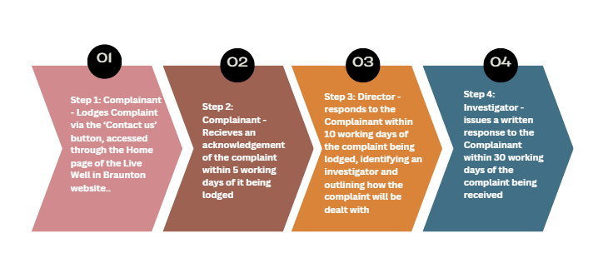

If the complainant wishes to appeal the Director’s decision, the Stage 2: Appeals Procedure applies.

All appeals should be lodged with the Chair of Live Well in Braunton,
Dr Susanna Hill, drsrhill0@btinternet.com

Stage 2 Appeals Procedure

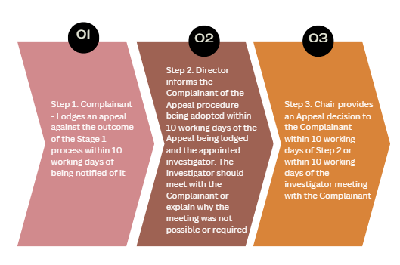

Circumstances for an Appeal could include procedural reasons arising in the first stage such as a failure to:
- Make the Complaints Policy and Procedure available
- Recognise and accommodate the Complainant's individual circumstances
- Convene a meeting to discuss the complaint with the Complainant
- Ensure that the Complainant was kept informed
- Adhere to expected and agreed deadlines
- Report the basis of findings
- Make sure that the Complaint was considered impartially

Additional Guidance

Complaints Procedure: Stage One

- All complaints must be Lodged via the ‘Contact us’ button, accessed through the Home page of the Live Well in Braunton website.
- A Director of Live Well in Braunton will acknowledge the Complaint within 5 working days of receiving it so that the Complainant has reassurance that the Complaint is being dealt with.
- The Director will inform the Complainant of how the Complaint will be dealt with and the appointed investigator within 10 working days.
- The Investigator will agree with the Complainant whether the Complaint will be dealt with informally or formally and the Investigator will then inform the Complainant how the investigation will proceed.

- In normal circumstances the Investigator should provide the Complainant with the findings and conclusions of the investigation within ten working days from being appointed.
- If the investigation will take longer than ten working days the Investigator should explain to the Complainant the reason for the longer time and endeavour to resolve the Complaint as soon thereafter as possible.

- The resolution of the Complaint should include the reasoning behind the Investigator's findings and conclusions, any action taken and details of how the Complainant can submit an Appeal if dissatisfied with the outcome.

- It is good practice that the Investigator provide an opportunity to meet face to face with the Complainant. This meeting may take place at the discretion of the Investigator at the outset or after the Investigator has undertaken other investigatory work.

- Live Well in Braunton will make every effort to be sensitive to the Complainant's individual circumstances and background. It may be beneficial for the Complainant to be supported by a friend or relative during the complaint procedure

Complaints Procedure Stage Two: Appeal

- If the Complainant is dissatisfied with our response at Stage One then the Complainant may request that the Complaint be considered at Stage Two Appeal.
- In order to ensure that a Complaint is resolved within a timely manner. In the interests of all parties the Complainant is asked to bring an Appeal within ten working days of the Complainant receiving the outcome at Stage 1. The Complainant is asked to explain their reasons for dissatisfaction with the outcome.
- If the Complainant brings an Appeal outside this time limit the Appeal will not be barred but the Complainant is reminded that delay in doing so may affect the ability to consider the Appeal and excessive delay may result in an Appeal being refused.

- The Chair of Live Well in Braunton will decide how the Appeal will proceed and whether a further review is required. The Chair may, in consultation with others if the Chair considers appropriate, decide to appoint an external Investigator.
- The Chair has the discretion to hear the Appeal internally or to appoint another external Investigator. An external person may be utilised to provide advice.

- It is important that the choice of Appeal procedure takes into account the concepts of fairness, objectivity, openness and robustness and that the views of the Complainant are taken into account.

- The Complainant must be informed of the Appeal procedure to be adopted within ten working days from the lodging of the Appeal.

- The Stage Two Appeal Investigator should make all practical attempts to meet directly with the Complainant or otherwise explain why such a meeting did not take place or was not required.
- The Stage Two Appeal Investigator will conclude their findings either rejecting the Appeal and confirming the original decision or endorsing the Appeal making suitable recommendations.

- The Appeal decision must be provided in writing to the Complainant within 10 working days of the decision to consider the Appeal or within 10 working days following an Appeal meeting with the Complainant whichever is the later. The response must include:
- The findings and conclusion regarding the original decision
- Any action to be taken to address the Complaint
- Clarification the Appeal stage outcome is final
- Details of external agencies to register their dissatisfaction if the Complainant remains dissatisfied with the outcome

Information Record Keeping.

- A record will be kept of all Complaints received, and documentation relating to the Complaint will be securely held in a central Complaints register for a minimum of six years and a maximum of twenty five years.

- All Complaints whether dealt with formally or informally will be documented in writing containing information about how each Complaint was handled and resolved and recorded in a central Complaints register.

- The record will include the names of the Investigator and the Complainant a summary of the key investigating points, the Complaint outcome and any residual actions

- The log of Complaints will be reviewed every six months.

- Personal information held about an individual working on behalf of Live Well in Braunton, employee, volunteer or contractor will not be disclosed.

Information

- Those who work on behalf of Live Well in Braunton are entitled to see all information held about them with the exception of third party references.

Associated Policies

- Safeguarding Policy. Whistle-blowing Policy. Disciplinary and Grievance Procedures

Key Contacts

Name | Role | email | Text/ Phone number
Dr Susanna Hill | Chair | drsrhill0@btinternet.com | 07968 291622
Roger Byrom | Director | roger@rpbfunerals.co.uk | 07974  561646
Dr Nicola Relph | Director | nicolarelph@nhs.net | 07855  473405  by text message
 | General Enquires | connect@livewellinbraunton.co.uk
Judy Flanagan | Volunteer Coordinator | support@livewellinbraunton.co.uk | 07840 298094

