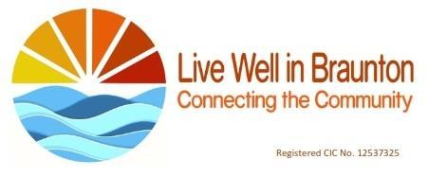

Safeguarding Vulnerable Adults and Young people Policy v2
Date of sign off and adoption by Committee: April 2026
Review date: August 2026

Purpose

The aim of this policy is to clarify Live Well in Braunton’s Safeguarding principles and practice, the Safeguarding roles and responsibilities of those who work on behalf of Live Well in Braunton and procedures for carrying them out.

Policy Statement

All individuals have the right to be safe from harm and should be able to live free from fear of abuse, neglect and exploitation. Some individuals are less able to protect themselves than others, and some have difficulty making their wishes and feelings known. This may make them more vulnerable.

Live Well in Braunton is committed to safeguarding and protecting from harm all of those who work on behalf of Live Well in Braunton and users of our services, and in particular vulnerable adults and young people. Those who work on behalf of Live Well in Braunton may be the first to notice signs of possible abuse and it is vital that they feel confident to report their concerns.

Policy Application

Live Well in Braunton may engage people through a variety of employment and/ or self-employment models. Where a member of staff is employed through a host organisation they will adhere to the host organisations. Lone working policy. Where a member of staff is directly employed by Live Well in Braunton they will comply with the Live Well in Braunton Safeguarding Vulnerable Adults and Young People Policy. Where Live Well in Braunton engage the services of individuals or an organisation through a contract the person or organisation will comply with The Live Well in Braunton policy and practice.

All volunteers should adhere to the Live Well in Braunton’s Safeguarding Policy and practice. The only exception to this is where Volunteer Leaders within the Community Garden (or immediately adjoining in case of interaction with them) are working with Braunton Academy students. In this case, Leaders should adhere to Braunton Academy Policies in relation to Braunton Academy students, including DBS checking and Braunton Academy Safeguarding training.

Definitions

What is abuse?

Abuse is a violation of an individual’s human and civil rights by any other person or persons.

Abuse may consist of a single act or repeated acts. It may be physical, verbal or psychological, it may be an act of neglect or an omission to act, or it may occur when a vulnerable person is persuaded to enter into a financial or sexual transaction to which she or he have not consented, or cannot consent. Abuse can occur in any relationship and it may result in significant harm to, or exploitation of, the person subjected to it.

Abuse can happen to anyone who may be unable to protect themselves against significant harm or exploitation.

What is safeguarding?

Everyone has a role to play in the protection of vulnerable persons from harm.

Safeguarding is the name given to multi-disciplinary work to minimise and manage risk to adults and young people who may be vulnerable. It includes protection from all forms of abuse whether it be physical, sexual, psychological or emotional harm or neglect and takes into consideration health and safety and the health and wellbeing of staff volunteers and users.
Safeguarding employs a framework which brings together all aspects of an investigation into an allegation of abuse against a vulnerable adult or young person. For any safeguarding issue the aim is to involve the vulnerable person and offer them as much choice as possible.

Safeguarding Principles
Live Well in Braunton aims to empower those who work on behalf of Live Well in Braunton to safeguard their colleagues and the people with whom we work and to act in accordance with the following principles:

- Empowerment: our service users are supported and encouraged to make their own decisions based upon informed consent
- Prevention: it is better to take action before harm occurs
- Proportionality: we shall seek the least intrusive responses that are proportionate and appropriate to the risks presented
- Protection: we shall seek to arrange support and representation for those in greatest need
- Partnership: we shall work in partnership with other services in our community
- Accountability: we shall seek to ensure accountability and transparency in delivering safeguarding

Safeguarding Practice

Standard One: Adults and Young People at risk are at the centre of our practice

We shall aim to:
- include the views of our users in the delivery of our services
- make our organisation as accessible as possible, by for example ensuring that our communications are appropriate and delivery of our service is suitable for our users
- work to ensure that our service takes into account and respects racial heritage, language, religion, faith , sexuality, gender and disability
- be aware of access issues for those with disability, whether physical or intellectual
- assess the risks that our users may encounter and where appropriate seeking to manage such risks
- ensure that our users know how to voice concerns and complaints

Standard Two: Safeguarding and E-Safety Lead

We shall:
- appoint a named safeguarding lead who shall have responsibility for dealing with any specific safeguarding issues and record them
- ensure our safeguarding lead receives appropriate training
- ensure all our users, staff and volunteers are aware who our lead is and their role
- make arrangements for cover if the lead is unavailable

Standard Three: Safer Staffing

We shall:
- Employees
- adopt a policy for safe recruitment: recruitment will be openly advertised, the application form will include a job description and person specification and the process of appointment will include references, formal identification and after short listing face to face interviews; following appointment there will be a probationary period, induction training, support and supervision
- ensure DBS checks are in place
- provide guidance for staff conduct
- ensure there is in place a disciplinary and grievance procedure
- ensure there is ongoing training
- have regard to appropriate standards for working with vulnerable adults and young persons
- Contractors
As Part of the contractor’s assessment the contractors will provide references, details and evidence of experience and safeguarding checks undertaken.

Standard Four: Policies and Practice

We shall aim to have in place:
- the annual review of policies
- written procedures for disclosures
- policies which shall include a whistleblowing policy, a complaints policy for users, an anti-bullying policy. All policies should be accessible to all, and demonstrate awareness of cross cutting issues such as mental ill health, domestic abuse, substance misuse etc.

Standard Five: Training

- There shall be a clear training policy for all roles within our organisation
- All staff and volunteers shall receive training at the appropriate level for safeguarding adults, child protection and e-safety
- records on training shall be kept with dates for refresher training

Standard Six: Performance and Practice

Those who work on behalf of Live Well in Braunton should be made aware of:
- Aware of how to make referrals for additional support including the Devon Safeguarding Adults Board and Children Board and the Devon Children and Families Partnership
- Aware of the procedure for escalating concerns in line with Live Well in Braunton’s practice guidance.
- be prepared to engage with multi-agency case planning as appropriate
- be able to demonstrate learning from training in serious case reviews and legislation

- where appropriate assessments of young people and vulnerable adults should be appropriately recorded in conformity with GDPR, the principles of this policy and legislative requirements
- all records with direct relevance to our safeguarding activities shall be kept for a minimum of 25 years

Standard Seven: Risk Management

- We should undertake a risk assessment for all activities organised by
Live Well in Braunton which should include first aid, accident reporting and the venue.

Appendices

Appendix 1

Policy in Practice

Everyone who work on behalf of Live Well in Braunton has a role to play in the protection of vulnerable persons from harm. Your role is to report, not to investigate. You will not be alone in carrying out your safeguarding role.

If you are worried about the health or safety of an adult or child, tell someone.

You should seek consent to pass information on from the adult or young person you are worried about, but the law enables you to take action without this if there is an immediate danger.

The action you have taken may need to be explained to the vulnerable person. You, your named contact or the safeguarding lead should do this whoever is thought to be most appropriate

How to respond to a disclosure

Always take disclosure seriously. You may be the first person in whom the adult or young person has confided.

Don’t express your own opinion, be comforting and sympathetic and tell them they are not responsible for what is happening to them and reassure the person that disclosure was the right thing to do

Explain to the person that you would like to share this information with the safeguarding lead or your named contact. If they do not want to take any further action at that time we should not go against their wishes, with the exception of children or adults who have difficulties, such as a person with learning difficulties.

If you can, talk with the person at risk to identify their views on the abuse and the next steps.

What to do if you suspect abuse is happening or an adult or young person discloses abuse.

If an Adult or young person is in Immediate danger

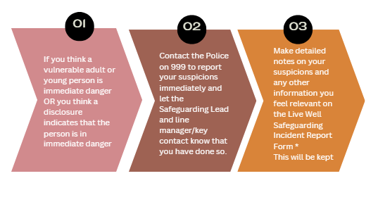

If an adult or young person is not in immediate danger

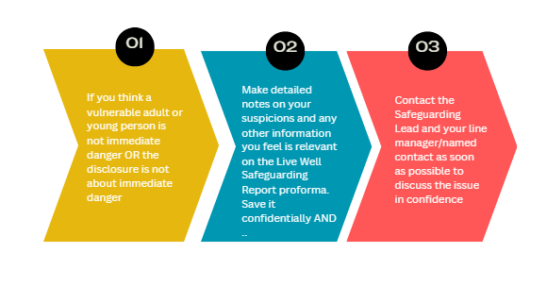

* A copy of the Incident Report Form is attached

Appendix 2

Livewell key contact details
Name | Role | email | Text/ Phone number
Dr Nicola Relph | Safeguarding lead | nicolarelph@nhs.net | 07855473405  by Text message
Dr Susanna Hill | Chair, and key contact for the Community Garden volunteers | Drsrhill0@btinternet.com | 07968 291622
 | General Enquiries | connect@livewellinbraunton.co.uk
Judy Flanagan | Volunteer coordinator | support@livewellinbraunton.co.uk | 07840 298094

Appendix 3

The following are the main categories of abuse and are set out in detail here in order to assist staff and volunteers to be aware of the indicators.

- Physical includes assault, hitting, slapping, pushing, giving the wrong (or no) medication, restraining someone or only letting them do certain things at certain times
- Domestic includes psychological, physical, sexual, financial or emotional abuse or coercive control and so-called 'honour' based violence
- Sexual includes rape, indecent exposure, sexual harassment, inappropriate looking or touching, sexual teasing or innuendo, taking sexual photographs, making someone look at pornography or watch sexual acts, sexual assault or sexual acts they did not consent to or were pressured into consenting
- Psychological includes emotional abuse, threats of harm or abandonment, depriving someone of contact with someone else, humiliation, blaming, controlling, intimidation, putting pressure on someone to do something, harassment, verbal abuse, cyber bullying, isolation or unreasonable and unjustified withdrawal of services or support networks
- Financial or Material includes theft, fraud, internet scamming, putting pressure on someone about their financial arrangements ( including wills, property, inheritance or financial transactions ) or the misuse or stealing of property, possessions or benefits
- Modern Slavery covers slavery ( including domestic slavery ), human trafficking and forced labour. Traffickers and slave masters use whatever they can to pressurise, deceive and force individuals into a life of abuse and inhumane treatment
- Discriminatory includes types of harassment or insults because of someone's race, gender or gender identity, age, disability, sexual orientation or religion
- Neglect and acts of omission includes ignoring medical, emotional or physical care needs, failure to provide access to educational services, or not giving someone what they need to help them live, such as medication, enough nutrition and heating
- Self- neglect covers a wide range of behaviour which shows that someone is not caring for their own personal hygiene, health or surroundings. It includes behaviour such as hoarding
- Organisational includes neglect and poor care in an institution or care setting such as a hospital or care home, or if an organisation provides care in someone's home. The abuse can be a one-off incident or repeated, ongoing ill treatment. The abuse can be through neglect or poor professional practice, which might be through structure, policies, processes or practices within an organisation

Appendix 4

Live Well in Braunton Adults and Young People Safeguarding policy
Key messages for volunteers summarised from the main Policy
If you’re worried - TELL SOMEONE
July 2024

Live Well is committed to safeguarding and protecting from harm all staff, volunteers and users of our services, and in particular vulnerable adults and young people.

Safeguarding includes protection from all forms of abuse whether it be physical, sexual, psychological or emotional harm or neglect and takes into consideration health and safety and the health and wellbeing of staff volunteers and users.

Everyone has a role to play in the protection of vulnerable persons from harm. Your role is to report not to investigate. You will not be alone in carrying out your safeguarding role.

If you are worried about the health or safety of an adult or child, tell someone.

You should seek consent to pass information on from the adult or young person you are worried about, but the law enables you to take action without this if there is an immediate danger.

The action you have taken may need to be explained to the vulnerable person. You, your named contact or the safeguarding lead should do this whoever is thought to be most appropriate

How to respond to a disclosure
Always take disclosure seriously. You may be the first person in whom the adult or young person has confided.
Don’t express your own opinion, be comforting and sympathetic and tell them they are not responsible for what is happening to them and reassure the person that disclosure was the right thing to do
Explain to the person that you would like to share this information with the safeguarding lead or your named contact. If they do not want to take any further action at that time we should not go against their wishes, with the exception of children or adults who have difficulties, such as a person with learning difficulties.
If you can, talk with the person at risk to identify their views on the abuse and the next steps.

What to do if you suspect abuse is happening or an adult or young person discloses abuse.

If an adult or a young person is in immediate danger

If an adult or young person is not in immediate danger.

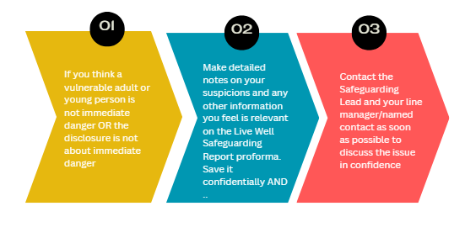

* A copy of the Incident Report Form is attached



INCIDENT REPORT FORM
Name of person reporting
Name of person who you have a concern about.
Date of completing the form:
Time of completing the form:
Are you reporting your own concerns or someone else’s?

VULNERABLE PERSON/CONCERN OVER A VOLUNTEER/STAFF MEMBER
Name
Contact details:

Are they aware of the fact you are reporting this?

Give a brief description of concerns including date/time/location of specific incidents (concerns over health, ability to look after self, vulnerability, safeguarding or safety of housing etc)

Are there any physical and/or behavioural signs? What are they?

Have you spoken to the individual/member of persons family? If so, what have you said?

Has anyone been alleged to be the abuser? If so, give details, including their relationship to the person. (Do not make assumptions)

Have you consulted/reported your concerns to anyone else? Give details and any other action that has been agreed.

Additional information or notes:

Name in Capitals:

Your Signature:

Date:

