Application For Admission
Today’s Date: _________
Name: ____________________________ DOB: _____________ SSN: _______________
Address: __________________________ City/State: _____________ Zip: _______________
Telephone: ________________________ Email: _________________________________
Desired Program/Course: _________________ Expected Start Date: ___________________
Admission Criteria
- Applicants should be 18 years of age or will be 18 years during the first term of enrollment.
- High School diploma or its equivalent is required for admission to the programs. At a minimum, the High School or its equivalent must be earned during the first term of enrollment, except NA.
- Programs requiring a bachelor’s degree for employment will be subject to the co-enrolment in or completion of a bachelor’s degree upon completion of those programs.
- A transcript of up to the highest educational achievement to date is required for assessment.
Programs (Check Your Desired Program)
- Management Support Tech (6mo/600hr)  - Operations Research Analyst (6mo/600hr)  - Applications Software Developer (6mo/600hr)  - Data Mngmt Analyst (6mo/600hr)* | - Nurse Aide/Nursing Assistant (4wk/100hr)  - Medication Aid/Medtn Asst (4wk/100hr)  - Medical Records & Health IT (6mo/600hr)*  - Project Scheduling & Control (4wk/100hr)*  - AI: Artificial Intel Basic (4wk/100hr)*  - AI: Artificial Intel Specialist (6mo/600hr)*
- Computer Support Specialist- DT  (6mo/600hr) | - Project Management (6mo/600hr)*  - Word Processing, kb by Touch(4wk/100hr)*
- Computer Systems Analyst/IT Analyst  (6mo/600hr)  - Database Administrator (6mo/600hr)  - Market Research Analyst/Marketing Specialist (6mo/600hr)* | - Human Resource Mngmt (6mo/600hr)*  - Data Proc, kb by Touch (4wk/100hr)* Coding Basic Programming (4wk/100hr)*  - Human Resource Specialist (4wk/100hr)*  - Finance Specialist (6mo/600hr)*
- Management Analyst (6mo/600hr)*  - Business Analyst (6mo/600hr)*  - Production, Planning, & Expediting (6mo/600hr)* | - System Maintenance & Repair(4wk/100hr)*  - Database Analyst (4wk/100hr)*  - Cost Estimator (6mo/600hr)*  - Data Analyst (6mo/600hr)*
- Service Unit Operators: Oil, Gas, & Mining (6mo/600hr)*  - Mechanical Drafter (6mo/600hr)* | - Information Security Analyst (6mo/600hr)*  - Accountants and Auditors (6mo/600hr)*  - Mechanical Engineering Tech(6mo/600hr)*
*TBA
How Did You Hear About Us? _________ Highest Education To-Date: ________ Date: ________
Work Experience and Dates (List with Dates):


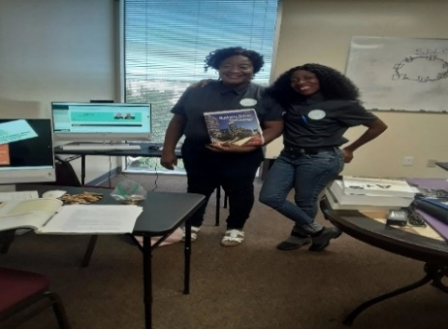
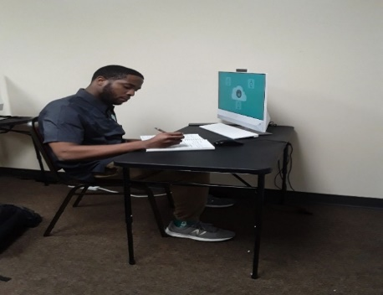
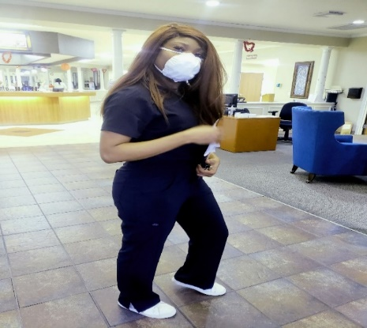

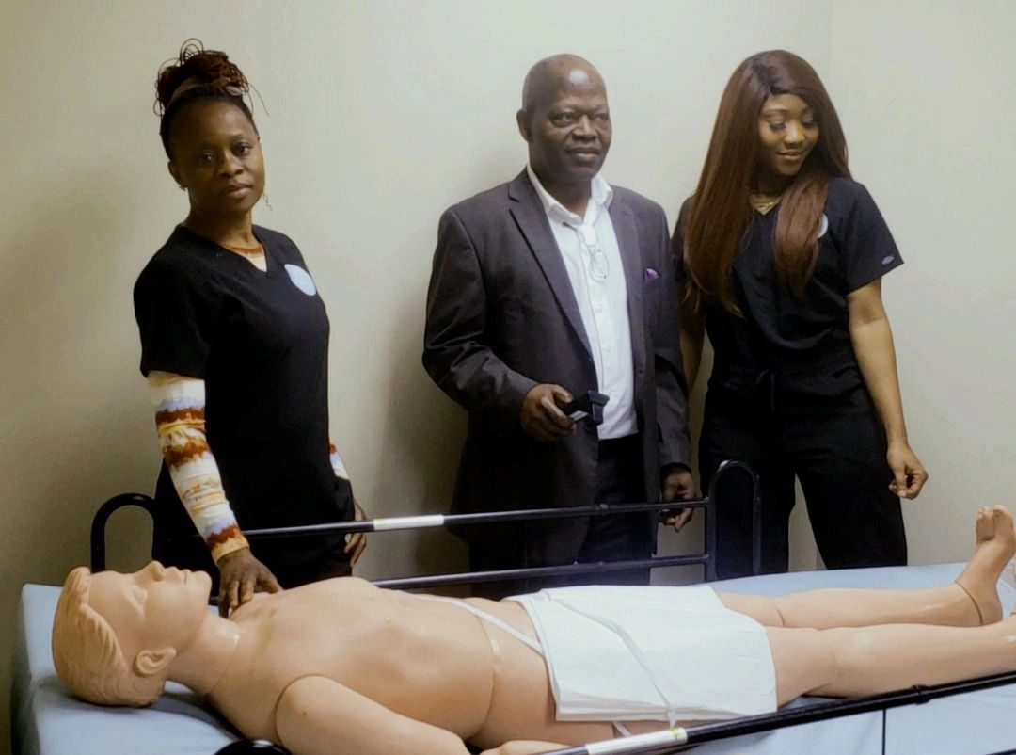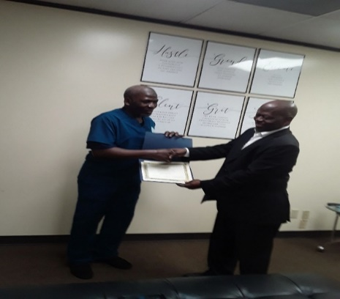
Employable Skilled Graduates
https://sbtech.edu

