**Foundations for Learning Preschool**

**Family Handbook**

**2020-2021**

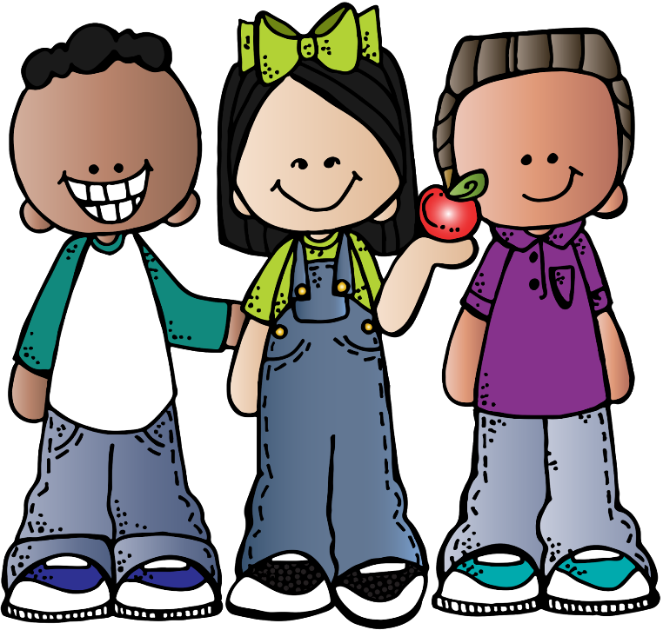

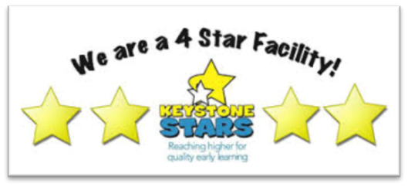



**Mission Statement**

**Foundations for Learning Preschool, provides a safe, nurturing environment that stimulates a child’s natural desire to learn. This is achieved by focusing on specific goals in all areas of learning, teaching specific content knowledge and skills, encouraging friendships and offering open communication with families.** **The aim is to include and enhance every child’s life; if special supports or assistance would help in reaching this goal we will access them.**

**Contents**

**Learning Environment**

1. Curriculum and Small Groups
2. Learning Centers
3. Parent Involvement
4. What to Wear to School
5. Celebrations
6. Transition to Kindergarten/Other Facility

**Assessment**

1. Parent Questionnaire
2. IEP Policy
3. Screening and Conference
4. Weekly Reports
5. Observation Based Assessment
6. Family Conference
7. Referrals
8. Care Plans

**Inclusion**

1. Inclusion Policy
2. Language and Academic Achievement / Home Language Policies
3. Behavior
4. Suspension and Expulsion

**Health, Safety, and Nutrition**

1. Health Procedures and Policies
2. Medication
3. Child Pick up
4. Safety Drills and Emergency Preparedness
5. Nutrition

**Beginning the Process**

1. Enrollment
2. Tuition
3. Daily Schedule & Annual Schedule
4. Photo and Social Media Permission

**Classroom Learning Environment**

1. **Curriculum and Small Groups**
   * **LEARN Every Day. The Preschool Curriculum** is a PA state-approved Early Childhood Curriculum. Each unit includes literacy, math, science, social studies, and creative arts. These experiences encourage exploration and discovery designed for multisensory learning. It is research-based, using developmentally appropriate methods within a nurturing environment that supports all learners.
2. **Small Groups**
   * Small groups are offered twice a day to encourage development in math and literacy skills. The group size ranges from 2-6.
     + **Curriculum Add-On: Brainzy**
       - learning sites enhance your child’s skills in technology, strategy, literacy and math.
     + **Curriculum Add-On: Pocket of Preschool**
       - As a support curriculum Pocket of Preschool is also implemented. Its Small Group Activities help to deepen learning in the following areas: Literacy and Math.
3. **Learning Centers** 
   * Learning Centers provide the most natural and effective use of classroom materials, time and space. Children are free to make choices, to handle, taste, smell and observe, to explore at their own developmental levels, to solve problems in their own way, to share with friends, to dramatize, and to create. Children move around freely and learn by doing. As they change activities, they meet different groups of children and have frequent contacts with the teacher they learn to work and socialize with others. They meet problems and learn to solve them. They grow in confidence and self-respect.
   * Most importantly, Learning Centers are fun and are based on purposeful play, which is integral to how young children learn. At center time, children choose the center in which they wish to work and which materials they use. Children need uninterrupted time to explore learning activities and develop interests and talents. Teachers observe children, ask open-ended questions and make suggestions that extend children’s play and support their learning.
   * Learning Centers integrate literacy learning by featuring reading and writing. Paper and writing tools are found in the Construction Center for children to use to create signs (“Please do not knock the building down.”); in the Dramatic Play Center for grocery lists, and signs “Dentist Office” or “Restaurant.” Alphabet books are placed in the Writing Center and appropriate books in the Discovery, Construction, and Art Center.
4. **Parent Involvement**

* A monthly newsletter will be shared at the beginning of the month. It will include Upcoming Events, Items of interest, What We’re Learning, and Monthly Teacher Tip/Reminder😊 This along a weekly Unit Letter, which will be posted on Class Dojo.
* I encourage you to ask your child about a specific activity, piece of artwork, the Unit of study (i.e. Oceans), Show and Tell, or what center they’re loving😊 This involvement helps the child know you are interested and care deeply about what he/she is learning.

1. **What to Wear to School?**
   * Comfortable, washable, weather-appropriate clothing is required. Your children will be very active. If they have trouble with sandals or flip flops when running you may want to reconsider. An extra set of clothing is needed, the clothing should be placed in a labeled zip lock bag. The clothing will be rotated seasonally.
2. **Celebrations**
   * Birthdays are celebrated with simple party activities, a gift (from me), and a cookie or cupcakes from home.
   * Halloween – a costume party (costumes must not be scary!) games, food, and gift bags.
   * Thanksgiving – books, crafts, snacks, and games.
   * Christmas – gift exchange, snacks, and cake to celebrate Christ’s birth.
   * Valentine’s Day – a valentine's exchange, games, snacks, and gift bags.
   * Easter- celebrating the “Real Easter Story” the death and resurrection of Christ as well as the Easter Bunny☺ - books, games, egg hunt, and snacks will be shared before Easter break.
   * If your family has any celebrations or traditions, you would like to share with the class, that would be wonderful! Please let me know, and we will find a day that suits you.
   * **I will be asking for donations such as cupcakes, cookies, plates/napkins/cups, and goodie bags. These will be requested on a rotating basis and will be included in the Monthly Newsletter.
3. **Transitioning**
   * Transitioning begins in the fall of the year before Kindergarten. During the initial conference of the year, the kindergarten checklist from Bedford Elementary School is reviewed. Your child’s skills lined up with the schools’ expectations are discussed. Additional goals will be worked on at school. If your child is attending another elementary school, I will do my best to get their enrollment information.
   * Consistency, familiarity, and trust are established and maintained within the classroom. When transitions are coming, such as a family leaving or a new group of friends coming, we prepare them for the change.
   * Throughout the year, your child is working in both small and large groups, learning in all domains; language and literacy, math, social and emotional, health, fine and gross motor, social studies, science, and the arts all in preparation for their transition into kindergarten.
   * In March/April, we will review the Kindergarten Checklist again. Continuing to move towards any goals we have at school and home. Dates and information on Kindergarten Registration at Bedford Elementary will be posted.
   * At the end of our school year, we celebrate with a spring graduation program at Del Grosso’s Amusement Park.
   * If a decision is made to withdraw early to enter another facility, one month’s notice is required unless the situation is out of your control. I will help to make the transition smooth for you, and you’re your child. We will forward any information requested by the parents.

**Assessment**

1. **Parent Questionnaire**
   * Within the enrollment folder, is a parent questionnaire. The answers will give me a little insight into your child’s likes and dislikes, along with some background information**.**
2. **IEP Policy**
   * If your child has an Individual Education Plan (IEP), the information will be used to individualize instruction. This information gives us a point of reference concerning your child’s progress in the identified areas. We will also participate with you in the IU8 meeting.
3. **Ages and Stages Screening**
   * Within 45 days of enrollment, you will receive an Ages and Stages Questionnaire to identify children who may need an additional evaluation or intervention strategies. The questionnaire will be completed at home by the family and at school. This screening tool offers short activities to share with your child and a simple scoring process of always, sometimes and never. When completed, we will discuss them during a brief phone conference.

1. **Observations and Assessment**
   * Observations and documentation are gathered throughout the year. The information is entered into an assessment tool approved by OCDEL (Office of Child Development and Early Learning) Teaching Strategies Gold, which provides us with a clear path of goals and expectations. The information gathered is then shared with the family at two conferences annually.
2. **Family Conferences**
   * You will receive two conferences a year with the initial Ages and Stages phone conference at the beginning of the year. The second conference for children moving on to kindergarten is held February/March. The final meeting for children staying on another year will be held later in the spring. The second is to discuss your child’s progress and goals moving forward.
3. **Referrals name a few or just refer to community resource manual?**
   * If any concerns are raised based on the screening tool or observations from the classroom or home, we will discuss the options available to us. There are various community services to assist with social skills, mental health, educational concerns, wellness, and medical services.
   * Two common resources are the IU8, and Early Childhood Mental Health (ECMH). Coming soon is the Asset Mapping System at the Community Action Office; this will be an interactive tool used to search a wide variety of supports. The Community Resource manual is available at school, as well.
   * Care plans for children with special needs, asthma, medical needs, food allergies, and medical administration will be requested as needed. Care for our Children will guide the policies and practices regarding their implementation.

Caring for Our Children is a national resource center for health and safety in child care and early education. Resource Center for Health ty in Child Care and Early Education

1. **Weekly Reports**
   * These will come throughout the week on Class Dojo. They will share some of your child’s interests for the week; and a photo or documentation of work they have done. It may include observations or progress your child is enjoying.

**Inclusion**

1. **Inclusion Policy**
   * Children of all abilities, cultures, and dual-language learners will have equal access. Our goal is to include and enhance every child’s life, holding high expectations to reach their full potential. If modifications or supports suggested for your child, they would be accessed. We work together with families and the IU (Preschool Early Intervention) to promote full participation.
   * Training will be provided for the staff to facilitate the process and support your family.

1. **Language and Academic Achievement / Home Language Policy**
   * We welcome families who are culturally and ethnically diverse as an enrichment to our class. If English is the family's second language, we will access the available resources to translate and assist in communication between staff and family, child, and their peers. We will incorporate the child’s native language in the classroom and include pieces of the family’s culture. The child will be encouraged to use his home language as well as English.
2. **Behavior**
   * We work on social and emotional skills daily. Your children are in the process of learning how to handle conflicts. They learn how to listen, step back if necessary, talk about how they feel, and use words to take care of themselves, their friends, and the problem.
3. **Suspension**
   * Inevitably there will be moments when your child struggles to manage their emotions. We step in quickly and calmly to redirect them. Many times, we step into the “Quiet Zone” to spend a little time together working on a puzzle or sharing a book. This gives them time to relax; then we can talk and figure things out.
   * If your child has an ongoing problem, we will notify you, and we can discuss ideas.
   * Perhaps your child just isn’t responding to the strategies used at home or school. Then we can discuss what other options we may have. The IU (Early Preschool Intervention) could be contacted and offer appropriate strategies, evaluations, and or additional support.
   * If we find ourselves at this point, our goal will be to keep your child included in all aspects of our play and learning, helping them to work through the situations with additional support in the classroom.
4. **Suspension and Expulsion**
   * Every effort to include all children always is the goal. If a situation has presented itself, and the child is not responding, we will exhaust every option available to us. Such as behavior documentation, Ages and Stages-SE, parent conferences, and professional development for teachers. At that point, we may have to discuss other choices; we would keep the communication open with the family, the IU, and the teacher. We would work together to find the best next step.
   * Helpline Referral, 1-800-692-7288

Image result for melonheadz  learning clipart**Health, Safety and Nutrition**

1. **Health Procedures**
   * To “Stay Healthy,” a few procedures developed by Caring for Our Children, have been implemented.
   * Hand washing; upon arrival, after blowing noses, toileting, playing outside, or with the cats. Along with washing before/after mealtime, sensory, and playdough time. We follow a standard hand-washing procedure posted above the sink.
   * Surfaces in the facility are sanitized throughout the day. Toys are sanitized on a rotating basis, or after being “mouthed.” Bedding is washed weekly, and the children are spaced 2 feet apart from each other at naptime to avoid the spread of germs.
   * An illness tracker is used to document, report if necessary, notify parents, and identify any procedures that could prevent the spread of the illness. If a sick child has been in the facility, additional sanitizing methods are implemented.

1. **Health, Safety and Nutrition Policies**
   * To “Stay Healthy,” a few procedures developed by Caring for Our Children, have been implemented.
   * Hand washing; upon arrival, after blowing noses, toileting, playing outside, or with the cats. Along with hand-washing before/after mealtime, sensory, and playdough time. We follow and standard hand-washing procedure posted above the sink.
   * The surfaces are sanitized in the facility throughout the day. Toys are sanitized on a rotating basis, or after being “mouthed.” Bedding is washed weekly, and the children are spaced 2 feet apart from each other at naptime to avoid the spread of germs.
   * An illness tracker is used to document, report if necessary, notify parents, and identify any procedures that could prevent the spreadof the illness. If a sick child has been in the facility, additional sanitizing methods are implemented.
     + Common conditions that do not require exclusion:
       - Common colds, runny noses (regardless of color or consistency of nasal discharge), and coughs
       - Fever without symptoms or signs of illness
       - Fever is defined as the temperature above 101 F orally, above 102 F rectally, or 100 F under the arm, or measured by an equivalent method.
       - If the child has a fever with routine behavior, the cause of the temperature should be sought, but the child may remain in care.
       - Watery discharge without fever, eye pain, or eyelid redness
       - Rash without fever and behavioral change
       - If your child has a viral pink eye, they can return to child care once they have seen a doctor. If your child has bacterial pinkeye and is taking antibiotics, they should stay home from child care or school until they’ve had the antibiotics for 24 hours.
     + Common Conditions Requiring Temporary Exclusion
       - Diarrhea – unless explained by diet or a more severe condition that requires more extended exclusion
       - Fever with other symptoms or a temperature above 101 orally, 102 rectally, 100 under the arm, or measured by an equivalent method.
       - Vomiting – PLEASE keep your child home.
2. **Medication**
   * Please schedule dosages around school hours, if possible. If medication must be administered at school, you will need to fill out and sign a medication log or provide a handwritten note with the following requirements; date, medication, refrigeration needs, dosage amount and schedule, signature.
3. **Safe Pick Up**
   * Using the emergency contact form as a guide, only the approved individuals will be permitted to pick up the child. If the person is unfamiliar to me, a photo ID is required. If an emergency should arise and your child needs to be picked up by a friend or family member, you must call to verify the information over the phone. Information will be documented, and a photo ID will be necessary.
   * When picking up your child, please be aware of children playing outside. If necessary, park at the top of the driveway to ensure their safety. If this creates a problem, please discuss this with me. The children are taught safety rules about vehicles; however, they get distracted, and we need to be sure they are safe. We will share the responsibility of your child until you leave the premises.
4. **Safety Drills and Emergency Preparedness**

* The following safety drills practiced monthly are fire, storm, stranger, and evacuation. The exercises prepare the children in case of an emergency.
* An Emergency Operations Plan is in place, and a copy is on file with the local Emergency Management Office.

1. **Nutrition**

* Your child will receive breakfast, lunch, and afternoon snack. Breakfast meal components are a whole grain item, fruit/vegetable, and skim milk. Lunch components are a low-fat protein, whole grain, two servings of fruits/vegetables, and skim milk. Snack is a choice of 2: protein, whole grain, fruit/vegetable, skim milk.
* Meal components required by the Child and Adult Food Program (CACFP), as well as meal times and food preparation, are monitored by the Greater Pittsburgh YWCA Child Care Food Program. Enrollment forms will be completed upon admission and updated annually. Periodically, the YMCA randomly chooses facilities and contacts the families to be sure their child is enrolled and attends.

 

**Enrollment Process**

**Enrollment Packet**

The enrollment packet includes a parent handbook, enrollment questionnaire, childcare agreement, emergency contact/parental consent, child health assessment, and a portion of the facility's emergency operations plan.

Information on public resources which may benefit your family, which may be included CHIP, Earned Income Tax Credit, and Child Care Information Services (CCIS). A comprehensive Community Resource Manual is also available.

**Tuition**

Tuition will be $30.00 per day, beginning August 1st, 2020. Breakfast, lunch, and afternoon snacks are provided as well.

Tuition for preschool/extended care will be $150.00 a week from August 1, 2020, through July 30, 2021. You are required to pay for the days your child is registered **unless** **the facility is closed**. Monthly payments due on the 25th of the month of care and are preferred. However, if a weekly or biweekly payment is easier for your family, that is fine. Please pay promptly to avoid late fees.

A few part-time spots are available with a minimum of 2 days per week at $30.00 per day. Tuition for before/after school care is $60.00 per week. If space allows a half-day option at $18.00 per day is available. Subsidized care provided through the CCIS of Bedford County is a great way to help with tuition. An appointment must be made with the CCIS office and paperwork filled out to see if your family is eligible. It is worth the time and effort if there may be a chance of receiving funding.

**Withdrawal Procedure**

An anticipated withdrawal would be your child’s transition into Kindergarten. If this schedule changes, please notify me immediately. A minimum of 1-month notice is required, and tuition will be due through the one month following notification. If a hardship occurs, I will work with you.

**Days Closed**

The facility will be closed, as noted on the Annual Schedule. If a situation arises requiring me to close for the day, I will notify you on Class Dojo.

**Family Engagement**

A family survey completed at the end of the year will help shape policies moving forward.

.