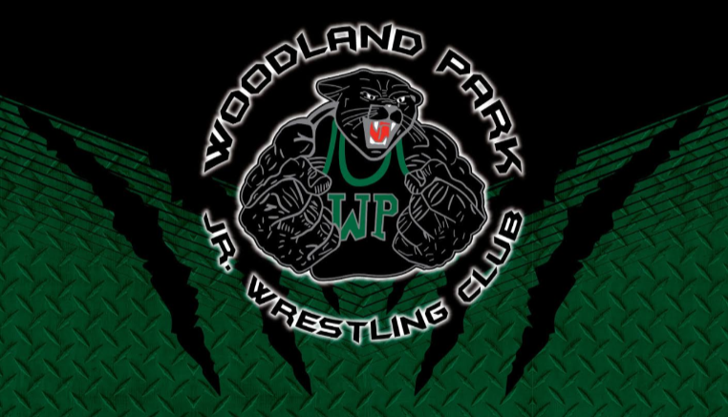
Woodland Park Jr. Wrestling Club Incident Reporting Form
Use this form to report any incident surrounding your wrestler.
Return completed form to the Director of Grievance and Compliance via email or in person.
(Please refer to the WPJWC Policies and Procedures regarding grievance processes)

This is documenting an:

Incident Observation Other:_________________________________________

Details of person involved (to be filled in by person involved if possible)

Person Completing Report:_____________________ Date:____________________
Person(s) Involved:______________________________________________________
Parent Name:__________________________________________________________

Event Details

Date of Event:_____________________ Location of Event:______________________

Time of Event:_____________________ Witnesses:___________________________

Description of Events (Describe what occurred):
_____________________________________________________________________________
______________________________________________________________________
______________________________________________________________________
______________________________________________________________________
______________________________________________________________________
*If more space is required please use the back of this form

Signature of Wrestler:_____________________________ Date:__________________
Signature of Parent:______________________________ Date:__________________

TO BE USED BY DIRECTOR OF GRIEVANCE AND COMPLIANCE ONLY
Comments:
________________________________________________________________________________________________________________________________________________________________________________________________________________________________________________________________________________________

Outcome:_______________________________ Board Appeal: YES NO

