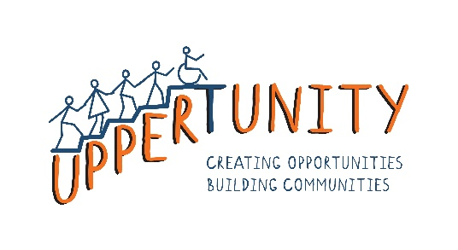
Uppertunity Ltd
Ground Floor Left
The Circle at Dudhope Castle
Barrack Road
Dundee, DD36HF

Uppertunity Application Form: Volunteer Trustee Board Member

Thank you for your interest in joining our team. We believe in having a diverse team and working as a team to achieve our mission aims. We look forward to receiving your application. This is for an unpaid role.

What to do next:

Once you’ve completed this form please send it back to us and we’ll get in touch. Email it to: danielledp@uppertunity.co.uk or post it to Uppertunity, Unit 47, The Circle, 4-6 Staffa Place, DD23SX. If we feel you are a good fit and meet the requirements, we will invite you to an interview.

Uppertunity complies with General Data Protection Regulation. All measures are taken to keep data safe and secure. Uppertunity will not share this information with any other individual or organisation. If you wish to update or remove any information, please contact the manager and we will not hesitate to do so.

- Personal details:

Name:
Contact number:
Contact email address:
Are there any health concerns you feel the organisation should know of? This is to ensure your safety:

- Skills and experience

- Why are you interested in joining the board?
- What are the skills, experience or qualifications that you feel would be relevant to this role?
- What experience do you have in company boards or social enterprises?
- Please briefly explain a time that you showed initiative.
- How can Uppertunity help make your experience with us exceptional?

- References

As the nature of Uppertunity works directly and indirectly with vulnerable adults, we require at least 2 references from you. Please provide details below:

Name or referee and how they know you | Contact details

- Disclosures and PVG’s

All volunteers, board members, placements and employed staff must complete a PVG check when working in direct contact with vulnerable adults. If your position requires this, you will be required to fill in a disclosure form. This is available separately. The Protecting Vulnerable Groups membership scheme is managed and delivered by Disclosure Scotland. It helps makes sure people whose behaviour makes them unsuitable to work with children and/or protected adults, can't do 'regulated work' with these vulnerable groups.

Please note: having a conviction will not necessarily stop you from volunteering, but will need to be taken into consideration when assessing your suitability.

- Declaration

Declaration I declare that to the best of my knowledge the information given on this form is true and accurate.

Signature: ______________________________________________

Date: __________________________________________________

