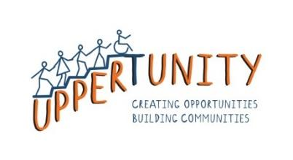

**Joining form for Uppertunity**

1. **Joining details**

| **Date of joining:** |  |
| --- | --- |
| **Full Name:** |  |
| **Date of Birth:** |  |
| **How did you find out about us?** |  |
| **Contact name, number and relationship** (In case groups are cancelled or changes are made): |  |
| **Guardian or Care Manager name and contact number and email address** (To discuss any information or safeguarding concerns): |  |
| **Emergency contact person and details** (If different)**:** |  |
| **I’ll attend groups:** | * With a carer or support worker/s * Independently * Other: _______________________ |
| **I will attend lunch:** | Yes/No |
| **Groups or services I will be attending/would like to attend:** |  |

1. **Information about your needs**

| **Additional needs, conditions or knowledge for support I’d like to share:** |  |
| --- | --- |
| **Risks to note** (Allergies, Anxieties, fears or concerns)**:** |  |
| **Communication details to know:** |  |
| **Environment accessibility needs:** |  |

1. **Information about your interest**

| **What I’d like to learn to do, try or improve:** |  |
| --- | --- |
| **I feel confident when:** |  |
| **You can encourage me by:** |  |
| **My triggers or sensitivities are:** |  |
| **What are your goals for your future?** |  |
| **How can Uppertunity help you achieve them?** |  |

Uppertunity complies with General Data Protection Regulation. All measures are taken to keep data safe and secure. Uppertunity will not share this information with any other individual or organisation. If you wish to update or remove any information, please contact the manager and we will not hesitate to do so.



**Photo Consent and Agreement Form**

Name: ___________________________________________________________________________

☐ I consent to Uppertunity taking photos of me.

☐ I consent to my photo being posted on Uppertunity’s social media and website.

☐ I consent to wellbeing checks and support.

As a member of the Uppertunity community, I consent to the procedures, community codes and information I’ve learned in the Uppertunity Induction pack. Uppertunity agrees not to use any of the information or media gained through this consent for other purposes. I will not hold Uppertunity responsible for the actions they’ve outlined here.  I understand that I am welcome to revoke my consent at any time by letting Uppertunity know of my changed wishes in writing.

| **Client Name** |  |
| --- | --- |
| **Signature of Client** |  |
| **Date** |  |
| **Carer Name (if required)** |  |
| **Signature of Carer (if required)** |  |
| **Date** |  |