**Applicant’s Name / Client**

GENERAL PERMIT AQUATIC RESOURCE IMPACT TABLE

FOR PENNSYLVANIA CHAPTER 105 WATER OBSTRUCTION AND ENCROACHMENT GENERAL PERMIT REGISTRATIONS

Please begin to complete the General Permit Aquatic Resource Impact Table by including the Applicant's Name / Client (upper right of the page). Also, complete the Project / Site Name (upper left of the table) and the date of registration package submission (upper right of the table, under Applicant's Name / Client). Then complete one row of data for each regulated (PA DEP Chapter 105) structure or activity and type of impact for the proposed project based on the instructions for each column below; add additional worksheets if needed. Provide completed General Permit Aquatic Resource Impact Table with **Chapter 105 Water Obstruction and Encroachment General Permit (GP) Registration;** DO NOT submit instructions or examples (pages 1‑3) for this table.

|  |
| --- |
| **DEP Permit Number:** leave blank, it will be completed by DEP upon permit acknowledgment/issuance/verification. |
| ***Project Information*** *provide the appropriate information based on the details on each impact for the project.* |
| **Structure / Activity Identifier:** provide a unique identifier for each regulated structure and/or activity being proposed, typically a name and number; this same unique identifier should be used in all aspect of the permit registration/application package. (i.e. GP‑5‑1, GP‑5‑2). |
| **Watercourse / Wetland /** provide whether the impacted aquatic resource is either a watercourse or wetland or body of water. If more than one resources is impacted  **Body of Water:** a separate line should be provided for each impact. Floodway impacts should not be included*. |
| **Latitude of impact:** provide the latitude of the aquatic resource impact in decimal degrees (most online mapping tools provide this by clicking or right clicking). |
| **Longitude of impact:** provide the longitude of the aquatic resource impact in decimal degrees (most online mapping tools provide this by clicking or right clicking). |
| **Waters Name:** provide the name of the stream or other body of water (if available). [eMapPA](https://gis.dep.pa.gov/emappa/) can assist in locating names. |
| **PA Code Chapter 93 Designation:** provide the [Chapter 93 Designation](https://www.pacodeandbulletin.gov/Display/pacode?file=/secure/pacode/data/025/chapter93/chap93toc.html&d=reduce) for the aquatic resource (i.e. HQ‑CWF, WWF, EV, MF and for [wetlands](https://www.pacodeandbulletin.gov/Display/pacode?file=/secure/pacode/data/025/chapter105/s105.17.html&d=reduce) EV or Other)  to Identify Chapter 93: Use [eMapPA](https://gis.dep.pa.gov/emappa/), or designation in [Chapter 93](https://www.pacodeandbulletin.gov/Display/pacode?file=/secure/pacode/data/025/chapter93/chap93toc.html&d=reduce), and identify [Existing Use](https://www.dep.pa.gov/Business/Water/CleanWater/WaterQuality/StreamRedesignations/Pages/Statewide-Existing-Use-Classifications.aspx) if more protective. |
| **Work Proposed:** provide the type of work proposed to impact the resource; (i.e **-** aerial utility line, horizontal drill/boring, utility line, road, placement of fill, etc.). |
| ***PA DEP Chapter 105 Impacts*** *provide the appropriate information based on the details on each impact for the project.* |
| **Impact Type:** provide the type of aquatic resource impact: temporary or permanent. *(See Below).* |
| **Impact Area:** provide the area of the aquatic resource impact in square feet. |
| **Impact Length:** provide the length of the aquatic resource impact in feet, for all Resource Types. (measured along the longest length of the impact). |

PADEP Impact Type: temporary or permanent.

Permanent Impacts are those areas affected by a water obstruction or encroachment that consist of both direct and indirect impacts that result from the placement or construction of a water obstruction or encroachment and include areas necessary for the operation and maintenance of the water obstruction or encroachment located in, along or across, or projecting into a watercourse, floodway* or body of water.

Temporary Impacts are those areas affected during the construction of a water obstruction or encroachment that consists of both direct and indirect impacts located in, along or across, or projecting into a watercourse, floodway or body of water that are restored upon completion of construction. This does not include areas that will be maintained as a result of the operation and maintenance of the water obstruction or encroachment located in, along or across, or projecting into a watercourse, floodway* or body of water (these are considered permanent impacts).

* As noted on the above table, Chapter 105 General Permits do not authorize any significant change to water surface profiles. Roadway approaches to bridges and culverts should be constructed at original grades where possible. Where necessary, depth of fill in the approaches shall be minimized to allow overflow of the roadway during periods of high water. Therefore, the General Permit ARIT does not need to include floodways as a “type of impact”. See General Permit conditions for additional information.

**NOTE: Form 3150-PM-BWEW0560 or equivalent must be submitted with GP Registrations.** Applicants may choose to submit their own version of this table, as long as the minimum information is included, with additional columns placed to the right in a spreadsheet format. Many applicants choose to provide additional information or data to help DEP reviewers understand the type of aquatic resource, its condition, the nature of the impact, or simply to cross‑reference the impact locations to maps, plans, or other application materials. Additional information often allows for a more efficient DEP review, and cross references to corresponding supplemental information is helpful and leads to less questions.

**Applicant’s Name / Client Example Applicant**

GENERAL PERMIT AQUATIC RESOURCE IMPACT TABLE

FOR PENNSYLVANIA CHAPTER 105 WATER OBSTRUCTION AND ENCROACHMENT GENERAL PERMIT REGISTRATION

|  |  |  |  |  |  |  |  |  |  |  |
| --- | --- | --- | --- | --- | --- | --- | --- | --- | --- | --- |
|  | Project / Site Name: Example Project | | | | | | | Date: 6/1/2024 | | |
| **DEP USE ONLY** | **Project Information** | | | | | | | **PA DEP / 105** | | |
| PADEP Permit Number | Structure / Activity Unique Identifier | Watercourse/ Wetland /Body of Water | Latitude | Longitude | [Waters Name](https://gis.dep.pa.gov/emappa/) | PA Code Chapter 93Designation | Work Proposed | Facility/ Impact Type:(temp / perm) | Impact Area in Square Feet | Impact LengthIn Feet |
|  | | | | | | | | | | |
| **Example 1: Land Development Project** | | | | | | | | | | |
|  | **GP-4-1** | **Watercourse** | **41.768015** | **-77.152305** | **Dunn Creek** | **CWF** | **Stormwater Outfall** | **Perm** | **8 x 12 = 96** | **12** |
|  | **GP-5-1** | **Watercourse** | **41.7710531** | **-77.152930** | **UNT to Dunn Creek** | **CWF** | **Underground Sewer Line** | **Perm** | **1 x 5 = 5** | **5** |
|  | **GP-5-1** | **Watercourse** | **41.7710531** | **-77.152930** | **UNT to Dunn Creek** | **CWF** | **Underground Sewer Line** | **Temp** | **20 x 5 = 100** | **20** |
|  | **GP-5-2** | **Wetland** | **41.7710618** | **-77.152945** | **Wetland A** | **Other** | **Underground Sewer Line** | **Perm** | **1 x 30 = 30** | **30** |
|  | **GP-5-2** | **Wetland** | **41.7710630** | **-77.152950** | **Wetland A** | **Other** | **Underground Sewer Line** | **Temp** | **20 x 30 = 600** | **30** |
|  | **GP-7-1** | **Watercourse** | **41.7710636** | **-77.152942** | **Dunn Creek** | **CWF** | **Culvert Road Crossing** | **Perm** | **10 x 70 = 700** | **70** |
|  | **GP-7-1** | **Stream** | **41.7710636** | **-77.152942** | **Dunn Creek** | **CWF** | **Culvert Road Crossing** | **Temp** | **10 x 90 = 900** | **90** |
|  | **GP-8-1** | **Watercourse** | **41.7710620** | **-77.152939** | **Dunn Creek** | **CWF** | **Temporary Road** | **Temp** | **4 x 40 = 160** | **40** |
|  |  |  |  |  |  |  |  |  |  |  |
| **Example 2: Roadway Project** | | | | | | | | | | |
|  | **GP-11-1** | **Watercourse** | **41.417772** | **-79.893263** | **Sugar Run** | **TSF** | **Culvert Replacement** | **Perm** | **37 x 6 = 296** | **37** |
|  | **GP-11-2** | **Watercourse** | **41.417772** | **-79.893263** | **Sugar Run** | **TSF** | **Culvert Replacement** | **Temp** | **54 x 15 = 810** | **54** |
|  | **GP-8-1** | **Wetland** | **41.418790** | **-79.890836** | **Wetland B** | **Other** | **Temporary Road** | **Temp** | **6 x 25 = 150** | **11** |
|  | **GP-8-2** | **Watercourse** | **41.417618** | **-79.890055** | **Sugar Run** | **TSF** | **Temporary Road** | **Temp** | **4 x 40 = 160** | **40** |
|  |  |  |  |  |  |  |  |  |  |  |

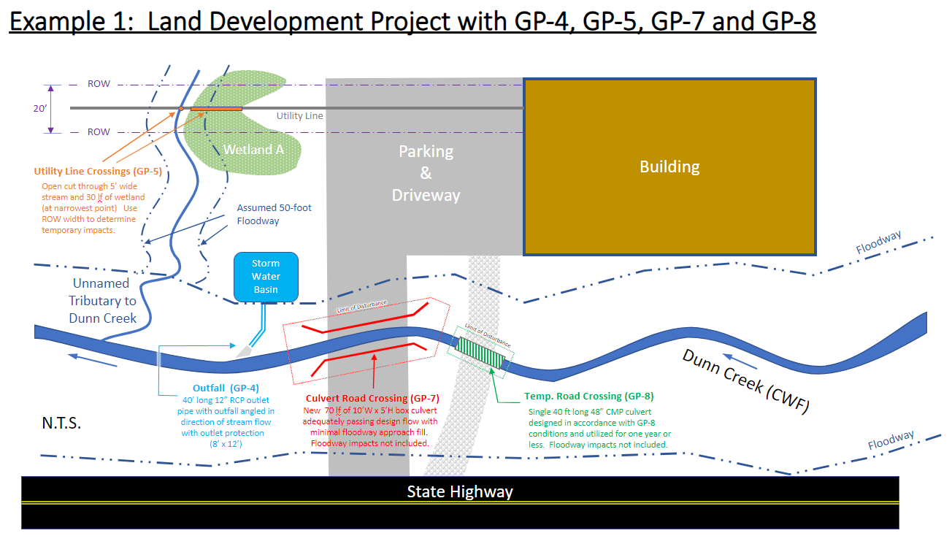

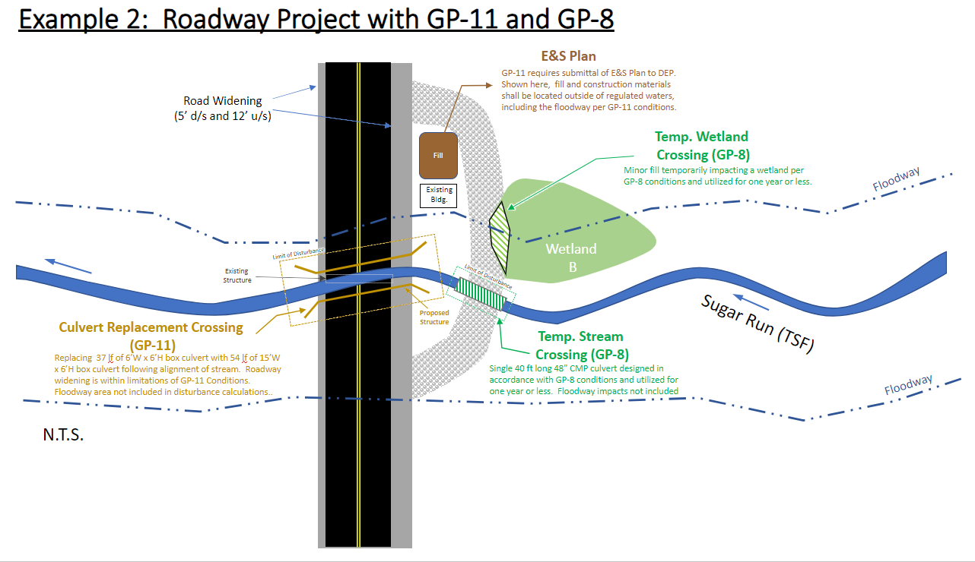

**Applicant’s Name / Client**

GENERAL PERMIT AQUATIC RESOURCE IMPACT TABLE

FOR PENNSYLVANIA CHAPTER 105 WATER OBSTRUCTION AND ENCROACHMENT GENERAL PERMIT REGISTRATION

|  |  |
| --- | --- |
|  | |
|  | Project / Site Name: | | | | | | | | Date: | | |
| **DEP USE ONLY** | **Project Information** | | | | | | | | **PA DEP / 105** | | |
| PADEP Permit Number | Structure / Activity Unique Identifier | | Watercourse / Wetland /Body of Water | Latitude | Longitude | [Waters Name](https://gis.dep.pa.gov/emappa/) | PA Code Chapter 93Designation | Work Proposed | Facility / ImpactType(temp / perm) | Impact Area in Square Feet | Impact Lengthin feet |
|  |  | |  |  |  |  |  |  |  |  |  |
|  |  | |  |  |  |  |  |  |  |  |  |
|  |  | |  |  |  |  |  |  |  |  |  |
|  |  | |  |  |  |  |  |  |  |  |  |
|  |  | |  |  |  |  |  |  |  |  |  |
|  |  | |  |  |  |  |  |  |  |  |  |
|  |  | |  |  |  |  |  |  |  |  |  |
|  |  | |  |  |  |  |  |  |  |  |  |
|  |  | |  |  |  |  |  |  |  |  |  |
|  |  | |  |  |  |  |  |  |  |  |  |
|  |  | |  |  |  |  |  |  |  |  |  |
|  |  | |  |  |  |  |  |  |  |  |  |
|  |  | |  |  |  |  |  |  |  |  |  |
|  |  | |  |  |  |  |  |  |  |  |  |
|  |  | |  |  |  |  |  |  |  |  |  |
|  |  | |  |  |  |  |  |  |  |  |  |
|  |  | |  |  |  |  |  |  |  |  |  |
|  |  | |  |  |  |  |  |  |  |  |  |
|  |  | |  |  |  |  |  |  |  |  |  |
|  |  | |  |  |  |  |  |  |  |  |  |
|  | | | | | | | | | | | |
| **DEP USE ONLY** | | | | | | | | | | | |
| US Army Corps of Engineers impacts for PASPGP determination | | | | | | | TOTAL linear feet of stream impacts | | |  | |
| TOTAL acres of waters impacted | | |  | |