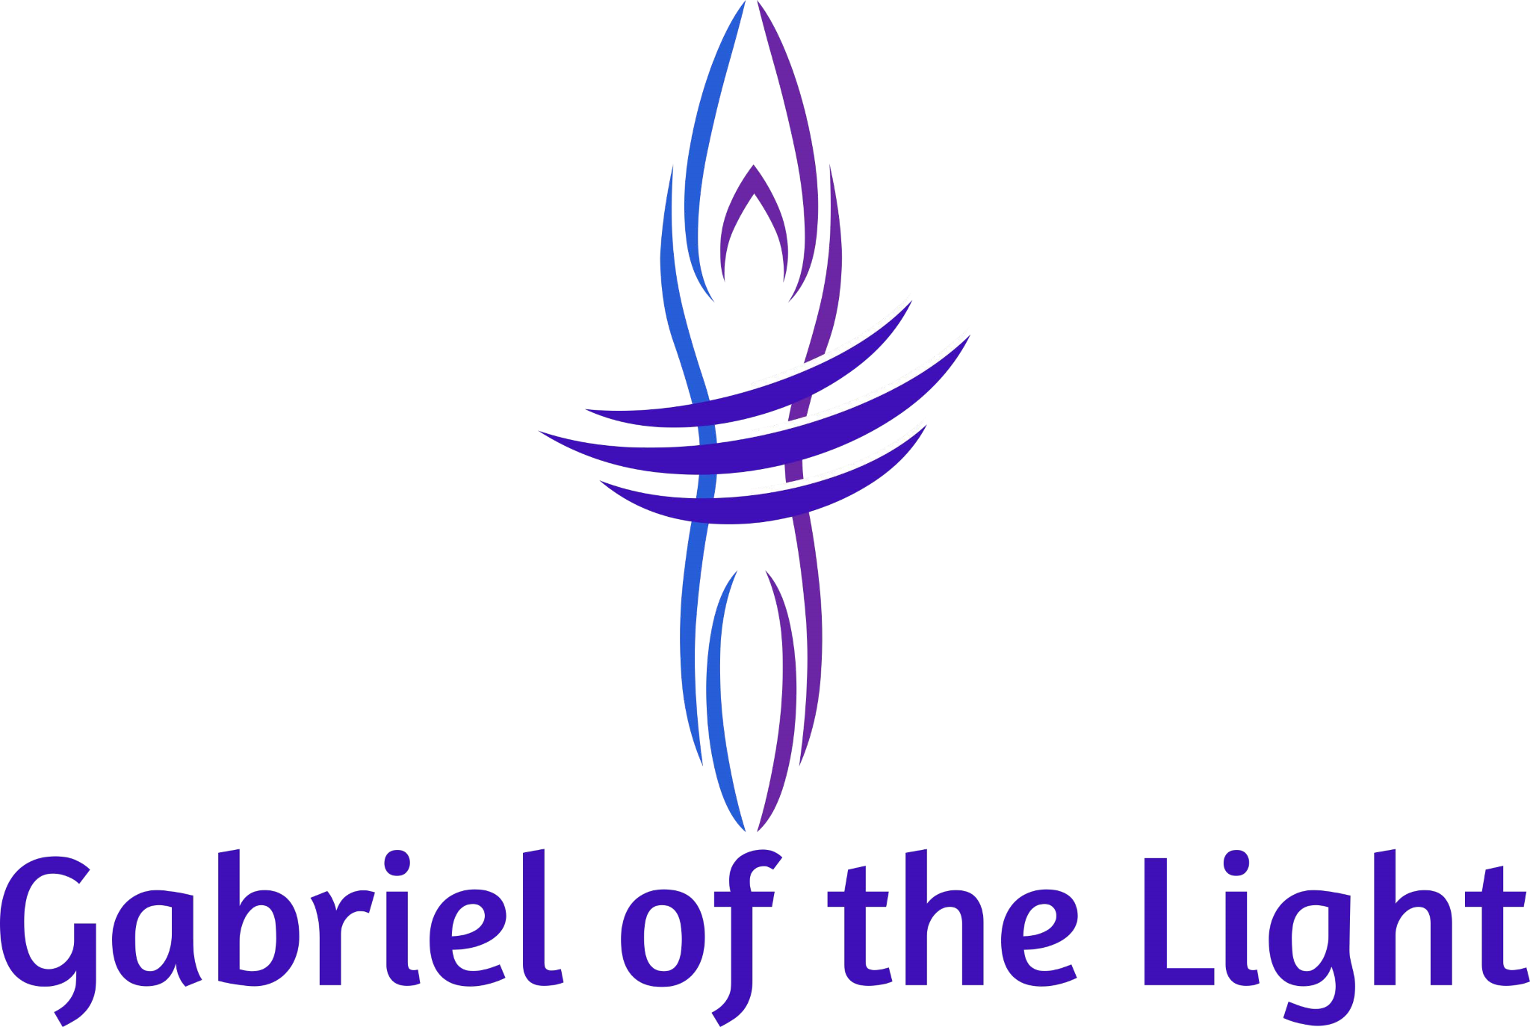
Sound Apprenticeship Application

Follow Your Bliss!
The Apprenticeship Program is a year-long commitment for those with a passion and calling to become a sacred sound therapist. Apprentices who complete the Program will have the tools, knowledge and experience needed to start their own sound therapy practice. This Program requires time, dedication and active participation.

Prerequisite: Level One Sacred Sound Ensemble Training including those with previous training or experience. Details about this training class can be found on the Classes page at www.gabrielofthelight.com.

Program Outline

The syllabus below is part of the mandatory requirements for successful completion of the Apprenticeship Program. This is a serious commitment of time and energy. Apprentices who miss two or more trainings may need to take them again in the next year to maintain their apprenticeship status.
- 12 weekend intensive trainings in Atlanta to learn principles of sound and to practice with Himalayan and Crystal singing bowls.
- Bimonthly online check-ins with GabrielNelson and other apprentices.
- Tuning forks, chimes, drums, Native American flutes and bells will be explored.
- Techniques for protection, grounding, blessing and purification.
- Toning and chanting.
- Apprentices will be supported in existing and developing gifts or experience such as intuition, Reiki and other healing modalities.
- Facilitation of 18 sacred sound meditations with GabrielNelson at various Atlanta locations.
- Monthly participation in sacred sound circles.
- 3 months of business training drawing upon GabrielNelson's 29 years of business and marketing experience.
- Final Capstone Project to plan, market and facilitate your own 1-hour sound meditation at a location of your choice.
- Ongoing support and check-ins from Gabriel-Nelson.

Additional Info
- Journaling is required.
- There will be handouts with required practice and readings between each monthly weekend intensive.
- The training will cover a variety of instruments such as tuning forks, chimes, drums and bells, to name a few. However the core program is with Himalayan and crystal singing bowls to develop a solid proficiency and to understand the nuances of both. Apprentices will discover their own preference or may already know it.
- Techniques for protection, grounding, blessing and purification is taught.
- Apprentices will be supported in existing and developing gifts or experience such as intuition, Reiki and other healing modalities.
- There are no refunds. Students and apprentices have the option of resuming at a future time in the event of an unforeseen life circumstance excluding moving or job relocation. It will be your responsibility to arrange for transportation and lodging in Atlanta to attend the weekend intensives should you move or have a job relocation.
- This is a fluid, “living” program with apprentices starting at various times throughout the year and changes occurring on the fly as needed and directed by the apprentices and Spirit.

Final Thoughts

My first year of intense practice with the bowls brought up a lot of old stuff and was not comfortable on many occasions. I was surprised by this which revealed my ego at play along with a few attachments I had about outcomes. We heal ourselves then heal others and it can be a lifetime affair. Students and apprentices need to understand this as not everything is pony bright, white light and rainbows. The sound vibrations can shake rattle and roll us!

My mission is empowerment and supporting the Divinity and Self-Sovereignty of all people. We give our power away too easily to people, some of whom vibrate with their own agenda or unchecked ego. As such, I will learn as much from you as you do from me. It is a magical dance where at times, we will not know who is following and who is leading. This is the essence of Spirit and it’s an honor to experience this with you.

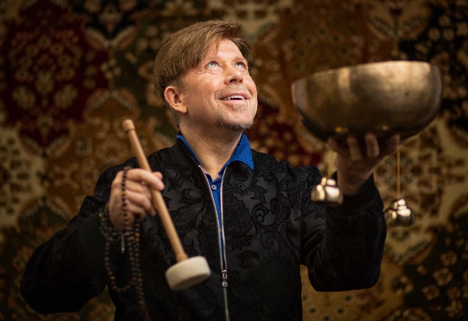
The Instructor
GabrielNelson Sears has studied and practiced meditation for over thirty years. He is a certified Vibrational Sound Therapist through the Vibrational Sound Association, a graduate of the Earthsong Sound Mystery School, and an advanced Usui Reiki practitioner. In addition to his private practice, GabrielNelson facilitates group sound meditations, teaches classes on vibrational sound and is a guest speaker at numerous venues throughout the United States, Costa Rica and Ecuador. You can learn more about his mission and offerings at www.gabrielofthelight.com.

What Others are Saying
GabrielNelson's classes are well planned with important information and concepts as well as hands-on experiences. He is a gifted, caring, supportive teacher and practitioner. - Michelle O’Reardon, Atlanta

Apprenticeship Program Pricing - Installment Plans Available
$2,000 - Program Only.
$2,325 - Program PLUS 3 Himalayan Singing Bowls.*
$2,650 - Program PLUS 3 Crystal Singing Bowls.*
$3,000 - Program PLUS 3 Himalayan Singing Bowls, 3 Crystal Singing bowls and 1 chime.*

* Certain payment requirements required. Please contact GabrielNelson for details.

Ga

Gabriel of the Light. All Right Reserved. 678.499.5771 gabrielofthelight@gmail.com www.gabrielofthelight.com

Sound Apprenticeship Application
Name: |  | Date: | Occupation:
Address: |  | Phone: | Date of Birth:
City: | State: | Zip Code: | Email:
Emergency Contact Name: |  |  | Phone:
How did you hear about us: |  |  | Referral Name:
Previous Training and Experience
Please list any previous sound, movement, musical, energy, psychic, or healing training and experience. Include places or people with whom you have trained. Also list any instruments that you have. NOTE: None is needed for consideration for the Apprenticeship Program.

Personal Info and Vision Statement
Please tell us about yourself, why you are interested in the Apprenticeship Program and your vision upon completion.

Health & Self-Care
- Methods of relaxation and exercise that you practice in your daily life:

- What forms of meditation do you practice?

- Do you have any sensitivity to sound or vibration? Yes No

- Please list any health conditions requiring ongoing medical supervision.

- Please list any accidents or surgeries in the last 2 years.

- Do you have any metal implants, a pacemaker, hearing aid or body piercings?

- Do you have any physical conditions or disabilities that prevent you from daily activities of normal living? Is yes, please describe.

Please read, print your name, sign and date.

I, ___________________________________, have read the Sound Apprenticeship Program information and understand that acceptance into the Program requires a 12-month commitment of time and energy. I agree to actively participate in the aforementioned Program Outline.

Signature Date
Privacy Policy: No information about any student will be discussed or shared with any third party without written consent.

Gabriel of the Light. All Right Reserved. 678.499.5771 gabrielofthelight@gmail.com www.gabrielofthelight.com

