Prehistoric Flutes

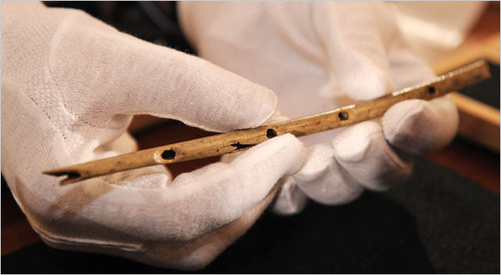

They were crafted during a time of inhospitable ice age chill 43,000 years ago, but just as recently as 2002 they were unearthed in the Hohle Fels Cave complex in Germany. Known as the Geissenklosterle Flutes, they are the oldest musical instruments ever found and indicate that musical creativity was an intrinsic part of early human expression.
Many of these "bone flutes" were made from mammoth ivory, but the finest and most significant of the Hohle Fels collection were crafted from the hollowed-out wing bones of a vulture. They bear the evidential cut marks of the animal being previously procured by human hands.
“These finds demonstrate the presence of a well-established musical tradition at the time when modern humans colonized Europe and may have been one of the places where human culture originated." - Nicolas J. Conard, University of Tubingen
The mouth of the instrument is V-shaped and it has a number of signature perforated finger holes along the piece. Modern flutes have not evolved drastically from this design.
“For a bone flute you have to hollow it out, get the exact form, smooth out the inside and outside, cut the ends to length, and cut the finger holes. But the tones are harmonic and provide a great range of notes and musical possibilities.” - Ian Tattersall, Museum of Natural History
Less than half an inch thick and around a foot in length, the primitive but innovative bone flute is diminutive in size but giant in stature because it serves as the very first known evidence of artistic creativity through the medium of music.

