Larzo Memorial

Golf Tournament 2020

Saturday, June 13th Shotgun Start at 2:00 PM

Copper Creek Golf Course, 4825 Copper Creek Dr, Pleasant Hill, IA 50327

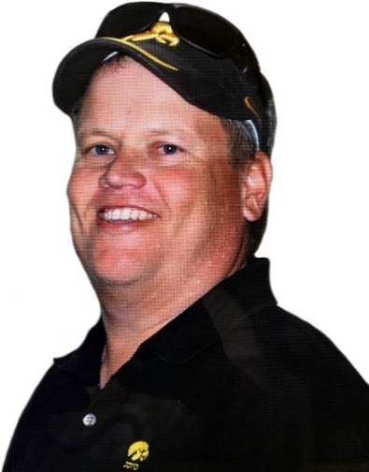Proceeds will be donated to these

two great organizations In

Mark’s honor!

Also, special guest Chuck Long

will be there!

1 PM sign in

2:00 PM shotgun start

$75 per person includes golf, cart, prizes and breakfast and lunch included. (Bring a foursome for $250)

**Return this form along with a check to LarzoGolf, LLC at** 4335 SE BEISSER DRIVE, GRIMES, IA  50111 or pay online at https://larzogolf.com



PLAYER # 1: _________________________________

PLAYER # 2: _________________________________

PLAYER # 3: _________________________________

PLAYER # 4: _________________________________

EMAIL: ______________________________________

EMAIL: ______________________________________

EMAIL: ______________________________________

EMAIL: ______________________________________

**If you don’t have four participants, you will be placed with other groups in order to make teams even.

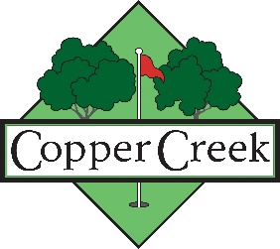COMPANY: _______________________________

**COMPANY SPONSOR A HOLE FOR $375, Includes a foursome.**

Keep up-to-date with the latest updates or changes at

**https://larzogolf.com**