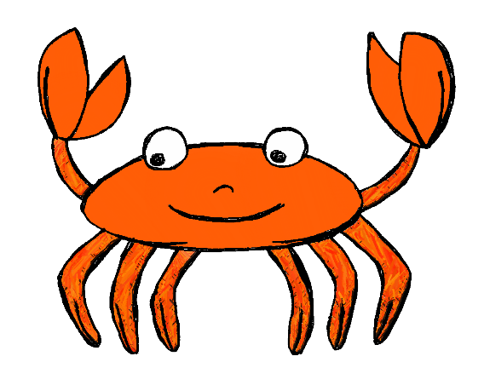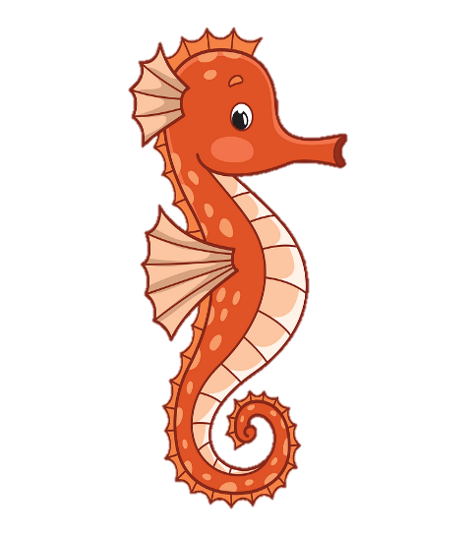sn

Who I am and what I do?

My name is Polly I am a Child Care Officer. I am here to look after the children and make sure they have an enjoyable time when they come to Canon’s House.

All about Me

My name is Polly.

What do I like?

* I like to bake. (My favourite things to Bake are Chocolate Brownies and cupcakes).
* I enjoy going to the seaside and have recently taken and interest in Paddle boarding.
* My favourite band is Artic Monkeys.
* I enjoy doing arts and Crafts with the children.

You can contact me by …

Pollyanna.Kent@wiltshire.gov.uk