Canon’s House

Locality Risk Assessment: April 2025

* Canon’s House is set in the rural Market Town of Devizes, Wiltshire. Situated within a small residential community, we are a short walk from the town centre. Public transport links, post-boxes, local shops a GP Surgery are all within a 2-minute walk. We are also incredibly fortunate to be within a 2-minute walk of the wonder Kennet and Avon Canal.
* Swindon, Chippenham, Trowbridge and Bath are all within easy reach, and offer a varied and eclectic range of shopping, restaurants, cultural and historical experiences and a range of leisure activities including bowling, cinema’s, parks, nature reserves and wild open spaces.
* Canon’s House itself, is a large house built around 1830. Over the years, Canons House has been adapted to meet the needs of children and young people and this includes the installation of a fully accessible bathroom on the ground floor, a lift, a large conservatory and hoisting equipment throughout the home.

Location:

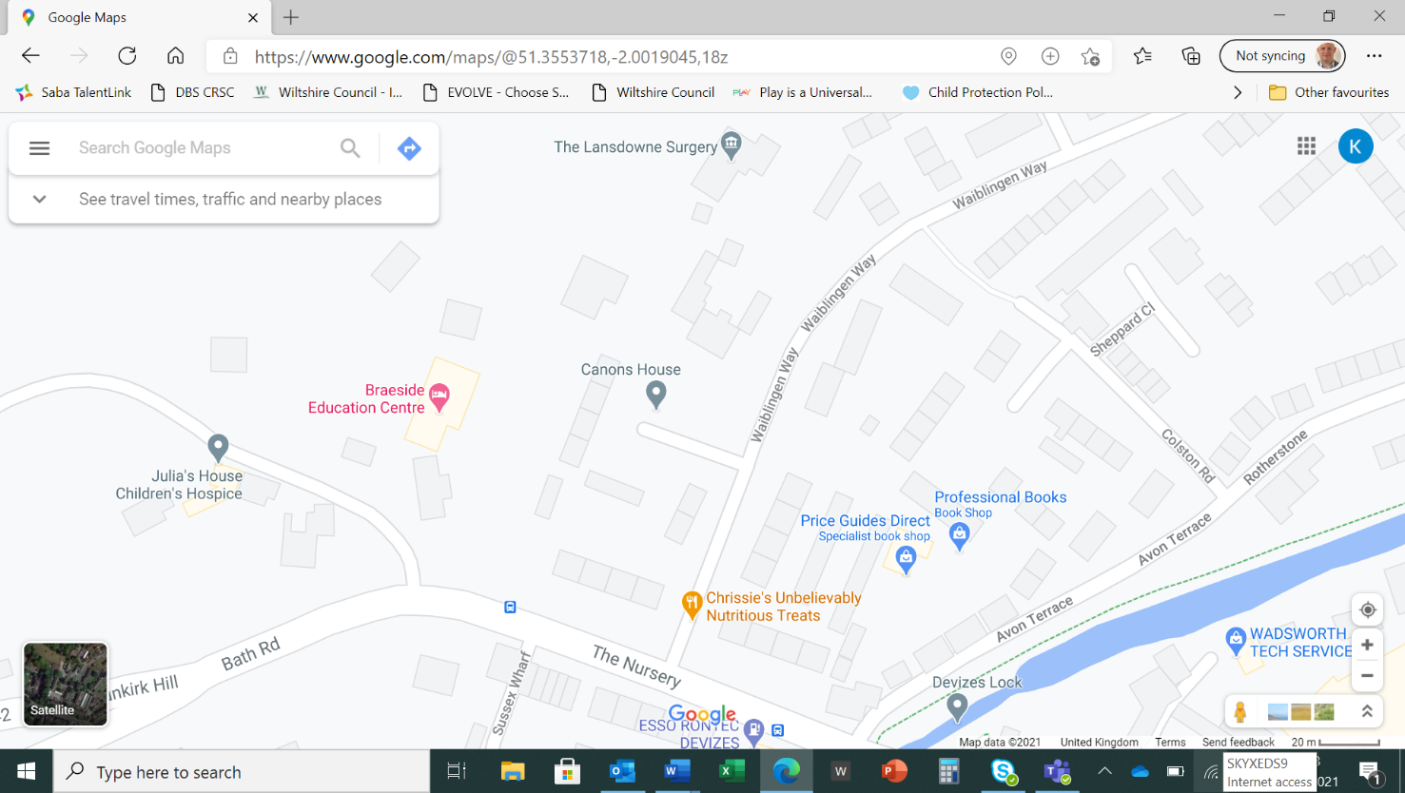

1. Canon’s House
2. Lansdowne GP

Surgery

1. Kennet and Avon Canal
2. A361 Bath Road

Summary of heightened safety risks, within close proximity:

**Canon’s House is located within a short walk of the A361:**

* The A361 is a busy main road that acts as a direct link road from Bath and Chippenham to Devizes, Swindon and London.
* The A361 is a busy main road that has a high level of traffic throughout the day and night.

**Canon’s House is located within a short walk of the Kennet and Avon Canal**

* The canal is a busy area that is popular with both local residents and tourists visiting the area.
* The Canal itself is around 4ft deep ad around 15 to 20ft wide.
* There are a number of lock’s at regular intervals.
* During the winter months, the canal can freeze

Local Area Crime Numbers within 12 Month Period

As of April 2025



[Devizes | Police.uk (www.police.uk)](https://www.police.uk/pu/your-area/wiltshire-police/devizes/?tab=Statistics)