Utilizing SCT Prize Machine for Immediate Revenue – Dealership Version
Wire Frame Demo – 2/19 – Working Model – 3/01

- Branding of the name – Prize Machine can be branded any name and offered as exclusive to a brand such as Ford. We can lock out competitors such as Honda, Toyota, etc. based on participation numbers.
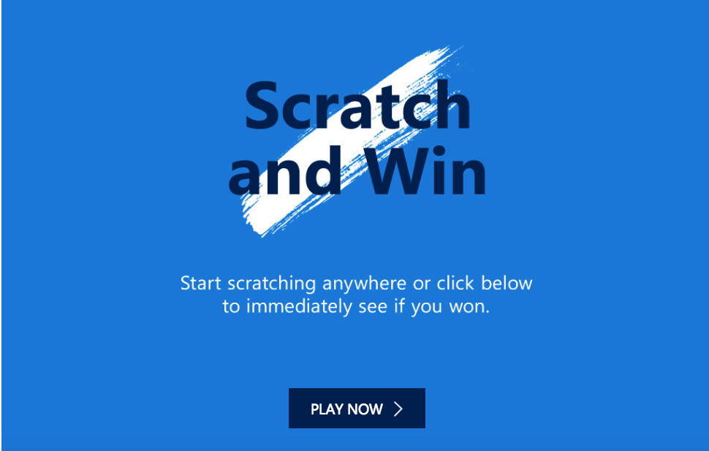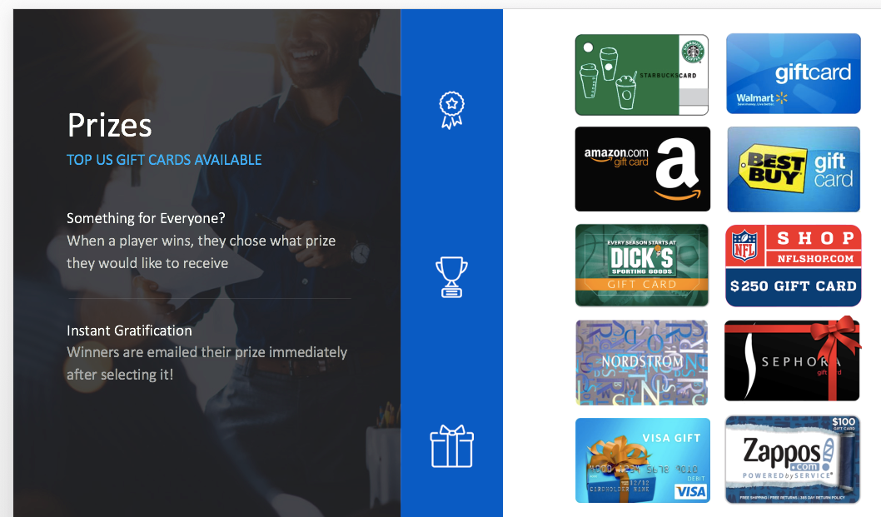

- Branding Sponsorships - These relationships, sponsorships, and strategies can be sold immediately. Sponsorships within the solution can also be utilized. Entries are in control of Smart Community Technologies and can be used as incentives to protect price points to drive consumers to certain brands.
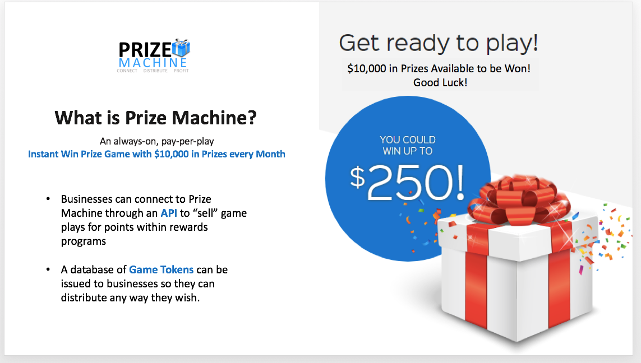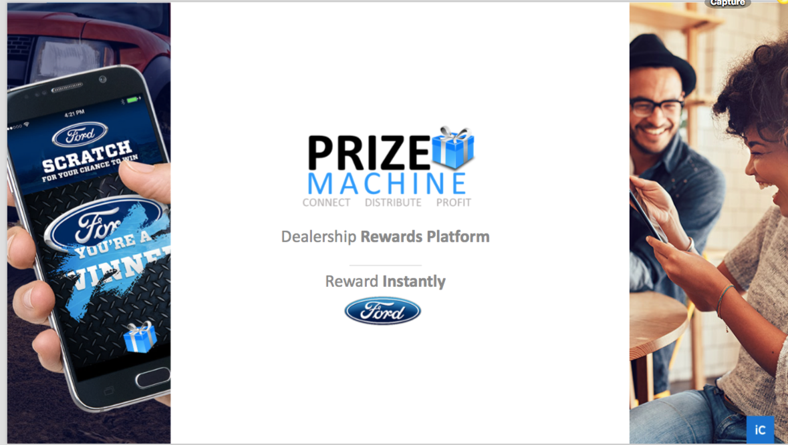

- Within the price charged to each dealership, each dealership will have custom branding and exclusive offers for their customers only. In other words, even though we may work with 1000s of Ford dealerships nationwide, each individual dealership can be featured and branded. In addition, each dealership will be able to offer custom prizes, drawings, and special offers unique to their dealership.

- The initial fee of Prize Machine - $500.00 per month - 6-month commitment, covers the following

  - 10,000 entries, game plays, or batched tokens, (normally .05) - $500 value + 20,000 additional entries $500.00 (optional). This is a beautiful and simple game experience which allows small business to do something they could never afford on their own.
  - Entries can be sold or used as incentives for purchase, service, oil change, test drives, visits, tweets, check-ins, receipts to partner locations, sponsorship support, etc. Entries can be allocated to certain brands such as Bridgestone or Michelin, allowing each dealership to collect a fee from the manufacturer for locking out the other brand.
  - Website-Mobile Site. Prize Machine game screens will be customized/branded by logo for each individual dealer. Prize Machine is not a brand and will not appear anywhere in the experience.
  - Log-in
  - Legal Rules and Requirements and Bonding/Registration
  - Lottery filings with governing boards and associations
  - Full operation for each dealer and allows companion points, miles, or stars from any customer loyalty program or partner to transfer those currencies into entries to play the game. Currently used by Microsoft Global to burn points, this ability can be customized for each dealer allowing them to partner with larger brands who are non-compete in a variety of strategies.
  - Hosting
  - Fulfillment to end winners
  - Development and customization
  - Up to 5 mobile games, initial game to be scratch off from phone. Illustrations below
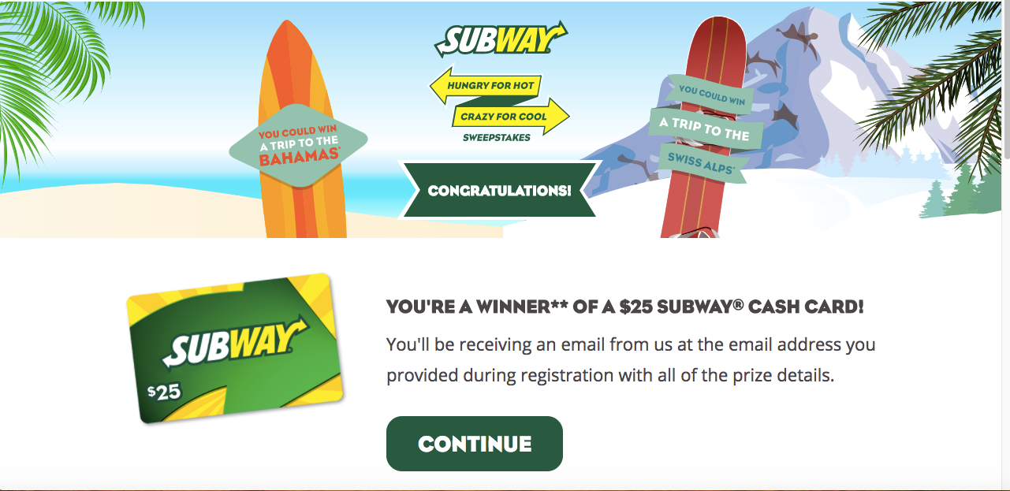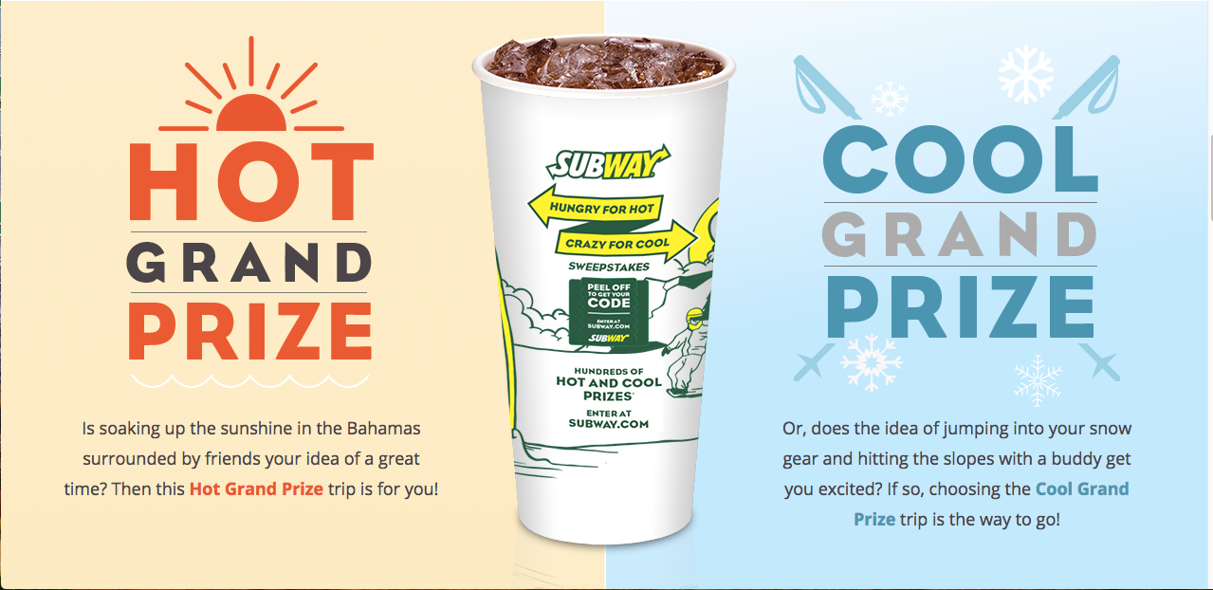
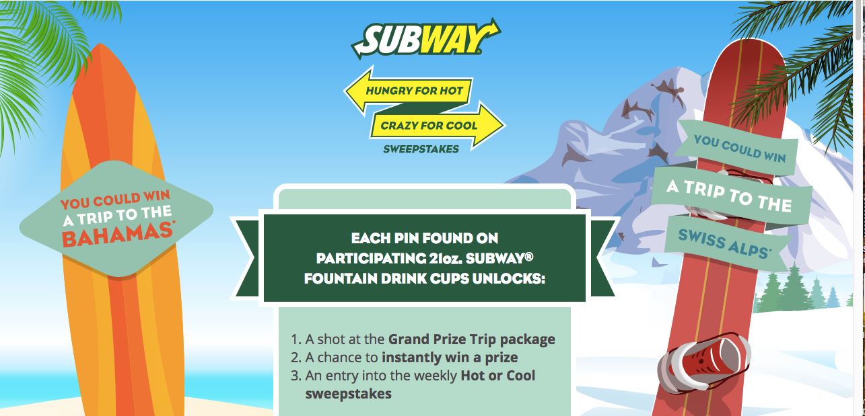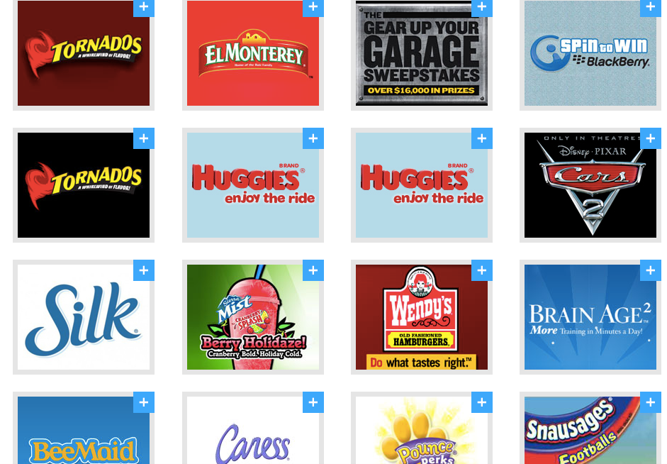
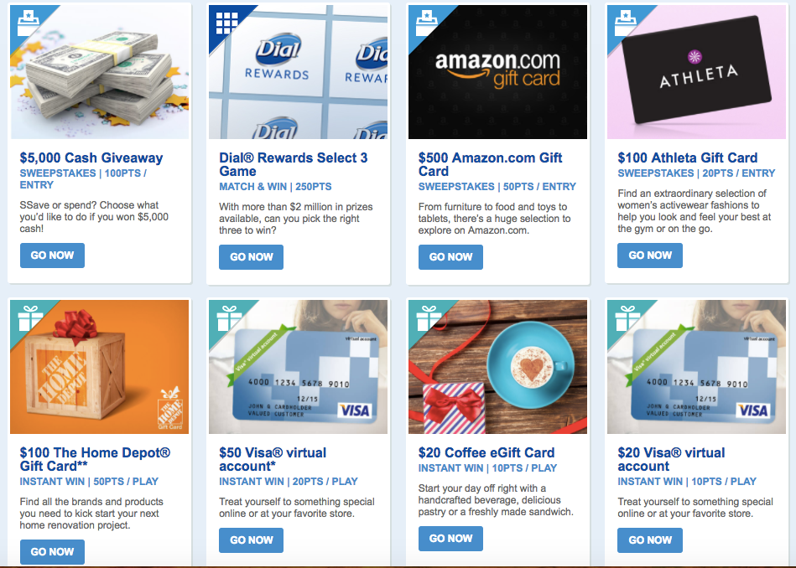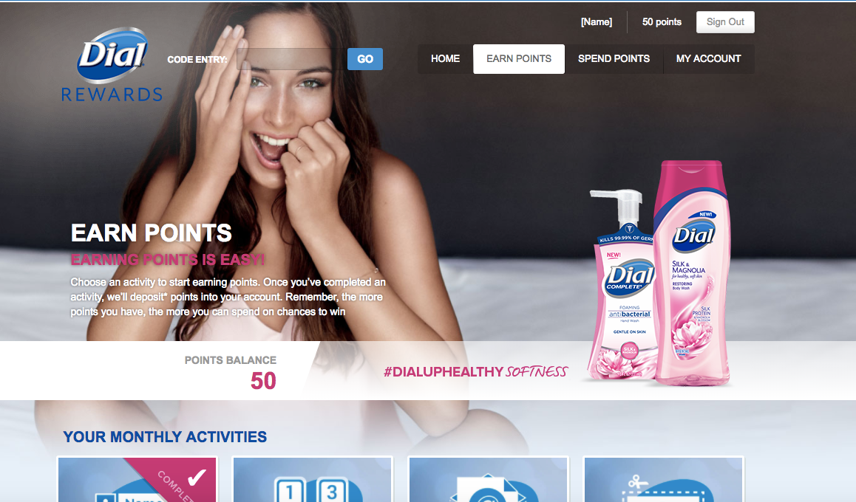

  - $10,000 in prizes + a $1,000 Sweepstakes prize each month. Each dealership can select the sweepstakes prize up to $1000 value which is paid by Prize Machine. Should the bonus sweepstakes prize be a $1000.00 Gas Gift card, then no additional charges will apply. Should the custom Sweepstakes prize require any type of custom fulfillment or ad creation, then a small additional fee will apply, but we will handle the process soup to nuts.
  - Prizes are Instant Win with Ford Scratch Off. Entries can be delivered via email, texting, snail mail, etc.
  - Prizes range from $10.00 gift cards to $250.00 gift cards from brands such as Wal-Mart, Starbucks, Amazon, Visa, and many others.
  - Each dealership can choose up to 10 gift cards for customers to choose. When customers win, they can select any one of the 10 for their gift card prize.
  - Any new data collected will be the property of Ford
  - Custom promotions with numerous data options for predictive analytics. Sweepstakes, instant win games, million $ games of chance, collect and win games have been our bread and butter for over 25 years. We execute many of these for the largest brands in the world including Microsoft, Twitter, Nestle American Express, Top Golf, Dial, and many others.
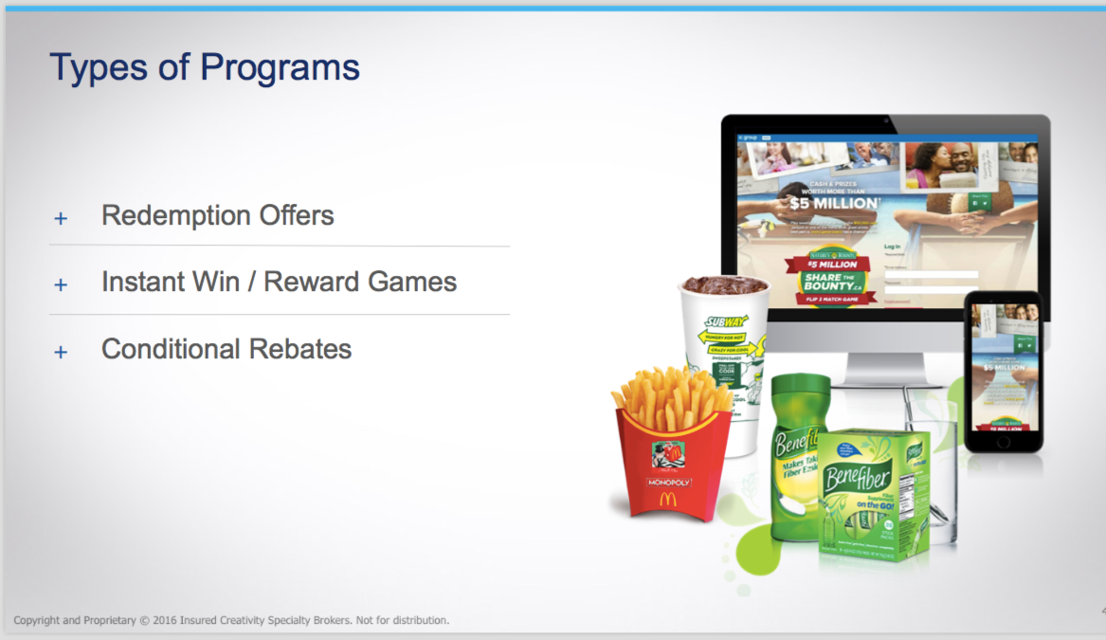
  - Everything is provided from development, creative, hosting, delivery, fulfillment, operations, legal, filings, and more. This is a full-service offering, ideas can be seen at www.demo.icgroup.com
  - We also provide insurance for any prizes from pizza’s and hamburgers to sports bonuses for performance, to free automobiles for PGA and golf. Anything with odds associated with it, are now insured within minutes.
  - Customer loyalty solutions with in-venue technology for sports and fan engagement as seen in www.fannex.live.com Exclusive live event engagement and entertainment.
  - We can help each dealer deliver amazing experiences, partnerships, sports contests and promotions on the local level with high school sports, college sports, and many ideas which can be exclusive to Ford. We can place amazing 3 story social media aggregator boards below.

- Further Customization for each Ford dealer.
  - Everything above is included in the initial Ford dealer fee.
  - Each dealer can create a special customized layer known as ‘Gold’ or ‘Platinum’ Membership which might cost $5.00 per month or $50.00 per year. Paid by customer.
  - With this added custom tier to Prize Machine, all prizes, drawings, and benefits listed will be exclusive to ‘Platinum’ members.
  - Each dealership will provide special incentives such as free oil changes, custom Ford Bucks balance, service incentives, digital coupons, etc.
  - In addition, other local businesses will offer free (no strings attached) benefits, such as free golf, free bowling, free appetizers, free kids’ activities, free movie tickets, and much more. Customers can either show their membership via the mobile app, or a custom Ford branded membership can be given, or both. Customers show this card around town for special treatment, offers, and benefits ONLY for Ford Platinum

  - We have discussed this strategy with the NFL and NBA Play 60 Campaign, and it’s something very desirable for the NFL and NBA with is a great opportunity for Ford.
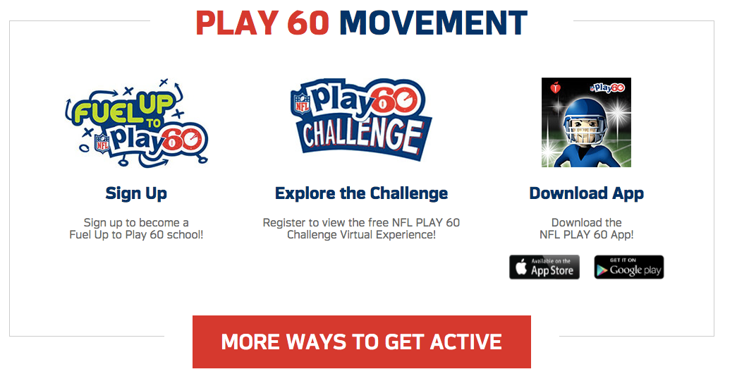
  - When customers join the custom member level, then ONLY those benefits and ONLY those prizes will be given to these members, and these members alone.
  - The value will continually grow as SCT secures special offers, donated prizes, amazing sports and concert experiences and more.
  - Not only does SCT donate 50% of all ‘membership fees’ to local communities (of the dealers’ choice), such as schools or special needs, we also provide exclusive marketing for partners of the dealer. We are able to provide data and marketing services which would cost much more than a leader item which supports the community. SCT shows everyone how to join hands in in a unique win/win/win strategy where everyone works together for the good of all.
  - Anything and everything can be added to this custom level for each dealership, which features special prizes, special offers, and local donations. Nationwide brands such as Disney, Cruise Lines, Airlines, and more provide special offers which can be used throughout the U.S.
  - This will feature amazing value far beyond the $5.00 per month or $50.00 yearly fee.
  - In addition, the GM’s or owners of each of the local dealers will issue large checks via televised press events which will cause the Ford membership strategy to grow virally.
  - Any large prizes given away to Platinum Members or SCT, can be insured. Special games can also be exclusive for Platinum Members. Here are a few examples.
    - Purchase any Ford before the Masters Golf Tournament, and if any player hits a hole in one on Sunday, their Ford purchase is FREE!
    - Free hamburgers or Free pizza if the local team does X, can all be insured and included for Platinum Members.
    - Additional Monopoly or Scrabble Games illustrated above can be allocated for Platinum Members Only.
  - SCT donates 50% of all membership fees to local needs and special needs. Out of the remaining 50%, SCT will also allocate and purchase automobiles from each dealer (based on participation), to give away for Platinum members each month. Whether this be once per quarter or once per month, it will be based on consumer participation. 10% of the remaining 50% will be allocated for the purchase of vehicles from each dealer as a special give-a-way for Platinum Members, and only those who are Platinum Members.
  - In addition, special Sweepstakes prizes for Platinum Members can also be customized for Platinum Members. The ideas are limitless.
  - The value of being a Ford Platinum Member will be worth many times the small monthly fee.

What about Entries, Game Plays, or Game Tokens?

  - We can help each dealership determine PLATINUM entries vs FREE entries. The default strategy will be that entries used in the FREE version of the game, will automatically populate to the PAID version of the game if the person playing is a Platinum Member.
  - Special licenses can be issued by the dealer allowing companion businesses or partners of the dealership to provide entries with their purchases. This can be an added revenue stream by each dealer or retained by SCT if they secure the offers.
  - When the customer logs into the web/mobile portal to play the game with their token, game play, or entry, the system will recognize if they are a Platinum Member and automatically include each FREE game play as an entry into all the custom prizes offered for Platinum Members only. We have some freedom to develop any idea we choose, but this seems to be the simplest option. The sign-up process will be customized and beautiful like below.
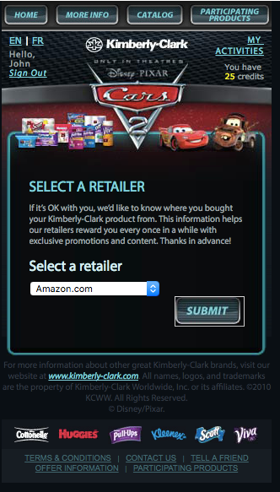

- Additional Benefits for each Ford Dealer

  - For each Ford dealer who is a member of the Smart Community Prize Machine family, we will provide custom ways to win special prizes. We will design and promote special events, sporting events, and huge fan engagement to the brand. Here are a few ideas
    - Come in on Sunday, take a test drive in any vehicle. We take the key of that vehicle and drop it in a bag with 99 other keys. We shake up the bag and allow the customer to pull a key from the bag. They get back in the car and see if the key starts the car, if it does, they win the car FREE OF CHARGE!
    - Buy a Ford between Monday and Saturday night at Midnight. If the local NFL, College, or High School team does X, you win the vehicle.
    - Special golf tournaments where Ford vehicles are featured for every day patrons to win the vehicle based on a hole in one, or other events. Or, entries to win the vehicle can be won by local charities, events, or behaviors at sporting events.
    - Only Platinum Members of the dealership are eligible for special prizes, games and chances to win all over town.
    - Since 50% of the membership fee goes to local causes, the entire fee feels like a donation, causing the vast majority of patrons to join the Ford Prize Now Membership.
    - Even customers who drive competitive brands will be enticed to join the Ford Membership program due to the value and community good will. Consumers all over the community will be constantly reminded that Ford is the one supporting their kids.
    - Custom scrabble games, monopoly games (we insured McDonalds monopoly and Subway Scrabble), can be set up with Ford vehicles and other non-compete partners of Ford to drive local dealer value. Illustrations above.
    - We have even insured weather triggers, so anything that has ‘odds’ associated with the outcome, we can issue an insurance policy, tie it to an event or game and engage consumers to the brand.
    - We have a patent pending Battle of the Fans and Gamification strategy with Twitter, as illustrated above.
    - Phase 2 of our solution will feature a custom app from Smart Community Technologies with another proprietary game we have developed, known as featuring Geo Social Media Scavenger Hunts. Amazing fun.
    - We also have a proprietary educational game built into the app to teach students communication and geography skills while helping them stay active at the same time!

Here is a quick early look of a few of our strategies which will be released later this year.

