***New Revenue Space Created by***

*Smart Community Technologies© and FAAST©*

*Known throughout the Digital Rewards & Loyalty Industry as:*

***DeCoy****©* - ***Decentralized Customer Loyalty****©*

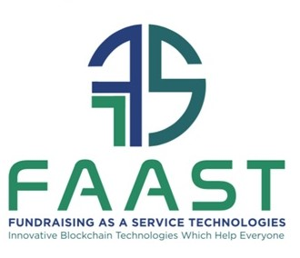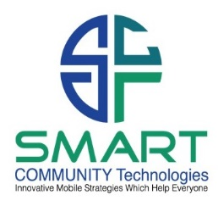

# Strategic & Executive Summary for SCT©

SCT© has designed and is developing a real-life mobile device driven game that will dynamically alter the membership space. The demand for the concept and the appeal to a variety of demographics places DeCoy© as a highly coveted refresh of the rewards, loyalty and membership space. The potential with strategic and proprietary marketing deployments and other in app enhancements, will deepen and fortify customer relationships, community involvement, and serve as a mobile incentive for any business, non-profit, or similar entity. The traffic generation and active cash flow due to the activity in the mobile app will prove its value driven experience to customers, communities, and members, deepening their relationship and loyalty to your brand. This is an investment in community, customer, and brand protection.

Below is an active and in market example of a mobile game in order to gain a conceptual idea of what SCT© is doing. As we will see, many of the game user platform approaches are worthy, yet there are many elements missing within the game. SCT© has designed and tested these “missing pieces”. The real-life game that SCT© will bring to market is far superior approach to gaming since it combines actual behaviors and interaction with others featuring real money rewards which can be transferred and donated anywhere in the world. This is why we are seeking a compatible funding source to maintain our development pursuits. Considering the collection of proprietary technologies, we are choosing not to list our complete development and go-to market advantages. DeCoy©, Decentralized Customer Loyalty©, utilizes the prowess of advancing technologies to create a blockchain based membership mobile app built on the Lightning Network layer 2 to the Bitcoin Network.

Having such an innovative solution creates a 360˚ win for everyone involved. In addition, when tactically deployed using the automation features within the app, the customer/community/member base will grow on autopilot. We have in app options to generate billions of dollars in revenue with no additional front-end or back-end costs. Based on the table below, you will see the sampling of projected numbers. To date, no other rewards, loyalty and or points, stars, or miles program on the market can accomplish these numbers other than DeCoy. Please review the SCT© business plan for a deeper explanation of our projections and analytics.

**CASE STUDY & PRESENTATION HISTORY FOR SCT© CONCEPT**

SCT© presented the initial concept without the power of blockchain capabilities and NFT’s in person at Ford Motor Company© headquarters in Detroit, Michigan on two different occasions to the c-suite executive team. Every member of the c-suite was excited and set up another demonstration in West Palm Beach, Florida to present the concept to the President of the Southern Florida Ford Dealers Association© (SFFDA©). Within 10 minutes of starting the presentation, everyone in the room desired to move forward. The President immediately asked for more information on how this unique real-life gamification concept could be adopted with their anticipated release of their redesigned Ford Mustang©. Mobile gaming had met brand development for Ford©.

Here is an archived explainer video of one concept for Ford: <https://smartcommunitytech.com/mobilegames>

Conversations continued with the SFFDA© as, Steve Schroeder, the CEO & Founder of SCT© had many opportunities to demonstrate to the regional dealership executives as well as other notable industry executives, celebrity athletes and representatives from the NFL© and PGA© who intently listened to what SCT© would do with fundraising options inside the proprietary mobile app to support those with disabilities. What they all took the most interest in was how SCT© was transforming the dealership experience for communities. Ford desired a regional test market study to confirm adoption for a national rollout out solution for every Ford dealer in the US. via Ford Direct© which would auto bill every dealership $2500.00 per month, in return for 50% of the revenue.

SCT© then ran test numbers in Southern Florida with dealerships in Orlando, Florida along with others mentioned in the SCT© business plan. Because of the popularity and measured usage rate of the mobile app prototype, SCT© projected a user base of:

|  |  |  |  |  |
| --- | --- | --- | --- | --- |
| Year | Local Member Count | Monthly Member Fee | Mo. Gross Revenue | Mo. Charitable Giving |
| 1st | 1,000,000 | $9.95 per month | $9,950,000 | $4,975,000 |
| 2nd | 2,500,000 | $9.95 per month | $24,875,000 | $12,437,500 |
| 3rd | 4,000,000 | $10.50 per month | $42,000,000 | $24,000,000 |

Allan Young, the Chairman of SFFDA© who took the South Florida Region from near bottom to No. 2 nationally in customer consideration has actively been aware of the evolution of mobile membership concepts but had never seen anything like we presented. The GROSS REVENUE above is PER MONTH. In addition to 50% of the $2500.00 yearly gross revenue from the license fee to every Ford dealer, Ford Direct desired 50% of the membership revenue as well and would perform marketing and TV advertising to boost memberships around the U.S. The other 50% would go directly to SCT© to manage and maintain the enterprising technologies and deployments of new versions and updates. The media momentum for the dealership and Ford© can be priceless due to the support and awareness campaigns for the local charities and causes driven by Ford©. Steve Schroeder designed a new slogan as a result “Have you driven a Ford lately? More importantly has Ford driven you?” Mr. Young who dynamically changed the customer experience at Ford© Dealerships in South Florida saw the benefit of turning the Dealership experience within the community into a ‘Community Center’ to celebrate local charities and causes as all check presentations for the designated local charities would be hosted at a Mr. Young governed Ford© Dealership.

SCT© referred to this specialized project as “Charity, Driven By Ford©”™

In addition, each Ford dealership was required to pay a license fee to gain access to a portfolio of continuing education of the mobile app’s features, car sales closing strategies and other proven customer satisfaction and retention models.

|  |  |  |  |  |  |
| --- | --- | --- | --- | --- | --- |
| Number of Ford© Dealerships | Interest | Monthly Fee | Mo. Gross Revenue | Mo. Ford Direct Rev. | |
| 3,000 | Yes | $2,500 | $7,500,000 | $3,750,000 |

The generation of $7.5 million dollars per month for licensure of the dealership directed mobile app allowed for Ford Direct© to receive an additional 50% of collected licensure revenue to utilize for Ford based interests and initiatives be they corporate or charitable minded.

Once launched, SCT© and Ford© projects the following through an incentive-based culture that approximately 40% of new car sales each quarter choose the mobile app option during the time of financial closing. See table below for an approximation of proposed revenue to local communities via this partnership of SCT© and Ford© each quarter.

|  |  |  |  |  |  |
| --- | --- | --- | --- | --- | --- |
| Quarter  Year | Ford Division Sales | Monthly  Member Fee | Percentage Engagement | New Gross  Revenue | New Charitable Giving |
| Q4 2020 | 507,579 | $9.95 | 40% | $2,020,164 | $1,010,082 |
| Q1 2021 | 492,271 | $9.95 | 40% | $1,959,238 | $979,619 |
| Q2 2021 | 448,745 | $9.95 | 40% | $1,786,005 | $893,002 |
| Q3 2021 | 380,606 | $9.95 | 40% | $1,514,811 | $757,405 |
| Q4 2021 | 483,171 | $9.95 | 40% | $1,923,020 | $961,510 |

SCT took these numbers and delivered a proof of concept with corresponding ideation for a mobile device driven game that allows the device user, who is a member, to engage in rewarding gamification concepts that benefit their community, their charity of choice and develops positive behaviors in the emerging world of digital assets and functions within the world of crypto driven commerce.

**PROOF OF CONCEPT & INTERNATIONAL MARKET APPEAL**

The global demand for device driven conveniences like keeping in contact with our peers; streaming our favorite entertainment; engaging with sports and brands via Twitter Telecasts and managing our lifestyle interests; we have all become influenced by these mobile technologies. With our acceptance of mobile banking and our increasing interest in handheld gaming, SCT© has developed an interactive hybrid that meets the best of entertaining gamification, monetary institution and applicable education. Below, is a model that begins to prove the appeal of these human interests. What SCT© has developed is far superior and meets today’s and tomorrow’s demanding marketplace for blockchain based real-life gamification through everyday behaviors.

**ARTICLE**: An NFT pet game called Axie Infinity© booms, while the broader crypto market struggles:

In the Summer of 2021, [Axie Infinity](https://links.coinbase.com/u/click?_t=3aca56371967418192255878e9689713&_m=a370435cea5547228a583a7c5e4d2938&_e=Q8QnSMQ-NES9hSjmfwevFaF2l1bQ97ZFyiu1rgkq7ZAmpF1AbfNKwqb2UvwJBc6gf5gKVCCW1fMKdONig5CencMu5x_6fadVw3eGz4KCKKaQa4hmUBNTttjUCySI_gfJmI8UvN10VBcodHFGm50ZZk3_kQAjZwwSR_36XK9Du38wnSiOTujkB4_JTJchAAc4CVn9ACxSihJ8tnlZxP74bycGB8rYms0cTRO2Q8Al7Ko3ZYDu5iXMmixMwx_Udm_bTYsTF397IreKapo0MRFvULCaXHtCTpv2GyELRDWi0mwxXT3yXCKqb7j_Xguip9SJRg710C_IVgvKkhK8T-sn0nU_mge3snwFQDJz-EjccCBKZSt7mKuQUqE7_bNYPN1W)©, a crypto-meets-Pokémon game drew international appeal in which players raise, battle, and trade adorably cute NFT aquapets called Axies©. The company [generated roughly $40 million](https://links.coinbase.com/u/click?_t=3aca56371967418192255878e9689713&_m=a370435cea5547228a583a7c5e4d2938&_e=Q8QnSMQ-NES9hSjmfwevFUQHTRBG0Lc9Cknqj3gWKMwnVZ46-6B8QsMkUE_tNexYKL-NZXw-Z90NhFIWHdyke4XugBGI4_rY5J_eRZjymqTw5YMbOTWRuurusUZ8phKxdehdQ1jbW89E38tjFT3LKRj4u2rWRXX1FwXA2pGrZ4atMlo0ttJ-ML4b2HBU76f0okEVbOTWzLFoHG7LB99uYG4kFfIzX9Cldti93Mty2RYSfhnqGKiT3vwESmD1E2Soh5d29VkRc64IemVtWg9EZ9jfJZBSz4j7Eu_v-piQbyeq__Ab4L62b0W7cjkrxsCi5FRuIkyqAttXZLNjTq4-TJMf90h4XBq7f6IufifLXtLKxHuZO6NDX5EZ76nTD-NGXiTuRtDJ3mUZBXnENn3AdaNnWnZ6yT0XRXv7h4KmZ2A%3D) in revenue (more than all of Ethereum© gas fees in the same period). As the broader crypto market struggles, Axie© and its two native cryptocurrencies have been booming. So, what's driving the popularity?

* Vietnamese developer, Sky Mavis, launched the game in 2018. It got a boost from [investors](https://links.coinbase.com/u/click?_t=3aca56371967418192255878e9689713&_m=a370435cea5547228a583a7c5e4d2938&_e=Q8QnSMQ-NES9hSjmfwevFeUyZE5X0XzGjpg5pLUrxsW3zvaqAFWuVzWh_eZ_38dK4rFjucq6041BMj-ZB6j19WSomTmolyBx30WCwaih96gOpL41-VzN97q-L-Tx8JkrELyslrK5AvtxtCty5Ihg2YQJVsgeelm6zjeoU3QEcjges1J4FcwuMkFquQr9pu-8Dl26BjggV9Bf9XAPK1GoVwcTlpnvpgEwXczlWDcljPQvj6opYx0tjdlU9-if1SY5DcL2hhaWexkTcPfbpbhSd_9165nkbzVeJFbIAl2LwUynkJvLP8X4r4TNcq1VAjt77CBKHvsN6UiyR4Q43sNu9clxwVJWmkrbhzWNd-kH2oVrtbpCT4y9pXw_fQqkeVK26arbnw78Q36URdiyXqScsz5AQkF8YGUmd4CzxtMcL9fXlTtHrMJv2bunpbr0PV9g2d9RzFGwA2-MODkpGi318g%3D%3D) including Dallas Mavericks© owner, Mark Cuban and Reddit© co-founder Alexis Ohanian in May of 2021. It runs on the Ethereum© blockchain, with most in-game transactions supported on a speedy, bespoke sidechain called Ronin©, which Sky Mavis designed to have lower fees for the users.
* To [start playing](https://links.coinbase.com/u/click?_t=3aca56371967418192255878e9689713&_m=a370435cea5547228a583a7c5e4d2938&_e=Q8QnSMQ-NES9hSjmfwevFSzm-UUWCsWYBUs2k4x3i-MIzu4xQn592v49f6POmbDvXb54YnC6LK4r5iM1X1zRg-AI-7BW5pOzy3AAZ3hyR6620R-W_gfBlGyaaU9AYuHdDdYxIIWC5PMhWF4II2ypN2z4dyKarhHWxMOkn-s8GuVT4Tpmfv3HRrA3tjiCBblcwqmUgkmMM0dD4NtLvs4iK6X1Ry_qKnQcSK-gwk5DjfHTgUJlQjY6OQr71KXTqldeHAf0cMx28j8eAH4wQvDspjna2jzDeWgyliePALuY3wnndoLXKL2aZSJ0sRhtZBScPxsiw9T3Gb-E2ZJDtq15lic1XnGjmgEfJ1Fl713Tk__rynOFEt7B6L1riPmg5qRlbjkK5Vx4JGzlt06u74SaKd4uTwwoS_7O-wDJh2yorGgPcEOuWbjbPJro3fnmf6X8), you need to buy at least three Axies© from the game’s marketplace. Sky Mavis takes a 4.25% cut of all the Axies©, virtual real-estate, and all other items the users sell to each other.
* Players can also “breed” new Axies©, which costs some of the game’s two native cryptocurrencies: Axie Infinity Shards© (AXS©, which is also a governance token that gives holders a say in the future of the game) and Small Love Potion© (SLP©, which is awarded to players for spending time in the game).
* Axie© Infinity has a "play to earn" model, and it can be [legitimately profitable](https://links.coinbase.com/u/click?_t=3aca56371967418192255878e9689713&_m=a370435cea5547228a583a7c5e4d2938&_e=Q8QnSMQ-NES9hSjmfwevFVOkDnPmenI9SoZrsnqbTwtZK7TjOJCvxGvqv0abq7mmndeqiP9pVP7Ma95v_8oJsfwwHX-0WjpPq4ZFIE9_ed7kI5DkVhC8p4TMOzcPAP3ArvX3CoeEe1IOR4ffgeMdp6yaCoyjcUEByXrbwhuGFl6ihqmi2ypD33yA_2TeqtPEiRDVVXYIFoCqT4faKCQA-Kx6-X2G_DVZgk1PnpDlTrxqnSC9OJLKUhugK0f8gYuiZueo1BfQ-x_SR2bSoloDZmqIHaBQsiQpWmSSDOO6nkCwdrJZI-XSv73e8W9iGlUK9EPD7Ifk0eemHTa6604UtdXqKGxKi42_jFobWbJ29VHewETtyZQ2L-HXPLlEh_Md8xJvz-t3b1-bT0wb2UFUAzz3xYCd89XIfzhTw8pbAC3viY1Ep5o3o_yiuTAPaZb6zTJPI3qBW8_Ji5uWv7tmmor3AAnKBtIdw0LZogcFdXI%3D) for some users.At the time of writing, rare Axies© can sell for as much as 30ETH. Desirable real estate in the fictional world of Lunacia© can go for nearly 270ETH. The game also rewards devoted players with as many as 200SLP© a day, often worth over $50USD at pricing when this was originally written.
* Axie Infinity© has more than half a million daily players, according to CoinDesk©, [with around 60% hailing from the Philippines](https://links.coinbase.com/u/click?_t=3aca56371967418192255878e9689713&_m=a370435cea5547228a583a7c5e4d2938&_e=Q8QnSMQ-NES9hSjmfwevFQWdJVUHHyfJTO1e4VcrCSzg_bd0rKEblNXTxUTWKqdWFha0GlwKn2o6_vfOQDCaQZFbmddecn0IaCDnb79WGT9HqlTByS5hP1bqINPEf7n8WLr0x7Qhq7Qr9f-Rp7FjUTpSmzJGnoft25rbttJ7Zswlnrsn4J7HI3R5LyzlRdonrk17vkFScs8l8l9Ck5wN75LtYMiyiyx6PdAL8739DSM-NsrMZ2u4kzVlM9kZazFKadzVlq-yuzQIuYZlerkk0mSqhvQ3u4nJry3xy4kcNi4ukhyzLF8pp6t7nwLKiAZvbrRyXQ2EUy3zwTIrokRWK0V9h19-EIxF6Der6MtTBbOgC8mCBHvpWxTxizYIsNPyKyfHxhTcdKdjIiTlmqEz74aAEG9V0i5zC_URNFySulFqVTr41XuRTpPFc0zMVmAQ). Why? In part, because chronic underemployment has long sent millions of the nation's citizens to work overseas. Now, some younger Filipinos are wondering if it might be better to stay home and grind in a virtual universe.
* Both AXS© and SLP© can be traded on many exchanges. And as the game’s popularity has spiked globally, prices have taken a wild ride.Prices remained up for the year of 2021. Game revenue topped virtually all other crypto protocols, dwarfing popular DeFi apps like: Aave©, SushiSwap©, and Compound© *combined*.
* Rare Axies© can sell for as much as 30ETH, or $60,000USD at time of article writing. And desirable real estate in the fictional world of Lunacia© inside Axie Infinity© can go for nearly 270ETH or $550,000USD at the time of writing.

**SCT**© **SUMMARY ON AXIE INFINITY**©**:**

Why does all of this matter? The user base numbers? The demand in economically impoverished markets? The appeal for mobile solutions? Answering these and other questions are what SCT© does best. To not just answer them, but to chart a course for companies that see these national and international market demands and want to meet them for their customer and user base while supporting important causes at the same time. Some industry critics have noted that Axie Infinity© has marketplace fees that are many times higher than those charged by most other crypto apps. This is a compelling business model that’s already giving rise to competitors who need the solutions that SCT© can provide interested parties. Being that the bulk of the revenue does go to the users and players, the “play to earn” model might be more than just a slogan for Axie©. It might even be the start of a new crypto-powered relationship between work and play. A legitimately profitable experience awaits users and players around the world and SCT© has the innovative mindset to deliver these benefits in a unique and simple way where everyone wins.

SCT© with its mastery of modern digital and mobile technologies has solutions for multiple verticals and industries. Whether it is the travel and hospitality, food and beverage, or sports and entertainment, we have customizable solutions for any company or entity that wants to provide a refreshed and modern appeal to their customer base and or fans. We deliver greater outcomes, simpler applications, more beneficial rewards with easier accumulation all while protecting and promoting the company or entity bottom line and supporting the community at no cost to that entity or brand while allowing that entity or brand to receive all the credit.

The UI/UX of the SCT© build is superior since we are including features and aspects which other technologies and mobile application builds have never included. SCT© is protected through innovation rather than patents, which is ideal for the new open-source world of blockchain technologies. We can partner with multiple parties in a simple and seamless fashion. Thereby increasing efficiency and retention.

We are entirely open source and have the capabilities to compete with major tech companies our partner with major companies who are desirous of purchasing our ecosystem such as Facebook©, Google© and Apple©. Our value that we provide is currently non-existent across all internet protocols. SCT© and DeCoy© create value and benefit for:

* Large companies, brands or entities such as Wal-Mart
* Digital Communities which have no borders.
* Small businesses owners and charities across the world.
* Consumers and Customers throughout the world via protection of data.
* Educational institutions
* Communities and Real Estate value through digital innovation.

**SCT© PROPRIETARY TECHNOLOGIES THRU MIX and MATCH DIGITAL MASTER CHEF CAPABILITIES**

SCT© redefines value in the marketplace. SCT© through its proprietary knowledge and access to current and emerging technologies can eliminate the need for ‘point of sale’ discounting and create revenue generators instead.

Accessing the SCT© portfolio of proprietary technologies like: VTC© Virtual Trading Cards©, GUSSH© Geo-Social Scavenger Hunts© and Tweet Receipts© which can be reviewed through our library of explainer and highlight videos on our website: [www.smartcommunitytech.com/mobilegames](http://www.smartcommunitytech.com/mobilegames) NFT’s, Digital Real Estate, Surprise & Delight, Automated Customer Loyalty, Dwell-Time rewards in multiple currencies are several other technologies and strategies which we are experts.

**SCT© HISTORY WITH VENTURE CAPITAL:**

SCT© presented FAAST© Fundraising as a Service Technology© to Kleiner Perkins in Menlo Park, CA during the evolutions of mobile apps. During a series of conversations, and an attractive offer to purchase the IP from Kleiner Perkins was offered. We decided the technology was better shared with a broader application audience.

**SCT© MISSION, COMPETITIVE ADVANTAGE & DESIGN FOR OPEN-SOURCE WORLD**:

Our over-arching mission is to expand overall community loyalty across the country by allowing developed and emerging business models to adopt these strategies to be better stewards to the communities they serve. The technologies that SCT© has developed and the blending of existing technologies we did not develop, will allow for mass appeal and adoption and a reduced user learning curve. The applied innovations of SCT© due to ability to mix and match are virtually impossible to duplicate. The technologies of today are developing at such a rapid pace, that many industry analysts and professors have indicated that these technologies will fundamentally change the way we conduct our everyday lives in the near future. Since they are developing so fast, many have trouble keeping up with what these technologies can do. SCT© appeals to emotional commerce and behavior economics. Our mission related focus services the needs and interests of 95% of the developed world.

**NEXT STEPS & FINANCIAL NEEDS:**

SCT© is seeking $2.8USD million of equity financing or an interest-bearing loan for continued development expenses. These injected funds will be used for further development of the customizable platform and mobile application for iOS and Android devices. Audio and video recordings with our developers for the wireframe architecture and the Minimum Viable Product with Wireframes is available upon request and upon proof of funds.

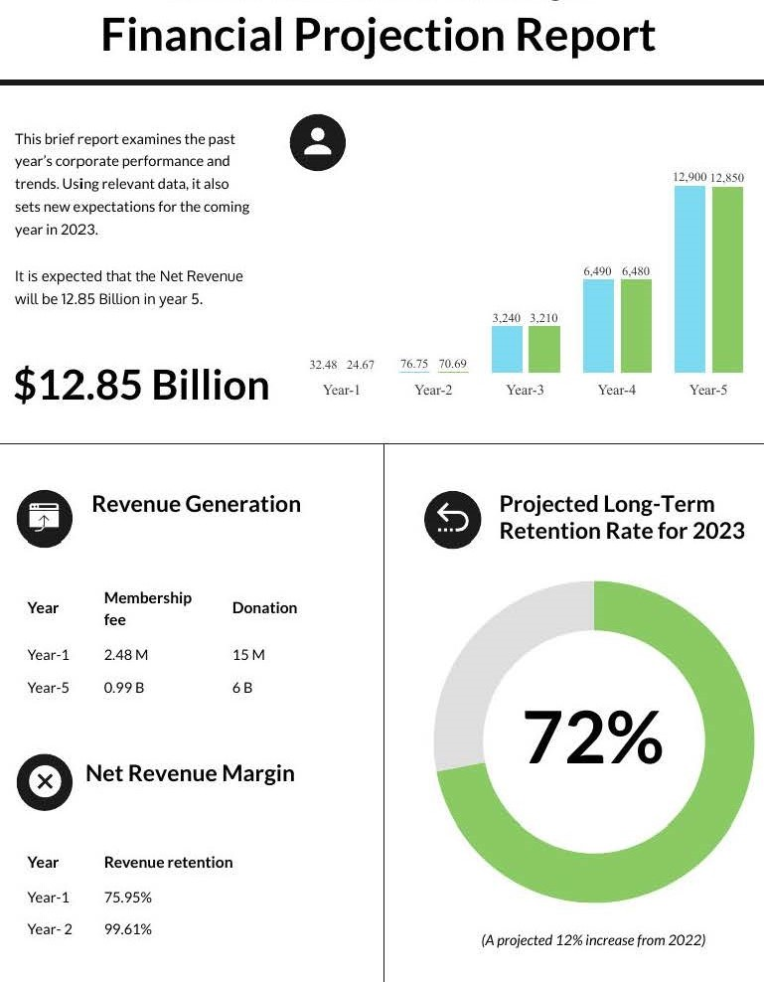

**SCT© LEADERSHIP & EXPERIENCE:**

The co-founder and CEO, Steve Schroeder, of SCT© has 15+ years of experience in traditional customer loyalty and rewards modeling. 3+ years of experience in Blockchain Technology. A PhD in Digital Assets & Digital Technologies and a second PhD underway in Austrian Economics. Jonathan Schroeder is the co-founder and CFO of SCT© and is the Digital Assets & Digital Currencies Officer. Jonathan also holds a PhD in Digital Assets & Digital Technologies and Austrian Economics. Rob Cudlip has 10+ years of customer acquisition and retention experience. Together, the three are the management and leadership core of SCT©

When we get investment dollars into Smart Community Technologies, it’s not just an investment for monetary gain.  It’s an investment to change the world in an amazing way and give hope to billions of people.

and bring people together rather than the divisive attitude which currently exists and threatens our existence as a Country.

Steve Schroeder – CEO/Founder 562.201.2580 [steve@smartcommunitytech.com](mailto:steve@smartcommunitytech.com)

Jonathan Schroeder CFO Digital Assets and Digital Currency Officer 425.366.1993 [jon@smartcommunitytech.com](mailto:jon@smartcommunitytech.com)