Smart Community Technologies© - A Bitcoin Company
The DeCoy© Business Plan

Developed on the Lightning Network Layer 2 to the Bitcoin Network
As Featured in the Top 100 Innovators and Entrepreneurs
3rd Quarter 2022 Edition Entitled The Butterfly Effect

THE TOP 100 MAGAZINE

The Official Publisher of Top 100 and Top 40 Publications

DeCoy© has founded Behavior as a Currency since behavior is a currency. DeCoy© rewards everyday behavior by depositing an immutable asset (bitcoin) into the digital wallets of its members and allowing those members to spend their currency, save their currency, convert their currency, or donate their currency anywhere in the world without any transfer fees. We thereby evolve the members outlook from one of desperation and doubt too one of hope and prosperity by protecting their assets and allowing them to help others at the same time.

Table of Contents

- What is DeCoy©?
- What problems does DeCoy© solve?
- How does DeCoy© work?
- How does DeCoy© make money?
- How does DeCoy© pay back investors?

- What is DeCoy©?

DeCoy© stands for and is an acronym for Decentralized Customer Loyalty, and the ‘Coy’ can also mean Customer Loyalty, Consumer Loyalty, Community Loyalty, Country Loyalty and or Currency Loyalty.

DeCoy© is a behavior technology which is agnostic to the behavior desired. In other words, DeCoy© is a technology solution which can incentivize any type of behavior needed from any desired group of people or from any individual anywhere in the world.

In this business plan, DeCoy© will focus on the Customer Loyalty aspect since it’s: simple, profitable, and well understood in the marketplace today. But DeCoy© is much more influential than a simple Customer Loyalty solution, which is why The Top 100 Magazine Editors have entitled DeCoy© as ‘The Butterfly Effect’.

DeCoy© uses Gaming Theory to reward people for their behaviors rather than using the incentive of punishment to avoid behavior. We feature real life gamification models using an entire suite of enhanced technologies, which have never been utilized in this fashion previously.

DeCoy© is a mobile application which can be downloaded in the traditional app stores of Google© and Apple© or any other app store. DeCoy© then transfers the downloaded data to an immutable blockchain to protect the customer’s assets and their identity (using LSATS or Lightning Service Authentication Tokens). We then reward our customers with FREE items in their community as well as depositing bitcoin into their DeCoy© wallet for positive behaviors while protecting and growing their assets unlike any mobile application previous.

Since DeCoy© combines and blends technologies in ways where popular brands benefit. The brands pay for the bitcoin and thus protect price points of the merchant by adding value to select brands or select behaviors which benefit the brands and thus revolutionizes traditional advertising as it’s known today. Rather than paying for advertising in advance and hoping it works, DeCoy© triggers an expense only AFTER the customer is visiting, spending money, or promoting the brand via word of mouth and influence driven social media. There is much more to share with you in conversation, but this is the simple explanation of how DeCoy© can deposit bitcoin into the wallets of consumers around the world; while lowering existing costs and giving consumers bitcoin after they perform the desired behavior the brand is looking to achieve.

Company Overview & At-A-Glance

Smart Community Technologies© (SCT©) and Fundraising as a Service Technologies© (F.A.A.S.T.©) and DeCoy© create simple and affordable membership subscription-based models or mobile membership apps starting at just $4.95 per month. This powerful-and-benefit-enhanced mobile membership allows the mobile user and member to allocate 50% of their monthly membership fee directly to any charitable cause of their choice and have that choice secured by Smart Contract Technology© so it’s guaranteed by code to arrive to its intended charitable cause and destination in the full amount expected by the member with full visibility.

DeCoy© Mobile App Membership Subscription Model & Highlights

The DeCoy© Mobile App allows for free and paid membership options. Starting at $4.95USD per month. DeCoy© provides the option to increase and adjust these membership options to any interest level at any time.

A previous version of DeCoy© has been proposed to Ford Motor Company©, which at the time offered to pay SCT $2,500.00USD per month per dealership. As of March 28th, 2022, there are 3,000+ Ford Dealerships across the United States with Texas having the most.

Beta test marketing with Ford© provided dynamic insights and potential for growth of DeCoy© across multiple brands. Major brands, such as: Walmart©, Papa John’s©, Miller-Coors©, Boyd Gaming© and others have been exposed to SCT© retention and reward concepts and the need for enhanced loyalty among it’s growing and shifting consumer base. We have worked with the following brands for years with great success and can do so with any brand or any specific brand within a certain retail space and block out their competitors.

Brand Relationships, Major Sponsors and Testimonials of SCT©
Automotive: Ford Motor Company©
Finance & Banking: Coinbase©
Food & Beverage: Applebee’s©, Chick-fil-A©, In-N-Out Burger©, Miller Coors©, Outback Steakhouse©, Papa John’s©, Wendy’s Hamburgers©
Gaming: Boyd Gaming & Casinos©
Professional & Collegiate Sports: MLB©, MLS©, NCAA Football©, NFL - Play 60©, PGA©, Strike 10 Bowling©, USBC©
Retail & Services: 24-Hour Fitness©, Walmart©

Membership Features & Rewards –

The DeCoy© membership app will be a digital wallet which can add value to any other digital wallet, digital membership, employee benefits package, brand memberships such as Wal-Mart Plus©, community fundraising, and much more. The foundational layer of DeCoy© will provide the following.

- FREE ITEMS in each community such as
  - 1 free large pizza per month at Papa Johns and only Papa John’s in the pizza space.
  - 2 free oil changes per year at any Ford dealership for any type of vehicle with special Ford Bucks and custom dealership membership options which we provided to all of our partners.
  - 2 free games of bowling per day from over 4000 different bowling centers.
  - Free glass of wine per day from Olive Garden (within a membership app as long as the membership fee covers the hard cost of alcohol, the offer is legally acceptable. Certain states have different rules which are easy to customize in the app based on Geo Location.
  - Free 20 oz. Miller Coors brand draft beer at 4000 bowling centers such as Blue Moon, Coors Light, or any other tap produced by Miller Coors.
  - Free round of golf each month from over 3500 different golf courses with more being added on a regular basis.
  - Free steak dinner at Ruth Chris steakhouse with any test drive of a Ford vehicle.
  - $10.00 per month in Wal-Mart cash which drops off automatically if not used like all of DeCoy offers.
  - Free appetizer from any Chili’s restaurant every week. No additional purchase is necessary, but most Chili’s require the DeCoy member to come inside and can take the appetizer to go if desired. In person dining or additional orders are not required.
  - Free entries into special games at bars such as Chili’s or local bars which are not in the Chili’s space. We have a use case patent pending game we have designed for NASCAR with life changing prizes covered by insurance. Just like Super Bowl boards where people normally pay for a square and once all the squares are filled, numbers are drawn and prizes given out, DeCoy has created a brand game which gives away squares for free to DeCoy members when they order any Miller Coors product. Squares cannot be purchased but we also allow each local Chili’s bar to offer a square for any ticket over $30.00 or for any patron who spends more than $30.00 per visit. We also allow multiple squares for every $30.00 spent or for every Miller Coors product ordered. In one of our test cases seen below in a bar in California, a patron walked in and ordered 100 Miller Coors for every patron in the bar in order to fill up the entire board with his name. Our prizes are huge prizes such as $40,000 in cash, a new Ford F-150 truck, we even have locations which award a new home which is custom built for the community with additional homes, automobiles, and Make a Wish type prizes which can’t be purchased for any price such as on-stage concerts and on field sports experiences.

Here is a picture of our test board being used at the bar mentioned above. Budweiser© replaced Miller Coors© since Budweiser© was the official sponsor of NASCAR© at the time. Other sponsors were Patron©, Grey Goose©, Ford©, Captain Morgan©, Uber©, and Pepsi© (listed in order on the board below with the prize listed. We also have the first ever autistic NASCAR© driver waiting for our sponsorship as you can see on the board.

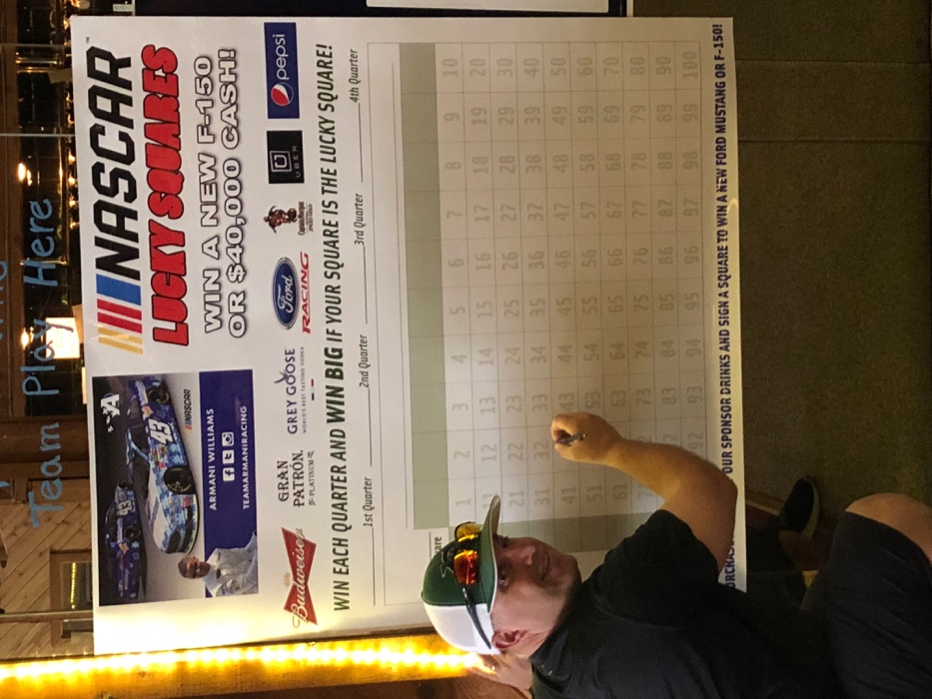
  - Free items and prizes are added in each community all the time for surprise and delight. We combine real life gamification with life changing values in ways all other mobile apps to date have failed to deliver.
  - We have approvals waiting with the PGA©, NFL©, MLB©, MLS© and can carry this out on the local level with any sport to help raise money for communities.

- In addition to free items for every member which are customized for each community, every member also earns bitcoin for certain types of everyday behaviors such as visiting Wal-Mart, completing a social media scavenger hunt, posting certain comments to Twitter, helping in the community, supporting special needs, grades in school, and much more.

- Fundraising benefits and technologies to support others around the world through a variety of pooled behaviors in order to bring people together without having to spend money.

- Free items, free Bitcoin, and special fundraising options are the foundational benefits of DeCoy, but there is much more behind the scenes which is why our build has been called…The Butterfly Effect.

These rewards, donations and satoshis will be paid for by the advertisers, brands, sponsors and dwell time locations using our suite of technologies such as Tweet Receipt© and other digital gamification concepts created by DeCoy© and SCT©.

Plan of Development, Membership Onboarding & Potential Partnerships:

When consumers choose to join DeCoy©, they now are referred to as members. Their membership status and all personal data is placed and transferred via the Lightning Network as layer 2 to Bitcoin using LSATS and Macaroons to authenticate and authorize data and transfer that data to bitcoin blockchain rails to ensure total security for the onboarding member.

Using these LSATs and Macaroons (developed by Google for decentralization) DeCoy© mobile app ensures the safety of all data and financial information of the DeCoy© member. This will be the first mobile app of its kind developed on the Lightning Network. The Lightning Network has been previously used in this fashion for the country of El Salvador by CEO of Strike Jack Mallers, but not to the degree which DeCoy utilizes the technology.

DeCoy uses the Lighting Network in a transformational fashion by allowing members to earn bitcoin rather than spend bitcoin and to earn bitcoin without the need to spend any money and then be able to transfer and pool that earned bitcoin to any other person, group, or entity through the DeCoy app to anywhere in the world. Through the use of the Lightning Network, we can convert any currency into any other currency for virtually free, and thus have transformed rewards, donations, gamification, fundraising, and the entire customer loyalty space with DeCoy.

- What Problems Does DeCoy Solve?

The Problem SCT© and DeCoy© are Addressing:

- Discounting. Discounting is a trillion-dollar problem for retailers and puts many small businesses out of business which are unable to compete with the pricing of larger brands who can buy in massive bulk. DeCoy is the only technological solution which has solved the problem of discounting by redefining value and doing so in a way where there is no cost to any business which partners with DeCoy.
- Advertising. We have eliminated and reversed the role of advertising in the retail space for DeCoy sponsors. We do this in very creative ways, but merchants no longer need to spend money on advertising to hope a customer visits their location and then order something where the price has been reduced. DeCoy is the only app which has figured out how to solve this problem.
- Fundraising. DeCoy has employed the technologies of FAAST or Fundraising as a Service Technologies which Kleiner Perkins tried to purchase several years ago. We have completely transformed fundraising in several areas.
  - Security of funds being delivered in a decentralized fashion with smart contracts.
  - The ability to raise money for other countries, other communities, or other people through BAAC or Behavior as a Currency.
  - The control of local entities through special codes so that non-profits and special needs groups can protect their donations by code and not worry about receiving the money or the proper amount of money with intermediaries.
  - Our digital drawing engine with custom entries similar to the NASCAR board game can call be spun off via a custom dashboard to train communities are to raise money on autopilot without the need to organize pancake breakfasts, car washes, signs on the street, sale of overpriced items, or the many different archaic methods employed for fundraising today.
- Frequency of Visitation. Many small businesses suffer with frequency and pricing of existing items or putting items on sale and lowering gross profit margins. This effects jobs, schools, education, growth, sovereignty and much more. The backbone of the U.S. is small business and if the U.S. is to survive, small businesses need to thrive. DeCoy fixes every problem that a community and small business would have. We fix the money; we fix the community.
- New Customer Acquisition. Another problem is attracting new customers and then making sure those new customers become loyal customers or repeat customers. We do this on autopilot for DeCoy merchant partners and members. DeCoy incorporates a number of technologies which can be used by any business (from high end Porsche dealerships to mom-and-pop convenience stores) which not only attract new customers but keep them coming back on auto pilot and then rewarding them with a hard asset which has no initial or redemption cost to the merchant.

In addition, to the above which is remarkable on its own DeCoy does things that no other solution has been able to do previous. Here is just a sample list of merchant benefits we provide at no cost to DeCoy merchant partners.
- We add value to their business which has customers requesting to pay full price and more than full price in order to get the value we provide at no cost to the merchant. Just think about how ingenious that one aspect to what DeCoy provides.
- We avoid discounting
- We can block competitors within the space with custom value.
- Introduce them to digital brand memberships (which FAAST founded) and allow them to keep 100% of a new revenue stream through the digital innovation of DeCoy which is provided at no charge. You have to be kidding me, right?
- We support their community on their behalf and give them the credit without having to write a check!
- Provide proprietary games tied to the app like the NASCAR board which they can’t get anywhere else. All at no cost to the merchant who is now getting paid from the brands illustrated on their custom board. We also have dice games with a complete set up and special golf games we provide as well.
- FAAST business plan sold this license for $49.95 per month to schools, churches, or any special needs group. A better strategy is to give this away FREE OF CHARGE and then handling everything on autopilot to increase the value, help the community as a result, and make money for Smart Community Technologies and DeCoy through the viral spread of the memberships which helps everyone.

No technology has been able to solve these problems other than DeCoy.

One simple idea we use that we never see implemented everywhere is the creative use of our Geo Fencing dashboard with surprise and delight rewards and mobile concierge customer service. Here is an idea which illustrates a basic use of our technology.
  - Customers are automatically tracked for number of visits to a desired location through permission based and decentralized location-based tracking inside the mobile app.
  - When a customer pulls into the parking lot, there name and other pertinent information is sent to the Apple watch of the employee.
  - When Steve walks in the door, he is greeted by name and treated with incredible mobile concierge customer service.
  - We also provide surprise and delight based on each 30-minute stay in the restaurant so that every stay has an automated different prize attached to that visit which increases in value based on the frequency of visits within 30 days. All of this is done automatically so that the customer shows the Apple Watch which is now integrated with Apple Pay and our wallet and the rewards automatically come. Here is a screen shot of what I am describing at the Ford dealership in West Palm Beach where we ran the beta. The top blue VALET PLAT means Valet Platinum Member. We have two-way communication with the customer via the watch and a special reward is triggered based on what he has done on autopilot. As you can imagine Google wants to partner with us and we are using Google Macaroons to illustrate the next level of Google revenue with a decentralized solution.
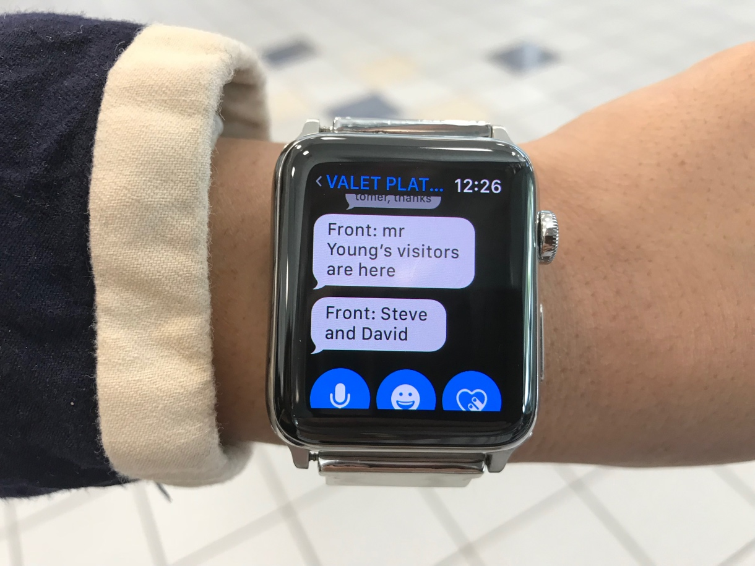

- Cost of customer loyalty solutions including the redemption of incentives, points, miles, stars, and the completely inept customer loyalty space. Whether this be with points, miles, stars, or any other confusing currency which can be printed with the value changing, we remove the corruption from customer loyalty with a completely innovative solution with DeCoy.
- Average Ticket. We automatically increase average ticket without spending money on advertising due the value we add to certain brand purchases or any type of purchase which is controlled by the master dashboard.
- Brand memberships for merchants as a new revenue stream. Another huge revenue stream small business has yet to fully grasp that I launched 10 years ago with Bowling Rewards and Miller Coors. We took 10 bowling centers which were selling 80% Budweiser to 20% Miller Coors. Within 60 days we had reversed the numbers to 80% Miller Coors and 20% Budweiser through a web-based loyalty solution that pales in comparison to DeCoy.
- Competition based on price. Because DeCoy changes the definition of value by providing merchants with that value at no cost to them, we issued the first SALE ITEM in a pro shop of a bowling center in Bowling Green, Ohio. We sold a bowling ball on sale for $100 more than the regular price by attaching digital value to the Bowling Rewards program I founded at no cost to the pro shop or bowling center. Over 80% of the customers chose the bowling ball ON SALE for $100 more than the regular price due to the value I placed on the ball which did not cost the pro shop or the bowling center any money. Just the opposite, I used this strategy to move customers from Budweiser to Coors, so Coors paid for the incentives since I tied to the two brands together digitally. We do far more now due to the tech advances of a decentralized currency and app than what I could do previous.
- Merchants feeling pressure to fund local causes without the money to fulfill these requests or needs. I was told by many small business owners they would get requests as often as 10X per day from schools, churches, softball teams, high schools, and an entire list of people who wanted him to support, sponsor, fund, or help out. Small business owners always felt guilty for saying no thinking that their business would be bad mouthed by the school or entity looking for sponsorship or donation. DeCoy fixes this and takes all the pressure and requests like this away from the business owner and combines technologies to raise money which is impossible to do until DeCoy.

SCT© plans to design a dynamic virtual educational series allowing community, business and philanthropic leadership to be trained virtually on how to on board local and regional merchants. Thus, increasing donations to the local charities and causes in addition to stimulating the return of community involvement and engagement that have suffered due to the pandemic and the social distancing initiatives.

This return to spirited community involvement directly increases the value for the participating merchants of DeCoy© inside the chosen community. SCT© and DeCoy© have created a built-in sales, promotion and influencer force with the schools, faith-based organizations, and other non-and-not-for-profit groups. All communities need people who promote and add value to the community to increase ongoing engagement, community spirit and promote contribution to charities and causes. This strategy feeds upon itself without needing a hired sales force.

- How Does DeCoy Work?

Company Policies:
  - Membership Policy:
Consumers can join for free or pay a $4.95 membership fee per month or $49.95 per year. Consumers can pay in USD currency or Bitcoin. In the future, more expensive memberships will be available but for the initial build, these will be the only two options.
  - Deposit Policy:
Consumers can deposit USD currency inside of the app and receive rewards in Satoshi’s based on the amount deposited with a scale to earn more Satoshi’s based on their USD deposit in the app. USD money in the app can be used or converted by a simple REDEEM NOW button inside the DeCoy app. For example, a $5.00 USD deposit might earn 1 Satoshi in rewards, but a $50 deposit would earn 25 Satoshi’s to encourage more USD deposits in the app and thus more Satoshi rewards which can be converted to USD at any time or transferred to any other member in the world.
  - Rewards Policy:
Groups, non-profits, churches, or special needs can pool their behaviors, purchases, and rewards to allocate to any community in need or desired community of their choice so that their rewards are automatically pooled from one community to the other. When this option is set, then the pooled benefits kick in by smart contract and the entire communities rewards and behavior benefits are pooled and transferred to that desired community anywhere in the world. The Satoshi’s can then be converted free of charge to the currency desired by the other community.

Since there is no charge for merchants to join DeCoy that provide value to DeCoy members, we can on board 1000s of locations with the push of a button such as we planned with Chick-fil-a, Ford, and Starbucks. We can ‘peel off’ the dashboard to allow each community, each State, or each non-profit entity in each community to control and upload custom value based on having their organization selected for the 50% of the membership fee.

Each community is trained on how-to on-board merchants to increase their donations due to the increased value for the merchants. SCT and DeCoy have created a built-in sales force with the schools, non-profits, special needs groups and community needs people who promote and add value to increase their ongoing donations as a result. The strategy feeds itself without needing a sales force, our non-profit beneficiaries are the sales force.

SCT Initiative Value Propositions:

Redemption Facility:
When a consumer deposits USD currency in the app then that currency can be accessed via Geo Location at member locations or wherever the master node indicates. For example, if a member walks into a Chili’s restaurant in Dardanelle, AR, the master node can unlock a Geo Fence inside of Chili’s or when the vehicle enters the parking lot of Chilis which allows the member to hit a simple REDEEM NOW on their phone to pay their bill.

We will then settle with that merchant or transfer the monies from the members account to the merchant account within 24 hours or whenever needed to settle for that merchant. We set up a smart contract to do this, so it’s automated to the merchant. The merchant can set up any number of options through their POS knowing that settlement is coming. We drive customers, we increase spending, we increase visitation frequency, we eliminate discounting, we reward customers, we surprise and delight customers with incentives, we gamify visits, we fund community causes on behalf of the merchant, all at no cost to the merchant. No company has ever created such a powerful solution without any cost to the merchant and reversed emotions and value by charging the consumer a small monthly fee. No other company has even considered using the Lightning Network to accomplish these tasks since they have never been able to ideate the tasks in the first place.

- Satoshi Savings Account:
When we open a member location, we track the number of visits to that location through the Geo Fence so that whenever the consumer visits again during a determined period of time or whatever rules set up in the dashboard, they receive a push message with a special reward for each additional visit which grows based on each individual visit. I first proposed this to Starbucks using their Stars which they finally implemented and has seen revenues grow by the billions of dollars as result.

In addition, there will be incentives for the customer to spend more money from the app at that location with added Satoshi Savings Account Rewards which are not paid by Starbucks or any merchant which is another first in business and loyalty history.

In our test case with 5 different bowling centers and local golf courses, we set up a free round of golf with a cart whenever $25.00 was spent inside the bowing center. The round of golf with cart had a value from the golf course of their normal price of $37.50 - $49.95 based on the time and day. The reason they gave a free round is due to what I provided the golf course with Geo Location and a sponsorship with Titleist that benefitted the golf course tremendously. This is what we know how to do at SCT and DeCoy which other companies do not understand or know how to execute using digital technologies.

Customers would walk into the bowling center with no desire to bowl, they just wanted to give the center $25.00 and leave just to get the value from spending $25.00 at the bowling center. Each of the bowling centers said this had never happened in the history of their center. The first center owner was so shocked, he had to call me to see if it was ethical to take money from people who did not want to bowl. I assured him it was, and we revolutionized the profits of that bowling center and many others when I founded Bowling Rewards.

- Membership benefit:
50% of the membership fee is directed to the non-profit or special needs cause of choice indicated by the member when they join. Using either a drop-down box where they can type in the name of that cause or a list with approved causes, whenever that cause is selected it becomes part of the ecosystem for future members to choose. This selection will be locked in for a year so non-profits or schools can secure donations and have contests on who can get the most members to join via their non-profit code. These donations will be ongoing donations, not just one-time donations and can be enhanced by brands which we explain when turning over dashboard controls to certain community entities.

- Revenue Collection:
The revenue generated by and for communities goes much further than receiving 50% of the membership fee. We show community leaders how to generate additional funds through the use of our dashboard and how to partner with brands and businesses in the community for even greater donations. This is the FAAST model which was originally designed by me 5 years previous when Kleiner Perkins desired to purchase the company.

Community groups sign on members using their phone and sending a message to the new member thanking them for supporting their cause and opening up community benefits with just their phone. All entities know that donations, rewards, and balances are protected by smart contract so that nobody can take their money or donations. Each time the consumer renews their membership after the 1-year period, the default will be the original cause selected so that the consumer has to opt out, pay a new membership, or take action to change where the 50% of their membership fee is allocated. When the 50% membership fee is allocated, then all the future benefits, prizes, and added donations from the consumer’s behavior is also locked into their selection for a one-year period. Consumers can choose multiple memberships if desired to support more than one cause in their community and then choose which added donations go to either one of their causes selected.

All of these things are done and secured by smart contract, so the monies are auto directed to that cause when the membership is paid.

- Geo Fencing:
By paid membership, members will be able to raise money for their desired cause by visiting certain businesses which are tracked by Geo Fence with time and date verification, so rewards or donations are only issued if a person spends 15 minutes at a location rather than just penetrating the geo fence for a minute or two.

We have designed virtually unlimited capabilities inside our Geo Location and Geo Fencing expertise including the ability to track dwell times in front of certain brands in certain aisles at any store in the U.S. with or without that store’s permission.

We will feature Geo Social Scavenger Hunt donations where paid members can spend 15 minutes at Wal-Mart, 15 minutes at Starbucks, take a picture of their Starbucks Coffee, and post that picture to their Twitter account, and through an API in the app with Twitter that thanks Starbucks for supporting their community, rewarding their behavior, and helping special needs causes.

We can do this with or without Starbucks knowledge or permission but when presented with the option, every brand welcomes these strategies and works together with us to ensure the best customer service experience.

- Tweet Receipt:
By this unique method, we tie the camera feature of the phone to take pictures of receipts with a TWEET RECEIPT option so if the consumer spends $10 at Wal-Mart, they take a picture in the app using their phone in the app and then post that picture to Twitter with time and date stamp to earn Satoshi Rewards for their community.

We have presented this concept to corporate TWITTER on behalf of a Canadian partner and Twitter loved the concept. We plan on announcing a formal partnership with them based on the value we create with Twitter once the app is completed in the MVP stage.

Merchant benefits:

- FREE or Paid Membership:
When the consumer makes their selection for either a free or paid membership, they receive a virtual or digital membership card or membership message on their phone which indicates on the card if it’s a FREE membership or a PAID membership. Consumers will show their membership card to receive benefits and then a REDEEM NOW BUTTON will trigger the redemption. If for any reason the membership is not paid or payment does not go through, the card converts to a FREE membership and then back to paid once monies are collected.
“Each transaction is recorded on the blockchain for immutable and permanent records”.

- Redeem Option:
We will have the ability to add merchant balances through the master node for select brands where special packages can be purchased through the app.

For example, a paying member can purchase 30 Miller Coors beers for $30 but will be blocked on redemption to 1 per day. This will be a use it or lose it type of package purchase so unless the member visits the business every day to use their Miller Coors package, then that number of beers disappears from the app and they have one less beer to use at that merchant.

When the member or consumer desires to use their package benefits at the merchant, a simple REDEEM NOW button removes the item and the merchant serves the consumer. We will have the option for each merchant to collect these packages on their own from our paying members so that each business we drive business too, encourages their customers to join Smart Community Technologies and we have a built-in viral marketing campaign at no cost to Smart Community Technologies and DeCoy.

- Smart Contract:
All agreements, rewards, balances, etc., are set by smart contract so the owner of any business does not need to do anything other than welcome in new customers and have them present their phone and hit the REDEEM NOW button.

Merchants don’t have to worry about analytics, POS systems, training employees, or tracking the results, everything is done on their behalf and the success can easily be documented to show their continued involvement.

Merchants don’t have to pay anything for these benefits and they no longer need to fund every request which comes through their door which many have told me exceed 5-10 requests per day. Now, they have a built-in mechanism to drive donations through our membership app which features their business.

We also add value through innovative concepts which cause our members to spend more, visit more, and bring friends more, all without cost to any business. The only thing needed is for the employee or the consumer to hit a REDEEM NOW button which only shows up when the Geo Fence is penetrated, or the consumer is at that location.

All donations and benefits to others in the app are secured by Smart Contract, this is the first time this type of app has delivered anything like what is being described in this business plan.

- Design your Own Digital Currency:
We also teach communities how to design their own community currency. Each community can design their own digital currency with SCT tech help and the license to use our dashboard to develop the currency. This unique custom currency per community can be used like a Willy Wonka Golden Ticket reward or as a custom fundraising currency, or as a monetary currency, or any number of combinations we can share with them upon adoption.

Since we control brand packages and which brands are able to offer consumers value added rewards and packages, brands will donate large amounts to community causes who issue their own currency as an additional balance which can only be spent at community approved locations.

For the sake of understanding, each community’s custom token could be a glorified rewards token which can only be used at the location desired by community leaders or based on the rules of the community we can set up with a consensus algorithm. There are unlimited options we can suggest and program on their behalf using their own custom currency.

- How Does DeCoy Make Money?

DeCoy© Highlights & Advantages within the growing Mobile Application Industry

History & Trends - Statistics indicate that the mobile app industry has consistently increased every year. From $97.7 billion USD in 2014 to $581.9 billion in in 2020. Projecting to climb to $935 billion by 2023. With over 5 billion smartphone users and 2 billion tablet users worldwide, there is no doubt in the growth rate of the of mobile app industry. Studies show that 88% of mobile time is spent on apps. Interestingly, studies share that 90% of apps in the market are free, and 98% of worldwide industry revenue comes from free apps. Smartphone users spend about three hours on their device and around 90% of that time is spent on apps.

SCT© Strategies & Deployments for the Next Generation of Mobile Apps - DeCoy© The proprietary mobile app of SCT© is built on the Lightning Network as Layer 2 to the Bitcoin Network without the requirement to access Bitcoin the asset. This means when we transfer money from USD to Argentina, we don’t have to worry about the volatility of bitcoin since the transaction is instantaneous and virtually free.

Proof of Concept - Social media posts with Tweet Receipt© and the technology of SCT© with their Geo-Social Scavenger Hunt© that was first proposed to Ford Motor Company© were well received by customers with over 90% of the users surveyed indicating they would sign-up for the feature as soon as the value and feature will be delivered in the mobile app. These concept proofs and Digital Geo Punch Cards© further the value of the concept by SCT©. Dwell times, rewards and AR gamification deposits based on AR clues, purchases and social media posts in conjunction with real life rewards using a gaming advancement model similar to Pokémon Go©, Minecraft© and Super Mario Bros©.

Value to your Communities & Neighborhood - Wrapped within DeCoy© is the distinct and unique ability to give back. Developed by SCT©, a modernization of charitable and contributory giving has been invented called F.A.A.S.T.© or Fundraising as a Service Technologies©. This modern twist on giving back to one’s community allows for members to support the interests and causes of their choice right in their own backyard or be able to give in real time to a situational cause or natural emergency across the globe.

Membership Growth & Financial Highlights - The below table indicates the forecasted growth of membership to DeCoy© globally and corresponding revenue.

Year | Monthly  Member Count | Monthly Fee  In USD | Monthly Revenue  In Millions
1 | 500,000 | $4.95 | $2.475
2 | 5,000,000 | $4.95 | $24.950
3 | 50,000,000 | $5.95 | $300.875
4 | 100,000,000 | $6.95 | $700.850
5 | 200,000,000 | $7.95 | $1.6B

Fundraising & Business Revenue Summary:

Smart Community Technologies© and Fundraising As A Service Technologies© revenue model is based on minimum projections of membership participation from our case study at the Ford Motor Company© auto dealership in Orlando, Florida. At the time, the President of the Southern Florida Ford Dealers Association© or SFFDA©, Mr. Allan Young, worked alongside SCT© while the case study was being offered to the dealership guests and surrounding Ford© owners. The case study with Ford© proposed a $9.95USD per month membership with:

Each Week: free appetizers from Applebee’s©
Each Month: 1 free round of golf at 10 different courses in the Southern Florida area
Each Quarter: 1 free steak dinner at Ruth’s Chris Steakhouse© for each verified test drive of a certain Ford© vehicle based on promotion
Each Year: 4 free oil changes per year, 1 free admission to Disney World© in Orlando, FL
Plus: 1 Free Night at a participating Marriott© hotel with no minimum stay

SCT© maintains a very active relationship with Ford© and SFFDA© and could exercise this partnership once DeCoy© is built. Yet, the potential and sheer power of the DeCoy© build with available technologies and recent digital innovations has increased tremendously since our case study in Orlando, FL. And due to the opportunities on the Lightning Network, we could align with other automotive brands based on the value provided to the DeCoy© member.

Revenue Highlight: Based on the above sampling, the marketing team at Ford© estimated a minimum of 1 Million members within a year’s time in Southern Florida. Which would generate $10 Million USD per month in gross revenue. $5 Million USD per month in charitable donations and contributions to local charities and causes of choice.

Value to Additional Participating Locations & Franchise Operators: Since there is no charge for additional merchants to join DeCoy© who provide value, we can board thousands of locations within hours, such as planned with Chick-fil-A© to provide additional value and community support to the causes that interest the designated geographic.

Customization Available to Participating Merchants: SCT© has designed DeCoy© allowing individual merchants, franchise groups and or corporate headquarters to ‘peel off’ from the DeCoy© dashboard to allow each community, each region, territory or state, or each non-profit entity in each community to control and upload additional value exclusive to their community or shared across the country based on which merchant decides to add value.

DeCoy© Valuation & Growth:

The numbers in the table below represent gross revenue from DeCoy© memberships alone. There are many additional ways DeCoy© and SCT© secure revenue. For simplicity sake, we will just discuss the largest generator of revenue and the largest generator of charitable donations, which is the DeCoy© subscription membership model at $4.95USD per month. Business valuation and EBITDA with ongoing SCT© innovation in the digital asset technology space is 10x to 20X. Within 2 years of the launch and considering demand and value to membership audience, DeCoy© could become a billion dollar brand in near term and grow rapidly.

Year | Yearly Member Count in Millions | Yearly Membership (Monthly Price X 10) | Gross Annual Revenue in Millions
2023 | 1 | $49.50 | $49.5
2024 | 5 | $49.50 | $247.5
2025 | 50 | $59.50 | $3B
2026 | 100 | $69.50 | $7B
2027 | 200 | $79.50 | $16B

- How Does DeCoy Pay Back Investors?

SCT© Officer & Management Team:

Steve Schroeder | Chief Executive Officer
Extensive background in brand strategy. Specializes in customer loyalty and rewards models. Active consulting for popular mobile app development and new version deployment. High proficiency in digital assets, financial structure and mobile technologies.
steve@smartcommunitytech.com 562.201.2580

Jonathan Schroeder | Chief Financial & Digital Currencies Officer
Has built an impressive career within financial management for high profile consumer brands. Keen and deep knowledge of digital assets and banking. Broad knowledge in digital currency strategies and foundations. Superior communication skills with key decision makers.
jon@smartcommunitytech.com

Robert Cudlip | Communications
Best known for team driven leadership and learning. Developed techniques for productive virtual collaborations. Career based in consumer acquisition, experience and retention models.
robert@smartcommunitytech.com

Capital Requirements for Deployment of DeCoy©
$2.5 Million USD
Available in 25 units at $100,000 USD each unit

Capital Pay Back
  - Each investor will receive 100X their initial investment in the following ways.

  - 100% of Membership Revenue to SCT and DeCoy from members will be allocated by smart contract as return of capital to investors. In other words, 100% of membership revenue will go to pay back the initial 2.5 million dollars raised so investors get their money back quickly.

  - Once all investors are paid back in full so their initial deposit amount has been returned, then 50% of the membership revenue to SCT will then go to each investor in order until 100X is returned to each investor.

  - No equity will be given to investors at the above level.

  - Should an equity investor desire a different arrangement, we are open to discussion.

