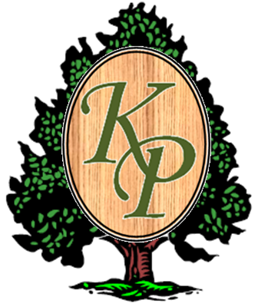 KELLY PLANTATION
HARVEST, ALABAMA
NEWSLETTER
August 2014

Well summer is almost over and the new school year has begun. Not sure where the time has gone, but we hope everyone has enjoyed their summer!! Several people have asked about the date for the pool closing and we are just playing it by ear like we did last year. We estimate to close around the end of September once the weather begins to cool off and the water starts to get too cold to swim. We will send out an email notification prior to the pool closing.

As neighbors, we can use this newsletter to spread good news and share with each other when our children get recognized for awards at school, if someone scores the winning touchdown in the high school football game or just anything else that we want others to know. We need to share when we find good sources for work on and around our property. If you find a painter that does an amazing job at a fair cost, have that published in the next newsletter so that your neighbors can take advantage of a good deal. Several of you own your own businesses and this newsletter can be a way to get that information out to your neighbors.

So, when you have something you’d like to share, please send information to kphoasecretary11@gmail.com.

And yes, it is football season again. YAY!!!! So for those of you interested in enjoying a Friday night of football:
2014 Sparkman High School’s Football Schedule

Date | Opponent | Location
8/22 | Albertville (Albertville, AL) | Away, Albertville High School
8/29 | Scottsboro (Scottsboro, AL) | Home
9/5 | Gadsden City (Gadsden, AL) | Home
9/12 | Bob Jones (Madison, AL) | Away, Bob Jones High School
9/19 | Huntsville (Huntsville, AL) | Home
9/26 | @Russellville (Russellville, AL) | Away, Russellville High School
10/3 | Hazel Green (Hazel Green, AL) | Home
10/10 | @Buckhorn (New Market, AL) | Away, Buckhorn High School
10/17 | @James Clemens (Madison, AL) | Away, James Clemens High School
10/17 | @Jackson (Jackson, AL) | Away, Madison Sports Complex
10/24 | Grissom (Huntsville, AL) | Home
10/31 | @Brewer (Somerville, AL) | Away, Brewer High School
11/7 | @TBA | Away, TBA
11/14 | @TBA | Away, TBA


We would like to welcome all the newcomers to Kelly Plantation. If you are new to Alabama, we hope you will enjoy the Harvest area & Huntsville. We enjoy a close communication with our neighbors & the HOA is striving to work with developers in maintaining the integrity of our neighborhood for the safety, well being & prosperity of our families & our children. If there is anything the HOA board can do for you or if you have any questions, please do not hesitate to call upon one or all of us.

Please welcome our new neighbors (since January 2014):

Resident: | Address: | Move-in Date:
Jonathan & Emily Spry | 231 Kelly Ridge Blvd. | June 2014
Erik & Jamie Srock | 236 Kelly Ridge Blvd. | June 2014
Lemond & Tessa Dixon | 237 Kelly Ridge Blvd. | August 2014
Michael & Mary Overfelt | 110 Burwell Ridge | TBD

FINANCIAL:

Budget Update:
A quarterly statement ending June 30, 2014 is posted to the KP web page at http://kellyplantationhoa.net/Home_Page.php to locate the statement click on “Resident Information”.

Dues:
Dues for 2014/2015 are coming up. Dues ($300) + Assessment ($180) will be due in one payment on October 1st 2014. Statements will be mailed out in September. Please see the reminders section for the address of where to mail your payment.

Audit:
An audit of the Kelly Plantation financial records was completed by an accounting firm in July 2014. The review included a review of procedures, review of expenses, payments, and deposits. The results of this audit are posted on the KP Website.

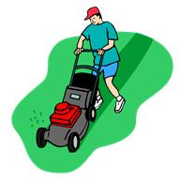GROUNDS/FACILITIES:

Security Access Control System:
As you all know we did have a few glitches along the way, but for the most part the installation of the new card access system has been very successful. Emergency Exit Buttons have also now been installed in both the Pool and Tennis Court areas. A few reminders with the new system:
- Your card gives you access to the pool gates, the tennis gates and will also be activated for the front clubhouse doors during your clubhouse rental timeframe.
- Each household is given one access card with the option to purchase one extra card for $10.
- All replacement cards for lost or stolen cards are $10 each. Lost cards will be immediately deactivated, so please report them missing as soon as possible.
- If you have any issues with your card, need a replacement, etc. please send an email to hoaboard@kellyplantationhoa.net and someone will contact you as soon as possible.

Grounds:
- Many of you have commented on the improvements to our common grounds. Kelly Plantation was nominated for the 2014 Beautification Award for Huntsville. We hope to hear the results soon.
- Installation on the front pond has begun. Electrical work is near completion in preparation for the installation of the fountain in the south pond. Full operation is expected by mid-September. Funding for the fountain in the North front pond will be included in our 2014/2015 budget.
- Many of you have noticed that our new family of geese is causing quite a mess at the front of our neighborhood. We are in search of a repellant that will hopefully safely result in the geese finding a new home. We are also now periodically having the front sidewalks washed.
- We are looking for someone, possibly a landscape architect student at one of the local colleges, to assess our neighborhood and create a master landscape plan for upkeep and improvements over the next few years. This plan would allow the Board to better budget for such improvements in the future. If anyone knows someone who may be interested in tackling this project, please contact the Board.

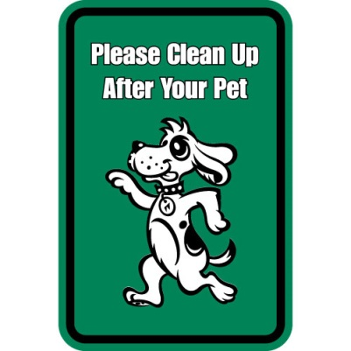PET OWNERS:
The board has been receiving several complaints recently about pet owners letting their dogs use private yards and public sidewalks as a bathroom and then not cleaning it up.
Most pet owners probably know that its common courtesy to take small plastic bags with them when they walk their dogs and to clean up any "deposits" the pups may leave along the way. Cleaning up is as simple as taking a plastic grocery bag, turning it inside out and placing your hand inside and using the bag as a plastic glove.
Parents please remind our younger dog walkers of this courtesy.
Also, for your pet’s safety and the safety of others please pay special attention in ensuring that your pet does not run loose through the neighborhood.

COVENANTS:
Lots of Improvement!
A drive through the neighborhood always seems to reveal homeowners making improvements to their homes. The Architectural Committee has recently approved fences, outdoor patios, fireplaces, decks and driveway extensions. In addition, many homeowners have begun concentrating on those areas needing attention; fences, iron railings, shutters and door painting/staining. Reminder, fences are to be stained inside and out and be in good repair (no bowing, missing boards etc.). More information on getting approvals for fences etc. can be found in the Architectural Guidelines located in the bottom right hand corner of the KPHOA Website.
The Growing Season!
Homeowners are reminded that during this season of growth, lawn maintenance includes regular watering, weekly mowing, edging and weeding of flowerbeds. This year covenants enforcement is focusing on weed control, overgrown flowerbeds, weekly mowing and eliminating lawn debris left in the gutters and on sidewalks after lawn maintenance. Your assistance in this will be greatly appreciated.
I want to thank each of you for your participation in making Kelly Plantation a desirable place to live. The neighborhood looks beautiful and desirable for potential new homeowners. A special thank-you to those who have been witnessed picking up trash in the common areas while on your daily walks!

PARKING:
Please remember that homeowners who park their cars in the roadway present an obstacle to traffic and otherwise decrease the aesthetics of the neighborhood. Per the covenants, homeowners are to park their cars in their driveway. The clubhouse parking lot is also prohibited to be used as overflow parking. On a case by case basis, homeowners may request from the board to use the clubhouse parking lot as overflow parking for special event (party etc.) provided that the clubhouse will not be rented nor interfere with normal pool operations parking.
Clubhouse Student Parking:
Kelly Plantation Sparkman High students desiring to park at the clubhouse during school hours must register for and display a KP decal on the dashboard while parked or be subject to tow. To register for a parking decal please contact Sue Bish at mgsueb@me.com.

EVENT COMMITTEE:

We had a wonderful time at the 4th of July Party!! Thanks to everyone who came out and participated and for those who worked so hard to make the event happen!

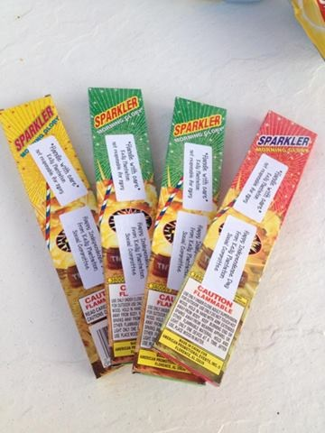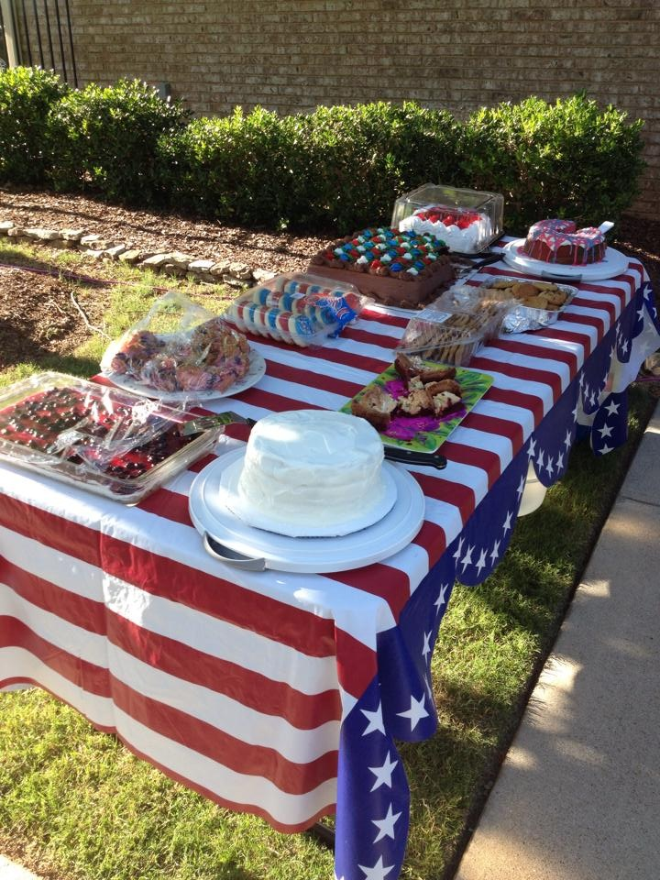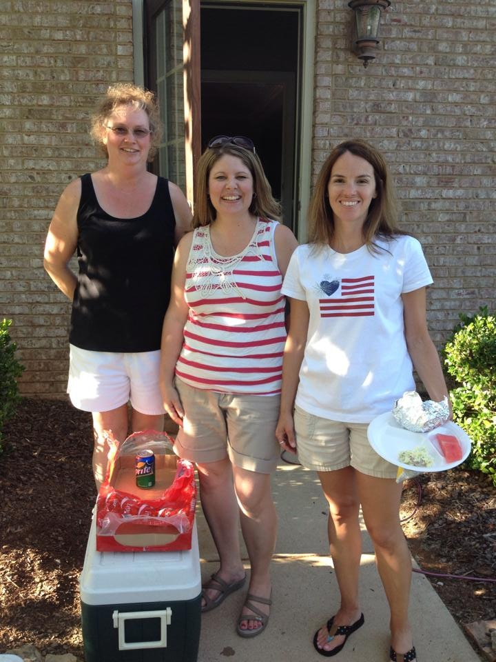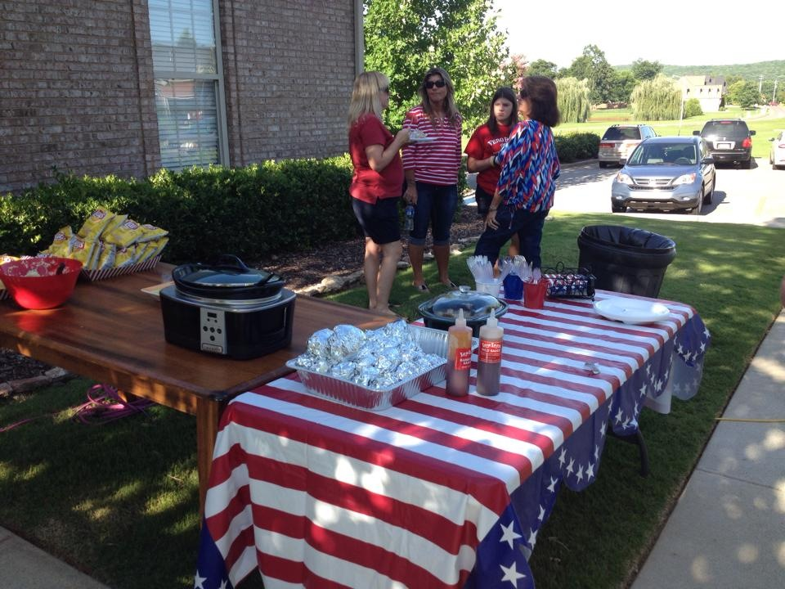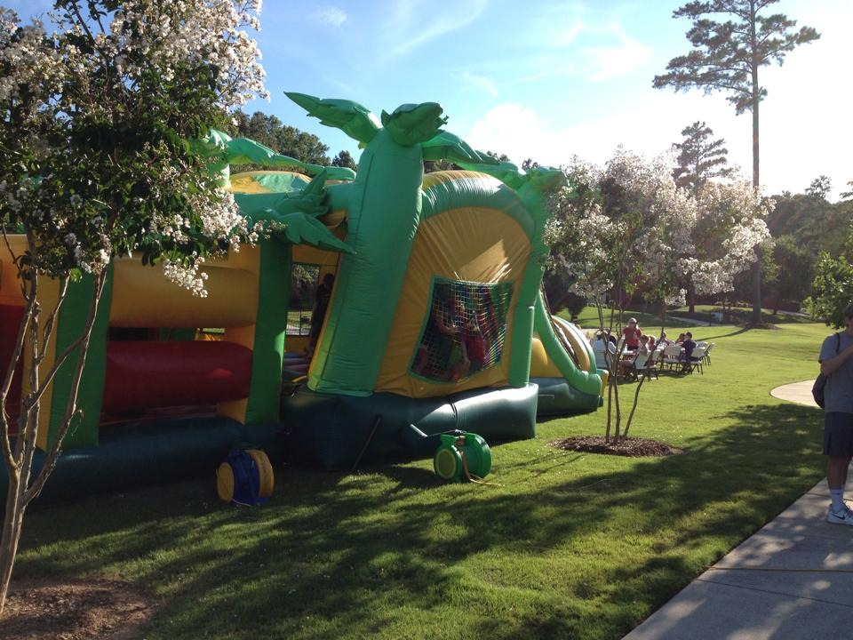


Jaime Pannell is stepping down as the Event Committee Chairperson after two years of outstanding service. Jaime has done an amazing job and organized some wonderful events for our neighborhood. When you see her, please take a minute to thank Jaime for her service to our community.

Rhonda Schoenig will be stepping into the Event Committee Chair role effective at our Annual Meeting in September. We know Rhonda will do a wonderful job as well and we look forward to having her serve in this position.

If you would like more information on joining the Event Committee please email Rhonda at rschoenig4@gmail.com.

Upcoming Events:

September 27 | Fall Yard Sale
November 1 | Annual Food Drive
November 15 | Fall Expo
December 6/7 | Cookies with Santa (exact date and time TBD)
December 13 | Luminaries (volunteer needed to lead this event)

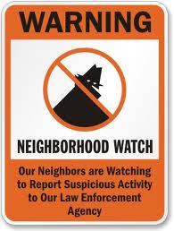NEIGHBORHOOD WATCH COMMITTEE:

Recent Incidents of Vandalism in Kelly Plantation:
Please do not keep valuables in your vehicles and ensure that you have properly locked them. If your vehicle is equipped with anti theft systems, ensure that they are activated. If you suspect any illegal activity near your property and have a vehicle alarm activation button on your key fob, don’t hesitate to activate it to run them out of the area and then call the Sheriff’s Department to report the incident. Even if no arrests are made, or evidence is gathered, the incident will make patrolling our neighborhood a higher priority.

Back To School!!!

Here are some reminders and Safety Tips from the National Safety Council (NSC) to share with your children to ensure their safety since heading back to school.


Riding the Bus to School:
Getting on the school bus
- When the bus arrives, stand at least three giant steps (6 feet) away from the curb.
- If you have to cross the street in front of the bus, walk on the sidewalk or along the side of the road until you are five giant steps (10 feet) ahead of the bus. Then you can cross the street.
- Be sure the bus driver can see you and you can see the bus driver.
- Never walk behind the bus.
- If you drop something near the bus, tell the bus driver. Never try to pick it up first because the driver may not be able to see you.

Behavior on the bus
- When on the bus, find a seat and sit down. Loud talking or other noise can distract the bus driver and is not allowed.
- Never put head, arms, or hands out of the window.
- Keep aisles clear—books or bags are tripping hazards and can block the way in an emergency.
- Before you reach your stop, get ready to leave by getting your books and belongings together.
- At your stop, wait for the bus to stop completely before getting up from your seat, then walk to the front door and exit, using the handrail.

Getting off the school bus
- If you have to cross the street in front of the bus, walk at least ten feet ahead of the bus along the side of the road until you can turn around see the driver.
- Make sure the bus driver can see you.
- Wait for a signal from the driver before beginning to cross.
- When the driver signals, walk across the road keeping an eye out for sudden traffic changes.
- Do not cross the center line of the road until the driver has signaled that it is safe for you to begin walking.
- Stay away from the wheels of the bus at all times.

Not just parents, but all motorists, need to know how to safely share the road with school buses, pedestrians, and bicyclists.

For Back-To-School Safety Tips for Motorists please visit the following NSC Web-Site:
http://www.nsc.org/safety_home/SafetyObservances/Documents/Back%20to%20School/Back%20to%20School%20Safety%20Tips%20for%20Motorists.pdf

For Teen Driving Safety See:
http://www.nsc.org/safety_home/SafetyObservances/Documents/Back%20to%20School/Teen%20Driving_2012.pdf
…and:
http://driveithome.org/Pages/home.aspx

Other helpful web resources are:
Playground Safety: http://www.nsc.org/safety_home/SafetyObservances/Documents/Back%20to%20School/Playground%20Safety_2012.pdf

Backpack Safety: http://www.nsc.org/safety_home/SafetyObservances/Documents/Back%20to%20School/Backpack%20Safety.pdf

Preventing Bullying:
http://www.nsc.org/safety_home/SafetyObservances/Documents/Back%20to%20School/Preventing%20Bullying.pdf

I hope you all have a great new school year!

Keith Stilwell
Kelly Plantation HOA
Neighborhood Watch Chair

FRIENDLY REMINDERS:

- KP Annual Dues are due October 1, 2014!! Address to send in your payment is:
KPHOA
P.O. Box 254
Harvest, AL 35749
- KPHOA Information is posted to our website and to our Facebook page:
  - www.kellyplantationhoa.net, username: kphoa, password: kphoa12
  - Please search Face Book for Kelly Plantation HOA, Harvest, AL to be added to the group for important community news.
- Please remember to obey speed limits and stop for all stop signs within our neighborhood.
- Please clean up the sidewalks and curbs from lawn debris after mowing per the architectural guidelines.

KELLY PLANTATION HOA BOARD:

Board Members:
President | Todd Watts
Vice-President, Covenants | Toni Baker
Vice-President, Facilities | Shawn Levy
Vice-President, Grounds | Mark Schoenig (Acting)
Vice-President, Security  Treasurer | Gina Bradley  Mark Schoenig
Secretary | Tracie McEnery
Non-Board Members:
Architectural Committee Chair | Toni Baker
Clubhouse Trustee | Tracie McEnery
Neighborhood Watch Chair | Keith Stilwell
Event Committee Chair  Welcome Committee Chair | Jaime Pannell  Lisa Taylor

Opportunities to Volunteer!!

Board Member:
We currently have one open board member position.
If anyone is interested in joining the Board, please provide us with a brief bio of yourself. We request that your bios be submitted to the board by the 5th of September. We will submit all interested candidates and their bios to the residents two weeks prior to the annual meeting and a vote by residents will be taken during the annual meeting.

All interested candidates should send your information to kphoasecretary11@gmail.com.

Neighborhood Watch Chair:
Keith Stilwell is stepping down as our KP Neighborhood Watch Chairperson after SEVEN years of outstanding service. First and foremost, we would like to thank Keith for his service. He has done great things for our community and we will miss him serving in this role. If you see Keith, please take a minute to shake his hand and thank him for a job well done.

That being said, we now also have an open slot for the Neighborhood Watch Chairperson. This is not a board member position, so will not require a vote. Please just let us know if anyone is interested in this position.

All interested candidates should send your information to kphoasecretary11@gmail.com.

Architectural Review Committee Member:
You are invited to participate as members of the Architectural Review Committee (AC). The Architectural Review Committee is responsible for assessing homeowner requests to make improvements to their residence. The following is the RAA for the AC:
1. Process homeowner requests: Receive, assess request to the covenants, and respond with approval or denial and document in spreadsheet for tracking purposes
2. Meet as needed to review requests in a timely manner
3. Work with Covenants VP to ensure compliance to the KPHOA covenants
4. Work with Covenants VP to update and or clarify Architectural Guidelines as needed

If anyone is interested in being a part of this committee please contact Toni Baker at covenants@kellyplantationhoa.net.


Board Meetings are held at the KP Clubhouse every second Thursday of the month at 7:00 pm.
All residents are welcome and encouraged to attend.

2014 ANNUAL MEETING will be held Thursday, September 25th at 7:00 pm.
The monthly meeting that would have been Thursday, September 11th is cancelled.

