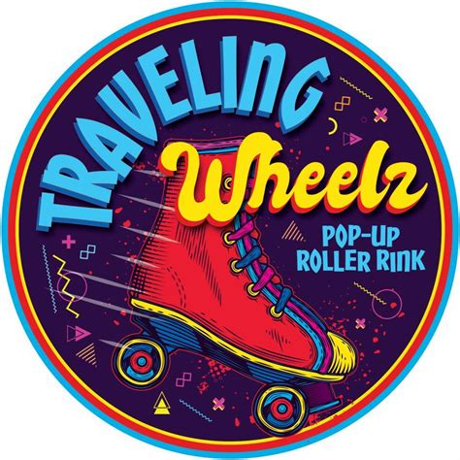
Open Skate Schedule
Winter 2025/2026
December Themes for the night
5th 8p-10pm (lessons 7p-8p) Twins
12th 7:30p-10pm Disney
19th 7:30p-10pm Holiday/Ugly Sweater
CLOSED December 26th

January Themes for the night
2nd CLOSED NO OPEN SKATE or lessons
9th 7:30p-10pm Winter Wonderland
16th 7:30p-10pm Retro 80’s/90’s
23rd 7:30p-10pm NEON Glow
30th 7:30p-10pm Alice & Wonderland

February Themes for the night
6th 8p-10pm (lessons 7p-8p) Red or Pink Night
13th CLOSED NO OPEN SKATE
20th 7:30p-10pm Superhero/Villian
27th CLOSED NO OPEN SKATE

First Friday of the month beginner/Intermediate skate lessons 7pm-8pm before open skate session $5/cash $6/card. Only ticket holders and one guardian of a minor will be permitted in the building during lessons. Open skate will start at 8pm first Friday of the month.


Admission $10
Rentals $5
Add $1 for card

TravelingWheelz.com
Located at The Madhouse
1335 Madison St. NE Salem OR

