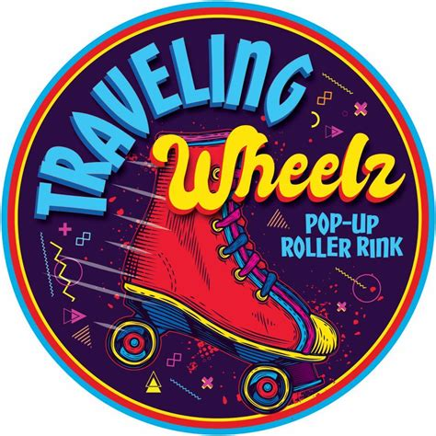

**Open Skate Schedule**

**Fall 2025**

**September *Themes for the night***

**5th 8p-10pm (lessons 7p-8p) Neon Glow Party**

**12th 7:30p-10pm Rock N Roll**

**19th 7:30p-10pm 70’s Disco**

**26th 7:30-10pm Adult Only Skate 18+**

**December *Themes for the night***

**5th 8p-10pm (lessons 7p-8p) Twins**

**12th 7:30p-10pm Disney**

**19th 7:30p-10pm Holiday/Ugly Sweater**

**CLOSED December 26th**

**November *Themes for the night***

**7th 8p-10pm (lessons 7p-8p) Punk Rock**

**14th 7:30p-10pm Pool Party**

**21st 7:30p-10pm Superhero/Villian**

**28th 7:30p-10pm Adult Only Skate 18+**

First Friday of the month beginner/Intermediate skate lessons from 7pm-8pm before open skate session $5/cash $6/card. Only ticket holders and one guardian of a minor will be permitted in the building during lessons. Open skate will start at 8pm first Friday of the month.

**Located at The MadHouse**

**1335 Madison St. NE Salem OR**

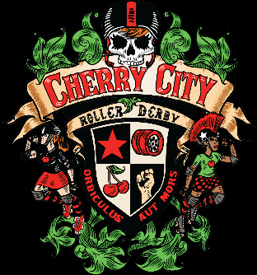

**Admission $10**

**Rentals $5**

**Adult Only Night $15**

**Add $1 for card**

**Info www.travelingwheelz.com**