ME3503 – Fluid Mechanics
SP26 – Final Project

Group 15

Team members:
- Adin Cohen
- Drew English
- Aidan Gregory
- Nick Reeder

Table of Contents
Team Member Roles 2
Introduction 3
Part I: DESIGN OF AN AIRCRAFT 4
1a) Problem definition 5
1b) Airfoil selection 6
1c) Wing design 7
1d) Drag estimate 8
1e) Power requirement and propulsion estimate 10
1f) Conclusions 10
Part II: CFD STUDY 11
2g) Airfoil CFD simulation 12
Part III: ENGINEERING WILD CARD 13
3h) Optimized Flight Control for the Cessna 172R 14
Part IV: NON-ENGINEERING WILD CARD 15
4i) Economic Impact of the Cessna 172 16
REFERENCES 17

Team Member Roles

Adin Cohen: Part I: Cessna Research, Part II Lead
Drew English: Part I Lead: Lift, Propulsion, Writeup
Aidan Gregory: Part I: Airfoil Research, Part III Lead
Nick Reeder: Part I: Drag, Part IV Lead

Introduction

This project focuses on the aerodynamic design and fluid analysis of a Cessna 172R. Instead of just looking at equations in a textbook, the goal is to see how they actually apply to a real aircraft. We started by setting up the basic specifications for the 172R, such as the takeoff velocity, its cruising altitude, and the weight of the plane. These numbers and assumptions are then used for the rest of the math on its lift and drag.

A big part of the work is focused specifically on the 172R’s wing airfoil. The Cessna 172R typically uses a NACA 2412, so we had to look for research on this specific airfoil to find the actual lift and drag coefficients. Then, we calculated the total wing area needed to get the plane off the ground and figured out its drag.

We ran the airfoil through a CFD simulation in Fluent. This let us compare the textbook data from our research to a numerical model to see where they are different. It also allowed us to see how the mesh quality or the boundary layer settings can change the results. We also looked at the propulsion for the plane as well, calculating how much power and fuel the engine actually needs to maintain its cruise speed at its cruising altitude.

Along with the core engineering design, the project also has two wild card sections to give further analysis into the aircraft. For the engineering wild card, we dove deeper into a specific technical engineering related area to see how it affects the overall design. For the non-engineering wild card, we looked at impacts on the plane like its history and its economic factors that caused the plane to become so common. Overall, the project shows how a bunch of fluid theories and external factors come together in the flight of a plane.

Part I: DESIGN OF AN AIRCRAFT

Part 1 of this report goes in detail on the initial design phase of the Cessna 172R. We define its weight, passenger capacity, and flight performance goals. These parameters are then used to select a suitable airfoil and to calculate the necessary wind dimensions, drag estimates, and engine power required to achieve the defined cruise conditions.

1a) Problem definition
The selected aircraft to be used in this analysis is the Cessna 172 Skyhawk. This is a high wing aircraft that can accommodate up to four individuals. It has one engine and is popularly used as a training aircraft in general aviation. Since this type of aircraft flies at subsonic speed only, it provides the best platform to study fluid mechanics in practice. In order to develop our design and evaluate its performance, we have made certain assumptions regarding its various operational capabilities. The Cessna 172, shown in the drawing below, is a four seated aircraft meaning that it can accommodate a total of four people, including the pilot. We assume that the aircraft cruises at an altitude of 8,000 feet or 2,438 meters. The cruising speed of the aircraft is given as 63.8 m/s or 124 knots, which is consistent with the 75 percent power cruising condition for the Cessna 172S found in the aircraft pilot operating handbook. Takeoff speed is set at 28.3 m/s or 55 knots [POH - CESSNA].

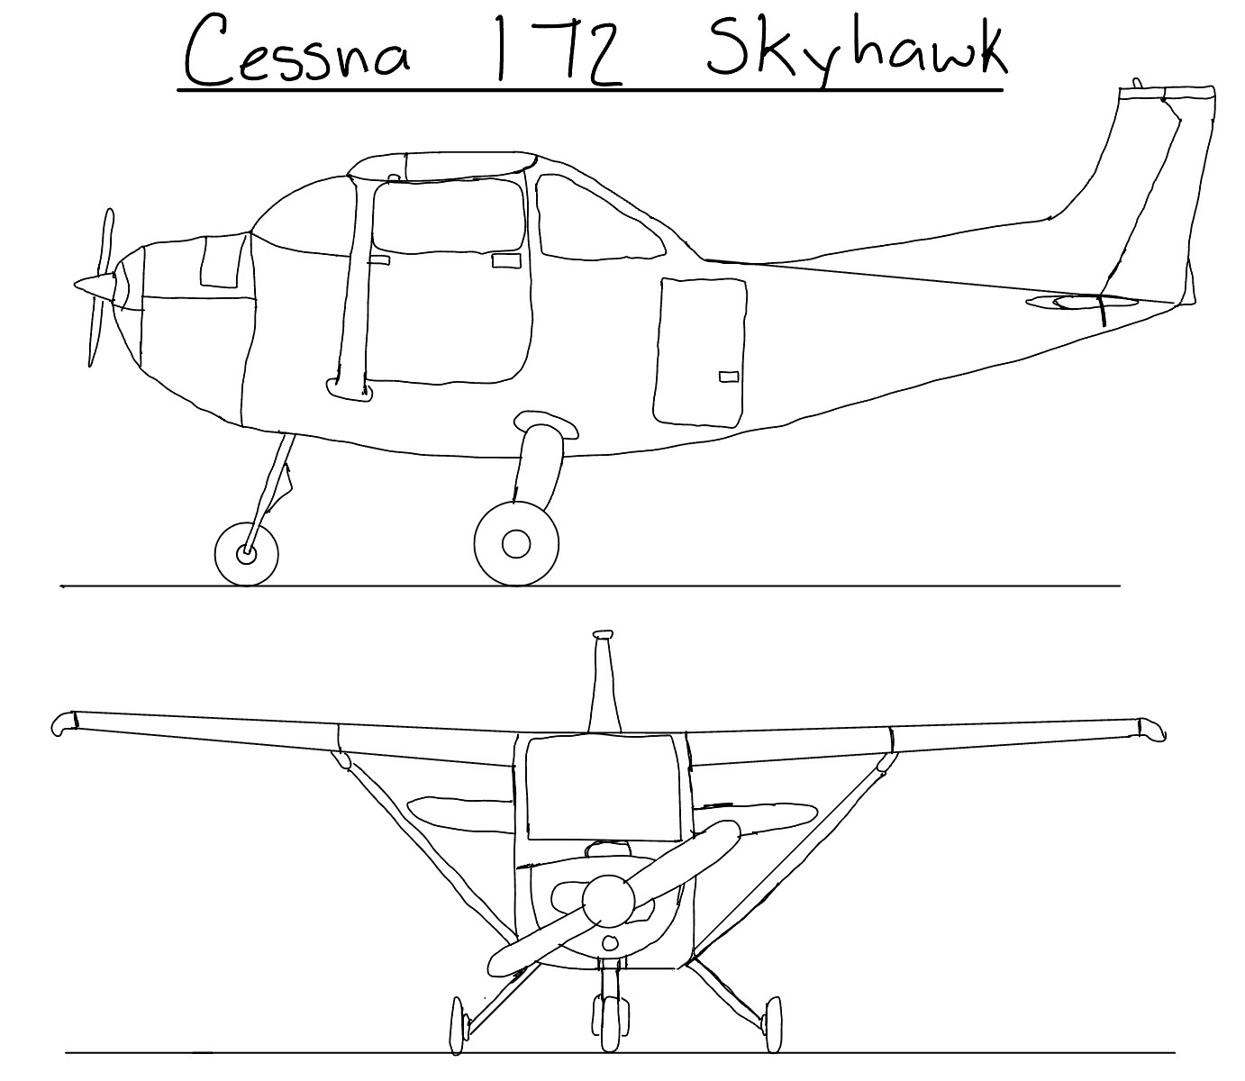
Figure 1: Sketch of Cessna 172 Skyhawk

To conduct the aerodynamics calculations, the following engineering assumptions are adopted, based on standard practice. First, it is assumed that the maximum takeoff weight is equal to 1,157 kg (2,550 lbs). This assumes the wings account for 202kg while airframe, fuel, payload, and internal systems account for the rest [POH - CESSNA]. All gravity force calculation will be made using 9.81 m/s² constant. The density at sea level (standard conditions for take-off) will be assumed 1.225 kg/m³. At the cruising altitude 8,000 ft, density will be 0.963 kg/m³ [MUNSON TABLES]. The lift equation and drag estimation will be done under these parameters to evaluate the propulsion requirements.

1b) Airfoil selection
The design for the plane is based on the NACA 2412 airfoil, as this is what the Cessna 172 was originally designed for. The decision to base wing on this airfoil was based on several factors. The NACA 2412 airfoil is one of the most studied airfoils in history because of Abbott and von Doenhoff’s extensive data that was published on it [Theory of Wing Sections]. Another paper focused on the 2412, “The effects of lift curve slope and lift coefficient on the wing Cessna 172S,” by Mohammed Qasim jalil offers coefficients for the linear portion of the lift coefficient curve. This was another reason that the airfoil was chosen [EFFECTS OF LIFT].

Coordinates of the NACA 2412 airfoil were taken from UIUC Airfoil Coordinates Database [UIUC]. The data is based on historical wind tunnel tests carried out at the variable density tunnels of the National Advisory Committee for Aeronautics between the 1930s and 1940s. Though wind tunnel experiments remain a standard method, coordinate information can be easily verified using CFD calculations.

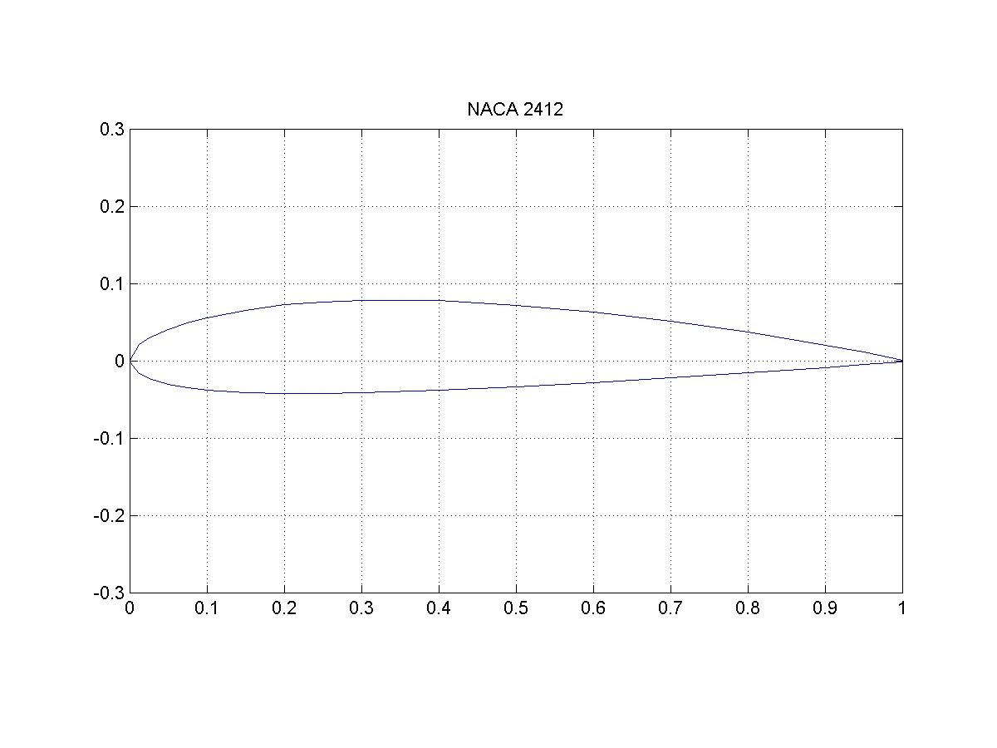
Figure 2: Plot of NACA 2412 Geometry

The lift curve slope ($aο$) and zero-lift angle of attack ($a_{Lo}$) of the Cessna 172S were set to 0.108 per degree and -2.74 degrees, respectively. Such design parameters were taken from Table 2 of Qasim Jalil’s paper shown below. These values, based on Abbott and von Doenhoff’s data, provide consistency with numerical modeling. The constants in this paper were calculated using empirical equations based on the analytical approach applied to the NACA 2412 profile. This way, the wing characteristics are described correctly throughout the entire flight envelope, starting from takeoff up to cruising regime.

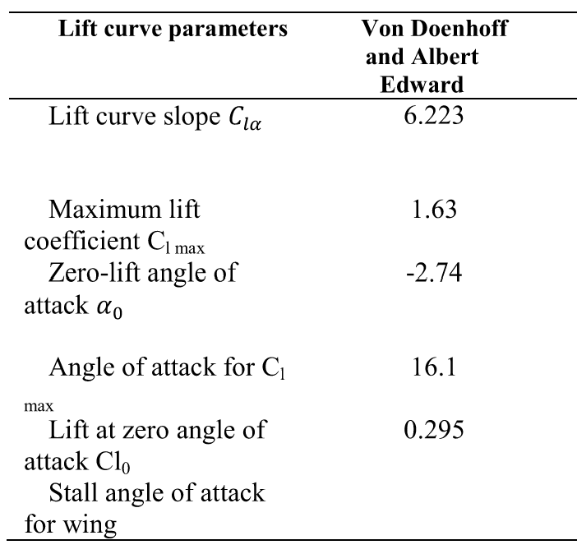
Table 1: Lift Curve Parameters – Qasim Jalil

1c) Wing design
For the determination of the total lift force, the maximum takeoff weight, 1,157 kg, is used. Given gravitational acceleration g = 9.81$\frac{m}{s^{2}}$, the weight of the plane can be expressed as 11,350.17 N. At the time of taking off, lift should be equal to the aircraft weight (L = W = 11,350.17 N). The required wing area (S) was calculated in MATLAB, using eq. 1, in which the standard sea-level air density ($ρ_{to}$) equals 1.225 $\frac{kg}{m^{3}}$, takeoff velocity ($V_{to}$) = 28.3 $\frac{m}{s}$, and lift coefficient (${CL}_{to}$) is assumed as 1.2. The assumed takeoff lift coefficient was determined by applying an 80% safety margin to the maximum lift coefficient (${CL}_{max}$ = 1.5) [THEORY OF WING]. As a result, the required wing area turned out to be about 19.28 $m^{2}$.

$$L= \frac{1}{2}{×ρ}_{to}×{V_{to}}^{2}×S{×CL}_{to}$$
Equation 1

To calculate the cruising parameters, cruise lift coefficient (${CL}_{cruise}$) was computed using MATLAB with an air density ($ρ_{cruise}$) of 0.9629 $\frac{kg}{m^{3}}$ which corresponds to an altitude of 8,000 feet. At the cruising velocity ($V_{cruise}$) of 63.8 $\frac{m}{s}$, cruise lift coefficient (${CL}_{cruise}$) of 0.3004 was required to maintain the level flight.

Cruising angle of attack was determined using MATLAB, avoiding any manual approximation with a traditional aerodynamics chart, which is associated with human error. In order to get the most precise and reproducible value, the linear fit was selected as the approach to finding the answer. Equation 2 was used, where lift curve slope ($a_{o}$) = 0.108 per degree and zero lift angle of attack ($a_{Lo}$) = -2.74 degrees [EFFECTS OF LIFT CURVE]. The plot was created and answer was determined to be cruising angle of attack ($a_{cruise}$) = 0.04 degrees. Figure 3 was produced to visualize where the cruising angle of attack sits on the angle of attack and lift coefficient curve.

$$CL= a_{o}×(a- a_{Lo})$$
Equation 2

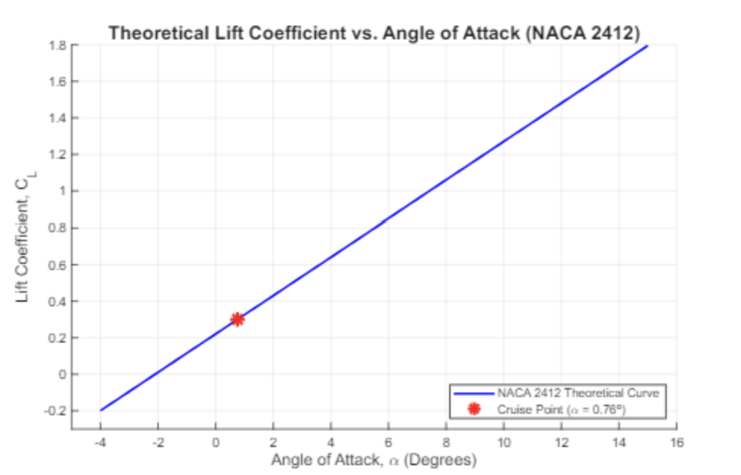
Figure 3: Cl vs a based on the theoretical curve

Wing planform was selected to be rectangular as the typical Cessna 172S design features. To determine a suitable wingspan, the aspect ratio of the Cessna 172s was determined based on the actual design wingspan and chord length. Based on equation 3, this was determined to be 7.32. This same equation was then used to determine the wingspan of the new design, keeping the AR the same but using the new area. The new design resulted in a wingspan of b = 11.8m, 0.8m longer than the original design of the Cessna. The wing was designed with the AR of the original 172 in mind because the engineers at Cessna already spent time researching what the best aspect ratio would be for their specific plane.

$$AR= \frac{b^{2}}{S}$$
Equation 3

1d) Drag estimate
For the drag estimate, the aircraft is assumed to be flying at cruise conditions. Using cruising speed V = 63.8 m/s, air density at 8,000 ft is $ρ=0.9629 \frac{kg}{m^{3}}$, and the wing area $S=14.58 m^{2}$. The cruise lift coefficient was found to be $C_{L}=0.3004$.

The drag force is calculated using:
$$D = \frac{1}{2}ρV^{2}SC_{D}$$

The dynamic pressure at cruise:
$$q = \frac{1}{2}\left(0.9629\right){\left(63.8\right)}^{2} = 1959.7 Pa$$

The profile drag coefficient for the NACA 2412 airfoil was estimated based on published airfoil data. According to Abbott and von Doenhoff (Theory of Wing Sections), the drag coefficient for NACA 2412 at a lift coefficient near $C_{L}=0.3$ falls in the range of approximately 0.006 to 0.010 depending on Reynolds number. A representative value of
$C_{D,profile} = 0.008$ was selected as a reasonable average for cruise conditions.

The wing profile drag is then:
$$D_{wing,profile} = qSC_{D} = \left(1959.7\right)\left(14.58\right)\left(0.008\right)=228.6 N$$

Induced drag will also need to be considered since the wing is producing lift. It can be estimated using: $C_{D,i}= \frac{C_{L}^{2}}{πeAR}$, where e = 0.8 and AR = 7.32.
$$C_{D,i}= \frac{{\left(0.3004\right)}^{2}}{π\left(0.8\right)\left(7.32\right)} = 0.00491$$

So the total wing drag is:
$$C_{D,wing}=C_{D,profile}+C_{D,i}=0.008+0.00491=0.01291$$

The fuselage drag is also calculated separately. Since the Cessna 172 has a streamlined fuselage, we assume the fuselage drag to be $C_{D,fuselage}=0.04$. The frontal area is assumed to be $A_{f}=2.0 m^{2}$.
$$D_{fuselage}=qA_{F}C_{D,fuselage}=\left(1959.7\right)\left(2.0\right)\left(0.04\right)=156.8 N$$

We can now calculate the estimated total drag on the aircraft during cruise:
$$D_{total}=D_{wing}+D_{fuselage}=487.61+156.8=644.39 N$$

We find that the total drag estimate is $D_{total}=644.39 N$.

Induced drag is important because it increases when the aircraft has to produce more lift. This is predominantly noticeable at lower speeds, such as takeoff and landing, because the wing must operate at a higher lift coefficient. At cruise, induced drag is lower but still adds a noticeable amount to the total wing drag. A way to decrease the induced drag is by increasing the wings' aspect ratio, but increasing the wingspan also adds more structural issues. This is why aircraft design requires a balance between aerodynamic efficiency and structural integrity. This further enforces the decision to use Cessna’s original aspect ratio.

1e) Power requirement and propulsion estimate
To calculate the required propulsion, the total drag ($D_{total}=644.39 N$), was multiplied by the cruising velocity ($V_{cruise}=63.8 m/s$). After converting to HP, the required power came out to be $P_{required}=55.13 HP$. It was assumed that the selected engine would have an efficiency of 80%, and cruising would take place at 75% of max continuous power. Because of this the total power necessary was calculated to be $P_{actual}=91.81 HP$.

To fit with original design of the Cessna 172, a fixed pitch propeller engine was selected. The 172 has an 180HP Lycoming Engine, but since the new design only required 92 HP, a 100HP Rotax 912 ULS was sized. Though it produces less power, the Rotax is lighter and therefore more fuel efficient. The fuel consumption of the Rotax 912 ULS is 18.50 L/Hr [ROTAX]. If this new aircraft flies at cruising velocity, the distance fuel economy would be 12.42 km/L or 29.20 MPG.

1f) Conclusions
After conducting the theoretical aerodynamic design calculations, the parameters obtained for the plane, such as the wing area required, the wing geometrical parameters, and the power needed, were compared against the practical specifications of the Cessna 172 Skyhawk. Though there were only minor discrepancies with the geometric calculations (the mean aerodynamic chord was found to be 1.62 m and the wingspan 11.88 m, among other similar values that matched the historical data) there were several inconsistencies with the power requirements.

The differences could be explained by some key fundamental assumptions and simplifications that took place when calculating the theoretical power requirements. First, the calculations of the lift and drag forces used 2D airfoil data, derived from historic wind tunnel testing. While the induced drag was partially accounted for, the simplified analytical equations can never precisely represent the complex 3D effects, such as wingtip vortices and downwash, that occur in reality. Second, the effect of the fuselage on the drag force was estimated via a standard drag coefficient instead of a physical experiment or the use of the CFD modeling software. This therefore reduced the required power of the theoretical aircraft.

In addition, it should be noted that the academic equations used in order to calculate the wing size assume ideal, smooth airflow. However, in reality, there will always be viscous effects occurring, due to the skin friction of the wing and control surface flow separation, that add up to the parasitic drag force. Therefore, it becomes clear why physical iterations are essential for the aerospace engineering process.

Figure 4 shows a drawing of what the theoretical aircraft may look like in design. The two differences from the concept drawing to note are the wingspan, and engine bay size. These design decisions were made based on the calculated wingspan and required power. Since the wingspan was determined to be larger than the original Cessna 172 design, the size of the wings in the drawing increased. Similarly, since the required power was determined to be lower than the original design, the size of the engine by was reduced to remove excess weight.

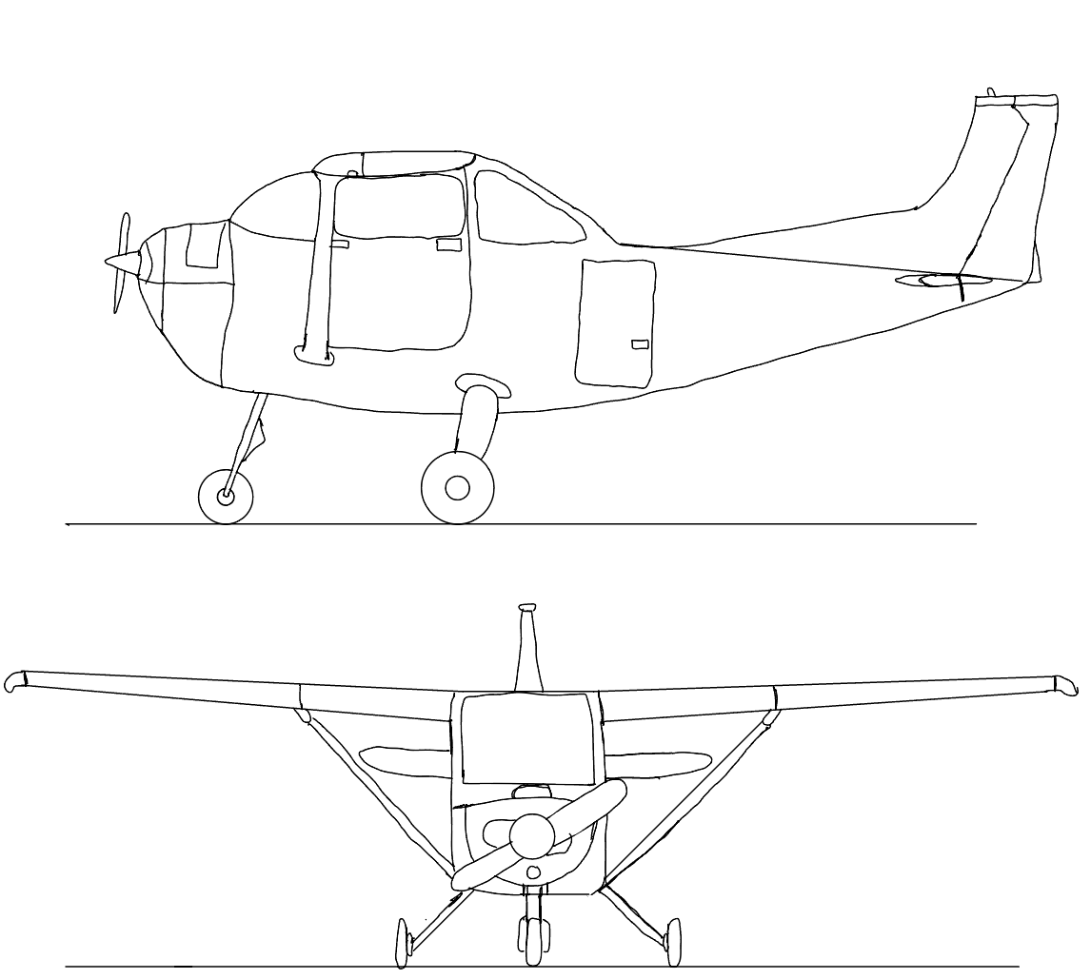
Figure 4: Sketch of Theoretical Plane

Part II: CFD STUDY
Airfoil Geometry
The selected airfoil for this simulation was the NACA 2412. The airfoil coordinate data was reformatted into the ANSYS coordinate format and imported as a 2D airfoil profile. The chord length was scaled to 1 m to match the original CFD tutorial setup. The airfoil was placed inside a surrounding fluid domain so that the flow behavior around the airfoil could be simulated.
The mesh was refined near the airfoil surface to better capture the flow behavior around the leading edge, trailing edge, and airfoil surfaces. Inflation layers were included near the airfoil to better resolve the near-wall region and boundary layer mesh. The mesh was gradually coarsened farther away from the airfoil to reduce computational cost while maintaining accuracy near the body.
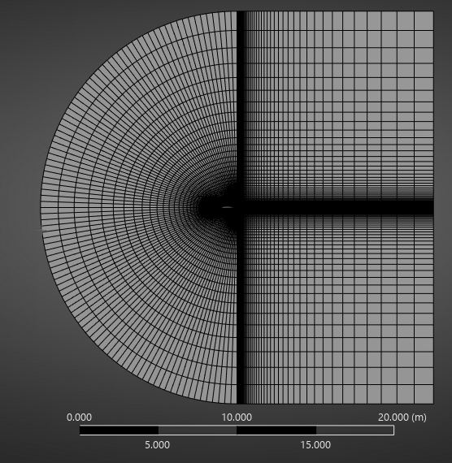
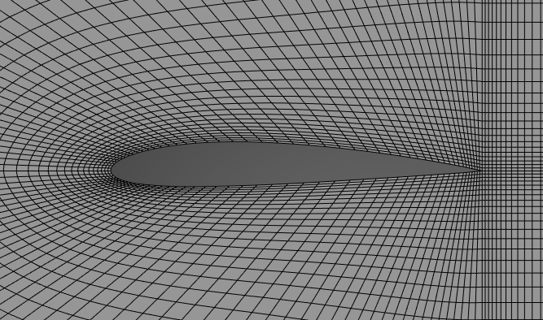

Grid independence was evaluated at an angle of attack of 8°. The course, medium, and fine meshes were compared using the resulting lift and drag coefficients. The change between the medium and fine meshes was small, suggesting that the medium mesh was sufficiently refined for the simulations.
Grid Independence Study at AOA = 8°
Airfoil: NACA 2412
Simulation Settings: 1
Velocity: 1 m/s
Mesh | Airfoil Divisions | Elements/Cells | Cl | Cd
Coarse | 35 | 4,900 | 0.9740 | 0.2238
Medium | 50 | 10,000 | 1.0110 | 0.2304
Fine | 75 | 22,500 | 1.0232 | 0.2330

Simulation Settings 1 used the same setup as the CFD recitation tutorial. The flow was modeled as steady and inviscid, with a 1 m chord length and 1 m/s inlet velocity magnitude. The angle of attack was changed by adjusting the inlet velocity vector components while keeping the airfoil geometry fixed. Since the simulation was inviscid, Reynolds' number effects, skin friction, boundary layer growth, and viscous separation were not modeled.
Simulation Settings 1: Tutorial Inviscid Setup
Airfoil: NACA 2412
Velocity: 1 m/s
AOA | Vx | Vy | Cl | Cd
-4° | 0.9976 | 0.0698 | 0.6531 | 0.2307
0° | 1.0000 | 0.0000 | 0.7724 | 0.2306
4° | 0.9976 | -0.0698 | 0.8917 | 0.2306
8° | 0.9903 | -0.1392 | 1.0110 | 0.2305
12° | 0.9781 | -0.2079 | 1.1303 | 0.2305
For the 8° angle of attack case, the lift and drag coefficients stabilized near the end of the simulation. Although the residuals showed small oscillations, the force coefficients were stable, so the simulation was considered sufficiently converged for reporting Cl and Cd.

The convergence plot shows that the continuity, x-velocity, and y-velocity residuals decreased by approximately five orders of magnitude, reaching values near 10^-5 by the end of the simulation. Although small oscillations were present, the overall trend was downward, and the lift and drag coefficients stabilized near the final iterations. Therefore, the simulation was considered sufficiently converged for reporting Cl and Cd.
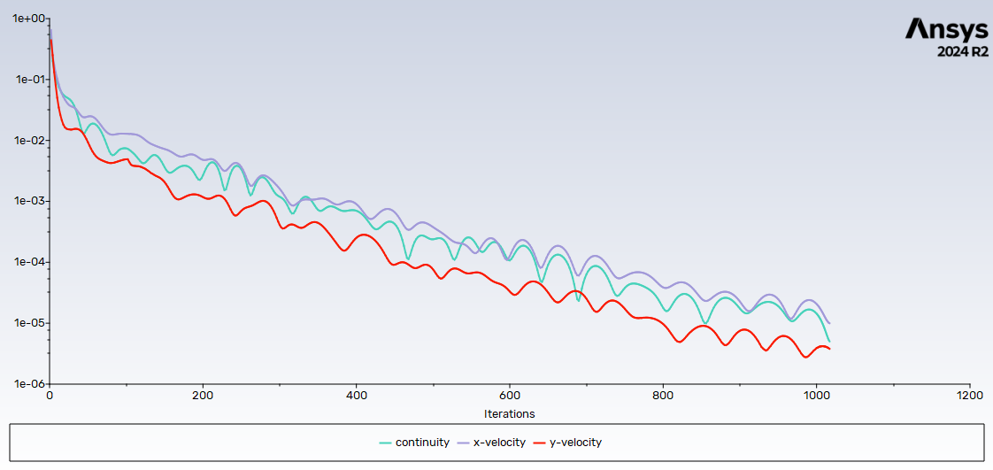

The contour plots were taken for the 8° angle of attack case using V = 1 m/s. This case was selected because it represents a moderate angle of attack and clearly shows the pressure and velocity behavior around the NACA 2412 airfoil.
Pressure Contour.
The pressure contour shows the pressure distribution around the NACA 2412 airfoil at 8° angle of attack. A pressure difference forms between the upper and lower surfaces of the airfoil, which contributes to the lift force. The contour also shows how the pressure changes near the leading edge and around the airfoil surface.
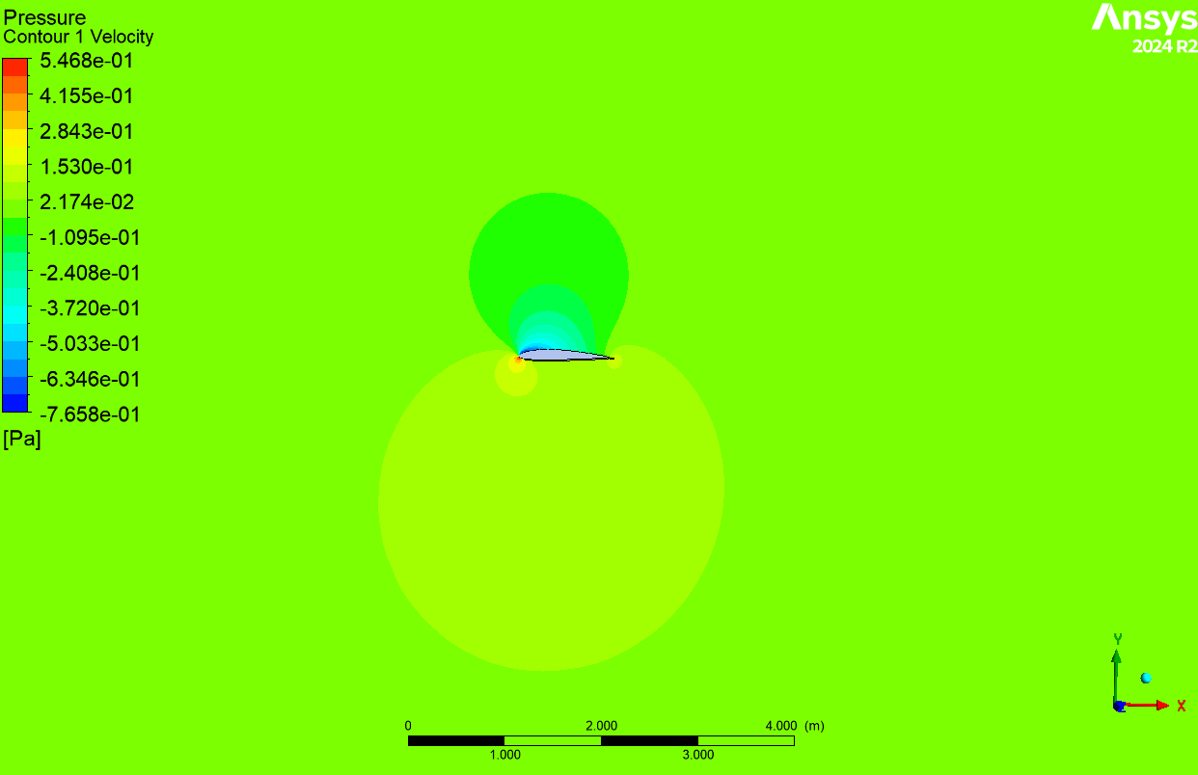
Velocity Contour.
The velocity contour shows how the freestream accelerates around the airfoil. Higher velocity regions appear near the airfoil surface, especially where the flow speeds up around the curved geometry. This velocity change corresponds to the pressure distribution observed in the pressure contour.
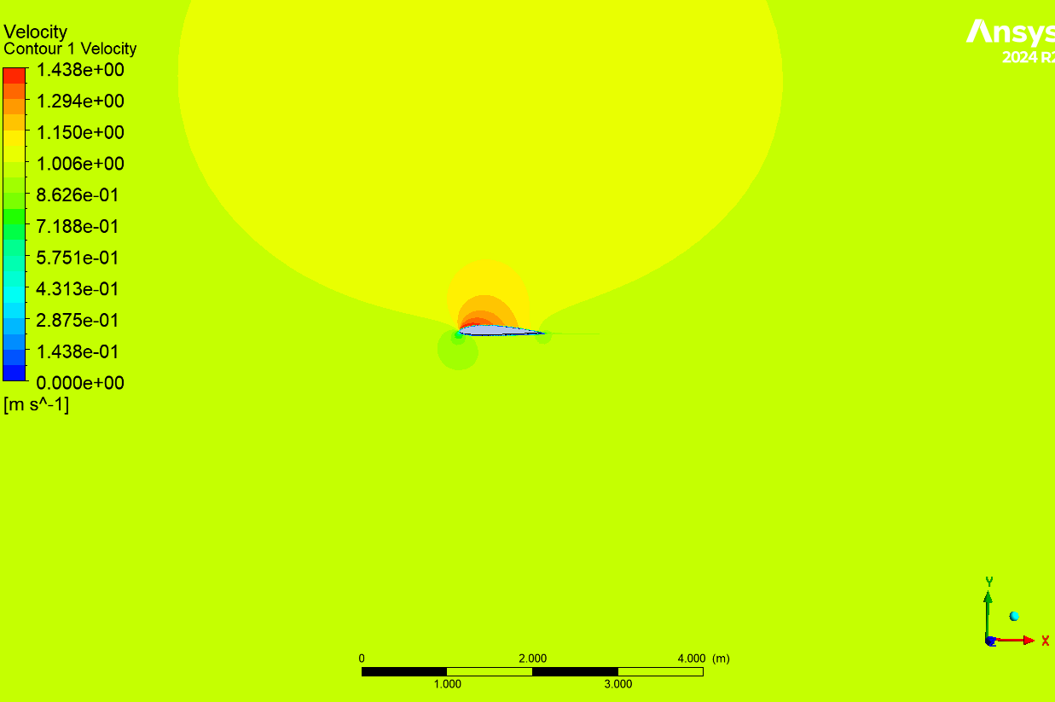

For Simulation Settings 2, the Fluent model was changed from inviscid to viscous using the k-omega SST turbulence model. This allowed Fluent to include wall shear stress, boundary layer effects, and viscous drag. The same airfoil, mesh, velocity magnitude, and angle of attack cases were used so the updated results could be directly compared with Simulation Settings 1.
At 8° angle of attack, the updated simulation produced Cl = 0.71296 and Cd = 0.50438. Compared to Simulation Settings 1, the lift coefficient decreased while the drag coefficient increased. This is expected because the viscous model accounts for drag-producing effects near the airfoil surface that were not included in the inviscid tutorial setup.
Simulation Settings 2: Viscous k-omega SST Setup
Airfoil: NACA 2412
Velocity: 1 m/s
AOA | Vx | Vy | Cl | Cd
-4° | 0.9976 | 0.0698 | 0.1736 | 0.4557
0° | 1.0000 | 0.0000 | 0.3534 | 0.4251
4° | 0.9976 | -0.0698 | 0.5333 | 0.4552
8° | 0.9903 | -0.1392 | 0.7126 | 0.5043
12° | 0.9781 | -0.2079 | 0.8938 | 0.5909
The residuals for continuity, velocity, k, and omega decreased to the 10^-4 to 10^-5 range. The lift and drag coefficients were relatively stable near the final iterations, so the simulation was considered sufficiently converged for comparison.

The literature data shows the expected trend for a NACA 2412 airfoil, where the lift coefficient increases as angle of attack increases. The drag coefficient remains relatively low at small angles of attack and begins to increase more noticeably at higher angles. Compared to the CFD results, the literature drag values are much lower, which is likely due to differences in Reynolds number, reference values, turbulence modeling, mesh quality, and the simplified assumptions used in the Fluent setup. The literature values are used as a baseline comparison, but exact agreement is not expected because the published data and the current simulations were not generated under identical conditions.
Literature Data: NACA 2412
AOA | Literature Cl | Literature Cd | Notes
0° | 0.250 | 0.0060 | Literature value
4° | 0.640 | 0.0070 | Literature value
8° | 1.080 | 0.0092 | Literature value
12° | 1.430 | 0.0150 | Literature value

The results from Simulation Settings 1 and Simulation Settings 2 show that changing the model from inviscid to viscous significantly affected the lift and drag coefficients. At 8° angle of attack, Simulation Settings 1 produced a higher lift coefficient, while Simulation Settings 2 produced a lower lift coefficient and higher drag coefficient. This difference is expected because the viscous model includes wall shear, turbulence, and boundary layer effects.
AOA | Settings 1 Cl | Settings 1 Cd | Settings 2 Cl | Settings 2 Cd
-4° | 0.6531 | 0.2307 | 0.1736 | 0.4557
0° | 0.7724 | 0.2306 | 0.3534 | 0.4251
4° | 0.8917 | 0.2306 | 0.5333 | 0.4552
8° | 1.0110 | 0.2305 | 0.7126 | 0.5043
12° | 1.1303 | 0.2305 | 0.8938 | 0.5909

The Cl vs angle of attack graph compares the lift coefficient results from the literature, Simulation Settings 1, and Simulation Settings 2. The literature data shows the expected increase in lift as angle of attack increases. Simulation Settings 1 also shows an increasing lift trend, but the values differ from the literature because the setup is inviscid and does not include all real flow effects. Simulation Settings 2 gives lower lift values than Settings 1 because viscous effects and turbulence modeling were included.
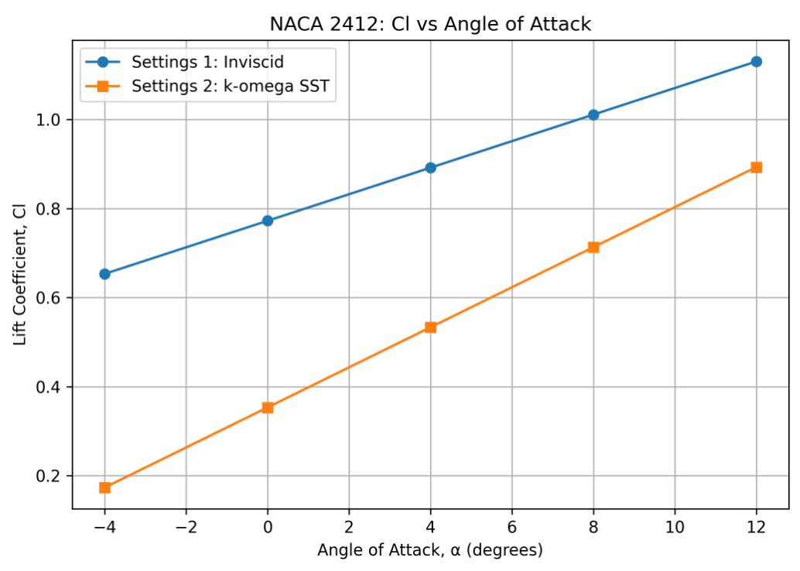

The Cd vs angle of attack graph compares the drag coefficient results from the literature, Simulation Settings 1, and Simulation Settings 2. The literature drag values are much lower than the Fluent results. Simulation Settings 1 produces nearly constant drag, which is likely due to the simplified inviscid setup and reference value assumptions. Simulation Settings 2 produces higher drag values because the viscous k-omega SST model includes wall shear stress, boundary layer effects, and turbulent losses.
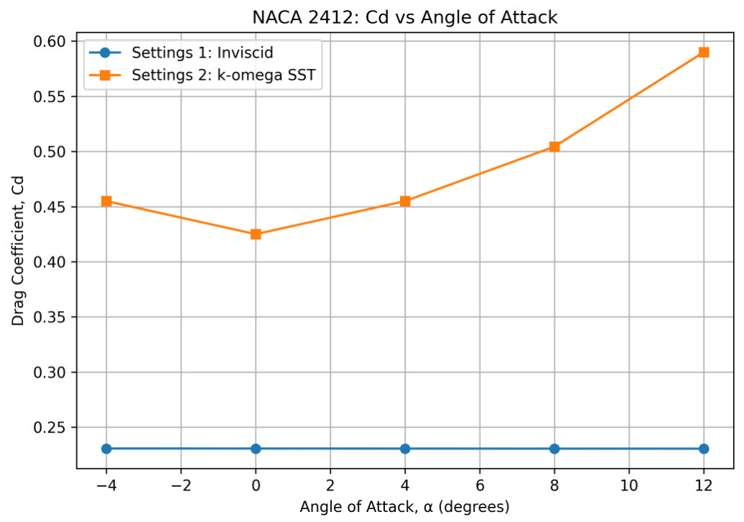

Discussion
The literature data and CFD results show the same general trend of increasing lift coefficient with increasing angle of attack. However, the exact values do not match perfectly because the simulation setup and literature conditions were not identical. Differences may be caused by Reynolds number, turbulence model, mesh resolution, boundary conditions, wall treatment, and whether the literature data came from experimental testing or higher-fidelity computational methods.
Simulation Settings 1 used an inviscid model, so it did not account for viscosity, skin friction, wall shear stress, or boundary layer separation. This helped simplify the simulation, but it limited the accuracy of the drag prediction. The lift coefficient from Settings 1 followed the expected increasing trend, but the drag coefficient stayed nearly constant, which is not typical for a real airfoil.
Simulation Settings 2 added viscous effects using the k-omega SST turbulence model. This produced lower lift and higher drag compared to Settings 1. This result makes sense because the viscous model includes losses near the airfoil surface. The drag values were still much higher than the literature values, which may be due to the low velocity of 1 m/s, reference value differences, mesh quality, turbulence model limitations, or differences between the simulation setup and the published data.
Overall, the updated viscous setup was more physically realistic than the inviscid tutorial setup because it included boundary layer and wall shear effects. However, exact agreement with the literature was not expected because the simulation conditions were simplified and did not perfectly match the conditions used to generate the literature airfoil data.

Conclusion
The NACA 2412 airfoil was simulated in ANSYS Fluent using two different sets of simulation settings. Simulation Settings 1 repeated the original tutorial setup using inviscid flow, while Simulation Settings 2 modified the model to include viscous effects with the k-omega SST turbulence model. The 8° angle of attack case was used for the contour plots and convergence discussion.
The grid independence study showed that the medium mesh with 10,000 cells was sufficiently refined for the remaining simulations. The convergence plot showed that the residuals decreased significantly and the aerodynamic coefficients stabilized near the end of the simulation. The pressure and velocity contours demonstrated the flow behavior around the airfoil and helped explain how the pressure difference around the airfoil generates lift.
Compared to literature data, the CFD results followed the general trend of increasing lift with increasing angle of attack, but the drag values differed significantly. These differences are likely due to simplified simulation assumptions, reference value differences, mesh limitations, and differences between the Fluent setup and the literature test conditions. Despite these differences, the simulations successfully showed how changes in angle of attack and physics settings affect the lift and drag behavior of the NACA 2412 airfoil.

Part III: ENGINEERING WILD CARD

The part of the project goes away from the static numbers of the Cessna 172R and looks specifically into how the plane actually behaves as it is being flown. We are designing a controller to figure out how to get the plane to a specific altitude change from cruising. This is done by simulating the elevators physical movement and its effects on the altitude in MATLAB.

3h) Optimized Flight Control for the Cessna 172R
The main goal was to build a cascaded control system to get the Cessna up an additional 100 meters in about 20 seconds without overshooting the target by more than 5%. To get the physics as close to the Cessna as we could, stability derivatives from research on the plane was used to look at how the nose reacts to the elevator and how the plane rotates (Vadivelu, 2020; Cel, 2019). These values allowed for transfer functions representing the body of the plane to be used in MATLAB. The script is set up to calculate all the necessary information from the planes cruising conditions and geometry to then find the best controller settings for the system using the pidtune command.

Initially, the plan was to use a PD controller for the pitch and a PI controller for the altitude. The reasoning for this was that the integral could get rid of any steady-state error, and the derivative could get rid of any potential oscillations. When the simulation was actually ran, there was a significant amount of integrator windup that caused a 20% overshoot before reaching the final desired altitude change. This was because degree limits were put in place for the elevator causing the controller to charge up while the elevator was at its limit. By the time the plane reached its desired altitude, it had so much momentum that it exceeded the 100 meter change with a roughly 20% overshoot. It also turned out that the Cessna is naturally very stable, having the optimal pitch derivative gain at 0 meaning the extra term was unnecessary and overcomplicating things.

To fix this, the whole thing was stripped to a simple dual-proportional setup. This shift worked because the altitude plant is already a type one integrator, so it already eliminated steady-state error without needing an extra integral term in the controller. The final results found the optimal proportional pitch gain to be -3.42357 and altitude gain to be 0.00558.
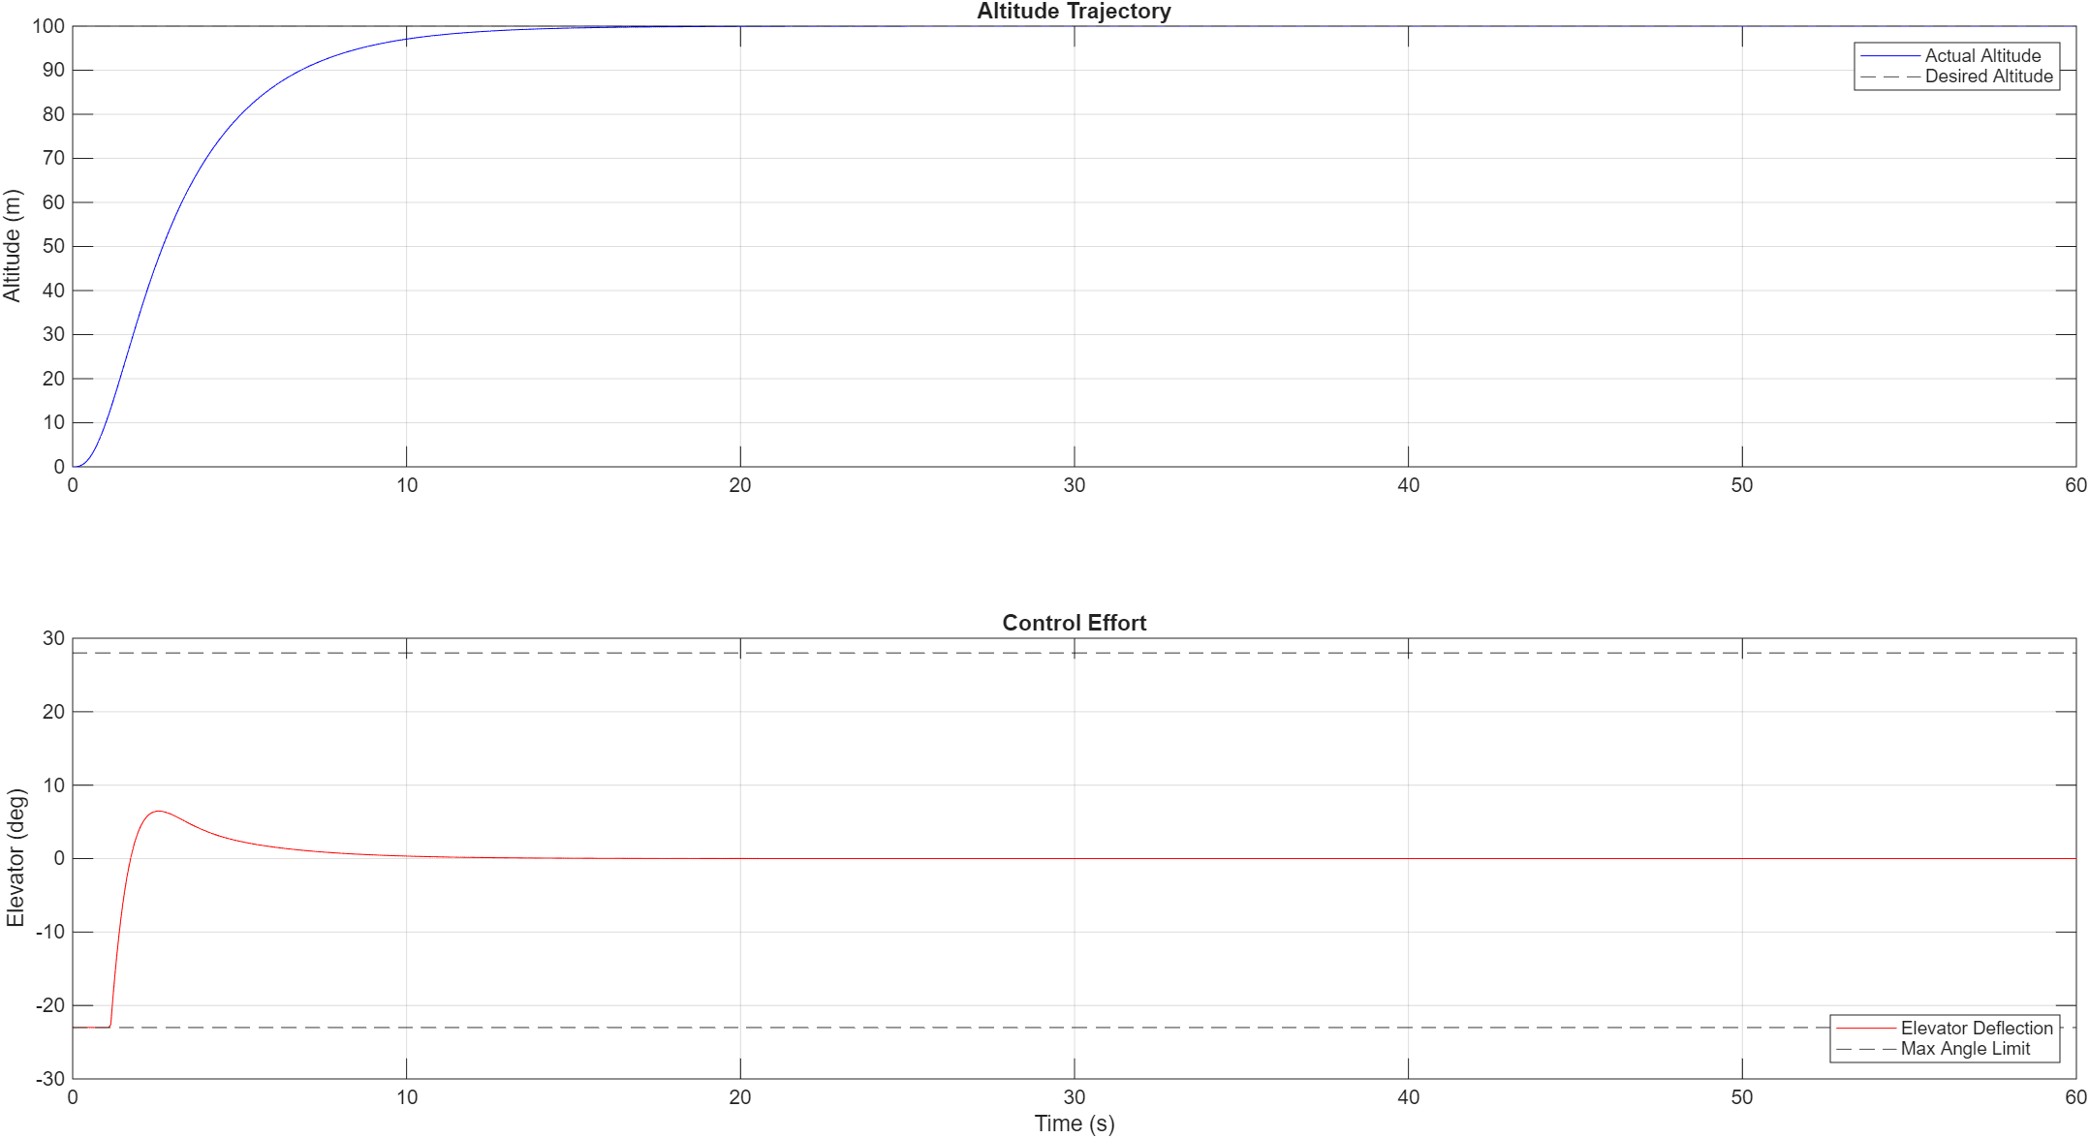
Figure X: Control Analysis Result for 100m Altitude Change

The final graph shows the plane climbing in a smooth arc that levels off perfectly at the desired 100 meter altitude change with zero overshoot while staying within theCessna’s elevator degree limits (Cel, 2019). The differential equations, block diagram, and transfer functions, were done by hand and is included in the references along with the MATLAB code, and two research studies that the geometry data was pulled from.

Part IV: NON-ENGINEERING WILD CARD

This section moves away from the technical aspects and focuses more on the real-world impact of the Cessna 172. Specifically, it looks at the economic impact the aircraft has had on the aviation industry. This includes its role in pilot training, how it has made flying more accessible, and its overall influence on the aviation industry. Instead of focusing on lift, drag, and power calculations, this section highlights how design choices don’t just affect performance but can also have long-term economic effects.

4i) Economic Impact of the Cessna 172
The Cessna 172 has had a major economic impact on the general aviation industry, especially when it comes to pilot training. Since it was first introduced, it has become one of the most widely used training aircraft due to its relatively low operating cost, reliability, and simple design. Aircraft with these characteristics are typically preferred for training because they reduce costs for flight schools while still providing a reliable learning platform for new pilots.
Because of this, the Cessna 172 has played a huge role in increasing the accessibility of aviation. Student pilots are most likely to train in an aircraft that is widely available and cost-effective, which is exactly what the Cessna 172 is known for. This has helped make it easier for people to become pilots, allowing for more people to pursue flight training and supporting the growth of the pilot population (Federal Aviation Administration, 2023).
In addition to training, the widespread use of the Cessna 172 has supported the growth of local aviation economies. Flight schools, maintenance operations, and small airports all benefit from aircraft that are consistently in demand. Because the Cessna 172 is so common, it has created a stable market for parts, maintenance services, and instructor training. General aviation in general contributes significantly to economic activity, and aircraft like the Cessna 172 are a key part of that system (General Aviation Manufacturers Association, 2023).
Another important factor is the aircraft’s longevity. The Cessna 172 has been in production for decades with only minor changes, which has helped keep training standardized across the industry. Flight instructors, maintenance technicians, and pilots are all very familiar with the platform, which reduces the need to retrain and increases efficiency. This consistency also helps flight schools avoid the cost of frequently updating fleets with entirely new aircraft designs (Textron Aviation, 2022).
Overall, the economic impact of the Cessna 172 shows how engineering design decisions can have effects far beyond performance. Features such as stability, simplicity, and cost-efficiency have allowed the aircraft to become a long-term standard in aviation. These characteristics not only make it effective from an engineering standpoint, but also allow it to support pilot training, improve accessibility, and contribute to the general aviation economy.

REFERENCES

Cel, M. M. (2019). Cessna 172: Flight simulation data (Revision 9). https://www.researchgate.net/publication/353752543_Cessna_172_Flight_Simulation_Data

Student Supplemental Work (2026). Fluid Mechanics Final Project Part 3:

Student Supplemental Work (2026). ME3503WildCard.m:

Vadivelu, P., Lakshmanan, D., Naveen, R., Mathivannan, K., & Kumar, G. Y. (2020). Numerical study on longitudinal control of Cessna 172 Skyhawk aircraft by tail arm length. IOP Conference Series: Materials Science and Engineering, 764(1), 012026. https://iopscience.iop.org/article/10.1088/1757-899X/764/1/012026

Federal Aviation Administration. (2023). U.S. civil airmen statistics. U.S. Department of Transportation. https://www.faa.gov/data_research/aviation_data_statistics/civil_airmen_statistics
General Aviation Manufacturers Association. (2023). General aviation statistical databook & industry outlook. https://gama.aero/facts-and-statistics/
Textron Aviation. (2022). Cessna 172 aircraft information. https://cessna.txtav.com/en/piston/cessna-skyhawk

