ME 3671 DESIGN PROJECT REPORT

“The (Mostly) Gearless Gearbox”
5/01/2026

Team Members:

Nick Reeder
Drew English

Andrew Heban
Adin Cohen

Aidan Gregory

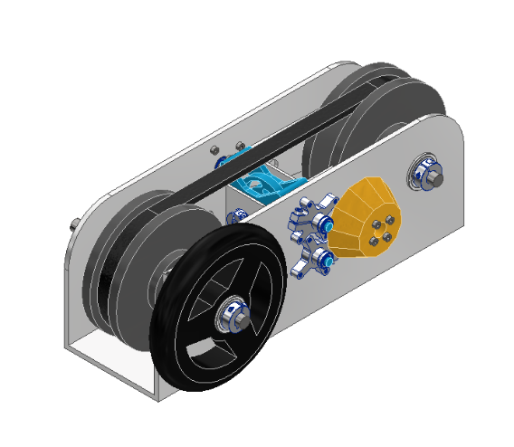

ABSTRACT
This project is a hands-on educational exhibit designed for a COSI-style museum environment. The exhibit demonstrates how a continuously variable transmission, or CVT, changes speed ratio using two variable-diameter pulleys and a V-belt. The main concept taught is mechanical advantage through changing pulley diameter ratios. A user turns a knob connected to a cam-driven actuation system. As the knob rotates, cam slots move follower pins, which slide the split pulley half-sheaves inward or outward. This causes one pulley’s effective pitch diameter to increase while the other decreases, changing the transmission ratio between the input and output sides.
The exhibit uses several key machine elements, including V-belts, split pulleys, half-sheaves, shafts, bearings, cam slots, follower pins, linear guides, and bevel gears. The design is intended to be safe, slow-moving, and easy for children or general museum visitors to understand. The final concept removes unnecessary rack-and-pinion complexity and uses a slotted cam mechanism to create controlled sheave motion while maintaining an approximately constant belt pitch length. The system fits within the required size envelope, uses manufacturable components, keeps motion constrained, and is designed to meet a minimum factor of safety of 1.25. Overall, the final design is a functional and safe educational CVT model that visually shows how changing pulley diameters changes transmission ratio.

ME 3671 DESIGN PROJECT REPORT i
ABSTRACT ii
LIST OF FIGURES vii
LIST OF TABLES viii
1.1 Project Overview 1
1.2 Educational Objective 2
2. DESIGN REQUIREMENTS AND SPECIFICATIONS 2
2.1 Functional Requirements 2
2.2 Constraints 4
Size Constraint 4
Safety Constraints 4
Manufacturability Constraints 5
Cost Constraints 5
Usability Constraints 6
2.3 Performance Targets 6
2.4 Assumptions 8
3. CONCEPT DEVELOPMENT 9
3.1 Concept 1: Rack-and-Pinion Actuated CVT 9
Description 9
How It Works 10
User Interaction 11
What It Demonstrates 11
Machine Elements Used 11
Pros 11
Cons 12
3.2 Concept 2: Slotted Cam Actuated CVT 12
Description 12
How It Works 13
User Interaction 14
What It Demonstrates 14
Machine Elements Used 14
Pros 15
Cons 15
3.3 Concept Selection: Trade-Off Analysis 16
Final Selection Justification 16
4. FINAL DESIGN DESCRIPTION 17
4.1 Overall System Description 17
4.2 User Interaction 19
4.3 Key Components 21
V-Belt 21
Split Pulleys 21
Half-Sheaves 21
Slotted Cam Disk 22
Follower Pins 23
Linear Guides 23
Knob 24
Shaft 24
Bearings 24
Frame 25
Guards or Covers 25
5. ENGINEERING ANALYSIS 25
5.1 Analysis Overview 25
5.2 Belt Geometry 26
5.3 Center Distance Calculation 27
5.4 Allowable Transmission Ratio Range 28
5.5 Sheave Geometry 30
5.6 Cam and Slot Geometry 31
5.7 Constraint Verification 33
5.8 Cam Motion and Slot Profiles 34
5.9 Follower Pin Stress and Factor of Safety 35
5.10 Engineering Analysis Summary 37
6. Force and Stress Analysis 38
6.1 Problem Formulation 38
6.2 Free Body Diagrams 39
6.3 Force / Torque Analysis 41
6.4 Component Analysis 43
6.5 Stress & Failure Analysis 46
6.6 Factor of Safety 47
6.7 Results Summary 49
7. ENGINEERING DESIGN UNDER CONSTRAINTS 49
7.1 Safety Considerations 49
7.2 Manufacturability 50
7.3 Cost Analysis 51
7.4 Reliability & Maintenance 51
7.5 Usability 51
8. ETHICS, SAFETY, AND SOCIETAL IMPACT 52
8.1 Public Safety Risks and Mitigation Strategies 52
8.2 Potential Failure Modes and Consequences 52
8.3 Ethical Responsibility in Public-Facing Design 53
8.4 Accessibility and Inclusivity Considerations 53
8.5 Environmental Impact 54
8.6 Economic and Societal Impact 54
9. COST AND BILL OF MATERIALS 55
10. DRAWINGS AND VISUALS 60
10.1 Assembly Drawings 60
10.2 Component Drawings 64
10.3 Exploded View 67
11. CONCLUSION AND RECOMMENDATIONS 67
CONCLUSION 67
RECOMMENDATIONS 69
12. SUMMARY/POSTER 71
13. REFERENCES 72
14. APPENDIX 76
Appendix A – MATLAB Script and Plots 76
A1: 76
A2: Stress Safety Calcs 82
Appendix B – Hand Calculations 86
B1: System Drawings, FBDs, and Safety Calculations 86

LIST OF FIGURES

Figure 1 Annotated system top view identifying the interaction between the follower pins, cam disk, and the axial motion of the four half-sheaves. 19
Figure 2 The core power transmission elements, consisting of a BX32 cogged V-belt and two split pulleys capable of varying effective pitch diameter. 22
Figure 3 Detailed view of the slotted cam disk, designed with custom-generated nonlinear paths to translate rotational input into specific axial sheave displacements. 23
Figure 4 CAD top view used to verify center distance (C = 10.186 in) and ensure clearance between the sheaves at maximum pitch diameter. 28
Figure 5 Cross-sectional geometry of a half-sheave showing the 20° half-angle (40° included) required to seat the BX32 V-belt. 31
Figure 6 Close-up of the cam-actuation assembly, illustrating how the follower pins are constrained to linear paths while riding in the rotating cam slots. 33
Figure 7 Sketch of input subsystem 39
Figure 8 FBD of input subsystem 40
Figure 9 FBD of bearing 40
Figure 10 Sketch of transfer subsystem 41
Figure 11 FBD of belt 41
Figure 12 Frontal elevation view demonstrating the alignment of the input bevel gear set and the symmetrical arrangement of the pulley sheaves. 46
Figure 13 Rear perspective of the exhibit highlighting the support frame and protected internal components, designed to minimize pinch points for public safety. 50
Figure 14 Side profile of the exhibit showing the manual input wheel and the visible alignment of the primary driver and driven shafts. 60
Figure 15 Detailed view demonstrating the alignment of the input bevel gear set and the symmetrical arrangement of the split pulley sheaves. 60
Figure 16 Full perspective highlighting the compact frame housing and the integration of the cam-driven actuation system. 61
Figure 17 View highlighting the support frame and protected internal components designed to minimize pinch points for public safety. 61
Figure 18 A direct view of the slotted cam disk illustrating the custom-generated nonlinear paths used to translate rotational input into axial sheave displacement. 62
Figure 19 Close-up of the internal mechanism showing how the follower pins are constrained to linear paths while riding in the rotating cam slots. 62
Figure 20 Isometric view of the BX32 V-belt seated within the two split pulleys at the 1:1 initial diameter condition. 63
Figure 21 Technical view used to verify center distance (C = 10.186 in) and ensure there is no mechanical interference between moving subsystems. 63
Figure 22 Gear Housing - Aluminum 64
Figure 23 Translational Arm - Aluminum 64
Figure 24 Pin Follower Housing - PLA 64
Figure 25 Cam - PLA 65
Figure 26 Driven Half Sheave - PLA 65
Figure 27 Driving Half Sheave - PLA 65
Figure 28 Wheel - PLA 66
Figure 29 Dial - PLA 66
Figure 30 Exploded view of CVT with labeled components 67

LIST OF TABLES
Table 1 Components and their factors of safety 49
Table 2 Bill of Materials 55

1. INTRODUCTION

1.1 Project Overview
The purpose of this project is to design an interactive educational machine elements exhibit for a COSI-style museum setting. The exhibit is meant to be understandable, hands-on, and safe for children and public users. The system demonstrates how a continuously variable transmission changes speed ratio without using fixed gear steps.
The main concept taught by the exhibit is:
Changing pulley diameter ratio changes transmission ratio.
The exhibit uses a V-belt running between two split pulleys. Each pulley is made from two half-sheaves. When the half-sheaves move closer together, the belt rides higher in the groove and the effective pitch diameter of that pulley increases. When the half-sheaves move farther apart, the belt rides lower in the groove and the effective pitch diameter decreases. By increasing the diameter of one pulley while decreasing the diameter of the other, the system changes the transmission ratio continuously.
This concept is useful because CVTs are used in real machines such as cars, scooters, snowmobiles, go-karts, and industrial belt-drive systems. Unlike a traditional transmission with fixed gears, a CVT can adjust smoothly between ratios. For a museum exhibit, this is interesting because users can physically see the belt move, turn the knob, and observe how the output changes.

1.2 Educational Objective
The educational objective is for the user to understand that a belt drive’s speed ratio depends on the relative effective diameters of the driving and driven pulleys.
A child should learn that:
- when one pulley gets effectively larger, the other gets effectively smaller
- this changes the output speed relative to the input speed
- a transmission does not always need fixed gears to change speed ratio
- smooth mechanical motion can be created using cams, pins, pulleys, and belts
The real-world connection is the continuously variable transmission used in vehicles and machines. In a CVT, the pulley diameters change to provide different speed and torque conditions. A low ratio can help with starting or climbing, while a higher ratio can help with faster motion. This exhibit simplifies that real engineering system into a visible hand-powered model.

2. DESIGN REQUIREMENTS AND SPECIFICATIONS

2.1 Functional Requirements
The system must demonstrate the basic operating principle of a CVT using a V-belt and two variable-diameter pulleys.
The functional requirements are:
- The user must be able to turn a knob by hand.
- The knob must rotate a cam system.
- The cam system must move follower pins through curved slots.
- The follower pins must move the half-sheaves linearly.
- One pulley must close while the other pulley opens.
- The V-belt must move to different effective pitch diameters on each pulley.
- The transmission ratio must change continuously over the motion range.
- The system must remain safe and slow enough for public interaction.
- The mechanism must be visible enough for a user to understand what is happening.
- The mechanism must stay within the assigned exhibit size limits.
The input is the user turning the knob. The output is the visible motion of the half-sheaves and the belt, along with a change in the effective pulley ratio:

 | $$R_{t}=D_{1}/D_{2}$$ | [1]

where:
- (R_{t}) = transmission ratio
- (D₁) = pitch diameter of pulley 1
- (D₂) = pitch diameter of pulley 2
At the initial condition:
 | $$D_{1}=D_{2}=D_{initial}$$ | [2]

 | $$R_{t}=1$$ | [3]

As the user rotates the knob, (D₁) and (D₂) change, which changes (R_{t}).

2.2 Constraints

Size Constraint
The complete exhibit must fit within the required COSI exhibit volume: 10 ft x 10 ft x 10 ft. The current design is much smaller than this limit and is intended to fit on a tabletop or compact exhibit stand.

Safety Constraints
The exhibit must be safe for children and the general public. Safety requirements include:
- no exposed pinch points where fingers can enter between moving sheaves
- slow hand-powered motion
- no high-speed rotating parts
- no sharp edges on the knob, cam, pulleys, or frame
- guards or clear covers around moving belt regions if needed
- secure shaft supports and bearings
- mechanical stops to prevent over-rotation of the cam
- low required user force
- no stored energy elements that could snap back unexpectedly
The cam slots should also include end limits so the knob cannot be forced beyond the intended travel range.

Manufacturability Constraints
The design should be manufacturable using common shop and prototyping methods. The parts should be reasonable to machine, 3D print, laser cut, or CNC route.
Manufacturability requirements include:
- simple plate-style cam geometry
- CAD-generated slot points for easy spline construction
- split pulley half-sheaves with simple revolved geometry
- standard shafts and bearings where possible
- standard V-belt section
- simple frame or base plate
- minimal custom precision components
The slotted cam mechanism was selected partly because it reduces the number of small gear and rack components required.

Cost Constraints
The exhibit should use low-cost, readily available parts where possible. Cost should be controlled by using:
- a standard catalog V-belt
- simple shafts
- standard bearings
- 3D printed or machined pulleys
- a laser-cut or machined cam disk
- simple follower pins
- standard fasteners
- minimal purchased specialty components
Removing the rack-and-pinion system reduced part count and likely reduced cost.

Usability Constraints
The exhibit must be intuitive for children and non-engineers. The interaction should be simple:
Turn knob $→$Watch pulleys change $→$Observe ratio change
The user should not need to understand the internal equations to learn the concept. The system should provide visible feedback through the belt position, pulley movement, and optional ratio markings on the dial.

2.3 Performance Targets
The system is not designed for high power transmission. It is a low-speed educational demonstration.
Performance targets include:
- hand-powered knob input
- smooth knob motion
- cam sweep of approximately 160 degrees
- low rotational speed
- controlled sliding motion of the half-sheaves
- constant approximate belt pitch length
- no sheave overlap
- cam slot radius greater than 18 mm
- cam diameter smaller than minimum sheave diameter
- center distance large enough to package the pulleys and cam
The cam angle range is:
P = -80° to +80°
with:
P = 0° at the 1:1 condition.
The minimum factor of safety target is:
[\boxed{n \ge 1.25}]
This factor of safety should be applied to structural components such as shafts, cam disk, pins, brackets, supports, and pulley connections. Since the exhibit is hand-powered and low-load, the design is expected to meet this requirement with proper material selection and reasonable dimensions.

2.4 Assumptions
The major design assumptions are:
- The belt is modeled as a standard 5L V-belt.
- The belt section is approximated as an isosceles trapezoid.
- The groove angle is assumed to be 40° included.
- The half groove angle is: $α={20}^{∘}$
- The McMaster belt length is treated as outer circumference.
- The pitch line is approximated to be halfway through the belt thickness.
- The approximate pitch length is:
[PitchLength=L_{outer}-\pi t]
- The exact manufacturer pitch-length correction factor is unavailable.
- Belt stretch is neglected.
- Belt slip is neglected for geometry calculations.
- The belt remains seated in the pulley grooves.
- The pitch length remains approximately constant.
- The center distance remains fixed.
- The half-sheave geometry does not change.
- The half-sheaves only translate axially.
- The cam pins are constrained by linear guides.
- The cam slots define the required pin displacement.
- The pins are assumed to follow the slot centerline.
- Friction in the slots and guides is neglected for first-pass geometry.
- The exhibit is hand-powered and low speed.
- Dynamic effects are neglected.
- The cam disk is assumed rigid.
- The frame is assumed rigid relative to operating loads.
- The sheaves may touch at the limiting condition but cannot overlap.
- The no-overlap condition is checked at maximum pitch diameter.
- A minimum slot radius greater than 18 mm is required.
- The cam maximum diameter is estimated as: D_{cam} = 2S_{max} + 0.5
- The center distance must satisfy:
[C \ge 5 + D_{sheave,max}]
- The system is designed primarily for educational clarity, not maximum efficiency.

3. CONCEPT DEVELOPMENT

3.1 Concept 1: Rack-and-Pinion Actuated CVT

Description
The first concept used a rack-and-pinion system to move the pulley half-sheaves. A hand knob would rotate a gear or pinion. The pinion would drive two racks in equal and opposite directions. Each rack would be connected to a half-sheave. As the racks moved, the half-sheaves would slide inward or outward.
Each pulley would use two half-sheaves. When the two half-sheaves moved closer together, the belt would ride higher in the V-groove and the effective pulley diameter would increase. When the half-sheaves moved farther apart, the belt would ride lower and the effective pulley diameter would decrease.
The original full system included:
- a knob
- bevel gears
- pinion gears
- four racks
- four half-sheaves
- one V-belt
- two variable-diameter pulleys

How It Works
The user turns the knob. The knob rotates a gear train or bevel shaft. That shaft turns pinion gears. Each pinion engages with two racks. The racks move in opposite directions. The racks push or pull the half-sheaves. One pulley closes while the other opens.
This changes the transmission ratio:
 | $$R_{t}=D_{1}/D_{2}$$ | [4]

User Interaction
The user would turn a knob or wheel. As the knob turns, the racks move. The user could watch the pulleys open and close and see the belt move up and down in the grooves.

What It Demonstrates
This concept demonstrates how linear sheave motion changes pulley diameter and how changing pulley diameters changes transmission ratio.

Machine Elements Used
This concept used several machine element categories:
- spur gears
- racks and pinions
- shafts
- bearings
- V-belt
- pulleys
- sliding guides
- bevel gears
- fasteners

Pros
- clear mechanical relationship between rotation and linear motion
- easy to explain rack-and-pinion motion
- positive mechanical engagement
- available catalog rack and pinion components
- predictable displacement based on gear pitch

Cons
- many components
- more backlash
- more alignment issues
- more pinch points
- more expensive than necessary
- rack travel was initially too small
- harder to package cleanly
- more difficult for a kid to understand compared to a visible cam
The rack travel analysis showed that the system initially used only about two rack teeth across the full motion range. This was judged too small, so the design was revised to target at least four teeth of rack travel. Eventually, the rack-and-pinion mechanism was removed completely.

3.2 Concept 2: Slotted Cam Actuated CVT

Description
The second concept replaced the rack-and-pinion system with a slotted cam mechanism. A rotating cam disk contains two curved slots. Follower pins ride in the slots. The follower pins are attached to linear sliders, which move the half-sheaves.
This concept keeps the same educational CVT principle but reduces the number of parts.
The current final system uses:
- a knob
- a bevel gear or direct shaft connection
- a slotted cam disk
- two follower pins
- linear guides
- four half-sheaves
- two split pulleys
- one V-belt

How It Works
The user turns the knob. The knob rotates the cam disk. The cam slots move the follower pins. The follower pins are constrained by linear guides, so they slide rather than orbit with the cam. The pins move the half-sheaves.
The final pin pairing is:
- Pin 1 drives half-sheaves 1 and 3
- Pin 2 drives half-sheaves 2 and 4
This causes one pulley to close while the other opens. The belt moves to different effective diameters, and the transmission ratio changes.

User Interaction
The user turns one knob. The knob rotates about 160 degrees over the full exhibit motion. At the centered position, the knob points upward along the positive (y)-axis. This corresponds to the 1:1 ratio.
As the user rotates the knob left or right, they observe:
- the cam rotating
- the follower pins moving through curved slots
- one pulley opening
- the other pulley closing
- the belt moving in the V-grooves
- the transmission ratio changing

What It Demonstrates
This concept demonstrates how a continuously variable transmission changes ratio by changing effective pulley diameters. It also shows how a cam can convert rotary motion into controlled linear motion.

Machine Elements Used
This concept uses:
- V-belts
- pulleys
- half-sheaves
- cams
- follower pins
- shafts
- bearings
- bevel gears
- sliding guides
- fasteners

Pros
- fewer parts than rack-and-pinion system
- less backlash
- simpler visual explanation
- easier to package
- smoother motion
- easier to create custom nonlinear displacement
- CAD-ready slot points can be generated by MATLAB
- cam profile can be designed to maintain approximate constant pitch length

Cons
- cam slot shape is custom
- follower pins need good linear guides
- slot friction must be considered
- cam must be strong enough around the slots
- manufacturing the slot accurately is important
- two slot profiles may be slightly different if exact constant pitch length is desired

3.3 Concept Selection: Trade-Off Analysis
Criteria | Concept 1: Rack-and-Pinion | Concept 2: Slotted Cam
Cost | Higher due to multiple racks, pinions, gears, and supports | Lower because it uses fewer custom moving parts
Complexity | More complex, many meshing parts | Simpler, one cam disk and follower pins
Educational Value | Shows rack-and-pinion plus CVT, but may distract from main concept | Clearly focuses on CVT pulley diameter change
Safety | More pinch points from racks and gears | Fewer exposed gear contacts, easier to guard
Manufacturability | Requires rack alignment and gear meshing | Requires accurate cam slot, but simpler assembly
Backlash | More backlash from gear and rack clearances | Less backlash if pins and slots are guided well
Packaging | More difficult to package cleanly | More compact and easier to fit
Motion Control | Linear and simple, but less flexible | Custom nonlinear slot can match belt geometry
Final Suitability | Good early concept but too complex | Best final choice

Final Selection Justification
The slotted cam design was selected as the final concept because it is simpler, safer, easier to package, and better suited for a public educational exhibit. The rack-and-pinion system worked in theory, but it added too many parts and made the mechanism harder to explain. The rack travel was also very small for the original pulley range, making the design sensitive to backlash.
The slotted cam system better matches the educational goal. A child only needs to turn one knob and watch the cam, pins, pulleys, and belt move. The cam slots can be designed using MATLAB to create the correct nonlinear motion needed to keep the belt pitch length approximately constant. This makes the final design more elegant and more directly focused on the main concept: changing pulley diameter ratio changes transmission ratio.

4. FINAL DESIGN DESCRIPTION

4.1 Overall System Description
The final design is a hand-powered educational CVT exhibit using a constant-length V-belt and two split pulleys. Each pulley is made from two half-sheaves. A rotating slotted cam moves follower pins, and the follower pins move the half-sheaves through linear guides.
The main system components are:
- one BX V-belt
- two split pulleys
- four half-sheaves
- one cam disk with two slots
- two follower pins
- linear slider guides
- knob
- shaft
- bearings
- support frame
- bevel gear connection
At the initial centered position:
 | $$D_{1}=D_{2}=D_{i}nitial$$ | [5]
 | R_{t} = 1 | [6]

The knob points upward along the positive (y)-axis. The cam pins are centered and aligned on the (y)-axis.
When the user turns the knob, the cam rotates. The pins follow the cam slots. The pins move the half-sheaves. One pulley closes and its effective pitch diameter increases. The other pulley opens and its pitch diameter decreases.
The ratio changes according to:
 | $$R_{t}=D_{1}/D_{2}$$ | [7]

The belt pitch length is approximately constant and calculated using:
 | Pitch Length = L_{outer} – πt | [8]

The pulley diameters are solved using:
$$Pitch Length=2C+π/2​\left(D_{1}​+D_{2}​\right)+{\left(D2​-D1​\right)}^{2}/4C$$ | [9]

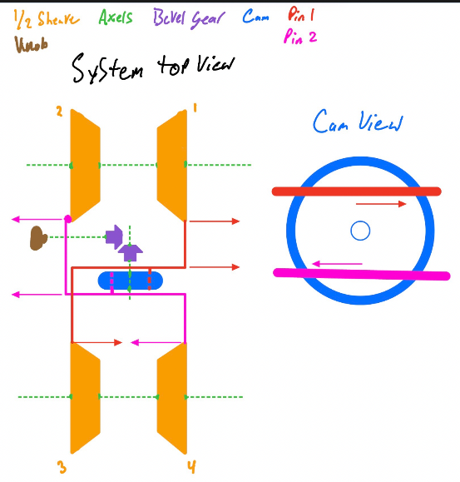
Figure 1 Annotated system top view identifying the interaction between the follower pins, cam disk, and the axial motion of the four half-sheaves.

4.2 User Interaction
The exhibit is designed to be intuitive.
The user sees a knob, a belt, two pulleys, and visible cam slots. The user turns the knob by hand.
At the center position:
- knob points upward
- pulleys are equal size
- ratio is 1:1
When the user rotates the knob one direction:
- the cam turns
- the follower pins move through the slots
- one pulley closes
- the other opens
- the belt moves higher on one pulley and lower on the other
- the transmission ratio changes
When the user rotates the knob the other direction, the opposite happens.
The user should observe that the system does not shift in steps like a normal gear train. Instead, it changes smoothly. This demonstrates the main CVT idea.
A COSI-style explanation could be:
“When you turn the knob, the pulleys change size. The belt rides higher on one pulley and lower on the other. This changes how fast one side turns compared to the other, just like a continuously variable transmission.”

4.3 Key Components

V-Belt
The belt transfers motion between the two pulleys. The current design uses a 5L belt. The belt is modeled as a trapezoid with a 40° included angle.
Function:
- connects the two pulleys
- transfers motion
- visually shows the changing ratio

Split Pulleys
Each pulley is made of two half-sheaves. The half-sheaves slide toward or away from each other.
Function:
- change effective pitch diameter
- guide the V-belt
- create the variable ratio

Half-Sheaves
There are four half-sheaves total. Each half-sheave has a fixed right-trapezoid cross-section. The sheave geometry does not change.
Function:
- form the 40° V-groove
- move axially to change belt height
- create changing pitch diameter
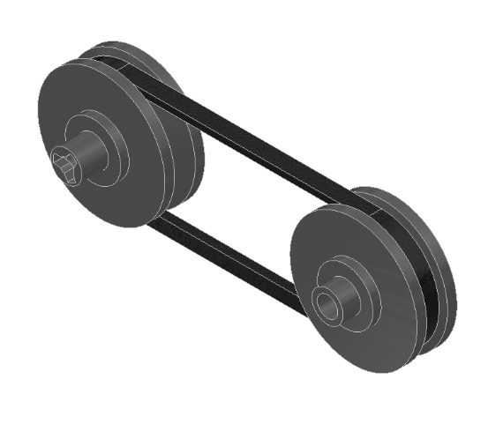
Figure 2 The core power transmission elements, consisting of a BX32 cogged V-belt and two split pulleys capable of varying effective pitch diameter.

Slotted Cam Disk
The cam disk has two curved slots. It converts knob rotation into follower pin displacement.
Function:
- controls nonlinear pin motion
- sets the transmission ratio path
- replaces the rack-and-pinion system

Figure 3 Detailed view of the slotted cam disk, designed with custom-generated nonlinear paths to translate rotational input into specific axial sheave displacements.

Follower Pins
The follower pins sit inside the cam slots and connect to the half-sheave sliders.
Function:
- follow the cam slot path
- transfer motion from cam to sheave sliders
- drive paired half-sheaves

Linear Guides
The follower pins and sheave sliders require linear guides so the pins do not simply rotate with the cam.
Function:
- constrain pin motion to linear sliding
- reduce unwanted motion
- keep the sheaves aligned

Knob
The knob is the user input.
Function:
- allows the user to rotate the cam
- provides hands-on interaction
- acts as the visible control for transmission ratio

Shaft
The shaft supports the rotating cam and knob.
Function:
- transmits knob rotation to the cam
- supports rotating components

Bearings
Bearings support the shaft and reduce friction.
Function:
- allow smooth rotation
- keep shaft alignment
- reduce user effort

Frame
The frame supports the entire exhibit.
Function:
- holds pulley shafts
- holds cam shaft
- supports linear guides
- keeps the system aligned
- provides safe mounting for the exhibit

Guards or Covers
Guards may be added around the belt, sheaves, and cam slots.
Function:
- prevent finger access to pinch points
- improve safety
- make the exhibit museum-ready

5. ENGINEERING ANALYSIS

5.1 Analysis Overview
The purpose of this analysis is to determine whether the CamShift CVT System can vary transmission ratio while maintaining a constant belt pitch length, preventing sheave interference, and satisfying packaging constraints. MATLAB was used as the primary tool to compute belt geometry, pulley diameters, cam slot profiles, and constraint verification.

5.2 Belt Geometry
This system uses a BX32 V-belt with an outer circumference of 35.0 inches, a top width of 0.6562 inches, and a thickness of 0.4063 inches. Since the provided belt length corresponds to the outer circumference, the pitch length must be approximated for use in pulley calculations. The pitch length is estimated using:
 | $$L=L_{o}-πt$$ | [10]

Using the given values, we find pitch length to be:
$$L=35.0-π\left(0.4063\right)=33.7236 in$$ | [11]

The bottom width of the belt is calculated as:
$$w_{b}=w_{t}-2t⋅tan\left(20°\right)=0.3605 in$$ | [12]

And the pitch width is:
 | $$w_{p}=w_{t}-t⋅tan\left(20°\right)=0.5084 in$$ | [13]

These values define the allowable geometry of the pulley sheaves and directly influence the allowed diameter range.

5.3 Center Distance Calculation
At the centered 1:1 ratio condition, both pulleys have the same diameter:

 | $$D_{1}=D_{2}=4.25 in$$ | [14]

We can find the center distance using the simplified open belt equation:

$$C=\left(L-πD\right)/2=\left(33.7236-π\left(4.25\right)\right)/2=10.1859 in$$ | [15]

The center distance is treated as constant throughout the operation of the system. As the transmission ratio changes, the pulley diameters will vary while maintaining the same center distance. This is critical to the design, as it ensures proper belt tension, preventing slack or excessive load during operation.
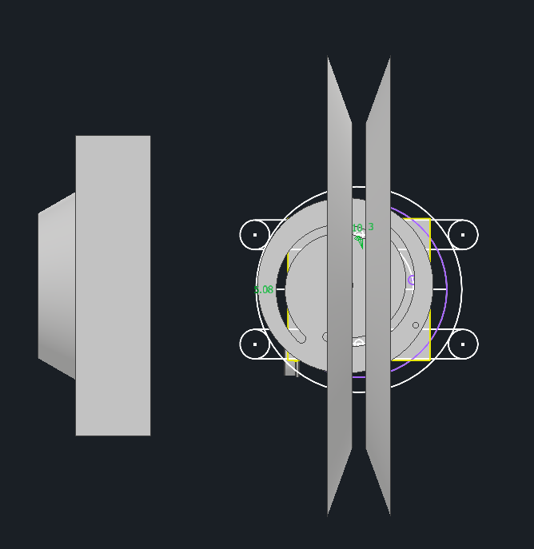
Figure 4 CAD top view used to verify center distance (C = 10.186 in) and ensure clearance between the sheaves at maximum pitch diameter.

5.4 Allowable Transmission Ratio Range
The allowable transmission ratio range is determined by the geometric limits of the pulley sheaves and the requirement that the belt maintains proper contact without causing interference. The limiting condition occurs when the half-sheaves are close to their minimum allowable gap, which prevents physical overlap while still supporting the belt. The transmission ratio is defined as:
 | $$R=D_{1}/D_{2}$$ | [16]

Where $D_{1}$ and $D_{2}$ are the pitch diameters of the two pulleys.
The allowable pitch diameter range is:
 | $$D_{m}in= 3.7471 in$$ | [16]

 | $$D_{m}ax= 4.7376 in$$ | [17]

The resulting transmission ratio range is:
 | $$R_{m}in= 0.7909$$ | [18]

 | $$R_{m}ax= 1.2643$$ | [19]

This range represents the physically achievable variation in transmission ratio while maintaining belt tension and preventing sheave interference.

5.5 Sheave Geometry
Each pulley contains two half sheaves forming a $40°$groove. The axial motion of the sheaves changes the belt position, which adjusts the pitch diameter.
The belt pitch radius is:
 | $$r=D/2$$ | [20]

Thus, the minimum and maximum radial positions of the belt are:

 | $$r_{m}in=D_{m}in/2-t/2=1.6704 in$$ | [21]

 | $$r_{m}ax=D_{m}ax/2+t/2=2.5719 in$$ | [22]

The required sheave height is:

 | $$∆r=r_{m}ax-r_{m}in=0.9015 in$$ | [23]

At maximum pitch diameter, the sheave gap approaches zero, meaning the sheaves contact but do not overlap. This satisfies the no-interference requirement.

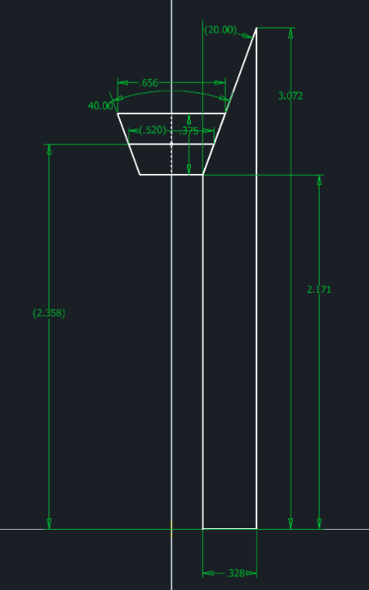
Figure 5 Cross-sectional geometry of a half-sheave showing the 20° half-angle (40° included) required to seat the BX32 V-belt.

5.6 Cam and Slot Geometry
The cam mechanism converts rotational input into constrained follower motion. The follower pin travels in a radial slot defined in polar coordinates, where the slot position is described by a radius r as a function of cam angle θ.
The slot geometry is defined by:

$x=r\left(θ\right)sinθ$, $y=r\left(θ\right)cosθ$ | [24]

Where $r\left(θ\right)$ is the radial position of the slot centerline, and $θ$is the cam rotation angle.
From MATLAB, we find that slot radius varies between:
$r_{m}in=0.7126 in \left(18.1 mm\right)$, $r_{m}ax=0.8928 in \left(22.68 mm\right)$
The minimum radius exceeds the required manufacturing constraint of 18 mm, ensuring the slot curvature is feasible for machining and avoids excessive stress.
The maximum cam diameter is determined by using the largest radial extent of the slot:

$$D_{c}am=2r_{m}ax+t_{c}=2.2857 in$$ | [25]

Where $t_{c}=0.5 in$. This diameter is less than the sheave diameter, ensuring that it satisfies packing constraints.

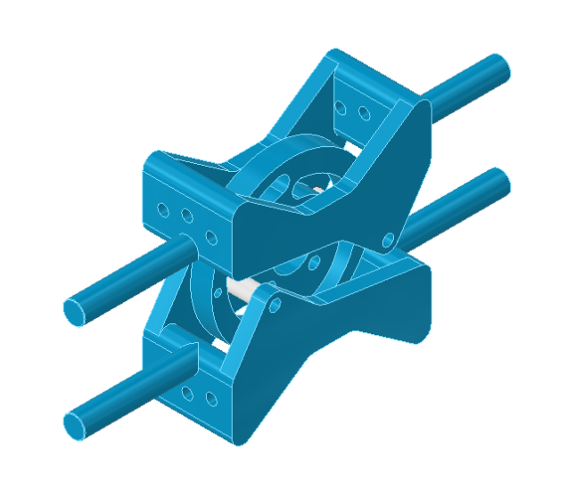
Figure 6 Close-up of the cam-actuation assembly, illustrating how the follower pins are constrained to linear paths while riding in the rotating cam slots.

5.7 Constraint Verification
Several constraints were evaluated to ensure the design is physically feasible.
The center distance requirement is:

$$C_{r}eq=5+D_{m}ax=10.1439 in$$ | [26]

Since the actual center distance is:
 | $$C=10.1859 in > C_{r}eq$$ | [27]

The constraint is satisfied.
The cam diameter must also fit within the minimum sheave diameter:
$$D_{c}am=2.2857 in < D_{\left(sheave,min\right)}=3.3408 in$$
So the cam fits within the available space.
The minimum slot radius is:
$$r_{m}in=0.7126 in=18.1 mm>18 mm$$
So the manufacturing constraint is satisfied.
All constraints are verified, confirming that the design is physically feasible.

5.8 Cam Motion and Slot Profiles
The cam rotates through a total range:
$$θ=-80° to 80°$$
The transmission ratio is mapped to the cam angle using a logarithmic relationship:

 | $$R(θ)=R\overset{θ/{θ_{\max{}}}}{max}{})$$ | [28]

Where:
$$θ_{m}ax=80°$$
At:
$$θ=0° → R=1$$
The pulley diameters $D_{1}$ and $D_{2}$ are determined from the constant pitch length constraint, and the corresponding sheave displacements are:
 | $$x=\left(D-D_{0}\right)/2tan\left(20°\right)$$ | [29]

These displacements define the required follower motion. Two slot profiles are generated, one for each follower pin, corresponding to the two pulley systems. The profiles follow a nonlinear relationship between $D_{1}$ and $D_{2}$. The resulting slot geometry is used in CAD to produce the cam.

5.9 Follower Pin Stress and Factor of Safety
The follower pin is subjected to shear as it transmits force from the cam to the sheave. The average shear stress is:
 | $$τ=V/A$$ | [30]

Where V is the shear force, and A is the cross-sectional area of the pin.
For the circular pin (assuming d=0.25 in):
 | $$A=\left(πd^{2}\right)/4=0.0491 in^{2}$$ | [31]

Assuming that the conserved load is V = 25 lb, the pin is subject to a shear stress of:

$$τ=25/0.0491=509.3 psi$$ | [32]

The factor of safety is defined as:

 | $$n=S/τ$$ | [33]

Using S = 30,000 psi, the factor of safety is:
$$n=30000/509.3=58.9≫1.25$$ | [34]

Since the factor of safety is much greater than our design constraint of 1.25, the design is safe.

5.10 Engineering Analysis Summary
The analysis demonstrates that the CVT system operates within all required geometric and packaging constraints. The belt pitch length is approximately 33.7236 in, and the calculated pulley center distance is 10.1859 in. The system achieves an allowable transmission ratio range from 0.7909 to 1.2643 while preventing overlap. The sheave gap reaches 0.0000 in at the maximum pitch diameter, indicating that the sheaves contact but do not overlap. The cam slot radius ranges from 18.1 mm to 22.68 mm, satisfying the minimum 18 mm radius constraint, and the maximum cam diameter of 2.2857 in is smaller than the minimum sheave diameter of 3.3408 in. The follower pin analysis yields a factor of safety of 58.9, which is well above the required minimum of 1.25. These results confirm that the design is geometrically and mechanically feasible.

6. Force and Stress Analysis

6.1 Problem Formulation
The most important engineering objective of this assessment involves proving that the structural integrity and reliability of "the exhibit can be ensured based on the loads generated by a typical user during its operation. Since the system is planned for installation within a public environment at COSI, it should be capable of withstanding repetitive manual rotation by museum visitors regardless of their age and muscle strength while maintaining an optimal level of safety. In turn, the objective of this assessment is to develop a link between the educational function and mechanical performance of the device to be able to operate safely.
This section addresses the problem of mechanical feasibility of a power transmission string. Such a system uses a manual rotation to generate the combination of geared and belt drive systems as an output. In particular, the calculations in question will focus on three important aspects: static strength, support reliability, and transmission efficiency. First, the bevel gear teeth are assessed for the possibility of their ability to withstand the maximal torque (50 in-lbf) without yielding and fatigue cracking. The reactions forces acting on the ball bearings will be calculated to ensure that the chosen type can withstand the combined axial and radial loads for the required service life. Lastly, the values of the belt tensions are calculated to ensure efficient motion transfer through the sheaves.
For verifying that the design has a mandatory Factor of Safety of 1.25, there are some essential numerical results to be provided from the performed analysis. Namely, such parameters as the transmitted tangential force $〖{\left(F\right)}_{t})$, radial load $〖{\left(F\right)}_{r})$, and axial thrust $〖{\left(F\right)}_{a})$ for the gear set are needed to determine the tooth stress. The total value of the radial reaction loads for both Bearings A and B should be provided to match the component to catalog rating. In turn, the following parameters are to be calculated for the belt part: tight-side $〖{\left(F\right)}_{1})$, slack-side $〖{\left(F\right)}_{2})$ , and initial tension $〖{\left(F\right)}_{i})$ values to calculate bending stresses and dynamic loads.

6.2 Free Body Diagrams
For the purpose of performing an engineering analysis of the exhibit, it was divided into two main subsystems: the input actuation system and the power transmission system. For each of these subsystems, the free body diagrams were prepared in order to illustrate the interaction between forces and moments acting on particular machine elements. The FBDs will serve as the starting point for the further calculations of the static equilibrium and stress analysis.

The first subsystem involves a mechanism consisting of an input shaft that can be manually manipulated using a knob to operate a pair of bevel gears. Below one can find the image describing physical design and dimensions of the subsystem.
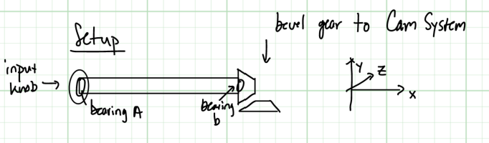
Figure 7 Sketch of input subsystem
The following figure represents the FBD of the input shaft. The diagram shows a set of forces (tangential force $〖{\left(F\right)}_{t})$, radial force $〖{\left(F\right)}_{r})$, axial force $〖{\left(F\right)}_{a})$) acting on the shaft due to the input torque $〖{\left(T\right)}_{in})$ at the point of contact of the gears.
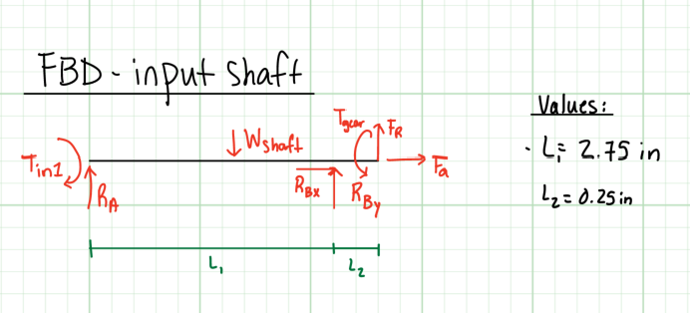
Figure 8 FBD of input subsystem
In order to make sure that the support used in the input actuation subsystem are reliable, a special FBD was created for bearing B. Being the critical support element in the input actuation subsystem, it is subjected to the action of the total radial force and the complete axial force generated by the bevel gears.
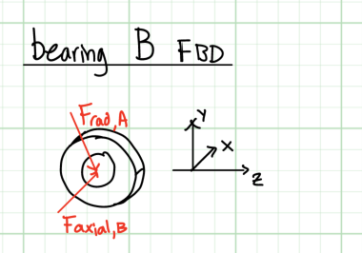
Figure 9 FBD of bearing
The power transmission subsystem is responsible for transferring torque from the driver sheave to the driven sheave. Below one can see the drawing showing spatial configuration of the V-belt system.

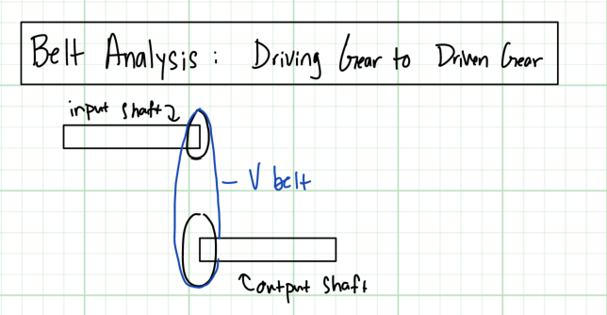
Figure 10 Sketch of transfer subsystem
In order to describe how the power is being transferred in the V-belt mechanism, one needs to look at its FBD. It describes the distribution of tensions in the belt and how these tensions allow it to transfer torque from the driver to the driven sheave. Below one can see the image of tight-side tension $〖{\left(F\right)}_{1})$ and slack-side tension ($〖{(F〗}_{2})$ that provide for overcoming $F_{t}$ tension and keep the belt fixed in the grooves.
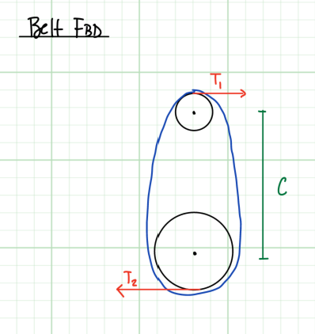
Figure 11 FBD of belt

6.3 Force / Torque Analysis
Static analyses of each of the mechanical elements were carried out by solving a set of equilibrium equations for each subassembly. These equations state that the sum of forces and sum of moments acting on the body must both equal to zero. This approach enabled calculating the necessary reactions on individual parts to prove that they will not surpass material strength and component design limits.
In the case of the input actuation mechanism, a torque of $T_{in}=50in.lbf$was considered. The tangential force $〖{\left(F\right)}_{t})$ at bevel gear pitch radius of $r_{g}=0.4742$in was found as $F_{t}=T_{in}/r_{g}$, which gave 105.84 lbf of tangential load. The radial ($F_{r}$) and axial ($F_{a}$) force components were calculated using the equations below based on the values of the pressure angle and the pitch angle of the miter gear set. With the help of the moment equation, which balances all external loads about the bearing supports, the reaction forces at Bearings A and B were resolved. It was established that Bearing B is the critical one as it carries the total radial reaction force ($F_{\left(rad,B\right)}$) of 119.22 lbf and the whole axial thrust ($F_{\left(axial,B\right)}$) of 27.24 lbf.
 | $$F_{t}=\frac{T_{in}}{r_{g}}$$ | [35]

 | $$F_{r}=F_{t}\tan{ϕ}\cos{γ}$$ | [36]

 | $$F_{a}=F_{t}\tan{ϕ}\sin{γ}$$ | [37]

In the power transmission system, the tensions needed to prevent belt slippage were calculated. For this purpose, the transmitted load ($F_{t}$) was first determined by the needs of the drive system. Then, the tension ratio of V-belt ($μ=0.3, θ=180°$) was used to calculate the tight-side tension ($F_{1}$) and slack-side tension ($F_{2}$). From the latter two, the initial belt tension ($F_{i}$) was estimated as 13.37 lbf. All calculations are included in Appendix A.
 | $$\frac{F_{1}-F_{c}}{F_{2}-F_{c}}=e^{μθ/\sin{β}}$$ | [38]

 | $$F_{i}=\frac{F_{1}+F_{2}}{2}$$ | [39]

6.4 Component Analysis
The testing process verifies all machine components which need to demonstrate their ability to withstand the specified operational loads. The analysis investigates three main components which make up the power transmission system including the bevel gear set, supporting ball bearings, and V-belt assembly. The system proves its reliability through tests which compare actual mechanical stresses and load requirements to both industrial standards and manufacturer specifications.
The bevel gear analysis begins with motion transfer through a 24-tooth MOD 1 standard miter gear set which connects to the input knob. The gear geometry requires a 45-degree pitch angle and a 20-degree pressure angle. The gear teeth receive a force of $F_{t}=105.84lbf$ which results from an input torque of $T_{i}n=50in.lbf$ and a pitch radius of $r_{g}=0.4724$ in. The tooth stress calculation uses American Gear Manufacturers Association (AGMA) equations for bending stress determination. The calculations use geometry factor ($J$) and face width ($F$) and overload/load distribution modifiers for their computation. The resulting bending stress is then compared to the allowable bending stress ($S_{A}T$) for the steel construction of the goBILDA gear to ensure no tooth failure occurs under peak loading.
 | $$S=\frac{F_{t}}{F}P_{d}K_{o}K_{v}\frac{K_{s}K_{m}}{K_{x}J}$$ | [40]

 | $$S_{all}=\frac{S_{at}K_{L}}{K_{T}K_{R}}$$ | [41]

The assessment of supporting hardware components requires complete bearing life analysis. The input shaft is supported by 1611 Series flanged ball bearings. Bearing B is the primary support element with a 119.22 lbf radial load and a 27.24 lbf axial thrust which combine to create its critical load. The system generates operational conditions, which require the determination of equivalent radial load ($F_{E}$) for these conditions. The required dynamic load rating ($C_{1}0$) is identified through the design life assumption of 2856 hours at a rotational speed of 60 RPM. The required value verifies that the bearing exceeds necessary performance criteria for the museum exhibit, which will last throughout its expected lifecycle, by comparing it to the manufacturer's catalog rating of 850 lbf.
 | $$F_{e}=X_{i}F_{r}+Y_{i}F_{a}$$ | [42]

The analysis of the V-belt assembly determines whether the system transmits power between the driving and driven sheaves in an effective manner. The system operates with a sheave, which has a pitch diameter of 4.25 in and a groove angle of 20 degrees. The analysis establishes two vital parameters, which include tight-side tension ($F_{1}$) and slack-side tension ($F_{2}$); these parameters enable the system to transmit torque efficiently without causing belt slip. The system requires its initial tension ($F_{i}$) to be defined through the tension ratio equation, which includes the coefficient of friction for rubber on a smooth sheave. The analysis ensures that the belt remains properly seated and functional during continuous user interaction, completing the validation of the mechanical transmission string.

 | $$C_{10}=F_{e}{\left(\frac{L_{D}n_{D}60}{L_{R}n_{R}60}\right)}^{1/a}$$ | [43]

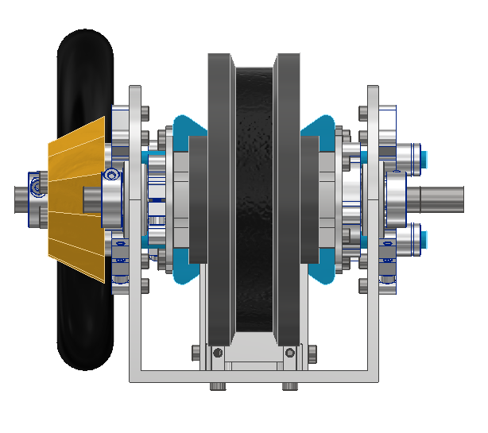
Figure 12 Frontal elevation view demonstrating the alignment of the input bevel gear set and the symmetrical arrangement of the pulley sheaves.

6.5 Stress & Failure Analysis
This section identifies and evaluates all critical failure modes that affect each main machine component. The analysis targets system points that experience maximum mechanical stress because these points serve as the most probable locations for component breakdown. The structural strength was confirmed by measuring its highest operational stresses and comparing those values to the material strength thresholds.
The bevel gear set is analyzed primarily for tooth bending failure. The critical point is identified at the root of the gear tooth, where the transmitted tangential force creates a maximum bending moment. The AGMA stress equations are used to calculate the actual bending stress $\left(S\right)$ by integrating both geometry factors and load distribution modifiers. This value is compared against the allowable bending stress ($S_{a}ll$) for the steel material used in the goBILDA gear. The manual input speed operates at a low level which results in surface wear and pitting becoming secondary issues when compared to the immediate danger of root fracture that occurs during peak user torque.
The analysis of support system failures concentrates on Bearing B because this component serves as the main support element which sustains overhung loads. The component will fail through two possible ways which include fatigue-induced surface bailing and permanent internal races deformation. The equivalent radial load ($F_{e}$) is computed to combine the 119.22 lbf radial reaction and 27.24 lbf axial thrust forces. The combined load determines the dynamic load rating ($C_{1}0$) which the exhibit needs to maintain throughout its entire duration. The failure criteria for the bearings is defined as the required load rating exceeding the actual manufacturer-rated capacity of 850 lbf.
The V-belt assembly could fail because of two possible examples: belt slip and tensile rupture. The analysis focuses on how the belt connects with the driving sheave. The maximum tensile stress occurs on the tight side of the belt ($F_{1}$), while the risk of slipping occurs if the initial tension ($F_{i}$) is insufficient to maintain the required friction ratio. The belt capacity to transmit motion without mechanical loss or slip is established through total allowable power ($H_{\left(a,total\right)}$) which is compared against nominal input power ($H_{n}om$). The evaluation examines all essential transmission points to confirm that they operate safely under maximum capacity.

6.6 Factor of Safety
The museum requires all essential machine components to maintain a minimum design Factor of Safety (FOS) which extends to 1.25. The purpose of this safety margin is to protect against all potential variations which may occur during operation through user-applied loads and changes in material characteristics and assembly process errors. The exhibit remains operational through repeated museum visitor use because the standard ensures its components stay intact.
The design Factor of Safety is calculated independently for each of the three primary transmission components. The FOS for the bevel gear set gets determined through the relationship between allowable bending stress ($S_{a}ll$) and actual AGMA bending stress ($S$). The support system determines its FOS through the comparison between its manufacturer's catalog dynamic load rating ($C_{1}0$) and the load rating which needs to be calculated based on system operation conditions. The safety margin of the V-belt assembly gets determined through the total allowable power ($H_{\left(a,total\right)}$) divided by the nominal input power ($H_{n}om$). The resulting values demonstrate that the design remains secure under all projected maximum load conditions which appear in the final results table.
 | $$H_{n}om=\left(T_{i}n⋅n\right)/63025$$ | [44]

 | $$n_{g}ear=S_{a}ll/S$$ | [45]

$$n_{b}earing=C_{\left(10,catalog\right)}/C_{\left(10,required\right)}$$ | [46]

$$n_{b}elt=H_{\left(a,total\right)}/\left(H_{n}omK_{s}\right)$$ | [47]

6.7 Results Summary
Table 1 Components and their factors of safety
Component | Max Stress/Load | Allowable/Rated | FOS
Bevel Gear | 21832 psi | 28440 psi | 1.30
Ball Bearing | 281.41 lbf | 850 lbf | 3.02
V-Belt | 0.0467 hp | 1.0700 hp | 22.48

7. ENGINEERING DESIGN UNDER CONSTRAINTS

7.1 Safety Considerations
The design used several safety features to ensure safe interaction for users of all ages, especially children. Potential pinch points exist between the moving belt and sheaves, as well as within the cam and follower mechanism. These hazards are mitigated with the use of protective guards and a transparent enclosure that prevents direct contact, while still allowing users to observe the system. All exposed edges are rounded, and the system operates at low speeds and input forces, reducing the risk of injury. Additionally, the range of motion of the cam and sheaves is physically constrained to prevent mechanical interference or unintended use.
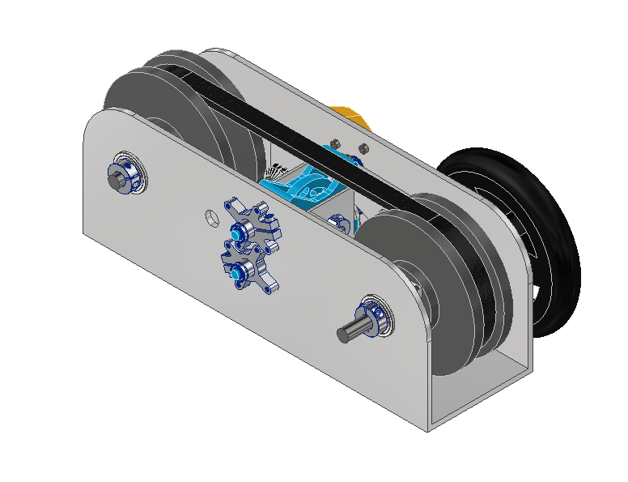
Figure 13 Rear perspective of the exhibit highlighting the support frame and protected internal components, designed to minimize pinch points for public safety.

7.2 Manufacturability
The system was designed with manufacturability as a primary consideration. Wherever possible, standard off-the-shelf components such as V-belts, bearings, and shafts are utilized to reduce cost and complexity. Custom components, including the cam plate and sheaves, are designed for ease of fabrication using common processes such as CNC machining or 3D printing. The cam slot geometry was generated using MATLAB and exported directly into CAD, ensuring precise and repeatable manufacturing. Minimum feature sizes, such as slot radius, were selected to avoid excessive tool wear and to maintain structural integrity during machining.

7.3 Cost Analysis
Cost efficiency was prioritized by minimizing the number of custom components and using available hardware. The use of standard components reduces both material costs and assembly time. The estimated total cost of the system is approximately $____, depending on material selection and manufacturing method and is determined to be an acceptable cost range for an educational exhibit. The design also avoids the need for specialized components or complex assemblies, further reducing costs.

7.4 Reliability & Maintenance
The system is designed for constant operation in a public setting, which requires high reliability and minimal maintenance. Operating at low speeds and loads reduces wear on critical components such as the belt, bearings, and cam surfaces. Materials were selected to provide adequate strength and wear resistance, ensuring long service life. The belt and bearings are considered consumable components and can be easily replaced if necessary. The simplified number of moving parts further enhances reliability and reduces the likelihood of failure.

7.5 Usability
The exhibit is designed to be intuitive and accessible to users of all ages. A single hand-operated dial provides a simple and engaging interface, allowing users to directly observe the effect of their input on the transmission ratio. The relationship between pulley diameter and speed is visually apparent, reinforcing the educational objective. The required input force is low, allowing children to easily operate the system without assistance. Together, the design emphasizes interactivity and ease of use, making it well-suited for a museum environment.

8. ETHICS, SAFETY, AND SOCIETAL IMPACT

8.1 Public Safety Risks and Mitigation Strategies
Going into a place like COSI, safety is the primary concern. Our design involves moving components that bring potential safety risks to the general public. The primary risk is fingers getting caught and pinched between the moving half-sheaves or between the V-belt and the pulleys. To address this, the final design will have a clear plastic shield. This will allow for complete visibility of the mechanical concept while preventing people from physically reaching the moving parts. Mechanical failure is another potential risk to the public. To prevent components from breaking or yielding, a minimum design safety factor of 1.25 is applied to all the structural elements in our design. Specifically, the follower pins have a calculated factor of safety of 58.9, well above our minimum, guaranteeing that they can withstand any aggressive or even improper use by the public. The final major safety risk is the cam slots potentially trapping fingers. The design addresses this by making sure that the only part that is accessible to the user is the knob itself with the cam being guarded by the same clear plastic.

8.2 Potential Failure Modes and Consequences
The potential failure modes were looked into to make sure that the design can stay operational and safe during the entire lifecycle. One failure mode that was chosen is the gradual wear of the BX32 V-belt. While its potential wear and stretching doesn’t pose any risk to the safety of the public, it would lose or diminish its primary goal of educating the public on continuously variable transmissions. To address this, the design uses a standard off-the-shelf belt to make sure that any maintenance or replacements can be done easily and cost-effectively by the staff during inspections. Another potential mode of failure is fatigue and wear on the follower pins from the continuous sliding in the cam slots. To prevent constant replacement or maintenance, using hardened steel pins would reduce the wear as well as using linear guides that do not require lubrication. The final addressed potential failure mode is the loosening of any fasteners or bolts from the constant use and vibrations. The best way to counter this would be to use nyloc nuts or thread-locking fluid so that the fasteners would not need to be adjusted regularly.

8.3 Ethical Responsibility in Public-Facing Design
With a public exhibit, any design must be both functional and honest about the mechanical principles that are being displayed. This design prioritizes both by making sure that our mechanism is accurately demonstrating the concepts of mechanical advantage rather than showing something that is overly simplified or purely decorative and visual. With using MATLAB to solve our nonlinear belt equations and generate our cam profiles, our design reflects the math and engineering that goes into designing a CVT. This means that any information that our design gives to the public is accurate and based in engineering principles and design. Also, the design balances mechanical complexity and safety to the public, making sure that it is not overly complex so that it would not have additional unnecessary safety risks.

8.4 Accessibility and Inclusivity Considerations
The design was made to be usable by anyone regardless of their physical ability or background. While it was designed to fit within a 10 x 10 x 10 ft volume, the actual mechanism is more at a table height so that the knob is reachable and visible to children and adults. The user interaction is also kept very simple, making it easy to understand regardless of the user's age. The system is designed to require a very low amount of input torque, making sure that children and those with little grip strength can still properly use the mechanism. Finally, using a very hands-on mechanism with both the adjustable cam and the knob, it allows kids to learn through physical feedback as opposed to solely visual which makes it applicable to a wider range of learning styles.

8.5 Environmental Impact
The lifecycle of the exhibit was considered to minimize its environmental footprint. The frame and pulleys can be made with materials like aluminum or plastics so they can be recycled at the end of the exhibits lifecycle without sacrificing a lot of durability. Another aspect of the design that promotes sustainability is how modular it is. Individual components like the bearings, belts, or pins can be replaced as they wear out without needing to discard other parts of the design. By selecting standard sizes for components, the design reduces a lot of environmental waste that comes with producing specialized custom parts. Because our exhibit is purely hand-powered and mechanical, it requires zero electricity to operate. This means that after its initial construction it will have a very small ongoing carbon footprint.

8.6 Economic and Societal Impact
Besides the function of the mechanism itself, the exhibit would have a broader impact on the community as a whole. By using standard off-the-shelf parts from vendors like McMaster-Carr, the design remains economically realistic for a museum such as COSI. On a societal level, the exhibit demonstrates continuously variable transmissions, something that is still utilized in many vehicles today. By having a simple and interactive model, the exhibit can properly show those in the museum, especially kids, how concepts learned in the classroom can eventually be used for real world application. This educational impact serves a big role societally because it potentially sparks an interest in engineering careers and increases the general public's knowledge of machines in the automotive industry.

9. COST AND BILL OF MATERIALS
Table 2 Bill of Materials
Cost Analysis of Materials
Purchased Components
Part | Manufacturer | Price | Quantity | Total Price
Linear Ball Bearings
8mm ID Linear Ball Bearing (15mm OD, 24mm Length) | GoBilda | 4.99 / 2 Pack | 2 | 8.98
12mm ID Linear Ball Bearing (21mm OD, 30mm Length) | GoBilda | $5.99 / 2 Pack | 2 | 11.98
Ball Bearings
32mm Bore 2-Side, 2-Post Pillow Block (43mm Width) | GoBilda | $13.99 | 4 | 55.96
Flanged Ball Bearing (8mm REX® ID x 14mm OD, 5mm Thickness) | GoBilda | $5.99 / 2 Pack | 2 | 11.98
12mm ID Flanged Ball Bearing (32mm OD, 10mm Thickness) | GoBilda | $5.99 | 4 | 23.96
32mm ID Flanged Ball Bearing (39mm OD, 5mm Thickness) | GoBilda | $11.99 | 1 | $11.99
Hubs
Clamping Hub (15mm Bore) | GoBilda | $7.99 | 4 | 31.96
Clamping Hub (32mm Bore) | GoBilda | $7.99 | 4 | 31.96
Aluminum Clamping Collar (12mm ID x 26mm OD, 9mm Length) | GoBilda | $5.99 | 4 | 23.96
Sonic Hub (8mm REX® Bore) | GoBilda | $7.99 | 2 | 15.98
Aluminum Clamping Collar (8mm REX® ID x 20mm OD, 9mm Length) | GoBilda | $4.99 | 1 | $4.99
Shafts
12mm Shaft (Stainless Steel, 200mm Length) | GoBilda | $6.39 | 1 | $6.39
12mm Shaft (Stainless Steel, 150mm Length) | GoBilda | $5.29 | 1 | $5.29
8mm REX® Shaft with E-Clip (Stainless Steel, 72mm Length) | GoBilda | $4.89 | 2 | 9.78
Other
Steel Miter Gear (8mm REX® Bore, 24 Tooth, MOD 1) | GoBilda | $15.99 | 2 | 31.98
M4 x 0.7mm Zinc-Plated Socket Head Screw | Gobilda | $3.39 /25 Pack | 3 | 10.17
Quad Block Pattern Mount | Gobilda | $6.99 | 2 | 13.98
4mm ID Spacer (6mm OD, 22mm Length) | Gobilda | $3.14 / 4 Pack | 1 | $3.14
BX32 Cogged V-Belt | McMaster | 21.49 | 1 | 21.49
Total Ordered Parts Cost |  |  |  | 335.92
Total Ordered Parts Cost (Tax/Shipping) - Estimated |  |  |  | 399.51
Custom Components
Part | Material | Price | Quantity | Estimated Cost
3D Printed
Driven Half Sheave | PLA | 1kg/$25 | .75kg | $37.50
Drive Half Sheave | PLA | 1kg/$25 | .3kg | $17.50
Dial | PLA | 1kg/$25 | .075kg | $1.88
Wheel | PLA | 1kg/$25 | .3kg | $7.50
Cam | PLA | 1kg/$25 | .01kg | 0.25
Pin Slide | PLA | 1kg/$25 | .05kg | 1.25
Laser Cut & Bent
Gear Housing | Aluminum | $12.00 | 2 | 24
Translation Arm | Aluminum | $4.00 | 4 | 16
Housing Channel | Aluminum | $50.00 | 1 | 50
Total Custom Parts Cost |  |  |  | 155.88
Total Parts Cost - Estimated |  |  |  | 555.39

10. DRAWINGS AND VISUALS

10.1 Assembly Drawings
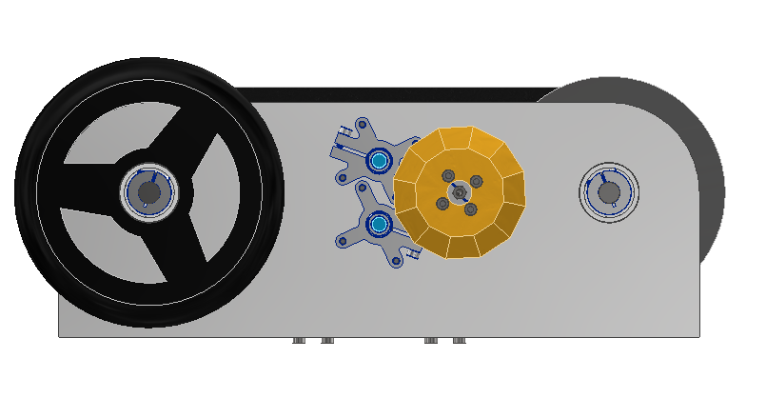
Figure 14 Side profile of the exhibit showing the manual input wheel and the visible alignment of the primary driver and driven shafts.

Figure 15 Detailed view demonstrating the alignment of the input bevel gear set and the symmetrical arrangement of the split pulley sheaves.
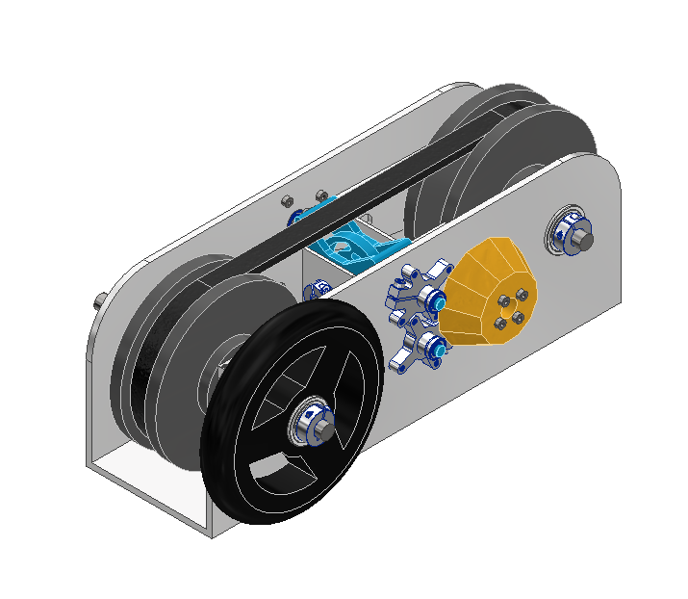
Figure 16 Full perspective highlighting the compact frame housing and the integration of the cam-driven actuation system.
Figure 17 View highlighting the support frame and protected internal components designed to minimize pinch points for public safety.
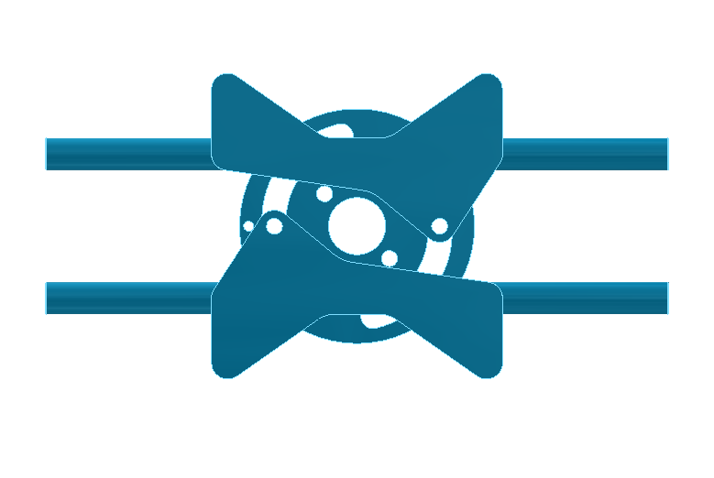
Figure 18 A direct view of the slotted cam disk illustrating the custom-generated nonlinear paths used to translate rotational input into axial sheave displacement.
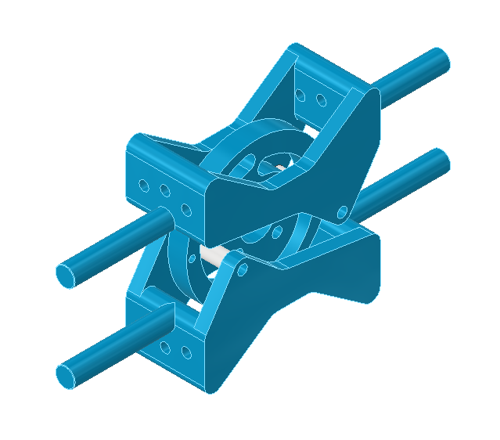
Figure 19 Close-up of the internal mechanism showing how the follower pins are constrained to linear paths while riding in the rotating cam slots.
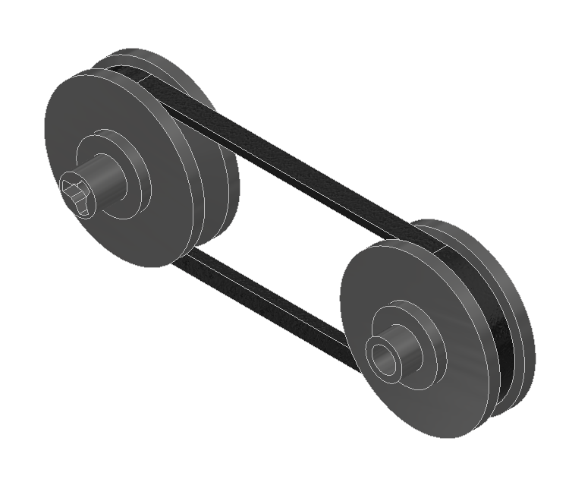
Figure 20 Isometric view of the BX32 V-belt seated within the two split pulleys at the 1:1 initial diameter condition.
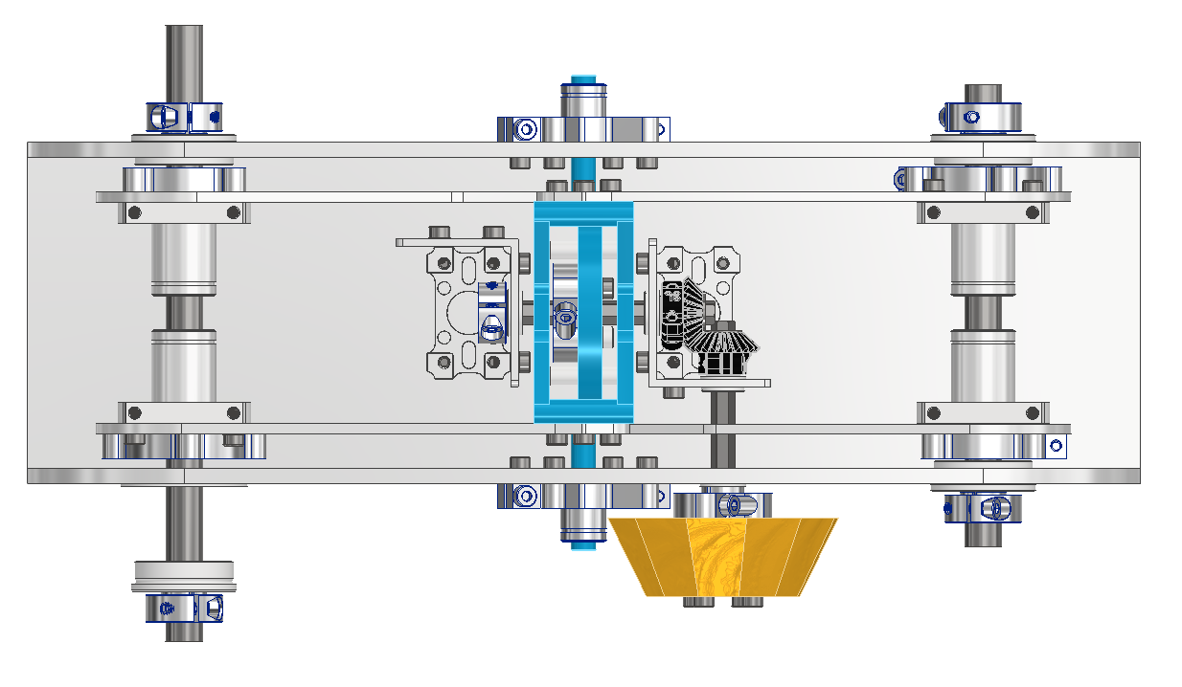
Figure 21 Technical view used to verify center distance (C = 10.186 in) and ensure there is no mechanical interference between moving subsystems.

10.2 Component Drawings
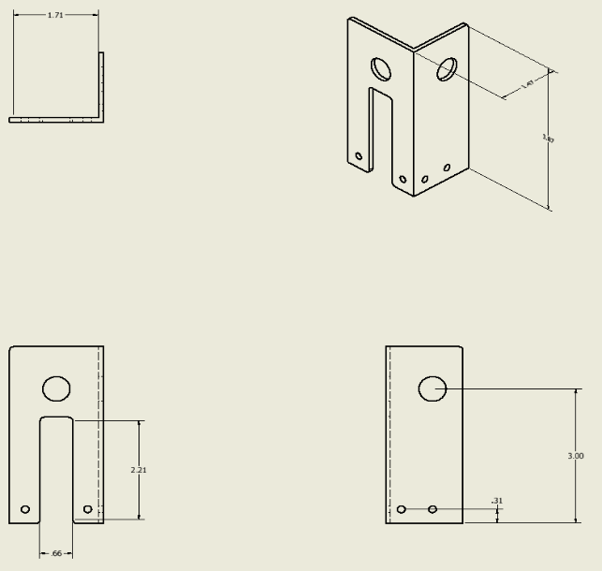
Figure 22 Gear Housing - Aluminum
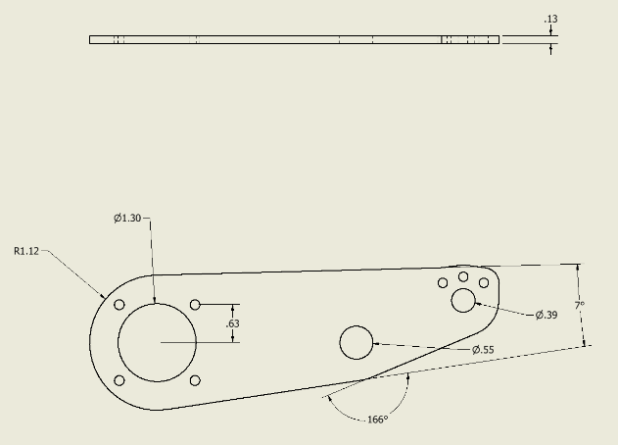
Figure 23 Translational Arm - Aluminum
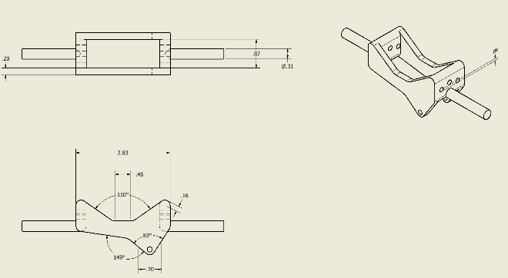
Figure 24 Pin Follower Housing - PLA
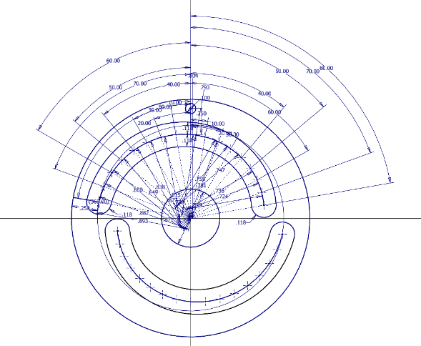
Figure 25 Cam - PLA
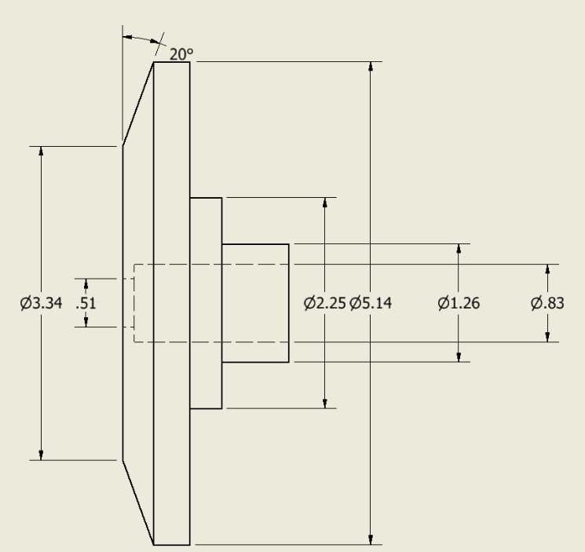
Figure 26 Driven Half Sheave - PLA
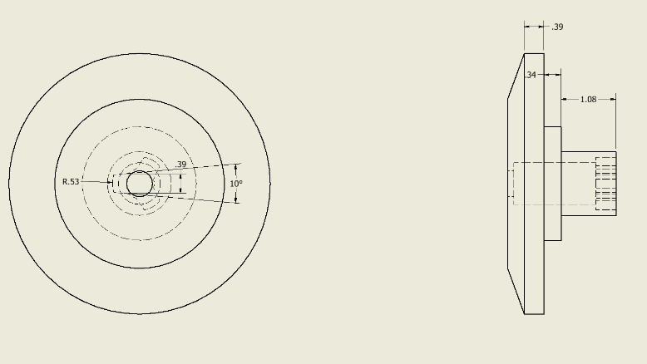
Figure 27 Driving Half Sheave - PLA
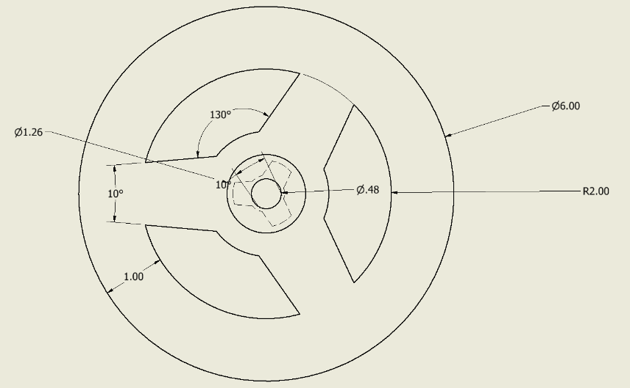
Figure 28 Wheel - PLA
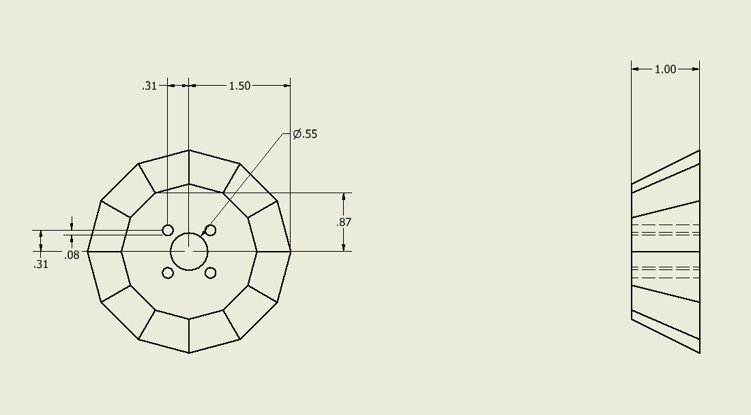
Figure 29 Dial - PLA

10.3 Exploded View
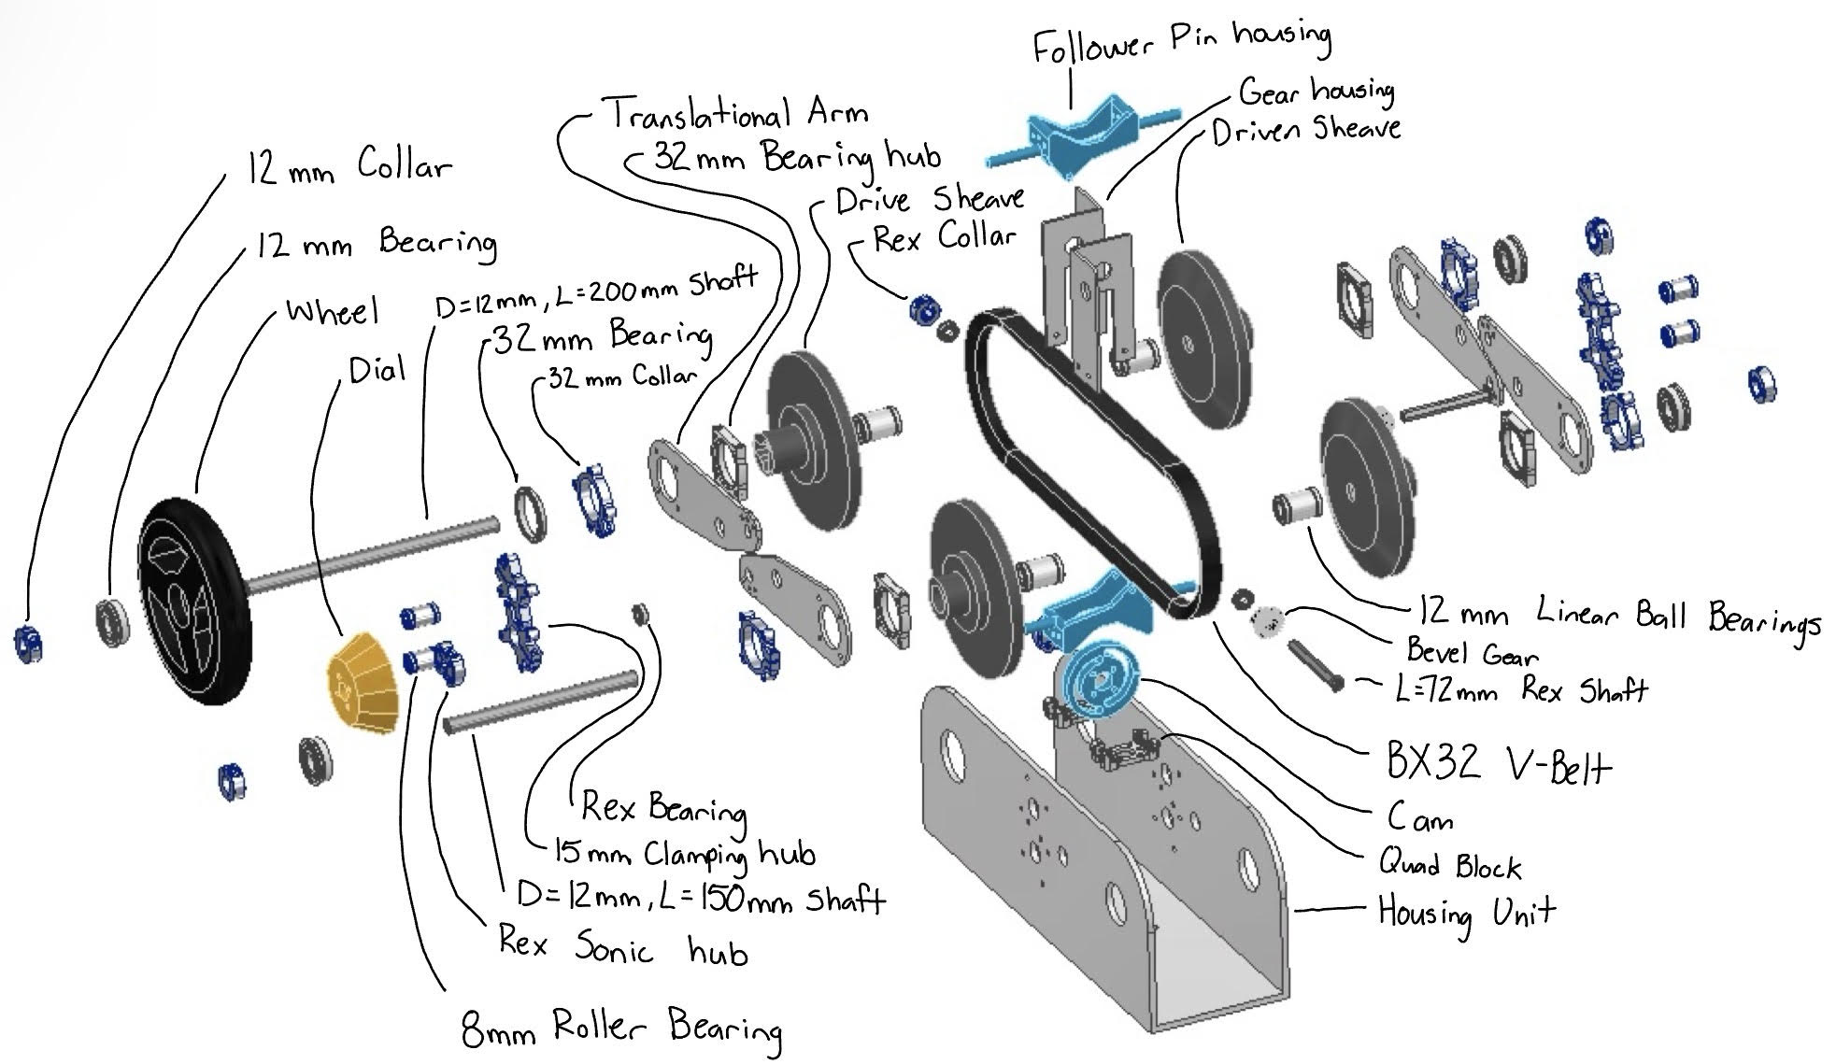
Figure 30 Exploded view of CVT with labeled components

11. CONCLUSION AND RECOMMENDATIONS

CONCLUSION
The objective of this project was to design a simplified and interactive model of a continuously variable transmission that could be used as an educational exhibit at COSI. The final design successfully demonstrated how a CVT operates by allowing the user to directly control the pulley diameters and visually see the change in transmission ratio.
The system uses a V-belt between two variable-diameter pulleys that are actuated by a slotted cam mechanism. This configuration allows one pulley to increase in pitch diameter, while the other decreases the correct amount, maintaining belt tension and producing a continuous ratio variation. The center position corresponds to a 1:1 ratio, and rotating the input knob will produce a smooth, continuous change in transmission ratio.
The engineering analysis, supported by the MATLAB modeling, confirms that this design satisfies the primary geometric and kinematic requirements. The belt pitch length remains relatively constant throughout operation, the sheave geometry prevents interference or overlap, and the cam slot profiles provide the required motion for the system. Packaging constraints, such as center distance and cam size, were also taken into account and verified to ensure the system is able to be physically implemented.
The MATLAB model was also used to solve for the nonlinear belt equations and was used to enforce constraints such as minimum slot radius and no sheave overlap. The generated cam slot coordinates are able to be directly implemented on CAD.
In addition to meeting functional requirements, the design achieves its educational goal by clearly illustrating the relationship between pulley geometry and speed ratio. The motion of the belt and sheaves is visible and directly tied to user input, making the system intuitive and engaging for a general audience.
In addition to meeting all functional requirements, the design also achieves its educational goal by clearly and simply illustrating the relationship between pulley geometry and speed ratio. The motion of the belt and sheaves is clearly visible and directly tied to the user input, making the system easily intuitive and engaging for the target audience.
Overall, the CamShift CVT System provides a mechanically accurate, visually clear, and interactive model of a continuously variable transmission behavior, making it a great science museum exhibit for kids.

RECOMMENDATIONS
While the current design meets all of the primary objectives of the project, there are several improvements that could be made to improve its accuracy, durability, and overall performance.
First, better refinement of the cam slot geometry would help. Because the constant pitch-length equation shows a nonlinear relationship between the pulley diameters, the two cam slot profiles might need to be optimized in order to perfectly match the required motion of each pulley. Future work could focus on refining the slot shapes so that the system more closely follows the exact theoretical position throughout the full range of operation.
Second, this design currently relies on an approximate belt pitch length based on the belt thickness. This approximation is good enough for preliminary design, but using manufacturer-specific pitch correction data would greatly improve accuracy and better represent real-world belt behavior. This would also lead to a more precise prediction of pulley diameters and transmission ratios.
Third, the analysis assumes ideal belt behavior with no slip, deformation, or frictional losses. In an actual physical implementation of this design, these effects would impact the system's performance. Building and testing a prototype would allow for experimental validation of the model, while also providing insight into real-world effects such as belt slip, wear, and friction. This would help refine both the analytical model and the physical design.
From a structural perspective, additional analysis should be conducted on key load-bearing components such as the cam disk, follower pins, and shafts. Verifying stresses and ensuring that all components meet the required factor of safety would strengthen the design and confirm that it is ready for repeated use in public.
Finally, improvements to the user interface should be taken into consideration to enhance the overall educational aspect of the exhibit. Adding a clearly labeled transmission ratio indicator would help users understand how their input is actually affecting the system. While the current design already implements a protective enclosure, further improving visual cues and labeling could make the system more intuitive and engaging for users.
With these improvements, the design could be further developed into a robust, accurate, and highly effective educational exhibit that clearly demonstrates the principles of continuously variable transmissions in a real-world context.

12. SUMMARY/POSTER
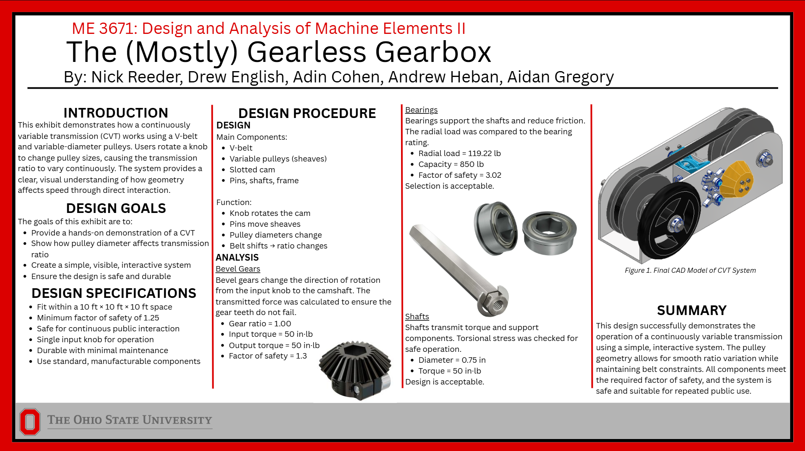

13. REFERENCES
[1] Mechanical Engineering Department, "ME 3671 Term Project Brainstorming Assignment," The Ohio State University, Columbus, OH, Assignment Guidelines, 2026.
[2] R. G. Budynas and J. K. Nisbett, Shigley's Mechanical Engineering Design, 11th ed. New York, NY, USA: McGraw-Hill, 2020.
[3] McMaster-Carr, "BX32 Cogged V-Belt," McMaster-Carr Catalog, 2026. [Online]. Available: https://www.mcmaster.com/.
[4] goBILDA, "Steel Miter Gear (8mm REX® Bore, 24 Tooth, MOD 1)," goBILDA Product Documentation, 2026. [Online]. Available: https://www.gobilda.com/.
[5] goBILDA, "1611 Series Flanged Ball Bearing (8mm REX® ID x 14mm OD)," goBILDA Product Documentation, 2026. [Online]. Available: https://www.gobilda.com/.
[6] goBILDA, "8mm ID Linear Ball Bearing (15mm OD, 24mm Length)," goBILDA Product Documentation, 2026. [Online]. Available: https://www.gobilda.com/8mm-id-linear-ball-bearing-15mm-od-24mm-length-2-pack/
[7] goBILDA, "12mm ID Linear Ball Bearing (21mm OD, 30mm Length)," goBILDA Product Documentation, 2026. [Online]. Available: https://www.gobilda.com/12mm-id-linear-ball-bearing-21mm-od-30mm-length-2-pack/
[8] goBILDA, "Ball Bearings," goBILDA Product Documentation, 2026. [Online]. Available: https://www.gobilda.com/bearings/
[9] goBILDA, "32mm Bore 2-Side, 2-Post Pillow Block (43mm Width)," goBILDA Product Documentation, 2026. [Online]. Available: https://www.gobilda.com/32mm-bore-2-side-2-post-pillow-block-43mm-width/
[10] goBILDA, "1611 Series Flanged Ball Bearing (8mm REX® ID x 14mm OD, 5mm Thickness)," goBILDA Product Documentation, 2026. [Online]. Available: https://www.gobilda.com/1611-series-flanged-ball-bearing-8mm-rex-id-x-14mm-od-5mm-thickness-2-pack/
[11] goBILDA, "12mm ID Flanged Ball Bearing (32mm OD, 10mm Thickness)," goBILDA Product Documentation, 2026. [Online]. Available: https://www.gobilda.com/12mm-id-flanged-ball-bearing-32mm-od-10mm-thickness/
[12] goBILDA, "32mm ID Flanged Ball Bearing (39mm OD, 5mm Thickness)," goBILDA Product Documentation, 2026. [Online]. Available: https://www.gobilda.com/32mm-id-flanged-ball-bearing-39mm-od-5mm-thickness/
[13] goBILDA, "Hubs," goBILDA Product Documentation, 2026. [Online]. Available: https://www.gobilda.com/hubs/
[14] goBILDA, "1302 Series Clamping Hub (15mm Bore)," goBILDA Product Documentation, 2026. [Online]. Available: https://www.gobilda.com/1302-series-clamping-hub-15mm-bore/
[15] goBILDA, "1302 Series Clamping Hub (32mm Bore)," goBILDA Product Documentation, 2026. [Online]. Available: https://www.gobilda.com/1302-series-clamping-hub-32mm-bore/
[16] goBILDA, "2910 Series Aluminum Clamping Collar (12mm ID x 26mm OD, 9mm Length)," goBILDA Product Documentation, 2026. [Online]. Available: https://www.gobilda.com/2910-series-aluminum-clamping-collar-12mm-id-x-26mm-od-9mm-length/
[17] goBILDA, "1309 Series Sonic Hub (8mm REX® Bore)," goBILDA Product Documentation, 2026. [Online]. Available: https://www.gobilda.com/1309-series-sonic-hub-8mm-rex-bore/
[18] goBILDA, "2910 Series Aluminum Clamping Collar (8mm REX® ID x 20mm OD, 9mm Length)," goBILDA Product Documentation, 2026. [Online]. Available: https://www.gobilda.com/2910-series-aluminum-clamping-collar-8mm-rex-id-x-20mm-od-9mm-length/
[19] goBILDA, "12mm Shaft (Stainless Steel, 200mm Length)," goBILDA Product Documentation, 2026. [Online]. Available: https://www.gobilda.com/12mm-shaft-stainless-steel-200mm-length/
[20] goBILDA, "12mm Shaft (Stainless Steel, 150mm Length)," goBILDA Product Documentation, 2026. [Online]. Available: https://www.gobilda.com/12mm-shaft-stainless-steel-150mm-length/
[21] goBILDA, "8mm REX® Shaft with E-Clip (Stainless Steel, 72mm Length)," goBILDA Product Documentation, 2026. [Online]. Available: https://www.gobilda.com/8mm-rex-shaft-with-e-clip-stainless-steel-72mm-length/
[22] goBILDA, "Clamping Steel Miter Gear (8mm REX® Bore, 24 Tooth, MOD 1)," goBILDA Product Documentation, 2026. [Online]. Available: https://www.gobilda.com/clamping-steel-miter-gear-8mm-rex-bore-24-tooth-mod-1/
[23] goBILDA, "M4 x 0.7mm Zinc-Plated Socket Head Screw," goBILDA Product Documentation, 2026. [Online]. Available: https://www.gobilda.com/
[24] goBILDA, "Quad Block Pattern Mounts," goBILDA Product Documentation, 2026. [Online]. Available: https://www.gobilda.com/quad-block-pattern-mounts/
[25] goBILDA, "1502 Series 4mm ID Spacer (6mm OD, 22mm Length)," goBILDA Product Documentation, 2026. [Online]. Available: https://www.gobilda.com/1502-series-4mm-id-spacer-6mm-od-22mm-length-4-pack/

14. APPENDIX

Appendix A – MATLAB Script and Plots

A1:
clear;
clc;
close all;
% Inputs
beltName = 'BX32';
beltOuterLength = 35.0; % [in]
beltTopWidth = 21/32; % [in]
beltThickness = 0.4063; % [in]
pitchDiameter0 = 4.25; % initial 1:1 pitch diameter [in]
vAngle = 40; % groove angle [deg]
halfAngle = vAngle/2;
camSweep = 160;
camMaxAngle = camSweep/2;
camMinAngle = -camMaxAngle;
minSlotRadius_mm = 18;
safety_mm = 0.1;
minSlotRadius_in = (minSlotRadius_mm + safety_mm)/25.4;
camAllowance = 0.5;
centerClearance = 5;
numPoints = 17;
notchStep = 0.1;
% Belt Geometry
beltBottomWidth = beltTopWidth - 2*beltThickness*tand(halfAngle);
pitchWidth = beltTopWidth - beltThickness*tand(halfAngle);
pitchLength = beltOuterLength - pi*beltThickness;
% Center Distance
centerDist = (pitchLength - pi*pitchDiameter0)/2;
if centerDist <= 0
error('Invalid geometry');
end
radius0 = pitchDiameter0/2;
% Ratio Limits
span = beltBottomWidth/tand(halfAngle);
sumDiam = (2/pi)*(pitchLength - 2*centerDist - span^2/(4*centerDist));
Dmin = (sumDiam - span)/2;
Dmax = (sumDiam + span)/2;
Rt_min = Dmin/Dmax;
Rt_max = Dmax/Dmin;
% Sheave Geometry
rInner = Dmin/2 - beltThickness/2;
rOuter = Dmax/2 + beltThickness/2;
sheaveMin = 2*rInner;
sheaveMax = 2*rOuter;
% Cam Mapping
angles = linspace(camMinAngle, camMaxAngle, numPoints);
ratios = Rt_max.^(angles/camMaxAngle);
D1 = zeros(size(angles));
D2 = zeros(size(angles));
for i = 1:length(angles)
r = ratios(i);
if r >= 1
[dSmall, dLarge] = solveDiameters(1/r, pitchLength, centerDist);
D1(i) = dLarge;
D2(i) = dSmall;
else
[dSmall, dLarge] = solveDiameters(r, pitchLength, centerDist);
D1(i) = dSmall;
D2(i) = dLarge;
end
end
% Motion
motion1 = ((D1 - pitchDiameter0)/2)*tand(halfAngle);
motion2 = ((D2 - pitchDiameter0)/2)*tand(halfAngle);
% Slot Radius
allMotion = [motion1 motion2];
S0 = minSlotRadius_in - min(allMotion);
S1 = S0 + motion1;
S2 = S0 + motion2;
Smin = min([S1 S2]);
Smax = max([S1 S2]);
% Cam Size
camDiameter = 2*Smax + camAllowance;
% Coordinates
rad = deg2rad(angles);
x1 = S1.*sin(rad);
y1 = S1.*cos(rad);
x2 = S2.*sin(rad);
y2 = S2.*cos(rad);
% Output
fprintf("\nCVT RESULTS\n");
fprintf("Center Distance: %.3f in\n", centerDist);
fprintf("Ratio Range: %.3f to %.3f\n", Rt_min, Rt_max);
fprintf("Pitch Diameters: %.3f to %.3f in\n", Dmin, Dmax);
fprintf("Sheave Diameters: %.3f to %.3f in\n", sheaveMin, sheaveMax);
fprintf("Cam Diameter: %.3f in\n", camDiameter);
fprintf("Slot Radius Min: %.3f in\n", Smin);
fprintf("Slot Radius Max: %.3f in\n", Smax);
% Plots
figure;
plot(angles, ratios);
grid on;
xlabel('Cam Angle [deg]');
ylabel('Transmission Ratio (D1/D2)');
title('Transmission Ratio vs Cam Angle');
figure;
plot(angles, D1); hold on;
plot(angles, D2);
grid on;
xlabel('Cam Angle [deg]');
ylabel('Pitch Diameter [in]');
title('Pitch Diameters vs Cam Angle');
legend('D1 (Driver)', 'D2 (Driven)', 'Location', 'best');
figure;
plot(x1, y1, '-o'); hold on;
plot(x2, y2, '-o');
grid on; axis equal;
xlabel('x Position [in]');
ylabel('y Position [in]');
title('Cam Slot Centerlines');
legend('Slot 1 (Pin 1)', 'Slot 2 (Pin 2)', 'Location', 'best');
% Solver Function
function [dSmall, dLarge] = solveDiameters(r, L, C)
a = (1 - r)^2/(4*C);
b = (pi/2)*(1 + r);
c = 2*C - L;
rootsD = roots([a b c]);
rootsD = real(rootsD(abs(imag(rootsD)) < 1e-8 & real(rootsD) > 0));
dLarge = max(rootsD);
dSmall = r*dLarge;
end

CVT RESULTS
Center Distance: 10.186 in
Ratio Range: 0.791 to 1.264
Pitch Diameters: 3.747 to 4.738 in
Sheave Diameters: 3.341 to 5.144 in
Cam Diameter: 2.286 in
Slot Radius Min: 0.713 in
Slot Radius Max: 0.893 in
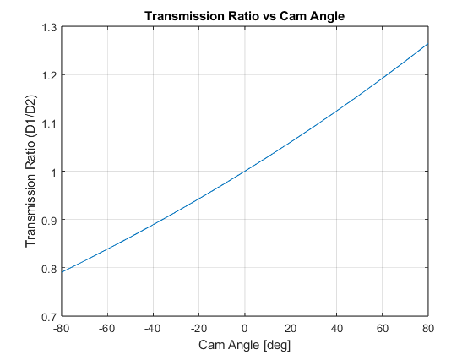
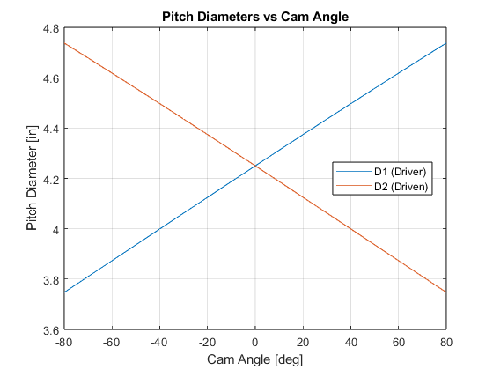
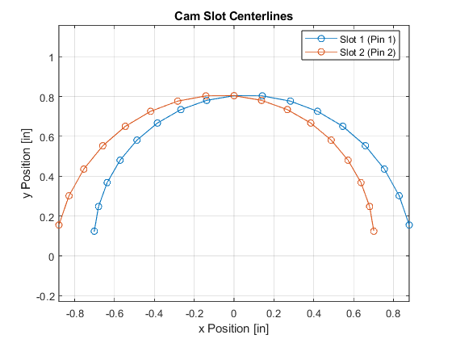
Published with MATLAB® R2024b

A2: Stress Safety Calcs
%% Initialization:

clear;
clc;
close all;

%% Bevel Gear (goBILDA 2320-4008-0024)

% Gear Variables:
m = 1; % (mm)
Pd = 25.4 / m; % (teeth/in)
Wt = 105.84; % (lbf) Calculated by hand
F = 0.315; % (in) from goBILDA website
J = 0.215; % Figure 15-7
Sat = 24000; % (psi) Table 15-6
Ko = 1; % Table 15-2
Kv = 1; % Figure 15-5
Km = 1.1; % Equation 15-11
Kx = 1.0; % Equation 15-13
KL = 1.185; % Equation 15-15 assumming 10^6 cycles
Ks = 0.5; % Equation 15-10
KT = 1; % Equation 15-18
KR = 1; % Table 15-3

% Calculations:
S = (Wt/F)*Pd*Ko*Kv*((Ks*Km)/(Kx*J));
Sall = (Sat*KL)/(KT*KR);
nGear = Sall/S;

% Command Window Output:
fprintf('Bevel Gear Analysis:\n');
fprintf(' Transmitted Tangential Load: %.2f lbf\n', Wt);
fprintf(' Calculated AGMA Bending Stress: %.0f psi\n', S);
fprintf(' Allowable Bending Stress: %.0f psi\n', Sall);
fprintf(' Factor of Safety (Bending): %.2f\n\n', nGear);

%% Ball Bearing (goBILDA 1611-0514-4008):

% Bearing Variables:
a = 3; % Chapter 11-3
Fr = 119.22; % (lbf) Calculated by hand
Fa = 27.24; % (lbf) Calculated by hand
nD = 60; % (rpm)
LD = 2856; % (hours) Assuming constant use
C10Catalog = 850; % (lbf) PBC Linear EPF08G data
X = 0.56; % Table 11-1
Y = 2.3; % Table 11-1
V = 1.0; % Chapter 11-6

% Calculations:
Fe = X*V*Fr + Y*Fa;
L90 = 60*LD*nD;
C10 = Fe*(L90/10^6)^(1/a);
nBearing = C10Catalog/C10;

% Command Window Output:
fprintf('Ball Bearing Analysis\n');
fprintf(' Critical Radial Load (Fr): %.2f lbf\n', Fr);
fprintf(' Critical Axial Load (Fa): %.2f lbf\n', Fa);
fprintf(' Equivalent Radial Load (Fe): %.2f lbf\n', Fe);
fprintf(' Required C10 Load Rating: %.2f lbf\n', C10);
fprintf(' Actual Catalog C10 Rating: %.0f lbf\n', C10Catalog);
fprintf(' Factor of Safety (C10 ratio): %.2f\n\n', nBearing);

%% V Belt:

% V-Belt Variables:
Tin = 50; % (in-lbf)
DPitch = 4.25; % (in)
mu = 0.3;
beta = 20; % (degrees)
theta = deg2rad(180); % (rad)
Ha = 1.07; % (hp) Table 17-12
NBelt = 1; % (# of belts)
KS = 1; % Table 17-15
nd = 1.25;

% Calculations:
Hnom = (Tin*nD)/63025;
Hd = Hnom*KS*nd;
Hatotal = Ha*NBelt;
nBelt = Hatotal/(Hnom*KS);
rSheave = DPitch/2;
FtBelt = Tin/rSheave;
tensionRatio = exp((mu*theta)/sind(beta));
F2 = FtBelt/(tensionRatio-1);
F1 = tensionRatio*F2;
Fi = (F1+F2)/2;

% Command Window Output:
fprintf('V-Belt Analysis\n');
fprintf(' Nominal Input Power (H_nom): %.4f hp\n', Hnom);
fprintf(' Total Allowable Power (Ha): %.4f hp\n', Hatotal);
fprintf(' Factor of Safety (Power): %.2f\n', nBelt);
fprintf(' Transmitted Load (Ft): %.2f lbf\n', FtBelt);
fprintf(' Tight Side Tension (F1): %.2f lbf\n', F1);
fprintf(' Slack Side Tension (F2): %.2f lbf\n', F2);
fprintf(' Required Initial Tension (Fi): %.2f lbf\n', Fi);

Output:
Bevel Gear Analysis:
Transmitted Tangential Load: 105.84 lbf
Calculated AGMA Bending Stress: 21832 psi
Allowable Bending Stress: 28440 psi
Factor of Safety (Bending): 1.30
Ball Bearing Analysis
Critical Radial Load (Fr): 119.22 lbf
Critical Axial Load (Fa): 27.24 lbf
Equivalent Radial Load (Fe): 129.42 lbf
Required C10 Load Rating: 281.41 lbf
Actual Catalog C10 Rating: 850 lbf
Factor of Safety (C10 ratio): 3.02
V-Belt Analysis
Nominal Input Power (H_nom): 0.0476 hp
Total Allowable Power (Ha): 1.0700 hp
Factor of Safety (Power): 22.48
Transmitted Load (Ft): 23.53 lbf
Tight Side Tension (F1): 25.13 lbf
Slack Side Tension (F2): 1.60 lbf
Required Initial Tension (Fi): 13.36 lbf

Appendix B – Hand Calculations

B1: System Drawings, FBDs, and Safety Calculations
