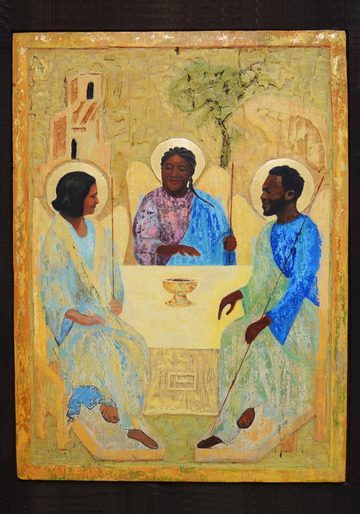
After Rublev by Meg Wroe
Available here: https://megwroe.com/new-gallery
Which Catholic teachings on the Trinity would you link to this picture?
________________________________________________________________________________________________________________________________________________________________________________________________
Which Bible stories might be relevant to this picture?
________________________________________________________________________________________________________________________________________________________________________________________________
Do you think it’s important to reimagine our understanding of the Trinity?
________________________________________________________________________________________________________________________________________________________________________________________________
What do you think this image is showing? Why?
________________________________________________________________________________________________________________________________________________________________________________________________

