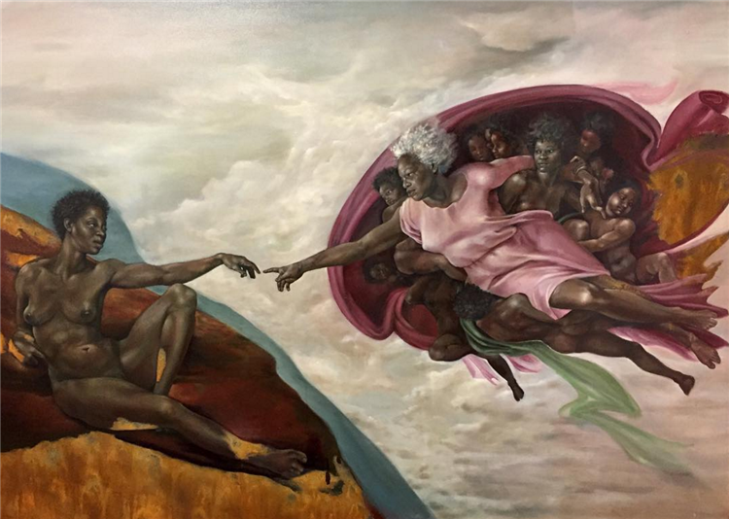
The Creation of God
This artwork is called ‘The Creation of God’ and is by American artist, Harmonia Rosales. Her artwork focuses on black female empowerment in Western culture, and is designed to encourage sympathy, empathy and empowerment.

Task: reflect on the painting and answer the questions below
- What similarities are there between this artwork and the ‘Creation of Adam’ by Michelangelo? __________________________________________________________________________________________________________________________________________________________________

- Which adjectives can you use to describe the impact of this painting? __________________________________________________________________________________________________________________________________________________________________

- Why do you think Rosales wanted to recreate the ‘Creation of Adam’ in this way? __________________________________________________________________________________________________________________________________________________________________

- If you had to give a caption to this artwork, taken from the Book of Genesis, which quotation would you use? _________________________________________________________________________________

- Rosales’ artwork is designed to encourage sympathy, empathy and empowerment. How does this painting achieve that purpose? __________________________________________________________________________________________________________________________________________________________________
This artwork can be found here: https://www.wikiart.org/en/harmonia-rosales/the-creation-of-god-2017 Harmonia Rosales’ website is as follows: https://www.harmoniarosales.art/

