Strong Tower Bible Study
Agenda
Lesson
Time 6:00pm -7:00pm
Study Topic: Willingness
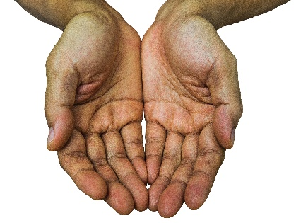
Welcome
Opening Prayer
Scripture Text: Matthew 8:1-4

Jesus Heals a Man With Leprosy
8 When Jesus came down from the mountainside, large crowds followed him. ² A man with leprosy^{[a]} came and knelt before him and said, “Lord, if you are willing, you can make me clean.”
³ Jesus reached out his hand and touched the man. “I am willing,” he said. “Be clean!” Immediately he was cleansed of his leprosy. ⁴ Then Jesus said to him, “See that you don’t tell anyone. But go, show yourself to the priest and offer the gift Moses commanded, as a testimony to them.”

Things to know:
The word Willing means: “Ready, Eager, or Prepared to do something” Also “Cheerfully consenting”
- Leprosy represented sin and defilement in the Bible, this also caused social emotional.

- Leprosy caused disfigurement, and often times there was a loss of limbs and life.
- Leprosy is known as Hansen’s disease now, which is some slow growing bacteria called (Mycobacterium leprae) pronounced “My-cro-bactreium leprae”

- Jesus is always willing

Discussion Questions:
- Have you ever needed something from the Lord but was not willing to be obedient?

- How important is obedience in receiving deliverance, healing or blessing from the Lord?

- What caused us to be disobedient?

- Does Jesus MAKE us have a willing spirit?

- What do you believed caused this man to have such great faith?

- What are you Willing to do for Christ?

Scriptures on Willingness:
Psalms 51:12
Matthew 26:41
Galatians 5:17
Galatians 5:23
1 Corinthians 2:4
Acts 7:51
2 Timothy 1:7
John 16:3
Luke 1:35

Closing Prayer:

