Strong Tower Bible Study
Agenda
Lesson 35
Time 6:00pm -7:00pm
Study Topic: God’s Promises
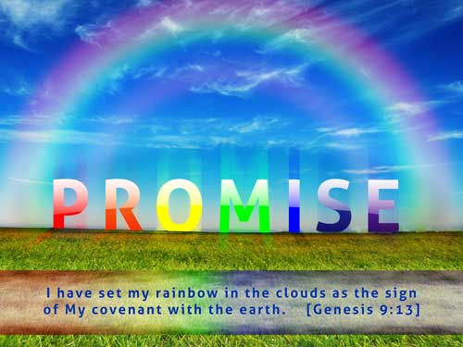
This Photo by Unknown Author is licensed under CC BY-SA-NC

Welcome
Opening Prayer
Scripture Text: Psalms 145:13
Additional Scripture: Numbers 23:19

Psalm 145^{[a]}

A psalm of praise. Of David.
¹ I will exalt you, my God the King;
I will praise your name for ever and ever.
² Every day I will praise you
and extol your name for ever and ever.
³ Great is the Lord and most worthy of praise;
his greatness no one can fathom.
⁴ One generation commends your works to another;
they tell of your mighty acts.
⁵ They speak of the glorious splendor of your majesty—
and I will meditate on your wonderful works.^{[b]}
⁶ They tell of the power of your awesome works—
and I will proclaim your great deeds.
⁷ They celebrate your abundant goodness
and joyfully sing of your righteousness.
⁸ The Lord is gracious and compassionate,
slow to anger and rich in love.
⁹ The Lord is good to all;
he has compassion on all he has made.
¹⁰ All your works praise you, Lord;
your faithful people extol you.
¹¹ They tell of the glory of your kingdom
and speak of your might,
¹² so that all people may know of your mighty acts
and the glorious splendor of your kingdom.
¹³ Your kingdom is an everlasting kingdom,
and your dominion endures through all generations.
The Lord is trustworthy in all he promises
and faithful in all he does.^{[c]}
¹⁴ The Lord upholds all who fall
and lifts up all who are bowed down.
¹⁵ The eyes of all look to you,
and you give them their food at the proper time.
¹⁶ You open your hand
and satisfy the desires of every living thing.
¹⁷ The Lord is righteous in all his ways
and faithful in all he does.
¹⁸ The Lord is near to all who call on him,
to all who call on him in truth.
¹⁹ He fulfills the desires of those who fear him;
he hears their cry and saves them.
²⁰ The Lord watches over all who love him,
but all the wicked he will destroy.
²¹ My mouth will speak in praise of the Lord.
Let every creature praise his holy name
for ever and ever.

Things to know:
- God is not like Man that he should lie
- God is eternal
- There is no one or nothing that can keep their Promise like God
- He is Holy — This is the most undebatable thing about God. ...
- He never lies. Whatever God says happens, maybe not when we expect it to but it ALWAYS comes to pass. ...
- He is love. ...
- He is omnipotent — ...
- He is merciful and gracious — ...
- He is good. ...
- He is glorious —

Discussion Questions:
- How easy is it for you to keep a promise?
- What promise is it hard for you to receive?
- How do you think David felt during his journey with God?
- Do you believe David ever doubted? (lets look at Psalms 13:1-6
- What should we always Remember?

Scriptures on God’s Promises:
Malachi 3:6
Jeremiah 1:5
Joshua 23:14
Colossians 1:12-13
Psalms 33:11
Psalms 147:3
1 Corinthians 13:8
Galatians 4:6
Philippians 2:13
1John 5:14

Closing Prayer

