Strong Tower Bible Study
Agenda
Lesson 42
Time 6:00pm -7:00pm
Study Topic: Being a Living Sacrifice
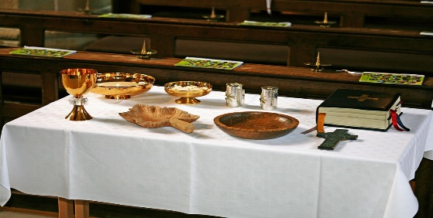

Welcome
Opening Prayer
Scripture Text: Romans 12:1-8

A Living Sacrifice
12 Therefore, I urge you, brothers and sisters, in view of God’s mercy, to offer your bodies as a living sacrifice, holy and pleasing to God—this is your true and proper worship. ² Do not conform to the pattern of this world, but be transformed by the renewing of your mind. Then you will be able to test and approve what God’s will is—his good, pleasing and perfect will.

Humble Service in the Body of Christ
³ For by the grace given me I say to every one of you: Do not think of yourself more highly than you ought, but rather think of yourself with sober judgment, in accordance with the faith God has distributed to each of you. ⁴ For just as each of us has one body with many members, and these members do not all have the same function, ⁵ so in Christ we, though many, form one body, and each member belongs to all the others. ⁶ We have different gifts, according to the grace given to each of us. If your gift is prophesying, then prophesy in accordance with your^{[a]} faith; ⁷ if it is serving, then serve; if it is teaching, then teach; ⁸ if it is to encourage, then give encouragement; if it is giving, then give generously; if it is to lead,^{[b]} do it diligently; if it is to show mercy, do it cheerfully.

Things to Know
- The word Sacrifice arrears over 200 times in the King James version of the Bible
- The word Sacrifice means to “Make and Offering of” To consecrate, to atone for, or to give thanks.
- Sin still vandalizes, offends, and disrespects God
- Our bodies and their abilities belong to the Lord
- Offering and Sacrifice are different.
- An offering is a gift
- A sacrifice is the act of surrendering “something” to atone for an offence or breech of agreement/covenant/relationship.

Discussion Questions:
- Why did the Israelites sacrifice in the Old Testament?
- Is it necessary to still offer sacrifices to GOD today?
- What does Paul mean by offering our bodies as a living sacrifice being our true and proper worship.?
- What are the patterns of this world?
- Why is humility challenging in the body of Christ?
- How can we remain humble regardless of our gift?

Sacrifice Scripture’s

Matthew 6:33
Matthew 9:13
Hebrews 13:6
Romans 5:8
1Corinthians 10:20
Hebrews 10:26
Philippians 2:4
Ephesians 5:2

Closing Prayer

