**Predictive Projects**

**eWorkbook Worksheets**





**6th Edition**

**Copyright Information**

**Baker, Dean A., 1945-**

***Predictive Projects eWorkbook Worksheet******s* 6th edition**

**This word file is a supplement for the *Predictive Projects eWorkbook,* 6th edition**

**It is not copyrighted and available for public use without any digital rights restrictions.**

**Distributed by**

**Team Implementers, LLC**

**38342 Humphrey Circle**

**North Ridgeville, Ohio 44039**

**Web:** [**www.TeamImplementers.com**](http://www.TeamImplementers.com)

**This publication contains information from authentic and highly regarded resources. Sources are indicated. Reasonable effort has been made to publish accurate information, but the author does not assume responsibility for the validity of all materials or consequences of their use.**

**The author, Dean A. Baker, grants permission to anyone that has purchased a copy or is using the *Predictive Projects eWorkbook* 6th edition in a course of study to reproduce, store, or transmit this publication of blank worksheets.**

**Microsoft and PowerPoint are either registered trademarks or trademarks of Microsoft Corporation in the United States and/or other countries.**

**PMI, PMP, and PMBOK are registered trademarks of the Project Management Institute, Inc. PMI does not endorse or otherwise sponsor this publication.**

**Contact the author at** [**DABaker@TeamImplementers.com**](mailto:DABaker@TeamImplementers.com)

**Table of Contents**

**Worksheet Access and Use . . . . . . iv**

**1.0 Project Overview Worksheets****. . . . . . 1**

**2.****0 Cooperate Worksheets****. . . . . . . 17**

1. **Communicate Worksheets****. . . . . . 35**
2. **Coordinate Worksheets.** **. . . . . . 57**
3. **Control Worksheets** **93**
4. **Complete Worksheets.** **. . . . . . 135**

**Worksheet Access and Use**

The *Predictive Projects eWorkbook Worksheets* 6th edition (*PP eWorkbook Worksheets*) is provided as a free download to anyone that has purchased or is using the *Predictive Projects eWorkbook*. in a course of study. This Word version of the worksheets provides a user-friendly editable worksheet free of watermarks and independent of the eWorkbook. It allows opening the *Predictive Projects eWorkbook* to the instructions, data page, or searching content, while the worksheet is opened in a second window beside it.

For quick access, the table of contents provides bookmarks to each chapter and the first page of each chapter provides a bookmark index to the individual worksheets. Place mouse on desired worksheet and hold the control button while left clicking to go to the selected chapter or worksheet within a chapter.

**Word Worksheet:** The *PP eWorkbook Worksheets* is a word file allowing students with computers flexibility to fully edit the worksheet using word for which they are familiar. The student or instructor uses “Share Screen” to edit the document while collaborating with a team or the whole class.

**Google Doc Worksheet**: Most worksheets can be edited simultaneously by the entire team or class, when converted from Word to Google Docs for a more collaborative experience. When exercises require consolidating the results from multiple teams, a single google doc worksheet for the class enables the summary to be filled automatically. Another benefit of the class google worksheet is that it enables everyone to have copies of all worksheets for future reference.

To set up the worksheets in google docs, extract all the worksheets for a specific class session from the *Predictive Projects eWorkbook Worksheets* and place in a word file with a unique name.If a worksheet is unique to each team, it will be necessary to create multiple copies to provide a worksheet for each team. Then upload, open, and save to Google docs. Ensure the file translated properly or make required corrections. Set up Edit and Share privileges. Provide a link to all students to access the worksheet file. Topics 4.2 and 4.3 worksheets use a landscape format and must be in a separate file from the other google worksheets. Topics 5.2 and 5.3 do not translate and require creating original google docs worksheets.

**1.0 Project Overview Worksheet Index**

**Worksheet Bookmark Page**

**1.1.1 Personal History****. . . . . . . 2**

**1.1.2 Class Charter****. . . . . . . . 3**

**1.2.1 Project Initiation Factors Worksheet** **. . . . 4**

**1.2.2 Strategic Project Worksheet** **. . . . . 5**

**1.2.3 Why Projects Fail** **. . . . . . 6**

**1.3.1 Project Examples Worksheet** **. . . . . 7**

**1.3.2 Executive Involvement in Projects** **. . . . 8**

**1.3.3 Project Roles Crossword Puzzle** **. . . . 9**

**1.4.1 Project Life Cycle Worksheet** **. . . . . 10**

**1.4.2 Course Project Description** **. . . . . 11**

**1.5.1 Preliminary Project Selection Worksheet** **. . . 12**

**1.5.2 Business Case Financials Project X Worksheet** **. . 13**

**1.5.3 Business Case Financials Bakersfield Worksheet** **. . 13**

**1.5.4 Multi-criteria Decisions Worksheet . . . . 15**

**1.1.1 Personal History Worksheet Student Name: ________________**

**Education and Experience**

**Family**

**Dislikes**

**Likes**

**1.1.2 Class Charter Worksheet**

**Relations & Attitude**

**Structure**

**Self-Managing**

**Communications**

**1.2.1 Project Initiation Factors Worksheet**

* **Team 1 -** **Market Demand, Social Need, & Environmental Considerations**
* **Team 2 -** **Business Need, Legal Requirements, & Economic Changes**
* **Team 3 - Technology Advance, Customer Request, and Material Issues**

**1.2.2 Strategic Project Worksheet**

* **Team 1 – GMI Strategic Considerations**
* **Team 2 – HTMI Strategic Considerations**
* **Team 3 – BCI Strategic Considerations**

**1.2.3 Why Projects Fail Worksheet Student Name: _____________________**

* **Failure Cause:**
* **Mitigation:**

* **Failure Cause:**
* **Mitigation:**
* **Failure Cause:**
* **Mitigation:**
* **References**

**1.3.1 Project Examples Worksheet**

* After giving students time to answer the questions, facilitate a class discussion. This can also be used as a subject for an online threaded discussion between class sessions.
* **Why do individuals, groups, companies, and governments perform projects?**

* **Project examples around the home**
* **Project examples in your personal life**
* **Project examples at work**

**1.3.2 Executive Involvement in Projects**

* After giving students time to answer the questions, facilitate a class discussion. This can also be used as a subject for an online threaded discussion between class sessions.
* **How closely should an executive monitor a project?**
* **What has been your experience with executives on your projects?**
* **Does an executive need project management training?**

**1.3.3 Project Roles Crossword Puzzle**

**ACROSS**

1. A not-for-profit professional organization to advance project management.
2. _________________involves on going activities to sustain a business.

6. The organization that will use the product/service/result from the project

10. Persons or organizations actively involved or impacted by the project

11. Collection of all projects and programs within an enterprise

13. Projects usually involve progressive ______________

14. External vendors that provide components/services to the project

**DOWN**

1. A Guide that establishes standard vocabulary for project management.

3. A Project creates a _______ product, service, or result.

4. Collection of related projects to meet specific company objectives

5. _______ managers carry out on going work and manage all tasks in their expertise

7. The people that directly utilize the project

8. An endeavor with specific beginning and end that creates a one of a kind result.

9. A Project's duration is _____________.

10. The person that provides the financial resources and champions the project

12. They provide specialized expertise, participate, and share risk in a project.

15. Work group with specific knowledge and skills that carry out a project

**Note: Size letters at 14 point to distinguish from the numbers set at 10.**

|  |  |  |  |  |  |  |  |  |  |  |  |  |  |  |  |
| --- | --- | --- | --- | --- | --- | --- | --- | --- | --- | --- | --- | --- | --- | --- | --- |
|  |  |  |  |  |  |  |  | **5** |  |  |  |  |  |  |  |
|  |  |  | **3** |  | **4** |  |  |  |  |  |  | **8** |  |  |  |
|  |  |  |  |  |  |  |  |  |  | **7** |  |  |  | **9** |  |
|  | **1** |  |  |  |  |  |  | **6** |  |  |  |  |  |  |  |
|  |  |  |  |  |  |  |  |  |  |  |  |  |  |  |  |
|  |  |  |  |  |  |  |  |  |  |  |  |  |  |  |  |
|  | **2** |  |  |  |  |  |  |  |  |  |  |  |  |  |  |
|  |  |  |  |  |  |  |  |  |  |  |  |  |  |  |  |
|  |  |  | **12** |  |  |  |  |  |  | **15** |  |  |  |  |  |
|  | **10** |  |  |  |  |  |  |  |  |  |  |  |  |  |  |
|  |  |  |  |  |  |  |  |  |  |  |  |  |  |  |  |
| **11** |  |  |  |  |  |  |  |  |  |  |  |  |  |  |  |
|  |  |  |  |  |  |  |  |  |  |  |  |  |  |  |  |
|  |  |  | **13** |  |  |  |  |  |  |  |  |  |  |  |  |
|  |  |  |  |  |  |  |  |  |  |  |  |  |  |  |  |
|  |  |  | **14** |  |  |  |  |  |  |  |  |  |  |  |  |

**1.4.1 Project Life Cycle Worksheet**

Project Phases

|  |  |  |  |  |  |  |  |  |  |  |  |  |  |  |  |  |  |  |  |  |
| --- | --- | --- | --- | --- | --- | --- | --- | --- | --- | --- | --- | --- | --- | --- | --- | --- | --- | --- | --- | --- |
| **Bar Graph of Project Phases** | | | | | | | | | | | | | | | | | | | | |
| **Project Phase** | **Time Scale** | | | | | | | | | | | | | | | | | | | |
|  |  |  |  |  |  |  |  |  |  |  |  |  |  |  |  |  |  |  |  |
|  |  |  |  |  |  |  |  |  |  |  |  |  |  |  |  |  |  |  |  |  |
|  |  |  |  |  |  |  |  |  |  |  |  |  |  |  |  |  |  |  |  |  |
|  |  |  |  |  |  |  |  |  |  |  |  |  |  |  |  |  |  |  |  |  |
|  |  |  |  |  |  |  |  |  |  |  |  |  |  |  |  |  |  |  |  |  |
|  |  |  |  |  |  |  |  |  |  |  |  |  |  |  |  |  |  |  |  |  |
|  |  |  |  |  |  |  |  |  |  |  |  |  |  |  |  |  |  |  |  |  |
|  |  |  |  |  |  |  |  |  |  |  |  |  |  |  |  |  |  |  |  |  |
|  |  |  |  |  |  |  |  |  |  |  |  |  |  |  |  |  |  |  |  |  |
|  |  |  |  |  |  |  |  |  |  |  |  |  |  |  |  |  |  |  |  |  |
|  |  |  |  |  |  |  |  |  |  |  |  |  |  |  |  |  |  |  |  |  |
|  |  |  |  |  |  |  |  |  |  |  |  |  |  |  |  |  |  |  |  |  |
|  |  |  |  |  |  |  |  |  |  |  |  |  |  |  |  |  |  |  |  |  |
|  |  |  |  |  |  |  |  |  |  |  |  |  |  |  |  |  |  |  |  |  |
|  |  |  |  |  |  |  |  |  |  |  |  |  |  |  |  |  |  |  |  |  |

**1.4.2 Course Project Description Worksheet**

**Team or Student Name: ________________ Project Name:_________________**

* **Description**

* **Why Now & Benefits**
* **Phases, Duration, and Milestones**
* **Resources and Funds**

**1.5.1 Preliminary Project Selection Worksheet**

* **Compare the Bakersfield New Tech Equipment and New Plant proposals. List the advantages of the New Tech Equipment proposal:**
* **Compare the Bakersfield New Tech Equipment and New Plant proposals. List the advantages of the New Plant proposal:**
* **Based on the preceding discussion regarding the advantages of the two proposals which option would you choose based on the current information?**

**1.5.2 Business Case Financials Project X Worksheet**

**Compute Payback**

**Compute ROI for year 5**



**1.5.3 Business Case Financials Bakersfield Worksheet**



Use the calculation tables on the following page for NPV.

**1.5.3 Bakersfield NPV Calculation Tables**







**1.5.4 Multicriteria Decisions Worksheet**

|  |  |  |  |  |  |  |  |  |
| --- | --- | --- | --- | --- | --- | --- | --- | --- |
| **Business Case Multicriteria Decision Making Worksheet** | | | | | | | | |
| **Parameter** | | **Score**  **Weight** | **Hi Tech**  **Equipment** | | **New Plant**  **California** | | **Consolidated**  **Project** | |
| **Score**  **0 - 5** | **Wgtd.**  **Score** | **Score**  **0 - 5** | **Wgtd.**  **Score** | **Score**  **0 - 5** | **Wgtd.**  **Score** |
| **Strategic** | **Increase Sales 50%** |  |  |  |  |  |  |  |
| **Leadership MW/SE** |  |  |  |  |  |  |  |
| **1st NE / 2nd West** |  |  |  |  |  |  |  |
| **Increase Eff. 5%/Yr.** |  |  |  |  |  |  |  |
| **Presence Asia/Europe** |  |  |  |  |  |  |  |
| **Finance** | **Payback** |  |  |  |  |  |  |  |
| **ROI Year 8** |  |  |  |  |  |  |  |
| **NPV @ 8 Years** |  |  |  |  |  |  |  |
| **Balance** | **Available Funds** |  |  |  |  |  |  |  |
| **Available Manpower** |  |  |  |  |  |  |  |
| **Values & Culture** |  |  |  |  |  |  |  |
| **Risk Tolerance** |  |  |  |  |  |  |  |
| **Totals** | |  |  |  |  |  |  |  |

Hint 1: Total of the "score weights" should equal 1.0 or 100%

Hint 2: Weighted score for a parameter = Score weight x Score

**2.0 Cooperate Worksheet Index**

**Worksheet Bookmarks** **Page**

2.1.1 EEF and OPA Identification . . . . . 18

2.1.2 Organizational Structures . . . . . 19

2.1.3 Project Structures . . . . . . 20

2.2.1 Domains and Process Groups Worksheet 21

2.3.1: Single Line Organization Chart . . . . 22

2.3.2: RACI Matrix . . . . . . . 23

2.3.3 Course Project RACI . . . . . . 24

2.3.4: Situational Matrix . . . . . . 26

2.3.5: Cooperation . . . . . . . 27

2.4.1 Team Formation . . . . . . 28

2.4.2 Team Development Stages Worksheet . . . . 29

2.4.3 Effective Team Characteristics Worksheet . . . 30

2.5.1 Stakeholder Classification Worksheet . . . . 31

2.5.2 Stakeholder Engagement Assessment Worksheet . . 32

2.5.3 Action Planning Issue Log . . . . . 33

2.6.1 Tailoring the Life Cycle . . . . . 34

**2.1.1 EEF and OPA Factor Identification Worksheet**



**2.1.2 Organizational Structures Advantages/Disadvantages Worksheet**

**Team 1 - Functional Organization**

**Advantages Disadvantages**

**Team 2 - Project Organization**

**Advantages Disadvantages**

**Team 3 - Matrix Organization**

**Advantages Disadvantages**



* + 1. **Project Structure Worksheet**
* After giving students time to answer the questions, facilitate a class discussion or use this as a subject for an online threaded discussion between class sessions.
* **How is your company organized to handle projects?**
* **Which structure best fits your organization?**
* **What can a project manager do to be successful in each of these structures?**

**2.2.1 Domains and Process Groups Data Sheet**

|  |  |  |
| --- | --- | --- |
| **Process Groups** | **Domains** | |
| **Initiate** | **Stakeholders** | **Delivery** |
| **Plan** | **Team** | **Measurement** |
| **Monitor & Control** | **Planning** | **Uncertainty** |
| **Execute** | **Project Work** |  |
| **Close** | **Development Approach and Life Cycle** | |
|  |  |  |
|  |  |  |
| **Domains and Process Groups Worksheet** | | |
| **Project Activity** | **Process Group** | **Domain** |
| Perform Quality Checks |  |  |
| Define Scope |  |  |
| Check Actual to Baseline costs |  |  |
| Identify Threats |  |  |
| Identify Project Approach & Phases |  |  |
| Sequence Activities |  |  |
| Create Charter |  |  |
| Lessons Learned Mtg. |  |  |
| Assemble Project Team |  |  |
| Final Project Report |  |  |
| Make Agreements w/suppliers |  |  |
| Identify Stakeholders |  |  |

**2.3.1 Single Line Org Chart Worksheet**

**Team 1 - GMI Single Line Org Chart**

**Team 2 - HTMI Single Line Org Chart**

**Team 3 - BCI Single Line Org Chart**

**2.3.2 Kitchen Project RACI Worksheet**

|  |  |  |  |  |  |  |  |  |  |  |  |
| --- | --- | --- | --- | --- | --- | --- | --- | --- | --- | --- | --- |
| **A**  **S**  **S**  **I**  **G**  **N**  **M**  **E**  **N**  **T** | **KITCHEN**  **PROJECT** | | **PARTICIPANTS** | | | | | | | | |
| **P**  **R**  **O**  **J**  **E**  **C**  **T**  **M**  **G**  **R.** | **S**  **P**  **O**  **U**  **S**  **E** | **D**  **E**  **S**  **I**  **G**  **N**  **E**  **R** | **H**  **O**  **M**  **E**    **I**  **M**  **P**  **R**  **V.**    **C**  **T**  **R.** | **E**  **L**  **E**  **C**  **T**  **R**  **I**  **C**  **I**  **A**  **N** | **P**  **L**  **U**  **M**  **B**  **E**  **R** | **C**  **A**  **B**  **I**  **N**  **E**  **T**  **I**  **N**  **S**  **T.** | **C**  **A**  **R**  **P**  **E**  **N**  **T**  **E**  **R** | **T**  **I**  **L**  **E**  **I**  **N**  **S**  **T**  **A**  **L**  **L**  **E**  **R** |
| **ID** | **TASK** |
| **T**  **E**  **A**  **M**  **1** | 1 | Concept Design |  |  |  |  |  |  |  |  |  |
| 2 | Order Appliances |  |  |  |  |  |  |  |  |  |
| 3 | Layout Design |  |  |  |  |  |  |  |  |  |
| 4 | Order Cupboards |  |  |  |  |  |  |  |  |  |
| 5 | Electrical Design |  |  |  |  |  |  |  |  |  |
| 6 | Establish Contracts |  |  |  |  |  |  |  |  |  |
| 7 | Secure Permits |  |  |  |  |  |  |  |  |  |
| **T**  **E**  **A**  **M**  **2** | 8 | Deliver Materials Ordered |  |  |  |  |  |  |  |  |  |
| 9 | Remove Oven & Burners |  |  |  |  |  |  |  |  |  |
| 10 | Remove Sink |  |  |  |  |  |  |  |  |  |
| 11 | Remove cabinets, soffett, drywall |  |  |  |  |  |  |  |  |  |
| 12 | Rough Electrical |  |  |  |  |  |  |  |  |  |
| 13 | Rough Plumbing |  |  |  |  |  |  |  |  |  |
| 14 | Install New Drywall |  |  |  |  |  |  |  |  |  |
| **T**  **E**  **A**  **M**  **3** | 15 | Paint |  |  |  |  |  |  |  |  |  |
| 16 | Finish Electrical Outlets |  |  |  |  |  |  |  |  |  |
| 17 | Install cabinets |  |  |  |  |  |  |  |  |  |
| 18 | Install Sink w/disposal |  |  |  |  |  |  |  |  |  |
| 19 | Install Microwave |  |  |  |  |  |  |  |  |  |
| 20 | Install Floor Tile |  |  |  |  |  |  |  |  |  |
| 21 | Finish Paint |  |  |  |  |  |  |  |  |  |

**2.3.3 Course Project RACI Name:_______________________**

**A. Participants:**

**_________________________________________________________________________________________________________________________________________________________________________________________________________________________________________________________________________________________________________________________________________________________________________________________________________________________________________________________________________________________________________________________________________________________________**

**B. Organization Chart**

**2.3.3 Course Project RACI continued Team Name: ___________________**

**C. RACI Template Worksheet**

|  |  |  |  |  |  |  |  |  |  |  |  |
| --- | --- | --- | --- | --- | --- | --- | --- | --- | --- | --- | --- |
| **PROJECT**  **NAME** | | | **PARTICIPANTS** | | | | | | | | |
|  |  |  |  |  |  |  |  |  |
| **ID** | | **TASK** |
| 1 |  | |  |  |  |  |  |  |  |  |  |
| 2 |  | |  |  |  |  |  |  |  |  |  |
| 3 |  | |  |  |  |  |  |  |  |  |  |
| 4 |  | |  |  |  |  |  |  |  |  |  |
| 5 |  | |  |  |  |  |  |  |  |  |  |
| 6 |  | |  |  |  |  |  |  |  |  |  |
| 7 |  | |  |  |  |  |  |  |  |  |  |
| 8 |  | |  |  |  |  |  |  |  |  |  |
| 9 |  | |  |  |  |  |  |  |  |  |  |
| 10 |  | |  |  |  |  |  |  |  |  |  |
| 11 |  | |  |  |  |  |  |  |  |  |  |
| 12 |  | |  |  |  |  |  |  |  |  |  |
| 13 |  | |  |  |  |  |  |  |  |  |  |
| 14 |  | |  |  |  |  |  |  |  |  |  |
| 15 |  | |  |  |  |  |  |  |  |  |  |

**2.3.4 Situational Matrix Worksheet**





**2.3.5 Cooperation Worksheet**

After giving students time to answer the questions, facilitate a class discussion or use this as a subject for an online threaded discussion between class sessions

**2.4 Roles and Responsibilities in MPM (Slides 4-6)**

**How do team norms, personal history exercise, matrix charts and responsibility charts improve project team cooperation?**

**What other techniques have you experienced that improved cooperation within groups?**

**When in the project life cycle is the best time to implement these techniques? Explain your answer.**

**2.4.1 Team Formation Worksheet - Team ___**

* **Agenda for _(Identify Team Type)_ Team Formation Meeting**

* **Deliverables from ________________ Team Formation Meeting**



**2.4.2 Team Development Stages Worksheet**

In class give students time to answer the questions, then facilitate a discussion.

Online use this as a threaded discussion between class sessions.

* **What is the stage of team development after the team formation event in the previous exercise?**
* **In your experiences with teams did you see these stages and can you give some examples?**
* **How long did each stage take and did they repeat?**

**2.4.3 Effective Team Characteristics Worksheet**

* **Ideas to Mitigate Barriers**
* **Barriers to Effective Teams**

**2.5.1 Stakeholder Classification Worksheet**

Use ID letter to place individuals assigned to your team on the Power/Interest and Influence/Impact grids and explain your logic.

Grid color coding:

Red - Manage Closely Yellow - Keep Satisfied

Grey - Keep Informed Green – Monitor

|  |  |  |  |  |  |  |  |  |  |  |  |  |  |  |
| --- | --- | --- | --- | --- | --- | --- | --- | --- | --- | --- | --- | --- | --- | --- |
| **Bakersfield Project** | | |  | **POWER/INTEREST GRID** | | | | | | | | | | |
|  | **ID** | **Name/Co./Position** | **HIGH** | | | | | | | | | | |
| **T** | A | H. Morris/GMI/CEO | **P**  **O**  **W**  **E**  **R** |  |  |  |  |  |  |  |  |  |  |
| **E** | B | D. Mills/GMI/Dir Purch |  |  |  |  |  |  |  |  |  |  |
| **A** | C | C. Helmet/HTMI/Mfg Mgr |  |  |  |  |  |  |  |  |  |  |
| **m** | D | T. Wadsworth/BCI/VP Constr |  |  |  |  |  |  |  |  |  |  |
| **1** | E | c. Atlas/BCI/CFO |  |  |  |  |  |  |  |  |  |  |
| **T** | F | V. Clark/GMI/VP Oper |  |  |  |  |  |  |  |  |  |  |
| **E** | G | J. Willy/GMI/Dir Engr |  |  |  |  |  |  |  |  |  |  |
| **A** | H | C. Englehof/HTMI/CEO |  |  |  |  |  |  |  |  |  |  |
| **M** | I | A.Wennberg/HTMI/VP Plan |  |  |  |  |  |  |  |  |  |  |
| **2** | J | Architech/BCI/Contract |  |  |  |  |  |  |  |  |  |  |
| **T** | K | A. Rost/GMI/M&E Buyer | **LOW** | | | | **INTEREST** | | | | **HIGH** | | |
| **E** | L | P. Smith/GMI/CFO |  | | | | | | | | | | |
| **A** | M | J. Muller/HTMI/VP Engr |
| **M** | N | K. Jansen/HTMI/Training | **INFLUENCE/IMPACT GRID** | | | | | | | | | | |
| **3** | O | A. Dodd/BCI/CEO | **HIGH** | | | | | | | | | | |
|  | | | **I**  **N**  **F**  **L**  **U**  **E**  **N**  **C**  **E** |  |  |  |  |  |  |  |  |  |  |
|  |  |  |  |  |  |  |  |  |  |
|  |  |  |  |  |  |  |  |  |  |
|  |  |  |  |  |  |  |  |  |  |
|  |  |  |  |  |  |  |  |  |  |
|  |  |  |  |  |  |  |  |  |  |
|  |  |  |  |  |  |  |  |  |  |
|  |  |  |  |  |  |  |  |  |  |
|  |  |  |  |  |  |  |  |  |  |
|  |  |  |  |  |  |  |  |  |  |
| **LOW** | | | | **IMPACT** | | | | **HIGH** | | |

**2.5.2 Stakeholder Engagement Assessment**



**2.5.3 Issues Log Worksheet**



**2.6.1 Tailoring the Life Cycle Worksheet**



**3.0 Communicate Worksheet Index**

**Worksheet Bookmark Page**

**3.1.1 Communication Channels** **. . . . . 36**

**3.1.2 Brainstorm** **. . . . . . . 37**

**3.1.3 Affinity Diagram** **. . . . . . 38**

**3.2.1 Project Charter** **. . . . . . 39**

**3.2.2 Course Project Charter** **. . . . . . 40**

**3.2.3 Project Management Plan Artifacts** **. . . 41**

**3.2.4 Predictive Project Artifacts** **. . . . . 42**

**3.3.1 Facilitation** **. . . . . . . 43**

**3.3.2 Context Diagram** **. . . . . . 44**

**3.3.3 Scope Statement** **. . . . . 45**

**3.4.1 Meeting Agendas** **. . . . . . 46**

**3.4.2 Meeting Effectiveness** **. . . . . . 47**

**3.4.3 Video Conference Call** **. . . . . . 48**

**3.4.4 Meeting and Video Conference** **. . . 49**

**3.4.5 Project Website** **. . . . . . 50**

**3.5.1 Communication Conflict** **. . . . . 51**

**3.5.2 Communication Elements/Examples** **. . . . 52**

**3.5.3 Social Media Communications**  **. . . 53**

**3.6.1 Request for Quote** **. . . . . . 54**

**3.6.2 Contract Types**  **. . . . . . 55**

**3.6.3 Equipment Acquisition Process** **. . . 56**

**3.1.1 Communication Channels Worksheet**

**Team 1 -** You manage a project team with seven other participants. Two months into the project two individuals are added to the team. How many additional communication channels were created? (Show calculations)

**Team 2 -** You have assembled a leadership team made up of yourself, your sponsor, and the purchasing agent from your company along with three other companies that are each providing a project manager, sponsor, and sales representative. How many communication channels exist in the Leadership team? (Show calculations)

**Team 3 -** The project steering committee including yourself has five members and you have created a design team with six engineers and an implementation team of eight technicians. How many communication channels among the steering committee, design team and implementation team? (Show calculations)

**3.1.2 Brainstorm Worksheet**

List all brainstorming ideas in front of the class using this worksheet shared on all computers or the class white board following the rules listed in the instructions

**Brainstorm List**

**3.1.3 Affinity Diagram Worksheet**

Group - ___________

Group - ___________

Group - ___________

Group - ___________

Group - ___________

Group - ___________

**3.2.1 Kitchen Replacement Project Charter Worksheet**

|  |  |  |  |
| --- | --- | --- | --- |
| **Project Name: Kitchen Replacement Project** | | | |
| **Mission**  (Purpose or  Justification) | |  | |
| **Goals**  (Objectives) | |  | |
| **Scope**  (Project  Description) | |  | |
| **Summary Milestone Schedule** | |  | |
| **Summary Budget** | |  | |
|  | | | |
| **User Acceptance Criteria/Quality** | | |  |
|  | | | |
| **Major Risks** |  | | |

**3.2.2 Course Project Charter Worksheet Team or Student Name: ____________________**

|  |  |  |  |
| --- | --- | --- | --- |
| **Project Name:** | | | |
| **Mission**  (Purpose or  Justification) |  | | |
| **Goals**  (Objectives) |  | | |
| **Scope**  (Project  Description) |  | | |
| **Summary Milestone Schedule** |  | | |
| **Summary Budget** |  | | |
| **User Acceptance & Quality Criteria** |  | | |
| **Major**  **Risks** |  | | |
|  | | | |
| **APPROVALS** | | | |
|  | | **Approval Signature** | **Date** |
|  | |  |  |
|  | |  |  |
|  | |  |  |

**3.2.3 Project Management Plan Artifacts Worksheet**

**Team 1 –** Describe project change control plan in the Bakersfield Project.

**Team 2 -** Describe project configuration management in the Bakersfield Project.

**Team 3 -** Describe the performance measurement baseline in the Bakersfield Project.

**3.2.4 Predictive Project Artifacts Worksheet**



**3.3.1 Facilitation Worksheet**

In class give students time to answer the questions, then facilitate a discussion.

Online use this as a threaded discussion between class sessions.

**Joint Application Design (JAD) and Quality Function Deployment (QFD) are two facilitation techniques used in collecting requirements. Name other facilitation opportunities over the entire project.**

**What experience have you had with facilitation meetings related to projects?**

**Beyond the stated purpose of the facilitation meeting, did the process strengthen relationships among the participants? Explain your answer.**

**3.3.2 Context Diagram Worksheet**

**3.3.3 Scope Statement Worksheet**

|  |  |
| --- | --- |
| **Project Name:_______________________ Project Phase _______________** | |
| **Scope**  (Project Description in more detail) |  |
| **Acceptance**  **Criteria** (Greater Detail) |  |
| **Deliverables** (Includes Ancillary Items) |  |
| **Exclusions** (Items out of Scope) |  |
| **Constraints** (Schedule, Cost, and Others) |  |
|  | |

**3.4.1 Meeting Agendas Worksheet**

Meeting Type: _________________ Meeting Location: ____________

Team Identity: _________________ Meeting Time: _______________

Meeting Participants: __________________________________________________________

____________________________________________________________________________

____________________________________________________________________________

____________________________________________________________________________

Subject Presenter/Facilitator

*************************************************** ****************

___________________________________________________ ________________

___________________________________________________ ________________

___________________________________________________ ________________

___________________________________________________ ________________

___________________________________________________ ________________

___________________________________________________ ________________

___________________________________________________ ________________

___________________________________________________ ________________

___________________________________________________ ________________

___________________________________________________ ________________

___________________________________________________ ________________

**3.4.2 Meeting Effectiveness Worksheet Team ___**

Meeting Type: ______________________

Team Identity: ______________________

**Leader: _____________**

Responsibilities: _____________________________________________________________

___________________________________________________________________________

___________________________________________________________________________

Tasks: _____________________________________________________________________

___________________________________________________________________________

___________________________________________________________________________

**Recorder: _____________**

Responsibilities: _____________________________________________________________

___________________________________________________________________________

___________________________________________________________________________

Tasks: _____________________________________________________________________

___________________________________________________________________________

___________________________________________________________________________

**Participant:**

Responsibilities: _____________________________________________________________

___________________________________________________________________________

___________________________________________________________________________

Tasks: _____________________________________________________________________

___________________________________________________________________________

___________________________________________________________________________

**3.4.3 Video Conference Call Worksheet**

**Hardware & Skype or other call set up (Team 3)**

**Pre-Call Planning (Team 1)**

**Conduct & Manage Conference Call (Team 2)**

**After Call Activities (Team 3)**

**3.4.4 Meetings and Video Conference Worksheet**

In class give students time to answer the questions, then facilitate a discussion.

Online use this as a threaded discussion between class sessions.

**What value does the agenda add to a meeting?**

**What experience have you had with meeting minutes that were never made or late? What was the result?**

**What’s your experience with video calls? What do you like? What do you dislike?**

**3.4.5 Project Website Worksheet**

**All Teams - General Site Content**

**Team 1 - Leadership Content**

**Team 2 - Engineering Content**

**Team 3 - Construction Content**

**Team 4 - Start Up Content**

**3.5.1 Communication Conflict Worksheet**

**Team 1 - What communication errors did Klaus make?**

**Team 2 - What should Diane do when she gets the call from Janet?**

**Team 3 - What more should James do regarding this call and Klaus attitude?**

**3.5.2 Communication Elements/Examples Worksheet**

**Team 1 - Project Verbal Communications**

**Team 2 - Project Written Communications**

**Team 3 - Communication Methods and Media**

**3.5.3 Social Media Communications Worksheet**

In class give students time to answer the questions, then facilitate a discussion.

Online use this as a threaded discussion between class sessions.

**How might Twitter, Facebook, or other social media facilitate Project Communications?**

**Cite experiences in your work or professional life where communications failed?**

**How might these communication failures have been avoided?**

**3.6.1 Request for Quote (RFQ)**

Team ___ Skilled Work being quoted: _____________________

**Owner Information and Instructions Provided with RFQ**

**Contractor Responsibilities**

**Contractor Deliverables**

**3.6.2 Contract Type Worksheet**

|  |  |  |
| --- | --- | --- |
| **Contract Type Characteristics and Risk** | | |
| **Type** | **Characteristics** | **Risk Owner** |
| **FFP** |  |  |
| **FP-EPA** |  |  |
| **FPIF** |  |  |
| **CPFF** |  |  |
| **CPIF** |  |  |
| **CPAF** |  |  |
| **T&M** |  |  |

|  |  |  |
| --- | --- | --- |
| **Contract Risks in Bakersfield Project** | | |
| **Company Pair** | **Contract Type** | **Contract Type Decision Logic** |
|  |  | **Team 1 Low Risk to GMI** |
| GMI/BCI |  |  |
|  |
|  |
|  |
| GMI/HTMI |  |  |
|  |
|  |
|  |
|  |  | **Team 2 – Low Risk to BCI and HTMI** |
| GMI/BCI |  |  |
|  |
|  |
|  |
| GMI/HTMI |  |  |
|  |
|  |
|  |
|  |  | **Team 3 - Best for Cooperation and Overall Success** |
| GMI/BCI |  |  |
|  |
|  |
|  |
| GMI/HTMI |  |  |
|  |
|  |
|  |

**3.6.3 Equipment Acquisition Process (EAP) Worksheet**

**Equipment Acquisition Process Agenda**

**Team: _____ Meeting Type: _________________________**

**Meeting Purpose: ___________________________________________________________**

**________________________________________________________________________________________________________________________**

**GMI Participants: _____________________________________________________**

**Meeting Agenda**

**Time: _____________________ & Location ______________________**

**Topic Presenter/Facilitator**

**\*\*\*\*\*\*\*\*\*\*\*\*\*\*\*\*\*\*\*\*\*\*\*\*\*\*\*\*\*\*\*\*\*\*\*\*\*\*\*\*\*\*\*\*\*\*\*\*\*\*\* \*\*\*\*\*\*\*\*\*\*\*\*\*\*\*\*\*\***

**___________________________________________________ __________________**

**___________________________________________________ __________________**

**___________________________________________________ __________________**

**___________________________________________________ __________________**

**___________________________________________________ __________________**

**___________________________________________________ __________________**

**___________________________________________________ __________________**

**___________________________________________________ __________________**

**___________________________________________________ __________________**

**___________________________________________________ __________________**

**4.0 Coordinate Worksheet Index**

**Worksheet Bookmark Page**

**4.1.1 Kitchen Replacement WBS Worksheet** **59**

**4.2.1 Network Diagram**  **60**

**4.2.2 PDM Networks Team 1** **61**

**4.2.2 PDM Networks Team 2** **62**

**4.2.2 PDM Networks Team 3**  **63**

**4.2.3 Kitchen Replacement Network Team 1**  **64**

**4.2.3 Kitchen Replacement Network Team 2** **65**

**4.2.3 Kitchen Replacement Network Team 3** **66**

**4.3.1 Duration Estimates Worksheet** **67**

**4.3.2 Estimating Techniques**  **68**

**4.3.3 Kitchen Repl. Network & Bar Chart Team 1** **69**

**4.3.3 Kitchen Repl. Network & Bar Chart Team 2** **71**

**4.3.3 Kitchen Repl. Network & Bar Chart Team 3** **73**

**4.3.3 Kitchen Repl. Paths & Timing Summary** **75**

**4.3.4 Milestones** **76**

**4.3.5 Course Project Schedule** **. . . . . 77**

**4.4.1 Resource Smoothing and Leveling Worksheet 79**

**4.4.2 Kitchen Project Leveling Team 1** **. 80**

**4.4.2 Kitchen Project Leveling Team 2** **81**

**4.4.2 Kitchen Project Leveling Team 3** **82**

**4.4.2 Kitchen Project. Leveling Solution Worksheet** **83**

**4.0 Coordinate Worksheet Index Continued**

**Worksheet Bookmark Page**

**4.5.1 Estimating Accuracy Worksheet** **84**

**4.5.2 Kitchen Repl. Budget Table Team 1 Worksheet** **85**

**4.5.2 Kitchen Repl. Budget Table Team 2 Worksheet** **86**

**4.5.2 Kitchen Repl. Budget Table Team 3 Worksheet** **87**

**4.5.2 Kitchen Repl. Budget Solution Worksheet**  **88**

**4.6.1 Resource Team Assignment** **89**

**4.6.2 Staff Selection Worksheet** **90**

**4.6.3 Multiple Choice Questions**  **. . . . . 91**

**4.6.4 Course Project Resource& Budget Worksheets** **. . 92**

**4.1.1 Kitchen Replacement WBS Worksheet**

**Team 1 - Project Phase _______________________**

**Team 2 - Project Phase _______________________**

**Team 3 - Project Phase** _______________________

**4.2.1 Network Diagram**

**A**

**B**

**C**

**D**

**E**

**F**

**G**

|  |  |  |  |  |  |  |  |
| --- | --- | --- | --- | --- | --- | --- | --- |
| **Task ID** | **A** | **B** | **C** | **D** | **E** | **F** | **G** |
| **Pred. ID** |  |  | **A, B** | **B** | **A** | **C, D** | **E, F** |

**4.2.2 PDM Networks Team 1**

**A**

**B**

**C**

**D**

**E**

**F**

**G**

**H**

**I**

|  |  |  |  |  |  |  |  |  |  |
| --- | --- | --- | --- | --- | --- | --- | --- | --- | --- |
| **Task ID** | **A** | **B** | **C** | **D** | **E** | **F** | **G** | **H** | **I** |
| **Pred. ID** |  |  | **A** | **A** | **B** | **B** | **D, E** | **C** | **F, G, H** |

**4.2.2 PDM Networks Team 2**

**A**

**B**

**C**

**D**

**E**

**F**

**G**

**H**

**I**

|  |  |  |  |  |  |  |  |  |  |
| --- | --- | --- | --- | --- | --- | --- | --- | --- | --- |
| **Task ID** | **A** | **B** | **C** | **D** | **E** | **F** | **G** | **H** | **I** |
| **Pred. ID** |  | **A** | **A** | **A** | **B** | **B** | **B** | **C, D** | **E, F, G, H** |

**4.2.2 PDM Networks Team 3**

**A**

**B**

**C**

**D**

**E**

**F**

**G**

**H**

**I**

|  |  |  |  |  |  |  |  |  |  |
| --- | --- | --- | --- | --- | --- | --- | --- | --- | --- |
| **Task ID** | **A** | **B** | **C** | **D** | **E** | **F** | **G** | **H** | **I** |
| **Pred. ID** |  |  |  | **A, B** | **B, C** | **D, E** | **E** | **A** | **H** |

**4.2.3 Kitchen Replacement Network Team 1**

**Concept Design**

**Order Appliances**

**Layout Design**

**Ord. Floor Tile, Sink, & Disposal**

**Electrical Design**

**Order Cupboards & Countertop**

**Order Electrical Fixtures**

**Contract**

**Tile Install**

**Contract Cupboard Install**

**Contract Plumb, Carp., Elec.**

**Secure Required Permits**

**Deliver Required Materials**

**4.2.3 Kitchen Replacement Network Team 2**

**Disc. & Remove Countertop Burners**

**Disc. & Remove Sink & Faucets**

**Disc. & Remove Oven**

**Remove Countertop**

**Remove Upper Cabinets**

**Remove Lower Cabinets**

**Remove Soffit**

**Remove Drywall behind Cabinets**

**Remove Floor Tile**

**Rough In Electrical**

**Rough In Plumbing**

**Install New Drywall**

**Paint**

**4.2.3 Kitchen Replacement Network Team 3**

**Finish Electrical Outlets**

**Install Upper Cabinet**

**Install Lower Cabinets**

**Install Countertop**

**Install Sink & Disposal**

**Install Dishwasher**

**Install Ceiling Light & Fan**

**Install Microwave**

**Install New Floor Tile**

**Install Stove**

**Finish Trim**

**Paint Trim & Touch Up**

**4.3.1 Duration Estimates Worksheet**

In class, give students time to answer the questions, then facilitate a discussion.

Online use this as a threaded discussion between class sessions.

**When you asked, how long will it take to do a task? How do you arrive at your answer?**

**Do you ever add in extra time? Why?**

**What are the consequences of being under or over your estimate?**

**4.3.2 Estimating Techniques Worksheet**

**Team 1 –** List any assumptions you make regarding this problem and show all calculations

**Team 2 –** List any assumptions you make regarding this problem and show all calculations

**Team 3 –** List any assumptions you make regarding this problem and show all calculations

**4.3.3 Kitchen Repl. Network Chart Team 1**

**2.) Concept Design**

**[5 days]**

**3.) Order Appliances**

**[5 Days]**

**4.) Layout Design**

**[1 Day]**

**5.) Order Tile, Sink, & Disposal**

**[2 Days]**

**7.) Electrical Design**

**[2 Days]**

**6.) Order Cupbds & Countertop**

**[1 Day]**

**8.) Order Electrical Fixtures**

**[2 Days]**

**10.) Contract Tile Install**

**[3 Days]**

**9.) Contract Cupboard Inst. [3 Days]**

**11.) Contract Plumb, Carp., Elec.[5 Days]**

**12.) Secure Req. Permits**

**[8 Days]**

**13.) Deliver Required Materials**

**[24 Days]**

|  |  |  |  |  |  |  |  |  |  |  |  |  |
| --- | --- | --- | --- | --- | --- | --- | --- | --- | --- | --- | --- | --- |
| **Task ID** | **2** | **3** | **4** | **5** | **6** | **7** | **8** | **9** | **10** | **11** | **12** | **13** |
| **Pred. ID** |  | **2** | **2** | **4** | **4** | **4** | **7** | **6** | **5** | **4, 5, 7** | **9, 10, 11** | **3, 5, 6, 8** |

**4.3.3 Kitchen Repl. Gantt Chart Team 1 (Continued)**

|  |  |  |  |  |  |  |  |  |  |  |  |  |  |  |  |  |  |  |  |  |
| --- | --- | --- | --- | --- | --- | --- | --- | --- | --- | --- | --- | --- | --- | --- | --- | --- | --- | --- | --- | --- |
| **Design Procure Phase Gantt Chart** | | | | | | | | | | | | | | | | | | | | |
| **ID** | **Task Name** | **Predecessor** | **Dur** | **Working Days** | | | | | | | | | | | | | | | | |
| **Days** | **2** | **4** | **6** | **8** | **10** | **12** | **14** | **16** | **18** | **20** | **22** | **24** | **26** | **28** | **30** | **32** | **34** |
| **2** | **Design**  **Concept** |  | **5** |  |  |  |  |  |  |  |  |  |  |  |  |  |  |  |  |  |
| **3** | **Order Appliances** | **2** | **5** |  |  |  |  |  |  |  |  |  |  |  |  |  |  |  |  |  |
| **4** | **Design**  **Layout** | **2** | **1** |  |  |  |  |  |  |  |  |  |  |  |  |  |  |  |  |  |
| **5** | **Ord. Tile, Sink, Disposal** | **4** | **2** |  |  |  |  |  |  |  |  |  |  |  |  |  |  |  |  |  |
| **6** | **Order Cabinets & Countertop** | **4** | **1** |  |  |  |  |  |  |  |  |  |  |  |  |  |  |  |  |  |
| **7** | **Design**  **Electrical** | **4** | **2** |  |  |  |  |  |  |  |  |  |  |  |  |  |  |  |  |  |
| **8** | **Order Elect. Fixtures** | **7** | **2** |  |  |  |  |  |  |  |  |  |  |  |  |  |  |  |  |  |
| **9** | **Contract Cab. Install** | **6** | **3** |  |  |  |  |  |  |  |  |  |  |  |  |  |  |  |  |  |
| **10** | **Contract Tile Install** | **5** | **3** |  |  |  |  |  |  |  |  |  |  |  |  |  |  |  |  |  |
| **11** | **Contract Carp. Elec., Plumb.** | **4,5,7** | **5** |  |  |  |  |  |  |  |  |  |  |  |  |  |  |  |  |  |
| **12** | **Secure**  **Permits** | **9,10,11** | **8** |  |  |  |  |  |  |  |  |  |  |  |  |  |  |  |  |  |
| **13** | **Deliver Materials** | **3,5,6,8** | **24** |  |  |  |  |  |  |  |  |  |  |  |  |  |  |  |  |  |

**4.3.3 Kitchen Repl. Network Chart Team 2**

**3.) Disc. & Remove Burners**

**[2 Days]**

**4.) Remove Sink/Fauc.**

**[1 Day]**

**5.) Disc. & Rem. Oven**

**[1 Day]**

**6.) Remove Countertop**

**[1 Day]**

**8.) Remove Upper Cab.**

**[1 Day]**

**7.) Remove Lower Cab.**

**[2 Days]**

**9.) Remove Soffit [1 Day]**

**10.) Remove Drywall behind Cab. [1 Day]**

**11.) Rem. Flr Tile [1 Day]**

**12.) Rough Elect[2 Days]**

**13.) Rough Plumb[1 Day]**

**14.) Install Drywall**

**[1 Day]**

**15.) Paint**

**[1 Day]**

|  |  |  |  |  |  |  |  |  |  |  |  |  |  |
| --- | --- | --- | --- | --- | --- | --- | --- | --- | --- | --- | --- | --- | --- |
| **Task ID** | **3** | **4** | **5** | **6** | **7** | **8** | **9** | **10** | **11** | **12** | **13** | **14** | **15** |
| **Pred. ID** |  |  |  | **3, 4** | **6** | **5** | **8** | **7, 9** | **7, 9** | **10** | **10** | **11, 12, 13** | **14** |

**4.3.3 Kitchen Repl. Gantt Chart Team 2 (Continued)**

|  |  |  |  |  |  |  |  |  |  |  |  |  |  |  |  |  |  |  |  |  |
| --- | --- | --- | --- | --- | --- | --- | --- | --- | --- | --- | --- | --- | --- | --- | --- | --- | --- | --- | --- | --- |
| **Tear Out & Prep Phase Gantt Chart** | | | | | | | | | | | | | | | | | | | | |
| **ID** | **Task Name** | **Predecessor** | **Dur** | **Working Days** | | | | | | | | | | | | | | | | |
| **Days** | **1** | **2** | **3** | **4** | **5** | **6** | **7** | **8** | **9** | **10** | **11** | **12** | **13** | **14** | **15** | **16** | **17** |
| **3** | **Disc. & remove Burners** |  | **2** |  |  |  |  |  |  |  |  |  |  |  |  |  |  |  |  |  |
| **4** | **Disc. & remove Sink/Faucets** |  | **1** |  |  |  |  |  |  |  |  |  |  |  |  |  |  |  |  |  |
| **5** | **Disc. & remove Oven** |  | **1** |  |  |  |  |  |  |  |  |  |  |  |  |  |  |  |  |  |
| **6** | **Remove Countertop** | **3,4** | **1** |  |  |  |  |  |  |  |  |  |  |  |  |  |  |  |  |  |
| **7** | **Remove Lower Cabinets** | **6** | **2** |  |  |  |  |  |  |  |  |  |  |  |  |  |  |  |  |  |
| **8** | **Remove Upper Cabinets** | **5** | **1** |  |  |  |  |  |  |  |  |  |  |  |  |  |  |  |  |  |
| **9** | **Remove**  **Soffett** | **8** | **1** |  |  |  |  |  |  |  |  |  |  |  |  |  |  |  |  |  |
| **10** | **Remove**  **Drywall** | **7,9** | **1** |  |  |  |  |  |  |  |  |  |  |  |  |  |  |  |  |  |
| **11** | **Remove Floor Tile** | **7,9** | **1** |  |  |  |  |  |  |  |  |  |  |  |  |  |  |  |  |  |
| **12** | **Rough In Electrical** | **10** | **2** |  |  |  |  |  |  |  |  |  |  |  |  |  |  |  |  |  |
| **13** | **Rough In Plumbing** | **10** | **1** |  |  |  |  |  |  |  |  |  |  |  |  |  |  |  |  |  |
| **14** | **Install new Drywall** | **11,12,13** | **1** |  |  |  |  |  |  |  |  |  |  |  |  |  |  |  |  |  |
| **15** | **Paint** | **14** | **1** |  |  |  |  |  |  |  |  |  |  |  |  |  |  |  |  |  |

**4.3.3 Kitchen Repl. Network Chart Team 3**

**4.) Finish Elec.[1 Day]**

**5.) Install Upper Cab.**

**[2 Days]**

**6.) Inst. Lwr Cab. [1Day]**

**7.) Install Countertop**

**[1 Day]**

**8.) Install Sink/Disp [1 Day]**

**9.) Install Dishwasher**

**[2 Days]**

**10.) Inst Light & Fan [1 Day]**

**11.) Install Microwave**

**[2 Days]**

**12.) Install New Floor Tile [1 Day]**

**13.) Install Stove**

**[1 Day]**

**14.) Finish Trim [2 days]**

**15.) Paint & Touch Up**

**[1 Day]**

|  |  |  |  |  |  |  |  |  |  |  |  |  |
| --- | --- | --- | --- | --- | --- | --- | --- | --- | --- | --- | --- | --- |
| **Task ID** | **4** | **5** | **6** | **7** | **8** | **9** | **10** | **11** | **12** | **13** | **14** | **15** |
| **Pred. ID** |  | **4** | **4** | **6** | **7** | **7** | **5** | **5** | **8, 9** | **12** | **12** | **10, 11, 13, 14** |

**4.3.3 Kitchen Repl. Gantt Chart Team 3 (Continued)**

|  |  |  |  |  |  |  |  |  |  |  |  |  |  |  |  |  |  |  |  |  |
| --- | --- | --- | --- | --- | --- | --- | --- | --- | --- | --- | --- | --- | --- | --- | --- | --- | --- | --- | --- | --- |
| **Install Phase Gantt Chart** | | | | | | | | | | | | | | | | | | | | |
| **ID** | **Task Name** | **Predecessor.** | **Dur** | **Working Days** | | | | | | | | | | | | | | | | |
| **Days** | **1** | **2** | **3** | **4** | **5** | **6** | **7** | **8** | **9** | **10** | **11** | **12** | **13** | **14** | **15** | **16** | **17** |
| **4** | **Finish Elec Outlets** |  | **1** |  |  |  |  |  |  |  |  |  |  |  |  |  |  |  |  |  |
| **5** | **Install Upper Cabinets** | **4** | **2** |  |  |  |  |  |  |  |  |  |  |  |  |  |  |  |  |  |
| **6** | **Install Lower Cabinets** | **4** | **1** |  |  |  |  |  |  |  |  |  |  |  |  |  |  |  |  |  |
| **7** | **Install Countertop** | **6** | **1** |  |  |  |  |  |  |  |  |  |  |  |  |  |  |  |  |  |
| **8** | **Install Sink w/Disposal** | **7** | **1** |  |  |  |  |  |  |  |  |  |  |  |  |  |  |  |  |  |
| **9** | **Install Dishwasher** | **7** | **2** |  |  |  |  |  |  |  |  |  |  |  |  |  |  |  |  |  |
| **10** | **Install Ceiling Light** | **5** | **1** |  |  |  |  |  |  |  |  |  |  |  |  |  |  |  |  |  |
| **11** | **Install Microwave** | **5** | **2** |  |  |  |  |  |  |  |  |  |  |  |  |  |  |  |  |  |
| **12** | **Install Floor**  **Tile** | **8,9** | **1** |  |  |  |  |  |  |  |  |  |  |  |  |  |  |  |  |  |
| **13** | **Install Stove** | **12** | **1** |  |  |  |  |  |  |  |  |  |  |  |  |  |  |  |  |  |
| **14** | **Finish Trim** | **12** | **2** |  |  |  |  |  |  |  |  |  |  |  |  |  |  |  |  |  |
| **15** | **Paint Trim & Touch Up** | **10,11,13,14** | **1** |  |  |  |  |  |  |  |  |  |  |  |  |  |  |  |  |  |

**4.3.3 Kitchen Repl. Paths & Timing Summary Worksheets**

|  |  |  |  |  |  |  |
| --- | --- | --- | --- | --- | --- | --- |
| **KRP Network Paths Table** | | | | | | |
| **Path** | **Team 1** | | **Team 2** | | **Team 3** | |
| **Description** | **Time**  **(Days)** | **Description** | **Time**  **(Days)** | **Description** | **Time**  **(Days)** |
| **A** |  |  |  |  |  |  |
| **B** |  |  |  |  |  |  |
| **C** |  |  |  |  |  |  |
| **D** |  |  |  |  |  |  |
| **E** |  |  |  |  |  |  |
| **F** |  |  |  |  |  |  |
| **G** |  |  |  |  |  |  |
| **H** |  |  |  |  |  |  |
| **I** |  |  |  |  |  |  |
| **J** |  |  |  |  |  |  |

|  |  |
| --- | --- |
| **KRP Timing Solutions Table** | |
| **Phase/Milestone Event** | **Days to Complete** |
| **Permits Complete** |  |
| **Material Delivery Complete** |  |
| **Design/Procure Complete** |  |
| **Tear Out Prep Complete** |  |
| **Install Complete** |  |
| **Project Close Complete** |  |

**4.3.4 Milestones Worksheet**

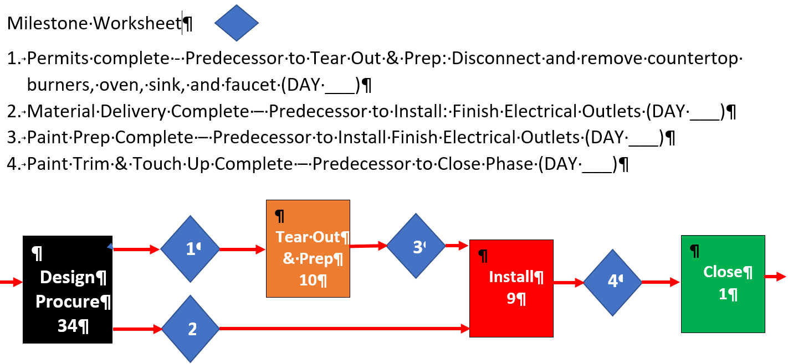

**4.3.5 Course Project Schedule Worksheet Name: ______________________________**

**A.) Activities Project name: _____________________________**

|  |  |  |  |
| --- | --- | --- | --- |
| **1.** | **2.** | **3.** | **4.** |
| **5.** | **6.** | **7.** | **8.** |
| **9.** | **10.** | **11.** | **12.** |
| **13.** | **14.** | **15.** | **16.** |

**B.) Network**

6.

5.

4.

3.

2.

1.

11.

10.

9.

8.

7.

12.

15.

14.

13.

**4.3.5 Course Project Schedule Worksheet – Continued Project Name: ________________________________**

**C. Schedule Gantt Chart**

|  |  |  |  |  |  |  |  |  |  |  |  |  |  |  |  |  |  |  |  |  |
| --- | --- | --- | --- | --- | --- | --- | --- | --- | --- | --- | --- | --- | --- | --- | --- | --- | --- | --- | --- | --- |
| **Course Project Gantt Chart** | | | | | | | | | | | | | | | | | | | | |
| **ID** | **Task Name** | **Predecessor.** | **Dur** | **Working ??** | | | | | | | | | | | | | | | | |
|  | **1** | **2** | **3** | **4** | **5** | **6** | **7** | **8** | **9** | **10** | **11** | **12** | **13** | **14** | **15** | **16** | **17** |
| **1** |  |  |  |  |  |  |  |  |  |  |  |  |  |  |  |  |  |  |  |  |
| **2** |  |  |  |  |  |  |  |  |  |  |  |  |  |  |  |  |  |  |  |  |
| **3** |  |  |  |  |  |  |  |  |  |  |  |  |  |  |  |  |  |  |  |  |
| **4** |  |  |  |  |  |  |  |  |  |  |  |  |  |  |  |  |  |  |  |  |
| **5** |  |  |  |  |  |  |  |  |  |  |  |  |  |  |  |  |  |  |  |  |
| **6** |  |  |  |  |  |  |  |  |  |  |  |  |  |  |  |  |  |  |  |  |
| **7** |  |  |  |  |  |  |  |  |  |  |  |  |  |  |  |  |  |  |  |  |
| **8** |  |  |  |  |  |  |  |  |  |  |  |  |  |  |  |  |  |  |  |  |
| **9** |  |  |  |  |  |  |  |  |  |  |  |  |  |  |  |  |  |  |  |  |
| **10** |  |  |  |  |  |  |  |  |  |  |  |  |  |  |  |  |  |  |  |  |
| **11** |  |  |  |  |  |  |  |  |  |  |  |  |  |  |  |  |  |  |  |  |
| **12** |  |  |  |  |  |  |  |  |  |  |  |  |  |  |  |  |  |  |  |  |
| **13** |  |  |  |  |  |  |  |  |  |  |  |  |  |  |  |  |  |  |  |  |
| **14** |  |  |  |  |  |  |  |  |  |  |  |  |  |  |  |  |  |  |  |  |
| **15** |  |  |  |  |  |  |  |  |  |  |  |  |  |  |  |  |  |  |  |  |

**4.4.1 Resource Smoothing and Leveling Worksheet**

|  |  |  |  |  |  |  |  |  |  |
| --- | --- | --- | --- | --- | --- | --- | --- | --- | --- |
| **Resource Smoothing Problem** | | | | | | | | | |
| **Task** | **Wk 1** | **Wk 2** | **Wk 3** | **Wk 4** | **Wk 5** | **Wk 6** | **Wk 7** | **Wk 8** | **Wk 9** |
| **A** | **2** | **2** | **2** |  |  |  |  |  |  |
| **B** |  |  | **3** | **3** | **3** |  |  |  |  |
| **C** |  |  |  | **4** | **4** | **4** |  |  |  |
| **D** |  | **1** | **1** | **1** |  |  |  |  |  |
| **E** |  | **1** | **1** | **1** | **1** | **1** |  |  |  |
| **Total** | **2** | **4** | **7** | **9** | **8** | **5** |  |  |  |
|  | | | | | | | | | |
| **Resource Smoothing Solution** | | | | | | | | | |
| **Task** | **Wk 1** | **Wk 2** | **Wk 3** | **Wk 4** | **Wk 5** | **Wk 6** | **Wk 7** | **Wk 8** | **Wk 9** |
| **A** |  |  |  |  |  |  |  |  |  |
| **B** |  |  |  |  |  |  |  |  |  |
| **C** |  |  |  |  |  |  |  |  |  |
| **D** |  |  |  |  |  |  |  |  |  |
| **E** |  |  |  |  |  |  |  |  |  |
| **Total** |  |  |  |  |  |  |  |  |  |
|  | | | | | | | | | |
| **Resource Leveling Problem** | | | | | | | | | |
| **Task** | **Wk 1** | **Wk 2** | **Wk 3** | **Wk 4** | **Wk 5** | **Wk 6** | **Wk 7** | **Wk 8** | **Wk 9** |
| **A** | **2** | **2** | **2** |  |  |  |  |  |  |
| **B** |  |  | **3** | **3** | **3** |  |  |  |  |
| **C** |  |  |  | **4** | **4** | **4** |  |  |  |
| **D** |  | **1** | **1** | **1** |  |  |  |  |  |
| **E** |  | **1** | **1** | **1** | **1** | **1** |  |  |  |
| **Total** | **2** | **4** | **7** | **9** | **8** | **5** |  |  |  |
|  | | | | | | | | | |
| **Resource Leveling @ 4 Workers Solution** | | | | | | | | | |
| **Task** | **Wk 1** | **Wk 2** | **Wk 3** | **Wk 4** | **Wk 5** | **Wk 6** | **Wk 7** | **Wk 8** | **Wk 9** |
| **A** |  |  |  |  |  |  |  |  |  |
| **B** |  |  |  |  |  |  |  |  |  |
| **C** |  |  |  |  |  |  |  |  |  |
| **D** |  |  |  |  |  |  |  |  |  |
| **E** |  |  |  |  |  |  |  |  |  |
| **Total** |  |  |  |  |  |  |  |  |  |

**4.4.2 Kitchen Project Leveling Team 1 – Bar Charts Original, Smooth, and Level**

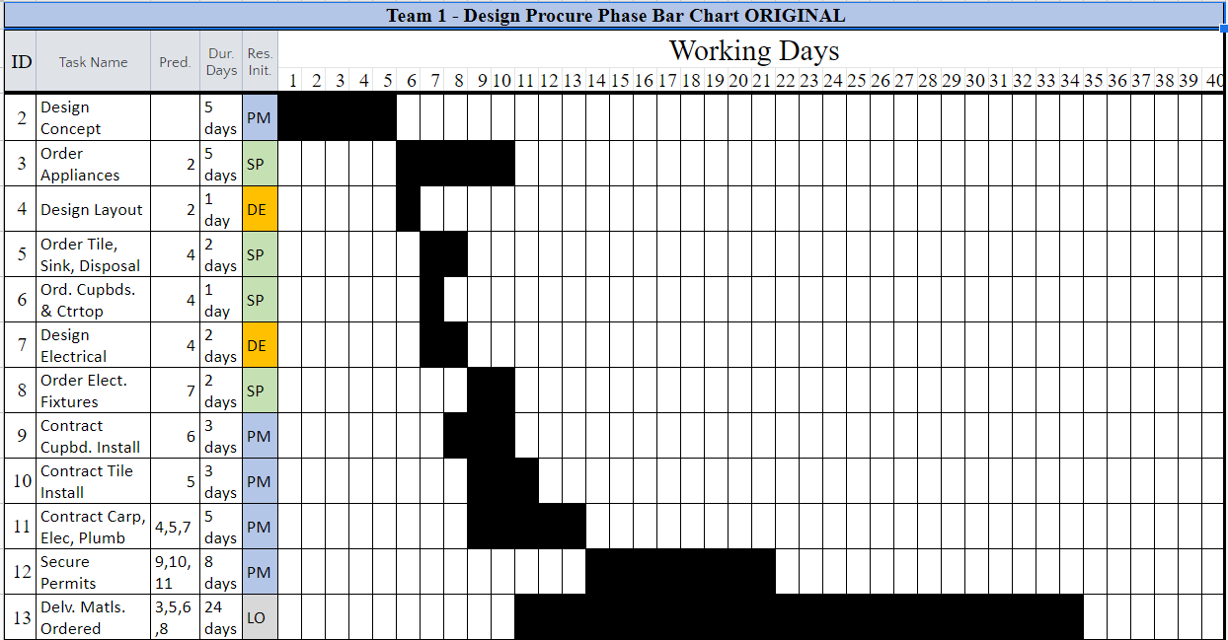

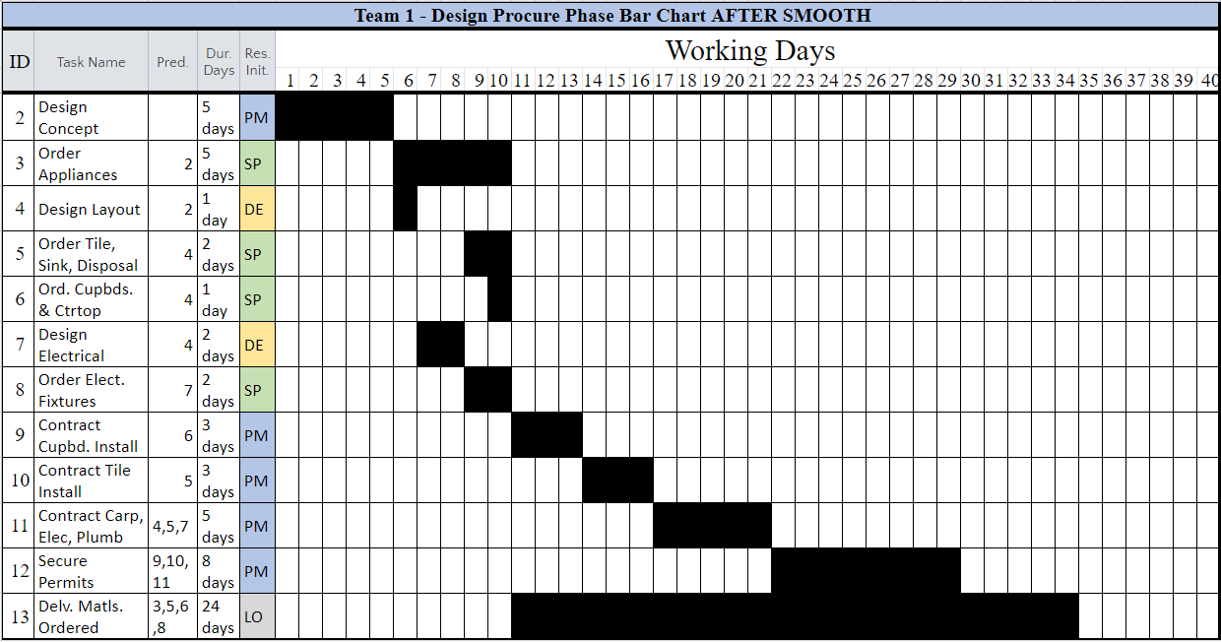

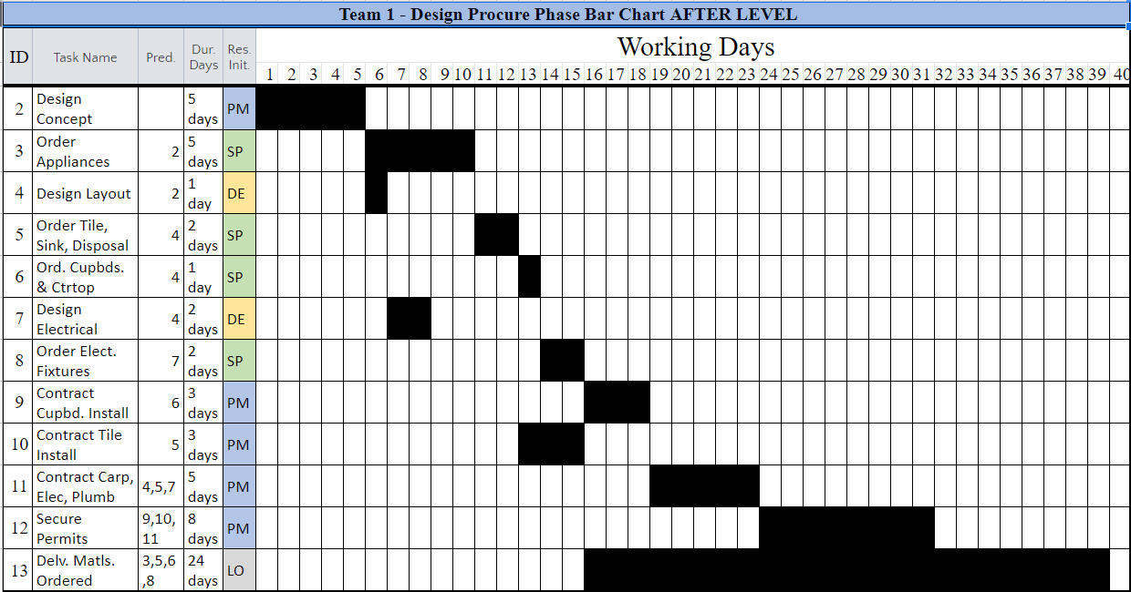

**4.4.2 Kitchen Project Leveling Team 2 - Bar Charts Original, Smooth, and Level**

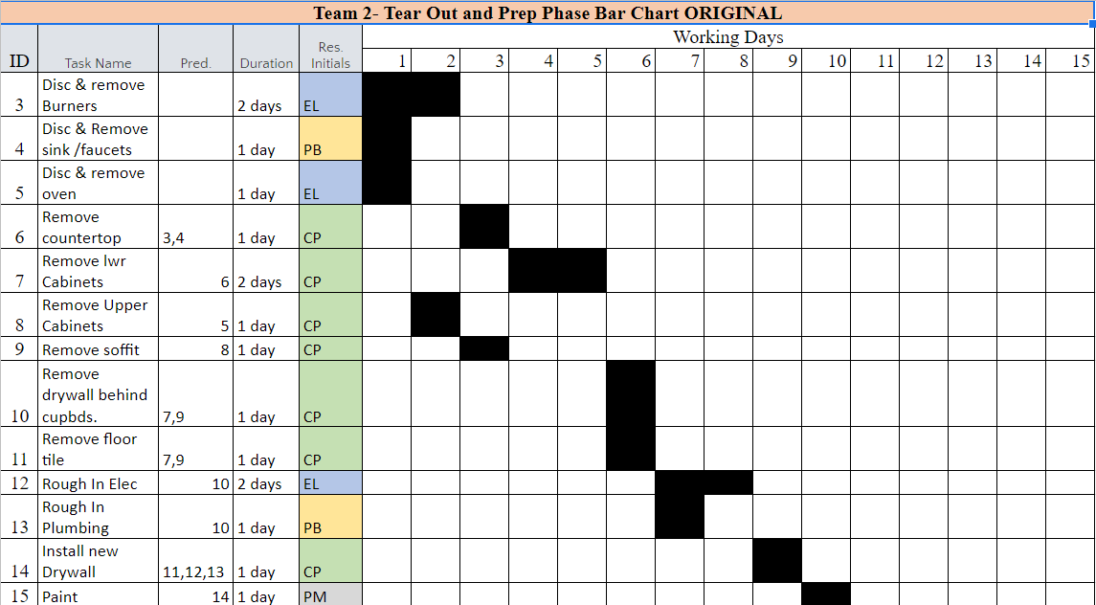

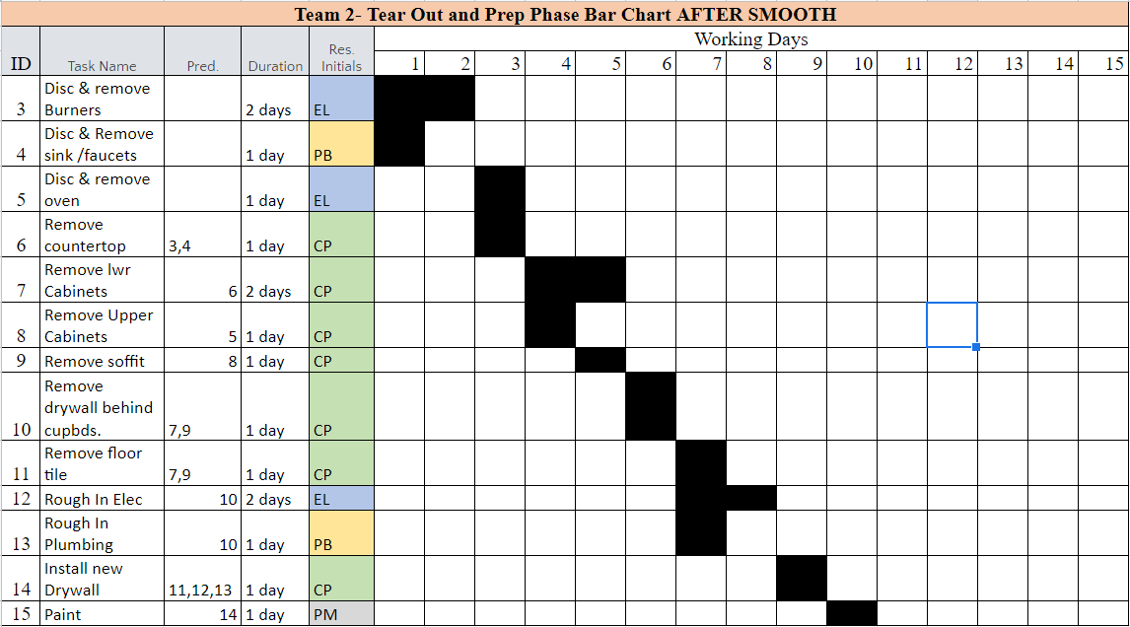

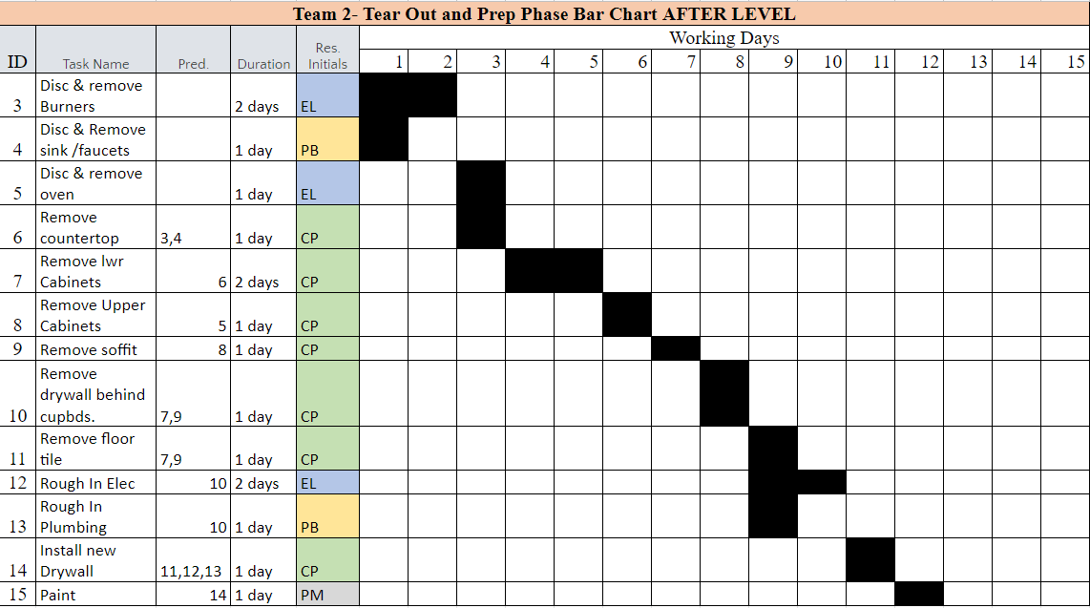

**4.4.2 Kitchen Project Leveling Team 3 - Bar Charts Original, Smooth, and Level**

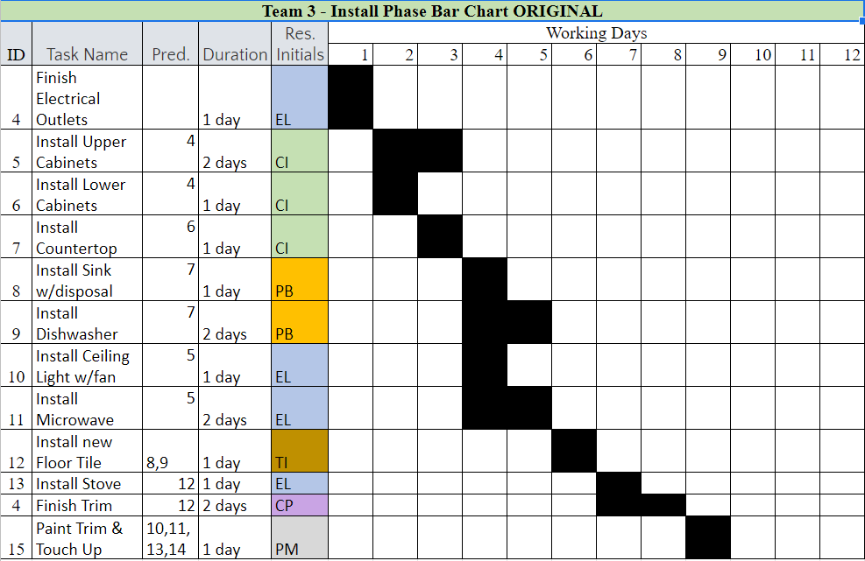

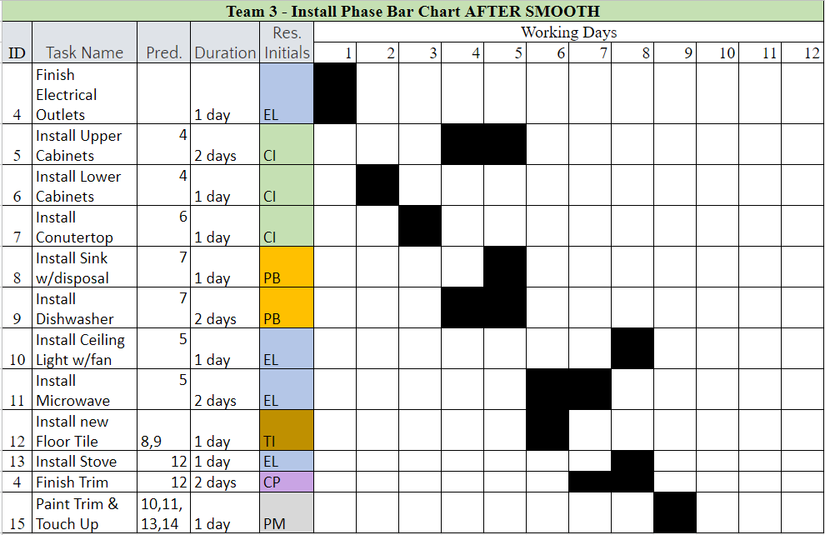

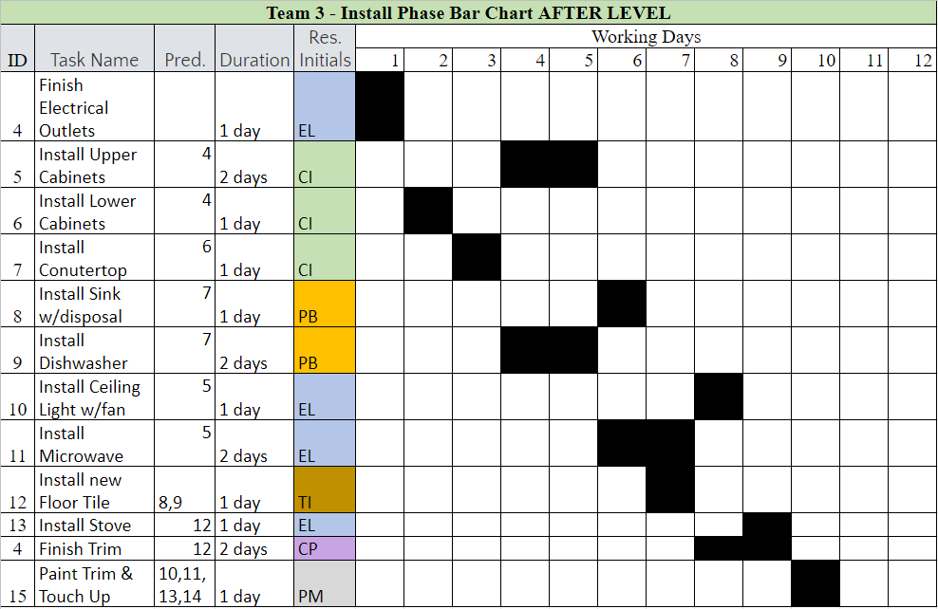

**4.4.2 Kitchen Project Leveling Solution Worksheet**

|  |  |  |  |  |
| --- | --- | --- | --- | --- |
| **Kitchen Project Leveling Solution Table** | | | | |
| **Status** | **Parameter** | **Design & Procure** | **Tear Out & Prep** | **Install** |
| **Original Plan** | **Over allocated Resources** |  |  |  |
| **Over allocated Tasks** |  |  |  |
| **Days to Complete** |  |  |  |
| **After Smoothing** | **Over allocated Resources** |  |  |  |
| **Over allocated Tasks** |  |  |  |
| **Days to Complete** |  |  |  |
| **After Leveling** | **Over allocated Resources** |  |  |  |
| **Over allocated Tasks** |  |  |  |
| **Days to Complete** |  |  |  |

**4.5.1 Estimating Accuracy Worksheet**

|  |  |  |  |
| --- | --- | --- | --- |
| **Estimate Accuracy Corrective Action** | | | |
| **Team** | **Item** | **Bad Estimate Root Cause** | **Corrective Action** |
| **1** | **1** | **Missing scope items** |  |
| **2** | **Wrong Equipment** |  |
| **3** | **Improper Estimating Method** |  |
| **2** | **4** | **Poorly Defined WBS** |  |
| **5** | **No Allowance for Inflation** |  |
| **6** | **Wrong Material/Quantity** |  |
| **3** | **7** | **Inadequate Risk Allowances** |  |
| **8** | **Too Optimistic** |  |
| **9** | **Wrong Human Skills/Quantity** |  |

**4.5.2 Kitchen Repl. Budget Team 1 Worksheet**

From the data table in the exercise instructions fill out the rate/hr. and fixed columns. Then follow instructions in the *Predictive Projects eWorkbook*.

|  |  |  |  |  |  |  |  |  |
| --- | --- | --- | --- | --- | --- | --- | --- | --- |
| **Design Procure Budget Table Worksheet** | | | | | | | | |
| **ID** | **Task Name** | **Dur.** | **Res.** | **Rate/Hr.** | **Rate/Day** | **Var.** | **Fixed** | **Total** |
| **2** | **Design**  **Concept** | **5** | PM |  |  |  |  |  |
| **3** | **Order Appliances** | **5** | SP |  |  |  |  |  |
| **4** | **Design**  **Layout** | **1** | DE |  |  |  |  |  |
| **5** | **Ord. Tile, Sink, Disposal** | **2** | SP |  |  |  |  |  |
| **6** | **Order Cabinets & Countertop** | **1** | SP |  |  |  |  |  |
| **7** | **Design**  **Electrical** | **2** | DE |  |  |  |  |  |
| **8** | **Order Elect. Fixtures** | **2** | SP |  |  |  |  |  |
| **9** | **Contract Cab. Install** | **3** | PM |  |  |  |  |  |
| **10** | **Contract Tile Install** | **3** | PM |  |  |  |  |  |
| **11** | **Contract Carp. Elec., Plumb.** | **5** | PM |  |  |  |  |  |
| **12** | **Secure**  **Permits** | **8** | PM |  |  |  |  |  |
| **13** | **Deliver**  **Materials** | **24** | LO |  |  |  |  |  |

**4.5.2 Kitchen Repl. Budget Team 2 Worksheet**

From the data table in the exercise instructions fill out the rate/hr. and fixed columns.. Then follow instructions in the *Predictive Projects eWorkbook*.

|  |  |  |  |  |  |  |  |  |
| --- | --- | --- | --- | --- | --- | --- | --- | --- |
| **Tear Out & Prep Budget Table Worksheet** | | | | | | | | |
| **ID** | **Task Name** | **Dur.** | **Res.** | **Rate/Hr.** | **Rate/Day** | **Var.** | **Fixed** | **Total** |
| 3 | **Disc & remove Burners** | **2** | EL |  |  |  |  |  |
| 4 | **Disc & Remove sink/faucet** | **1** | PB |  |  |  |  |  |
| 5 | **Disc & remove oven** | **1** | EL |  |  |  |  |  |
| 6 | **Remove countertop** | **1** | CP |  |  |  |  |  |
| 7 | **Remove lwr Cabinets** | **2** | CP |  |  |  |  |  |
| 8 | **Remove Upper Cabinets** | **1** | CP |  |  |  |  |  |
| 9 | **Remove**  **soffit** | **1** | CP |  |  |  |  |  |
| 10 | **Remove**  **drywall** | **1** | CP |  |  |  |  |  |
| 11 | **Remove floor tile** | **1** | CP |  |  |  |  |  |
| 12 | **Rough In**  **Elec** | **2** | EL |  |  |  |  |  |
| 13 | **Rough In Plumbing** | **1** | PB |  |  |  |  |  |
| 14 | **Install new Drywall** | **1** | CP |  |  |  |  |  |
| 15 | **Paint** | **1** | PM |  |  |  |  |  |

**4.5.2 Kitchen Repl. Budget Team 3 Worksheet**

From the data table in the exercise instructions fill out the rate/hr. and fixed columns Then follow instructions in the *Predictive Projects eWorkbook*.

|  |  |  |  |  |  |  |  |  |
| --- | --- | --- | --- | --- | --- | --- | --- | --- |
| **Install Budget Table Worksheet** | | | | | | | | |
| **ID** | **Task Name** | **Dur.** | **Res.** | **Rate/Hr.** | **Rate/Day** | **Var.** | **Fixed** | **Total** |
| 4 | **Finish Electrical Outlets** | **1** | EL |  |  |  |  |  |
| 5 | **Install Upper Cabinets** | **2** | CI |  |  |  |  |  |
| 6 | **Install Lower Cabinets** | **1** | CI |  |  |  |  |  |
| 7 | **Install Countertop** | **1** | CI |  |  |  |  |  |
| 8 | **Install Sink w/disposal** | **1** | PB |  |  |  |  |  |
| 9 | **Install Dishwasher** | **2** | PB |  |  |  |  |  |
| 10 | **Install Ceiling Light w/fan** | **1** | EL |  |  |  |  |  |
| 11 | **Install Microwave** | **2** | EL |  |  |  |  |  |
| 12 | **Install new Floor Tile** | **1** | TI |  |  |  |  |  |
| 13 | **Install**  **Stove** | **1** | EL |  |  |  |  |  |
| 14 | **Finish**  **Trim** | **2** | CP |  |  |  |  |  |
| 15 | **Paint Trim & Touch Up** | **1** | PM |  |  |  |  |  |

**4.5.2 Kitchen Repl. Budget Solution Worksheet**

|  |  |  |  |
| --- | --- | --- | --- |
| **Kitchen Repl. Budget Solution Table** | | | |
| **Project Phase** | **Variable Cost** | **Fixed Cost** | **Total Cost** |
| **Design/Procure** |  |  |  |
| **Tear Out/Prep** |  |  |  |
| **Install** |  |  |  |
| **Close** |  |  |  |
| **Total Project** |  |  |  |

**4.6.1 Resource Team Assignment**

|  |  |  |
| --- | --- | --- |
| **Company** | **Project Participants** | |
| **Leadership - Team 1** | **Engineering – Team 2** |
| **GMI** |  |  |
|  |  |
|  |  |
|  |  |
|  |  |
| **HTMI** |  |  |
|  |  |
|  |  |
|  |  |
|  |  |
| **BCI** |  |  |
|  |  |
|  |  |
|  |  |
|  |  |
| **Contract** |  |  |
|  |  |
|  |  |

|  |  |  |
| --- | --- | --- |
| **Company** | **Project Participants** | |
| **Construction – Team 3** | **Plant Start Up Team 3** |
| **GMI** |  |  |
|  |  |
|  |  |
|  |  |
|  |  |
| **HTMI** |  |  |
|  |  |
|  |  |
|  |  |
|  |  |
| **BCI** |  |  |
|  |  |
|  |  |
|  |  |
|  |  |
| **Contract** |  |  |
|  |  |
|  |  |

**4.6.2 Staff Selection Criteria Worksheet**

|  |  |  |
| --- | --- | --- |
| **Team 1 – Project Engineer** | | |
| **Selection Criteria** | **Weight** | **Logic** |
|  |  |  |
|  |  |  |
|  |  |  |
|  |  |  |
|  |  |  |
|  |  |  |
|  |  |  |
|  |  |  |

|  |  |  |
| --- | --- | --- |
| **Team 2 – Project Scheduler** | | |
| **Selection Criteria** | **Weight** | **Logic** |
|  |  |  |
|  |  |  |
|  |  |  |
|  |  |  |
|  |  |  |
|  |  |  |
|  |  |  |
|  |  |  |

|  |  |  |
| --- | --- | --- |
| **Team 3 – Financial Analyst** | | |
| **Selection Criteria** | **Weight** | **Logic** |
|  |  |  |
|  |  |  |
|  |  |  |
|  |  |  |
|  |  |  |
|  |  |  |
|  |  |  |
|  |  |  |

**4.6.3 Multiple Choice Questions Student Name: ________________________**

1. **Situation and Question:** **Topic #: ___**

**Choices and Answer:**

**Explanation:**

1. **2.) Situation & Question: Topic #: ___**

**Choices and Answer:**

**Explanation:**

1. **3.) Situation & Question: Topic #: ___**

**Choices and Answer:**

**Explanation:**

**4.6.4 Course Project Resource& Budget Worksheets Name: ___________________**

**A. Human Resource Cost Rate Data Sheet Project Name:_________________**



**B. Resource Assignment and Fixed Cost**



**C. Course Project Budget Spreadsheet**



**5.0 Control Worksheet Index**

**Worksheet Bookmark Page**

**5.1.1 Project Control Worksheet** **. . . . . 95**

**5.2.1 Forward and Reverse Pass Network/Table**  **. . . 96**

**5.2.2 Kitchen Repl. Critical Path Network/Table – Team 1** **. 97**

**5.2.2 Kitchen Repl. Critical Path Network/Table – Team 2** **. 98**

**5.2.2 Kitchen Repl. Critical Path Network/Table – Team 3** **. 99**

**5.2.3 Burn Down Chart Class Worksheet** **. . . . 100**

**5.3.1 Crash Cost Worksheet**  **. . . . . 101**

**5.3.2 Schedule Recovery Worksheet** **. . . . 102**

**5.3.3 Schedule Improvement Worksheet** **. . . . 103**

**5.3.4 Course Project Schedule Improvement Worksheet** **. . 104**

**5.4.1 Earned Value Case A Example Worksheet** **. . . 105**

**5.4.2 Earned Value Case B Team 1 Worksheet** **. . . 106**

**5.4.2 Earned Value Case C Team 2 Worksheet** **. . . 107**

**5.4.2 Earned Value Case D Team 3 Worksheet** **. . . 108**

**5.4.2 Causes for Earned Value Performance Table** **. . 109**

**5.4.3 Forecasting Case A Example Worksheet** **. . . 110**

**5.4.4 Forecasting Team 1 Worksheet** **. . . . 111**

**5.4.4 Forecasting Team 2 Worksheet** **. . . . 112**

**5.4.4 Forecasting Team 3 Worksheet** **. . . . 113**

**5.4.4 Forecast Solutions Graphing & Probability Worksheet** **. 114**

**5.4.5 Performance Trends** **. . . . . . 115**

**5.0 Control Worksheet Index Continued**

**Worksheet Bookmark Page**

**5.5.1 Change Control Process Worksheet**  **. . . . 116**

**5.5.2 Change Control Implementation Team 1** **. . . 117**

**5.5.2 Change Control Implementation Team 2** **. . . 118**

**5.5.2 Change Control Implementation Team 3** **. . . 119**

**5.5.2 PM Plan Components and Documents affected by change** **. 120**

**5.6.1 Quality Benefits Worksheet**  **. . . . . 121**

**5.6.2 Quality Metrics Part A**  **. . . . . 122**

**5.6.2 Quality Metrics Part B** **. . . . . 123**

**5.6.3 Project Deliverables** **Certification . . . . 124**

**5.6.4 Project Quality Situations Worksheet** **. . . 125**

**5.7.1 Conflict Reduction Worksheet** **. . . . 126**

**5.7.2 Personality Conflict Worksheet** **. . . . 127**

**5.8.1 Sources of Uncertainty Worksheet** **. . . . 128**

**5.8.2 Risk Identification Worksheet** **. . . . 129**

**5.8.3 Risk Register Worksheets** **. . . . . 130**

**5.8.4 Course Project Risk Register** **Worksheet . . . 131**

**5.8.5 Risk Management Worksheet** **. . . . 133**

**5.1.1 Project Control Worksheet**







**5.2.1 Forward and Reverse Pass Network – Class Worksheet**

Double click on an activity box to enter values in the excel table

**Early Start**

**Early Finish**

**Float**



**Activity**

**Late Finish**

**Late Start**

**Time**

 

  

|  |  |  |  |  |  |  |  |  |
| --- | --- | --- | --- | --- | --- | --- | --- | --- |
| **Forward & Reverse Pass Table - Class Worksheet** | | | | | | | | |
| **Activity** | **Pred.** | **Time** | **Earliest** | | **Latest** | | **Float** | **Critical**  **Path** |
| **ES** | **EF** | **LS** | **LF** |
| **A** | **-** | **2** |  |  |  |  |  |  |
| **B** | **-** | **4** |  |  |  |  |  |  |
| **C** | **A, B** | **1** |  |  |  |  |  |  |
| **D** | **C** | **3** |  |  |  |  |  |  |
| **E** | **C** | **2** |  |  |  |  |  |  |

**5.2.2 Forward and Reverse Pass Network – Team 1 Worksheet**

Double click on an activity box to enter ES, EF, LS, & LF values in the excel table

** **

 

   

  



|  |  |  |  |  |  |  |  |  |  |
| --- | --- | --- | --- | --- | --- | --- | --- | --- | --- |
|  | **Forward & Reverse Pass Table - Class Worksheet** | | | | | | | | |
| **ID** | **Activity** | **Pred.** | **Time** | **Earliest** | | **Latest** | | **Float** | **Critical**  **Path** |
| **ES** | **EF** | **LS** | **LF** |
| **2** | Concept Design | **-** | **5** |  |  |  |  |  |  |
| **3** | Order Appliances | **2** | **5** |  |  |  |  |  |  |
| **4** | Layout Design | **2** | **1** |  |  |  |  |  |  |
| **5** | Order Floor., Sink, Disposal | **4** | **2** |  |  |  |  |  |  |
| **6** | Order Cupboard/Top | **4** | **1** |  |  |  |  |  |  |
| **7** | Electrical Design | **4** | **2** |  |  |  |  |  |  |
| **8** | Order Elec. Fixtures | **7** | **2** |  |  |  |  |  |  |
| **9** | Contract Cupboard. Install | **6** | **3** |  |  |  |  |  |  |
| **10** | Contract Tile Install | **5** | **3** |  |  |  |  |  |  |
| **11** | Contr. Carp/Elec/Plum | **4,5,7** | **5** |  |  |  |  |  |  |
| **12** | Secure Permits | **9,10,11** | **8** |  |  |  |  |  |  |
| **13** | Delivery. Materials | **3,5,6,8** | **24** |  |  |  |  |  |  |

**5.2.2 Forward and Reverse Pass Network - Team 2 Worksheet**

Double click on an activity box to enter values in the excel table

  

   

  

  

|  |  |  |  |  |  |  |  |  |  |
| --- | --- | --- | --- | --- | --- | --- | --- | --- | --- |
|  | **Forward & Reverse Pass Table - Class Worksheet** | | | | | | | | |
| **ID** | **Activity** | **Pred.** | **Time** | **Earliest** | | **Latest** | | **Float** | **Critical**  **Path** |
| **ES** | **EF** | **LS** | **LF** |
| **3** | Remove Burners | **-** | **2** |  |  |  |  |  |  |
| **4** | Remove Sink/Faucet | **-** | **1** |  |  |  |  |  |  |
| **5** | Disc & Remove oven | **-** | **1** |  |  |  |  |  |  |
| **6** | Remove Countertop | **3,4** | **1** |  |  |  |  |  |  |
| **7** | Remove Lower Cab. | **6** | **2** |  |  |  |  |  |  |
| **8** | Remove Upper Cab. | **5** | **1** |  |  |  |  |  |  |
| **9** | Remove Soffett | **8** | **1** |  |  |  |  |  |  |
| **10** | Remove Drywall | **7,9** | **1** |  |  |  |  |  |  |
| **11** | Remove Floor Tile | **7,9** | **1** |  |  |  |  |  |  |
| **12** | Rough in Electrical | **10** | **2** |  |  |  |  |  |  |
| **13** | Rough in Plumbing | **10** | **1** |  |  |  |  |  |  |
| **14** | Install new Drywall | **11,12,13** | **1** |  |  |  |  |  |  |
| **15** | Paint | **14** | **1** |  |  |  |  |  |  |

**5.2.2 Forward and Reverse Pass Network - Team 3 Worksheet**

Double click on an activity box to enter values in the excel table

**  **

  

  

  

|  |  |  |  |  |  |  |  |  |  |
| --- | --- | --- | --- | --- | --- | --- | --- | --- | --- |
|  | **Forward & Reverse Pass Table – Team 3 Worksheet** | | | | | | | | |
| **ID** | **Activity** | **Pred.** | **Time** | **Earliest** | | **Latest** | | **Float** | **Critical**  **Path** |
| **ES** | **EF** | **LS** | **LF** |
| **4** | Finish Electrical Outlets | **-** | **1** |  |  |  |  |  |  |
| **5** | Install Upper Cabinets | **4** | **2** |  |  |  |  |  |  |
| **6** | Install Lower Cabinets | **4** | **1** |  |  |  |  |  |  |
| **7** | Install Countertop | **6** | **1** |  |  |  |  |  |  |
| **8** | Install Sink w/disposal | **7** | **1** |  |  |  |  |  |  |
| **9** | Install Dishwasher | **7** | **2** |  |  |  |  |  |  |
| **10** | Install Light w/fan | **5** | **1** |  |  |  |  |  |  |
| **11** | Install Microwave | **5** | **2** |  |  |  |  |  |  |
| **12** | Install new Floor Tile | **8,9** | **1** |  |  |  |  |  |  |
| **13** | Install Stove | **12** | **1** |  |  |  |  |  |  |
| **14** | Finish Trim | **12** | **2** |  |  |  |  |  |  |
| **15** | Paint Trim & Touch Up | **10,11,13,14** | **1** |  |  |  |  |  |  |

**5.2.3 Burndown Chart Worksheet**





1. What is the planned duration for Charts A and B? ____
2. Which chart is ahead of schedule and what is the expected finish? ___, ___
3. Which chart is behind schedule and what is the expected finish? ___, ___

**5.3.1 Crash Cost Worksheet**

Double click on an activity box to enter values in the excel table

Completed Tasks designated by black columns with times in parentheses

** **

   

 

Network activities A, B, and C are complete showing the actual times. Assume a linear relationship between estimated and crash times to compute and record the missing data in the following two charts. The cost to complete A, B, and C was $25,000.

|  |  |  |  |  |  |  |  |
| --- | --- | --- | --- | --- | --- | --- | --- |
| **Crash Cost Data Table** | | | | | | | |
| **Activity** | **Time (Weeks)** | | **Cost ($000s)** | | **Time Difference** | **Cost**  **Difference** | **Incremental Crash Cost/wk.** |
| **Normal** | **Crash** | **Normal** | **Crash** |
| **D** | **15** | **10** | **15** | **30** |  |  |  |
| **E** | **7** | **6** | **10** | **12** |  |  |  |
| **F** | **20** | **10** | **10** | **20** |  |  |  |
| **G** | **12** | **8** | **12** | **20** |  |  |  |
| **H** | **5** | **4** | **20** | **24** |  |  |  |

|  |  |  |  |
| --- | --- | --- | --- |
| **Crash Cost Comparison Table** | | | |
| **Parameter** | **Project Before Crashing** | **Team Assigned** | **Instructor Crash All** |
| **Completion Time** |  | 1 |  |
| **Critical Path** |  | 2 |  |
| **Cost** |  | 3 |  |

**5.3.2 Schedule Recovery Worksheet**

Double click on an activity box to enter values in the excel table

Completed Tasks designated by black column with times in parentheses

** **

   

 

|  |  |  |  |  |  |  |  |  |
| --- | --- | --- | --- | --- | --- | --- | --- | --- |
| **Schedule Recovery Data Table** | | | | | | | | |
| **Activity** | **Time (wks.)** | | **Cost ($000s)** | | **Incremental Crash Cost/Wk.** | **Project After Crashing** | | **Critical Path** |
| **Normal** | **Crash** | **Normal** | **Crash** | **Cost** | **Time** |
| **A** |  |  |  |  |  | **$25K** | **3** |  |
| **B** |  |  |  |  |  | **9** |  |
| **C** |  |  |  |  |  | **10** |  |
| **D** | **15** | **10** | **15** | **30** |  |  |  |  |
| **E** | **7** | **6** | **10** | **12** |  |  |  |  |
| **F** | **20** | **10** | **10** | **20** |  |  |  |  |
| **G** | **12** | **8** | **12** | **20** |  |  |  |  |
| **H** | **5** | **4** | **20** | **24** |  |  |  |  |

Network activities A, B, and C are complete showing the actual times in parentheses. Copy the incremental crash cost/wk. for each activity and the Before Crashing parameters from exercise 5.3.1.  Then determine the least cost solution to achieve a 36-week completion. Fill in the missing data on these two charts.

|  |  |  |
| --- | --- | --- |
| **Schedule Recovery Solution Table** | | |
| **Parameter** | **Project Before Crashing** | **After Recovery** |
| **Completion Time** |  |  |
| **Critical Path** |  |  |
| **Cost** |  |  |

**5.3.3 Schedule Improvement Worksheet - Team ___**

Double click on an activity box to enter values in the excel table

Completed Tasks designated by black columns with times in parentheses

** **

**   **

** **

|  |  |  |  |  |  |  |  |  |
| --- | --- | --- | --- | --- | --- | --- | --- | --- |
| **Schedule Improvement Data Table** | | | | | | | | |
| **Activity** | **Time (wks.)** | | **Cost ($000s)** | | **Incremental Crash Cost/Wk.** | **Project After Crashing** | | **Critical Path** |
| **Normal** | **Crash** | **Normal** | **Crash** | **Cost** | **Time** |
| **A** |  |  |  |  |  | **$25K** | **3** |  |
| **B** |  |  |  |  |  | **9** |  |
| **C** |  |  |  |  |  | **10** |  |
| **D** | **15** | **10** | **15** | **30** |  |  |  |  |
| **E** | **7** | **6** | **10** | **12** |  |  |  |  |
| **F** | **20** | **10** | **10** | **20** |  |  |  |  |
| **G** | **12** | **8** | **12** | **20** |  |  |  |  |
| **H** | **5** | **4** | **20** | **24** |  |  |  |  |

Network activities A, B, and C are complete showing the actual times in parentheses. Copy the incremental crash cost/wk. for each activity and the 36-week Recovery parameters from exercise 5.3.2. Then determine the least cost solution for your assigned completion. Fill in the missing data on these two charts.

|  |  |  |  |  |
| --- | --- | --- | --- | --- |
| **Schedule Improvement Solution Table** | | | | |
| **Parameter** | **Recovery** | **Team 1** | **Team 2** | **Team 3** |
| **36 Week** | **35 Week** | **34 Week** | **33 Week** |
| **Least Cost Increment** |  |  |  |  |
| **Critical Path** |  |  |  |  |
| **Est. at Completion** |  |  |  |  |

**5.3.4 Course Project Schedule Improvement Name:________________**

**Course Project Network and Critical Path Project Name:_____________________**



**15% Schedule Improvement ideas and impact (Schedule, Cost, Scope, Quality, Risk):**

**5.4.1 Earned Value Example Worksheet Part A**

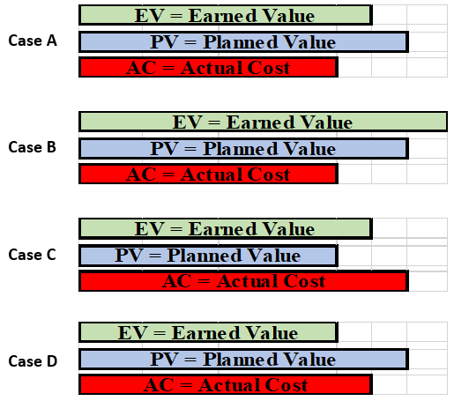

**Identify which case meets each set of conditions:**

1. **Ahead of Schedule & Under Budget?**
2. **Ahead of Schedule & Over Budget?**
3. **Behind Schedule & Under Budget?**
4. **Behind Schedule & Over Budget?**

**5.4.1 Earned Value Example Worksheet Part B**

**Earned Value Example Case A Worksheet**

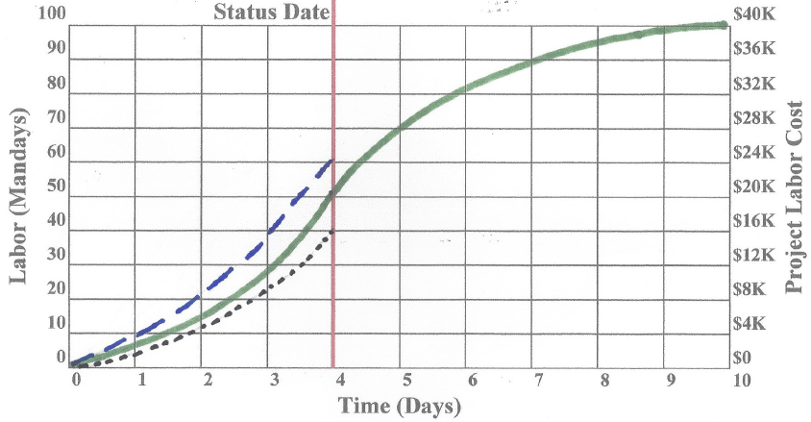

PV = __________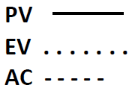

EV = __________

AC = __________

SV = _____ CV= ______

SPI = ____ CPI = ____

Schedule Status: _______ Budget Status: ________

**Show Calculations**

**5.4.2 Earned Value Case B Team 1 Worksheets**

**Earned Value Case B Worksheet Team 1**

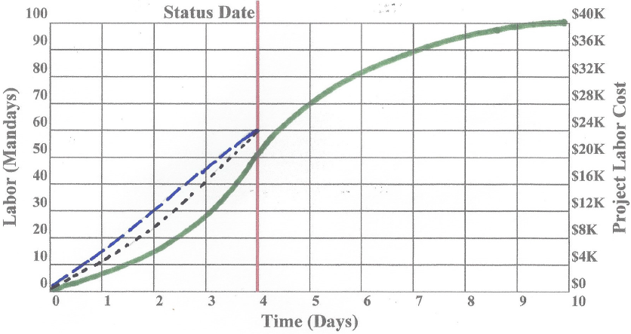

PV = __________

EV = __________

AC = __________

SV = _____ CV= ______

SPI = ____ CPI = ____

Schedule Status: _______ Budget Status: ________

**Show Calculations**

**5.4.2 Earned Value Case C Team 2 Worksheets**

**Earned Value Case C Worksheet Team 2**

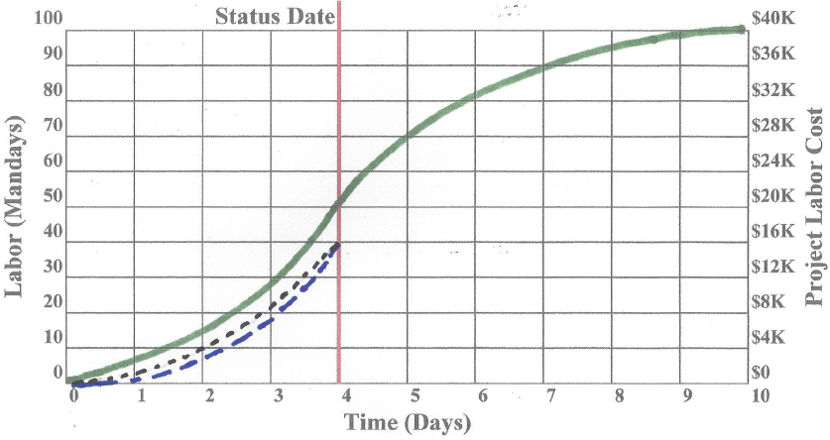

PV = __________

EV = __________

AC = __________

SV = _____ CV= ______

SPI = ____ CPI = ____

Schedule Status: _______ Budget Status: ________

**Show Calculations**

**5.4.2 Earned Value Case D Team 3 Worksheets**

**Earned Value Case D Worksheet Team 3**

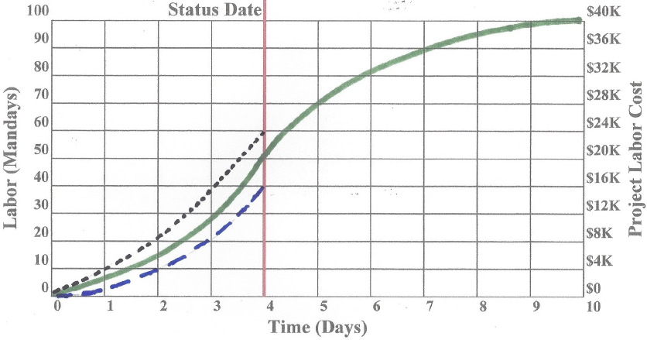

PV = __________

EV = __________

AC = __________

SV = _____ CV= ______

SPI = ____ CPI = ____

Schedule Status: _______ Budget Status: ________

**Show Calculations**

**5.4.2 Earned Value Performance Causes Worksheet**

Causes for Earned Value Performance for Cases A through D in exercises 5.4.1 and 5.4.2

This table lists possible causes leading to the performance reflected in the earned value charts from the current exercise as well as the prior class exercise. The charts are identified as Cases A through D. This summary chart is sequenced after the individual cases and is larger than the one in the *Project Management eWorkbook* to provide more space for answers.

|  |  |  |  |
| --- | --- | --- | --- |
| **Causes for Earned Value Performance Table** | | | |
| **Case A - Class** | **Case B - Team 1** | **Case C - Team 2** | **Case D - Team 3** |
|  |  |  |  |
|  |  |  |  |
|  |  |  |  |
|  |  |  |  |
|  |  |  |  |
|  |  |  |  |
|  |  |  |  |
|  |  |  |  |
|  |  |  |  |
|  |  |  |  |
|  |  |  |  |
|  |  |  |  |
|  |  |  |  |

**5.4.3 Forecasting Example Worksheet Part A**

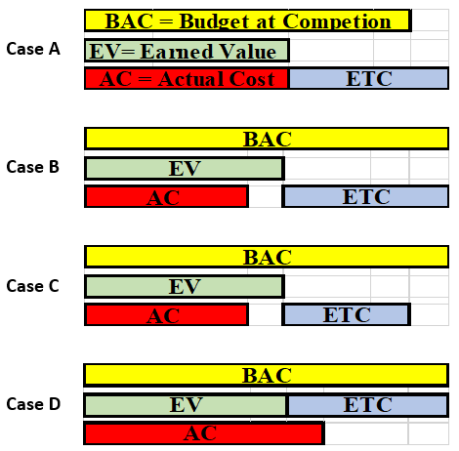

**Identify which case meets each set of conditions:**

1. **CPI<1, TCPI=1, EAC Over Budget?**
2. **CPI>1, TCPI>1, EAC Under Budget?**
3. **CPI>1, TCPI=1, EAC Under Budget?**
4. **CPI=1, TCPI<1, EAC Over Budget?**

**5.4.3 Forecasting Example Worksheet Part B**

**Forecasting Example Case A Worksheet**



Compute the following based on the given assumptions: 

1. Forecast @ 100% Eff. ETC = ____ EAC = ____
2. ETC Efficiency to Meet the Budget TCPI = _____

**Show Calculations**

**5.4.4 Forecasting Team 1 Worksheet**

**Forecasting Case B Worksheet Team 1**



1. Forecast @ 125% Eff. ETC = ____ EAC = ____
2. ETC Efficiency to Beat Budget by $2K TCPI = _____

**Show Calculations**

**5.4.4 Forecasting Team 2 Worksheet**

**Forecasting Case C Worksheet Team 2**



1. Forecast @ 125% Eff. ETC = ____ EAC = ____
2. ETC Efficiency to Beat Budget by $2K TCPI = _____

**Show Calculations**

**5.4.4 Forecasting Team 3 Worksheet**

**Forecasting Case D Worksheet Team 3**



1. Forecast @ Current Eff. ETC = ____ EAC = ____
2. ETC Efficiency to Beat Budget by $12K TCPI = _____

**Show Calculations**

**5.4.4 Forecast Solutions Graphing and Probability Worksheet**

The following table summarizes the current and forecasted (TCPI) efficiencies for Cases A through D. Each team records efficiencies for their assigned case, discusses the probability of meeting the forecast, and records their conclusions in terms of zero, low, medium, and high. After reports on probability, the class prioritizes the four cases with one being the most likely to the least likely.

|  |  |  |  |  |
| --- | --- | --- | --- | --- |
| **Probability of Meeting New Budget Goal Table** | | | | |
| **CASE** | **Current Eff.** | **TCPI Eff.** | **Probability** | **Priority** |
| Case A Class | **0.67** |  |  |  |
| Case B – Team 1 | **1.00** |  |  |  |
| Case C – Team 2 | **1.00** |  |  |  |
| Case D – Team 3 | **1.50** |  |  |  |

**5.4.5 Performance Trends Worksheet Team ___**

Project Data: The following table and graph reflect data for the first five weeks of an eight-week project. The data represents the cumulative costs from the beginning of the project to the end of the specified week for each parameter. (i.e. 350 is the cumulative EV for the first three weeks.)





**Assigned Week ___, PV = _______ AC = _________ EV = ________**

**Identify chart area for under budget EV values: _________________________________**

**Identify chart area for behind schedule EV values: _______________________________**

**CPI = ________ SPI = _________ Project Status: __________________________**

**EAC = __________ Budget Variance at Completion: ___________**

**5.5.1 Change Control Process Worksheet Team ____**

**Change Request Form**

**Change Request Flow Chart**

**5.5.2 Change Control Implementation Team 1 Worksheet A**

**Material Substitution**

**Bakersfield Plant Project Change Request Form**

**When Should Change be Initiated: ____________________________________________**

**Justification:**

**Analysis:**

**Recommendation:**

**5.5.2 Change Control Implementation Team 2 Worksheet B**

**Specification Change**

**Bakersfield Plant Project Change Request Form**

**When Should Change be Initiated: ____________________________________________**

**Justification:**

**Analysis:**

**Recommendation:**

**5.5.2 Change Control Implementation Team 3 Worksheet C**

**Equipment Layout Change**

**Bakersfield Plant Project Change Request Form**

**When Should Change be Initiated: ___________________________________________**

**Justification:**

**Analysis:**

**Recommendation:**

**5.5.2 PM Components and Project Documents affected by Change**

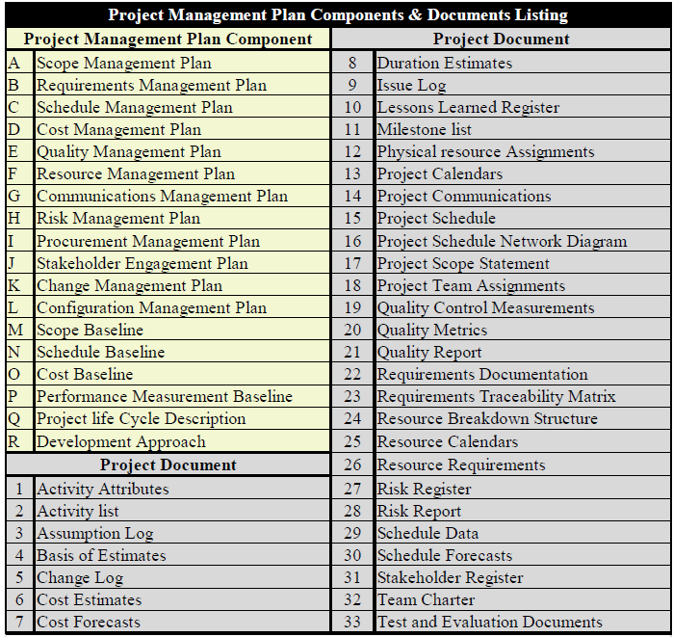

|  |  |
| --- | --- |
| **Components/Documents Affected by Change** | |
| **Project Management Plan Components** | **Project Documents** |
| **Team 1 – Material Substitution** | **Team 1 – Material Substitution** |
|  |  |
| **Team 2 – Specification Change** | **Team 2 – Specification Change** |
|  |  |
| **Team 3 – Equipment Layout Change** | **Team 3 – Equipment Layout Change** |
|  |  |

**5.6.1 Quality Benefits Worksheet**

In class give students time to answer the questions, then facilitate a discussion.

Online use this as a threaded discussion between class sessions.

**What are the benefits of having an effective quality process?**

**What value does a company get from a strong quality reputation?**

**What causes project managers to make poor quality decisions?**

**5.6.2 Quality Metrics Part A Worksheet**

|  |  |
| --- | --- |
| **Team 1 – Cost Metrics, Tools, Techniques** | |
| **Metric** | **Tools/Techniques** |
|  |  |
|  |  |
|  |  |
|  |  |
|  |  |
|  |  |
|  |  |
|  |  |
|  |  |

|  |  |
| --- | --- |
| **Team 2 – Time Metrics, Tools, Techniques** | |
| **Metric** | **Tools/Techniques** |
|  |  |
|  |  |
|  |  |
|  |  |
|  |  |
|  |  |
|  |  |
|  |  |
|  |  |

|  |  |
| --- | --- |
| **Team 3 – Scope Metrics, Tools, Techniques** | |
| **Metric** | **Tools/Techniques** |
|  |  |
|  |  |
|  |  |
|  |  |
|  |  |
|  |  |
|  |  |
|  |  |
|  |  |

**5.6.2 Quality Metrics Part B Worksheets**

|  |  |
| --- | --- |
| **Team 1 – Human Resources Metrics, Tools, Techniques** | |
| **Metric** | **Tools/Techniques** |
|  |  |
|  |  |
|  |  |
|  |  |
|  |  |
|  |  |
|  |  |
|  |  |
|  |  |

|  |  |
| --- | --- |
| Team 2 – Communication Metrics, Tools, Techniques | |
| Metric | Tools/Techniques |
|  |  |
|  |  |
|  |  |
|  |  |
|  |  |
|  |  |
|  |  |
|  |  |
|  |  |

|  |  |
| --- | --- |
| **Team 3 – Problem Resolution Metrics, Tools, Techniques** | |
| **Metric** | **Tools/Techniques** |
|  |  |
|  |  |
|  |  |
|  |  |
|  |  |
|  |  |
|  |  |
|  |  |
|  |  |

**5.6.3 Project Deliverables Validation**

|  |  |
| --- | --- |
| **Team 1 BCI** | |
| **Item #** | **Facility - Deliverables Validation** |
|  |  |
|  |  |
|  |  |
|  |  |
|  |  |

|  |  |
| --- | --- |
| **Team 2 HTMI** | |
| **Item #** | **Manufacturing Process - Deliverables Validation** |
|  |  |
|  |  |
|  |  |
|  |  |
|  |  |

|  |  |
| --- | --- |
| **Team 3 GMI** | |
| **Item #** | **Production & Delivery of Gadget - Deliverables Validation** |
|  |  |
|  |  |
|  |  |
|  |  |
|  |  |

**5.6.4 Project Quality Situations Worksheet**

**Situation A - Software Testing - Team 1**

**Decision Authority: ________________________**

**Decision: ___________________________________________**

**Supporting Philosophy: ________________________________**

**Bullet Points supporting the decision**

**Situation B – Training – Team 2**

**Decision Authority: ________________________**

**Decision: ____________________________________________**

**Supporting Philosophy: ________________________________**

**Bullet Points supporting the decision**

**Situation C - Equipment Buy off at Supplier – Team 3**

**Decision Authority: ________________________**

**Decision: ______________________________________________**

**Supporting Philosophy: __________________________________**

**Bullet Points supporting the decision**

**5.7.1 Conflict Reduction Worksheet**

**Team 1 - Responsibilities - Conflict Reduction Tools and Techniques**

**Team 2 - Cost - Conflict Reduction Tools and Techniques**

**Team 3 - Schedule - Conflict Reduction Tools and Techniques**

**5.7.2 Personality Conflict Worksheet**

**TEAM 1 - Put yourself in Diane’s position as project manager. How would you resolve the conflict you have with John Willy?**

**TEAM 2 - Put yourself in John’s position responsible for the new process performance. What would you do to resolve your conflict with Diane Baldwin?**

**TEAM 3 - As the CEO of GMI, what actions would you take to minimize the conflict between Diane and John?**

5.7.3

**5.8.1 Sources of Uncertainty**

**Brainstorm Rules**

* Ideas are not criticized & questions only asked for clarification
* No attempt is made to respond to items
* Facilitator ensures each item meets respondent’s satisfaction
* Facilitator goes in order & each person offers only one item
* Pass if unable to contribute. Your turn will come again.
* Facilitator maintains brisk pace & numbers each item
* Repeated or reworded items are recorded
* Facilitator does not offer ideas, but rotates facilitation

**Sources of Uncertainty**

**Sources of Uncertainty**

**5.8.2 Risk Identification Worksheet - Team ___**

1. **Risk Identification Worksheet**
2. **Risk Probability/Impact (P/I) Matrix Worksheet**

|  |  |  |  |  |  |  |  |  |
| --- | --- | --- | --- | --- | --- | --- | --- | --- |
| **P**  **R**  **O**  **B**  **A**  **B**  **I**  **L**  **I**  **T**  **Y** |  | **Risks** | | | **Opportunities** | | |  |
| **High** |  |  |  |  |  |  | **High** |
|  |  |  |  |  |  |  |  |
|  |  |  |  |  |  |  |  |
|  |  |  |  |  |  |  |  |
| **Med.** |  |  |  |  |  |  | **Med.** |
|  |  |  |  |  |  |  |  |
|  |  |  |  |  |  |  |  |
|  |  |  |  |  |  |  |  |
| **Low** |  |  |  |  |  |  | **Low** |
|  | **Low** | **Med.** | **High** | **High** | **Med.** | **Low** |  |
| **Impact** | | | | | | | |

**5.8.3 Risk Register Worksheets Team ____**

1. **Risk Strategy**

|  |  |  |  |  |  |  |  |
| --- | --- | --- | --- | --- | --- | --- | --- |
| **Risk Response Strategy Table** | | | | | | | |
| **Label** | **Risk Description** | **Escalate** | **Avoid** | **Accept** | **Transfer** | **Mitigate** | **Share** |
| **A** |  |  |  |  |  |  |  |
| **B** |  |  |  |  |  |  |  |
| **C** |  |  |  |  |  |  |  |
| **D** |  |  |  |  |  |  |  |

1. **Risk Register**

|  |  |  |  |  |  |  |
| --- | --- | --- | --- | --- | --- | --- |
| **Risk Register** | | | | | | |
| **Identification** | | **Assessment** | | **Response** | | |
| **Risk** | **Consequence** | **Prob.**  **L-M-H** | **Impact**  **L-M-H** | **Action Trigger** | **Resp. Person** | **Plan** |
|  |  |  |  |  |  |  |
|  |  |  |  |  |  |  |
|  |  |  |  |  |  |  |
|  |  |  |  |  |  |  |

**5.8.4 Course Project Risk Register Name: ___________________**

**A.) Risk Identification Project Name: ________________________**

1. **Risks:**

**B.) Risk Probability/Impact (P/I) Matrix Worksheet**

|  |  |  |  |  |  |  |  |  |
| --- | --- | --- | --- | --- | --- | --- | --- | --- |
| **P**  **R**  **O**  **B**  **A**  **B**  **I**  **L**  **I**  **T**  **Y** |  | **Risks** | | | **Opportunities** | | |  |
| **High** |  |  |  |  |  |  | **High** |
|  |  |  |  |  |  |  |  |
|  |  |  |  |  |  |  |  |
|  |  |  |  |  |  |  |  |
| **Med.** |  |  |  |  |  |  | **Med.** |
|  |  |  |  |  |  |  |  |
|  |  |  |  |  |  |  |  |
|  |  |  |  |  |  |  |  |
| **Low** |  |  |  |  |  |  | **Low** |
|  | **Low** | **Med.** | **High** | **High** | **Med.** | **Low** |  |
| **Impact** | | | | | | | |

**5.8.4 Course Project Risk Register Cont’d Name:____________**

**C.) Risk Strategy**

|  |  |  |  |  |  |  |  |
| --- | --- | --- | --- | --- | --- | --- | --- |
| **Risk Response Strategy Table** | | | | | | | |
| **Label** | **Risk Description** | **Escalate** | **Avoid** | **Accept** | **Transfer** | **Mitigate** | **Share** |
|  |  |  |  |  |  |  |  |
|  |  |  |  |  |  |  |  |
|  |  |  |  |  |  |  |  |
|  |  |  |  |  |  |  |  |
|  |  |  |  |  |  |  |  |

**D.) Risk Register**

|  |  |  |  |  |  |  |  |
| --- | --- | --- | --- | --- | --- | --- | --- |
| **Risk Register** | | | | | | | |
| **Identification** | | **Assessment** | | | **Response** | | |
| **Risk** | **Consequence** | **Prob.**  **L-M-H** | **Impact**  **L-M-H** | **Action Trigger** | | **Resp. Person** | **Plan** |
|  |  |  |  |  | |  |  |
|  |  |  |  |  | |  |  |
|  |  |  |  |  | |  |  |
|  |  |  |  |  | |  |  |
|  |  |  |  |  | |  |  |

**5.8.5 Risk Management Worksheet**

In class, give students time to answer the questions, then facilitate a discussion.

Online use this as a threaded discussion between class sessions

**What is your experience with formal or informal risk identification and contingency planning?**

**How and when do you manage risk on a project?**

**What value does risk management add to the project plan and what effect does it have on results?**

**6.0 Complete Worksheet Index**

**Worksheet Bookmark Page**

**6.1.1 Leadership Situations** **Worksheet . . . . 136**

**6.1.2 Leadership Structures** **Worksheet . . . . 137**

**6.1.3 Decision Making** **Worksheet . . . . . 138**

**6.1.4 Project Management Benefits Worksheet** **. . . 139**

**6.2.1 Project Manager Role Worksheet** **. . . . 140**

**6.2.2 Character Traits Worksheet** **. . . . . 141**

**6.2.3 Project Balance Team 1 Worksheet** **. . . . 142**

**6.2.3 Project Balance Team 2 Worksheet** **. . . . 143**

**6.2.3 Project Balance Team 3 Worksheet** **. . . . 144**

**6.3.1 Project Score card Worksheet** **. . . . 145**

**6.3.2 Checklists Worksheet** **. . . . . . 146**

**6.3.3 Visual Control Boards** **Worksheet . . . . 147**

**6.4.1 Class Lessons Learned Worksheet** **. . . . 148**

**6.4.2 Lessons Learned Integration Worksheet . . . 149**

**6.5.1 Project Closure Worksheet** **. . . . . 150**

**6.5.2 Project to User Linkage Worksheet** **. . . . 151**

**6.5.3 Project Evaluation Form Worksheet Team** **. . . 152**

**6.5.4 Future Opportunities Worksheet** **. . . . 153**

**6.6.1 Ethics Importance and Support Worksheet** **. . . 154**

**6.6.2 Bribes Worksheet** **. . . . . . 155**

**6.6.3 Ethics Worksheet** **. . . . . . 156**

**6.6.1 PMP Application – Experience Worksheet Team** **. . 157**

**6.1.1 Leadership Situations Worksheet**

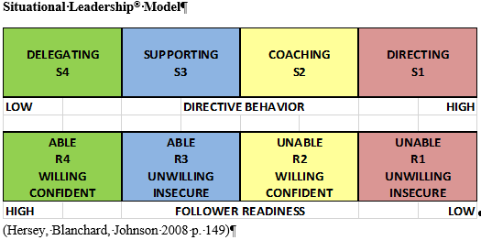

For each situation identify leadership style, readiness, and expected level of success.

**Situation A Team 1**

**Readiness: _______________ Leadership Style: __________________**

**Level of Success: __________ Best Leadership Style: _____________**

**Explain:**

**Situation B Team 2**

**Readiness: _______________ Leadership Style: __________________**

**Level of Success: __________ Best Leadership Style: _____________**

**Explain:**

**Situation C Team 3**

**Readiness: _______________ Leadership Style: __________________**

**Level of Success: __________ Best Leadership Style: _____________**

**Explain:**

**6.1.2 Leadership Structures Worksheet**

In class give students time to answer the questions, then facilitate a discussion.

Online use this as a threaded discussion between class sessions.

**Based on your experience with a group led by a supervisor: Describe experience, method of leader appointment, level of self-leadership**

**Based on your experience with a group led by a co-performer: Describe experience, method of leader appointment, level of self-leadership**

**Based on your experience with a group led by an outside facilitator: Describe experience, method of leader appointment, level of self-leadership**

**6.1.3 Decision Making Worksheet**

|  |  |  |
| --- | --- | --- |
| **Best Decision** | | |
| **Situation** | **Best Approach** | **Logic** |
| **A**  **Team 1** |  |  |
|  |  |
|  |  |
| **B**  **Team 2** |  |  |
|  |  |
|  |  |
| **C**  **Team 3** |  |  |
|  |  |
|  |  |

|  |  |  |
| --- | --- | --- |
| **Worst Decision** | | |
| **Situation** | **Worst Approach** | **Logic** |
| **A**  **Team 1** |  |  |
|  |  |
|  |  |
| **B**  **Team 2** |  |  |
|  |  |
|  |  |
| **C**  **Team 3** |  |  |
|  |  |
|  |  |

**6.1.4 Project Management Benefits Worksheet**

* **Project Management Benefits to Project Participants.**
* **Project Management Benefits to the Project and customers**
* **Project Management Benefits to Participating Companies**

**6.2.1 Project Manager Roles Worksheet**

In class give students time to answer the questions, then facilitate a discussion.

Online use this as a threaded discussion between class sessions.

**Why do Project Manager’s require skills in leadership, business, and strategic planning?**

**Name the top three qualities you would look for when hiring a project manager? Explain your selection**

**What issues should be considered when promoting an outstanding engineer to project manager?**

**6.2.2 Character Traits Worksheet Team ____**

|  |  |  |  |
| --- | --- | --- | --- |
| **Character Trait Examples** | | |  |
| **Positive**  **Character**  **Trait** | **Class**  **Member**  **1st Name** | **Action Exemplifying**  **Positive Trait** | **Priority** |
| **Organizer** |  |  |  |
| **Expert** |  |  |  |
| **Recorder** |  |  |  |
| **Analyst** |  |  |  |
| **Timekeeper** |  |  |  |
| **Achiever** |  |  |  |
| **Inquirer** |  |  |  |
| **Peacemaker** |  |  |  |

|  |  |  |
| --- | --- | --- |
| **Balancing Character Traits** | | |
| **Negative**  **Trait** | **Offsetting**  **Trait** | **Explanation** |
| **Riddler**  **Team 1** |  |  |
| **Critic**  **Team 1** |  |  |
| **Filibuster**  **Team 2** |  |  |
| **Hermit**  **Team 2** |  |  |
| **Procrastinator**  **Team 3** |  |  |
| **Gladiator**  **Team 3** |  |  |

**6.2.3** **Project Balance Team 1 Worksheet**

**Approving a Change Request**

**Developing an initial schedule**

**Resolving a personality conflict**

**6.2.3 Project Balance Team 2 Worksheet**

**Assigning a task to a team**

**Approving a vacation request**

**Authorizing overtime**

**6.2.3 Project Balance Team 3 Worksheet**

**Developing the project estimate**

**Problem solving a technical issue**

**Selecting a new supplier for project materials**

**6.3.1 Project Scorecard Worksheet - Team ___**

|  |  |  |  |  |  |  |  |
| --- | --- | --- | --- | --- | --- | --- | --- |
| **Metrics, Goals, Status** | | | **Four (Day or Week) Data** | | | | **Cumm.**  **to**  **Date** |
| **Data as of ______** | | |
| **Metric** | **Goal** | **Status** | **1** | **2** | **3** | **4** |
|  |  |  |  |  |  |  |  |
|  |  |  |  |  |  |  |  |
|  |  |  |  |  |  |  |  |
|  |  |  |  |  |  |  |  |
|  |  |  |  |  |  |  |  |
|  |  |  |  |  |  |  |  |
|  |  |  |  |  |  |  |  |
|  |  |  |  |  |  |  |  |
|  |  |  |  |  |  |  |  |
|  |  |  |  |  |  |  |  |
|  |  |  |  |  |  |  |  |
|  |  |  |  |  |  |  |  |
|  |  |  |  |  |  |  |  |
|  |  |  |  |  |  |  |  |
|  |  |  |  |  |  |  |  |
|  |  |  |  |  |  |  |  |
|  |  |  |  |  |  |  |  |
|  |  |  |  |  |  |  |  |
|  |  |  |  |  |  |  |  |

**Analysis and Corrective Action:**

**__________________________________________________________________________**

**__________________________________________________________________________**

**__________________________________________________________________________**

**__________________________________________________________________________**

**__________________________________________________________________________**

**__________________________________________________________________________**

**6.3.2 Checklists Worksheet Team ___**

**Preparatory Checklist for First Class**

Course Number: _________________ Start Date: ____________

Course Title: ____________________

**Course sign up**

**Books, equipment and materials**

**Personal adjustments**

**Work in preparation for class**

**Other ideas**

**6.3.3** **Visual Control Boards Worksheet**

**Overall Course Information - Team 1**

**Contact Information - Team 2**

**Course Schedule - Team 3**

**Course Progress - Team 3**

**Course Issues and Other Ideas - All Teams**

**6.4.1 Lessons Learned Worksheet Name:___________________**

**Course Name _______________**

* **Lessons Learned**
* **Class Improvement**

**6.4.2 Lessons Learned Integration Worksheet**

* **Team 1 – Content and Pace**

**Related Lessons Learned:**

**Means to Incorporate into current and/or Future Class**

* **Team 2 – Requirements**

**Related Lessons Learned:**

**Means to Incorporate into current and/or Future Class**

* **Team 3 – Facilitation**

**Related Lessons Learned:**

**Means to Incorporate into current and/or Future Class**

**6.5.1 Project Closure Worksheet**

In class, give students time to answer the questions, then facilitate a discussion.

Online use this as a threaded discussion between class sessions. When answering the following questions, think of this course as a project with each week being a phase in the project.

**When should lessons learned be identified?**

**How should we close out the course?**

**What steps are needed?**

**How is satisfaction measured?**

**How do we celebrate?**

**6.5.2 Project to User Linkage Worksheet**

In class, give students time to answer the questions, then facilitate a discussion.

Online use this as a threaded discussion between class sessions

**What are the benefits for HTMI when the GMI Manufacturing Department is heavily involved with the equipment installation?**

**What are some obstacles to securing GMI Manufacturing Department’s involvement in the equipment installation?**

**What are the benefits for GMI when their manufacturing personnel are involved in the installation of the HTMI equipment?**

**6.5.3 Project Evaluation Form Worksheet Team ____**

**Project Title: ___________________**

|  |  |
| --- | --- |
| **Project Results** | |
| **Goals/Deliverables** | **Rating System** |
|  |  |
|  |  |
|  |  |
|  |  |
|  |  |
|  |  |
|  |  |

|  |  |
| --- | --- |
| **Process** | |
| **Parameters** | **Rating System** |
|  |  |
|  |  |
|  |  |
|  |  |
|  |  |
|  |  |
|  |  |

Comments:________________________________________________________________________________________________________________________________________________________________________________________________________________________________

Recommendations:________________________________________________________________________________________________________________________________________________________________________________________________________________________________________________________________________________________________________

**6.5.4 Future Opportunities Worksheet**

|  |  |  |
| --- | --- | --- |
| **Collaboration Opportunities for Interactions Over Bakersfield Product Life Span** | | |
| **Team 1 - GMI and BCI** | **Team 2 - GMI and HTMI** | **Team 3 - HTMI and BCI** |
|  |  |  |
|  |  |  |
|  |  |  |
|  |  |  |
|  |  |  |
|  |  |  |
|  |  |  |
|  |  |  |
|  |  |  |

|  |  |  |
| --- | --- | --- |
| **Leverage Relationships in Other Projects** | | |
| **Team 1 - GMI and BCI** | **Team 2 - GMI and HTMI** | **Team 3 - HTMI and BCI** |
|  |  |  |
|  |  |  |
|  |  |  |
|  |  |  |
|  |  |  |
|  |  |  |
|  |  |  |
|  |  |  |
|  |  |  |

|  |  |  |
| --- | --- | --- |
| **Estimated $ Value of Future Joint Relationships (Use 5 Year Window)** | | |
| **Team 1 - GMI and BCI** | **Team 2 - GMI and HTMI** | **Team 3 - HTMI and BCI** |
|  |  |  |

**6.6.1 Ethics Importance and Support Worksheet**

**Team 1 - Why are ethics more important for project managers than typical middle managers?**

**Team 2 - What steps can companies take to support ethical behavior?**

**Team 3 - What steps can PM’s take to support ethical behavior?**

**6.6.2 Bribes Worksheet**

In class, give students time to answer the questions, then facilitate a discussion.

Online use this as a threaded discussion between class sessions

**How prevalent are bribes aimed at Project Managers?**

**Do all bribes look alike?**

**What about free lunch, sports tickets, or gifts at holiday time?**

**6.6.3 Ethics Worksheet**

**Team 1 – HTMI develops a new testing procedure.**

**Team 2 - Diane is approached by her uncle during Thanksgiving**

**Team 3 - Diane has holiday issue with German nationals in U.S.**

**6.7.1 PMP Application – Experience Worksheet Team ___**





**Project Title ____________________________ Industry_______________________ Description**

________________________________________________________________________________________________________________________________________________________________________________________________________________________________________________________________________________________________________________________________________________________________________________________________________________________________________________________________________________________________________________________________________________________________________________________________________________________________________________________________________________________________________________________________________________________________________________________________________________________________________________________________________________________________________________________________________________________________________________________________________________________________________________________________________________________________________________________________________________________________________________________________________________________________________________________________________________________________________________________________________________________________________________________________________________

**6.7.1 PMP Application - Domain Tasks Performed Worksheet Team ____**

