Project Scheduling
eWorkbook Worksheets

2nd Edition

Project Scheduling eWorkbook Worksheets 2nd Edition

This word file is a supplement for the Project Scheduling eWorkbook 2nd edition
It is not copyrighted and available for public use without any digital rights restrictions.
(Worksheets are in Word format)

by Dean A. Baker, PMP

Distributed by
Team Implementers, LLC
38342 Humphrey Circle
North Ridgeville, Ohio 44039

Web: www.TeamImplementers.com
The author, Dean A. Baker, grants permission to anyone that has purchased a copy or is using the Project Scheduling eWorkbook 2nd edition in a course of study to reproduce, store, or transmit this publication of blank worksheets
Microsoft and PowerPoint are either registered trademarks or trademarks of Microsoft Corporation in the United States and/or other countries.
PMI, PMP, and PMBOK are registered trademarks of the Project Management Institute, Inc. PMI does not endorse or otherwise sponsor this publication.
Contact the author at DABaker@TeamImplementers.com

Table of Contents
Worksheet Access and Use . . . . . . v
1.0 Project Phases
1.1 Project Phases . . . . . . 1
1.2 Starting MS Project . . . . . 2
2.0 Work Breakdown Structure
2.1 Work Breakdown Structures . . . . 3
2.2 Kitchen Replacement WBS . . . . 4
2.3 MS Project KRP Work Breakdown . . . 5
3.0 Networks
3.1 Network Diagramming . . . . . 6
3.2 PDM Networks Team 1. . . . . . 7
3.2 PDM Networks Team 2. . . . . . 8
3.2 PDM Networks Team 3. . . . . . 9
3.3 Networks in MS Project . . . . . 10
4.0 Durations
4.1 Estimating Techniques . . . . . 11
4.2 Identifying Network Paths . . . . 12
4.3 Durations in MS Project . . . . . 12
5.0 Resources
5.1 Resources in MS Project . . . . . 13
5.2 Resource Overallocation Resolution Ideas . . 14
6.0 Leveling
6.1 Smoothing and Leveling . . . . . 15
6.2 Smoothing with MS Project . . . . 16
6.3 Leveling with MS Project . . . . . 16
6.4 Fix Overallocations in MS Project . . . 17

7.0 Critical Path
7.1 Forward and Reverse Pass . . . . 18
7.2 Kitchen Replacement Critical Path Team 1. . . 19
7.2 Kitchen Replacement Critical Path Team 2. . . 20
7.2 Kitchen Replacement Critical Path Team 3. . . 21
7.3 Critical Path in MS Project . . . . 22
8.0 Cost
8.1 Estimating Accuracy . . . . . 23
8.2 KRP Cost in MS Project Part A. . . . . 24
8.2 KRP Cost in MS Project Part B. . . . . 25
8.3 KRP Budget Resolution in MS Project . . . 26
9.0 Baseline
9.1 Baseline in MS Project . . . . . 27
9.2 Status in MS Project . . . . . 28
9.2 Status After Corrections . . . . . 29
10.0 Earned Value
10.1 Earned Value . . . . . . 30
10.2 Earned Value Calculations . . . . 31
10.3 Earned Value in MS Project . . . . 32

Worksheet Access and Use
All worksheets in the Project Scheduling eWorkbook. 2nd edition (PS eWorkbook) can be printed or copied electronically as individual pdf documents with water marks to protect digital rights. The Project Scheduling eWorkbook Worksheets 2nd edition is provided as a free download to anyone that has purchased or is using the PS eWorkbook. in a course of study. This Word version of the worksheets provides a user-friendly editable worksheet free of watermarks. It allows opening the PS eWorkbook to the instructions, data page or lecture slide, while the worksheet is opened in a second window beside it. This enables participants to see the instructions, data sheets, and lecture content, while completing the worksheet.
For quick access, the table of contents provides bookmarks to the individual worksheets. Place mouse on desired worksheet and hold the control button while left clicking to go to the selected worksheet.
Word Worksheet: The Project Scheduling eWorkbook Worksheets in a word file without watermarks allows students to fully edit rather than just annotate the worksheet using word for which they are more familiar. The student or instructor uses “Share Screen” to edit the document while collaborating with a team or the whole class.
Google Doc Worksheet: Most worksheets can be edited simultaneously by the entire team, when converted from Word to Google Docs for a more collaborative experience. To do this extract all the worksheets for a specific class session from the Project Scheduling eWorkbook Worksheets and place in a word file with a unique name. If a worksheet is unique to each team, it will be necessary to create multiple copies to provide a worksheet for each team. Then upload, open, and save to Google docs. Ensure the file translated properly or make required corrections. Set up Edit privileges and Share the file with the class.

1.1 Project Life Cycle

PM Course Project Life Cycle Phases
Phases:

Bar Graph of Project Phases

1.2 Starting MS Project
MS Project Ribbons Solution

MS Project Functions

2.1 Work Breakdown Structures
Commercial Construction Template WBS Info

Commercial Construction Template Items: ______
Commercial Construction Template Tasks: ______
Commercial Construction Template Summary Tasks: ____
Commercial Construction Template Levels: __

2.2 Kitchen Replacement WBS
Kitchen Replacement WBS Worksheet
- Team 1 - Project Phase:

- Team 2 - Project Phase:

- Team 3 - Project Phase:

2.3 MS Project KRP Work Breakdown
KRP WBS Composite Spreadsheet
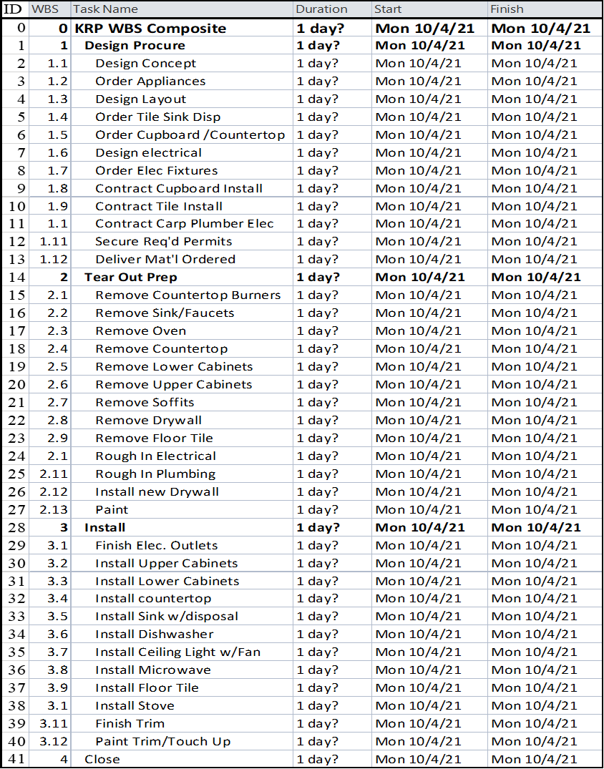
KRP Items: __ KRP Levels: __ KRP Elements in Level One: __
Tasks by Phase: Design/Procure __, Tear Out/Prep __, Install __, Close __, Total __

3.1 Network Diagram

A
B
C
D
E
F
G

Task ID | A | B | C | D | E | F | G
Pred. ID |  |  | A, B | B | A | C, D | E, F

3.2 PDM Networks Team 1

A
B
C
D
E
F
G
H
I

Task ID | A | B | C | D | E | F | G | H | I
Pred. ID |  |  | A | A | B | B | D, E | C | F, G, H
3.2 PDM Networks Team 2

A
B
C
D
E
F
G
H
I

Task ID | A | B | C | D | E | F | G | H | I
Pred. ID |  | A | A | A | B | B | B | C, D | E, F, G, H

3.2 PDM Networks Team 3

A
B
C
D
E
F
G
H
I

Task ID | A | B | C | D | E | F | G | H | I
Pred. ID |  |  |  | A, B | B, C | D, E | E | A | H

3.3 Kitchen Replacement Network

4.1 Estimating Techniques
4.1 Team 1 –List assumptions, show all calculations, and round any fractions up to next whole number
You are estimating the time to paint the interior rooms of your company’s High Point Hotel Complex which contains 100 units. You have four hours to complete the estimate next year’s annual plan of unit availability. Two years ago, a similar project to paint the interior of the Central Arms Hotel that included 80 units took eight weeks. What time would you estimate?

4.1 Team 2 – List assumptions, show all calculations, and round any fractions up to next whole number
You are estimating a project to paint the interior rooms of the 100-unit High Point Hotel Complex. You need to define the overall duration of the project and the maximum number of units out of service. Based on your experience, a two-man crew can complete three typical hotel rooms in 3 days. Using a four-man crew, six days a week, determine workdays and maximum number of units out of service? Round partial days to the next full day.

4.1 Team 3 – List assumptions, show all calculations, and round any fractions up to next whole number
You are estimating painting the interior rooms of the 100-unit Hotel Complex. A maximum of six rooms can be out of service at any time. You plan to use a four-man crew working six days a week with the following performance on similar projects: Averaged 12 rooms/week, Best being 15 rooms/week, Worst being six rooms/week. What is your best estimate on project duration?

4.2 Identifying Network Paths
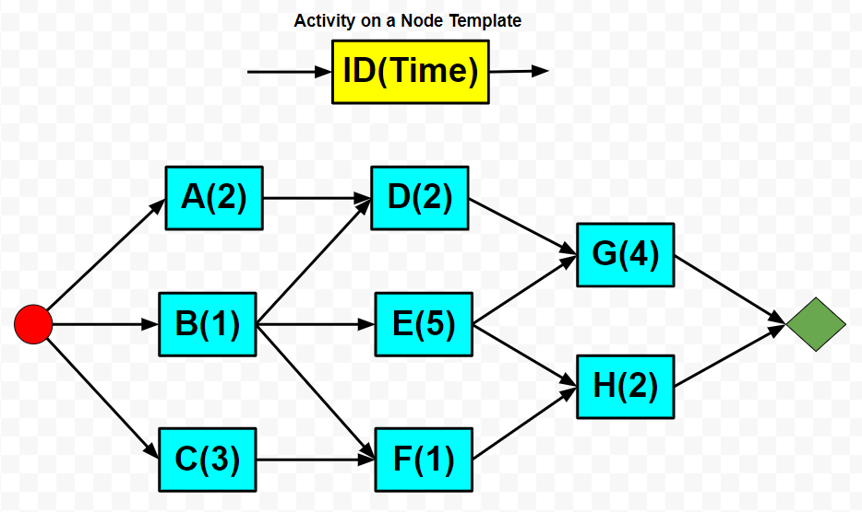

4.3 Durations

5.1 Resources

Over-allocated Tasks and Resources

Resource Over-allocation Dates

Original Plan

Tear Out
& Prep

Design
Procure

Close

Install

5.2 Resource Overallocation Resolution Ideas
Design/Procure

Tear Out/Prep

Install

6.1 Resource Smoothing Part A

Resource Smoothing Solution
Task | Wk 1 | Wk 2 | Wk 3 | Wk 4 | Wk 5 | Wk 6 | Wk 7 | Wk 8 | Wk 9
A
B
C
D
E
Total

6.1 Resource Leveling Part B

Resource Leveling @ 4 Workers Solution
Task | Wk 1 | Wk 2 | Wk 3 | Wk 4 | Wk 5 | Wk 6 | Wk 7 | Wk 8 | Wk 9
A
B
C
D
E
Total

6.2 Smoothing in MS Project
Smoothing Plan

Tear Out
& Prep

Design
Procure

Close

Install

6.3 Leveling in MS Project
Leveling Plan

Tear Out
& Prep

Design
Procure

39

Close

Install

6.4 Fix Resources Overallocations

Tear Out
& Prep

Design
Procure

Close

Install

Total Project ___ workdays

7.1 Forward and Reverse Pass

Double click on an activity box to enter values in the excel table
Early Start
Early Finish
Float

Activity
Late Finish
Late Start
Time

Forward & Reverse Pass Table - Class Worksheet
Activity | Pred. | Time | Earliest |  | Latest |  | Float | Critical  Path
 |  |  | ES | EF | LS | LF
A | - | 2
B | - | 4
C | A, B | 1
D | C | 3
E | C | 2

7.2 Kitchen Replacement Critical Path

Team 1 - Design Procure Critical Path
Double click on an activity box to enter ES, EF, LS, & LF values in the excel table

 | Forward & Reverse Pass Table - Class Worksheet
ID | Activity | Pred. | Time | Earliest |  | Latest |  | Float | Critical  Path
 |  |  |  | ES | EF | LS | LF
2 | Concept Design | - | 5
3 | Order Appliances | 2 | 5
4 | Layout Design | 2 | 1
5 | Order Floor., Sink, Disposal | 4 | 2
6 | Order Cupboard/Top | 4 | 1
7 | Electrical Design | 4 | 2
8 | Order Elec. Fixtures | 7 | 2
9 | Contract Cupboard. Install | 6 | 3
10 | Contract Tile Install | 5 | 3
11 | Contr. Carp/Elec/Plum | 4,5,7 | 5
12 | Secure Permits | 9,10,11 | 8
13 | Delivery. Materials | 3,5,6,8 | 24
7.2 Team 2 - Tear Out Prep Critical Path
Double click on an activity box to enter values in the excel table

 | Forward & Reverse Pass Table - Class Worksheet
ID | Activity | Pred. | Time | Earliest |  | Latest |  | Float | Critical  Path
 |  |  |  | ES | EF | LS | LF
2 | Remove Burners | - | 2
3 | Remove Sink/Faucet | - | 1
4 | Disc & Remove oven | - | 1
5 | Remove Countertop | 2,3 | 1
6 | Remove Lower Cab. | 5 | 2
7 | Remove Upper Cab. | 4 | 1
8 | Remove Soffett | 7 | 1
9 | Remove Drywall | 6,8 | 1
10 | Remove Floor Tile | 6,8 | 1
11 | Rough in Electrical | 9 | 2
12 | Rough in Plumbing | 9 | 1
13 | Install new Drywall | 10,11,12 | 1
14 | Paint | 13 | 1

7.2 Team 3 - Install Critical Path
Double click on an activity box to enter values in the excel table

 | Forward & Reverse Pass Table – Team 3 Worksheet
ID | Activity | Pred. | Time | Earliest |  | Latest |  | Float | Critical  Path
 |  |  |  | ES | EF | LS | LF
2 | Finish Electrical Outlets | - | 1
3 | Install Upper Cabinets | 2 | 2
4 | Install Lower Cabinets | 2 | 1
5 | Install Countertop | 4 | 1
6 | Install Sink w/disposal | 5 | 1
7 | Install Dishwasher | 5 | 2
8 | Install Light w/fan | 3 | 1
9 | Install Microwave | 3 | 2
10 | Install new Floor Tile | 6,7 | 1
11 | Install Stove | 10 | 1
12 | Finish Trim | 10 | 2
13 | Paint Trim & Touch Up | 8,9,11,12 | 1

7.3 Critical Path in MS Project

8.1 Estimating Accuracy Sample Response

8.2 KRP Cost in MS Project Solution Part A

8.2 KRP Cost Reduction Ideas Sample Response Part B

8.3 KRP Budget Resolution Solution

9.1 Baseline in MS Project Solution

1.) Permits Complete
1b.) Construction Lag to 1/24/22
2.) Material Delivery Complete
3.) Tear Out Prep Complete
4.) Install Complete

Tear Out
& Prep

Baseline Plan

Design
Procure

Install

Close

9.2 Status in MS Project

9.2 Status in MS Project Statistics After Corrections
Design Procure Statistics - No corrections required due to delay introduced for construction.
Tear Out Prep Statistics – PM and Spouse work Saturday to finish removing soffitt to recover day lost and get back on schedule.
Install Statistics – Added second carpenter to finish trim task recover 1 day. Added Spouse to help PM perform paint trim/touch up and close tasks to recover half a day on each task.
Milestones
Permits Complete: ________
Material Delivery Complete: _________
Tear Out Prep Complete: ___________

10.1 Earned Value Example Solution

1.) Performance
SV = EV – PV =
SPI = EV/PV =
Schedule Status: _________________
CV = EV/AC =
CPI = EV/AC =
Budget Status: __________________

2.) Cause: Conditions contributing to this performance
___________________________ ____________________________
___________________________ ____________________________

3.) Forecast at 100% efficiency for balance of the Project
ETC = (BAC-EV)/1.00 =
EAC = ETC + AC =

4.) TCPI Needed to meet the Budget Goal
TCPI = (BAC-EV)/(BAC-AC) =

5.) Probability: ___________________
10.2 Earned Value Team #___

1.) Performance
SV = EV – PV =
SPI = EV/PV =
Schedule Status: _________________
CV = EV/AC =
CPI = EV/AC =
Budget Status: __________________

2.) Cause: Conditions contributing to this performance
___________________________ ____________________________
___________________________ ____________________________

3.) Forecast at 100% efficiency for balance of the Project
ETC = (BAC-EV)/1.00 =
EAC = ETC + AC =

4.) TCPI Needed to meet the Budget Goal
TCPI = (BAC-EV)/(BAC-AC) =

5.) Probability: ___________________
10.3 Earned Value in MS Project Solution

Durations % Complete = $\frac{Sum the Durations of Full or Partially Completed tasks}{Sum Durations of all Tasks}$
Actual Duration = $Project Duration ×\% Complete$
Work % Work Complete = $\frac{Actual Work Hours Completed}{Total Work Hours}$
Cost % Budget Spent = $\frac{Actual Ependitures}{Baseline Cost}$

