Mountain Toastmasters Member and Guest Packet

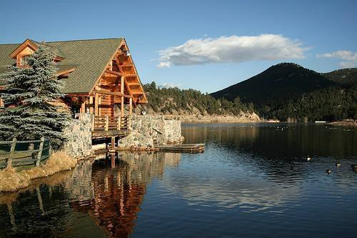

*As Mountain Toastmasters’ club members and officers, our ultimate purpose is to build and maintain a thriving and dynamic Toastmasters club in which we mutually support members in attaining additional public speaking skills and techniques and help to promote both professional and personal development.*

*As such, it is our collective mission to encourage, support, and mentor members in their development, education, and advancement through the Toastmasters program. Additionally, our mission is to recruit new members and promote our club as a beneficial educational tool which builds, reinforces, and fosters personal and professional growth, particularly in the areas of communication, social, and leadership skills.*

# Table of Contents

Mountain Toastmasters, Club 7992 4

When 4

Where 4

Contact Information 4

Welcome 5

Toastmasters International 6

Mission 6

Vision 6

Values: 6

Club Etiquette 7

Cast of Characters 8

Presiding Officer: 8

Toastmaster of the Day 8

Table Topics Master: 8

Speakers 8

Timer 8

General Evaluator 8

Evaluator: 8

Grammarian 8

Ah Counter 8

Mountain Toastmasters Meeting Format 9

Watch the Clock 10

Frequently Asked Questions about Toastmasters 11

How to Join 12

As a New Member of Mountain Toastmasters 13

Mentor 13

Log in to toastmasters.org 13

Choose Your Language 13

Choose Your Experience 13

Order Your Path 13

2

Begin Your First Project 13

The *Toastmaster* magazine 13

Toastmasters Learning Path Descriptions 14

Dynamic Leadership 14

Effective Coaching 14

Innovative Planning 14

Leadership Development 14

Motivational Strategies 14

Persuasive Influence 14

Presentation Mastery 15

Strategic Relationships 15

Team Collaboration 15

Visionary Communication 15

Path Levels 16

Level 1: Master the Fundamentals 16

Level 2: Learning Your Style 16

Level 3: Increasing Knowledge 16

Level 4: Building Skills 16

Level 5: Demonstrating Expertise 16

Cost of Membership 18

Toastmasters History 19

Toastmasters Features, Benefits, Value 20

3

**When and Where**

# Mountain Toastmasters, Club 7992

**When:** 2nd and 4th Monday of each month, beginning promptly at 7PM Duration: 1.5 hours

### ZOOM MEETINGS DURING CORONAVIRUS PANDEMIC

Join Zoom Meeting

https://us02web.zoom.us/j/4267402898?pwd=SGQyaFdiTkZOL 2xrWDgvQ3dYcUwydz09

Meeting ID: 426 740 2898

Passcode: 378040

**Same Time and same Days**

### Where (unless there is a Zoom meeting): TO BE DETERMINED Mountain Toastmasters Websites:

Mountaintoastmasters.com Mountaintoastmasters.org https://7992.toastmastersclubs.org/

### Contact Information:

For answers to any questions related to Mountain Toastmasters, please contact the VP of Membership, or any of the officers listed below.

|  |  |  |  |
| --- | --- | --- | --- |
| *President* | *Debra Finch* | *(720) 212-1864* | [Debra_alex@msn.com](mailto:Debra_alex@msn.com) |
| *VP Education* | *Mary Welch* | *(303) 809-7240* | [fussweed@gmail.com](mailto:fussweed@gmail.com) |
| *VP of Membership* | *Elizabeth Harris* | *(720) 985-6021* | [elizabethharris2@aol.com](mailto:elizabethharris2@aol.com) |
| *VP of Public Relations*  *Treasurer/Secretary* | *Joan Blick*  *Kathryn Puseman* | *303-674-9086*  *(303) 906-3359* | [joanmcgrathblick@outlook.com](mailto:joanmcgrathblick@outlook.com) [kathy.puseman@gmail.com](mailto:kathy.puseman@gmail.com) |
| *Sergeant-At-Arms* | *David Ross* | *(720) 341-3337* | [drbleaf@gmail.com](mailto:WTraylor3@protonmail.com) |

# Welcome

Dear Guest,

We are pleased to welcome you to the Mountain Toastmasters club. We sincerely hope your visit to our club will be a pleasant experience.

First, congratulations on being here! Attending your first Toastmasters meeting can be a big step. We applaud your interest in self-improvement.

The people that you will meet at Toastmasters come from a variety of professions and backgrounds. Some will be just beginning their careers, while others will already be established in their work. Some have been in Toastmasters for many years and are accomplished speakers, while others have just started out and are as nervous and inexperienced as you may feel you are. This diversity ofbackgrounds, interests, and speaking experiences has proven to be one of the great advantages of Toastmasters membership. The only prerequisite is that you must be at least 18 years of age.

At this meeting, we will share with you how Toastmasters has helped us to learn how to express our thoughts, ideas, and opinions, and develop our leadership potential through an enjoyable, yet thoroughly educational, program. The best way to learn is by doing, and that’s how Toastmasters program has been successful for nearly 90 years.

We hope that the enclosed information will help you to understand Toastmasters and the Mountain Toastmasters club. We have provided the phone numbers of several people who would be happy to talk to you more about Toastmasters. Please do not hesitate to call.

Please feel free to share this packet with someone else that you think may be interested in our club.

Thank you again for choosing to visit Mountain Toastmasters. We hope that you enjoy the experience of the Toastmasters program. At the end of the meeting, we will ask you for your feedback. We want to make our guests feel welcome and comfortable, and we are grateful any thoughts and suggestions you have.

Sincerely,

The Officers and Members of Mountain Toastmasters Chartered: November 1, 1995

# Toastmasters International

[**www.toastmasters.org**](http://www.toastmasters.org/)

## Mission:

Toastmasters International is the leading movement devoted to making effective oral communication a worldwide reality.

Through its member clubs, Toastmasters International helps men and women learn the arts of speaking, listening, and thinking – vital skills that promote self-actualization, enhance leadership potential, foster human understanding, and contribute to the betterment of mankind.

It is basic to this mission that Toastmasters International continually expand its worldwide network of member clubs, thereby offering ever-greater numbers of people the opportunity to benefit from its programs.

## Vision:

Toastmasters International empowers people to achieve their full potential and realize their dreams. Through our member clubs, people throughout the world can improve their communication and leadership skills, and find the courage to change.

## Values:

Toastmasters International’s core values are integrity, dedication to excellence, service to the member, and respect for the individual. These are values worthy of a great organization, and we believe we should incorporate them as anchor points in every decision we make. Our core values provide us with a means of not only guiding but also evaluating our operations, our planning, and our vision for the future.

# Club Etiquette

To fully benefit from your first meeting, please follow these guidelines:

* Applaud at the introduction of each speaker and again at the end of each speech (this is the Toastmaster equivalent to a group hug). It is part of the nurturing environment that encourages personal growth.

##### If you are comfortable, volunteer to be a speaker during the Table Topics portion of the meeting.

* Vote for the Best Speaker, Best Evaluator and Best Table Topics Speaker
* Ask questions of the members before and after the meeting.
* Provide your feedback on the meeting at the conclusion. We welcome your questions and your input.

You have taken an important first step towards improving your communication skills by joining us tonight. We suggest that you take the following next steps:

* Determine where you stand as a speaker and a leader, and you may wish to form a written plan for the areas where you would like to improve.
* Talk to one of the officers in the club by email or a phone call. Contact information is included in this packet.
* **Attend the next meeting.**

# Cast of Characters

It helps to know the roles that individuals play during each meeting. Other than the Presiding Officer, people rotate through the various roles each week.

**Presiding Officer:** The most senior ranking officer present, typically the Club President; Opens the meeting, introduces the Toastmaster of the day and conducts the business portion at the end of the meeting.

**Toastmaster of the Day:** The master of ceremonies, the Toastmaster hosts and conducts the meeting including introducing the various participants.

**Table Topics Master:** The Table Topics Master selects a topic of general interest and members deliver, brief, impromptu speeches on the topic.

**Speakers:** Typically, there are 2 or 3 speakers each meeting. Each speaker gives a prepared speech based on a project assignment with specific objectives.

**Timer:** Toastmasters provides the opportunity for members to practice expressing their thoughts within a specific time. The Timer helps keep the meeting on schedule and times each speech, as well as oral Evaluations and Table Topics. The timer keeps track of these times using a stopwatch and timing lights, then reports each speaker’s results.

**General Evaluator:** The General Evaluator evaluates the entire meeting and provides constructive feedback on the meeting – what worked well and what could be improved upon. They oversee the individual evaluators and the grammarian.

**Evaluator:** An Evaluator is assigned to each speaker for the purpose of providing feedback to the speaker on how well the speaker met the objectives of their speech. The Evaluator notes areas where the speaker excelled and offers constructive suggestions to the Speaker on areas for improvement.

**Grammarian:** The Grammarian chooses the Word of the Day and provides the definition and proper use of the chosen word, which the members are encouraged to use throughout the meeting. The Grammarian also listens to the way members speak and presents a verbal report at the end of the meeting providing feedback to help members improve their language skills and vocabularies.

**Ah Counter:** The Ah Counter listens for the use of “filler” sounds, such as “um, “ah”, and “uh”, as well as filler words such as “and”, “well”, “but so”, “you know”, etc. The Ah Counter presents a verbal report at the end of the meeting.

# Mountain Toastmasters Meeting Format

The Mountain Toastmasters club meetings basically follow the format shown below. There are deviances from time to time, but the typical meeting proceeds as follows:

1. The Club President opens the meeting.
   * The meeting is called to order
   * Pledge of Allegiance
   * Introductions of members and guests
   * Introduces the evening’s Toastmaster
2. The Toastmaster runs the meeting. Prior to the meeting, they create a meeting agenda, which is distributed at the meeting.
   * Opening thoughts/Theme of the evening
   * Introductions of the people assigned to each role:
     + Guests
     + Grammarian
     + Speakers
     + Timer
     + General Evaluator
     + Evaluators
     + Ah Counter
     + Table Topics Master
     + Tip of the Day
   * Each person assigned to the roles listed above will provide a brief description oftheir assigned duties
3. Prepared speeches
4. Table Topics
5. General Evaluator
   * Introduces the Evaluator(s)
     + Each Evaluator gives their evaluation of the Speaker’s performance
   * Calls for Timer’s report
     + The Timer provides a timer’s report on each Speaker (Speakers, Table Topics

speakers, and Evaluators)

* + Calls for Grammarian’s report
  + Provides overall evaluation of the meeting
  + Returns control of meeting back to Toastmaster

1. Toastmaster
   * Calls for vote of Best Speaker
   * Calls for vote of Best Evaluator
   * Calls for vote Best Table Topics Speaker
   * Returns control of meeting to President
2. President
   * Conducts club business
   * Welcomes comments from guests
   * Adjourns meeting

# Watch the Clock

One of the benefits of Toastmasters is the opportunity to plan ahead and plan your speech around targeted time frames.

All speaking roles are timed. The chart below will help you understand the timing of various roles.

The table below represents the typical time frames for the different kinds of speaking roles. While these times are typical, each speech project specifies the time objective for that particular speech and some projects may require different times than those listed below.

|  |  |  |  |
| --- | --- | --- | --- |
| **Speech Type** | **Green Light (minimum)** | **Yellow** | **Red (maximum)** |
| Table Topics | 1:00 | 1:30 | 2:00 |
| Oral Evaluations | 2:00 | 2:30 | 3:00 |
| Ice Breaker | 4:00 | 5:00 | 6:00 |
| Basic Speeches | 5:00 | 6:00 | 7:00 |
| Advanced Speeches | 8:00 | 9:00 | 10:00 |

The green light comes on at the minimum time, the red light comes on at the maximum time, and the yellow light comes on halfway in between.

* All speaking assignments are given a 30 second allowance in either direction (shorter or longer than the minimum and maximum).
* Table Topics speeches are allowed an additional 30 seconds to the length, but must be a minimum of at least 60 seconds.

Should a speaker not meet the minimum or maximum time, that speaker does not “qualify” and is not eligible for the Best Table Topics or Best Speaker award of the evening. The speech will, however, count towards their project completion.

# Frequently Asked Questions about Toastmasters

#### Q: WHAT WILL I BE DOING DURING MY FIRST YEAR OF TOASTMASTERS?

**A:** You will be assigned a mentor who will assist you (if you wish) with advice on speech preparation and delivery for your first three speeches. You will be given the opportunity to take an active part in the meetings soon after joining by performing one of the many roles such as Timer, Grammarian, Ah Counter, etc. As soon as you are comfortable (we hope it will be soon after you join) you will prepare your first speech, The Icebreaker. As the year progresses, you will develop your communication skills by working through projects in your Path.

#### Q: WHAT OCCURS AT A TYPICAL MOUNTAIN TOASTMASTERS CLUB MEETING?

**A:** The meeting consists of two parts. The first part of the meeting is the practical application of the speaking skills we are trying to develop. It allows members and guests to practice speaking in public, with one to three prepared speeches delivered by club members, followed by an impromptu speaking exercise that everyone, members and guests, can participate in.

The second part of the meeting is the practical application of leadership skills that we are trying to develop. This is the evaluation portion of the meeting during which evaluators provide feedback to the speakers and the meeting participants.

#### Q: WHY SHOULD I JOIN TOASTMASTERS?

**A:** Whether you are starting your career, are close to retirement, or are somewhere in between, Toastmasters will help you develop confidence, essential communication skills, and leadership skills that will benefit you in all aspects of your professional career, as well as your personal life. The skills that you develop will aid you in performing your job more efficiently and will help you to stand out above your peers in a competitive job market. Outside of the workplace, Toastmasters skills will enhance your capabilities while working with charitable organizations, tackling politics, or mentoring a child. The applications of Toastmasters skills are everywhere!

#### Q: HOW DO I JOIN?

**A:** Contact the Vice President of Membership or any Mountain Toastmasters officer and they will help you complete the application form (see the section in this manual, ***How to Join***).

#### Q: WHAT ARE THE BENEFITS OF EXPERIENCING PATHWAYS ON BASE CAMP VERSUS PRINTED MATERIALS?

**A:** Base Camp gives you a more robust learning experience. You can access your Path online from anywhere with an internet connection, choose from all ten available Paths, watch videos, complete activities and quizzes, download printable versions of your projects and resources, store your speech evaluations, give feedback to members of your club and earn badges.

Printed materials are shipped from Toastmasters International World Headquarters. You have less Path options and cannot view the videos or complete the activities and quizzes on your Path. You can log in to Base Camp to see your Path completion badges, print certificates, and download and print resources.

#### Q: WHAT IF I DON’T LIKE MY PATH?

**A:** You can exchange your Path within 30 days of receiving it. If you are using Base Camp, your new Path will replace your current Path at no cost. If you are using printed materials, you must mail your current Path to Toastmasters International World Headquarters to receive your new Path. You are responsible for shipping costs to and from World Headquarters.

You cannot exchange your Path after this 30-day period. If you want to switch Paths after 30 days, you must purchase a new Path.

To read the full Pathways exchange policy, visit [**www.toastmasters.org/Pathways-FAQ**.](http://www.toastmasters.org/Pathways-FAQ)

# How to Join

Step 1:

Attend a meeting. See page 3, ***When and Where***, for details.

Step 2:

Complete the membership application provided by the VP of Membership. Ask the Treasurer, the VP of Membership, or any of the club officers if you have any questions about the required information or the amount due for the fees. We’re here to help.

Step 3:

Give your application and dues to the Treasurer. To see how the Membership dues our calculated, see the section in this manual entitled ***Cost of Membership***.

* The Treasurer will sign you up online at Toastmasters.org.
* You will receive a welcome email from Toastmasters International with a link for signing on to Toastmasters.org to take the Pathways Assessment and choose your Path.
* Attend the meetings.

# As a New Member of Mountain Toastmasters

## Mentor

As a new member, you will be assigned a Mentor (if you wish). The Mentor is there to help answer your questions and help you to achieve your goals. They can help you understand how the club works and can help you prepare for your first few speeches.

## Log in to toastmasters.org

Visit [**www.toastmasters.org/StartPathways**](http://www.toastmasters.org/StartPathways) and log in with your member ID and password. You will need to create a user ID and password if this is the first time you have logged in.

##### Choose Your Language

When prompted, choose the language in which you would like to complete your Path. Your learning experience is available in English, Simplified Chinese, Traditional Chinese, Portuguese, Spanish, French, German, Japanese, and Arabic.

##### Choose Your Experience

You will be prompted to choose Base Camp (online materials) or printed materials as your primary mode for accessing your Path. If you choose Base Camp, you will take the online Pathways Assessment to determine your Path. Three Paths will be recommended to you – you can choose one of these or any of the other Paths. If you choose printed materials, read the Path descriptions and select the Path that is most appealing to you.

##### Order Your Path

After you select your Path, either through the Pathways Assessment or on your own if you choose printed materials, complete your order by following the steps on the screen to finish. If this is your first Path, the price is included in your membership fee. However, if you choose printed materials, you will pay an additional $25.00 fee.

## Begin Your First Project

Base Camp users can access Level 1 within one hour of ordering their Path. Print users will receive their first shipment in standard shipping time; however, you can begin your Path before you receive your materials. You can start your first project, the “Ice Breaker,” by visiting [**www.toastmasters.org/Pathways.**](http://www.toastmasters.org/Pathways) Explore the “Ice Breaker” project and review all the resources you find. When you are comfortable with the information in the project, work to complete the assignment. Use the steps given on the Project Checklist resource to guide you.

The VE Education can help with the process of completing project assignments and scheduling your speeches. Base Camp tutorials also show you how to navigate the online projects if you choose to experience Base Camp.

**The *Toastmaster* magazine**

Your annual dues will include a subscription to *The Toastmaster* magazine.

# Toastmasters Learning Path Descriptions

##### Dynamic Leadership

Helps you build your skills as a strategic leader. The projects in the Path focus on understanding leadership and communication styles, the effect of conflict on a group, and the skills needed to defuse and direct conflict. These projects also emphasize the development of strategies to facilitate change in an organization or group, interpersonal communication, and public speaking. This Path culminates in a project focused on applying your leadership skills. *Not available in non-English printed materials.

##### Effective Coaching

Helps you build your skills as a positive communicator and leader. The projects on this Path focus on understanding and building consensus, contributing to the development of others by coaching and establishing strong public speaking skills. Each project emphasizes the importance of effective interpersonal communication. This Path culminates in a “High Performance Leadership” project of your design. *Not available in printed materials.

##### Innovative Planning

Helps you build your skills as a public speaker and leader. The projects on this Path focus on developing a strong connection with audience members when you present, speech writing, and speech delivery. The projects contribute to an understanding of the steps to manage a project, as well as creating innovative solutions. This Path culminates in a

“High Performance Leadership” project of your design. *Not available in printed materials.

##### Leadership Development

Helps you build your skills as an effective communicator and leader. The projects on this Path focus on learning how to manage time, as well as how to develop and implement a plan. Public speaking and leading a team are emphasized in all projects. This Path culminates in a “High Performance Leadership” project of your design.

##### Motivational Strategies

Helps you build your skills as a powerful and effective communicator. The projects focus on learning strategies for building connections with the people around you, understanding motivation and successfully leading small groups to accomplish tasks. This Path culminates in a comprehensive team-building projects that brings all of your skills together – including public speaking. *Not available in printed materials.

##### Persuasive Influence

Helps you build your skills as an innovative communicator and leader. The projects on this Path focus on how to negotiate a positive outcome together with building strong interpersonal communication and public speaking skills. Each project emphasizes developing leadership skills to use in complex situations, as well as creating innovative solutions to challenges. This Path culminates in a “High Performance Leadership” project of your design. *Not available in printed materials.

##### Presentation Mastery

Helps you build your skills as an accomplished public speaker. The projects on this Path focus on learning how an audience responds to you and improving your connection with audience members. The projects contribute to developing an understanding of effective public speaking technique, including speech writing and speech delivery. This Path culminates in an extended speech that will allow you to apply what you have learned.

##### Strategic Relationships

Helps you build your skills as a leader in communication. The projects in the Path focus on understanding diversity, building personal and/or professional connections with a variety of people, and developing a public relations strategy. Communicating well interpersonally and as a public speaker is emphasized in each project. The Path culminates in a project to apply your skills as a leader in a volunteer organization. *Not available in non-English printed materials.

##### Team Collaboration

Helps you build your skills as a collaborative leader. The projects on this Path focus on active listening, motivating others, and collaborating with a team. Each project contributes to building interpersonal communication and public speaking skills. This Path culminates in a project focused on applying your leadership skills. *Not available in non- English printed materials.

##### Visionary Communication

Helps you build your skills as a strategic communicator and leader. The projects on this Path focus on developing your skills for sharing information with a group, planning communications, and creating innovative solutions. Speech writing and speech delivery are emphasized in each project. This Path culminates in the development and launch of a long-term personal or professional vision. *Not available in printed materials.

# Path Levels

No matter which Path you choose, you will complete at least 14 educational projects and present a minimum of 15 prepared speeches. You will also serve in various meeting roles.

Each Path is divided into five levels that build in complexity. The levels help you build on and apply what you have learned.

##### Level 1: Master the Fundamentals

Develop or enhance your understanding of the fundamentals needed to be a successful public speaker and evaluator. You will focus on speech writing and basic speech delivery, as well as receiving, applying, and delivering feedback.

##### Level 2: Learning Your Style

Develop an understanding of your personal styles and preferences. You will have the opportunity to identify your leadership or communication styles and preferences. You will also be introduced to the basic structure of the Pathways Mentor program.

##### Level 3: Increasing Knowledge

Begin increasing your knowledge of skills specific to your Path. You will complete one required proect and at least two elective projects that address your goals and interests through a wide variety of topics.

##### Level 4: Building Skills

Build the skills you need to succeed on your Path. You will have the opportunity to explore new challenges and begin applying what you have learned. You will complete one required project and at least one elective project.

##### Level 5: Demonstrating Expertise

In this final level, you will demonstrate your expertise in the skills you have learned. You will have the opportunity to apply what you have learned at all levels to accomplish larger projects. You will complete one required project, at least one elective project, and the “Reflect on Your Path” project to bring closure to your Path. At the completion of this level, you will become “Proficient.”

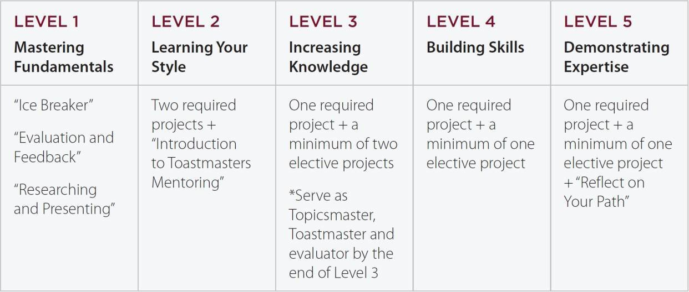

# Cost of Membership

All Mountain Toastmasters Club members pay bi-annual dues of $69 (twice per year).

To join Mountain Toastmasters, there is an initial new member fee of $20, plus the membership dues which are pro-rated based on the month in which you join. Please note that if you choose printed materials, there is an additional $25.00 fee no matter which month you join. Thereafter the fee of $69 is paid on a bi-annual basis in March and September.

*New Member Dues*

The following table shows the cost of joining Mountain Toastmasters according to the month in which you join.

|  |  |  |  |  |  |  |
| --- | --- | --- | --- | --- | --- | --- |
| **Month Joining** | **New Member Fee** | **Dues for Toastmasters International\*** | **Dues for Mountain Toastmasters Club** | **Total Amount Due** | | |
| April or October | **$20** | **$45** | **$24** | **$20** + **$45** + **$24** | = | **$89\*** |
| May or November | **$38** | **$20** | **$20** + **$38** + **$20** | = | **$78\*** |
| June or December | **$30** | **$16** | **$20** + **$30** + **$16** | = | **$66\*** |
| July or January | **$23** | **$12** | **$20** + **$23** + **$12** | = | **$55\*** |
| August or February | **$15** | **$8** | **$20** + **$15** + **$8** | = | **$43\*** |
| September or Mar | **$8** | **$4** | **$20**+ **$ 8** + **$4** | = | **$32\*** |

##### * Add $25.00 for printed materials

Mountain Toastmasters can accept payments through cash and checks.

Checks should be made payable to: ***Mountain Toastmasters***

# Toastmaster’s History

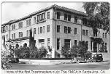When people hear the word “basement” they’re more likely to picture mold and spiders than the birth place of a global communication and leadership training organization. But a basement in a YMCA in Santa Ana, California, is exactly where, in 1924, Ralph C. Smedley held the first meeting of what would eventually become Toastmasters International.

Smedley began working as director of education for a Young Men’s Christian Association (YMCA) after he graduated from college. He observed that many of the young patrons needed “training in the art of public speaking and in presiding over meetings” and Smedley wanted to help them. He decided the

training format would be similar to a social club. During the early 1900s, the word “toastmaster” referred to a person who proposed the toasts and introduced the speakers at a banquet. Smedley named his group “The Toastmasters Club” because he thought it suggested a pleasant, social atmosphere appealing to young men.

When Smedley started the Toastmasters group at the YMCA in Santa Ana, California, members practiced speaking skills in a supportive, informal atmosphere. The seedling club blossomed. Word spread about Smedley’s YMCA experiment, and soon people in other communities and even other states began asking for permission and help to start their own Toastmasters meetings. By 1930, the burgeoning clubs had established a federation to help coordinate activities and provide a standard program. Toastmasters became **Toastmasters International** after a speaking club in New Westminster, British Columbia, Canada, expressed interest in joining the organization.

A series of rented office spaces in Southern California served as Toastmasters International’s “home office” until 1962. That year the staff moved into its first World Headquarters building in Santa Ana, not far from the YMCA where the first Toastmasters club met.

Over the next three decades, the number of Toastmasters grew and so did the need for a larger staff to service them. World Headquarters relocated in 1990 to its new building in Rancho Santa Margarita, California, about 20 miles south of Santa Ana. You can see a detailed timeline of Toastmaster’s history at [**http://www.toastmasters.org/timeline**.](http://www.toastmasters.org/timeline)

The evolution of its educational programs and resources are a big part of Toastmasters International’s success and growth. Training has expanded from the 15-project manual *Basic Training for Toastmasters,* developed by Smedley, to include other materials to help members develop skills in listening, giving feedback, decision-making, delegating, and mentoring.

With more than 13,000 clubs and more than 270,000 members in 116 countries, Ralph Smedley’s “basement brainstorm” continues to thrive in the 21st century.

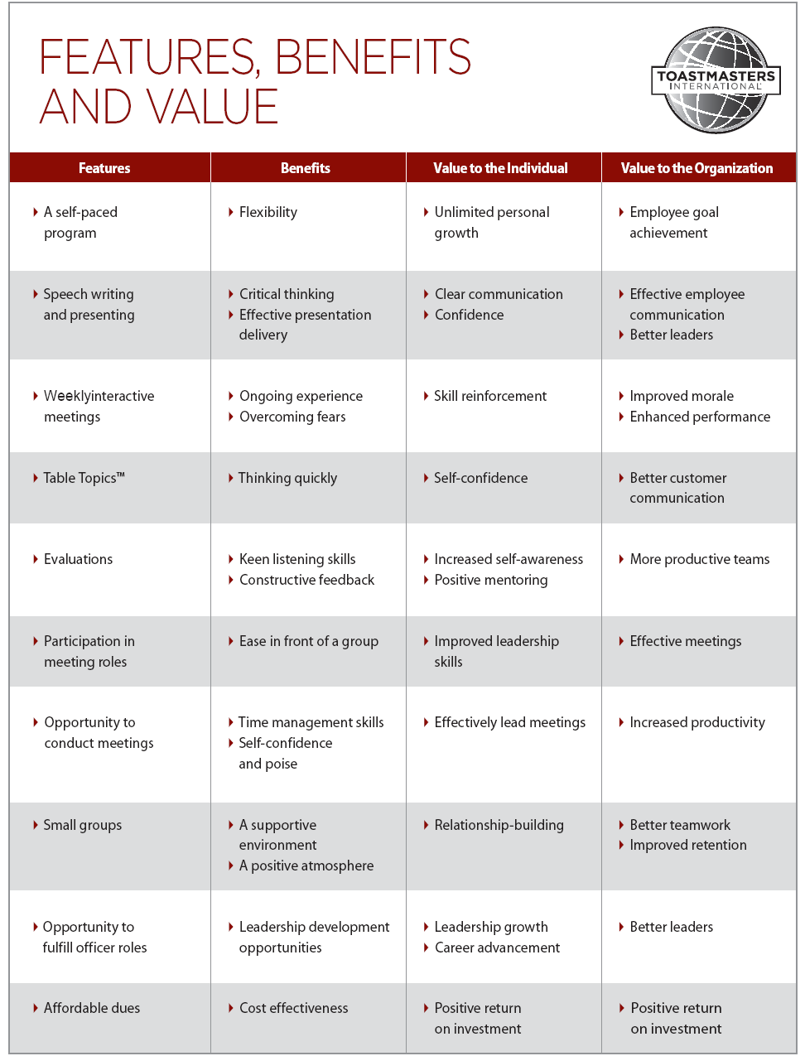

Interactive Meetings

- 2x per Month