**Residential Property Insurance for the Louisiana Dweller, Student Material**

**PPT 1:** Residential real estate agents in South Louisiana face their share of hurdles when trying to help clients buy or sell property. They have dealt with soft markets and low inventory, rigorous loan requirements and too many poorly qualified buyers. But possibly the most consistently difficult challenge in this area for real estate agents may be property insurance and the struggle to find affordable and/or acceptable products. You can help your clients and bring value to your worth by maintaining a working knowledge of property insurance.

Slide: Name the biggest hurdles you face as a real estate agent, when trying to help a client find a home.

**PPT 2: Slide: Residential Property Insurance for the Louisiana Dweller**

**PPT3:** The instructional learning objectives for this class are designed to help you best assist your clients navigate the complex residential property insurance landscape of South Louisiana. We all want our buyers to be able to get into the house they love and can afford. We also need to ensure home sellers are best informed as to what conditions on their properties might greatly affect their sales.

Slide: **Instructional Learning Objectives for this class:**

-The real estate agent will display a general knowledge of the different types of residential property policies and explain their purpose and function.

-The real estate agent will determine the different types of policies which might apply to particular residential housing circumstances to assist the home buyer.

-The real estate agent will ascertain general areas of concern about different home insurance companies and apply those concerns to the home buyer’s experience.

-The real estate agent will apply general pricing factors for residential property policies to best understand the home buyer’s needs for affording insurance for his/her house.

-The real estate agent will display general knowledge of key aspects of residential property policies to best understand the home buyer’s needs and rights for choosing appropriate insurance.

**PPT4:** The term homeowners insurance actually covers a very broad array of products, more than just the owner-occupied single-family dwelling of which we generally think. And even when we speak about the single-family dwelling, there exists quite a few “homeowners” policies providing differing levels of coverage, HO-0,1,2,3,5,8.

Slide: Home Insurance, Owner-Occupied HO-0,1,2,3,5,8

**PPT5:** HO-0,1,2

Slide: Home Insurance, Owner-Occupied HO-0,1,2

* Most local insurance agents do not have the HO-0 policy in their portfolio. Generally, this product is only offered by a limited number of insurance agencies to mortgage companies. This product largely only covers the structure for the balance of the mortgage (not the contents), and this product is usually very expensive. As a real estate agent, if you discover your client is being “force-placed” for home or flood insurance, you should let him/her know that he/she is probably paying inordinate prices for minimum coverage and should contact an insurance agent:

Slide: HO-0 Dwelling & Fire Form: A policy that provides coverage on a home against fire, smoke, windstorm, hail, lightning, explosion, vehicles, and civil unrest. It does not cover the insured's personal property, medical expenses, or liability coverage. It is also the type of policy a mortgage lender will buy for a borrower to “force-place” on the borrower if the latter's homeowner policy lapses.

* The HO-1 Basic Form is the starting place for most home insurance agents. This policy provides very limited, ACV coverage to the structure and for contents. This policy works for the customer who can afford to self-insure and really eschews paying insurance premiums. It may also be the product for homes in poor repair (if the insurance company will accept the risk). However, today, even Louisiana Citizens is more selective of what properties they will accept.

Slide: HO-1 Basic Form: A policy that provides coverage on a home against 11 listed perils; contents are generally included in this type of coverage but must be explicitly enumerated. The perils include fire or lightning, windstorm or hail, vandalism or malicious mischief, theft, damage from vehicles and aircraft, explosion, riot or civil commotion, glass breakage, smoke, volcanic eruption, and personal liability. Exceptions include floods and earthquakes.  Generally, this policy only covers actual cash value (depreciated) coverage.

The HO-2 policy is the middle of the road product that provides many of the coverages of the better policies, but not all, and costs a little less. Generally, agents will just as soon offer the homeowner the HO-3 policy rather than parsing through the differences of the HO-2. The additional covered perils are weight of ice, snow or sleet, accidental discharge or overflow of water, sudden and accidental tearing apart, cracking, burning, or bulging, freezing, sudden and accidental damage from artificially generated electrical current.

Slide: HO-2 Broad Form: A policy that provides coverage on a home against 16 listed perils (including all 11 on the HO1). The coverage is usually a "named perils" policy, which lists the events that would be covered.

**PPT6:**HO-3,5,8

Slide: Home Insurance, Owner-Occupied HO-3,5,8

* Most agents offer the HO-3 policy to homeowners. It is a very good policy which works for most situations. Many of the features of the better, HO-5 policy can be added to the HO-3.

Slide: HO-3 Special Form: A policy that provides coverage on a home against 16 listed perils (including all 11 on the HO1). The coverage is usually an open perils policy, which only lists the exclusions that would not be covered, though, the HO-3 policy jacket does usually actually list the 16 basic covered perils.

* The HO-5 policy is generally the very best product in the business. Usually, internal limits for contents and specialized items such as jewelry are higher. This product works best for the client who needs more specialized coverage.

Slide: HO-5 Comprehensive Form: A policy that covers the same as HO3 plus more. On this policy the contents are covered on an open peril basis, therefore if the cause of loss is not specifically excluded in the policy, it will be covered for that cause of loss. This is generally considered to be the **best** home insurance policy.

* The HO-8 policy is a specialized product. Many traditional HO-3/5 products now have the flexibility to meet the needs filled by the HO-8, and few companies offer this product, Lighthouse being the only company I could find.

Slide: HO-8 Modified Coverage Form: A policy for the owner-occupied older home whose replacement cost far exceeds the property's market value. The policy only offers actual cash value (depreciated) coverage and often does not include protection for water damage.

**PPT 7:** As there are not many townhomes in this area, insurance agencies often do not think to ask the client if his/her home is a townhome. The real estate agent would greatly assist his/her client by advising the client to notify quoting insurance agencies that the home in question is a townhome.

Slide: Townhomes

Townhomes are covered by homeowners insurance policies; however, the general amount of structural coverage needed is less because the townhomes share walls with at least one adjacent unit. Townhomes usually do not need “other structures” coverage, as those constructions are often owned by the townhome association and coverage is provided by the association’s policy. Supposedly, some companies will cover a townhome under the HO-6 condominium policy.

**PPT 8:** The “split” policy is generally not favored by homeowners, real estate agents, or insurance agents. Often the effect of having 2 separate policies means a higher aggregate premium. However, many times, the split policy can be less expensive than a single product. The customer should pay attention to the details of the coverages provided to ensure they are matching coverages when comparing prices.

Slide: “Split” Homeowners Policies (without Wind/Hail Coverage) & Wind/Hail only Coverage

To reduce their exposure to huge risks, many home insurance companies will often now not offer wind and hail coverage on their policies. In these circumstances the homebuyer must then purchase another wind and hail only policy. Several of the larger insurance companies operating in Louisiana are offering wind and hail only policies for the coastal areas.

**PPT 9:** Builders Risk coverage can vary greatly from company to company, so the customer needs to be careful when shopping.

Slide: Builders Risk Insurance: Covering Homes Under Construction

There are several important questions for the client looking to purchase the builder’s risk policy. Who is purchasing the policy, the home buyer or a commercial builder? If the homebuyer is purchasing the policy, will he/she be a general contractor for the project? Different insurance companies will have very different rules about what risks they will insure, and the client needs to begin looking for a policy well in advance of the needed effective date to take into account the time the insurance company may need for determining if it will accept the risk.

**PPT 10:** DP-1,2,3 Landlords insurance is designed to provide coverage for non-owner-occupied residential properties housing generally 1-6 families. The Real Estate Agent might look to advise a homeowner, who may be moving to a new home, but keeping the old home for leasing purposes, to inform his/her insurance agent about the change in occupation. The landlords policy largely covers the dwelling with little to no additional coverage for contents. Coverages for these policies can vary greatly, so the purchaser needs to pay close attention to what is provided in each policy. It is especially important to know if the policy maintains comprehensive personal liability coverage, which is not in the Louisiana Citizens (Fair Plan) dwelling policies, the policy of choice in South Louisiana for many rental properties. Landlords policies are dollar-for-dollar more expensive than owner-occupied policies, as the “pride of ownership” factor keeps home insurance policies lower. Like the homeowners policies, dwelling policy coverage improves from DP-1 to DP-3. Some companies will let customer write dwelling policies for owner occupied situations.

Slide: Landlords Insurance DP-1,2,3

DP-1 Basic Form: A named-risk policy that provides coverage for all listed perils on the policy. Only offers actual cash value on the house and does not include loss of rent.  
  
DP-2 Broad Form: A named-risk policy that provides coverage for all listed perils on the policy. Provides replacement cost on the house and loss of rent.  
  
DP-3 Special Form: An open-peril policy that provides coverage for all perils, unless specifically excluded. Provides replacement cost on the house and loss of rent

**PPT 11:** The comprehensive personal liability policy is generally inexpensive, but an extremely valuable part of residential property insurance. Usually this coverage is built into a residential policy. A property owner needs to consider purchasing this policy when the coverage is not in the primary policy. The CPL protects the property owner from non-criminal injury caused by the property owner’s interests. Notice the claim data on the slide. The two highlighted rows point to liability-type claims. You can see why insurance companies have restrictions on the type of animals and dogs that they will allow. Those types vary by company.

Slide: Comprehensive Personal Liability (CPL) Coverage

CPL is designed to provide coverage for primary and secondary residences, rentals, vacation homes, homes during construction, vacant homes, and vacant land.

This coverage is necessary for structures, when the primary policy does not include liability coverage (ex. Louisiana Citizens dwelling policies).

|  |  |  |
| --- | --- | --- |
| **Type of Claim** | **Claims Each Year** | **Average Damage** |
| **Wind and Hail** | *1 in 47 homes* | *$10,182* |
| **Water Damage and Freezing** | *1 in 49 homes* | *$10,234* |
| **All Other Property Damage** | *1 in 151 homes* | *$5,823* |
| **Theft** | *1 in 323 homes* | *$4,264* |
| **Fire and Lightning** | *1 in 357 homes* | *$68,322* |
| **Bodily Injury/Property Damage** | *1 in 1,250 homes* | *$26,085* |
| **Medical Payments** | *1 in 3,300 homes* | *$3,465* |
| **Dog Bites** | *1 in 3,250 homes* | *$44,760* |
| **Credit Card Theft** | *1 in 10,000 homes* | *$368* |

**PPT 12:** The condominium unit owners policy was largely not required by lenders prior to Hurricane Katrina. But now persons borrowing for a condominium often are required to attain this coverage. It generally stands to reason, as most condominium association policies do not provide complete structural coverage throughout the unit, thus, the lender’s interest is exposed without the HO-6 coverage.

Slide: Condominium Unit Owners HO-6

HO-6 Unit-Owners: Policy for condominium owners. This policy can be written for owner and non-owner occupancy, though, some companies will not write a non-owner-occupied HO-6.

It insures personal property, walls, floors, and ceiling (sheetrock in) against the perils listed in the broad form. The rest of the condo is covered by a separate policy purchased by the association.

Some condominium association policies will cover the complete structure of the units, too.

It is very important to understand if the unit will be owner-occupied full-time, part-time, and leased the rest of the time, or only leased. Some companies will not cover leased units.

LA Citizens only offers a dwelling policy for tenant-occupied units (remember, no comprehensive personal liability coverage with that policy.

**PPT 13:** Condominiums, properties in the French Quarter, the Faubourg Uptown and fishing/hunting camps are often secondary homes. The real estate agent might try to remember to advise the homebuyer to notify his insurance agent of this fact. Sometimes, insurance companies will not require the homeowner of a secondary home to maintain liability coverage, as the primary home policy may cover both homes. Secondary home policies also may require a lower contents minimum coverage.

Slide: Secondary Home Insurance

When a homeowner owns a second home in which he/she is the occupant (not leased to others), then the homeowner will need to inform his/her insurance company that the home is a secondary home (The secondary home is the home occupied least.). Often, that policy can be a little less expensive, as some coverages can be reduced or eliminated.

**PPT 14:** Most tenants do not carry renters insurance, which is a very inexpensive policy. In addition to contents and liability coverage, good renters policies can provide coverage for loss of use including situations involving government-declared mandatory evacuations, often an effect of hurricanes. In addition, many companies will offer large discounts on their auto policies when customers purchase that company’s renters insurance. The general point, here, is that renters should purchase renter’s insurance. Virtually anyone can find a renters policy, as it is sold by many companies including Louisiana Citizens Insurance.

Slide: Renters Insurance HO-4

HO-4 Contents-only: A policy that covers personal property against the same perils as the contents portion of the HO-2 or HO-3. An HO-4 generally also includes liability coverage for personal injury or property damage inflicted on others.

This policy is primarily designed for the non-homeowner occupant. Note, often tenants will think that the building owner’s property policy will cover the tenants’ property. This is almost always not the case, including for situations where a child or parent or an unmarried partner is living with a homeowner.

**PPT 15:** Landlords should consider requiring a tenant to purchase renters insurance, as the tenant will then have liability coverage available for injuries to others including fire to the property. If the landlord does not want to require the tenant to purchase renters insurance, then the landlord should at least require the tenant to sign a waiver of responsibility to the landlord should the tenant receive damages to his/her property for perils otherwise covered by a renters and/or flood policy. Real estate agents operating as property managers should advise property owners of these considerations.

Slide: Tenants’ Renters / Flood Insurance Waiver of Responsibility

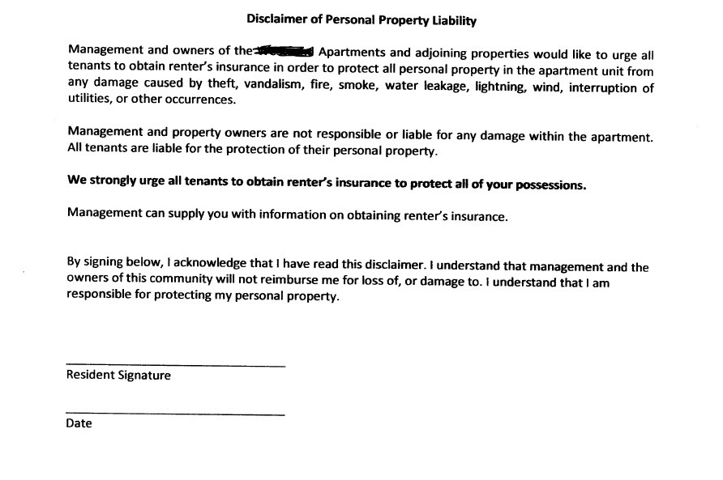

**PPT 16:** Many traditional standard insurance companies will no longer provide mobile home insurance, as they do not want the risk. Purchasers can attain coverage from mobile home dealers and smaller insurance companies and Louisiana Citizens Insurance.

Slide: HO-7 Mobile Home:

A policy that is specifically designed for mobile homes and manufactured homes. The same fundamentals of insurance policies apply to mobile home insurance policies. Mobile home policies cover the actual mobile home structure, adjacent structures, and personal belongings. Liability coverage to help cover certain types of accidents on your property may also be included (not Louisiana Citizens which only offers coverage through its dwelling policy).

**PPT 17: Instructional Learning Objectives for this Class:**Slide: **The real estate agent will display a general knowledge of the different types of residential property policies and explain their purpose and function.**

1. What is generally considered to be the best home insurance policy? The HO-1, 2, 3, 5, 8?
2. A policy covering a house under construction is called what?
3. What homeowners policy provides personal property coverage for an owner-occupied condominium unit? The HO-1, 2, 3, 4, 5, 6, 7, 8?
4. True or False: The landlord’s dwelling policy provides personal property coverage for the tenant’s belongings?
5. True or False: The Louisiana Citizens dwelling policy provides comprehensive personal liability protection to the building owner?

**PPT 18: Instructional Learning Objectives for this Class:**Slide: **The real estate agent will determine the different types of policies which might apply to residential housing circumstances to assist the home buyer.**

1. A tenant-occupied home should have what type of policy? Homeowners/Landlords?
2. The person who might want the minimum amount of coverage for a landlords policy might purchase which type? DP-1, 2, 3?
3. Tenants should purchase what type of insurance to protect their belongings?

**PPT 19:** Slide: Class Break 10 Minutes

**PPT 20:** Every year on average 2-3 new home insurance companies enter the Louisiana market. Some of these companies have been in business for decades; most are less than 15-years-old. The Louisiana Department of Insurance has aggressively sought to bring more companies into the state to spread the general risk and to try to lower the average cost of residential property insurance with business competition.

Slide: New Residential Property Insurance Companies in LA

Post Katrina, as many traditional residential property insurance companies have lost their appetites for endless risks in the more hazardous areas of the country (Atlantic and Gulf of Mexico coast properties, especially), an opening has been created for many smaller and more aggressive companies to fill the void. Around 2 dozen new companies, many only very shortly in business, have started doing business in Louisiana and have generally helped lower the average premium in the state.

1. Access
2. Americas
3. ASI Lloyds
4. Bankers
5. Centauri
6. Coastal Select
7. Federated National Ins. Co
8. Gulfstream
9. Lighthouse

10. Maison

11. Republic

12. Southern Fidelity

13. Capital

14. Occidental

15. Excalibur National

16. Gulf States Insurance

17. Ocean Harbor Insurance

18. Safepoint Insurance

19. Spinnaker Insurance

20. Geovera

21. North Light Insurance

22. Lexington Insurance

23. Lloyds of London

24. Dover Bay

25. UPC

26. ICAT

**PPT 21:** In the last 20 years the residential property environment has become much more complex. The two biggest insurers in the state have limited their exposure and a large amount of new companies have entered the business. Almost every day some company is changing its rules. The new homeowners insurance environment has witnessed a regression in the technical environment. Many of these companies are more difficult to quote, requiring the agent to fill out a form and wait several days for the quote. This reality causes a stress on a realty system which wants the answer, now. Moreover, we just do not know how financially secure some of these smaller companies are. Many of these companies initiated their business in Florida, so they are familiar with the environment. They are spreading their risks via reinsurance, which is a good thing. At the same time, a few of these new companies have gone out of business because of poor underwriting decisions. So, what does all this information mean to the real estate agent? The real estate agent should probably seek to maintain a general, reasonable knowledge of the property insurance company environment and develop relationships with several insurance agents to ensure they are gaining credible advice.

Slide: What Are the Risks in Doing Business with these New Companies?

1. This is a very difficult question.
2. Most of these companies do not have the history of surviving a major hurricane to prove they can handle such a situation
3. At the same time, they probably all have shared their risk via **reinsurance** to help them survive a major catastrophe.
4. Each year these companies tend to spread their risks to other areas of the country, thereby, decreasing their exposure to any single catastrophe.
5. New companies are coming into the state each year, and their status changes each regularly.

**PPT 22:** For the longest time A.M. Best has been the measuring stick for insurance companies. Agents would generally not willingly sell products not rated by this rating company. Since A.M. Best will not rate newer companies, insurance agents and everyone else are left with more difficult questions. A.M. Best believes it has strong reasons for not making changes to its standards, and Demotech has willingly filled in for this void. In addition, we do have state insurance departments auditing insurance companies. Change is a constant, and determining if a home insurance company is financially viable to cover a large hurricane is more difficult than in the past.

Slide: A.M. Best versus Demotech

**A.M. Best** is a U.S.-based insurance rating company since 1899, generally considered the gold standard for measuring insurance companies’ ability to pay claims. It measures insurance companies’ financial viability and their general risks.

The ratings scale includes six "Secure" ratings:

**A++, A+** (Superior); **A, A−** (Excellent); **B++, B+** (Good)

The scale also includes ten ratings for companies deemed "Vulnerable":

**B, B−** (Fair); **C++, C+** (Marginal); **C, C−** (Weak); **D** (Poor); **E** (Under Regulatory Supervision); **F** (In Liquidation); **S** (Rating Suspended)

*There are many companies that A.M. Best follows but does not issue a Best's Credit Rating on. These companies are designated as Not Rated (NR). New companies without the minimum amount of time in business are not rated by A.M. Best.

**Demotech** is a U.S.-based insurance rating company since 1985 that provides ratings for smaller/newer insurance companies, often not rated by A.M. Best.

** Reinsurance moneys largely come from overseas investments. They can be very complex and difficult to understand. Reinsurance rates dropped for about 10 years but have recently been rising.

**PPT 23:** Most of the new home insurance companies that have come into the state in the last 10 years are also new to the business and, therefore, rated by Demotech.

Slide: New Residential Property Insurance Companies in LA Rated by:

1. Access Demotech

2. Americas Demotech

3. ASI Lloyds A.M. Best

4. Bankers Demotech

5. Centauri Demotech

6. Coastal Select Demotech

7. Federated National Ins. Co Demotech

8. Gulfstream Demotech

9. Lighthouse Demotech

10. Maison Demotech

11. Republic A.M. Best

12. Southern Fidelity Demotech

13. Capital Demotech

14. Occidental A.M. Best

15. Excalibur National Demotech

16. Gulf States Insurance Demotech

17. Ocean Harbor Insurance Demotech

18. Safepoint Insurance Demotech

19. Spinnaker Insurance Demotech

20. Geovera Insurance A.M. Best

21. North Light Insurance A.M. Best

22. Lexington Insurance A.M. Best

23. Lloyds of London A.M. Best

24. Dover Bay A.M. Best

25. UPC Demotech

26. ICAT A.M. Best

Email ad from one depopulating Demotech Co.

 **PPT 24:** It is probably a good idea for the real estate agent to monitor the Demotech companies. Over the last few years, they have been making many changes, especially via merging, business takeovers and expansion of risk to other states to maintain adequate financial ratings for the states in which they operate. Demotech-rated insurance company activity in Florida has been high.

Slide: A.M. Best versus Demotech…continued

Many Demotech-rated companies now have the minimum time experience to now request an A.M. Best review. However, most are remaining with Demotech. Why?

1. They probably would not score well under A.M. Best’s scrutiny.
2. An A.M. Best rating review can be expensive.
3. The Demotech-rated companies are surviving the dwelling insurance business so far.

Though each state maintains an individual relationship with each insurance company, probably the best way to maintain an eye on the Demotech environment is to watch how these companies are performing in Florida.

**Demotech Reveals Florida Insurer Ratings, Says Market ‘Most Difficult’ in U.S.**

**By**[**Amy O'Connor**](https://www.insurancejournal.com/author/amy-oconnor/)**| April 3, 2020**

The long-awaited Demotech rating decisions for Florida domestic carriers are in, with many carriers having satisfied necessary steps to avoid ratings downgrades by the financial analysis firm.

**Demotech to Maintain Financial Stability Ratings® of Southern Fidelity and Capitol Preferred**

**Columbus, Ohio, August 17, 2020:** Demotech has reviewed the second quarter 2020 statutory financial statement filings for Southern Fidelity Insurance Company and Capitol Preferred Insurance Company.  Currently, both companies have been assigned Financial Stability Ratings® (FSRs) of A, *Exceptional*.  Based on our communications with management, Demotech will maintain the current FSRs while management executes its plans during the next several weeks.  Those plans include the pending merger of the two entities as well as contribution of additional capital in the remaining company, Southern Fidelity Insurance Company.

**PPT 25:** To add a little more complexity to the mix, we bring in the Excess/Surplus line home insurance company. These companies are usually subsidiaries of standard companies which have been in business for many years and are A.M. Best-rated. So, they have proven financial viability. The drawback to these companies is that they have much more autonomy to change coverages or rates without the state’s approval. Historically, these companies have honored their claims and have survived, well, catastrophe claim situations. But as with the non-A.M. Best-rated companies, they leave the insurance agent a bit more uncomfortable.

Slide: Standard versus Excess/Surplus line Insurance

Non-admitted carriers offer **excess/surplus** line insurance. Traditionally, surplus lines insurance has been found in the commercial arena. But now, more and more, surplus lines are working their way into personal lines, especially homeowners.

While admitted carriers are licensed with the state, non-admitted carriers are not. Admitted carriers share in the guarantee fund. Non-admitted carriers do not. What does this mean?

Should an admitted carrier default in a state, its responsibilities are backed by the state’s other admitted carriers. The LA Fair Plan assessment that is paid by the property policy holders of all admitted carriers reflects this ruling.

Non-admitted, excess/surplus carriers do not pay these assessments and are not beholden to support the admitted carriers, the insurance rules of the state or any restrictions on rates.

Geovera, North Light, Lexington, others are surplus products sold in this state. They are also all part of A.M. Best-rated companies. So, what does this mean? **Historically, these companies pay their claims very well.**

**PPT 26:** Of the previous 26 home insurance companies newly operating in the state that we have posted, most of them are admitted carriers.

Slide: Standard versus Excess/Surplus line Insurance…continued

Admitted carriers offer standard insurance policies.

All these companies are admitted carriers except **Geovera, North Light, Lexington, Dover Bay, ICAT** and **Lloyds**.

1. Access

2. Americas

3. ASI Lloyds

4. Bankers

5. Centauri

6. Coastal Select

7. Federated National Ins. Co

8. Gulfstream

9. Lighthouse

10. Maison

11. Republic

12. Southern Fidelity

13. Capital

14. Occidental

15. Excalibur National

16. Gulf States Insurance

17. Ocean Harbor Insurance

18. Safepoint Insurance

19. Spinnaker Insurance

**20. Geovera Insurance**

**21. North Light Insurance**

**22. Lexington Insurance**

**23. Lloyds of London**

**24. Dover Bay**

**25. UPC**

**26. ICAT**

**PPT 27:** Louisiana Citizens is one of the largest property insurers in the state. Each year insurance agents throughout Louisiana write thousands of policies with this insurance company.

Slide: What is Louisiana Citizens Insurance (Fair Plan)?

Louisiana Citizens Property Insurance Corporation is a non-profit insurance corporation created to provide insurance products for residential and commercial property applicants who are in good faith entitled, but unable, to procure insurance through the voluntary insurance marketplace.  
  
Louisiana Citizens is the insurance of last resort and is state-mandated to be **more costly** than private property insurance companies.

Most states have some type of “Fair Plan.”

Is Louisiana Citizens a “bad” company?

Not really. They pay their claims. They do get a bad rap. They are just generally expensive. They will also cover properties that no one else will.

**PPT 28:** Each Fall since Hurricane Katrina, Louisiana Citizens Property Insurance Corporation (Louisiana Citizens/LA Fair Plan) conducts property policy **“depopulations”**. When the policies depopulate, oftentimes to many of the new companies we have previously seen in earlier slides, the premiums on the policies generally will reduce by at least 10%. It could be argued that some of the gaining insurance companies are not as financially viable as Louisiana Citizens (Demotech-rated companies), but the fact is that the Department of Insurance now only allows standard insurance companies to participate in the depopulation process, and policy holders of standard insurance companies are protected from default by the other participating standard companies.

Slide: What is “Depopulation”?

Louisiana Citizens Insurance Rolls Shrinking

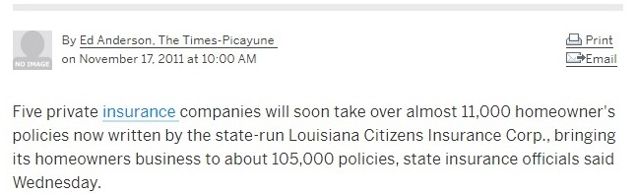

The Louisiana legislature created the state’s Matching Surplus Program to reduce the number of property owners who have insurance coverage through Louisiana Citizens Property Insurance Corporation (Louisiana Citizens/LA Fair Plan), the state’s insurer of last resort. Under the program, (created by Act 447 of the 2007 Regular Legislative Session) new or existing private insurance companies are encouraged to assume policies currently covered by Louisiana Citizens. Through this process, Louisiana Citizens can transfer policies back to the private insurance market.

Basically, oftentimes, when people purchase a Louisiana Citizens home insurance policy, a private company will ask the writing agent if he/she will allow that policy to be assumed by the private company. If the agent agrees and the insured does not opt out of the transfer, the transfer occurs.

**PPT 29:** Instructional Learning Objectives for this Class:

Slide: **The real estate agent will ascertain general areas of concern about different home insurance companies and apply those concerns to the home buyer’s experience.**

1. True or False: Louisiana has admitted many new home insurance companies into the state since Hurricane Katrina?
2. Who is the “insurance of last resort” in Louisiana?
3. Which insurance companies sell Excess/Surplus lines of insurance: admitted or non-admitted?
4. The process whereby Louisiana Citizens Insurance allows admitted insurance companies to take insurance policies out of the Citizens book of business is called:
5. Demotech specializes in rating what type of insurance companies? Older, newer?

**PPT 30:** Slide: Class Break 10 Minutes

**PPT 31:** It is important that customers review their property policies regularly with their insurance agents, as insurance companies often add new discounts to policies. In addition, some discounts have time limits and must be renewed periodically. If the customer is not reading all of his/her insurance correspondence (and there can be a lot of correspondence) and speaking with his/her agency at the policy renewals, the customer runs the risk of missing valuable cost-savings means.

Slide: Discounts on Owner-Occupied Insurance Policies

There are many different types of home insurance discounts, and each company has its own rules and dollar amounts for its discounts.

These discounts include:

1. Age of home
2. Type of roof (hip roofs get discounts)
3. Payment plan
4. Claim-free
5. Early-signing
6. Safe home
7. 55-and-retired
8. Loyalty
9. Storm Shutter

10. Hail-resistant roof

11. Smoke-free

12. Multiple policy

13. Architectural shingles vs 3-tab

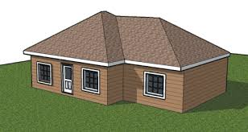

Ex. Hip roof, eligible for a discount

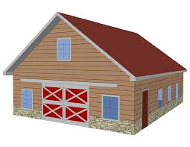

Ex. Gable roof, not eligible for a discount…….why do you think not?

**PPT 32:** Replacement Cost Value versus Actual Cash Value apply separately to the residence structure and the policy owner’s contents. The customer should ensure he/she understands what type of coverage he/she has on his/her policy. It should be noted that one means by which a customer can lower his/her premium is to assume actual cash value coverage on his/her contents and then lower his/her contents coverage. Usually, if the customer elects to maintain Replacement Cost Value coverage on his/her contents, then he/she must keep a set minimum amount of contents coverage (generally between 66 and 75% of the structural coverage.

Slide: Replacement Cost Value vs Actual Cash Value

These are methods of valuing insured property.

Replacement Cost Value (RCV) is the value of property as it costs today, regardless of the age of the property. For instance, a customer purchased a television set for $2,000 five years ago, and it was destroyed in a hurricane. Today a comparable television costs $2,500. The insured gets $2,500, less his/her deductible. RCV is more expensive.

Actual Cash Value (ACV) is computed by subtracting depreciation from replacement cost. The depreciation is usually calculated by establishing a useful life of the item determining what percentage of that life remains. This percentage multiplied by the replacement cost equals the ACV. In the same instance, the customer purchased a television set for $2,000 five years ago and it was destroyed in the hurricane. His/her insurance company says that all televisions have a useful life of 10 years. A similar television today costs $2,500. The destroyed television had 50% (5 years) of its life remaining. The ACV equals $2,500 (replacement cost) times 50% (useful life remaining) or $1,250.

The homes, themselves can have RCV or ACV coverage, though, even for homes with RCV coverage, if they undergo extensive damage, the claim will be initially paid via ACV standards, and once the repairs are made, then the difference made up to RCV standards. These law-backed rules help curtail insurance fraud.

**PPT 33:** Possibly, the most frustrating aspect of the property insurance agent’s job is the home inspection. Very often the results of the inspection cause significant changes to the policy, and usually, those changes mean higher insurance premiums. Some insurance companies are notorious for quoting low prices up front, then, following the inspection, greatly increasing the premium. The results can render unhappy customers and challenged business. Real estate agents can assist homebuyers by pointing out potential problem areas before a closing.

Slide: Property Inspections

Real estate agents are familiar with appraisers and home inspectors in the house-selling business.

Since Hurricane Andrew, home insurance companies have more frequently used home inspectors to verify the insurable state of properties **after** the sale of the policy. Nowadays, every home insurance company, including Louisiana Citizens, conducts more detailed home inspections (**usually subcontracted**) than in the past, uncovering under/over-insured properties and properties with unwelcomed risks. Increasingly, inspection companies are conducting interior inspections as well, looking for fuse panels, wiring types and the condition of the plumbing system.

Those risks include:

1. Trees
2. Damage
3. Unfenced pools and trampolines, pools with slides/diving boards
4. Dangerous animals
5. Roof problems
6. Other issues

Since these inspections are performed after the customer purchases the policy, the customer can oftentimes find him/herself facing costly repairs after the fact. You can imagine how difficult these circumstances can be for a home buyer. The real estate agent, here, can often help the prospective home buyer identify potential problem areas before the purchase.

**PPT 34:** Louisiana has elected the same Commissioner of Insurance for quite a while, now.He first assumed the position in 2006 after Robert Wooley resigned. It is my experience that the Louisiana Department of Insurance will respond to client inquiries and concerns, readily.

Slide: James J. Donelon, Commissioner of Insurance



Louisiana Department of Insurance

1702 N 3rd St #5143,

Baton Rouge, LA 70802

800.259.5300

<http://www.ldi.la.gov/>

**PPT 35:** As previously, it wise to review one’s property insurance policies at least every two years. It is a good idea to ensure the coverages are adequate and correct and the premiums are relatively competitive.

Slide: How Can a Homeowner Shop for Property Insurance?

* Shop your rates using LDI’s Homeowner’s Comparison Guide:

<http://www.ldi.la.gov/online-services/shop-your-rates>

* Talk to your agent for assistance.
* Online shopping: search online for a product that suits your needs if you confidently understand the process.
* Contact the Louisiana Department of Insurance for assistance.

**PPT 36:** There are other items to review on your property insurance policies. The following slides address the more important areas. We have already reviewed the most important type of exclusions of wind/hail, liability coverage, and flooding. Note the below general types.

Slide: Other Factors to Consider on Property Insurance Policies: Exclusions

**Exclusions** are situations that are not covered. All homeowners’ forms contain exclusions and conditions that apply to the property coverage.

**Section I: Property Coverage**

* **Ordinance or Law**
* **Earth movement**
* **Flooding**
* **Neglect** – the insured’s failure to save and preserve property after a loss, or to protect it from loss
* **War**
* **Intentional Loss**: losses caused by the insured or by someone else at the insured’s direction
* **Concurrent causation exclusions**
* **Vandalism and malicious mischief, or glass breakage** if the home has been vacant for more than **30 consecutive days**.

**Section II: Liability**

* + **Intentional acts:** liability for injury or damage that is expected or intended by the insured
  + **Motor vehicles:** liability arising out of ownership, maintenance, use, loading or unloading of motor vehicles
  + **Watercraft**: liability arising out of ownership, maintenance, use, loading or unloading of aircraft

**PPT 37:** It is important for clients to recognize that their policies may have internal limits for some items such as jewelry, musical instruments, and electronics or for certain activities or incidents. For most policies they can purchase additional coverage to add to their policies.

Slide: More Factors to Consider on Property Insurance Policies: Endorsements and Riders

**Endorsements or Riders** are added provisions that modify the coverage of a policy. Many companies offer endorsements at an additional cost to help tailor policies to the insured’s needs.

**Section I Endorsements:**

* Jewelry
* Cameras, projectors, films, and equipment
* Musical instruments
* Silverware
* Golf equipment
* Fine arts

**Other endorsements include:**

Personal property replacement cost

Permitted Incidental Occupancies/Incidental business

Earthquake

Home day care coverage

**PPT 38:** Deductibles are extremely important matters for which property owners should pay attention. They can vary greatly. Some policies include very large hurricane deductibles. For insurance, a 5% hurricane deduction on a house with $500,000 coverage would amount to a $25,000 deductible for damage caused by a hurricane.

Slide: More Factors to Consider on Property Insurance Policies: Deductibles

The deductible is the policyholder’s responsibility. The deductible usually applies to Section I and not Section II but will be clearly be stated in the policy language and provisions.

* + There is one deductible applied, per occurrence, based on the policy language and provisions
  + **All (covered) Perils Deductible**
  + **Wind/Hail Deductible**
  + **Hurricane/Named Storm Deductibles (usually 2 to 5 percent)**
    - Declared Hurricane or named storm
    - Most companies have implemented mandatory hurricane deductibles.
      * Required disclosure, La. R.S. 22:1332 (6)
      * One hurricane deductible per year, La. R.S. 22:1337

**PPT 39:** Many things affect the cost of home policies, and they can change on an annual basis. Fire department ratings can change. Insurance companies can update their interpretations of wind patterns in storms.

Slide: Factors that Contribute to a Policy Premium

**There are many different factors that determine your premium including:**

* The replacement costs to rebuild your home (Coverage A)
* The distance from your home to a fire department, the rating of your fire department
* The distance from your home to the Gulf of Mexico or Lake Pontchartrain

The information in the CLUE Report

Your personal choices:

The coverage you choose, including optional endorsements

The deductible you choose

Multi-line coverage (Bundling Auto and Home coverage can provide a discount)

**PPT 40:** Whenever possible, I would recommend that a policy holder speak to his/her insurance agency before filing a claim. This action can help prevent future unnecessary problems for the client. For instance, a client may want to file a claim for a stolen $250 camera, but not realize that his/her policy has a $1,000 deductible. The client will not get any recompense in this situation, but may incur a claim count, if he/she files the claim.

Slide: Filing a claim

How often you file a claim and the types of claims you file often affect your premium and policy renewal.

If the cost to repair the damage is not much more than your deductible, you might want to pay for the repairs without filing a claim.

To file a claim, contact your insurance agent or company as soon as possible. Ask about forms or documents you will need to support your claim.

You are also required to protect your home from further damage. For example, you might need to board up your home or clean up water from your floor – mitigation.

**PPT 41:** The state of Louisiana takes insurance complaints and fraud very seriously and will demand a response of all parties involved. As with the real estate industry, quite frankly most of the time the error or misunderstanding lies with the client.

Slide: Filing a Complaint against an Insurance Company or Agency

To file complaint the client will be directed to fill out an online form: <https://www.ldi.la.gov/onlineservices/ConsumerComplaintForm>

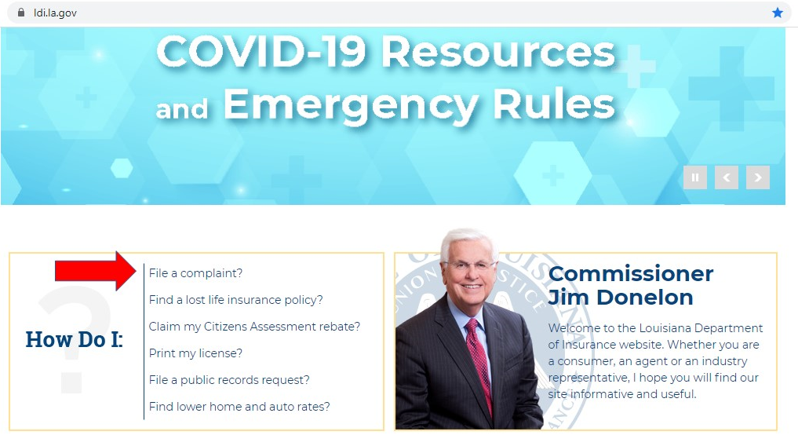

**PPT 42:** Instructional Learning Objectives for this Class:

Slide: The real estate agent will apply general pricing factors for residential property policies to best ensure the home buyer can afford his/her house.

The real estate agent will display general knowledge of key aspects of residential property policies to best understand the home buyer’s needs and rights for choosing appropriate insurance.

1. Which type of coverage will probably generally be more expensive: Replacement Cost Value or Actual Cash Value?
2. Which roof style is could be eligible for a discount: hip or gable?
3. True or False: Property policies never have exclusions?
4. True or False: A property on the Gulf of Mexico will be rated differently than a property in the middle of the state?
5. True or False: The Louisiana Department of Insurance generally will ignore policy holders’ complaints?

**PPT 43:**

Slide: Final Thoughts

Residential property insurance in Louisiana is complex and always changing.

The real estate agent can greatly assist the home buyer/seller/owner in this business environment by recognizing problem areas and assisting the customer with basic knowledge.

Real estate agents can stay current on residential property matters by maintaining relationships with several engaged insurance agents.

Comments / Questions