

**DOT & PF Wolfe Point Slope Stability Improvements**

**Public Notice**

**03/10/25**

Where? Wolfe Point Scenic Wayside Parking Lot

When? 03/12/25 to 10/31/2025

The Wolfe Point Scenic Wayside Parking Lot (4511 N Tongass Highway) will be closed from during blasting activities, and limited closures during excavation activities. 7 days a week 6am – 6pm

Please refer to the map below for details.

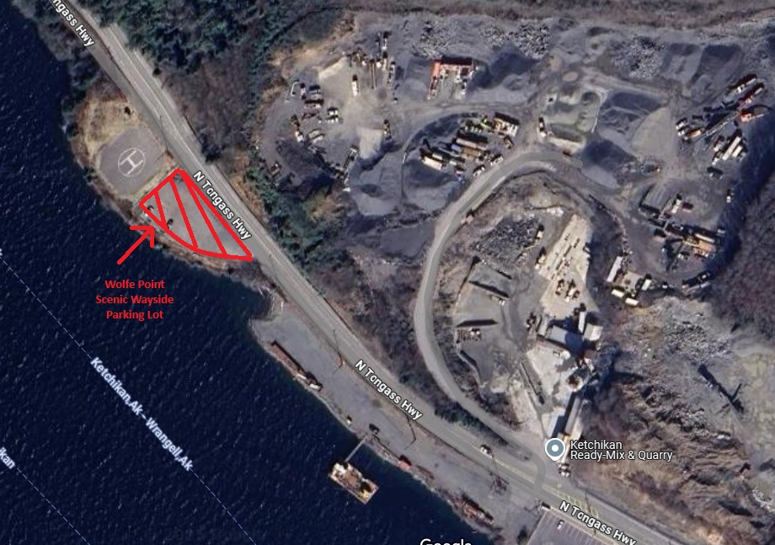

**TRANSIT** **ALERTS** **-** Transit Alerts | Ketchikan Gateway Borough, AK - Oﬃcial Website (https://[www.kgbak.us/844/Transit-Alerts)](http://www.kgbak.us/844/Transit-Alerts))

**BE** **AWARE** **OF** **CHANGES** **TO** **TRAFFIC** **PATTERNS,** **PEDESTRIAN** **TRAFFIC,** **PARKING,** **BUSINESS** **ACCESS**

**Check** **our** **website** **for** **traﬃc** **updates:** **https://**[**www.facebook.com/secon.ak**](http://www.facebook.com/secon.ak) **https://ketwolfepoint.com**

Project Oﬃce: 4418 Tongass Ave, Ketchikan, AK 99901 Phone: 907-204-1335 Fax: 907 225-6492

Public Information Coordinator: Marianne Kordowski – [mkordowski@colaska.com](mailto:mkordowski@colaska.com)