Textures for Planets

**Getting Started**

Texture for Planets is a tool that allows you to easily bulk generating wrapping textures for worlds to use in space art, space games, or whatever the reason the reason you're here. By easily setting up and configuring a set of steps, the tool will randomly then generate wrapping textures in a folder of your choice.

This tutorial walks through generating textures for heavily cratered Martian like planets.

**Welcome**

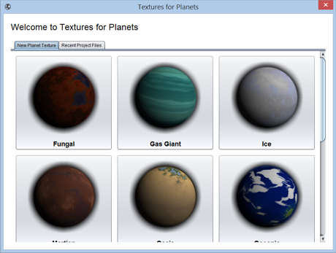

When you first start Textures for Planets it asks you to select a preset. This will setup all the basic you need to generate textures for similar worlds. Select the **Martian** preset.

**Generating Preview**

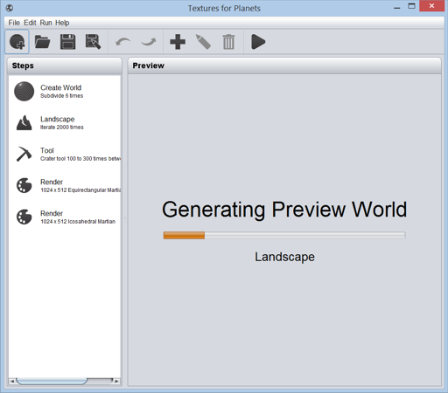

The main window is divided into two sections. On the left is the steps used to create the textures and on the right is a preview of what planet textures may look like given the steps on the left. The tool has started generating a preview of our Martian world.

You can keep working while the preview is generating. If you change something, it will just restart.

**Increase the Detail**

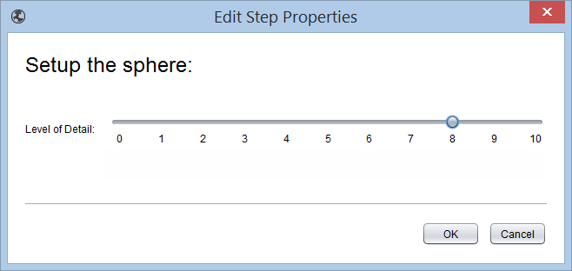

The first step is the "Create World" step. This tells the engine how detailed a world to generate. For smaller textures decrease the value as higher numbers require more time and memory.

Double click on the "Create World" step and drag the slider to 8 to increase the detail level. Click OK once complete.

**Add More Craters**

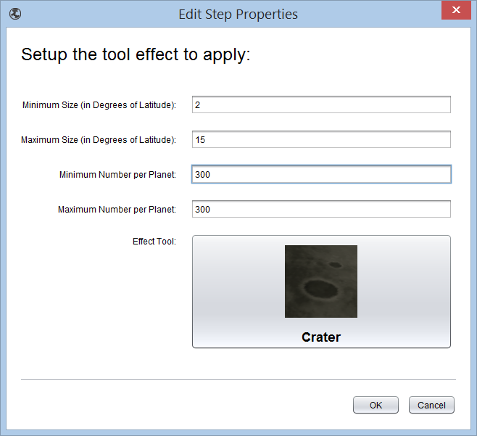

Typically after the world is setup effects and such are added. Double click on the "Crater" tool entry. Notice the available parameters allow you to configure the minimum and maximum sizes for the craters and the numeric range of how many to put on the planet. When generating each texture a random number between this range will be selected. Increase the minimum and maximum number per planet to 300. Click OK when done.

**Generate Textures**

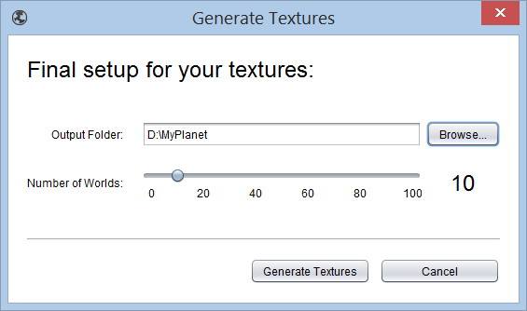

Once you're happy with the texture setup, click the "Run" button in the toolbar to bulk generate png files of your highly cratered Martian worlds. You will be asked to save your project which would allow you to re-open the same steps for use again. After saving (or not), select a folder in which to save the texture images.

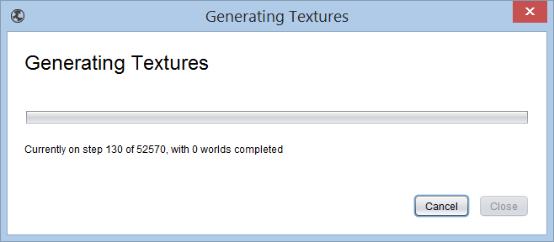**Wait a Bit**

Depending on the detail, tools, and number of worlds this may take a while. It's a free tool! Be patient.

**Use Your Textures**

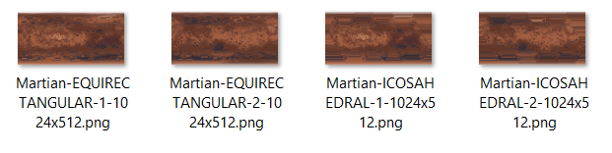

As the textures are generated they will appear in the selected folder. Notice that the steps have two output formats: icosahedral and equirectangular. Based on your needs you can use either or both by deleting or adding steps to your project.

**Output**

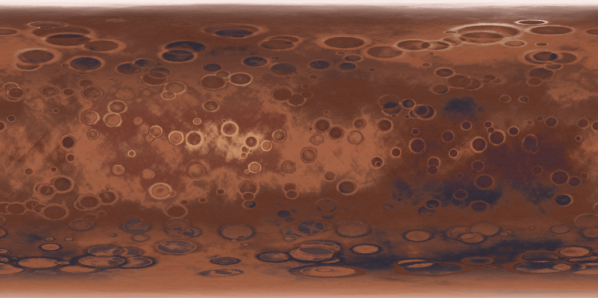

1024x512 equirectangular projection of the very cratered Martian like world.

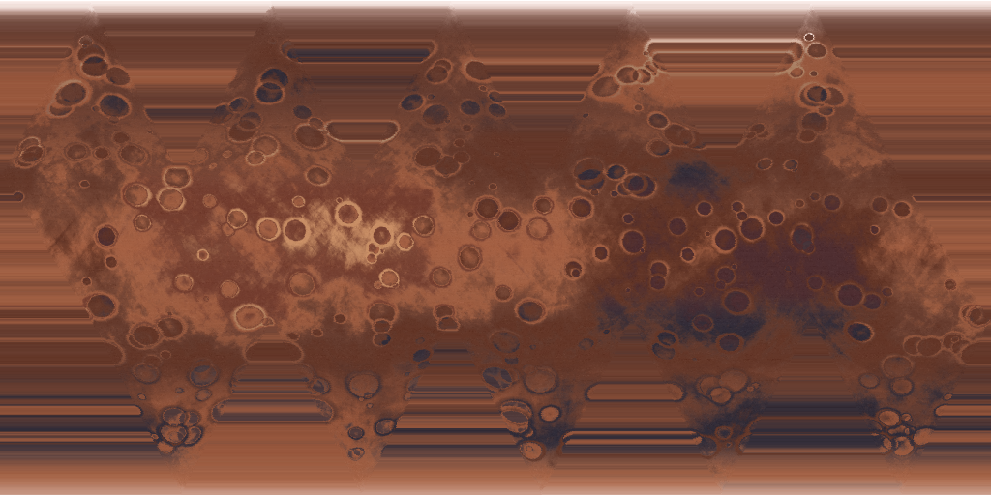

1024x512 icosahedral projection of the very cratered Martian like world.

[Textures for Planets](http://blog.texturesforplanets.com/)

## Sunday, January 18, 2015

### Customize a Wrapping Planet Texture - Part 1 - Surface

#### Introduction

In this post we'll create a wrapping planet surface texture for a toxic planet using [Textures for Planets](http://www.texturesforplanets.com/), a free tool to generate planet textures. In [part 2](http://blog.texturesforplanets.com/2015/01/customize-wrapping-planet-texture-part.html) we add the cloud layer.  
  
Here's a rendering of our goal toxic planet:

[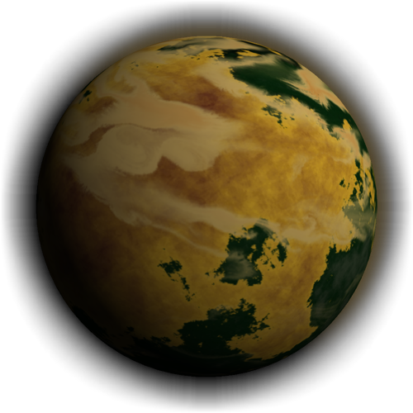](http://2.bp.blogspot.com/-ftApDLnLOyk/VLubXNDa31I/AAAAAAAAA8M/psaWlyY_8YI/s1600/Toxic.png)

#### Create a Colour Palette

Textures for planets doesn't come with colours for toxic planets so we'll make our own. Using your favourite graphics editor (Gimp, Corel PhotoPaint, PhotoShop, etc.) create a 200 x 200 pixel image. This image will provide a palette for Textures for Planets to colour your world. At the top of the image is the colouring for the highest altitudes, at the bottom of the image is the colouring for the lowest altitudes. To the right is the poles, and the left is the equator.

Highest

Lowest

[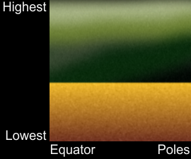](http://3.bp.blogspot.com/-7pM84i1mspk/VLuOgBPNeOI/AAAAAAAAA6U/wtpJAK_V-_c/s1600/heightandlatitude.png)

Equator Poles

You can get creative with your colours. In the above I've created toxic seas of yellowed water and green sludge above. I've painted with broad strokes, blurred, then added noise. I used two layers to keep a clean shoreline. Export your image to a PNG file.

#### 

#### Create a Colourizer

To use in Textures for Planets some more information is required. You'll need to create three files:

* colours.png
* sample.png
* colourizer.txt

Please note that the file names are case sensitive so use lower case letters.

For now, use your 200x200 pixel PNG image for both colours.png and samples.png by saving it twice. PNG must be 24-bit colour depth!  
  
The colourizer.txt file tells Textures for Planets some information about your Colourizer. It is a set of properties and looks like this:

name=Toxic  
template=plain  
template_colourizer_surface=Toxic  
template_colourizer_clouds=  
show_in_start_gallery=true  
author=Textures for Planets

These will be explained later but for now just enter or copy the above verbatim. Zip the three files into a file called "toxic.zip".

[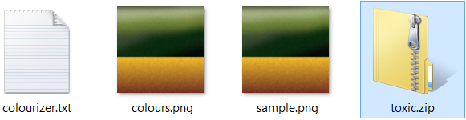](http://1.bp.blogspot.com/-Qn2-r8Qw0lU/VLuPz5ow7dI/AAAAAAAAA6g/hwC_F4ta1BA/s1600/files.png)

Copy the zip file into the "Colourizers" folder of your "Textures for Planets" home folder. The program asks you to select this when you first start it up. On Windows 8 it defaults to something like C:\Users\<your name>\TexturesForPlanets\Colourizers.

#### Test it Out

[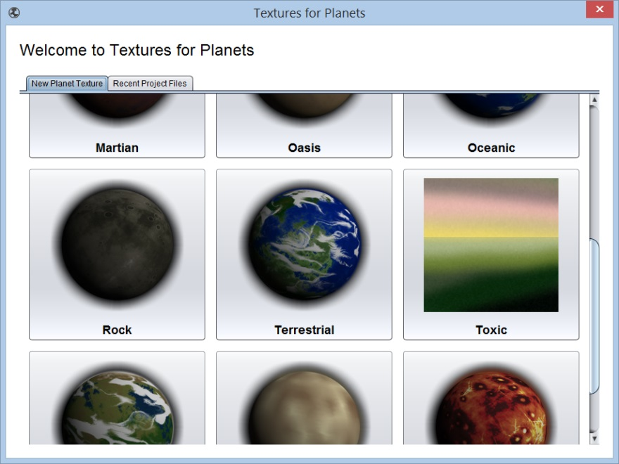](http://4.bp.blogspot.com/-MayNiV-W4U8/VLuRiV1PpXI/AAAAAAAAA6w/LltncCHE_yY/s1600/ShowsInTFP.png)Launch Textures for Planets and you should see the Toxic option in the start screen's gallery of worlds.

[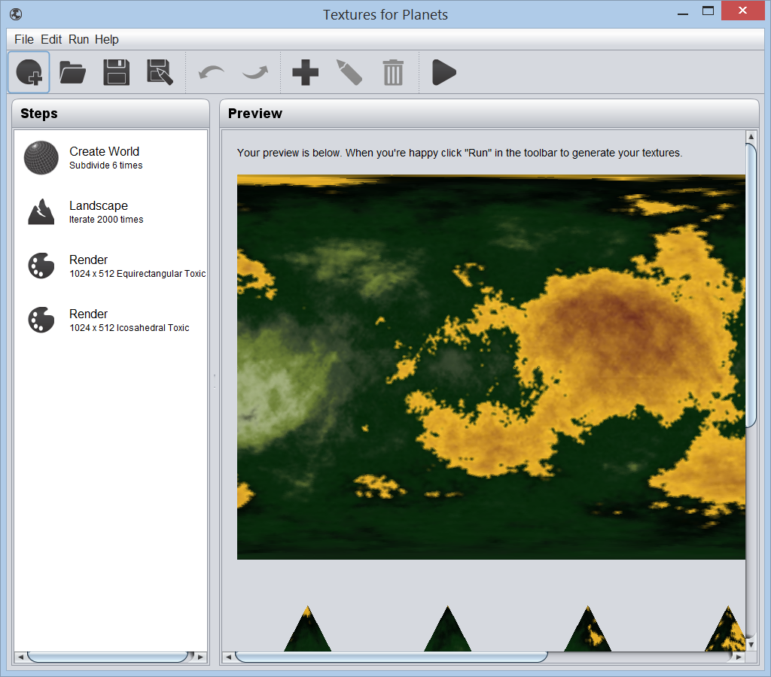](http://2.bp.blogspot.com/-kWN4UeNscBY/VLuS_2WSVdI/AAAAAAAAA68/_5cpnRk0jK0/s1600/sampleplanet.png)If you don't see it, double check that you followed all the steps and that the colourizer.txt file is filled in correctly and that the filenames are all lower case. Also check that the .PNG file has a high enough colour depth, 24-bit works. Might need Corel PaintShop to make these.  
  
If you like, you can download the completed zip [here](http://www.texturesforplanets.com/downloads/blogfiles/toxiccolourizer/basic/toxic.zip).

Select the Toxic option and your preview world will appear:

That's it. You're now free to add tools and other effects and customize the output for your toxic planets. When you're happy click the Run button in the toolbar to generate as many unique textures as you want.

Here are two example outputs:

[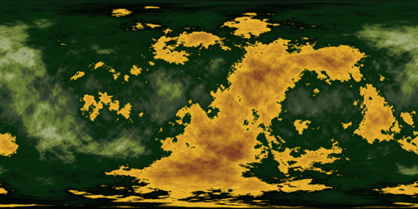](http://2.bp.blogspot.com/-xBHZPAQ-bY8/VLuT91qRWEI/AAAAAAAAA7M/hr_1_e6NKok/s1600/ToxicWrappingPlanetTexture1.png)

[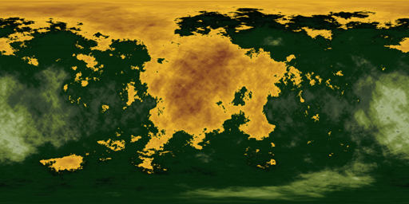](http://2.bp.blogspot.com/-TXSjtmPGvIM/VLuT_k1zldI/AAAAAAAAA7U/7Ygj8AuQ8n4/s1600/ToxicWrappingPlanetTexture2.png)

### Customize a Wrapping Planet Texture - Part 2 - Clouds

#### Introduction

In [part 1](http://blog.texturesforplanets.com/2015/01/customize-wrapping-planet-texture.html) we looked at customizing a [Textures for Planets](http://www.texturesforplanets.com/) world by installing our own colour palette into the too. In this section we will add toxic clouds to the mix. Many of the steps are the same.  
  
Here's a reminder of our goal toxic planet:

[](http://2.bp.blogspot.com/-ftApDLnLOyk/VLubXNDa31I/AAAAAAAAA8M/psaWlyY_8YI/s1600/Toxic.png)

#### Create a Colourizer

Cloud layers also use a 200x200 png file as the palette in the same way as surface colourizers. For clouds though, use a transparent background and fade the clouds to clear. That will allow them to fade around their edges.

[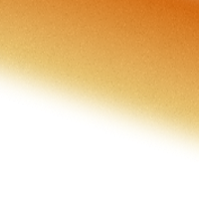](http://2.bp.blogspot.com/-X4tcaxlG-7E/VLuWkWdcARI/AAAAAAAAA7w/UuFOZePFp_Q/s1600/colours.png)Here is the colours.png for our toxic clouds:

Use this same file for the colours.png and the sample.png for now. For the colourizers.txt file, use the following content:

name=Toxic Clouds  
template=plain  
template_colourizer_surface=  
template_colourizer_clouds=Toxic Clouds  
show_in_start_gallery=false  
author=Textures for Planets

Zip the three files into toxicclouds.zip and copy them to your Textures for Planets colourizer folder. You can find the completed zip [here](http://www.texturesforplanets.com/downloads/blogfiles/toxiccolourizer/basic/toxicclouds.zip) if you like.

#### Update the Toxic Colourizer

By default we want our toxic colourizer (made in [part 1](http://blog.texturesforplanets.com/2015/01/customize-wrapping-planet-texture.html)) to include clouds. Update its colourizer.txt file to look like this:

name=Toxic  
template=terrestrialclouds  
template_colourizer_surface=Toxic  
template_colourizer_clouds=Toxic Clouds  
show_in_start_gallery=true  
author=Textures for Planets

The changes tell Textures for Planets to use "Toxic Clouds" as the default cloud colour and to use the template "terrestrialclouds" instead of plain. When users select the Toxic option to start a new world, the cloud layer will be automatically copied from the default terrestrialclouds templates.  
  
Rezip the toxic colourizer files (colours.png, sample.png, and colourizer.txt) into "toxic.zip" and copy that to the colourizers folder. Replace the earlier versions.

#### Test it Out

Start up Textures for Planets and select the Toxic planet option. The steps view should now include the Clouds step and the sample generated should include clouds:

[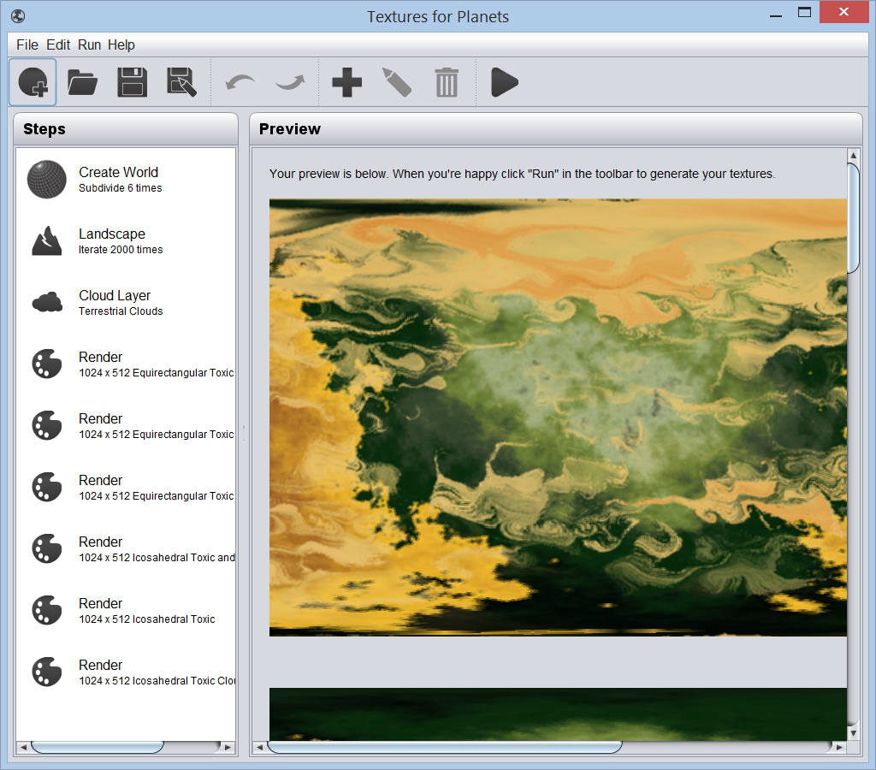](http://3.bp.blogspot.com/-xu_SF1gyiHo/VLuZz9c1ztI/AAAAAAAAA8A/6QwlTsE4S6Y/s1600/sampleplanetwithclouds.png)

#### Update the Sample Images

When you're happy with the output and colours selected you can update the sample images to 3D renderings to match the tool. Here are final [toxic.zip](http://www.texturesforplanets.com/downloads/blogfiles/toxiccolourizer/final/toxic.zip) and [toxicclouds.zip](http://www.texturesforplanets.com/downloads/blogfiles/toxiccolourizer/final/toxicclouds.zip) that you can use.