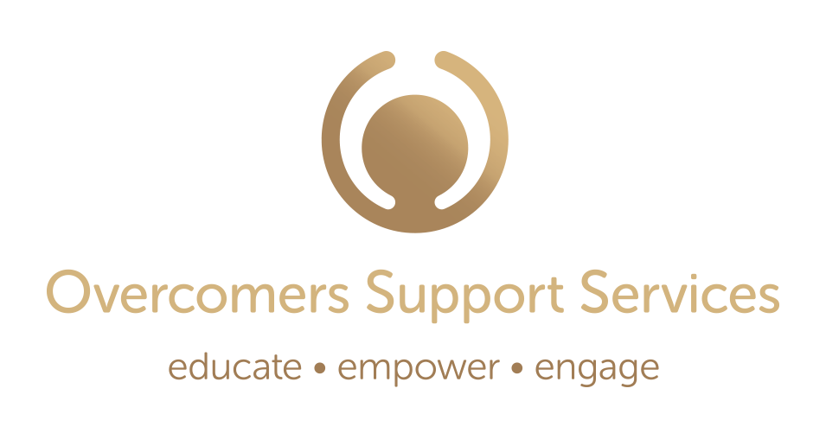
Case Manager Job Description
Overcomers Support Services: Overcomers Support Services is a recently established 501(c)(3) private non-profit that provides post resettlement services to the refugee populations of the greater Concord and Manchester areas. Our goal is to help New Americans become fully engaged, successful participants in their new community. Most of our clients are from Africa although our doors are open to all.
Looking to hire: We are seeking a part-time (20 hrs/week) case manager to provide practical support to New Americans in Concord and, on occasion, in Manchester. The case worker works one on one with refugees, helping them with access to social services, housing, medical care and educational opportunities, and provides encouragement and direction to improve their capacity to participate in community life. The case manager works to ensure that the needs of New Americans are appropriately assessed and met in a culturally and linguistically appropriate manner.
This person will also assist with our women and youth programs.
Job Requirements:

- Strong knowledge of case management and refugee resettlement.
- Experience in social services preferred.
- Excellent verbal and written communication in Kinyarwanda and English. Additional French and/or Swahili would be helpful.
- Excellent people skills.
- Ability to work independently, analyze and make sound judgments to resolve problems quickly.
- A valid driver’s license, clean driving record and reliable transportation.
- Cultural and geographic background comparable to client population.
- Basic computer skills.

How to Apply: Send your resume and cover letter to Clement Kigugu, Executive Director director@overcomersnh.org www.overcomersnh.org

Job Location: Concord

Salary/Hours: $19/hour 20 hours/week
Updated: 12/22/2023

