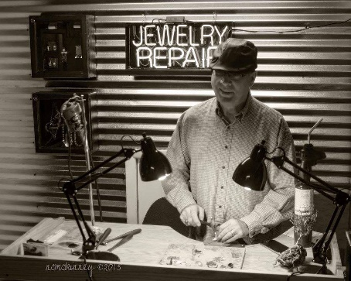***Jewelry Sawing with Artist Duane Basinger***

***Creator Bio:***

My name is Duane Baysinger, and art and working with my hands has been my passion since I was a young teen. I found that real satisfaction in life always surrounded some field of art. In my early teens, I learned how to sketch, do leather work, wood carving and later learned stained glass.

At 19, I started doing hobby silversmithing making coin rings. That led to cuttlebone casting, then sand casting. A store saw some of the pieces I was making and hired me. There they taught me to carve waxes and do lost wax casting. My first job as a jeweler was in 1980. By 1984, a friend and I started a jewelry store in downtown Corbin.

I have learned nearly all facets of jewelry making. Hand fabrication, lapidary, faceting, all forms of stone setting and any kind of jewelry repair and many forms of metal working. I’ve been active as a professional jeweler for 42 years.

I love teaching and sharing what I have learned through the years and look forward to the future classes at the Carnegie Center.

***Class Description:***

***Jewelry Sawing***

In this class we will learn how to design and cut an intricate pendant or brooch from copper and brass. We will learn how to drill 1mm holes and how to load a 1mm sawblade in a jewelers sawframe. Then how to cut out intricate designs. We will then rivet it to another piece of metal or wood to complete the piece.

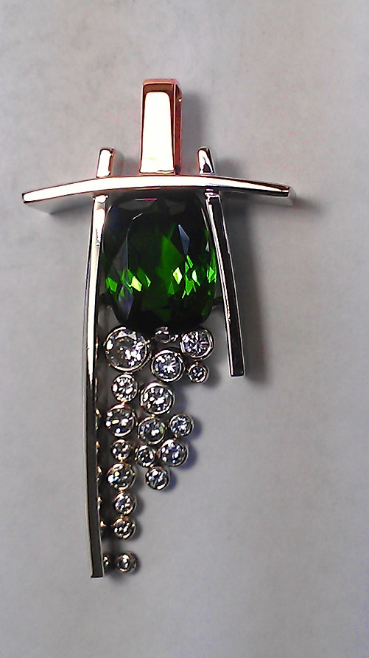

***Class Supply List:***

All tools and materials for the class will be provided

**Class Maximum: 8**

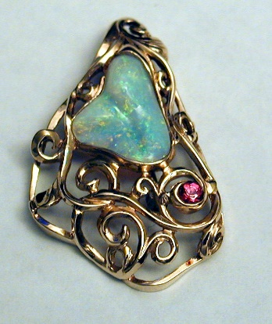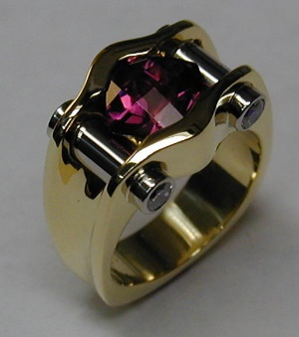**Class Minimum: 6**