ZINFANDEL 2018

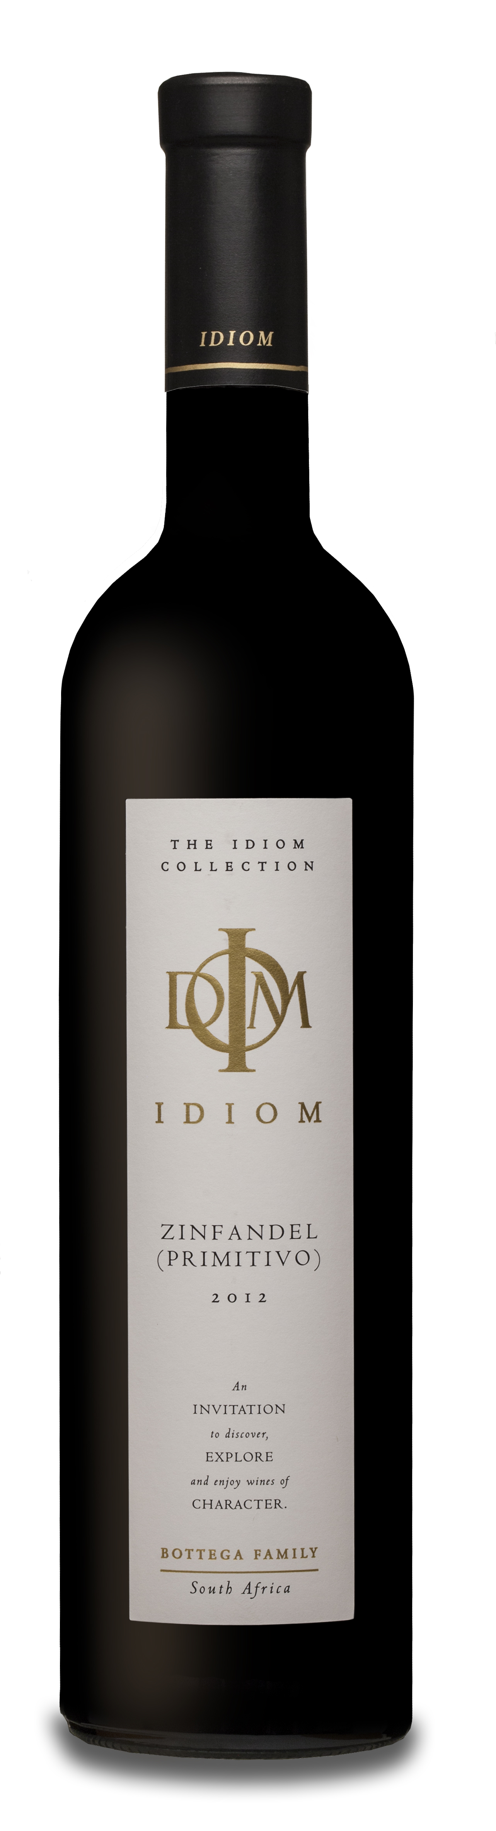
VINIFICATION
Wine maker description | Silky and spicey. This elegant, medium bodied expression of Stellenbosch Zinfandel exhibits a superb power-to-weight ratio. Aromas of candied raspberry and hibiscus dominate the nose. An effortless entry leads to an explosive revolving tray of bay leaf, tobacco and mulberry flavours dancing on the palate. A refreshing wine with an attractive long finish.
Varieties | 100% Zinfandel
Origin | Wine of Origin Stellenbosch
Vinification details | The grapes were cold soaked for 4 days prior to fermentation. During fermentation the temperatures were kept at between 22-28°C. Malo-lactic took place in tank, on French oak staves before being matured in 60/40 % French and American 225l oak barrels for 12-14 months.
Date of bottling | 24th February 2020
Analysis | pH 3.47 Total acidity 5.7 g/l  Residual sugar 2.5g/l Alcohol 14 %
PROVENANCE
Vineyard – Da Capo, Sir Lowry’s Pass, Helderberg

Soils | Granite/Tukulu (decomposed granite)/Table Mountain Sandstone
Aspect | North west
Area | 1.11 Hectares
Trellising | Vertical Shoot Positioning
Irrigation | Drip
Predominant wind | SE Summer/NW Winter
Date of planting | 1999
Clones | ZD1AXA on R110
Balling at picking | 23.7°B

