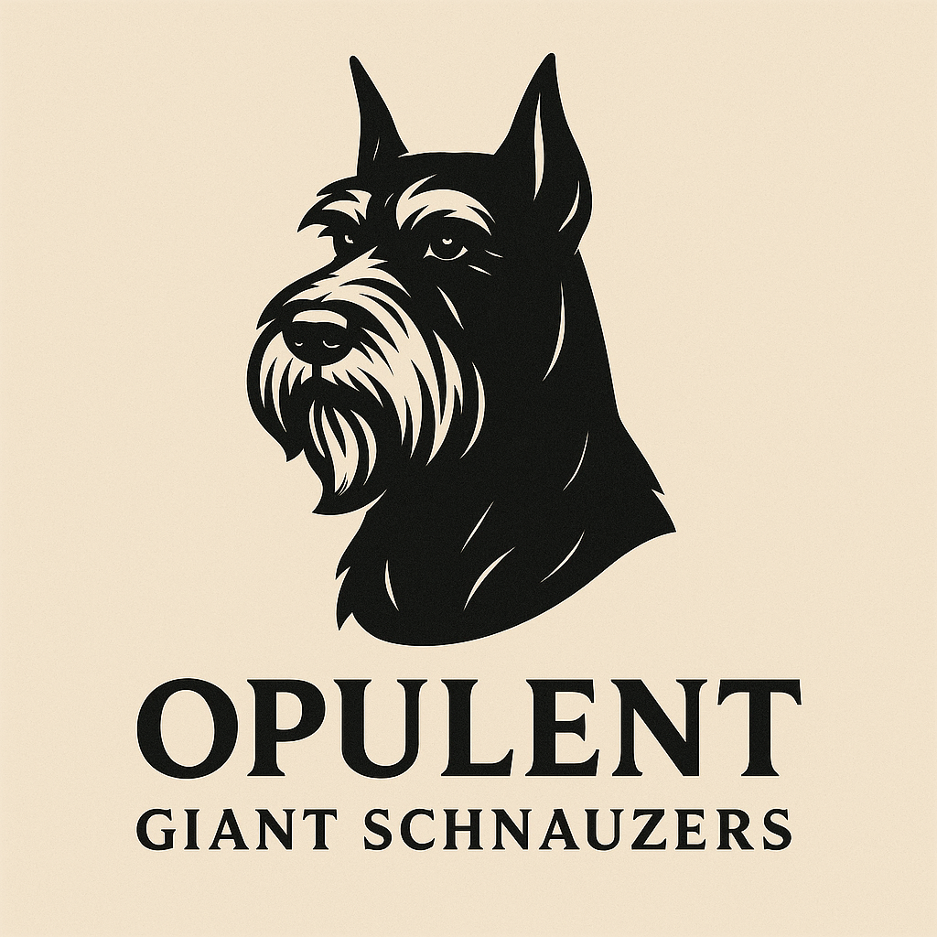

# Opulent Giant Schnauzers Health Guarantee

This Health Guarantee is made between Opulent Giant Schnauzers (hereinafter referred to as 'Seller') and _________________________________ (hereinafter referred to as 'Buyer') for the Giant Schnauzer puppy described below:  
  
Date of Birth: ______________ Sex: ______ Color: ________   
  
1. The Seller certifies that the above-described puppy is in good health at the time of sale, has been examined by a licensed veterinarian, and has received age-appropriate vaccinations and deworming.  
  
2. The Buyer is required to have the puppy examined by a licensed veterinarian within 72 hours of pickup. Failure to do so voids this health guarantee.  
  
3. If the licensed veterinarian determines that the puppy has a life-threatening genetic or congenital defect, the Buyer must notify the Seller in writing with vet documentation within 3 days of the diagnosis. The Seller reserves the right to obtain a second opinion from a veterinarian of their choosing.  
  
4. If a valid claim is made, the Buyer will be offered a replacement puppy of equal value when available. No cash refunds will be issued.  
  
5. This guarantee does not cover the following:  
 - Parasites (internal or external)  
 - Common illnesses such as kennel cough, giardia, or coccidia  
 - Injuries, neglect, abuse, or health issues due to environmental conditions  
 - Ear cropping results or complications  
  
6. The Seller offers a one-year health guarantee against life-threatening congenital or hereditary conditions only. The guarantee expires on the puppy’s first birthday.  
  
7. The Buyer agrees to provide proper nutrition, vet care, training, and safe housing. Any neglect or abuse voids this health guarantee.  
  
8. This document is governed by the laws of the State of Georgia and any disputes shall be handled in Paulding County, Georgia.  
  
Buyer Signature: ____________________________ Date: ___________  
Seller Signature: ____________________________ Date: ___________  
 Buyer also agrees to spay or neuter the puppy by 18 months of age and provide proof of the procedure upon request. Failure to do so will be considered a breach of this agreement. Additionally, the Buyer may not sell, give away, rehome, or transfer ownership of the puppy to any individual or organization without written consent from the Seller. Violation of this clause may result in legal action and the return of the dog to the Seller.