2023 Auto Value Super Stock Rules
All 2023 revisions are listed in (red)
• BODY:
• Must Remain Stock Appearing, ABC BODIES MAY USED. (NO carbon fiber) FULL Metal body will get 50# weight brake (see matrix).
• No functional fresh air hood scoops.
• Rear spoiler is allowed 5” max height, not to extend past deck lid sides.
• Weight identification number will be displayed somewhere near driver side "A" pillar. Number will include any and all penalty/matrix weight. MUST BE CLEARLY VISIBLE!
• Bumpers are not to extend out past the body and must not have any exposed sharp edges that may hook another car or pop tires. All ends must be capped and rounded. Subject to inspector approval.
• CHASSIS:
• Roll Cage and Framework
• Cars must have a six-point perimeter roll cage. (No offset cages allowed IMCA STYLE)
• Cars must have door bars on both sides of car, with a minimum of 3 door bars on driver’s side which must be plated to top of door, and 2 right side door bars.
• Roll bar tubing must be minimum of 1 ¾” in diameter with walls not to be less than .090” thick. All new cars must use roll bar tubing for cage.
• No pipe fitting, square tubing, galvanized pipe, exhaust pipe or conduit allowed within the main cage supports.
• Some type of X brace must be installed between the roll cage uprights behind the driver.
• Steel plate on left side door mandatory. 1/8” steel minimum from post to post. Extending as far forward to foot area as possible.
• Rebuilding of rear stub allowed
• Start at centerline of rear axle, straight back horizontally.
• Two parallel frame members of 10 inches minimum outside circumference, 1/8” thick tubing. (Square, round, rectangle).
• Shall extend level from existing axle frame kick up.
• Join cross member at rear with same material. (Must be symmetrical).
• Must tie into roll cage.
• Fuel cell protector hoop is required with 2 braces 2” below fuel cell.
• No underslung rear frame rails.
• All ballast (added weight) must be painted white and be securely fastened into car. Must also have car number clearly marked on each weight.
• All holes in firewall must be covered and must seal engine area from driver’s compartment.
• Foot boxes allowed. Must have 1/8 min steel floor pan and drive shaft wall up at least 6”. Aluminum panels must be .040 thick.
• Minimum 108” wheelbase (GM). Ford and Chrysler 104” minimum. No more than a 1-inch difference between left and rightside frames. Measured from centerline of wheels. OEM frame only.
• NO; Titanium parts of any kind.
• SUSPENSION:
Suspension system must remain completely and strictly stock, no modification permitted, no modifications to any control arms or trailing arms. Must remain stock OEM for your chassis. Exceptions listed below:
• No heim joints, front, or rear, except outer heim joint ends on the tie rods are legal with no penalty.
• All four flanges must have a 5‐bolt pattern.
• All control arms must be located in stock OEM location. (i.e., right on right, left on left). Metric cars must run metric OEM lower control arms and spindles. All cars must run OEM lower control arms and OEM spindles that match the original frame/car.
• No panhard bars, coil‐over shocks, small diameter springs, sliders, coil‐overs, eliminators, left bars, pull bars, bump stops, coil binding setups, rear sway bars, spring rubbers, or air springs. NO COIL or SUSPENSION BINDING PERMITTED!
•Shocks allowed in factory position only (4 shocks only). Any stock appearing shocks, non‐adjustable, and non‐ rebuildable. Rebuildable QA1 FC Series shocks allowed (1900, 1600, 78, 23, 53) and QA1 Series 50/51/26. "THESE ARE THE ONLY PERMITTED REBUILDABLE SHOCKS" Shocks may be claimed by the DCRA Board at any time for $140/shock.
•Absolutely NO; coil-over shocks, remote reservoirs, bump stops, or coil binding setups, eliminators, left bars, pull bars, air springs, spring rubbers, etc.
• Rear weight jacks and front adjustable spacers permitted.
• Minimum ground clearance of 4” including the driver, not including exhaust. THIS MINIMUM HEIGHT MUST BE MAINTAINED AT ALL TIMES AND CAN BE CHECKED AT ANY TIME!
• Mid‐American series hub & rotors allowed FOR MAKE AND MODEL OF CAR ONLY.
• No drop spindles.
• Sway Bars: Maximum diameter on any car will be 1-3/8”. OEM style sway bars only.
• Tubular upper A arms are OK if they follow these guidelines:
• Steel construction only (steel pivot shafts only, no aluminum).
• One-piece style allowed (adjustable heim style prohibited).
• Conventional style bolt on ball joints allowed (screw in style ALLOWED).
• Bushing style pivot shafts allowed (ball bearing pivots prohibited).
• Upper control arms to measure 8” plus or minus one inch on GM Metric and 9” plus or minus 1” on GM Full‐Size.
• Slotted shafts allowed.
• The only permitted, non-adjustable aftermarket trailing arm allowed are from the kits from Speedway Motors, MFG. Part # 91634055 for GM metric chassis and Part # 91634051 for GM Full-Size Chassis. Steel only.
• No slotting of holes or floating mounts or mounting points for trailing arms or A-arms.
• NO; Titanium parts of any kind.
• Steering:
• No rack and pinion type, except on ford uni‐bodies.
• A collapsible type shaft with locking collar recommended.
• No gear reduction steering boxes. Steering boxes must be stock OEM part numbers.
• Steering Quickeners are permitted!
• Tires and Wheels:
• Tires must be purchased from the official track tire salesman and be marked with his brand (Norway Speedway Tires).
• 2023 DCRA approved Super Stock tire will be the Hoosier D800.
• Four new tires will be allowed on the first week of racing. After week one, refer to the Norway Speedway official schedule for the Super Stock tire schedule. One new tire will be allowed every other night and on Auto Value races.
• You must run a “zero” tire night prior to a “1” new tire night in order to earn a new tire.
• If you miss the season opener you must run four used/scanned Norway tires.
• Must run the tires you qualified on for that night’s races.
• Must run the tires that were ran the previous week unless it’s their week to purchase a new tire.
• Name and brand must be visible. All markings must be left on tires.
• The use of tire softener will not be permitted or tolerated.
• NO IMCA SUPER LIGHT WHEELS ETC. ALLOWED! 19 lb. Minimum weight on rim.
• Longer and oversized stud bolts required, ½” min. diameter. Oversized wheel nut mandatory. Studs must have at least 3 threads past nuts.
• No shimming behind wheels of any kind!! No wheel spacers allowed at all. No welding wheel spacers/plates to the back of rims.
• All racing wheels on car must be of same offset (unless you take matrix penalty). 8” wheel max.
• No air bleeders allowed.
• Can flip tires ‐ run rights on left.
• PENALTY: anyone found not complying with the tire rules will be disqualified for the rest of the night’s events immediately, lose all pay and points for that night, and face a possible suspension.
• In the event of a popped or flat tire, you must use one of your used tires that is scanned and approved for use. No new tires shall be put on the car. Tires are subject to tire marshal/board approval.

• BRAKES:
• Aftermarket Calipers allowed Maximum MSRP. $109.99.
• Dual master cylinders allowed.
• Brake bias adjusters allowed anywhere in the car.
• FUEL CELLS:
Manufactured fuel cell in a steel box is required and must be mounted in CENTER of stub (front to rear and side to side centering). 11” minimum ground clearance. Two 1” straps in each direction, square tubing or angle iron with 1/8” minimum thickness surrounding the fuel cell box on all four sides mandatory. IF rear stub is stock, cell must be as far forward as possible.
• Must be mounted behind the rear axle.
• Fuel cell height TBD.
• WEIGHT:
• 58% left side weight (maximum percentage).
• All cars must scale before qualifying. The top 5 cars will scale after the feature race events and at any time the official’s request.
• In the event your car does not fit on the scales, you must provide a jack to put the car on the track’s official scales next to the scale shack. The scales will be removed from the pads following the completion of everyone else in line scaling.
• DRIVETRAIN:
• Engine/Weight
• Up to 360 CID Engine and up to 9.5 to 1 compression (Base Weight on the matrix).
• Cubic Inch - 360 CID Engine and over ADD 150# to base weight.
• Compression Ratio - 9.6 to 1 and up to 11.1 to 1 compression ADD 150# to base weight.
• Any engine, any size over 11.2 to 1 compression must ADD 300#.
• 58% max left side weight (will include any penalty). With driver.
• Un‐altered GM part #88958602, 19258602, & 88869602. Stock crate engine only (Base Weight).
• ENGINE:
• SETBACK: Maximum setback from top steering box mounting bolt measured to back of block mounting surface: GM‐32 ½” GM Metric. Engine must be mounted in the center of the chassis, no offset allowed. GM‐Full‐size & Ford must be in stock OEM location.
• Engine must be centered between frame rails.
• No aluminum blocks or heads.
• Factory street production heads only. (No Turbo, Bowtie, angle plug or aftermarket heads). No Porting or Polishing.
• Any flat tappet camshaft. Three pushrods must be marked with vertical white line at top.
• No roller cams/roller rockers. Stock appearing valve train 1 3/8” max. Diameter valve springs.
• No accu‐sumps or dry sump engines allowed. No remote oil filters. Aftermarket oil pan allowed.
• ¾‐1 inch sight plug in oil pan in line with rod journal ‐ (option) remove oil pan at the track at your expense.
• Solid motor mounts required if you run solid throttle linkage.
• Only cast iron or forged steel crankshafts are permitted. Titanium crankshafts are prohibited.
• All crankshafts have a minimum weight of 48lbs. No Knife Edging, Undercutting & Honda Journals are prohibited.
• Minimum crankshaft centerline height; 10‐1/2” (front and back).
• CARBURETOR:
• Rochester on GM, Motorcraft on Ford, ect.
• Rochester carb 2Gc throttle 1 3/8 inch bore 1 ‐ 11/16-inch base. Stock base plate only ‐ no aftermarket.
• No carburetor spacing allowed (Minimal gasket allowed) (35 thousandths .035 max thickness). One spacer/gasket only.
• Holley 4412’s (part #s’ 4412S & 4412C) allowed, must remain stock.
• 500 CFM only. • Throttle Bore = 1.688”, Venturi = 1.376”, Butterflies # 128, 0.093 idle bypass on butterflies.
• Approved adapters (Mr. Gasket 1937, Holley 17‐43 or Transdapt 2039 or 2086). One adapter only!
• Metering Block ‐ Only metering block 134‐137 or 134‐276 is permitted. Adjustable metering blocks are prohibited. Metering block must not be altered.
• General Carburetor Rules
• Carburetor Body ‐ No polishing, grinding, or drilling permitted. Factory type air bleeds only. Screws in air bleeds are prohibited.
• Choke ‐ The choke may be removed.
• Choke Horn ‐ The choke horn may not be removed.
• Boosters ‐ The booster location may not be changed. The size or shape must not be altered. Boosters may not be tapered. Height must remain standard.
• Venturi area must not be altered. Casting ring must remain.
• Base Plate – Base plate must not be altered.
• Butterflies ‐ Butterflies must not be thinned or tapered. Retaining screws may not be altered.
• Throttle Shafts ‐ Throttle shafts must not be thinned.
• Any Carburetor can be claimed or exchanged by DCRA at any time.
• INTAKE AND EXHAUST:
• Stock 2bbl. Cast iron intake ONLY. The only aluminum intakes permitted: GM; Edelbrock Performer #2101, RPM #7101, #7404, Speedway Motors Part # 91011465. Ford; Edelbrock #3721, #7121, #2181, #7181.
Approved intake for the open motor vortec head is part number 555-513074 – Available in Jegs magazine.
• Matrix addition: Headers are allowed with a 100# weight penalty on an open motor but must follow the following guidelines:
• 1 ‐ 5/8” tube over or under chassis, single pipe collector design only. Spec. type economy header only.
• 3” maximum exhaust and collector diameter Except Speedway Motors Part #91013146 over the top header. Must neck down to 3” off the collector.
• No stainless-steel collectors.
• No 180 degree or step headers.
• The ONLY over the top header allowed will be Speedway Motors Part #91013146 and Schoenfeld 145.
• This will be allowed with the 100# matrix penalty for open motors and no penalty for sealed 602 GM crate engines.
• No porting or polishing of any kind on any intake or exhaust parts. Any evidence of sanding, polishing, relieving, grinding, porting, chemical treating, abrasive blasting, ceramic work, addition of material or any alteration to original form is prohibited.
• All cars must have mufflers of reverse flow design or glass packs UNALTERED. Exhaust will be 3" max. Diameter; exhaust may exit out passenger side door but still has to remain under 95 decibel limit-No exceptions!
• 95 decibel limit MANDATORY!!! No exhaust popping, or other irregular exhaust noise.
• Only one intake gasket allowed between head and intake.
• FUEL/FUEL PUMP:
Absolutely no Alcohol or E85. No oxygen bearing or performance enhancing additives may be introduced into the inductions or fuel supply. Regularly available pump gas or racing gasoline only. No alcohol, nitro methane, nitro, propane, nitrous oxide, other oxygenating agents, other additives, and/or fuels that contain masking agents or oxygen.
• IGNITION:
• Any stock appearing single point or magnetic pick‐up type may be used. Module must be 4‐pin (No 2‐pin modules). Stock appearing coil in the distributor must be used. No MSD boxes or similar.
• No electronic traction control or on-board computers will be allowed.
• No programmable circuit boards, MSD Boxes, soft touch, or any rev limiting devices allowed. No external boxes of any kind will be permitted.
• No internally adjustable or chipped distributors allowed.
• No rev limiting tachometers allowed.
• The DCRA board will reserve the right to impound any distributor, cap, rotor, module and or wiring.
• TRANSMISSION AND REAR END:
• 10‐1/2" diameter clutch on GM, 10" diameter clutch on Ford.
• Clutch disc must be the conventional solid disc type.
• No clutches such as: Button, Multi‐disk, ram couplers, sportsman clutches, or other small clutches. No puck or paddle type clutches are allowed.
• No Aluminum flywheels.
• OEM type flywheel and flex plate only. Must be full-face steel only. No spoke type, ultra-lightweight flywheels, or flex plates.
• Provisions must be made for clutch inspection, such as bell‐housing inspection hole. The DCRA officials reserve the right to have you remove your clutch at the track if inspection hole isn’t adequate to determine clutch type.
• Only stock OEM transmissions allowed. No racing or after-market transmissions will be allowed. Factory case only.
• Transmission must have forward and reverse in working order. No direct drive or clutch‐less setups.
• Automatic Transmissions allowed with working torque converter. NO COUPLERS!
• Rear end must remain in stock mounting location.
• Quick change rear ends will be allowed, located in the stock location with the stock trailing arms, and will be added to the matrix with a 50# weight penalty. 10-inch ring gear only. No aluminum tubes allowed. You must run the same gear as you run in qualifying.
• No cambered rear tubes, snouts etc. as to cause rear camber.
• Ford 9" will be allowed. No shaving axle tubes, or any work allowed to lighten the housing. Stock OEM ONLY!
• STOCK OEM (center section, cover, axle tubes, snouts, etc. must all be steel, NO ALUMINUM OR LIGHTWEIGHT Parts).
• Racing axles recommended.
• Rear drums may be aluminum.
• No Aluminum drive‐shafts, steel drive‐shafts only. Driveshaft must be painted White for safety.
• Rear Disc Brakes are legal.
• CRATE MOTOR:
• GM part #88958602, 19258602, & 88869602‐ Must have factory GM Seal bolts!
• DCRA approved 650 CFM Holley carburetor only: Part # 0‐4777 ‐ (1‐7 & C). Carb can be claimed or exchanged by DCRA at any time.
• Recommended Approved Schoenfeld headers are part #185VCM on metric. See header/exhaust rules for legal header types. The only over the top header allowed will be Speedway Motors Part #91013146 and the Schoenfeld 145. This will not result in a penalty for the 602 sealed GM crate engine.
• Repair/Rebuild ‐ You must use a DCRA BOARD Approved Source for any Crate motor repairs or rebuilds, CHECK BEFORE ANY SUCH WORK.
• Absolutely NO MODIFICATIONS allowed to the engine, no 1.6 rockers, or bee‐hive springs.
• Must provide purchase history or bill of sale for your crate engine.
• TRANSPONDERS/RACECEIVERS/RADIOS:
• The transponder must be mounted on the left frame rail no further forward than 23 inches forward of the rear axle tube in the hanging position, and no higher than 24 inches from the racing surface.
• RACECEIVERS ARE MANDATORY.
• SPOTTER TO DRIVER COMMUNICATION RADIOS ARE RECOMMENDED!
• DISCLAIMER:
DCRA Executive Board reserves the right to modify or change rules at any point. You as a driver are responsible for understanding and following the listed rules. If your car contains a rule not listed on the below matrix, please contact DCRA board for accommodations. All weights are subject to change. Additional infractions not listed in the matrix found in non‐compliance with the base weight rules are subject to additional penalty weight. Non‐compliance will be subject to loss of points and or pay and possible suspension.
• Matrix – Overall weight defined below must be displayed on or near the driver’s side “A” pillar at all times.

Rules Updated: 3/1/23

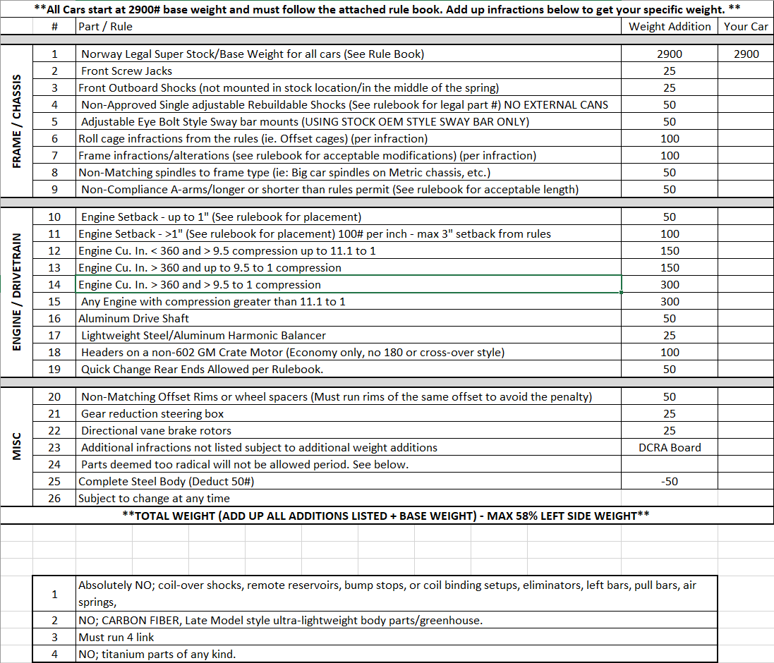

** Matrix Updated: 3/1/23**

