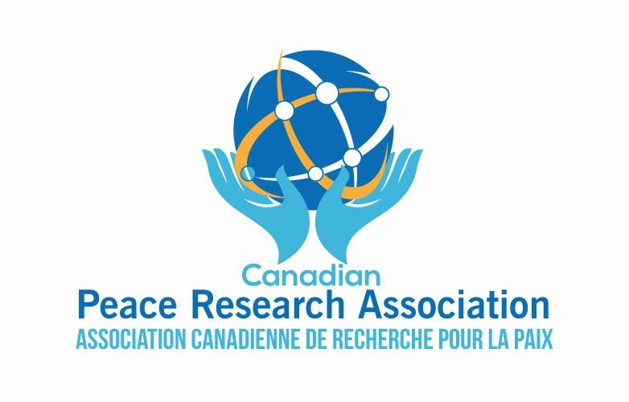

Canadian Peace Research Association (CPRA - ACRP)
Congress 2021 of the Humanities and Social Sciences

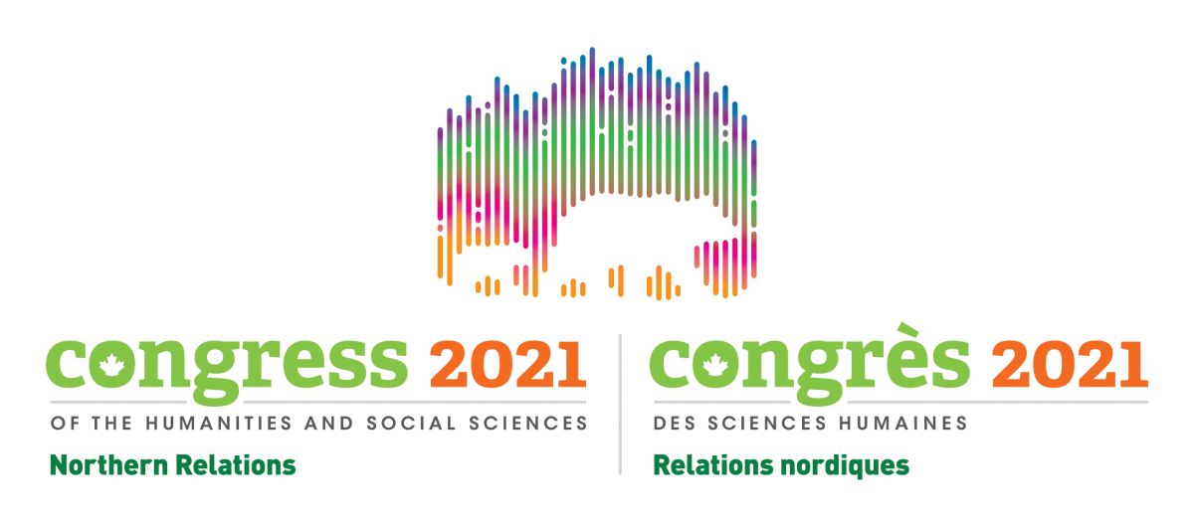

Wednesday June 2 - Friday June 4, 2021
CPRA Staff can be reached at: General Correspondence
CPRA President and Program Chair: Professor Erika Simpson at the University of Western Ontario
Local Arrangements Coordinator: Professor Andy Knight at the University of Alberta

A Cordial Invitation from the Program Committee:
We are pleased to invite you to the 2021 Annual Conference of the Canadian Peace Research Association - Association canadienne de recherché pour la paix (CPRA - ACRP). The CPRA – ACRP Conference is part of the Federation for the Humanities and Social Sciences, which promotes research, and teaching for “the advancement of an inclusive, democratic, and progressive society.” The Federation is the organizational body that promotes Congress 2021.

With a membership now comprising Canada’s universities, colleges, and scholarly associations, the Federation represents a diverse community of researchers and graduate students across Canada. The Federation organizes Canada’s largest academic gathering, the Congress of the Humanities and Social Sciences, bringing together thousands of participants each year.

In 2021, it is expected that thousands of scholars will gather under the aegis of a virtual platform using Zoom showcasing approximately 45 academic associations representing a rich spectrum of disciplines in education, social sciences, social work, peace research and other academic disciplines. Congress represents a unique showcase of scholarly excellence, creativity, and leadership.

The CPRA - ACRP Conference, as a constituent of Congress 2021, hopes to offer a welcoming milieu for peace researchers, social scientists, teachers, as well as activists and advocates, in order to present their research as well as influence peace studies.

Congress Theme:
Through its Congress 2021 Theme–Northern Relations–the Federation proposes to open a virtual space for dialogue. We are embracing this theme in the CPRA - ACRP’s programming, collaborating with other associations, and making many of our sessions open to all Congress participants and to the public. Our goal is to deliver a positive virtual experience for our association’s members and attendees. The Federation team and the CPRA - ACRP team are here to support you. We look forward to providing you with all you need to make Congress 2021 a memorable experience for all involved.

We encourage researchers to consider different ways of becoming involved in the conference. Please see the following pages in this Handout for more detailed information about Congress.

All emails that relate to becoming involved in the conference, must be submitted to the General Correspondence Email address with copies to the President/Program Chair or they will not be considered. Please ensure you have selected Option A, Option B or Option C and copied your proposal to the following two email addresses:

- Professor Erika Simpson at the University of Western Ontario. Email address: simpson@uwo.ca
- General Correspondence Email Address: CPRAmail@gmail.com

Option A: Keynote Panel or Individual On Demand sessions (pre-recorded Zoom presentations hosted by CPRA President Erika Simpson on behalf of the CPRA); Deadline March 31, 2021
These will be pre-recorded Zoom presentations of individual presenters or a panel of presenters that are uploaded on April 1, 2021 to the virtual event platform by the Congress. These sessions will be open to all registered attendees of Congress on May 25, 2021 and will continue to be available until June 30, 2021. These sessions must be pre-recorded by March 31, 2021 in order to be made freely available by Congress to thousands of Congress attendees. The Program Chair must invite you on behalf of the Program Committee to contribute a keynote as these sessions attract large audiences of attendees who tend to be generalists, not specialists in peace research. The “Keynote Panel or Individual or On Demand sessions” are always hosted, and recorded by CPRA President Erika Simpson, and they will be made permanently available on the CPRA website, beginning July 1, 2021.

A single Zoom presentation (possibly including a proposal for a research paper) and/or Panel or Roundtable Zoom Presentation must include the tentative title of the presentation and an approximately 50-word description, for advertising purposes. In addition, each paper’s abstract could outline the argument or inquiry to be developed; identify the method of analysis to be used (if applicable); and show the theoretical significance of what is proposed in relation to existing scholarship in the field. Once the title and description of the In-Demand Zoom presentation (not the abstract) has been submitted, the submitter(s) will not be able to refine the title because your Zoom presentation will be featured as an “In Demand” lecture, and it will be advertised on the Congress’s website, and in its public program, and be made freely available to all the Congress attendees.

Option B: Panel or Individual Simu-live sessions (pre-recorded Zoom presentations hosted and recorded by your co-chairs/moderators with time for a live Q&A that will be recorded in June); Deadline April 30, 2021
Pre-recorded presentations are created and uploaded to the virtual event platform by individual presenters or panels of individual presenters. These sessions will start with a recorded introduction by the chair/moderator followed by one pre-recorded presentation (or several individual recorded presentations). Following those presentations, the chair/moderator and the presenters can take more time to engage in a live Q&A discussion during the actual CPRA program in June. These sessions must be pre-recorded by April 30, 2021 in order to be included in the online program with links. All the contributors including each panellist must have paid the Early Bird fee, by March 31, 2021, or the Panel could be jettisoned if a single panellist neglects to pay the Congress fee by April 30, 2021. On the day of the event, programmed between June 2-4, 2021 (GMT-7 time), an event technician and/or room monitor will be online to ensure that all your technical needs are taken care of. A recording of the entire event, with the pre-recorded presentations, and the live Q & A, will then be generated and uploaded to the conference agenda as a raw recording, the next day.

One disadvantage of the Simu-live session is that your panel pre-recording, and the subsequent Q & A, must stay within a strict time-slot of 1 one-hour session (Congress will stop recording after one hour). Alternatively, a 2-, 3- or 4-person panel, including one or two co-chairs/moderators. could be booked for two hours on the Simu-Live program, and then proceed to a pre-set time in the Networking Lounge, in a Break-out Room afterwards, for further discussion that is not recorded. These sessions will not be open to all registered attendees of Congress on May 25, 2021. They will only be available to paid CPRA members until June 30, 2021. After June 30, 2021, they may be made permanently available on the CPRA website, beginning July 1, 2021, with written permission from all the panel’s attendees, and the written endorsement of the CPRA Program Committee.

With respect to the hard copy of the individual papers, the individual or panel proposal must include the title of the panel, and an approximately 50 word description of the panel for advertising purposes. If you wish to include a link to a hard copy of a paper, you must provide by April 30, 2021 the following materials: a 150-word abstract, the author/co-author’s name(s), e-mail(s), affiliation(s), rank(s), paper title, and an approximately 250-word abstract for each presenter and the name, e-mail, affiliation and rank for the chair and discussant(s). If the proposal is accepted by the Program Committee, the final submitted abstract (and possibly links to the hard copies pending Congress’s approval) will be made available in the CPRA’s Final Program (but not on the Congress website).

OPTION C: Live session (live recorded Zoom presentations hosted and recorded by Congress during the June conference, with time for a live Q & A); Deadline June 2-4, 2021
This is technically the most challenging to produce, given time zones across the world and foreseeable problems with Zoom. If one panellist neglects to pay their Congress fees on time, for example, the entire panel’s live session must be jettisoned. If a paid Congress attendee poses an inappropriate question on camera, the Zoom session must be edited using Congress’s paid technicians. Therefore, our programming committee’s decisions will determine how many one-hour sessions we would like to present in a live setting, based on the attendant risks. A one-hour (maximum) live presentation will require a rehearsal, and some additional technical support. An events technician will be available to support us, and the other presenters through a rehearsal. On the day of the event, an event technician and room monitor will be online to ensure that all technical needs are taken care of. A recording of the entire event will then be generated and uploaded to the conference agenda as a raw recording the next day.

The entire presentation can be no longer than one hour in duration (no exceptions). If presenters wish to have editing done to the recording, they will need to immediately arrange for the edits, pay the charges for extra time for the room monitors and/or technical personnel, and arrange for written permission forms. These sessions will not be open to all registered attendees of Congress on May 25, 2021. They will be available only until June 30, 2021. Then they may be made permanently available on the CPRA website, beginning July 1, 2021 with written permission from all the panel’s attendees, including the paid Congress attendees who pose questions on camera, and the endorsement of the CPRA Program Committee. In short, live sessions are fraught with difficulties and we will have to make haste slowly if we want to record three continuous days of live sessions, as in previous years, during 2021-23. At the time of writing, it is also uncertain where hard copies of papers presented “live” will be stored for the audience to access (i.e. Zoom viewers cannot access URLS from the program therefore one possibility being discussed is to save the Chat recording somewhere).

The Program Committee welcomes submissions and presentations
in both Canada’s official languages: English and French.

Final Program Information
Keynote “In Demand” Speakers, “Simu-Live” Panels, “Live Presentations,” Graduate Student Roundtables, Workshops, and Poster Sessions:

We have already confirmed the attendance of many academics, notable speakers, peace experts, and graduate students. You will be able to read more about them in the latest version of our Program that will be made available on our website. Please take a look at the confirmed attendees and encourage your colleagues and friends to think about joining the CPRA – ACRP. All the information you need to join is available on the CPRA - ACRP website.

A preliminary program of Program Chairs, Panel Topics, and Confirmed Speakers can be downloaded from the 2021 Congress website and the CPRA websites in March 2021. It will be regularly updated, and the Penultimate Program will be made available in April 2021. The Final Program will be available in June 2021.

In order to possibly win a graduate award from the Congress and/or the CPRA, the Congress will open up its competition in June 2021 – moreover, the CPRA program committee will award three Graduate Merit Awards worth $150 each. Graduate students must pay the 2021 student fee for Congress & the CPRA annual membership fee in order to be considered for the CPRA Graduate Merit Award. You will be contacted by the President of the CPRA on behalf of the CPRA in order to be considered for Congress and/or CPRA awards.

What do you need to do now to participate?

To ensure a positive conference experience, please read the next section before submitting your proposal.
- Who can Submit: We welcome submissions from faculty members, non-academics and graduate students.
Disciplines and Professions that can submit:
The CPRA seeks to bring together academics, researchers, educators, and peace activists from Canada and abroad to examine and discuss current and emerging issues and challenges in the field of Peace Research. Individual papers and panels in Peace Research, especially those that have international significance are invited from all disciplines and professions including: Anthropology; Communications; Economics; Education; Environment; Global Studies; Indigenous Studies; International Relations; International Security; Law; Peace & Conflict Studies; Philosophy; Physics; Political Science; Psychology; Science for Peace; Social Justice; Social Work; Theology; Theatre & Film Studies; Women’s Studies; and/or related Interdisciplinary Studies.

Graduate student members proposing papers must have had their PhD thesis proposals approved before submission (in other words, be ABD). Those at earlier stages of their studies, who wish to present their own work, are encouraged to participate in the Graduate Student roundtable or submit a poster proposal. Submissions from Master’s level students will only be considered so long as they are made in conjunction with an academic supervisor. All PhD, Master’s and Undergraduate student proposals require sponsorship by a faculty member. Two separate Roundtables for Graduate Students are mentored by experienced full professors each year. Participating by Zoom in the roundtables are excellent opportunities for graduate students and tenure-track professionals to receive professional feedback on how to present papers and network at Congress.

Graduate Student roundtables: A Graduate Student proposal to be included in a roundtable must include a title and a 50-word description, for advertising purposes. If the proposal is accepted, then you will need to provide a 150-word abstract by April 31, 2021. The abstract could outline the main argument, method of inquiry, method of analysis (if applicable) and theoretical significance of the MA thesis, MRP, or doctoral thesis that will form the content of the presentation.

- How many Submissions are permitted: Individuals (not including chairs/discussants) will be limited to a maximum of 2 presentations. More than two submissions can be made but the Program Committee will choose among them in order to follow this rule. Faculty members may also be asked to serve as co-chairs and co-discussants.

Important Checklist #1: Items you must include in your submission:
- Title of your paper, as you wish it to appear in the Final Program.
- Your full name (first name, last name), with your title, if applicable.
- An approximately 100 to 200-word Biographyote about each presenter. You may not make changes to the Biography after April 31, 2021. The Program Committee will resend the Biographical note to you if it is shortened or changed in any way. Model biographical notes are available on the CPRA website.
- Short Description of your presentation, and or paper, for advertising purposes.

Checklist #2: Items you could include in your submission:
- Abstract of your Research Paper (sole or co-authored). The advertising Description, Abstract and the Research Paper itself will not have any stipulations regarding the number of pages or its wordcount. You may use whatever academic style you prefer (e.g. APA, Chicago, MLA, etc.). For example, your abstract can be 150-words with its principal argument and conclusion stretching to 10,000 words or even longer.
- Keynotes: If you are intending to submit a proposal to make a Keynote In-Demand submission, please note we can accept proposals from and on behalf of individual prominent speakers, such as a Canada Research Chair, a prominent peace activist and/or Professor Emeritus who will possibly be featured by Congress among all the scholarly associations.
- Time Constraints in a Virtual Conference: If you have a suggestion for a Keynote In-Demand speaker or a panel, please send your suggestions, but keep in mind the following constraints: We are meeting entirely by Zoom. This year we are and operating on Mountain Standard Time (GMT-7) in Western Canada at the University of Alberta (not Eastern Standard Time in Central Canada). Each speaker - including the Keynote In-Demand Speakers - must pay the Congress and Association fees. If a speaker neglects to pay the Congress and Association fees, the Virtual Congress online system will prevent entry into the “Virtual Environment,” including the “Big Thinking Sessions,” the “Networking Lounges,” the “Virtual Auditoriums,” the “Virtual Regular Classrooms,” the “Virtual Workshops,” the “Book Expo,” the “Book Launches,” etc.
- Q & A concerns: If you are proposing a “Simu-Live” or “Live Sessions”, please be aware that due to time and space constraints, most panelists must be scheduled to answer questions and be present between 9:00 AM GMT-7 (EST 11:00 AM) – 5:00 PM GMT-7 (EST 8 PM) over three days. It can be difficult to coordinate many speakers across different time-zones, therefore the Program Committee strongly recommends you choose to pre-record each speaker’s Zoom session as an individual presentation which could be grouped together as one panel on the CPRA and/or Congress programs, with a separate Q & A, or a break-out room in the Networking Lounge. You may even want to zoom record your own Q & A - with questions on the Chat that are composed by viewers in your own home - rather than wait to record paying Congress attendees.
- Requests for refereeing: Your submission can be refereed by the Co-Chairs/Co-Convenors if you abide by the deadlines; and if you request a blind refereeing process by two referees, then we can contact the Co-Chairs and Co-Convenors of another panel, but you must abide by the deadlines.
- Workshops – you could propose to co-lead a Workshop in the Regular Virtual Classroom. You (and possibly another Workshop Leader) can offer to teach the attendees special skills relevant to peace research, such as how to become a successful peace researcher. Another option is that you pre-record your Workshop without any attendees, and then you informally discuss your workshop’s recording in a break-out room in the Networking Lounge.
- Posters – please read the information above about posters and advise whether you are offering to show a sole- or co-authored research poster. All the posters will be available for sharing in one online viewing room with Poster Presentation Time slots booked for you and your co-authors that are available for viewing over three days (June 2-4, 2021).
- Extra equipment: Finally, please specify any extra equipment required for your presentation. The Congress staff will provide us with technical assistance including a “Command Centre” and a “Virtual Greeting Room.” Requests for particular types of AV equipment (e.g. microphones, green screens) will not be considered. You may need to register and then take the Congress’s virtual tutorials – by March or April 31, 2021 - in order to learn how to pre-record your Zoom sessions and submit them as files. If you are currently unfamiliar with Zoom, nor registered, you are responsible for learning how to use Zoom. The CPRA President has recorded one 35-minute tutorial to teach beginners how to use Zoom and Powerpoint which is available on the CPRA website,

Changes due to the Pandemic:

Please note we will offer a rich and diverse program, however, unlike in previous years, time and space considerations - due to the pandemic - have necessitated many more changes:
- The Annual General Meeting (AGM) and Elections will be moved to a virtual class-room this year, and in future years the Congress staff may help us to set up the AGM and Elections using Zoom.
- The one-hour virtual Time Slots have been changed to reflect all the other associations’ time slots so all Zoom events will last for one hour and they will begin and end at the same time. Like other associations, lunchtime is shortened from 2 hours previously. This means the CPRA events will begin and end later than you are used to if you live in Central or Eastern Canada. And if you live abroad, for instance in New Zealand or Mongolia, you could use any sort of Time Zone Converter – Time Difference Calculator.
- Book launches will be held but your new book must be available for purchase from the Book Expo from among the available Exhibitors. Authors may not sell copies of their books online or in the booked virtual rooms due to Congress restrictions. You may be invited to exhibit at Congress 2021—“an extraordinary opportunity to showcase your programs, products and services to the largest gathering of academics in Canada.” To join over 50 exhibitors at Canada’s largest academic tradeshow, you will need to complete the Application to exhibit at Congress 2021 and Review the Expo Terms and Conditions (PDF). The CPRA cannot administer the Book Expo launch for you –the book’s author(s) need to do the paperwork because of the requisite forms only they can fill out.

Congress and CPRA registration types:
- Congress attendee - regular: Attendees who are employed full time, part-time or sessional, a member of a faculty, post-doctoral, or those who do not meet the criteria below.
- Congress attendee - retired: Attendees who are currently retired from employment and are no longer engaged in their regular research, academic or other scientific activities (age 55 +).
- Congress attendee - student: Attendees who are currently enrolled in an academic program full time and will be able to provide a student ID card/number. This includes undergraduate students and graduate students.
- Congress attendee - unwaged: Attendees who are currently unemployed (no income), under-employed or in temporary employment and not of retirement age (as stated above).

Congress fees
Congress fees | Early bird rate (prior to March 31) | Regular rate (as of April 1)
Regular attendee | $140.00 | $165.00
Student, retired or unwaged attendee | $55.00 | $70.00
*Congress open event programming only |  | $25.00 (starting May 17)
*Complimentary Free Passes | On February 28, the Federation will roll out a new complimentary pass registration process for Congress 2021, including for categories of attendees self-identifying as Black or Indigenous. ﻿ | Please see the Congress website for more details.
Association conference fees
The association conference fees are mandatory for all attendees participating at an association conference or session, including organizers, speakers, presenters, panelists, association staff, special guests and those chairing or attending a session. Association conference fees do not cover the association’s membership fees. For membership inquiries, please contact the association directly.

CPRA fees
CPRA fees | Early bird rate (prior to March 31) | Regular rate (as of April 1)
Regular attendee | $135.00 | $165.00
Student, retired or unwaged attendee | $75.00 | $100.00
*Complimentary Free Passes | The CPRA and the Congress have rolled out a new complimentary pass registration process for Congress 2021, including for categories of attendees self-identifying as Black or Indigenous.﻿ | Please see the Congress website for more details. The CPRA membership is complimentary/free for categories of attendees self-identifying as Black or Indigenous.

TOTAL Congress and CPRA fees
Congress & CPRA fees | Early bird rate (prior to March 31) | Regular rate (as of April 1)
Regular attendee | $275.00 | $330.00
Student, retired or unwaged attendee | $150.00 | $170.00
*Congress open event programming only |  | $25.00 (starting May 17)
*Complimentary Free Passes | On February 28, the Federation rolled out a new complimentary pass registration process for Congress 2021, including for categories of attendees self-identifying as Black or Indigenous.﻿ | Please see the Congress website for more details. The CPRA membership is complimentary/free for categories of attendees self-identifying as Black or Indigenous.

Registration
When you register, you will receive an email confirmation that indicates your registration category. Registration is mandatory for all conferences and events, including open events. If you do not register, you will not have access to the virtual platform and you will not be able to attend your conference(s) and/or open events. More questions? See the FAQs page.

You must attach a copy of the internet purchase receipt of your registration issued by the Canadian Federation of the Humanities and Social Sciences to the General Correspondence website of the CPRA. Please note that non-registered presenters who do not register by April 30, 2021 will not be included in the Preliminary or Final Programs of the CPRA annual meeting.

Online: At Congress 2021 Registration. This system is secure and easy to use beginning in mid-January. All attendees, including organizers, speakers, presenters, panelists and those chairing or attending a session, must pay the Congress fee. (If the fee is complimentary, they must register as a CPRA and Congress attendee). The revenues collected from the Congress fee support the long-term development of Congress, and keeps the annual meeting format viable by ensuring that infrastructure and services are in place from year to year. The following are some of the activities covered:

- managing the online registration software and the registration process including pre, onsite and post Congress registration labour, as well as the staffing of the onsite Information Centre Planning and coordinating logistical services for attendees
- supporting the associations through the planning process including staffing 100+ student contractors to support virtual Congress activities.
- managing and administering three funds including evaluating, awarding and distributing monetary funds to member associations
- soliciting, managing and coordinating the Congress Expo and related programming
- promoting Congress and association activities via social media, website and documentation development and distribution
- financially supporting all complimentary Congress registrations from approximately 70 member associations
International Participants
International attendees may participate, however, before applying, registering, and paying their fees they must confirm how and whether their online participation in a different time zone could be affected. Although Citizenship and Immigration Canada (CIC) provides a list of countries for which visa restrictions apply, as well as other pertinent information attendees may require before making travel plans, this year’s Congress is entirely online so International Participants must participate using Zoom from abroad.

Accommodation:
In previous years since the CPRA was founded in 1964, there were several thousand in-person attendees at Congress and attendees reserved accommodation as soon as possible - but now you can accessibly join Congress from the comfort of your own home office. Please keep in mind that each year Congress uses the host university’s time zone so in 2021, we will use Mountain Time (GMT-7) in Alberta. This means the CPRA events will begin and end later than you are used to if you live in Central or Eastern Canada. And if you live abroad, for instance in New Zealand or Mongolia, you could use any sort of Time Zone Converter – Time Difference Calculator.

Subsidies:
The CPRA - ACRP is a registration fees-generated conference therefore it is unable to financially assist attendees for Zoom or other conference-related expenses. The CPRA cannot provide individual funding to obtain access to wider broad-bands, enable the provision of green screens, use of microphones, purchase of computer cameras, etc.

CPRA - ACRP 2021 General Council and Board of Directors meetings:
A notice is hereby given to all attendees of the CPRA - ACRP conference who pay their membership fees by June 2 2021 that the CPRA - ACRP Board of Directors and the Chair of the General Council will meet at the virtual site of the CPRA - ACRP conference. Each year, a provisional agenda of the CPRA - ACRP Board will be emailed to the CPRA - ACRP membership four weeks in advance (by May 1, 2021). All regular and associate delegates of the CPRA - ACRP are invited to submit agenda items for the General Council and the Board of Directors by May 1 to the CPRA General Correspondence Address.
Please send to: cpramail@gmail.com

The next election for the CPRA - ACRP executive positions will be held during the 2021 Congress as elections are held biennially. Notably, if there is a resignation or death, in that case, the CPRA - ACRP Board nominates, and votes, for an interim executive member who holds office until the next election. We do not offer online voting or proxy voting or pre-voting. Voting takes place during the General Council meeting, every two years, by a show of hands. Beginning in June 2021, the Congress staff will assist us to hold the virtual General Council meeting, during which the virtual election will be held.

Contacts for CPRA - ACRP Conference:

CPRA - ACRP President and Program Chair Dr. Erika Simpson at simpson@uwo.ca and/or cpramail@gmail.com

CPRA – Vice President and Program Committee Member Dr. Chris Hrynkow at chrynkow@stmcollege.ca and/or cpramail@gmail.com

The Local Arrangements Coordinator is Dr. Andy Knight at knight@ualberta.ca and/or cpramail@gmail.com

The Treasurer who receives the CPRA fees is Peter Venton at peter.venton@bell.net and/or cpramail@gmail.com

Interns & Student Assistants:
Ms. Nabeel Junaid, Communications, Marketing and Branding Assistant Manager
Mr. Min Kim, Equality, Diversity, Inclusion, and Decolonization (EDID) Officer and Technical Support
Ms. Lamis Mohamed, CPRA Program, Advertising and Branding Assistant Manager
Ms. Yifei Zhang, Accounting, Excel and Membership Assistant Manager
Ms. Urooj Anees, Virtual Congress Program Information Assistant

All of us look forward to welcoming you to the Congress and the CPRA - ACRP Conference.

In Peace,
Dr. Erika Simpson
President, CPRA – ACRP

Dr. Chris Hrynkow
Vice-President, CPRA – ACRP

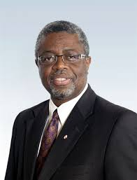
Dr. Andy Knight
Local Arrangements Coordinator, CPRA – ACRP

Board Members CPRA – ACRP 2019-2021
President: Dr. Erika Simpson  Email: simpson@uwo.ca | Erika Simpson was the former Vice President (2015-17, 2017-19) and currently the President of the Canadian Peace Research Association (CPRA) (2019-2021). She is Associate Professor of International Relations in the Department of Political Science at Western University. Dr. Simpson’s research focuses on nuclear issues including arms control, disarmament, nuclear power, proliferation, and terrorism. She is interested in North American defense and Canadian foreign policy. She has written widely on peace related issues, and in 2015 she was awarded the ‘Shirley Farlinger Lifetime Achievement Award for Peace Writings’ by Voice of Women. Dr. Simpson is a syndicated columnist for  the Postmedia Network, Canada’s largest newspaper chain, and a frequent commentator on CTV National Television. She is a Past Vice-Chair, Director, and former Treasurer of the Canadian Pugwash Group (2000-15). She serves as a Canadian Institute for Military and Veteran Health peer reviewer (2017-20) and a SHRCC Insight Development Grant reviewer (2015-17). She is author of the book, NATO and the Bomb (McGill-Queen’s University Press, 2001, 2002) and moe than 150 book chapters, journal articles and op eds available at Scholarship@Western and on Erika Simpson’s blog She holds a Ph.D. and Masters in International Relations from the University of Toronto and a B.A. (Hons.) from the University of Saskatchewan. She completed a postdoc at Carleton University, and she was an Alton Jones Fellow, a CIIPS Postdoctoral Fellow, a Liu Institute Visiting Fellow, and a NATO Fellow.  Associate Professor, Western University, London, ON  Faculty Webpage , Personal Webpage , Blog , Copies of all publications
Vice President: Dr. Christopher Hrynkow  Email: chrynkow@stmcollege.ca | Christopher Hrynkow, PhD (Peace and Conflict Studies, University of Manitoba), ThD (Christian Ethics, University of Toronto) is an Associate Professor in Religion and Culture at St. Thomas More College, University of Saskatchewan. There, he teaches courses in Religious Studies, Catholic Studies, and Critical Perspectives on Social Justice and the Common Good. From January 2019 to July 2019, he is serving as Patrick and Barbara Keenan Visiting Chair in Religious Education at the University of St. Michael's College in the University of Toronto. Hrynkow is also a graduate student in Education (University of Bath) and Social Justice and Community Action (University of Edinburgh). In July 2019, he will return to St. Thomas More College as Department Head and Graduate Chair in Religion and Culture for the University of Saskatchewan. Hrynkow will also teach the university's inaugural section of Introduction to Peace Studies in the Fall Term 2019, as part of a collaborative plan to build the first full fledged Peace Studies program in Saskatchewan. As of April 2019, he has published 28 peer reviewed journal articles and 12 peer reviewed book chapters  Associate Professor, St. Thomas More College: University of Saskatchewan, Saskatoon, SK
Past President: Shreesh Juyal  Email: shreeshjuyal@ymail.com  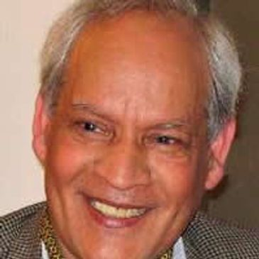 | Shreesh Juyal (D.Litt.) is a former Dean of the Faculty of International Studies and Distinguished Professor of International Law and Political Science at Himgiri Zee University, Dehradun Uttarakhand, India. He is a former full Professor of Political Science at the University of Regina, Regina, Saskatchewan, Canada and the Director of the United Nations and International Affairs Institute, University of Regina. He is the President of the Canadian Peace Research Association (2004-19) and the Vice-President of the World Federation of Scientific Workers, Paris, France. Dr. Juyal is the author or editor of nine books including Peace Issues in the 21st Century Global Context, eds. John Duncan, Shreesh Juyal (UK: Cambridge Scholars Publishing, 2017); Shreesh Juyal, International Organizations (Strathmor Publications, 1996) and Shreesh Juyal, Global Issues: A Primer for Model United Nations (Strathmor Publications, 1995). He is a recipient of the United Nations Association (Canada) Global Citizen Award and the Peace Medal of the YMCA Canada.  Senior Research Scholar, St. Thomas University, Fredericton, NB
General Secretary: Joanna Quinn  Email: | Joanna R. Quinn is President of the College of New Scholars, Artists and Scientists of the Royal Society of Canada. She is Associate Professor of Political Science and Director of the Centre for Transitional Justice and Post-Conflict Reconstruction at Western University, where she is cross-appointed to the Faculty of Law and affiliate-appointed to the Department of Women’s Studies and Feminist Research. Dr. Quinn’s research considers the role of acknowledgement, or the recognition of past events, in overcoming the effects of human rights abuses after conflict. She is interested in its potential to affect real and lasting change. She has written widely on the role of acknowledgment in truth commissions and in customary law in Uganda, Haiti, Canada, Fiji, Solomon Islands, and Canada. Her current project considers how to flip the switch to make people care about what has taken place in post-conflict societies. She holds a Ph.D. from McMaster University, a Master’s from Acadia University, and a B.A. (Hons.) from the University of Waterloo.  Associate Professor, Western University, London, ON  Director for the Center for Transitional Justice and Post-Conflict Reconstruction, Western University, London, ON
Treasurer: Peter Venton  Email: ﻿peter.venton@bell.net  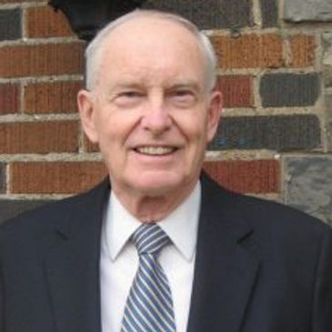 | Peter Venton is the Treasurer of the Canadian Peace Research Association (CPRA) (2015-17, 2017-19). He was the Bursar, University of St. Michael’s College in the University of Toronto, Toronto (2001-2009). The modern equivalent of Bursar is Vice President: Administration and Finance, which includes oversight management of Human Resources administration and management’s representative in labor negotiations, as well as oversight management of the University’s physical plant. He is also the former Vice President: Administration and Finance, Wilfrid Laurier University, (1979-1984). Formerly he was an economist and senior policy advisor in the Ontario Government's Ministry of Finance. He holds a MA in Economics from Queen’s University. Venton is currently the President of JPV Associates consulting in economics and public policy in the public interest and public sector management. He has presented papers on economic inequality, environmental sustainability, democracy, globalization and capitalism in Canada, Greece and Taiwan. His publications include, "Radical changes in Canadian democracy: for ecology and the public good," Ecological Systems Integrity: Governance, law and human rights, eds. Laura Westra, Janice Gray and Vasiliki Karagerorgou (New York: Routledge Earthscan, 2015). Currently he serves as the Treasurer of the Canadian Pugwash Group (2017-19), a registered Canadian charitable foundation, and as a Board Member and Director of the Canadian Pugwash Group (2015-2019).  Former Vice President, Administration and Finance, Wilfrid Laurier University, Waterloo, ON
Chair of the National Advisory Council: Dr. Rose Dyson  Email: rose.dyson@alumni.utoronto.ca  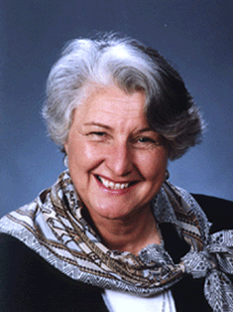 | Rose Dyson, Ph.D. Ed.D. (Ontario Institute for Studies in Education, University of Toronto) is the author of MIND ABUSE Media Violence in an Information Age (2000) and the co-author of 11 other peer-reviewed books. She was the editor for 17 years of The Learning Edge (Canadian Association for the Study of Adult Education). She was the associate editor of Peace Issues in the 21st Century Global Context, eds. John Duncan, Shreesh Juyal (UK: Cambridge Scholars Publishing, 2017). She is the President of Canadians Concerned About Violence in Entertainment and Chair of the National Advisory Council of the Canadian Peace Research Association (2013-15, 2015-17, 2017- 2019). She is a member of the Climate Action Network, the Global Ecological Integrity Group, and Just Earth. She is also the Director of Communication and a member of the World Federalist Movement, Toronto Branch, Canada.  Author Professor Emeritus
Director of Communications and Public Relations: Dr. Mark Raymond  Email: mraymond@ou.edu  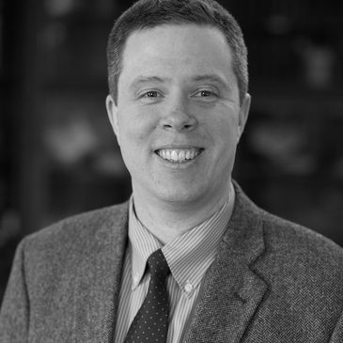 | Mark Raymond is the Wick Cary Assistant Professor of International Security and Director of the Cyber Governance and Policy Center at the University of Oklahoma. He is a Carnegie Fellow at the School of International and Public Affairs at Columbia University; an External Affiliate of the Ostrom Workshop at Indiana University; and a Fellow with the Center for Democracy and Technology. He is the author of Social Practices of RuleMaking in World Politics (New York: Oxford University Press, 2019). His work appears in various academic journals including International Theory, Strategic Studies Quarterly, The Cyber Defense Review, the UC Davis Law Review, and the Georgetown Journal of International Affairs. He is also the co-editor of Organized Chaos: Reimagining the Internet (Waterloo, Canada: CIGI, 2014). He has testified before the United Nations Commission on Science and Technology for Development, and participated in the Internet Governance Forum. His current research projects examine the politics of global rulemaking, as well as Internet governance and cybersecurity governance. He received his Ph.D. from the University of Toronto.  Wick Cary Assistant Professor of International Security and Director of the Cyber ​​Governance and Policy Center at the University of Oklahoma. Norman, OK.
Director of Membership: Ms. Anne Venton  Email: anne.venton@sympatico.ca  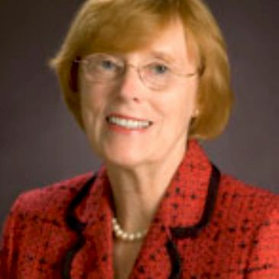 | Anne Venton earned a MA (University of Toronto) and was a Media Studies educator with the Toronto District School Board (TDSB). She also served as Head of Library at Northern Secondary School, North Toronto Collegiate, and City Adult Learning Centre. She was a Project Director at the Ontario Institute for Studies in Education (OISE) on projects including the ‘Canadian English Language Achievement Test’ and ‘Sex Stereotyping in Elementary Readers’. With extensive experience on many boards, Ms. Venton served on boards for the Immigration and Refugee Board of Canada; the Council of the Association of Professional Engineers of Ontario; the Greater Toronto Marketing Alliance; and the College of Dental Hygienists of Ontario. She was the Riding President of the Toronto Centre Federal Liberal Association (TCFLA) and President of the Ontario Women's Liberal Commission (OWLC). Currently, she serves on the executive of CCAVE (Canadians Concerned About Violence in Entertainment) as Director of Communications and on the Sinfonia Toronto Board. She is also a former Vice-President of the OISE Alumni Association, which represents one of the largest faculties at the University of Toronto with over 70,000 graduates.  Toronto District School Board (TDSB) Media Studies Educator, Toronto, ON  Head of Library Northern Secondary School Toronto, ON Collegiate and City Adult Learning, Toronto, ON  Vice-President OISE Alumni Association, Toronto, ON
International Representative: Dr. Katerina Standish  Email:  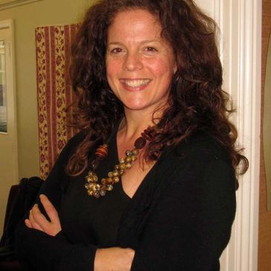 | Katerina Standish is the Deputy Director of the National Centre for Peace and Conflict Studies, University of Otago, New Zealand. Dr Standish is an expert on culture and violence and specialises in curricular analysis. Her publications include content on gender, conflict and cultural learning, as well as alternative education (peace education and decolonizing education), violence and self-harm in Indigenous and Non-Indigenous culture, and practical violence transformation. She has published five books and many refereed articles including most recently, Suicide Through a Peacebuilding lens: Medical and Instrumental Suicide (New York: Palgrave MacMillan, 2019). She holds a doctoral degree in Peace and Conflict Studies from the University of Manitoba, a Master's Degree in Human Security and Peacebuilding from Royal Roads University, a post-baccalaureate in Communications from Simon Fraser University and an undergraduate degree in Sociology, Anthropology and Humanities from Simon Fraser University. Dr Standish is a specialist in transformative education, the creator of Yogic Peace Education and the inventor and primary researcher for the Peace Education Curriculum Analysis (PECA) (pecaproject.org). Her peace practices include working in partnership with local communities in Canada and Aotearoa/New Zealand. She has experience in peacebuilding in Uganda, Palestine, Israel and with the Red Cross in Canada and New Zealand. She has been a Yoga, breath and meditation instructor for 15 years.  Assistant Professor and Director, University of Otago, New Zealand
International Representative: Dr. Franke Wilmer  Email: frankewilmer1@gmail.com  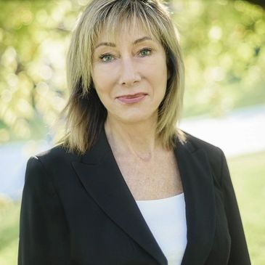 | Franke Wilmer is a Professor, International Relations, Montana State University who specializes in conflict and conflict resolution, international law, public policy, international relations and foreign policy. Dr. Milmer served four terms in the Montana legislature. She was elected by colleagues from both parties to serve as Speaker Pro Tempore in 2009, chaired the interim committee on State Administration and Veterans' Affairs in 2007-2009, served on House Education; Fish Wildlife and Parks; and State Administration and Veterans' Affairs committees. She received two awards from veteran’s groups for legislative work including Legislator of the Year from the Vietnam Veterans of American Montana Council in 2011. She served on the Council of the American Political Science Association and the Editorial Board of the International Studies Quarterly. She has travelled to over 50 countries as a guest lecturer or researcher, including six times to the former Yugoslavia during wartime and one trip to Regina, Saskatchewan to deliver the keynote speech to the CPRA in 2018.  Professor, Montana State University, Bozeman, MT
Member-at-Large: Dr. Robert David Armstrong  Email: | David Armstrong is a Canada Research Chair in Political Methodology, Tier 2 - September 2017 - September 2022, Social Sciences and Humanities Research Council (SSHRC). He is an Associate Professor in the Department of Political Science at Western University and a former Associate Professor in the Department of Political Science at the University of Wisconsin-Milwaukee. He earned a Ph.D. in Government and Politics from the University of Maryland in 2009. His research interests focus on measurement and data visualization along with a substantive focus on democracy and state repression. His research has been published in the American Journal of Political Science, the American Political Science Review and the American Sociological Review and his book on measurement models, Analyzing Spatial Models of Choice and Judgment with R (co-authored with Ryan Bakker, Royce Carroll, Chris Hare, Keith Poole and Howard Rosenthal) was published by CRC Press in 2014.  Canada Research Chair in Political Methodology (Tier 2) September 2017- September 2022  Social Sciences and Humanities Research Council (SSHRC)  Associate Professor, Western University, London, ON
Member-at-Large: Walter Dorn  Email: walter.dorn@rmc.ca  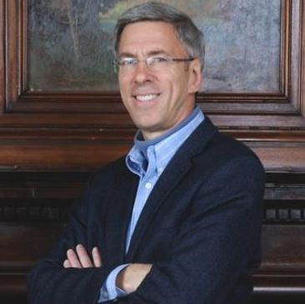 | Walter Dorn is Professor of Defence Studies at the Canadian Forces College and at the Royal Military College, Kingston. A scientist by training (Ph.D. Chemistry, University of Toronto), his doctoral research was on chemical sensing for arms control. He assisted with the negotiation, ratification and implementation of the Chemical Weapons Convention. His interests are broader now, covering international and human security, especially peace operations and the United Nations (UN). A. Walter Dorn is the author of Air Power in UN Operations: Wings for Peace (Ashgate, 2014); Keeping Watch: Monitoring, Technology and Innovation in UN Peace Operations (United Nations University Press, 2011) and the editor of World Order for a New Millennium: Political, Cultural and Spiritual Approaches to Building Peace (Palgrave Macmillan Press, 1999) Dorn has extensive experience in UN field missions. He served as a district electoral officer with the United Nations (UN) Mission in East Timor in 1999; in Ethiopia on a UNDP project; and at UN headquarters as a Training Adviser with the UN's Department of Peacekeeping Operations (DPKO). He was on the UN’s Panel of Experts on Technology and Innovation in UN Peacekeeping in 2014. He served as the Innovation and Protection Technology Expert within the UN’s Department of Field Support in 2017- 18, providing advice to improve UN missions in the Middle East and Africa including Lebanon, the Central African Republic, the Democratic Republic of the Congo and Mali. He has served as the UN Representative of Science for Peace, a Canadian NGO since 1983. He is the President of the World Federalist’s Association, Ottawa and the Past Chair of the Canadian Pugwash Group (2015-17, 2017-19). He was a Senior Research Fellow at Cornell University (1998-2000); a consultant to Yale University (1996); a visiting scholar at the Cooperative Monitoring Centre (1999) and an adviser to the Federation of American Scientist’s Biological Weapons Control expert group (1990). At the University of Toronto, he was a Research Fellow with the International Relations Programme as well as the Peace and Conflict Studies Programme, and he was the Physical Science Don at Trinity College.  Professor, Canadian Forces College and the Royal Military College, Kingston, ON
Member-at-Large: Lt. Col. Sylvie Lemieux  Email:  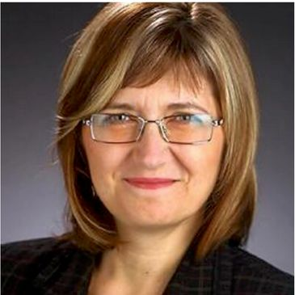 | Sylvie Lemieux holds a Ph.D in Conflict Studies from St. Paul University, Ottawa; a MA in globalization and international development from the University of Ottawa; and a Bachelor of Applied Science from the Ecole polytechnique de Montreal - Université de Montreal. A retired Lieutenant-Colonel from the Canadian Armed Forces (Army) and former civil servant, she was a leadership candidate for the Green Party in 2010. She is a Board member of the G78, a member of the Canadian Pugwash Group, a member of the Voice of Women, and a member of Integrative Peacebuilding. She has been a Member-at-Large for the Canadian Peace Research Association (CPRA) since 2015. Currently working on a book based on her doctoral thesis, she is unable to attend the Congress at UBC in 2019, however she accepts the nomination to continue as a Memberat-Large (2019-21).  PhD Candidate, St. Paul University, Ottawa, ON
Member-at-Large: Dr. Kathleen Manion  Email: kathleen.manion@royalroads.ca  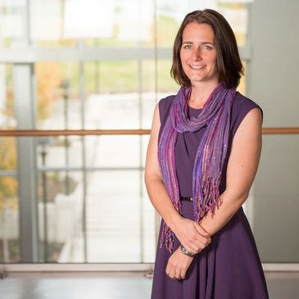 | Kathleen Manion, Associate Professor, Royal Roads University and Program Head, BA in Justice Studies. Manion is an educator and researcher who has spent the past 20 years working within social and community services. She is passionate about social justice and social inclusion and particularly interested in helping to bridge the gap between practitioner experiential knowledge, academic theory and policy objectives across multiple disciplines. Manion has worked on projects tackling issues related to child protection, homelessness, healthy early childhood development, environmental protection, family violence, youth justice, and international social work. Before joining Royal Roads in 2013, Manion’s diverse experience included research and practice in various countries and settings, working at both a national ministerial level and also at the grassroots. Manion completed her undergraduate studies at the University of Waterloo (BA in psychology, diploma in peace and conflict studies and certificate in social work). She earned her master’s (international social work and community development studies) and her PhD in sociology from the University of East London in the UK. Manion's doctoral studies focused on the perceptions of success of interventions with commercially sexually exploited girls in Canada, Australia and the United Kingdom.  Associate Professor and Program Head, Royal Road University, Colwood, BC  ​
Local Arrangements Coordinator and Member-at-Large: W. Andy Knight  Email: knight@ualberta.ca  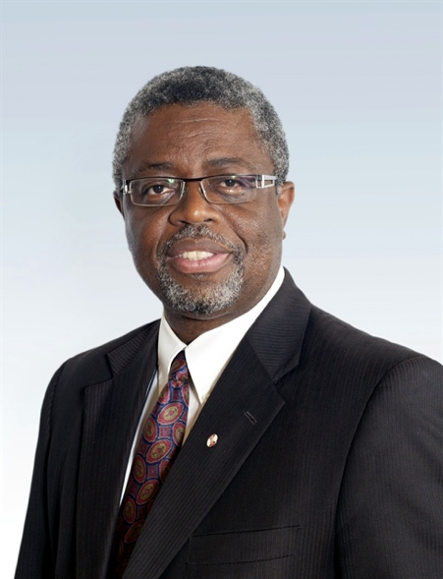 | W. Andy Knight is Professor of International Relations in the Political Science Department at the University of Alberta and past Chair of the Department. He is former Director of the Institute of International Relations, The University of the West Indies, Trinidad & Tobago. He is co-editor in Chief of African Security journal and former co-editor of Global Governance journal. A Fellow of the Royal Society of Canada, Knight’s most recent book is the award winning, Female Suicide Bombings: A Critical Gendered Approach, with Tanya Narozhna (University of Toronto Press, 2016). His recent publications address issue of global health governance, global health security, vulnerabilities, and resiliency.  W. Andy Knight, PhD, FRSC  University of Alberta

CANADIAN PEACE RESEARCH ASSOCIATION 2019 CONSTITUTION

(As adopted in June 1966, and revised in subsequent years and revised again and adopted by the General Council at its May 30, 2018 meeting and its June 5, 2019 meeting.)

ARTICLE I - NAME

The name of the Association shall be the Canadian Peace Research Association (CPRA). The CPRA was established at the Learned Societies Conferences held at the University of Sherbrooke, Quebec, on June 12, 1966.

ARTICLE II - OBJECTIVES:

1. The principal objective of CPRA is to advance research and promote education in the study of the causes of war and the conditions of peace, and in particular:

a) to promote Peace Studies in Canada through inter-disciplinary research activities and academic teaching;

b) to stimulate the establishment of peace research centres and programs on conflict resolution and peace at Canadian universities and higher education schools;

c) to encourage the national and international dissemination of results of peace studies and of information on significant development of peace research and peace education;

d) to popularize knowledge on the causes and the instruments of war, and the possibilities of peace;

e) to organize those Canadians who are engaged or interested in peace research or peace education in order to facilitate contacts and communications between them, and between them and other scholars in the world;

2. To achieve the above purposes, CPRA will undertake, resources permitting, the following activities:

a) to direct the attention of academics, scientists, politicians, and government entities to those results of peace studies that are meaningful, and to those aspects of peace research and education that might require further investigation;

b) to provide assistance in the delivery and publication of papers of original research;

c) to disseminate information about grants and scholarships to study subjects relating to peace;

d) to hold regional, national and international conferences of scholars and researchers engaged in peace studies;

e) to collaborate with organizations involved in peace studies, such as the International Peace Research Association;

f) to cooperate with international inter-governmental organizations such as the UNESCO, and their national agencies such as the Canadian Commission for UNESCO.

ARTICLE III - MEMBERSHIP

1. Regular Membership is open to individual academics, scholars, graduate students, teachers, researchers, and institutions presently engaged in peace studies and/or peace education. All regular members shall have the right to vote and elect officers at the meetings of the General Council.

2. Associate Membership is open to academics, scholars, teachers, and researchers who are engaged in peace studies or peace education who do not wish to attend the annual conference of the CPRA at the Congress of Humanities and Social Sciences; or who live in other countries; or who are determined by the CPRA General Council to be honorary members.

3. Membership fees for the above two categories (articles III.1, and III.2) and institutions shall be determined by the General Council or may be delegated by the General Council to the Board of Directors. Special fees for joint membership with other associations and organizations shall be determined by the Board of Directors.

4. Membership may be terminated by a member/associate member/ institution through a letter of resignation or withdrawal, or by a majority vote of the Board of Directors, or because of non-payment of annual dues.

ARTICLE IV – OFFICERS AND THE BOARD OF DIRECTORS (BOARD)
The Board of Directors (Board/ Executive Council) shall consist of the following office bearers with specific responsibilities: President, Past
President, Vice President, General Secretary, Treasurer, Director of Communications and Public Relations, Membership Director, and the Chair of the National Advisory Council. All members of the Board of Directors (Executive Council) and a limited number of Members-at-Large shall be elected for a term of two years.

1. PRESIDENT:

a) The President shall preside over all meetings of the Board, and the General Council and other organizational meetings of CPRA. In case of a tie, he/she shall cast the deciding vote.

b) He/she shall be the spokesperson for CPRA, and as such shall represent CPRA on all occasions.

c) He/she shall be responsible for all major activities, shall consult with the Board on all major activities, and shall keep it informed, as far as possible.

d) He/she shall be, ex-officio, the Program Chair of the annual conference of CPRA. He/she may designate another CPRA officer to act in his/her place.

2. PAST PRESIDENT:

The Past President shall be ex-officio, a member of the Board until such time when the current President's term has expired.

3. VICE PRESIDENT:

a) He/she shall assist the President in general and/or specific activities of CPRA.

b) He/she shall act as President during the incapacity of the President, or when directed by the President.

4. GENERAL SECRETARY:

a) He/she shall keep the minutes (a record of the proceedings) of the meeting of the Board, and the General Council, and shall carry out general correspondence and coordinate general organizational activities.

b) He/she shall coordinate the activities of the Members-at-Large, and the Membership Director.

c) He/she shall assist the President in all activities of the organization.

d) He/she shall maintain the membership roster and shall present reports on membership to the annual meeting of the General Council.

5. TREASURER:

a) He/she will be responsible for all financial matters including accounts, receipts and payments, membership dues, subventions, grants, proceedings from the sale of publications, fees for special services, etc.

b) He/she shall prepare and present an annual financial report to the General Council.

6. DIRECTOR OF COMMUNICATIONS AND PUBLIC RELATIONS:

a) He/she, under the direction of the President and in collaboration with the General Secretary, shall help organize public relations, outreach programs, media-contacts, and information-related activities.

b) In the absence of the General Secretary, or when so directed by the President, the Director of Communications, shall act as General Secretary.

7. DIRECTOR OF TECHNOLOGY
a) He/she shall help coordinate such technical matters as the CPRA website creation and management, and other matters that may be related to the various technological needs of the association.
b) He/she shall under the general direction of the President, undertake his /her responsibilities in collaboration with the General Secretary.

8. MEMBERSHIP DIRECTOR:

a) He/she shall undertake the membership drives; shall, in cooperation with the Treasurer and the General Secretary, maintain the membership roster, and shall present reports on membership to the annual meeting of the General Council.

b) He/she shall assist the General Secretary in all activities of the CPRA.

9. INTERNATIONAL REPRESENTATIVE AND MEMBERS-AT-LARGE:

a) An international regular member of CPRA shall be elected as International Representative. He/shall promote the CPRA internationally, and represent CPRA at international organizations/activities, when so directed by the President.

b) A limited number of regular members of CPRA shall be elected as Members-at-Large at the annual General Council meeting. The activities of Members-at-Large shall be determined by the Board and coordinated by the General Secretary.

10. AD HOC AND STANDING COMMITTEES:

The Board may coopt additional regular and associate members by creating Ad Hoc and Standing Committees as and when necessary for the proper functioning of CPRA.

11. VACANCIES:

a) Should a vacancy in an officer's position arise between annual meetings of the General Council, the Board shall fill the vacancy by selecting another Board member for the position for the remainder of the term.

b) The President in consultation with the Board of Directors may, if needed, appoint new officers and additional Members-at-Large in between General Council meetings.

12. REGIONAL REPRESENTATION:

The General Council shall strive to ensure a balanced regional representation on the Board to the five regions of Canada.

13. NATIONAL ADVISORY COUNCIL:

a) An Advisory Council comprising peace researchers of eminence, and peace advocates/activists of long standing shall be established by the General Council at its annual meetings or by the Board when the General Council is not in session.

b) Members of the Advisory Council may attend the meetings of the Board as non-voting participants

c) The Advisory Council shall develop broad and long-term strategic guiding principles for the CPRA and under the direction of the President and the coordination of the General Secretary, it may initiate such projects as fund-raising and membership growth. The recommendations of the National Advisory Board shall be submitted to the Board and the General Council of CPRA

d) A Chair of the National Advisory Council shall be established. The Chair will be elected by the General Council as a member and officer of the Board

ARTICLE V - GENERAL COUNCIL:

1. All bona fide regular members of CPRA shall constitute the General Council, which shall ordinarily meet once every year, usually at the time of the annual conference of CPRA.
2. All Officers of the Board must present their annual reports and recommendations for the approval of the General Council.

3. With the exception of the Past President, all officers of the Board and a limited number of Members-at-Large shall be elected by the General Council at its annual meeting.

4. In case of doubt, the Robert's Rules of Order shall be followed for the conduct of all meetings of CPRA.

5. All regular bona fide members who are delegates to the annual conference of CPRA may submit written agenda items and/or nominations for positions on the Board of Directors for the General Council meeting no later than four working weeks prior to the date of the General Council meeting.

ARTICLE VI: AMENDMENTS OF THE CONSTITUTION:

1. The Constitution of CPRA may be amended by a two-thirds majority vote of bona fide regular members present at a meeting of the General Council, provided that a written notice of the proposed amendment is sent to the members at least two working weeks prior to the General Council Meeting.

2. If the Board is convinced that a delay in the consideration of a certain amendment is not in the best interest of CPRA, the Board may decide, on an ad hoc basis, upon the amendment, subject to ratification by the General Council at its next meeting.

File: CPRA 2019 Constitution

