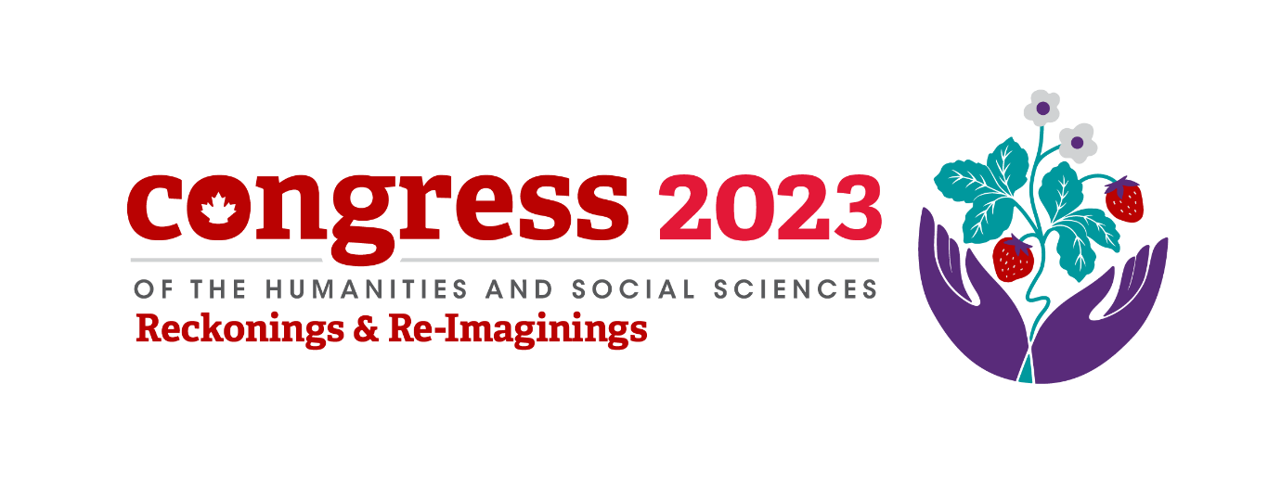
CANADIAN PEACE RESEARCH ASSOCIATION (CPRA - ACRP)
2023 Conference and Annual Meeting
May 31 to June 2, 2023
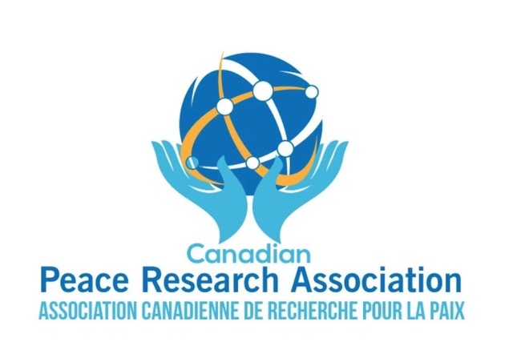

HYBRID CONFERENCE CO-SPONSORED BY
THE CONGRESS OF HUMANITIES
AND SOCIAL SCIENCES
WITH YORK UNIVERSITY
CANADA

2023 THEMATIC APPROACHES

Congress Theme:
Through its Congress 2023 Theme–Reckonings and Re-Imagining’s–the Congress proposes to open a hybrid (in-person and virtual) space for dialogue. We are hoping to embrace this theme in the CPRA - ACRP’s programming, collaborate with other associations, and make many of our sessions open to all Congress participants and to the public.
Let’s work together to make the CPRA - ACRP Conference at the 2023 Congress our best yet! Our goal is to deliver a positive hybrid experience for our association’s members and attendees. The Federation team and the CPRA - ACRP team are here to support you. We look forward to providing you with all you need to make Congress 2023 a memorable experience for all involved.
Themes: This year’s CPRA Sessions focus on 12 recurrent Themes in PEACE RESEARCH:
Theme 1: The Case For and Against Nuclear Modernization & Deterrence
Look for these titles if you are interested:
Guy Roberts on ‘The Case for Nuclear Modernization
Key Events in NATO Cyber Defence Policy, 2000-2022

Theme 2: Empowering Farmers and Indigenous People in Brazil and Sri Lanka
Indigenous and rural farmer issues are a major theme this year:
Preventing Land Grabs in the Rain Forest

Food Security in Sri Lanka

The Hunger Crisis in Somalia

Theme 3: How do International Treaties Work?
If you are interested in any aspect of international law, we are sponsoring some related panels:
Arctic Peace and Security Policy Issues

Reflections on the Land Mines and Cluster Bomb Treaties

Theme 4: Intertwining Peace and Children’s Rights
Intertwining Peace and Children’s Rights – if you are interested in new thinking about Intertwining Peace and Children’s Rights – look out for these titles:
Intertwining Peace and Children’s Rights: Education’s Role in Building Synergies in Elementary Schools in Uganda and Canada
Vulnerabilities of Children in the Digital Age and the Effects on World Stability
Postmodernism and the Re-Invention of Egerton Ryerson

Theme 5: Postmodernism in Digital Age: Children's Education and Vulnerabilities
This year’s Congress theme is Reckonings and Reimagining’s, and the CPRA is sponsoring many panels related to the Digital Age and Re-education. Look for these titles in particular:
Vulnerabilities of Children in the Digital Age and the Effects on World Stability
Postmodernism and the Re-Invention of Egerton Ryerson

Theme 6: Mental Health, Suicide and Unsafe Digital Spaces
Learning how to become a peace researcher is a lifelong challenge. Experienced peace researchers can help you forge a career in mental health and the protection of women in digital space
Usage Of Natural Language Processing (NLP) to Assess Refugee Mental Health and Suicide
TECH-Facilitated VAW online: Digital unsafe spaces for political women

Theme 7: Peace: Lessons for Ukraine and Russia
How can we learn about peace negotiations for Ukraine and Russia? Experienced peace researchers can help you understand the situation and propose solutions
Canadian Pugwash Group (CPG) Peace Table for Ukraine and Russia
Addressing Challenges Facing the United States and NATO Using Lessons Learned from Afghanistan and Ukraine

Theme 8: Navigating Tensions and Backsliding
Learning more about Indigenous treaty rights and responsibilities as well as democratic challenges in European countries can help navigate tensions and prevent democratic erosion.
Democratic Backsliding within the European Union: The Case of Poland and Hungary
Post-Secondary Education for Peace in Treaty Six: Pedagogical Considerations for Navigating Tensions Between Proselytization and Contextual Critical Normativity

Theme 9: Peace and Globalization: Where do they lead?
The philosophies of eminent thinkers like Keynes on peace and the scale of globalization around the world deserves further thought and discussion.
The Price of Peace
Globalization on a Scale: Where Will It Lead? A Case of Canada & Mexico

Theme 10: Decision-making in Crisis
The leadership circles in the United States can make hasty and pressure-filled decisions. Let’s try to understand decision-making during international crises and how to improve outcomes.
Trump's worst decision: the ethics and politics of maximum pressure
The Taliban in Afghanistan: The Crisis After the Conflict

Theme 11: Peacekeeping: Education & Training
Experienced peacekeepers and peace researchers can help you forge a career in education and training toward peace whether in service of Global Governance, the UN or Canada’s national police force.
Simulating Peace: How digital simulations can help train and educate peacekeepers
Path into Policing and Peacekeeping

Theme 12: Warfare in the Future and the Past
The tools of warfare are changing to embrace cyberwarfare and move away from conventional war – or are they? What are the lessons of World War II and cyberwarfare preparations at NATO?
Key Events in NATO Cyber Defence Policy, 2000-2022
The Significance of Allied Strategic Bombing over Germany to the defeat of the German Air Force during World War II
New! CPRA became a member of the Federation in 2021!
The CPRA has been involved in Congress since 1966.
New! Venues at York University:
Please note that all Sessions and the CPRA Annual General Meeting (AGM) will be held in Ross-R N836, Ross Building (South)and in Zoom Rooms rented from Congress including “Green Rooms”. Please note the Green Rooms open 30 minutes early for the speakers to set up with paid assistance from Congress’s technicians.
Giving you the look and feel of being on the beautiful York University campus in person, the Congress 2023 Lobby is your gateway to accessing association conferences, open events, Expo, networking lounges and more! To learn more about York University: https://www.federationhss.ca/en/congress/congress-2023/about-york-university.

We will use Eastern Standard Time (EST).
To quickly figure out your time, go to this calculator:
Time Zone Converter – Time Difference Calculator.
A Cordial Invitation from the Program Committee:
We are pleased to invite you to the 2023 Annual Conference of the Canadian Peace Research Association - Association canadienne de recherché pour la paix (CPRA - ACRP). The CPRA – ACRP Conference is part of the Federation for the Humanities and Social Sciences, which promotes research, and teaching for “the advancement of an inclusive, democratic, and progressive society.” With a membership now comprising over 160 universities, colleges, and scholarly associations, the Federation and Congress 2023 represents a diverse community of 91,000 researchers and graduate students across Canada.
The Federation organizes Canada’s largest academic gathering, the Congress of the Humanities and Social Sciences, bringing together each year more than 8,000 participants. In 2023, it is expected that thousands of scholars will gather at York University in Toronto, Ontario, Canada in person and under the aegis of a virtual platform using Zoom showcasing approximately 70 academic associations representing a rich spectrum of disciplines in education, social sciences, social work, peace research and other academic disciplines. Congress represents a unique showcase of scholarly excellence, creativity, and leadership.
The CPRA - ACRP Conference, as a constituent of Congress 2023, hopes to offer a welcoming milieu for peace researchers, social scientists, teachers, as well as activists and advocates, in order to present their research as well as influence peace studies.

CPRA Website and Contacts

Congress Contacts
CPRA Staff can be reached at: General Correspondence available here: cpramail@gmail.com
CPRA President and Program Chair: Erika Simpson: simpson@uwo.ca
Local Arrangements Coordinator: Professor Sergei Plekhanov at York University available here: cpramail@gmail.com
Contact Us
For all inquiries relating to Congress of the Humanities and Social Sciences, please contact the Federation for the Humanities and Social Sciences where a member of their team will be able to assist you. Please note that during peak periods, it may take a little longer for us to respond.

- Email: congress@ideas-idees.ca
- Telephone: 613-238-6112 ext 320
- Address: 200-141 Laurier Avenue West, Ottawa, Ontario, K2P 5J3
For media enquiries, click herehttps://fhss.swoogo.com/23-media-outreach-relations-mediatiques
If you are a Congress organizer (Program Chair or Local Arrangement Coordinator), please email organizers@ideas-idees.ca.

Advertise at Congress
As some of the most avid consumers of information, academics buy goods and services all year round. By advertising at Congress 2023, you can build interest in your products or services, drive traffic directly to your website, build relationships with a community of opinion leaders, and benefit from the following visibility and promotion:
- 6,000+ attendees
- 166,000+ visits to Congress website
- 40,000+ YouTube views
- 6,450+ Twitter followers
- 219,128 impressions of 148 tweets by the Federation
- 3,050+ Facebook fans

Advertising opportunities include:
- Website advertising - new opportunities available!
- Platform advertising - new opportunities available including a Hybrid publications table and our Hybrid event bag!

For more information, download the Advertise & exhibit at Congress 2023 brochure.
To advertise at Congress please complete the Advertising Order Form.

Congress Advisory Committee on Equity, Diversity, Inclusion, and Decolonization (AC-EDID)
On April 8, 2023, following six months of consultations, research and a comprehensive review of literature and resources, the independent Congress Advisory Committee on Equity, Diversity, Inclusion, and Decolonization (AC-EDID) released their final report and recommendations available here: https://congress2023.ca/congress-advisory-committee-edid
Here is the Federation’s Code of Conduct. available https://congress2023.ca/register/congress-code-conduct. Here is information on the EDID Initiatives Fund: https://www.federationhss.ca/en/programs-policy/funding-awards/edid-initiatives-fund

Work and Volunteer at Congress
Call for volunteers! Congress 2023 volunteers play an essential role in Canada’s largest interdisciplinary conference, which will bring approximately thousands of attendees together in person and virtually. As a volunteer, you will gain valuable leadership skills by supporting the operations of Canada’s largest gathering of scholars, and contribute to delivering a memorable conference experience for attendees.
Congress 2023 is currently recruiting more than 500 volunteers in varying roles. This opportunity is open to everyone – students, staff, community members, anyone interested in making Congress 2023 an incredible experience. Join the team today to help showcase the best of Congress 2023, hosted in- person and virtually from the York University. The deadline is early: March 27, 2023

Disciplines and Professions that conduct Peace Research:
The CPRA seeks to bring together academics, researchers, educators, and peace advocates from Canada and abroad to examine and discuss current and emerging issues and challenges in the field of Peace Research. Individual papers and panels in Peace Research, especially those that have international significance are invited from all disciplines and professions including:
Anthropology | Peace and Conflict Studies
Communications and Journalism | Philosophy
Economics | Political Science
Education | Psychology
Environment and Society | Science for Peace
Ethics and Law | Science, Technology and Global Peace
Indigenous Studies | Social Justice
Global Studies | Social Work
History | Sociology
Human Rights | Theatre and Film, and
International Relations | Women's Studies
Law/International Law | Or related Interdisciplinary Studies

Journals Related to Peace Research
The CPRA publicizes information about journals that publish peace research. A comprehensive list of journals related to peace and conflict is available on the CPRA website here: https://cpra-acrp.com/journals-related-to-peace. Dr. Katerina Standish is the Chief Editor and Erika Simpson is an Associate Editor of Peace Review: A Journal of Social Justice (Taylor & Francis) available here: https://www.tandfonline.com/action/journalInformation?show=aimsScope&journalCode=cper20 Dr. W. Andy Knight is the Chief Editor of International Journal (Sage) available here: https://thecic.org/research-publications/ij/
.

DAY ONE - PRELIMINARY INFORMATION
WEDNESDAY MAY 31, 2023

Session 1 | 7:30 am – 8:00 am

7:30-8:00 AM EST Room Ross-R N836 will be staffed by Anjali Bhaheeratha
Ms. Bhaheeratha is a recent graduate of Western University, where she completed an Honours Double Major in Political Science and Sociology. In September 2023, she will be undertaking an M.A. in Political Science at Western University.
Ms. Bhaheeratha and Congress volunteers will help you plan your schedule and send you to the Congress’s Speaker Service Centre.
Register
Preparing for your presentation
Recording your presentation via Zoom
Live presentation - before, during, and after
Technical information
Chair and moderator information
Questions
7:30-8:00 AM EST Networking Lounge Breakout Rooms
If you an experienced presenter - but you would like to practice your presentation or consult with others - Ms. Bhaheeratha can invite you into a Zoom break-out room with Volunteers at Congress. In the break-out rooms, you can work with other volunteers and attendees, and consult about strategies.

New! DAY ONE CPRA Social Mixer
Wednesday, May 31, 2023 6:00 – 8:00 PM (EST)
Session 7 | 6:00 pm – 8:00 pm

6:00-8:00 PM EST Social Mixer and Meet and Greet Event at Timbers Lodge Social Grill, York Lanes, Toronto (or you can attend by Zoom. A link will be provided to CPRA members)
This is a good time to ‘meet and greet’ either in person and by Zoom (6:00 PM in Toronto = 3:00 PM PCT in Vancouver = 7:00 PM in Halifax). Please note the Congress is holding the President’s Reception this year on Thursday, June 1 so this is our Hybrid Social Mixer and Meet & Greet Time.
Only registered Congress attendees who registered as CPRA members in 2023-24 will be permitted to enter any Zoom waiting rooms (including the Networking Lounge). However, if you have not registered as a CPRA member (2023-22) –or you neglected to pay your Congress fees - then you will be allowed into our ‘live’ and ‘in-person” Social Mixer and Meet and Greet Session. Remember to pay your fees on time by the Early Bird deadline!

DAY ONE
DAY ONE MAY 31, 2023
Ross-R N836, Ross Building (South) Opening – Remarks & Instructions.
Session 1 | 7:30 am – 8:00 am

7:30-8:00 AM EST Ross-R N836, Ross Building (South)and by Zoom with greeting from Anjali Bhaheeratha
Ms. Bhaheeratha is a recent graduate of Western University, where she completed an Honours Double Major in Political Science and Sociology. In September 2023, she will be undertaking an M.A. in Political Science at Western University.
8:00- 9:00 AM EST Ross-R N836, Ross Building (South)and by Zoom Erika Simpson, “Welcome, Opening Remarks and Guest Speaker: Guy Roberts on ‘The Case for Nuclear Modernization’”
Dr. Simpson is the President of the CPRA and an Associate Professor in the Department of Political Science, University of Western Ontario, London, Ontario.
This Session featuring a Guest Speaker: Guy Roberts, the former U.S. Assistant Secretary of Defense will be pre-recorded. If you would like to learn more about how to join the CPRA and how to ask questions in person and/or by Zoom, please attend this pre-recorded ‘live’ (hybrid) session featuring a former Trump official in dialogue with CPRA members.
DAY ONE
DAY ONE, May 31, 2023
Session 2, Ross-R N836, Ross Building (South)1, Wednesday May 31, 2023, 9:00 am – 10:30 am
Session 2 | 9:00 am – 10:30 am | Empowering Farmers and Indigenous People in Brazil and Sri Lanka

Empowering Farmers and Indigenous People in Brazil and Sri Lanka
Chair/Moderator: Christopher Hrynkow
Dr. Hrynkow is Professor in Religion and Culture at St. Thomas More College, University of Saskatchewan. He serves as Co-Director of the Irene and Doug Schmeiser Centre for Faith, Reason, Peace, and Justice. Additionally, Hrynkow is Graduate Chair in Religion and Culture for the University of Saskatchewan and teaches in the new Peace Studies certificate program.
9:30-9:45 AM Anne Venton on “Preventing Land Grabs in the Rain Forest”
Ms. Venton is the Secretary of the CPRA and the former Head of Library, Toronto District School Board and member of the Immigration and Refugee Board of Canada, Toronto.
9:45-10:00 AM Anjali Bhaheeratha on “Food Security in Sri Lanka”
Ms. Bhaheeratha is a recent graduate of Western University, where she completed an Honours Double Major in Political Science and Sociology. In September 2023, she will be undertaking an M.A. in Political Science at Western University.
10:00 AM-10:15 AM Colton Stevenson on “The Hunger Crisis in Somalia”
Mr. Stevenson completed the political science undergraduate program at the University of Western Ontario and will pursue a MA at the University of Western Ontario in September 2023. His plans for research focus on sustainability, particularly on our dependence on nuclear weapons and climate change under the field of International Relations.
10:00-10:30 AM Simu-Live Q & A in Networking Lounge Break-out Room
Session 2, Ross-R N836, Ross Building (South) Wednesday May 31, 2023, 10:00 am - 10:30 am. The Q & A in the break-out room is not recorded.

Session 3 | 10:30 am – 12:00 pm | How do International Treaties Work?

How do International Treaties Work?
Chair/Moderator: Kathleen Manion
Dr. Manion is Professor and program Head for Graduate Certificate Transforming Child Protection to Wellbeing, as well as the former Program Head for the MA in Disaster and Emergency Management, Royal Roads University, Victoria.
11:00-11:15 AM Adele Buckley on “Arctic Security: Past, Present and Future”
Dr. Buckley is a physicist, engineer and environmental scientist. She is the former Chair and Treasurer of the Canadian Pugwash Group and she leads the CPG campaign for a nuclear-weapon-free Arctic. Since 2007, she has presented the proposal to establish an Arctic Nuclear Weapon Free Zone in six countries.
11:15-11:30 AM Earl Turcotte on ““Reflections on the Land Mines and Cluster Bomb Treaties” and Tara Almosawi “Nuclear Waste Management, and the Growing Concerns of Deep Geological Repositories”
Mr. Turcotte (MA U of Ottawa, MA Carleton University) served variously as a parliamentary assistant, CIDA program manager, First Secretary and Chief of CIDA’s Mine Action Unit. He joined the UNDP on the Mine Action Team and was lead for Canada’s engagement on the Ottawa Convention on Landmines and the chief Canadian negotiator of the Convention on Cluster Munitions. His on-demand video recording is available to all Congress attendees for the entire Congress online.
Ms. Almosawi is entering fourth year at the University of Western Ontario in Political Science and is an associate member of the Canadian Pugwash Group who works on nuclear energy exploration.
11:30-12:00 AM Simu-Live Q & A in Networking Lounge Break-out Room

Session | 12:00 pm – 1:00 pm | Big Thinking – 1 hour break

Big Thinking - 1-hour Break

Session 4 | 12:30 am – 2:00 pm | Intertwining Peace and Children’s Rights

Session 4, Ross-R N836, Ross Building (South), Wednesday May 31, 2023, 12:30 pm - 2:00 pm

Intertwining Peace and Children’s Rights
Chair/Moderator: Rose Dyson
Dr. Rose Dyson, Ed. D., is President of Canadians Concerned About Violence In Entertainment; Vice President of the World Federalists - Toronto Branch; the author of Mind Abuse and the recipient of the CPRA Lifetime Achievement Award.
1:00-1:15 PM Shelley Jones on “Intertwining Peace and Children’s Rights: Education’s Role in Building Synergies in Elementary Schools in Uganda and Canada”
Shelley Jones, BA, BEd, MA, PhD, is a Professor of Interdisciplinary Studies at Royal Roads University and a board member of International Institute of Child Rights and Development. She is the Head of Undergraduate Programs in the College of Interdisciplinary Studies at RRU
1:15-1:30 PM Kathleen Manion on “Intertwining Peace and Children’s Rights: Education’s Role in Building Synergies in Elementary Schools in Uganda and Canada”
Kathleen Manion, BA, MA, LLM, PhD, is a Professor at Royal Roads University and an Associate at the International Institute of Child Rights and Development. She is the Program Head for the MA Disaster and Emergency Management program and the Graduate Certificate Child Protection to Wellbeing and teaches with the Justice Studies Programs.
1:30-2:00 PM Simu-Live Q & A in Ross-R N836, Ross Building (South) and Networking Lounge Break-out Room

Session 5 | 2:00 pm - 3:30 pm | Postmodernism in Digital Age: Children's Education and Vulnerabilities

Session 5, Ross-R N836, Ross Building (South), Wednesday May 31, 2023, 2023
Postmodernism in Digital Age: Children's Education and Vulnerabilities
Chair/Moderator: Franke Wilmer

Dr. Wilmer was a Professor, International Relations, Montana State University who specializes in conflict and conflict resolution, international law, public policy, international relations and foreign policy.

2:30-2:45 PM Charlene Doak-Gebauer on “Vulnerabilities of Children in the Digital Age and the Effects on World Stability”
Dr. Doak-Gebauer is an international speaker on her theory of digital supervision for child protection, London; the 2023 recipient of the Distinguished Londoner Award; and the 2018 International Women of Excellence Award.
2:45-3:00 PM Rose Dyson on “Postmodernism and the Re-Invention of Egerton Ryerson”
Dr. Rose Dyson, Ed. D., is President of Canadians Concerned About Violence In Entertainment; Vice President of the World Federalists - Toronto Branch; the author of Mind Abuse and the recipient of the CPRA Lifetime Achievement Award.
2:45-3:30 PM Simu-Live Q & A in Ross-R N836, Ross Building (South) and Networking Lounge Break-out Room

Session 6 | 3:30 pm - 5:00 pm | Mental Health, Suicide and Unsafe Digital Spaces

Session 6, Ross-R N836, Ross Building (South), Wednesday May 31, 2023
Mental Health, Suicide and Unsafe Digital Spaces
4:00-4:15 PM Noor Qureshi on “Usage Of Natural Language Processing (NLP) to Assess Refugee Mental Health and Suicide”
Noor Qureshi is an intern who will be overseas working on NLP models to identify refugee populations, assess their mental health, and categorize specific clinical diagnoses to identify suicide risks.
4:15-4:30 PM Katerina Standish on “TECH-Facilitated VAW online: Digital unsafe spaces for political women”
Dr. Standish is an expert on culture and violence and specializes in curricular analysis. Her publications include content on gender, conflict and cultural learning, as well as alternative education (peace education and decolonizing education), violence and self-harm in Indigenous and Non-Indigenous culture, and practical violence transformation. She has published five books and many refereed articles including Suicide Through a Peacebuilding lens: Medical and Instrumental Suicide (Palgrave MacMillan, 2019).
4:30-5:00 PM Simu-Live Q & A in Room Ross-R N836, Ross Building (South) and Networking Lounge Break-out Room

Session 7 | 6:00 pm – 8:00 pm | Social Mixer Timbers Lodge Social Grill

Session 7, Social Mixer and Meet & Greet, Timbers Lodge Social Grill, York Lanes, Toronto Wednesday May 31, 2023
Social Mixer Timbers Lodge Social Grill, York Lanes, Toronto

Hosts: Erika Simpson, text for exact location: 519-520-3630 and Anjali Bhaheeratha, email for exact location: abhaheer@uwo.ca
6:00-6:15 PM Introductions
6:15-8:00 pm: Social Mixer and Meet & Greet
DAY TWO

Session 1 | 7:30 am – 9:00 am | Peace: Lessons for Ukraine and Russia

Session 1, Ross-R N836, Ross Building (South), Thursday June 1, 2023
Peace: Lessons for Ukraine and Russia
Chair/Moderator: Erika Simpson
Dr. Simpson is the President of the CPRA and an Associate Professor in the Department of Political Science, University of Western Ontario, London, Ontario
8:00-8:30 AM Erika Simpson on “Addressing Challenges Facing the United States and NATO Using Lessons Learned from Afghanistan and Ukraine”
Dr. Simpson is the President of the CPRA and an Associate Professor in the Department of Political Science, University of Western Ontario, London, Ontario
8:30-9:00 Sylvie Lemieux on ““Reflections on the Peace Table for Ukraine and Russia”
Dr. Lemieux is a retired LCol Army engineer and former Public Service executive who represented the Green Party of Canada in two federal elections. As a part-time consultant for Global Affairs Canada as well as a member of non-governmental organizations, Dr. Lemieux serves as the co-chair of the Canadian Network to Abolish Nuclear Weapons (CNANW).
9:00-9:30 AM Simu-Live Q & A in Ross-R N836, Ross Building (South) and Networking Lounge Break-out Room

Session 2 | 9:00 am – 10:30 am | Navigating Tensions and Backsliding

Session 2, Ross-R N836, Ross Building (South), Thursday June 1, 2023

Navigating Tensions and Backsliding
Chair/Moderator: Anjali Bhaheeratha
Ms. Bhaheeratha is a recent graduate of Western University, where she completed an Honours Double Major in Political Science and Sociology. In September 2023, she will be undertaking an M.A. in Political Science at Western University.
9:00-9:15 AM Abigail Sobin on “Democratic Backsliding within the European Union: The Case of Poland and Hungary”
Abigail Sobin is a recent graduate of Western University, where she completed an Honours Specialization in International Relations and a Minor in Transitional Justice and Post-Conflict Reconstruction. Next year, she will attend the University of Waterloo's Master of Public Service program. a
9:15-9:30 AM Christopher Hrynkow on “Post-Secondary Education for Peace in Treaty Six: Pedagogical Considerations for Navigating Tensions Between Proselytization and Contextual Critical Normativity”
Dr. Hrynkow is Professor in Religion and Culture at St. Thomas More College, University of Saskatchewan. He serves as Co-Director of the Irene and Doug Schmeiser Centre for Faith, Reason, Peace, and Justice. Additionally, Hrynkow is Graduate Chair in Religion and Culture for the University of Saskatchewan and teaches in the new Peace Studies certificate program.
9:30-10:00 AM Simu-Live Q & A in Networking Lounge Break-out Room

Session 3 | 10:30 am - 12:00 pm | Peace and Globalization: Where do they lead?

Session 3, Ross-R N836, Ross Building (South), Thursday June 1, 2023
Peace and Globalization: Where do they lead?
Chair/Moderator: Alistair Edgar
Dr. Edgar is Associate Professor of Political Science at Wilfrid Laurier University, and the Balsillie School of International Affairs. He is an editor of Global Governance: A Review of Multilateralism and International Organizations (Brill/Nijhoff) and series co-editor for the ACUNS Series on the United Nations (Edward Elgar Publishers). He served as Executive Director of the Academic Council on the United Nations System (ACUNS) 2003-2008 and 2010-2018.

11:00-11:15 AM Peter Venton on “The Price of Peace”
Mr. Venton was the Bursar, University of St. Michael’s College in the University of Toronto, Toronto (2001-2009). He is also the former Vice President: Administration and Finance, Wilfrid Laurier University, (1979-1984). Formerly he was an economist and senior policy advisor in the Ontario Government's Ministry of Finance.
11:15-11:30 AM Ward Shafa Amri on “Globalization on a Scale: Where Will It Lean? A Case of Canada & Mexico”
Ward Shafa Amri is a candidate for an Honours Bachelor's of Specialization in Medical Cell Biology at the University of Western Ontario. Following graduation, in 2025, he aspires to pursue an M.D. at the Schulich School of Medicine & Dentistry.
11:30-11:45 AM Presentation of 2022 Commemorative Life Service Award to Peter Venton
Based on the conviction that we need more good people to care for our precious planet, voices of our membership are invited to reminisce about Peter Venton’s contribution to world peace.
11:45-12:00 AM Simu-Live Q & A in Networking Lounge Break-out Room.
Session | 12:00 pm – 1:00 pm | Big Thinking
Big Thinking - 1-hour Break

Session 5 | 12:30 pm – 2:00 pm | Decision-making in Crisis

Session 5, Ross-R N836, Ross Building (South), Thursday June 1, 2023
Decision-making in Crisis
Chair/Moderator: Anne Venton
Ms. Venton is the Director of Membership for the CPRA and the former Head of Library, Toronto District School Board and member of the Immigration and Refugee Board of Canada, Toronto.
1:00-1:15 PM Parsa Albeheshti on “Trump's worst decision: the ethics and politics of maximum pressure”
An undergraduate student at the University of Western Ontario, Parsa Albeheshti focuses on the Joint Comprehensive Plan of Action (JCPOA); the errors of the “Iran Deal”; and recommendations for President Joseph Biden’s administration on arms control.
1:15-1:30 PM Bethany Yeung on “The Taliban in Afghanistan: The Crisis After the Conflict”
Bethany Yeung is an undergraduate political science student at Western University pursuing an honours specialization degree in international relations. She is currently working as a research intern on a project studying the history of espionage and failures of intelligence over human history.
1:30-2:00 PM Simu-Live Q & A in Networking Lounge Break-out Room

Session 6 | 2:00 pm – 3:00 pm | Peacekeeping: Education & Training

Session 6, Ross-R N836, Ross Building (South), Thursday June 1, 2023
Peacekeeping: Education & Training
Chair/Moderator: Bethany Yeung
Ms. Yeung is an undergraduate student at the University of Western Ontario.
2:30-2:45 PM Walter Dorn on “Simulating Peace: How digital simulations can help train and educate peacekeepers”
Dr. Dorn is a Professor, Royal Military College and Canadian Forces College, Toronto.
2:45-3:00 PM Ben Maure on “Path into Policing and Peacekeeping”
RCMP Inspector Benoit J.S. Maure, M. Sc., is the author of Leading at the Edge: True Tales from Canadian Police in Peacebuilding and Peacekeeping Missions Around the World. (Edge of Water Designs, 2020). He works in the RCMP’s E Division in British Columbia and serves as the CPRA’s Director of Membership.
2:45-3:00 PM Simu-Live Q & A in Networking Lounge Break-out Room

Session 7 | 3:30 pm – 5:00 pm | Warfare in the Future and the Past

Session 7, Ross-R N836, Ross Building (South), Thursday June 1, 2023
Warfare in the Future and the Past
Chair/Moderator: Walter Dorn is a Professor, Royal Military College and Canadian Forces College, Toronto.
4:00-4:15 PM Ryan Atkinson on “Key Events in NATO Cyber Defence Policy, 2000-2022”
Mr. Atkinson (MA) is a PhD Candidate, University of Western Ontario, London and led the Cybersecurity and Information Warfare program at the NATO Association of Canada as research analyst and program manager. He is the 2023 recipient of the Congress Merit Award and he represented Canada as an intern at NATO Headquarters for six months in 2022.
4:15-4:30 PM Zuhayr Khan on “The Significance of Allied Strategic Bombing over Germany to the defeat of the German Air Force during World War II”
Mr. Khan is a second-year undergraduate health science student at the University of Western Ontario. His research interests include political science and the history of the modern world since 1900, with a focus on great wars and conflicts, among other areas.
4:15-4:30 PM Zuhayr Khan on “The Significance of Allied Strategic Bombing over Germany to the defeat of the German Air Force during World War II”
4:30-5:00 PM Simu-Live Q & A in Networking Lounge Break-out Room

Session 7 | 5:00 pm – 8:00 pm | President’s Reception, York University, Toronto (in-person, not by Zoom)

Session 7, President’s Reception, York University, Toronto Thursday June 1, 2023
President’s Reception, York University, Toronto (in-person, not by Zoom)

Host: President of York University
5:00-6:00 PM Introductions and Speeches
6:15-8:00 pm: Social Mixer and Meet & Greet

DAY THREE
Session 1 | 9:00 am – 10:00 am | Board Meeting by Zoom EST

Zoom Meeting will be sent separately to Board Members for Friday June 2, 2023 9:00 EST.
Board Meeting: How to Meet Future Challenges
Chair/Moderator: Erika Simpson
Dr. Simpson is the President of the CPRA and an Associate Professor in the Department of Political Science, University of Western Ontario, London, Ontario
9:00-9:15 AM Erika Simpson, “Meeting the Challenges of Congress, EDID, and Zoom”
Dr. Simpson was elected as the Vice-President of the CPRA (2015-17, 2017-19) and continues to serve as the President and Program Chair (2019-21, 2021-23). She serves on the Boards of the Canadian Pugwash Group (CPG) and the Canadian Network to Abolish Nuclear Weapons (CNANW).
9:15-9:30 AM Peter Venton on ““The CPRA, the CPG and the CNANW: Charitable Status, Websites, and Financial Management”
Mr. Venton was the Bursar, University of St. Michael’s College in the University of Toronto, Toronto (2001-2009) and the former Vice President: Administration and Finance, Wilfrid Laurier University, (1979-1984). Formerly he was an economist and senior policy advisor in the Ontario Government's Ministry of Finance. He serves on the Board of the CPRA as Treasurer (2015-17, 2017-2019, 2019-21, 2021-23) and on the Boards of the CPG and the CNANW as Treasurer (2015-2023).
9:30-10:30 AM
Chair/Moderator: President of CPRA
CPRA BOARD OF DIRECTORS MEETING
Chair: Erika Simpson, Western University, London
1. Call to Order
2. Adoption of the Provisional Agenda of the Board of Directors Meeting (Note: this meeting is not a General Council Meeting; it is a Board of Directors Meeting)
3. President's Report
4. Vice President's Report (optional)
5. General Secretary's Report (optional)
6. Treasurer's Report (optional)
7. The National Advisory Council Report (optional)
8. Reports from other officers (optional)
11. Motions:
- That the CPRA strike a sub-committee to consider the ways and means of raising funds under the auspices of the Canadian Pugwash Group’s charitable foundation status (Simpson, Venton);
- That the CPRA strike a sub-committee to explore methods of voluntarily assisting Peace Research: A Journal of Social Justice and its chief editor CPRA International Representative Dr. Katerina Standish (Simpson, Standish).
- That the ‘2023 Commemorative Life Service Peace Research Award’ be awarded to Erika Simpson (Hrynkow, Venton);
15. Other Business
16. Adjournment

Session 2 | 10:30 am - 12:00 pm | Annual General Meeting
Annual General Meeting
10:30-12:00 PM Simu-Live Board Meeting by Zoom
We cannot tape the discussion for confidentiality reasons nor can the chair record the Simu-live discussion. The Congress’s Book Expo closes early Friday and there are very associations still in attendance at York -- therefore to save money, the CPRA will move to a Zoom format and there will no in-person meeting at York University. The Chair will send the Zoom link separately to CPRA members that have paid their annual CPRA membership fees on or before June 2, 2023.
1. Call to Order
2. Approval of the Minutes of the 2021 General Council Meeting
3. Adoption of the Agenda
4. President's Report: Dr. Erika Simpson
5. Vice President's Report: Dr. Chris Hrynkow
6. General Secretary's Report: Anne Venton
7. Treasurer's Report: Mr. Peter Venton
9. The National Advisory Council report: Chair, Dr. Joanna Quinn (regrets)
10. Reports from other officers
11. Election of CPRA Board of Directors for two-year terms
Note: This is the president and the vice-president’s slate for election on June 2, 2023:
President: Erika Simpson
Vice President: Chris Hrynkow
General Secretary: Anne Venton
Treasurer: Peter Venton
Chair, National Advisory Council: Katerina Standish
Director of Communications and Public Relations: Yerin Chung
Director of Membership: Ben Maure
International Representatives: Frederic S. Pearson, Franke Wilmer
Local Arrangements Coordinator: Sergei Plekhanov (York University)
Members-at-Large: Alistair Edgar, Sylvie Lemieux, Kathleen Manion
12. Motions:
That the ‘2023 Commemorative Life Service Peace Research Award’ be awarded to Erika Simpson (Hrynkow, Venton).
13. Other Business
14. Adjournment and Bon Voyage!

Media
Researchers, opt into the media outreach program
Are you a researcher presenting material at Congress that the media should know about? Be sure to opt into the media outreach program before the April 22 deadline.

Media, become accredited. Accreditation provides access to all Congress Sessions and Open Events. Unable to attend Congress 2023? Simply contact the Congress media team for support. They can help set up telephone and skype interviews, provide Congress researcher abstracts, and share media releases. Click here: https://fhss.swoogo.com/23-media-outreach-relations-mediatiques

Career Corner: a kick-start to your career
Everyone from graduate students to established scholars can benefit from attending Career Corner, the Congress’s professional development workshop series. They have brought together leading experts to help you advance your career, publish and market your research, improve your teaching skills or even consider new career paths. Workshops include a range of topics from confronting colonialism in academic publishing and exploring careers in social justice, to practicing Indigenous-engaged scholarship. Discover 15+ workshops.
Programming: Current Challenges and Future Considerations
- For more program additions/modifications, and other questions and clarifications, please contact the President of the CPRA and the Program Chair Dr. Erika Simpson at simpson@uwo.ca and/or cpramail@gmail.com. The 2023 Program Committee [in alphabetical order by last name] was Dr. Chris Hrynkow, Dr. Erika Simpson and Mr. Peter Venton. The 2024 Program Committee will be chaired by Dr. Simpson and new members are welcome to apply by Dec. 1, 2023.
- Please note that this year the Congress put in place many new and early deadlines because Congress takes place early this year. It was not permitted to move keynote presentations for Open Events nor cancel rooms after March 1, 2020 for example. The Congress and the CPRA could not accommodate any changes in the Final Program after March 31 due to the Congress’s request for a Preliminary Program to be posted online.
- In previous years, if you could not attend in person or by Zoom -- due to illness or an unforeseen commitment -- you could send the Program Chair Erika Simpson your pre-recorded presentation. Due to the early deadlines and the complexity of using York’s Zoom license, the chair of your Session can no longer share your presentation (on a shared screen) during your time slot. Also we cannot move your presentation to another time slot. Now you must appear online with your pre-recording presentation after having paid your Congress fee.
- If you are an invited Keynote Speaker or Panel for an Open Event, you must submit your pre-recording to Congress’s website by March 1st (no exceptions). The Congress needs more time to make it widely available. The instructions on how to submit pre-recordings proved to be too complicated for associations. Now the Congress arranges this, but their technicians need considerably more time. This means pre-recordings must be arranged and done by March 1.
- If you are not an invited Keynote Speaker or Panel, you do not need to submit a pre-recording. You must deliver your presentation ‘live’ in your time slot -- but you could pre-record your presentation and share your screen while you attend. You would share your pre-recorded presentation and Congress would make the entire Session’s recording available a few weeks later for other CPRA members to view (not all Congress attendees to view). All the Session’s presenters must consent, however, to sharing their recording (and if a single panelist refuses or withdraws consent, this means the entire Session cannot be shared).

Zoom Presentations including Keynotes cannot be Edited:

- You cannot edit your ‘live’ presentation, nor will Congress edit it. Therefore, you may choose to pre-record your presentation – and then share your screen during your scheduled time period. Instead of delivering ‘live’ you can pre-record and then share your pre-recording ‘live’. Complicated! Yes! This is the option that some speakers choose because they cannot attend the Congress in person, or they need to practice a few times in order to keep their comments to no more than 15 minutes! Why 15 minutes? The technicians must take breaks every hour and they require 30 minutes to set up Zoom for every hour! Please bear with us due the new Hybrid format which assuredly will remain for years to come.

- Although the CPRA is now a Federation – and we can advertise our keynote speakers across Congress as an Open Event – we are limited in the number of keynote presentations we can advertise through Congress to no more than 20 advertised keynote presentations or episodes. In 2021, the CPRA program committee had great difficulty deciding upon and obtaining the 20 advertised keynote episodes, and the fact that in 2023 most speakers were not advertised as keynotes relates to many extenuating factors, including availability for pre-recording before March 1, seniority, youth representativeness, suitability for a general (not an expert) audience, star power of a speaker, etc. The Program Committee selected only 2 keynotes.

New! Networking Venues at the York University
- This year, due to the shortened time slots and the expense of travelling to Toronto, live audiences will necessarily be smaller. The Zoom attendance and the Zoom break-out rooms will have higher attendance. They will be set up by the technicians at Congress during the half-hour preceding each panel. You must request a Zoom break-out room be set up by the technicians. We cannot set up our own separate Zoom rooms. Your attendees may not meet on Zoom hosted by one of the people, like the Chair, in order to record the discussion/discussant’s comments during the time allotted in the Networking Lounge. If you do so, this is considered a violation of Congress’s contract and the association could be subject to legal fees.
- The Congress will record all the live presentations [not the discussions in the Networking Lounge] and make them available after June 30, 2023. However, every panelist must have signed the form allowing for their commentary to be recorded and distributed. Lesson? We cannot count on a session’s recording being made available.
- The CPRA may be able to post the successfully recorded simu-live presentations on the CPRA website beginning October 1, 2023. Due to copyright restrictions, it remains unclear and unknown whether we post the live Q & A discussions – another advantage of attending the Congress in person.

Congress’s New Regulations regarding Zoom Recordings and Technical Assistance

- The Program Committee has done its best to program the Panels and Sessions so that Themes meet at different times. Remember, too that you may be able to view the Sessions later on your own time after June 30th. Beginning October 1, 2023 the CPRA has the right to transfer all the Zoom recordings to our own CPRA – ACRP website available here: https://cpra-acrp.com/ Also notice is hereby given that professors may use some pre-recorded or recorded presentations in their online and hybrid classes. If they do so, they should contact the presenter except that professors are allowed to use recordings that are online. This poses a dilemma – therefore if you do not want your lecture to be viewed outside of Congress, please contact the Congress and the Program Chair before/after your presentation so as to ensure your presentation is not transferred to the CPRA website.
- Please understand that due to new regulations in 2023, Congress employees and volunteers must be accorded a 15-minute break each hour, at the end of each hour and in order to prepare for the next Session of speakers. Therefore, we must abide, very strictly by the Congress’s new time limits. The Chair of each Session must assist in ensuring the cut-off- times are dealt with fairly and help deal with speakers that go over time. We must abide by Congress’s strict program availability time for each speaker.
- All this has implications for our future participation in Congress in future years which we can discuss during the AGM and Board Meetings. The Chair of the CPRA Program Committee decided that the advantages of staying in Congress this year and in future years outweighed the disadvantages – although the vast plethora of forms with time limits are onerous and trying. The advantages are that the paid Congress staff help the Program Committee to organize the conferences and the CPRA can apply for some funding sources.

CPRA and Congress Registration Fees:
The Congress has reminded the CPRA that the payment of 1) the Congress 2023 registration fee plus 2) the CPRA association’s separate annual membership fee is compulsory for every delegate’s online entry including all attendees, invited keynote speakers, presenters of papers/panelists, and those chairing or attending a session. The Congress 2023 registration fee will not be reduced, although the Congress will be hybrid. Due to many associated costs with going hybrid, such as increased technical support, paid technical support time, and virtual room rental, the CPRA will not reduce its fees for Zoom attendees. The CPRA will reduce, however, the fee for BIPOC students, and similarly to Congress, the CPRA will not charge registration fees for students who self-identify as Black/Indigenous/Person of Colour (BIPOC).
CPRA and Congress Fees:
$350 Full Member Fees by Early Bird Deadline.
$180 Associate Member Fees by Early Bird Deadline.
To summarize, $160 for Regular CPRA Members/Delegates/Participants if received by March 31, 2023 “Early Bird” deadline or $200 after deadline. Plus $190 Congress Regular Attendee fee if received by March 31, 2023 “Early Bird” deadline is $360 on site = total of $360 by Early Bird deadline [or up to $450 if you do not register until on site].
$100 for CPRA Students, Retired and Unwaged Delegates if received by March 31, 2023 “Early Bird” Deadline or $125 after deadline. $80-150 Congress fees for students, underemployed and different categories = total of $180 by Early Bird deadline [or up to $330 if you do not register until on site].
Complimentary ($0) Black and Indigenous students. The Federation and the CPRA offers the Congress student fee category for free. To learn more on what the Federation is doing for Equity, Diversity, Inclusion and Decolonization, see here: https://www.federationhss.ca/en/programs-policy/equity-diversity-inclusion-and-decolonization-edid

CPRA Annual Membership:
The CPRA meeting fee entitles participants to two year’s membership in the CPRA between May 31, 2023 to May 30, 2025. The CPRA holds its meetings at Congress every two years, depending on the location of the Congress’s site (TBA).
Please note that those whose abstracts/proposals are accepted should register with both the Congress and the CPRA before 31 March 2023 so that the online purchase of your registration is recorded by the Canadian Federation of the Humanities and Social Sciences by March 31, 2023. Choose #46 or write Peace Research in the box. It will present two options – pay the fee or contact our association. Choose either box as it will calculate the full fee. You must pay the CPRA and Congress fee together.
Please note that the biographies and abstracts of student presenters that fail to registrar before May 31, 2023 or cancel their presentation based on a valid or invalid reason will be deleted from the Final Program of the CPRA annual meeting. If need be, the Program Committee will also email thesis supervisors (who must approve of their participation) and advise supervisors of unexpected cancellations as it could be an academic offense to claim a ‘no-show’ as a line item on your curriculum vitae even if you paid the Congress and CPRA fees.
How to Register beginning in mid-January 2023:
Online: At Congress 2023 Registration. This system is secure but complex to use - beginning in mid-January. Choose #46 and then move your cursor away from the box. Choose any bullet denoting that you have not or you do plan to contact the CPRA association to pay our fee. Make sure to select a province (like Ontario) when you use your credit card. Book plenty of time to register as it is complex. Unfortunately the Congress fees have increased substantially due to their costs.
All attendees, including organizers, speakers, presenters, panelists and those chairing or attending a session, must pay the Congress and the CPRA fees. The revenue collected from the Congress fee supports the long-term development of Congress, and keeps the annual meeting format viable by ensuring that infrastructure and services are in place from year to year. The following are some of the activities covered:
- Managing the online registration software and the registration process including pre, onsite and post Congress registration labour, as well as the staffing of the onsite Information Centre Planning and coordinating logistical services for attendees
- Supporting the associations through the planning process including staffing over 100 student contractors to support virtual Congress activities. The CPRA must pay for the student contractors with our fees.
- Managing and administering three funds including evaluating, awarding and distributing monetary funds to member associations
- Soliciting, managing and coordinating the Congress Expo and related programming
- Promoting Congress and association activities via social media, website and documentation development and distribution
- Financially supporting all complimentary Congress registrations from approximately 70 member associations

Association conference fees
You are welcome to attend any association conference at Congress regardless of membership status if you pay the corresponding association member or non-member fees. The Federation for the Humanities and Social Sciences collects these fees on behalf of associations. Generally, the associations use these funds to cover the cost of planning and holding their conferences at Congress. The CPRA is #46 Canadian Peace Research Association – select #46 on their drop-down menu.
Regular and Associate (Retired/Unwaged/Student and BIPOC Student) Member Information:
- CPRA - ACRP Regular members (who are also called ‘voting delegates’) include full-time, retired or part-time faculty members, researchers, and staff members in universities, colleges, research centres and other similar educational-, governmental- or professional institutions. These CPRA - ACRP regular members pay the Regular Congress and Association fees. The Congress’s higher Regular fees can be avoided by choosing to pay the Early Bird fee before March 31, 2023.
- CPRA - ACRP Associate members (who are also called ‘non-voting delegates’) generally include postdoctoral students and candidates for the doctoral or master’s degree (e.g. ‘ABDs’, MAs, PhDs, BAs) and other part-time students and others (e.g. volunteers, interns) with a similar standing in educational institutions and research organizations. The CPRA includes post-doctoral students as students (and non-voting delegates); however, if they so choose, post-doctoral students can elect to become Regular members (‘voting delegates’)
- At this time, the CPRA - ACRP Associate member category (or ‘non-voting delegates’) also includes retired and low-waged attendees so this means a retired professor emeritus/emerita can pay the lower fee (and does not lose their voting rights). We do not stipulate low-waged so low-waged persons can self-identify as low-waged and choose the Associate member fee structure (and not lose their right to vote).
- BIPOC students are being offered by the Federation and the CPRA, the Congress student fee category for free. To learn more on what the Federation is doing for Equity, Diversity, Inclusion and Decolonization, see here: https://www.federationhss.ca/edid. Students can self-identify as BIPOC and choose the Associate member fee structure (and as students are non-voting delegates).
International Participants
International attendees may participate, however, before applying, registering, and paying their fees they must confirm how and whether their online participation in a different time zone could be affected. Although Citizenship and Immigration Canada (CIC) provides a list of countries for which visa restrictions apply, as well as other pertinent information attendees may require before making travel plans, international attendees must pursue their own visa requirements and follow their location’s administrative regulations. If you need a visa, a letter of invitation does not guaranteed that a visa will be issued. The CPRA Program Committee cannot provide participants with letters and invitations to assist the process of obtaining visas.
Accommodation:
There will be several thousand in-person attendees at Congress, therefore it is highly recommended that you reserve your accommodation as soon as possible – or you can accessibly join Congress from the comfort of your own home office. Please keep in mind that each year Congress uses the host university’s time zone. In 2023, at York University, we will use Eastern Standard Time in Toronto.
This means the Congress and CPRA events will begin later than you are used to if you live in Europe or Eastern Canada and earlier if you live in Asia or Western Canada.

Big Thinking Events
Please make sure to attend the Big Thinking events which are scheduled at lunchtime (EST).
Hybrid Subsidies:
The CPRA - ACRP is a registration fees-generated conference therefore it is unable to financially assist attendees for hybrid, Zoom or other conference-related expenses (e.g. access to wider broad-bands, microphones, Wi-fi, Powerpoint subscriptions, etc.).
CPRA - ACRP 2023 General Council and Board of Directors meetings:
A notice is hereby given to all attendees of the CPRA - ACRP conference who paid their regular (full) membership fees by June 4, 2020 or who intend to pay their regular (full) membership fees by next June that the CPRA - ACRP General Council will meet virtually and in-person at the site of the CPRA - ACRP conference and the CPRA - ACRP Board of Directors will meet at the virtual and in-person site of the CPRA - ACRP conference. Each year, a provisional agenda of the CPRA - ACRP General Council will be emailed to the CPRA - ACRP membership by May 31. All regular and associate delegates of the CPRA - ACRP are invited to submit agenda items for the General Council and the Board of Directors by May 1 to the CPRA General Correspondence Address. Please send to: cpramail@gmail.com
The next election for the CPRA - ACRP executive positions will be held at during the Congress in June 2023. Our elections are held biennially every two years. Notably, if there is a resignation or death, in that case, the CPRA - ACRP Board nominates, and votes, for an interim executive member who holds office until the next election. We do no offer proxy voting or pre-voting. Voting takes place during the General Council meeting every two years by a show of hands in-person and on Zoom. Beginning in June 2021, the Congress staff assisted us to hold the General Council meeting so that a hybrid election could be held on Day 3 (Friday) of the CPRA conference.

ACRONYMS
ZOOM-RELATED GLOSSARY OF TERMS
AST: Atlantic Standard Time (possibly next year’s time in Halifax, Nova Scotia at Dalhousie University)
EST: Eastern Standard Time (time in Ottawa/Toronto). All Sessions are scheduled using EST as the York University is officially hosting this year’s Congress.
GMT: Greenwich Mean Time (time in the United Kingdom)
GMT-5: 5 hours behind Greenwich Mean Time during Daylight Standard Hours
MST: Mountain Standard Time (time in Edmonton or Calgary).
PST: Pacific Standard Time (time in Vancouver/Victoria)
IN DEMAND: Denotes presentation is freely available anytime for Congress attendees to view beginning May 27 until June 20, 2023.
Keynote Presentation: Denotes special presentation by prominent invited peace researcher that is slightly longer than regular presentation times. May be pre-recorded on Zoom. “Simu-Live” Keynote Presentations are presented as part of “Open Events” by the CPRA and Congress. These Sessions must be pre-recorded by March 1, 2023. They are made available to all Congress attendees between mid-May and -mid-June 2023. The keynote speaker may or may not attend the Zoom break-out room assigned to them, depending on their own time schedules.
Moderator (or Chair): The Chair/Moderator will not be able to personally introduce Speakers on their Zoom pre-recordings as over-dubbing of pre-recordings on Zoom cannot later be easily engineered. Moreover, the Chair/Moderator is not in charge of soliciting or managing Zoom recordings. Each presenter is responsible for saving their own Zoom pre-recording and submitting it to Congress and/or to Erika Simpson as a shared file that is easily accessible.
NETWORKING LOUNGE: Hybrid meeting place with its own timetable and announcements. The Networking Lounge will have different break-out rooms inside it. You will be able to choose your Break-out Room. You will not be assigned to a break-out room by the Chair of your Session.
Powerpoint: lecture slides that are shared on Zoom using Powerpoint Slides, possibly with copyright-free images.
Pre-Recorded: The Presenter during a particular Session may pre-record their presentation using Zoom, and therefore their Q & A may be live (Simu-live) or there may be no Q & A at all.
Pre-recorded Introduction: The Program Chair/Moderator may not be able to pre-record on your pre-recorded Zoom Session any sort of introduction for you. They can if you appear live but keep in mind the time spent will take away from the time for your ‘live’ Session time. This means you are responsible for introducing yourself on the pre-recording, perhaps using a slide. This is because Zoom cannot dub two voices over one recording. We have also learned that you may not be able to add music to slides and to your recording later. If you would like to add music or special effects, you are responsible for doing so at your end beforehand but Congress technical support cannot help later.
Q & A: Question & Answer period may be Pre-Recorded or Simu-Live (live at end of Pre-R or Live presentation)
Simu-Live: Speakers and Chair/Moderator will offer a mix of Pre-Recorded and Live (unrecorded) discussion. A “Simul-Live Q & A” is a Question & Answer period of no more than 20 minutes that is recorded live; therefore, it is not available as part of an On-Demand Session. Please be aware that online attendees may or may not have viewed the Keynote *Open Events* Presentation.
T.B.A.: Denotes “To Be Announced”
T.B.C.: Denotes “To Be Confirmed”
BOARD MEMBERS June 7, 2021-June 2, 2023
Please note the biographies below have changed considerably since the Board’s election in June 2121. Updated biographies are included in the Speaker’s Biographies for the Program and in the documents relevant to preparation for the next Board’s election on June 2, 2023
President: Dr. Erika Simpson
Email: simpson@uwo.ca

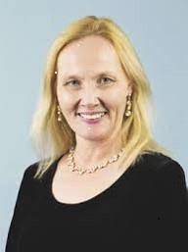
Erika Simpson is an associate professor of international relations at the University of Western Ontario and president of the Canadian Peace Research Association (CPRA). She is the author of NATO and the Bomb and her articles have appeared in The Brown Journal of World Affairs, International Journal, Invictus Pax, Peace Magazine, Peace Research, Peace Review, and Policy Options. A newspaper columnist for Canada’s largest digital and newspaper chain, and for Ottawa’s Hill Times, she is a past vice president of the CPRA (2015-19), she is a past vice-chair of the Canadian Pugwash Group, a reviewer for the CIMVH, and former Alton Jones Fellow, Barton Fellow, Liu Institute Fellow, and NATO Fellow. In 2015, the Voice of Women in Canada awarded her a lifetime achievement award.
Past President: Dr. Shreesh Juyal
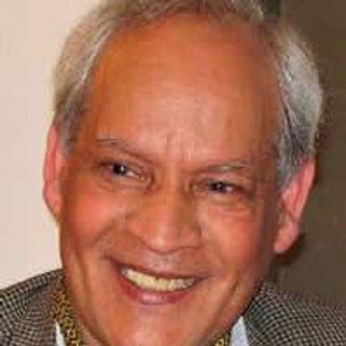
Shreesh Juyal (D.Litt.) is a former Dean of the Faculty of International Studies and Distinguished Professor of International Law and Political Science at Himgiri Zee University, Dehradun Uttarakhand, India. He is a former full Professor of Political Science at the University of Regina, Regina, Saskatchewan, Canada and the Director of the United Nations and International Affairs Institute, University of Regina. He is the President of the Canadian Peace Research Association (2004-19) and the Vice-President of the World Federation of Scientific Workers, Paris, France. Dr. Juyal is the author or editor of nine books including Peace Issues in the 21st Century Global Context, eds. John Duncan, Shreesh Juyal (UK: Cambridge Scholars Publishing, 2017); Shreesh Juyal, International Organizations (Strathmor Publications, 1996) and Shreesh Juyal, Global Issues: A Primer for Model United Nations (Strathmor Publications, 1995). He is a recipient of the United Nations Association (Canada) Global Citizen Award and the Peace Medal of the YMCA Canada.
Vice President: Dr. Christopher Hrynkow
Email: chrynkow@stmcollege.ca
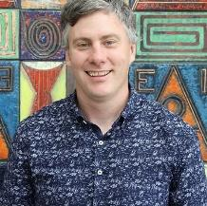
Christopher Hrynkow, PhD (Peace and Conflict Studies, University of Manitoba), ThD (Christian Ethics, University of Toronto) is an Associate Professor in Religion and Culture at St. Thomas More College, University of Saskatchewan. There, he teaches courses in Religious Studies, Catholic Studies, and Critical Perspectives on Social Justice and the Common Good. From January 2019 to July 2019, he is serving as Patrick and Barbara Keenan Visiting Chair in Religious Education at the University of St. Michael's College in the University of Toronto. Hrynkow is also a graduate student in Education (University of Bath) and Social Justice and Community Action (University of Edinburgh). In July 2019, he will return to St. Thomas More College as Department Head and Graduate Chair in Religion and Culture for the University of Saskatchewan.
Secretary: Ms. Anne Venton
Email: anne.venton@sympatico.ca
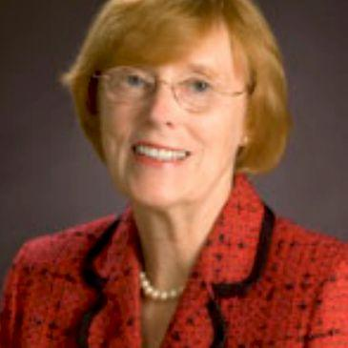
Anne Venton earned a MA (University of Toronto) and was a Media Studies educator with the Toronto District School Board (TDSB). She also served as Head of Library at Northern Secondary School, North Toronto Collegiate, and City Adult Learning Centre. She was a Project Director at the Ontario Institute for Studies in Education (OISE) on projects including the ‘Canadian English Language Achievement Test’ and ‘Sex Stereotyping in Elementary Readers’. With extensive experience on many boards, Ms. Venton served on boards for the Immigration and Refugee Board of Canada; the Council of the Association of Professional Engineers of Ontario; the Greater Toronto Marketing Alliance; and the College of Dental Hygienists of Ontario. She was the Riding President of the Toronto Centre Federal Liberal Association (TCFLA) and President of the Ontario Women's Liberal Commission (OWLC). Currently, she serves on the executive of CCAVE (Canadians Concerned About Violence in Entertainment) as Director of Communications and on the Sinfonia Toronto Board. She is also a former Vice-President of the OISE Alumni Association, which represents one of the largest faculties at the University of Toronto with over 70,000 graduates.
Treasurer: Peter Venton
Email: ﻿peter.venton@bell.net
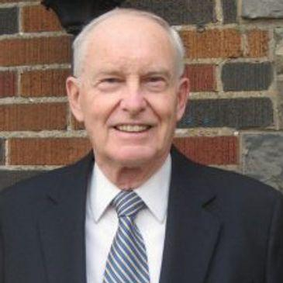
Peter Venton is the Treasurer of the Canadian Peace Research Association (CPRA) (2015-17, 2017-19). He was the Bursar, University of St. Michael’s College in the University of Toronto, Toronto (2001-2009). The modern equivalent of Bursar is Vice President: Administration and Finance, which includes oversight management of Human Resources administration and management’s representative in labor negotiations, as well as oversight management of the University’s physical plant. He is also the former Vice President: Administration and Finance, Wilfrid Laurier University, (1979-1984). Formerly he was an economist and senior policy advisor in the Ontario Government's Ministry of Finance. He holds a MA in Economics from Queen’s University. Venton is currently the President of JPV Associates consulting in economics and public policy in the public interest and public sector management. He has presented papers on economic inequality, environmental sustainability, democracy, globalization and capitalism in Canada, Greece and Taiwan. His publications include, "Radical changes in Canadian democracy: for ecology and the public good," Ecological Systems Integrity: Governance, law and human rights, eds. Laura Westra, Janice Gray and Vasiliki Karagerorgou (New York: Routledge Earthscan, 2015). Currently he serves as the Treasurer of the Canadian Pugwash Group (2017-19), a registered Canadian charitable foundation, and as a Board Member and Director of the Canadian Pugwash Group (2015-2019).

Chair (2019-2021)/Past Chair (2023) National Advisory Council: Dr. Joanna Quinn
Email: jquinn2@uwo.ca
Joanna R. Quinn is Past Chair of the National Advisory Council and Past President of the College of New Scholars, Artists and Scientists of the Royal Society of Canada. She is Associate Professor of Political Science and Director of the Centre for Transitional Justice and Post-Conflict Reconstruction at Western University, where she is cross-appointed to the Faculty of Law and affiliate-appointed to the Department of Women’s Studies and Feminist Research. Dr. Quinn’s research considers the role of acknowledgement, or the recognition of past events, in overcoming the effects of human rights abuses after conflict. She is interested in its potential to affect real and lasting change. She has written widely on the role of acknowledgment in truth commissions and in customary law in Uganda, Haiti, Canada, Fiji, Solomon Islands, and Canada. Her current project considers how to flip the switch to make people care about what has taken place in post-conflict societies. She holds a Ph.D. from McMaster University, a Master’s from Acadia University, and a B.A. (Hons.) from the University of Waterloo.
Past Chair (2021) of the National Advisory Council: Dr. Rose Dyson
Email: rose.dyson@alumni.utoronto.ca
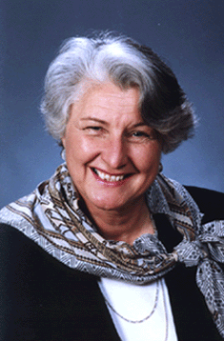
Rose Dyson, Ph.D. Ed.D. (Ontario Institute for Studies in Education, University of Toronto) is the author of Mind Abuse: Media Violence in an Information Age (2000) and the co-author of 11 other peer-reviewed books. She was the editor for 17 years of The Learning Edge (Canadian Association for the Study of Adult Education). She was the associate editor of Peace Issues in the 21st Century Global Context, eds. John Duncan, Shreesh Juyal (UK: Cambridge Scholars Publishing, 2017). She is the President of Canadians Concerned About Violence in Entertainment and Chair of the National Advisory Council of the Canadian Peace Research Association (2013-15, 2015-17, 2017- 2019). She is a member of the Climate Action Network, the Global Ecological Integrity Group, and Just Earth. She is also the Director of Communication and a member of the World Federalist Movement, Toronto Branch, Canada.
Director of Communications and Public Relations: Yerin Chung

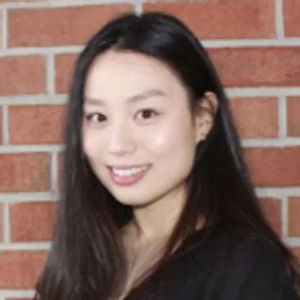
Ms. Chung (MA) is a PhD candidate at Kingston University and a recent graduate of the Political Philosophy stream at the University of Western Ontario. Her PhD in Political Theory and Peace Research focuses on contemporary political philosophy in the areas of global distributive justice, historical injustice, human rights and the ethics of climate change as it pertains to issues of intergenerational justice. She has worked as a teaching assistant at The University of Western Ontario for various faculty members of Political Science. She holds a Master’s degree and a B.A. (Hons.) degree in Political Science both from The University of Western Ontario. Yerin serves as Director of Communications and Public Relations for the Canadian Peace Research Association (CPRA). Yerin Chung can be reached at: ychung73@uwo.ca
International Representative: Dr. Katerina Standish
Email: katerina.standish@otago.ac.nz
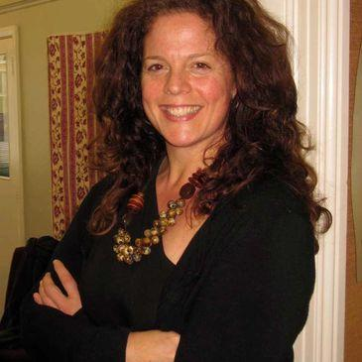
Katerina Standish is the Deputy Director of the National Centre for Peace and Conflict Studies, University of Otago, New Zealand. Dr Standish is an expert on culture and violence and specialises in curricular analysis. Her publications include content on gender, conflict and cultural learning, as well as alternative education (peace education and decolonizing education), violence and self-harm in Indigenous and Non-Indigenous culture, and practical violence transformation. She has published five books and many refereed articles including most recently, Suicide Through a Peacebuilding lens: Medical and Instrumental Suicide (New York: Palgrave MacMillan, 2019). She holds a doctoral degree in Peace and Conflict Studies from the University of Manitoba; a Master's Degree in Human Security and Peacebuilding from Royal Roads University; a post-baccalaureate in Communications from Simon Fraser University: and an undergraduate degree in Sociology from SFU.
International Representative: Dr. Franke Wilmer
Email: frankewilmer1@gmail.com
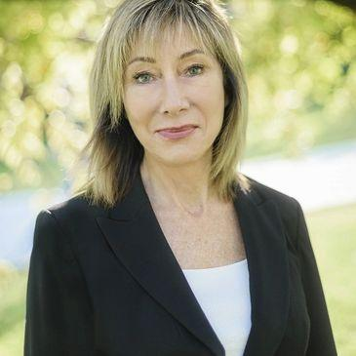
Franke Wilmer is a Professor, International Relations, Montana State University who specializes in conflict and conflict resolution, international law, public policy, international relations and foreign policy. Dr. Milmer served four terms in the Montana legislature. She was elected by colleagues from both parties to serve as Speaker Pro Tempore in 2009, chaired the interim committee on State Administration and Veterans' Affairs in 2007-2009, served on House Education; Fish Wildlife and Parks; and State Administration and Veterans' Affairs committees. She received two awards from veteran’s groups for legislative work including Legislator of the Year from the Vietnam Veterans of American Montana Council in 2011. She served on the Council of the American Political Science Association and the Editorial Board of the International Studies Quarterly. She has travelled to over 50 countries as a guest lecturer or researcher, including six times to the former Yugoslavia during wartime.
Member-at-Large: Dr. Walter Dorn
Email: walter.dorn@rmc.ca
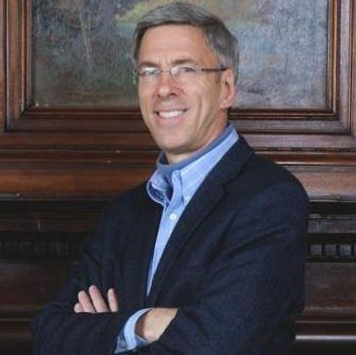
Walter Dorn is Professor of Defence Studies at the Canadian Forces College and at the Royal Military College, Kingston. A scientist by training (Ph.D. Chemistry, University of Toronto), his doctoral research was on chemical sensing for arms control. He assisted with the negotiation, ratification and implementation of the Chemical Weapons Convention. His interests are broader now, covering international and human security, especially peace operations and the United Nations (UN). A. Walter Dorn is the author of Air Power in UN Operations: Wings for Peace (Ashgate, 2014); Keeping Watch: Monitoring, Technology and Innovation in UN Peace Operations (United Nations University Press, 2011) and the editor of World Order for a New Millennium: Political, Cultural and Spiritual Approaches to Building Peace (Palgrave Macmillan Press, 1999) Dorn has extensive experience in UN field missions. He served as a district electoral officer with the United Nations (UN) Mission in East Timor in 1999; in Ethiopia on a UNDP project; and at UN headquarters as a Training Adviser with the UN's Department of Peacekeeping Operations (DPKO). He was on the UN’s Panel of Experts on Technology and Innovation in UN Peacekeeping in 2014. He served as the Innovation and Protection Technology Expert within the UN’s Department of Field Support in 2017- 18, providing advice to improve UN missions in the Middle East and Africa including Lebanon, the Central African Republic, the Democratic Republic of the Congo and Mali. He has served as the UN Representative of Science for Peace, a Canadian NGO since 1983.
Member-at-Large: Lt. Col. Sylvie Lemieux
Email: slemieux3599@rogers.com
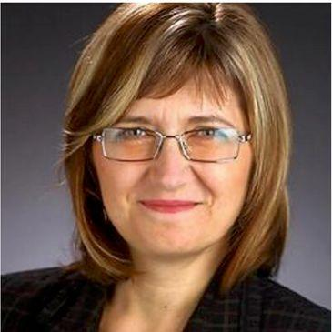
Sylvie Lemieux holds a Ph.D in Conflict Studies from St. Paul University, Ottawa; a MA in globalization and international development from the University of Ottawa; and a Bachelor of Applied Science from the Ecole polytechnique de Montreal - Université de Montreal. A retired Lieutenant-Colonel from the Canadian Armed Forces (Army) and former civil servant, she was a leadership candidate for the Green Party in 2010. She is a Board member of the G78, a member of the Canadian Pugwash Group, a member of the Voice of Women, and a member of Integrative Peacebuilding. She has been a Member-at-Large for the Canadian Peace Research Association (CPRA) since 2015.

Member-at-Large: Dr. Kathleen Manion
Email: kathleen.manion@royalroads.ca
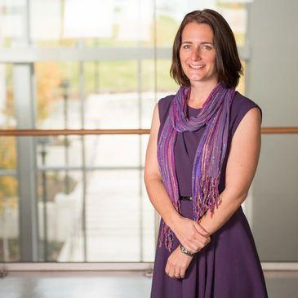
Manion is an educator and researcher who has spent the past 20 years working within social and community services. She is passionate about social justice and social inclusion and particularly interested in helping to bridge the gap between practitioner experiential knowledge, academic theory and policy objectives across multiple disciplines. Manion has worked on projects tackling issues related to child protection, homelessness, healthy early childhood development, environmental protection, family violence, youth justice, and international social work. Before joining Royal Roads in 2013, Manion’s diverse experience included research and practice in various countries and settings, working at both a national ministerial level and also at the grassroots. Manion completed her undergraduate studies at the University of Waterloo (BA in psychology, diploma in peace and conflict studies and certificate in social work). She earned her master’s (international social work and community development studies) and her PhD in sociology from the University of East London in the UK. Manion's doctoral studies focused on the perceptions of success of interventions with commercially sexually exploited girls in Canada, Australia and the United Kingdom.
Member-at-Large: Dr. Jennifer Ball
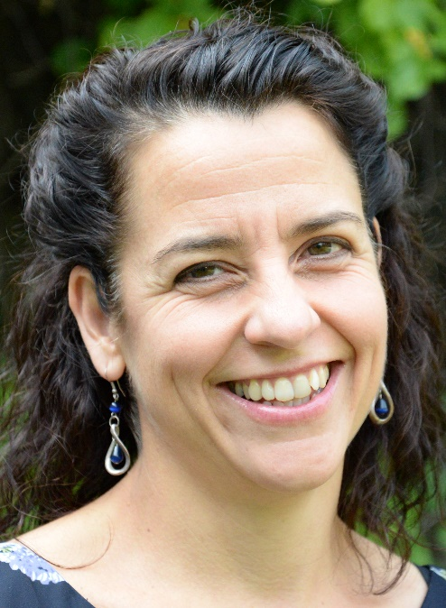
Dr. Jennifer Ball is an assistant professor of Peace and Conflict Studies at Conrad Grebel University College. She holds PhD in Rural Studies, with a focus on Sustainable Rural Communities, from the University of Guelph. Her research interests pertain broadly to women’s community-based peacebuilding, Circle as pedagogy & community engagement process, community resilience, rural planning & community development, and narrative methodologies. Her three books reflect this range: Women, Development and Peacebuilding in Africa: Stories from Uganda (2019), Better Decisions Together: A Facilitation Guide for Community Engagement (2015), Doing Democracy with Circles: Engaging Communities in Public Planning (2010). Jennifer is a registered professional planner and worked for several years in rural Ontario. Jennifer Ball can be reached at: jennifer.ball@uwaterloo.ca.
Local Arrangements Coordinator at the University of Alberta and Member-at-Large: Dr. W. Andy Knight
Email: knight@ualberta.ca
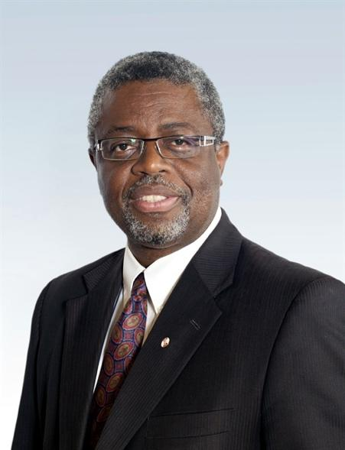
W. Andy Knight is Professor of International Relations in the Political Science Department at the York University and past Chair of the Department. He is former Director of the Institute of International Relations, The University of the West Indies, Trinidad & Tobago. He is currently co-editor in Chief of African Security journal and of International Journal. A former co-editor of Global Governance journal and Vice Chair of the Academic Council on the United Nations System (ACUNS), Knight has served as Governor of the International Development Research Centre (IDRC) and is A Fellow of the Royal Society of Canada. His most recent book is the award winning, Female Suicide Bombings: A Critical Gendered Approach, with Tanya Narozhna (University of Toronto Press, 2016). His recent publications address issues of UN Reform, global health governance, global health security, piracy in the Horn of Africa, and the vulnerabilities and resiliency of small states.

Local Arrangements Coordinator at York University and Member-at-Large: Dr. Sergei Plekhanov
Email: Associate Professor Sergei Plekhanov
Local Arrangements Coordinator, CPRA – ACRP

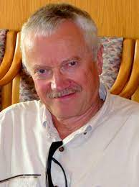
Born in Moscow, Russia, Dr. Plekhanov holds B.A. and M.A. in International Relations from Moscow State Institute of International Relations and a Ph.D. in History from Institute for the Study of the USA and Canada, Academy of Sciences of the USSR. From 1988 to 1993 he served as the Deputy Director of the Institute for the Study of the USA and Canada. Dr. Plekhanov has taught as a Visiting Professor at the University of California, Irvine, and Occidental College (Los Angeles), and served as Soviet Affairs Consultant with CBS News (1989-1991). Since his arrival in Canada in 1993, he has been a frequent commentator on Russian and East European affairs for Canadian TV and radio networks and print media. Currently an Associate Professor in the Department of Politics, York University, he is the Coordinator of the Post-Communist Studies Program at York Centre for International and Security Studies and Senior Associate of the Centre for European, Russian, and Eurasian Studies, University of Toronto.
Contacts for CPRA - ACRP Conference:

CPRA - ACRP President and Program Chair Dr. Erika Simpson at simpson@uwo.ca and/or cpramail@gmail.com
CPRA – Vice President and Program Committee Member Dr. Chris Hrynkow at chrynkow@stmcollege.ca and/or cpramail@gmail.com
The Local Arrangements Coordinator at U of Alberta was Dr. Andy Knight at knight@ualberta.ca and/or cpramail@gmail.com
The Local Arrangements Coordinator at York University is Dr. Sergei Plekhanov at cpramail@gmail.com
The Treasurer is Peter Venton at peter.venton@bell.net and/or cpramail@gmail.com

Programming Committee, Interns & Student Assistants:

Ms. Anjali Bhaheeratha, Volunteer Intern and Program Committee Director (until June 2, 2023)
Ms. Yerin Chung, Volunteer Intern and Director of Social Media and Communications (until June 2023), Association Assistant (June 1-4, 2021)
Ms. Balqees Al-Badri, CPRA Program and Zoom Assistant (until April 27, 2023)
Mr. Min Kim, Equality, Diversity, Inclusion, and Decolonization (EDID) Assistant (until April 27, 2021)
Ms. Lamis Mohamed CPRA Program and Zoom Assistant (until April 27, 2021)
Mr. Niveithan Parthipan CPRA Zoom and Google Assistant (until April 27, 2022)
Ms. Hiba Sayed CPRA Program and Zoom Assistant (until April 27, 2023)
Mr. Chirag Singhal Zoom and YouTube Assistant (until April 27 2023)
Ms. Jiaxin Yan, Accounting and Excel Assistant (until April 27, 2023)
Ms. Yifei Zhang, Accounting and Excel Assistant (until April 27, 2021)
Canadian Peace Research Association (CPRA)
Biographies of Speakers & Chairs at the 2023 Conference

Albeheshti, Parsa
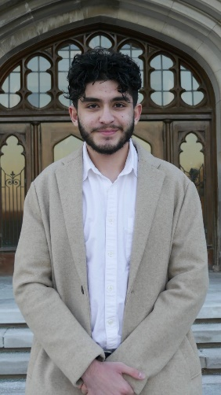
Mr. Parsa Albeheshti is a second-year undergraduate student studying at the School of Advanced Studies in the Arts and Humanities (SASAH) and majoring in philosophy at Western University. He is an Iranian Canadian activist and has published on the impact of sanctions on ordinary people. Parsa can be reached at: palbehes@uwo.ca

Almosawi, Tara

Ms. Almosawi is entering fourth-year as a Political Science student at the University of Western Ontario, London. Tara will be undertaking a 4th year Reading Course on Nuclear Exploration Energy Issues under the supervision of Dr. Erika Simpson. Tara Almosawi can be reached at: talmosaw@uwo.ca

Atkinson, Ryan

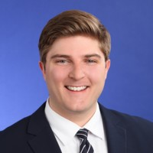
Mr. Atkinson (MA) is a PhD Candidate, University of Western Ontario, London and led the Cybersecurity and Information Warfare program at the NATO Association of Canada as research analyst and program manager. Ryan Atkinson can be reached at: ratkin23@uwo.ca.

Bhaheeratha, Anjali
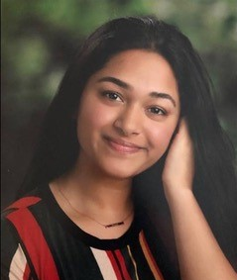
Ms. Anjali Bhaheeratha is a recent graduate of Western University, where she completed an Honours Double Major in Political Science and Sociology. In Fall 2023, she will be undertaking an M.A. in Political Science at Western University. Anjali’s research interests concern international relations and global political economy, particularly focusing on immigration policy and settlement services. Anjali Bhaheeratha can be reached at abhaheer@uwo.ca.

Buckley, Adele
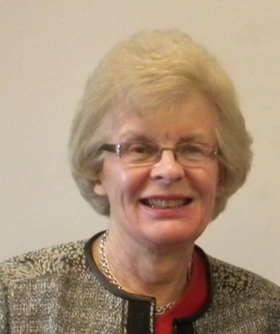
Dr. Adele Buckley is a physicist, engineer and environmental scientist. She is the former Chair and Treasurer of the Canadian Pugwash Group and she leads the CPG campaign for a nuclear-weapon-free Arctic. Since 2007, she has presented this proposal in six countries. She is a member of the advisory board of Canadians for a Nuclear Weapons Convention. For the Global Issues Project, she led an expert roundtable on freshwater, one of a series on crises of sustainability. Formerly she was the founding partner and Vice President (VP), Sciex, developer of mass spectrometry systems with extensive worldwide installations; VP Technology and Research, Ontario Centre for Environmental Technology Advancement; and VP Solarchem Environmental Systems. Her wide-ranging work in environmental technology includes commercialization of new technology, verification of performance, and projects in Bangladesh and China. Adele Buckley can be reached at: adele-buckley@rogers.com.

Doak-Gebauer, Charlene
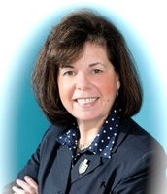
Charlene Doak-Gebauer has created the theory of digital supervision for proactive online child protection and is the founder and chair of the federal Canadian charity Internet Sense First and the AICET Council and Anti Internet Child Exploitation Team. Her objectives are to educate the public for proactive online child protection and provide funding for therapy for victims of internet child exploitation. Recently she won awards for the Best Producer and Best Director for the documentary, “Vulnerable Innocence", a film that has already won twenty-four international awards. The author of two books, Digital Sexual Victims: True Cases has been nominated for many international awards, and her latest book release is The Internet: Are Children In Charge? Doak-Gebauer was recently awarded with an Honorary Doctorate by Rai Technology University, Bangalore, India; the 2022 Inaugural Phoenix Award, B.E. A S.H.E.R.O. Foundation, Las Vegas; the 2018 International Women of Excellence Award; and the 2006 Bishop Townshend Award of Teaching Excellence Education. Her education at the University of New Brunswick, the University of Western Ontario, the University of Toronto, and the University of California Santa Barbara formerly led her to become a specialist in computer science in education and a network administrator in secondary schools. Charlene Doak-Gebauer can be reached at: internetsense.first@rogers.com.

Dorn, A. Walter
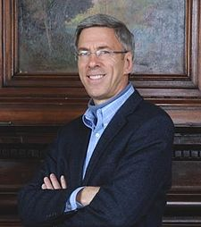
Dr. Walter Dorn is Professor of Defence Studies at the Canadian Forces College and at the Royal Military College, Kingston. A scientist by training (PhD Chemistry, University of Toronto), his doctoral research was on chemical sensing for arms control. He assisted with the negotiation, ratification and implementation of the Chemical Weapons Convention. His interests are broad covering international and human security, especially peace operations and the United Nations (UN). Professor Dorn is the author of Air Power in UN Operations: Wings for Peace (Ashgate, 2014); Keeping Watch: Monitoring, Technology and Innovation in UN Peace Operations (United Nations University Press, 2011) and the editor of World Order for a New Millennium: Political, Cultural and Spiritual Approaches to Building Peace (Palgrave Macmillan Press, 1999). He has extensive experience in UN field missions. He served as a district electoral officer with the UN Mission in East Timor in 1999; in Ethiopia on a UNDP project; and at UN headquarters as a Training Adviser with the UN's Department of Peacekeeping Operations (DPKO). He was on the UN’s Panel of Experts on Technology and Innovation in UN Peacekeeping in 2014. He served as the Innovation and Protection Technology Expert within the UN’s Department of Field Support in 2017-18, providing advice to improve UN missions in the Middle East and Africa including Lebanon, the Central African Republic, the Democratic Republic of the Congo, and Mali. He has served as the UN Representative of Science for Peace, a Canadian NGO since 1983. He is the President of the World Federalist’s Association, Ottawa and the Past Chair of the Canadian Pugwash Group. Previously he was a Senior Research Fellow at Cornell University; a consultant to Yale University; a visiting scholar at the Cooperative Monitoring Centre (1999); an adviser to the Federation of American Scientist’s Biological Weapons Control expert group; a Research Fellow with the University of Toronto’s International Relations, and Peace and Conflict Studies programs; and the Physical Science Don at the University of Toronto’s Trinity College. A. Walter Dorn can be reached at: dorn@cfc.dnd.ca and walter.dorn@rmc.ca.

Dyson, Rose
Dr. Rose Dyson, Ph.D. Ed.D. (Ontario Institute for Studies in Education, University of Toronto) is the author of two books including Mind Abuse: Media Violence in an Information Age (Black Rose Books) and the co-author of 11 other peer-reviewed books. She was the editor for 17 years of The Learning Edge (Canadian Association for the Study of Adult Education). She was the associate editor of Peace Issues in the 21st Century Global Context, eds. John Duncan, Shreesh Juyal (UK: Cambridge Scholars Publishing, 2017). She is the President of Canadians Concerned About Violence in Entertainment and Chair of the National Advisory Council of the Canadian Peace Research Association (2013-15, 2015-17, 2017- 2019). She is a member of the Climate Action Network, the Global Ecological Integrity Group, and Just Earth. She is also the Director of Communication and a member of the World Federalist Movement, Toronto Branch, Canada. Dr. Dyson can be reached at: rose.dyson@alumni.utoronto.ca

Edgar, Alistair
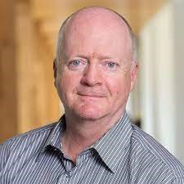
Dr. Alistair Edgar is Associate Professor of Political Science at Wilfrid Laurier University, and the Balsillie School of International Affairs. He is an editor of Global Governance: A Review of Multilateralism and International Organizations (Brill/Nijhoff) and series co-editor for the ACUNS Series on the United Nations (Edward Elgar Publishers). He served as Executive Director of the Academic Council on the United Nations System (ACUNS) 2003-2008 and 2010-2018. Alistair Edgar can be reached at: aedgar@wlu.ca.

Hrynkow, Christopher
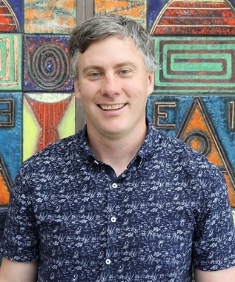
Dr. Christopher Hrynkow (PhD, Peace and Conflict Studies, University of Manitoba), ThD (Christian Ethics, University of Toronto) is a Professor in Religion and Culture at and Department Head and Graduate Chair in Religion and Culture at St. Thomas More College, University of Saskatchewan, Saskatoon. He serves as Co-Director of the Irene and Doug Schmeiser Centre for Faith, Reason, Peace, and Justice. Additionally, Hrynkow is Graduate Chair in Religion and Culture for the University of Saskatchewan and teaches in the new Peace Studies certificate program. He has published 28 peer-reviewed journal articles and 12 peer-reviewed book chapters. He teaches courses in religious studies, Catholic studies, and critical perspectives on social justice and the common good. Hrynkow also teaches the university's inaugural section of Introduction to Peace Studies as part of a collaborative plan to build the first full-fledged Peace Studies program in Saskatchewan. From January 2019 to July 2019, he served as Patrick and Barbara Keenan Visiting Chair in Religious Education at the University of St. Michael's College at the University of Toronto. Hrynkow is the Vice President of the Canadian Peace Research Association (CPRA) and a graduate student in Education (University of Bath) and Social Justice and Community Action (University of Edinburgh). Christopher Hrynkow can be reached at: chrynkow@stmcollege.ca.

Jones, Shelley
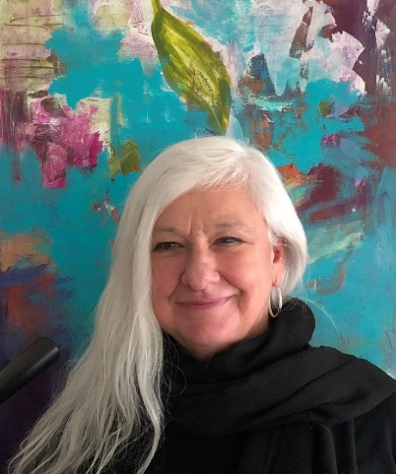
Dr. Shelley Jones, BA, BEd, MA, PhD, is a Professor of Interdisciplinary Studies at Royal Roads University and a board member of International Institute of Child Rights and Development. She is the Head of Undergraduate Programs in the College of Interdisciplinary Studies at RRU. Dr. Shelley Jones can be reached at: Shelley.12jones@royalroads.ca

Khan, Zuhayr
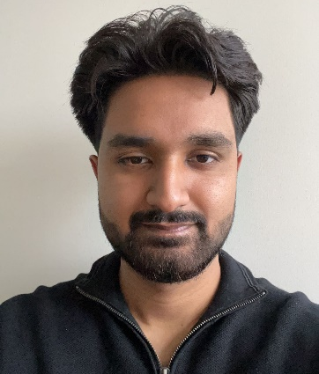
Mr. Khan is a second-year undergraduate health science student at the University of Western Ontario. His research interests include political science and the history of the modern world since 1900, with a focus on great wars and conflicts, among other areas.
He can be reached at: zkhan282@uwo.ca

Lemieux, Sylvie
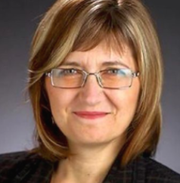
Dr. Sylvie Lemieux is a retired LCol Army engineer and former Public Service executive who represented the Green Party of Canada in two federal elections. As a part-time consultant for Global Affairs Canada as well as a member of non-governmental organizations, Dr. Lemieux serves as the co-chair of the Canadian Network to Abolish Nuclear Weapons (CNANW). She holds a Ph.D in Conflict Studies from St. Paul University, Ottawa; a MA in globalization and international development from the University of Ottawa; and a Bachelor of Applied Science from the Ecole polytechnique de Montreal - Université de Montreal. A retired Lieutenant-Colonel from the Canadian Armed Forces (Army) and former civil servant, she was a leadership candidate for the Green Party in 2010. She is the co-chair with Robin Collins of the Canadian Network to Abolish Nuclear Weapons; a Board member of the G78, a member of the Canadian Pugwash Group, a member of the Voice of Women, and a member of Integrative Peacebuilding. She has been a Member-at-Large for the Canadian Peace Research Association (CPRA) since 2015. Sylvie Lemieux can be reached at: slemieux3599@rogers.com.
Manion, Kathleen
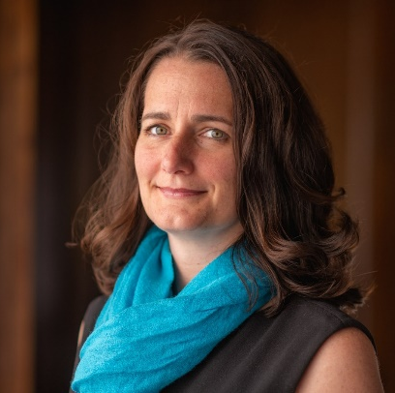
Kathleen Manion, BA, MA, LLM, PhD is a Professor at Royal Roads University and an Associate at the International Institute of Child Rights and Development. She is currently the Program Head for the MA Disaster and Emergency Management program and the Graduate Certificate Child Protection to Wellbeing and teaches with the Justice Studies Programs. With nearly thirty years experience in research, social and community services and academia, Kathleen’s academic and practice interests focus on systems that support children to thrive. Using various qualitative and quantitative research methodologies and community engagement processes, Kathleen has worked on projects tackling issues related to child protection, child rights, homelessness, climate justice, early childhood development, service innovation, trafficking, violence against children and within families, youth justice, and child migration in North and South America, Europe, Asia, Africa, and the Pacific. Kathleen Manion can be reached at: Kathleen.Manion@RoyalRoads.ca.

Maure, Ben
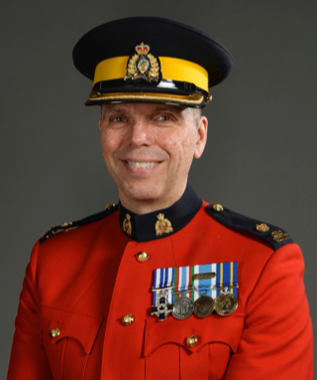
Ben (Benoit) Maure is a serving Peace Officer with the Royal Canadian Mounted Police. He has over 32 years of police experience, most of which has been spent in British Columbia. In 1999, Ben completed a one-year secondment tour of duty as a United Nations Peacekeeper in Quetzaltenango, Guatemala. Between 2009 and 2013, Ben acted as a Police Liaison Officer (First Secretary) at the Embassy of Canada in the Dominican Republic. He is fluent in French, English and Spanish and as a command of the German language. Ben holds a Bachelor of Technology degree from the British Columbia Institute of Technology (BCIT) and a Master of Arts degree in Social Justice from the University of the Fraser Valley (UFV). He is passioned about peace studies and international policing. Ben is also a recipient of the Governor General’s Meritorious Service Cross (M.S.C.). Ben is the author of a recently published book on Canadian Police Peacekeeping titled: Leading at the Edge. Ben Maure can be reached at: bjmaure@shaw.ca.

Quereshi, Noor
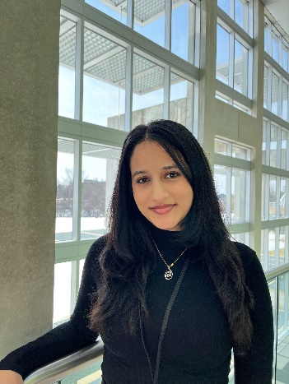

Noor Qureshi is an intern who will be overseas working on NLP models to identify refugee populations, assess their mental health, and categorize specific clinical diagnoses to identify suicide risks. Ms. Quereshi can be reached at: nqures3@uwo.ca

Shafa Amri, Ward
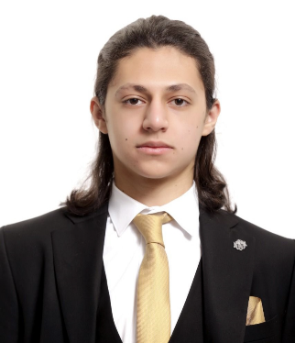
Ward Shafa Amri is a candidate for an Honours Bachelor's of Specialization in Medical Cell Biology at the University of Western Ontario. Following graduation, in 2025, he aspires to pursue an M.D. at the Schulich School of Medicine & Dentistry. Ward's research interests concern international relations and the global political economy with a focus on the Northern American economies. Furthermore, he previously conducted astrobiological research and now expresses interest in medical research in the near future. Ward Shafa Amri can be reached at wshafaam@uwo.ca

Simpson, Erika
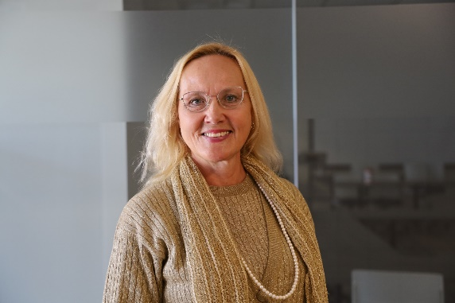
Dr. Erika Simpson (PhD and MA, University of Toronto) is an Associate Professor of International Relations at Western University, London, Canada and the President of the Canadian Peace Research Association (CPRA). Her research interests are in international security and North American foreign and defence policy, particularly arms control, disarmament, nuclear proliferation, nuclear waste, and peacekeeping. She is the author of NATO and the Bomb (McGill-Queen’s University Press, 2001) and her articles have appeared in leading journals including International Journal; In Victus Pax: Journal of Peace Education and Social Justice; Peace Magazine; Peace Research; Peace Review: A Journal of Social Justice; and Policy Options. She is a columnist for the Hill Times, Canada’s foreign policy weekly and the Postmedia Network, and a frequent commentator on al-Jazeera, BBC, CTV, CBC, Sputnik, and Urdu News. She serves as a Director on the Board of the Canadian Pugwash Group and the Board of the Canadian Network to Abolish Nuclear Weapons; a Consultant for the Nuclear Abolition Forum; and a Peer Reviewer for the Canadian Institute for Military and Veteran Health and SSHRC. Formerly she was an Alton Jones Fellow; a Barton Fellow; a Liu Institute Visiting Fellow; a NATO Research Fellow; and the Treasurer and Vice-Chair of the Canadian Pugwash Group. In 2015 the Voice of Women – Canada awarded her the ‘Shirley Farlinger Lifetime Achievement Award for Peace Writings.’ Erika Simpson can be reached at: simpson@uwo.ca.

Sobin, Abigail
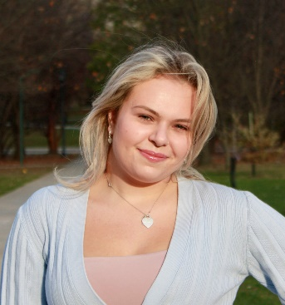
Abigail Sobin is a recent graduate of Western University, where she completed an Honours Specialization in International Relations and a Minor in Transitional Justice and Post-Conflict Reconstruction. Next year, she will attend the University of Waterloo's Master of Public Service program. Ms. Sobin’s research interests include international politics and history, with a focus on Eastern and Central Europe, democracy, social policy and posthumanism. Abigail Sobin can be reached at asobin@uwo.ca

Stevenson, Colton
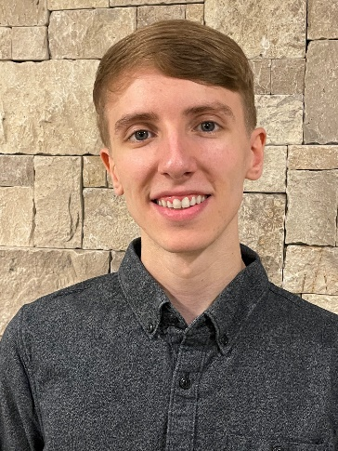
Mr. Colton Stevenson completed the political science undergraduate program at the University of Western Ontario and will pursue a MA at the University of Western Ontario in September 2023. His plans for research focus on sustainability, particularly on our dependence on nuclear weapons and climate change under the field of International Relations. Colton Stevenson can be reached at: csteve59@uwo.ca

Standish, Katerina

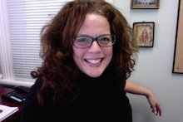
Dr. Katerina Standish is an expert on culture and violence and specializes in curricular analysis. Her publications include content on gender, conflict and cultural learning, as well as alternative education (peace education and decolonizing education), violence and self-harm in Indigenous and Non-Indigenous culture, and practical violence transformation. She has published five books and many refereed articles including Suicide Through a Peacebuilding lens: Medical and Instrumental Suicide (Palgrave MacMillan, 2019). Her publications include content on gender, conflict and cultural learning, as well as alternative education (peace education and decolonizing education), violence and self-harm in Indigenous and Non-Indigenous culture, and practical violence transformation. She has published five books and many refereed articles including most recently, Suicide Through a Peacebuilding lens: Medical and Instrumental Suicide (New York: Palgrave MacMillan, 2019). She holds a doctoral degree in Peace and Conflict Studies from the University of Manitoba, a Master's Degree in Human Security and Peacebuilding from Royal Roads University, a post-baccalaureate in Communications from Simon Fraser University and an undergraduate degree in Sociology, Anthropology and Humanities from Simon Fraser University. Dr Standish is a specialist in transformative education, the creator of Yogic Peace Education and the inventor and primary researcher for the Peace Education Curriculum Analysis (PECA) (pecaproject.org). Her peace practices include working in partnership with local communities in Canada and Aotearoa/New Zealand. She has experience in peacebuilding in Uganda, Palestine, Israel and with the Red Cross in Canada and New Zealand. She has been a Yoga, breath and meditation instructor for 15 years. Katerina Standish can be reached at: katerinastandish@gmail.com

Turcotte, Earl
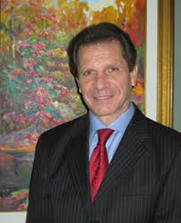
Mr. Turcotte (MA U of Ottawa, MA Carleton University) served variously as a parliamentary assistant, CIDA program manager, First Secretary and Chief of CIDA’s Mine Action Unit. He joined the UNDP on the Mine Action Team and was lead for Canada’s engagement on the Ottawa Convention on Landmines and the chief Canadian negotiator of the Convention on Cluster Munitions. Earl Turcotte can be reached at: earl.turcotte@gmail.com

Venton, Anne
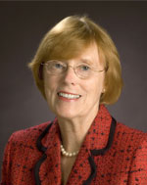
Anne Venton earned a MA (University of Toronto) and was a Media Studies educator with the Toronto District School Board (TDSB). She also served as Head of Library at Northern Secondary School, North Toronto Collegiate, and City Adult Learning Centre. She was a Project Director at the Ontario Institute for Studies in Education (OISE) on projects including the ‘Canadian English Language Achievement Test’ and ‘Sex Stereotyping in Elementary Readers’. With extensive experience on many boards, Ms. Venton served on boards for the Immigration and Refugee Board of Canada; the Council of the Association of Professional Engineers of Ontario; the Greater Toronto Marketing Alliance; and the College of Dental Hygienists of Ontario. She was the Riding President of the Toronto Centre Federal Liberal Association (TCFLA) and President of the Ontario Women's Liberal Commission (OWLC). Currently, she is a VP Community Outreach for TCFLA and she serves on the executive of C-CAVE (Canadians Concerned About Violence in Entertainment) as Director of Communications. She is also the Vice-President of the OISE Alumni Association, which represents one of the largest faculties at the University of Toronto with over 70,000 graduates. Anne Venton can be reached at: a.e.venton@gmail.com.
Venton, Peter

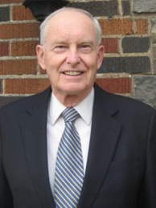
Peter Venton is the Treasurer of the Canadian Peace Research Association (CPRA) (2015-17, 2017-19). He was the Bursar, University of St. Michael’s College in the University of Toronto, Toronto (2001-2009). The modern equivalent of Bursar is Vice President: Administration and Finance, which includes oversight management of Human Resources administration and management’s representative in labor negotiations, as well as oversight management of the University’s physical plant. He is also the former Vice President: Administration and Finance, Wilfrid Laurier University, (1979-1984). Formerly he was an economist and senior policy advisor in the Ontario Government's Ministry of Finance. He holds a MA in Economics from Queen’s University. Venton is currently the President of JPV Associates consulting in economics and public policy in the public interest and public sector management. He has presented papers on economic inequality, environmental sustainability, democracy, globalization and capitalism in Canada, Greece and Taiwan. His publications include, "Radical changes in Canadian democracy: for ecology and the public good,"​ Ecological Systems Integrity: Governance, law and human rights, eds. Laura Westra, Janice Gray and Vasiliki Karagerorgou (New York: Routledge Earthscan, 2015). Currently he serves as the Treasurer of the Canadian Pugwash Group (2017-19), a registered Canadian charitable foundation, and as a Board Member and Director of the Canadian Pugwash Group (2015-2019). Peter Venton can be reached at: peter.venton@bell.net.

Wilmer, Franke

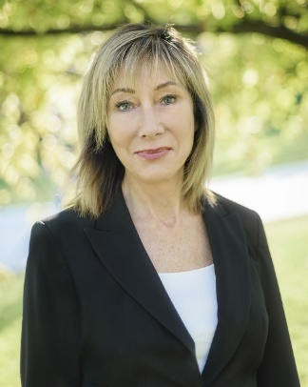
Dr. Franke Wilmer is a Professor, International Relations, Montana State University who specializes in conflict and conflict resolution, international law, public policy, international relations and foreign policy. Dr. Wilmer served four terms in the Montana legislature. She was elected by colleagues from both parties to serve as Speaker Pro Tempore in 2009, chaired the interim committee on State Administration and Veterans' Affairs in 2007-2009, served on House Education; Fish Wildlife and Parks; and State Administration and Veterans' Affairs committees. She received two awards from veteran’s groups for legislative work including Legislator of the Year from the Vietnam Veterans of American Montana Council in 2011. She served on the Council of the American Political Science Association and the Editorial Board of the International Studies Quarterly. She has travelled to over 50 countries as a guest lecturer or researcher, including six times to the former Yugoslavia during wartime. Franke Wilmer can be reached at: frankewilmer1@gmail.com.

Yeung, Bethany
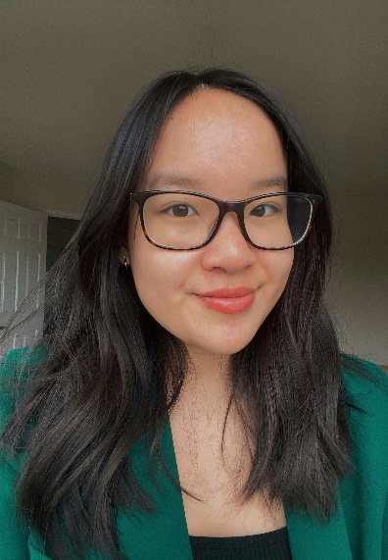
Bethany Yeung is an undergraduate political science student at Western University pursuing an honours specialization degree in international relations. She is currently working as a research intern on a project studying the history of espionage and failures of intelligence over the course of human history. The project is intended to aid in training intelligence officers, policy makers, and strategists about the causes and consequences of intelligence failure. Ms. Bethany Yeung can be reached at: bethanyy167@gmail.com

