Board Members CPRA
President: Dr. Erika Simpson  Email: simpson@uwo.ca  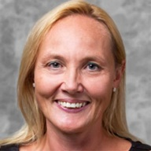 | Erika Simpson was the former Vice President (2015-17, 2017-19) and currently the President of the Canadian Peace Research Association (CPRA) (2019-2021). She is Associate Professor of International Relations in the Department of Political Science at Western University. Dr. Simpson’s research focuses on nuclear issues including arms control, disarmament, nuclear power, proliferation, and terrorism. She is interested in North American defense and Canadian foreign policy. She has written widely on peace related issues, and in 2015 she was awarded the ‘Shirley Farlinger Lifetime Achievement Award for Peace Writings’ by Voice of Women. Dr. Simpson is a syndicated columnist for  the Postmedia Network, Canada’s largest newspaper chain, and a frequent commentator on CTV National Television. She is a Past Vice-Chair, Director, and former Treasurer of the Canadian Pugwash Group (2000-15). She serves as a Canadian Institute for Military and Veteran Health peer reviewer (2017-20) and a SHRCC Insight Development Grant reviewer (2015-17). She is author of the book, NATO and the Bomb (McGill-Queen’s University Press, 2001, 2002) and moe than 150 book chapters, journal articles and op eds available at Scholarship@Western and on Erika Simpson’s blog She holds a Ph.D. and Masters in International Relations from the University of Toronto and a B.A. (Hons.) from the University of Saskatchewan. She completed a postdoc at Carleton University, and she was an Alton Jones Fellow, a CIIPS Postdoctoral Fellow, a Liu Institute Visiting Fellow, and a NATO Fellow.  Associate Professor, Western University, London, ON  Faculty Webpage , Personal Webpage , Blog , Copies of all publications
Vice President: Dr. Christopher Hrynkow  Email: chrynkow@stmcollege.ca  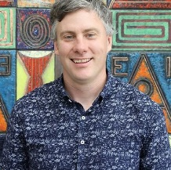 | Christopher Hrynkow, PhD (Peace and Conflict Studies, University of Manitoba), ThD (Christian Ethics, University of Toronto) is an Associate Professor in Religion and Culture at St. Thomas More College, University of Saskatchewan. There, he teaches courses in Religious Studies, Catholic Studies, and Critical Perspectives on Social Justice and the Common Good. From January 2019 to July 2019, he is serving as Patrick and Barbara Keenan Visiting Chair in Religious Education at the University of St. Michael's College in the University of Toronto. Hrynkow is also a graduate student in Education (University of Bath) and Social Justice and Community Action (University of Edinburgh). In July 2019, he will return to St. Thomas More College as Department Head and Graduate Chair in Religion and Culture for the University of Saskatchewan. Hrynkow will also teach the university's inaugural section of Introduction to Peace Studies in the Fall Term 2019, as part of a collaborative plan to build the first full fledged Peace Studies program in Saskatchewan. As of April 2019, he has published 28 peer reviewed journal articles and 12 peer reviewed book chapters  Associate Professor, St. Thomas More College: University of Saskatchewan, Saskatoon, SK
Past President: Shreesh Juyal  Email: shreeshjuyal@ymail.com  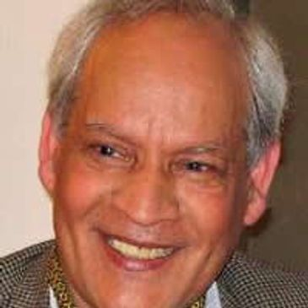 | Shreesh Juyal (D.Litt.) is a former Dean of the Faculty of International Studies and Distinguished Professor of International Law and Political Science at Himgiri Zee University, Dehradun Uttarakhand, India. He is a former full Professor of Political Science at the University of Regina, Regina, Saskatchewan, Canada and the Director of the United Nations and International Affairs Institute, University of Regina. He is the President of the Canadian Peace Research Association (2004-19) and the Vice-President of the World Federation of Scientific Workers, Paris, France. Dr. Juyal is the author or editor of nine books including Peace Issues in the 21st Century Global Context, eds. John Duncan, Shreesh Juyal (UK: Cambridge Scholars Publishing, 2017); Shreesh Juyal, International Organizations (Strathmor Publications, 1996) and Shreesh Juyal, Global Issues: A Primer for Model United Nations (Strathmor Publications, 1995). He is a recipient of the United Nations Association (Canada) Global Citizen Award and the Peace Medal of the YMCA Canada.  Senior Research Scholar, St. Thomas University, Fredericton, NB
General Secretary: Joanna Quinn  Email: | Joanna R. Quinn is President of the College of New Scholars, Artists and Scientists of the Royal Society of Canada. She is Associate Professor of Political Science and Director of the Centre for Transitional Justice and Post-Conflict Reconstruction at Western University, where she is cross-appointed to the Faculty of Law and affiliate-appointed to the Department of Women’s Studies and Feminist Research. Dr. Quinn’s research considers the role of acknowledgement, or the recognition of past events, in overcoming the effects of human rights abuses after conflict. She is interested in its potential to affect real and lasting change. She has written widely on the role of acknowledgment in truth commissions and in customary law in Uganda, Haiti, Canada, Fiji, Solomon Islands, and Canada. Her current project considers how to flip the switch to make people care about what has taken place in post-conflict societies. She holds a Ph.D. from McMaster University, a Master’s from Acadia University, and a B.A. (Hons.) from the University of Waterloo.  Associate Professor, Western University, London, ON  Director for the Center for Transitional Justice and Post-Conflict Reconstruction, Western University, London, ON
Treasurer: Peter Venton  Email: ﻿peter.venton@bell.net  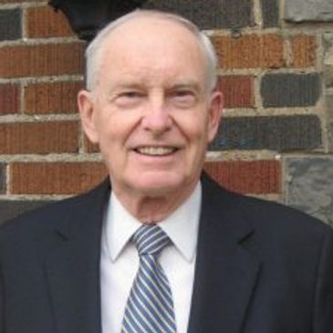 | Peter Venton is the Treasurer of the Canadian Peace Research Association (CPRA) (2015-17, 2017-19). He was the Bursar, University of St. Michael’s College in the University of Toronto, Toronto (2001-2009). The modern equivalent of Bursar is Vice President: Administration and Finance, which includes oversight management of Human Resources administration and management’s representative in labor negotiations, as well as oversight management of the University’s physical plant. He is also the former Vice President: Administration and Finance, Wilfrid Laurier University, (1979-1984). Formerly he was an economist and senior policy advisor in the Ontario Government's Ministry of Finance. He holds a MA in Economics from Queen’s University. Venton is currently the President of JPV Associates consulting in economics and public policy in the public interest and public sector management. He has presented papers on economic inequality, environmental sustainability, democracy, globalization and capitalism in Canada, Greece and Taiwan. His publications include, "Radical changes in Canadian democracy: for ecology and the public good," Ecological Systems Integrity: Governance, law and human rights, eds. Laura Westra, Janice Gray and Vasiliki Karagerorgou (New York: Routledge Earthscan, 2015). Currently he serves as the Treasurer of the Canadian Pugwash Group (2017-19), a registered Canadian charitable foundation, and as a Board Member and Director of the Canadian Pugwash Group (2015-2019).  Former Vice President, Administration and Finance, Wilfrid Laurier University, Waterloo, ON
Chair of the National Advisory Council: Dr. Rose Dyson  Email: rose.dyson@alumni.utoronto.ca  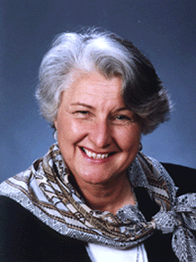 | Rose Dyson, Ph.D. Ed.D. (Ontario Institute for Studies in Education, University of Toronto) is the author of MIND ABUSE Media Violence in an Information Age (2000) and the co-author of 11 other peer-reviewed books. She was the editor for 17 years of The Learning Edge (Canadian Association for the Study of Adult Education). She was the associate editor of Peace Issues in the 21st Century Global Context, eds. John Duncan, Shreesh Juyal (UK: Cambridge Scholars Publishing, 2017). She is the President of Canadians Concerned About Violence in Entertainment and Chair of the National Advisory Council of the Canadian Peace Research Association (2013-15, 2015-17, 2017- 2019). She is a member of the Climate Action Network, the Global Ecological Integrity Group, and Just Earth. She is also the Director of Communication and a member of the World Federalist Movement, Toronto Branch, Canada.  Author Professor Emeritus
Director of Communications and Public Relations: Dr. Mark Raymond  Email: mraymond@ou.edu  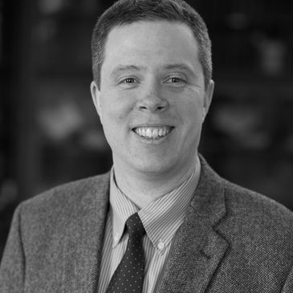 | Mark Raymond is the Wick Cary Assistant Professor of International Security and Director of the Cyber Governance and Policy Center at the University of Oklahoma. He is a Carnegie Fellow at the School of International and Public Affairs at Columbia University; an External Affiliate of the Ostrom Workshop at Indiana University; and a Fellow with the Center for Democracy and Technology. He is the author of Social Practices of RuleMaking in World Politics (New York: Oxford University Press, 2019). His work appears in various academic journals including International Theory, Strategic Studies Quarterly, The Cyber Defense Review, the UC Davis Law Review, and the Georgetown Journal of International Affairs. He is also the co-editor of Organized Chaos: Reimagining the Internet (Waterloo, Canada: CIGI, 2014). He has testified before the United Nations Commission on Science and Technology for Development, and participated in the Internet Governance Forum. His current research projects examine the politics of global rulemaking, as well as Internet governance and cybersecurity governance. He received his Ph.D. from the University of Toronto.  Wick Cary Assistant Professor of International Security and Director of the Cyber ​​Governance and Policy Center at the University of Oklahoma. Norman, OK.
Director of Membership: Ms. Anne Venton  Email: anne.venton@sympatico.ca  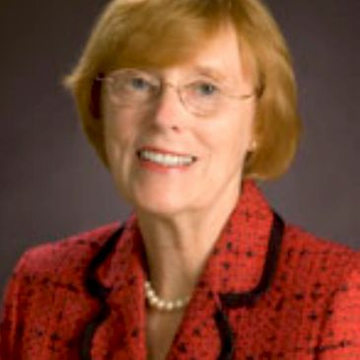 | Anne Venton earned a MA (University of Toronto) and was a Media Studies educator with the Toronto District School Board (TDSB). She also served as Head of Library at Northern Secondary School, North Toronto Collegiate, and City Adult Learning Centre. She was a Project Director at the Ontario Institute for Studies in Education (OISE) on projects including the ‘Canadian English Language Achievement Test’ and ‘Sex Stereotyping in Elementary Readers’. With extensive experience on many boards, Ms. Venton served on boards for the Immigration and Refugee Board of Canada; the Council of the Association of Professional Engineers of Ontario; the Greater Toronto Marketing Alliance; and the College of Dental Hygienists of Ontario. She was the Riding President of the Toronto Centre Federal Liberal Association (TCFLA) and President of the Ontario Women's Liberal Commission (OWLC). Currently, she serves on the executive of CCAVE (Canadians Concerned About Violence in Entertainment) as Director of Communications and on the Sinfonia Toronto Board. She is also a former Vice-President of the OISE Alumni Association, which represents one of the largest faculties at the University of Toronto with over 70,000 graduates.  Toronto District School Board (TDSB) Media Studies Educator, Toronto, ON  Head of Library Northern Secondary School Toronto, ON Collegiate and City Adult Learning, Toronto, ON  Vice-President OISE Alumni Association, Toronto, ON
International Representative: Dr. Katerina Standish  Email:  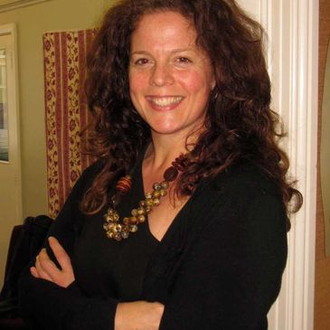 | Katerina Standish is the Deputy Director of the National Centre for Peace and Conflict Studies, University of Otago, New Zealand. Dr Standish is an expert on culture and violence and specialises in curricular analysis. Her publications include content on gender, conflict and cultural learning, as well as alternative education (peace education and decolonizing education), violence and self-harm in Indigenous and Non-Indigenous culture, and practical violence transformation. She has published five books and many refereed articles including most recently, Suicide Through a Peacebuilding lens: Medical and Instrumental Suicide (New York: Palgrave MacMillan, 2019). She holds a doctoral degree in Peace and Conflict Studies from the University of Manitoba, a Master's Degree in Human Security and Peacebuilding from Royal Roads University, a post-baccalaureate in Communications from Simon Fraser University and an undergraduate degree in Sociology, Anthropology and Humanities from Simon Fraser University. Dr Standish is a specialist in transformative education, the creator of Yogic Peace Education and the inventor and primary researcher for the Peace Education Curriculum Analysis (PECA) (pecaproject.org). Her peace practices include working in partnership with local communities in Canada and Aotearoa/New Zealand. She has experience in peacebuilding in Uganda, Palestine, Israel and with the Red Cross in Canada and New Zealand. She has been a Yoga, breath and meditation instructor for 15 years.  Assistant Professor and Director, University of Otago, New Zealand
International Representative: Dr. Franke Wilmer  Email: frankewilmer1@gmail.com  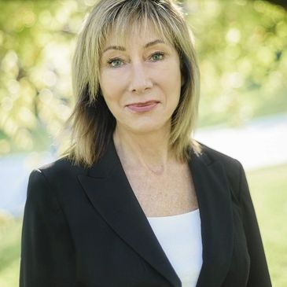 | Franke Wilmer is a Professor, International Relations, Montana State University who specializes in conflict and conflict resolution, international law, public policy, international relations and foreign policy. Dr. Milmer served four terms in the Montana legislature. She was elected by colleagues from both parties to serve as Speaker Pro Tempore in 2009, chaired the interim committee on State Administration and Veterans' Affairs in 2007-2009, served on House Education; Fish Wildlife and Parks; and State Administration and Veterans' Affairs committees. She received two awards from veteran’s groups for legislative work including Legislator of the Year from the Vietnam Veterans of American Montana Council in 2011. She served on the Council of the American Political Science Association and the Editorial Board of the International Studies Quarterly. She has travelled to over 50 countries as a guest lecturer or researcher, including six times to the former Yugoslavia during wartime and one trip to Regina, Saskatchewan to deliver the keynote speech to the CPRA in 2018.  Professor, Montana State University, Bozeman, MT
Member-at-Large: Dr. Robert David Armstrong  Email:  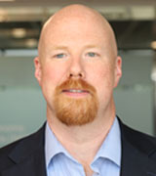 | David Armstrong is a Canada Research Chair in Political Methodology, Tier 2 - September 2017 - September 2022, Social Sciences and Humanities Research Council (SSHRC). He is an Associate Professor in the Department of Political Science at Western University and a former Associate Professor in the Department of Political Science at the University of Wisconsin-Milwaukee. He earned a Ph.D. in Government and Politics from the University of Maryland in 2009. His research interests focus on measurement and data visualization along with a substantive focus on democracy and state repression. His research has been published in the American Journal of Political Science, the American Political Science Review and the American Sociological Review and his book on measurement models, Analyzing Spatial Models of Choice and Judgment with R (co-authored with Ryan Bakker, Royce Carroll, Chris Hare, Keith Poole and Howard Rosenthal) was published by CRC Press in 2014.  Canada Research Chair in Political Methodology (Tier 2) September 2017- September 2022  Social Sciences and Humanities Research Council (SSHRC)  Associate Professor, Western University, London, ON
Member-at-Large: Walter Dorn  Email: walter.dorn@rmc.ca  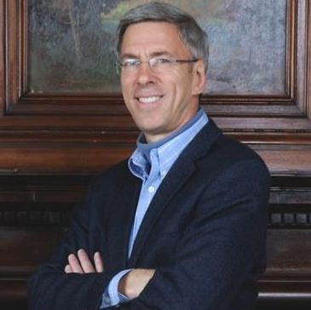 | Walter Dorn is Professor of Defence Studies at the Canadian Forces College and at the Royal Military College, Kingston. A scientist by training (Ph.D. Chemistry, University of Toronto), his doctoral research was on chemical sensing for arms control. He assisted with the negotiation, ratification and implementation of the Chemical Weapons Convention. His interests are broader now, covering international and human security, especially peace operations and the United Nations (UN). A. Walter Dorn is the author of Air Power in UN Operations: Wings for Peace (Ashgate, 2014); Keeping Watch: Monitoring, Technology and Innovation in UN Peace Operations (United Nations University Press, 2011) and the editor of World Order for a New Millennium: Political, Cultural and Spiritual Approaches to Building Peace (Palgrave Macmillan Press, 1999) Dorn has extensive experience in UN field missions. He served as a district electoral officer with the United Nations (UN) Mission in East Timor in 1999; in Ethiopia on a UNDP project; and at UN headquarters as a Training Adviser with the UN's Department of Peacekeeping Operations (DPKO). He was on the UN’s Panel of Experts on Technology and Innovation in UN Peacekeeping in 2014. He served as the Innovation and Protection Technology Expert within the UN’s Department of Field Support in 2017- 18, providing advice to improve UN missions in the Middle East and Africa including Lebanon, the Central African Republic, the Democratic Republic of the Congo and Mali. He has served as the UN Representative of Science for Peace, a Canadian NGO since 1983. He is the President of the World Federalist’s Association, Ottawa and the Past Chair of the Canadian Pugwash Group (2015-17, 2017-19). He was a Senior Research Fellow at Cornell University (1998-2000); a consultant to Yale University (1996); a visiting scholar at the Cooperative Monitoring Centre (1999) and an adviser to the Federation of American Scientist’s Biological Weapons Control expert group (1990). At the University of Toronto, he was a Research Fellow with the International Relations Programme as well as the Peace and Conflict Studies Programme, and he was the Physical Science Don at Trinity College.  Professor, Canadian Forces College and the Royal Military College, Kingston, ON
Member-at-Large: Lt. Col. Sylvie Lemieux  Email:  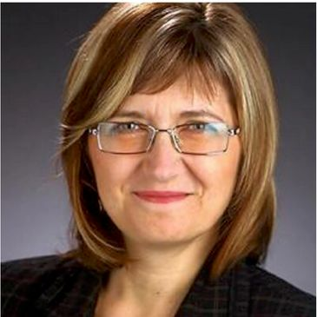 | Sylvie Lemieux holds a Ph.D in Conflict Studies from St. Paul University, Ottawa; a MA in globalization and international development from the University of Ottawa; and a Bachelor of Applied Science from the Ecole polytechnique de Montreal - Université de Montreal. A retired Lieutenant-Colonel from the Canadian Armed Forces (Army) and former civil servant, she was a leadership candidate for the Green Party in 2010. She is a Board member of the G78, a member of the Canadian Pugwash Group, a member of the Voice of Women, and a member of Integrative Peacebuilding. She has been a Member-at-Large for the Canadian Peace Research Association (CPRA) since 2015. Currently working on a book based on her doctoral thesis, she is unable to attend the Congress at UBC in 2019, however she accepts the nomination to continue as a Memberat-Large (2019-21).  PhD Candidate, St. Paul University, Ottawa, ON
Member-at-Large: Dr. Kathleen Manion  Email: kathleen.manion@royalroads.ca  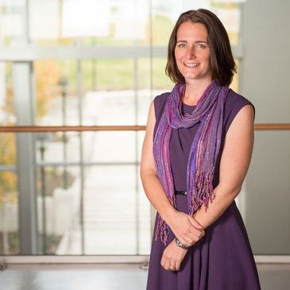 | Kathleen Manion, Associate Professor, Royal Roads University and Program Head, BA in Justice Studies. Manion is an educator and researcher who has spent the past 20 years working within social and community services. She is passionate about social justice and social inclusion and particularly interested in helping to bridge the gap between practitioner experiential knowledge, academic theory and policy objectives across multiple disciplines. Manion has worked on projects tackling issues related to child protection, homelessness, healthy early childhood development, environmental protection, family violence, youth justice, and international social work. Before joining Royal Roads in 2013, Manion’s diverse experience included research and practice in various countries and settings, working at both a national ministerial level and also at the grassroots. Manion completed her undergraduate studies at the University of Waterloo (BA in psychology, diploma in peace and conflict studies and certificate in social work). She earned her master’s (international social work and community development studies) and her PhD in sociology from the University of East London in the UK. Manion's doctoral studies focused on the perceptions of success of interventions with commercially sexually exploited girls in Canada, Australia and the United Kingdom.  Associate Professor and Program Head, Royal Road University, Colwood, BC  ​
Local Arrangements Coordinator and Member-at-Large: W. Andy Knight  Email: knight@ualberta.ca  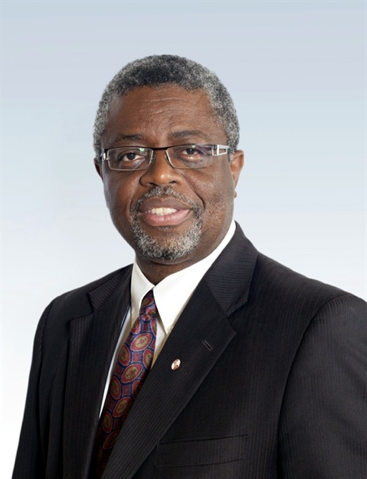 | W. Andy Knight is Professor of International Relations in the Political Science Department at the University of Alberta and past Chair of the Department. He is former Director of the Institute of International Relations, The University of the West Indies, Trinidad & Tobago. He is co-editor in Chief of African Security journal and former co-editor of Global Governance journal. A Fellow of the Royal Society of Canada, Knight’s most recent book is the award winning, Female Suicide Bombings: A Critical Gendered Approach, with Tanya Narozhna (University of Toronto Press, 2016). His recent publications address issue of global health governance, global health security, vulnerabilities, and resiliency.  W. Andy Knight, PhD, FRSC  University of Alberta

