Canadian Peace Research Association (CPRA)
Biographies of Speakers & Chairs at the 2023 Conference

Albeheshti, Parsa
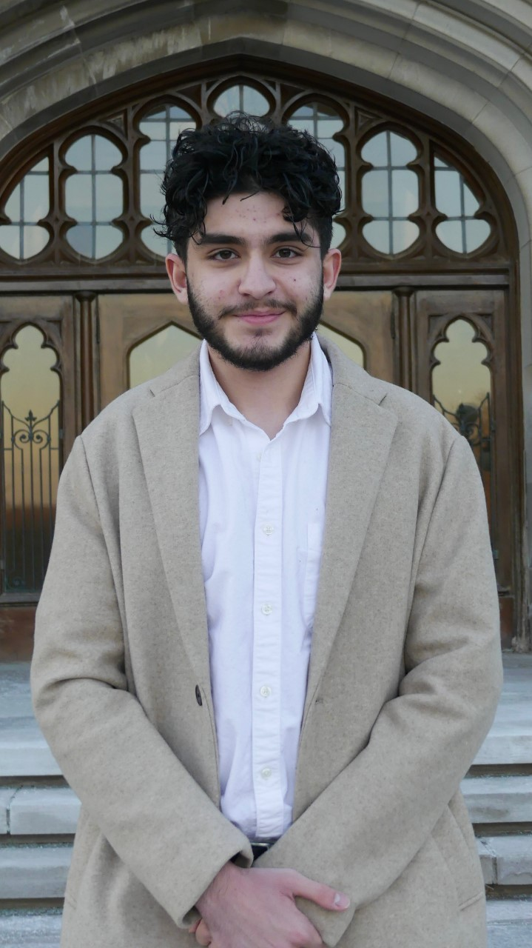
Mr. Parsa Albeheshti is a second-year undergraduate student studying at the School of Advanced Studies in the Arts and Humanities (SASAH) and majoring in philosophy at Western University. He is an Iranian Canadian activist and has published on the impact of sanctions on ordinary people. Parsa can be reached at: palbehes@uwo.ca

Atkinson, Ryan
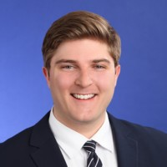
Mr. Atkinson (MA) is a PhD Candidate, University of Western Ontario, London and led the Cybersecurity and Information Warfare program at the NATO Association of Canada as research analyst and program manager. Ryan Atkinson can be reached at: ratkin23@uwo.ca.

Bhaheeratha, Anjali
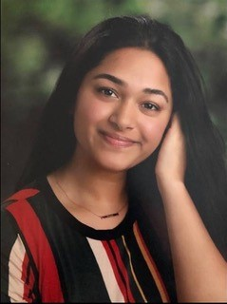
Ms. Anjali Bhaheeratha is a recent graduate of Western University, where she completed an Honours Double Major in Political Science and Sociology. In Fall 2023, she will be undertaking an M.A. in Political Science at Western University. Anjali’s research interests concern international relations and global political economy, particularly focusing on immigration policy and settlement services. Anjali Bhaheeratha can be reached at abhaheer@uwo.ca.

Buckley, Adele

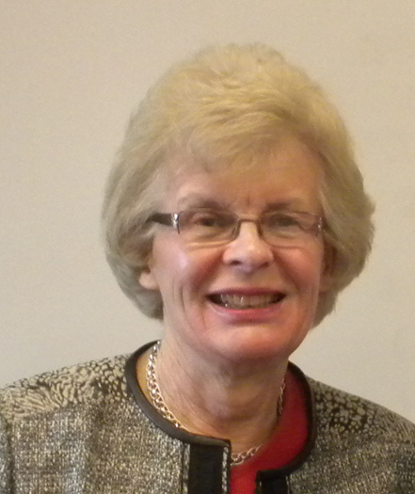
Dr. Adele Buckley is a physicist, engineer and environmental scientist. She is the former Chair and Treasurer of the Canadian Pugwash Group and she leads the CPG campaign for a nuclear-weapon-free Arctic. Since 2007, she has presented this proposal in six countries. She is a member of the advisory board of Canadians for a Nuclear Weapons Convention. For the Global Issues Project, she led an expert roundtable on freshwater, one of a series on crises of sustainability. Formerly she was the founding partner and Vice President (VP), Sciex, developer of mass spectrometry systems with extensive worldwide installations; VP Technology and Research, Ontario Centre for Environmental Technology Advancement; and VP Solarchem Environmental Systems. Her wide-ranging work in environmental technology includes commercialization of new technology, verification of performance, and projects in Bangladesh and China. Adele Buckley can be reached at: adele-buckley@rogers.com.

Doak-Gebauer, Charlene
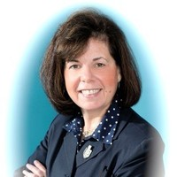
Charlene Doak-Gebauer has created the theory of digital supervision for proactive online child protection and is the founder and chair of the federal Canadian charity Internet Sense First and the AICET Council and Anti Internet Child Exploitation Team. Her objectives are to educate the public for proactive online child protection and provide funding for therapy for victims of internet child exploitation. Recently she won awards for the Best Producer and Best Director for the documentary, “Vulnerable Innocence", a film that has already won twenty-four international awards. The author of two books, Digital Sexual Victims: True Cases has been nominated for many international awards, and her latest book release is The Internet: Are Children In Charge? Doak-Gebauer was recently awarded with an Honorary Doctorate by Rai Technology University, Bangalore, India; the 2022 Inaugural Phoenix Award, B.E. A S.H.E.R.O. Foundation, Las Vegas; the 2018 International Women of Excellence Award; and the 2006 Bishop Townshend Award of Teaching Excellence Education. Her education at the University of New Brunswick, the University of Western Ontario, the University of Toronto, and the University of California Santa Barbara formerly led her to become a specialist in computer science in education and a network administrator in secondary schools. Charlene Doak-Gebauer can be reached at: internetsense.first@rogers.com.

Dorn, A. Walter

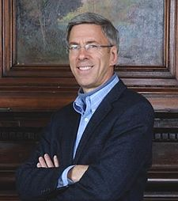
Dr. Walter Dorn is Professor of Defence Studies at the Canadian Forces College and at the Royal Military College, Kingston. A scientist by training (PhD Chemistry, University of Toronto), his doctoral research was on chemical sensing for arms control. He assisted with the negotiation, ratification and implementation of the Chemical Weapons Convention. His interests are broad covering international and human security, especially peace operations and the United Nations (UN). Professor Dorn is the author of Air Power in UN Operations: Wings for Peace (Ashgate, 2014); Keeping Watch: Monitoring, Technology and Innovation in UN Peace Operations (United Nations University Press, 2011) and the editor of World Order for a New Millennium: Political, Cultural and Spiritual Approaches to Building Peace (Palgrave Macmillan Press, 1999). He has extensive experience in UN field missions. He served as a district electoral officer with the UN Mission in East Timor in 1999; in Ethiopia on a UNDP project; and at UN headquarters as a Training Adviser with the UN's Department of Peacekeeping Operations (DPKO). He was on the UN’s Panel of Experts on Technology and Innovation in UN Peacekeeping in 2014. He served as the Innovation and Protection Technology Expert within the UN’s Department of Field Support in 2017-18, providing advice to improve UN missions in the Middle East and Africa including Lebanon, the Central African Republic, the Democratic Republic of the Congo, and Mali. He has served as the UN Representative of Science for Peace, a Canadian NGO since 1983. He is the President of the World Federalist’s Association, Ottawa and the Past Chair of the Canadian Pugwash Group. Previously he was a Senior Research Fellow at Cornell University; a consultant to Yale University; a visiting scholar at the Cooperative Monitoring Centre (1999); an adviser to the Federation of American Scientist’s Biological Weapons Control expert group; a Research Fellow with the University of Toronto’s International Relations, and Peace and Conflict Studies programs; and the Physical Science Don at the University of Toronto’s Trinity College. A. Walter Dorn can be reached at: dorn@cfc.dnd.ca and walter.dorn@rmc.ca.
Dyson, Rose
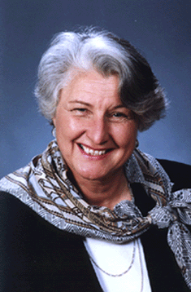
Dr. Rose Dyson, Ph.D. Ed.D. (Ontario Institute for Studies in Education, University of Toronto) is the author of MIND ABUSE Media Violence in an Information Age (2000) and the co-author of 11 other peer-reviewed books. She was the editor for 17 years of The Learning Edge (Canadian Association for the Study of Adult Education). She was the associate editor of Peace Issues in the 21st Century Global Context, eds. John Duncan, Shreesh Juyal (UK: Cambridge Scholars Publishing, 2017). She is the President of Canadians Concerned About Violence in Entertainment and Chair of the National Advisory Council of the Canadian Peace Research Association (2013-15, 2015-17, 2017- 2019). She is a member of the Climate Action Network, the Global Ecological Integrity Group, and Just Earth. She is also the Director of Communication and a member of the World Federalist Movement, Toronto Branch, Canada. Dr. Dyson can be reached at: rose.dyson@alumni.utoronto.ca
Edgar, Alistair
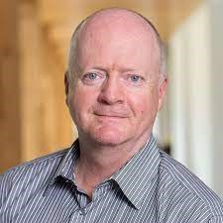
Dr. Alistair Edgar is Associate Professor of Political Science at Wilfrid Laurier University, and the Balsillie School of International Affairs. He is an editor of Global Governance: A Review of Multilateralism and International Organizations (Brill/Nijhoff) and series co-editor for the ACUNS Series on the United Nations (Edward Elgar Publishers). He served as Executive Director of the Academic Council on the United Nations System (ACUNS) 2003-2008 and 2010-2018. Alistair Edgar can be reached at: aedgar@wlu.ca.

Hrynkow, Christopher
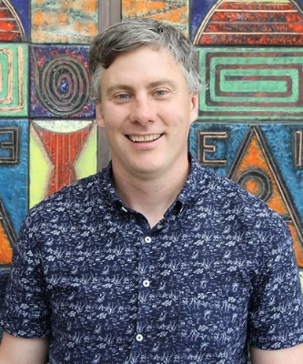
Dr. Christopher Hrynkow (PhD, Peace and Conflict Studies, University of Manitoba), ThD (Christian Ethics, University of Toronto) is a Professor in Religion and Culture at and Department Head and Graduate Chair in Religion and Culture at St. Thomas More College, University of Saskatchewan, Saskatoon. He serves as Co-Director of the Irene and Doug Schmeiser Centre for Faith, Reason, Peace, and Justice. Additionally, Hrynkow is Graduate Chair in Religion and Culture for the University of Saskatchewan and teaches in the new Peace Studies certificate program. He has published 28 peer-reviewed journal articles and 12 peer-reviewed book chapters. He teaches courses in religious studies, Catholic studies, and critical perspectives on social justice and the common good. Hrynkow also teaches the university's inaugural section of Introduction to Peace Studies as part of a collaborative plan to build the first full-fledged Peace Studies program in Saskatchewan. From January 2019 to July 2019, he served as Patrick and Barbara Keenan Visiting Chair in Religious Education at the University of St. Michael's College at the University of Toronto. Hrynkow is the Vice President of the Canadian Peace Research Association (CPRA) and a graduate student in Education (University of Bath) and Social Justice and Community Action (University of Edinburgh). Christopher Hrynkow can be reached at: chrynkow@stmcollege.ca.

Jones, Shelley
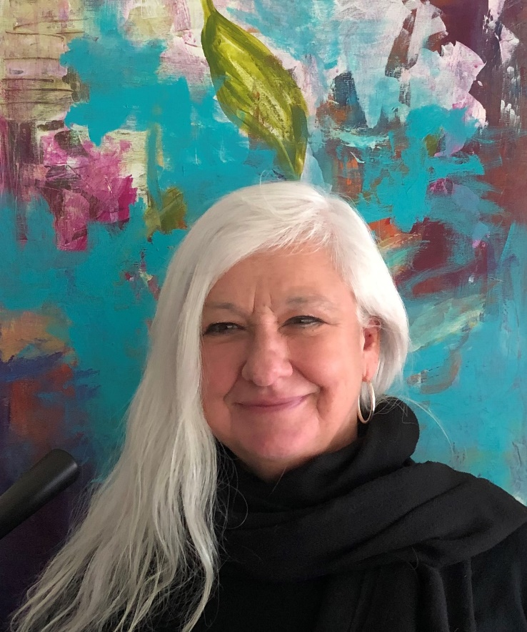
Dr. Shelley Jones, BA, BEd, MA, PhD, is a Professor of Interdisciplinary Studies at Royal Roads University and a board member of International Institute of Child Rights and Development. She is the Head of Undergraduate Programs in the College of Interdisciplinary Studies at RRU. Dr. Shelley Jones can be reached at: Shelley.12jones@royalroads.ca

Khan, Zuhayr
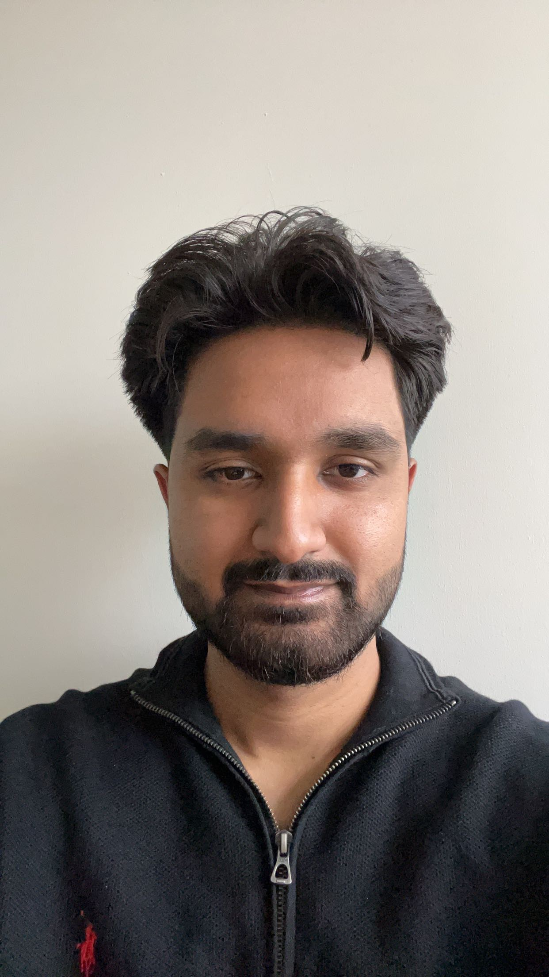
Mr. Khan is a second-year undergraduate health science student at the University of Western Ontario. His research interests include political science and the history of the modern world since 1900, with a focus on great wars and conflicts, among other areas.
He can be reached at: zkhan282@uwo.ca

Lemieux, Sylvie
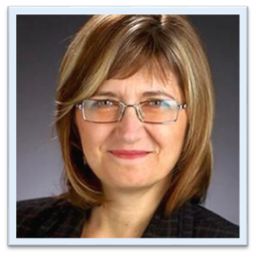
Dr. Sylvie Lemieux is a retired LCol Army engineer and former Public Service executive who represented the Green Party of Canada in two federal elections. As a part-time consultant for Global Affairs Canada as well as a member of non-governmental organizations, Dr. Lemieux serves as the co-chair of the Canadian Network to Abolish Nuclear Weapons (CNANW). She holds a Ph.D in Conflict Studies from St. Paul University, Ottawa; a MA in globalization and international development from the University of Ottawa; and a Bachelor of Applied Science from the Ecole polytechnique de Montreal - Université de Montreal. A retired Lieutenant-Colonel from the Canadian Armed Forces (Army) and former civil servant, she was a leadership candidate for the Green Party in 2010. She is the co-chair with Robin Collins of the Canadian Network to Abolish Nuclear Weapons; a Board member of the G78, a member of the Canadian Pugwash Group, a member of the Voice of Women, and a member of Integrative Peacebuilding. She has been a Member-at-Large for the Canadian Peace Research Association (CPRA) since 2015. Sylvie Lemieux can be reached at: slemieux3599@rogers.com.
Manion, Kathleen
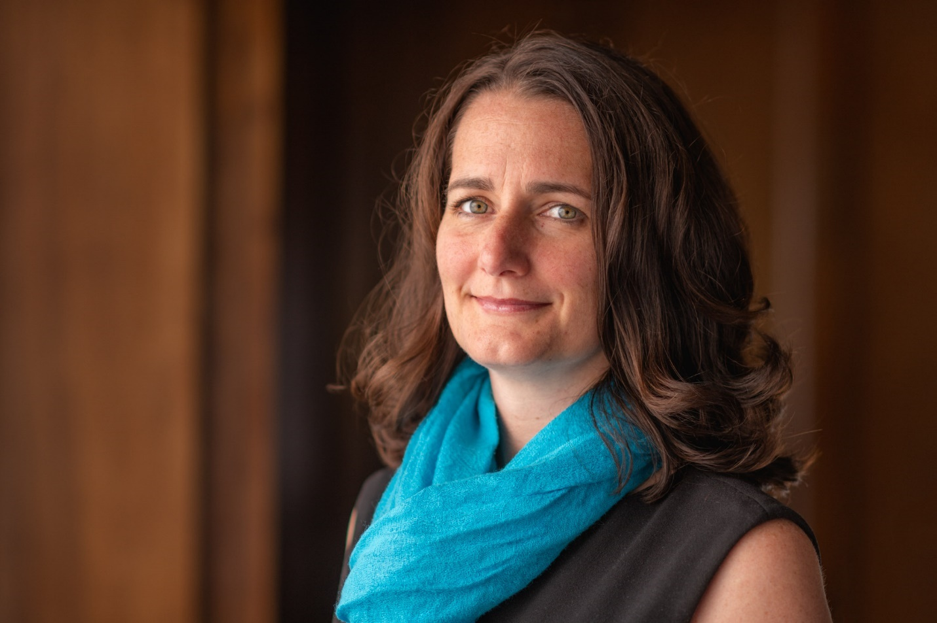
Kathleen Manion, BA, MA, LLM, PhD is a Professor at Royal Roads University and an Associate at the International Institute of Child Rights and Development. She is currently the Program Head for the MA Disaster and Emergency Management program and the Graduate Certificate Child Protection to Wellbeing and teaches with the Justice Studies Programs. With nearly thirty years experience in research, social and community services and academia, Kathleen’s academic and practice interests focus on systems that support children to thrive. Using various qualitative and quantitative research methodologies and community engagement processes, Kathleen has worked on projects tackling issues related to child protection, child rights, homelessness, climate justice, early childhood development, service innovation, trafficking, violence against children and within families, youth justice, and child migration in North and South America, Europe, Asia, Africa, and the Pacific. Kathleen Manion can be reached at: Kathleen.Manion@RoyalRoads.ca.

Maure, Ben
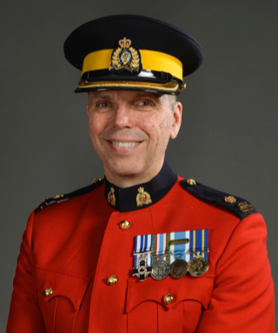
Ben (Benoit) Maure is a serving Peace Officer with the Royal Canadian Mounted Police. He has over 32 years of police experience, most of which has been spent in British Columbia. In 1999, Ben completed a one-year secondment tour of duty as a United Nations Peacekeeper in Quetzaltenango, Guatemala. Between 2009 and 2013, Ben acted as a Police Liaison Officer (First Secretary) at the Embassy of Canada in the Dominican Republic. He is fluent in French, English and Spanish and as a command of the German language. Ben holds a Bachelor of Technology degree from the British Columbia Institute of Technology (BCIT) and a Master of Arts degree in Social Justice from the University of the Fraser Valley (UFV). He is passioned about peace studies and international policing. Ben is also a recipient of the Governor General’s Meritorious Service Cross (M.S.C.). Ben is the author of a recently published book on Canadian Police Peacekeeping titled: Leading at the Edge. Ben Maure can be reached at: bjmaure@shaw.ca.

Quereshi, Noor


Noor Qureshi is an intern who will be overseas working on NLP models to identify refugee populations, assess their mental health, and categorize specific clinical diagnoses to identify suicide risks. Ms. Quereshi can be reached at: nqures3@uwo.ca

Shafa Amri, Ward

Ward Shafa Amri is a candidate for an Honours Bachelor's of Specialization in Medical Cell Biology at the University of Western Ontario. Following graduation, in 2025, he aspires to pursue an M.D. at the Schulich School of Medicine & Dentistry. Ward's research interests concern international relations and the global political economy with a focus on the Northern American economies. Furthermore, he previously conducted astrobiological research and now expresses interest in medical research in the near future. Ward Shafa Amri can be reached at wshafaam@uwo.ca

Simpson, Erika
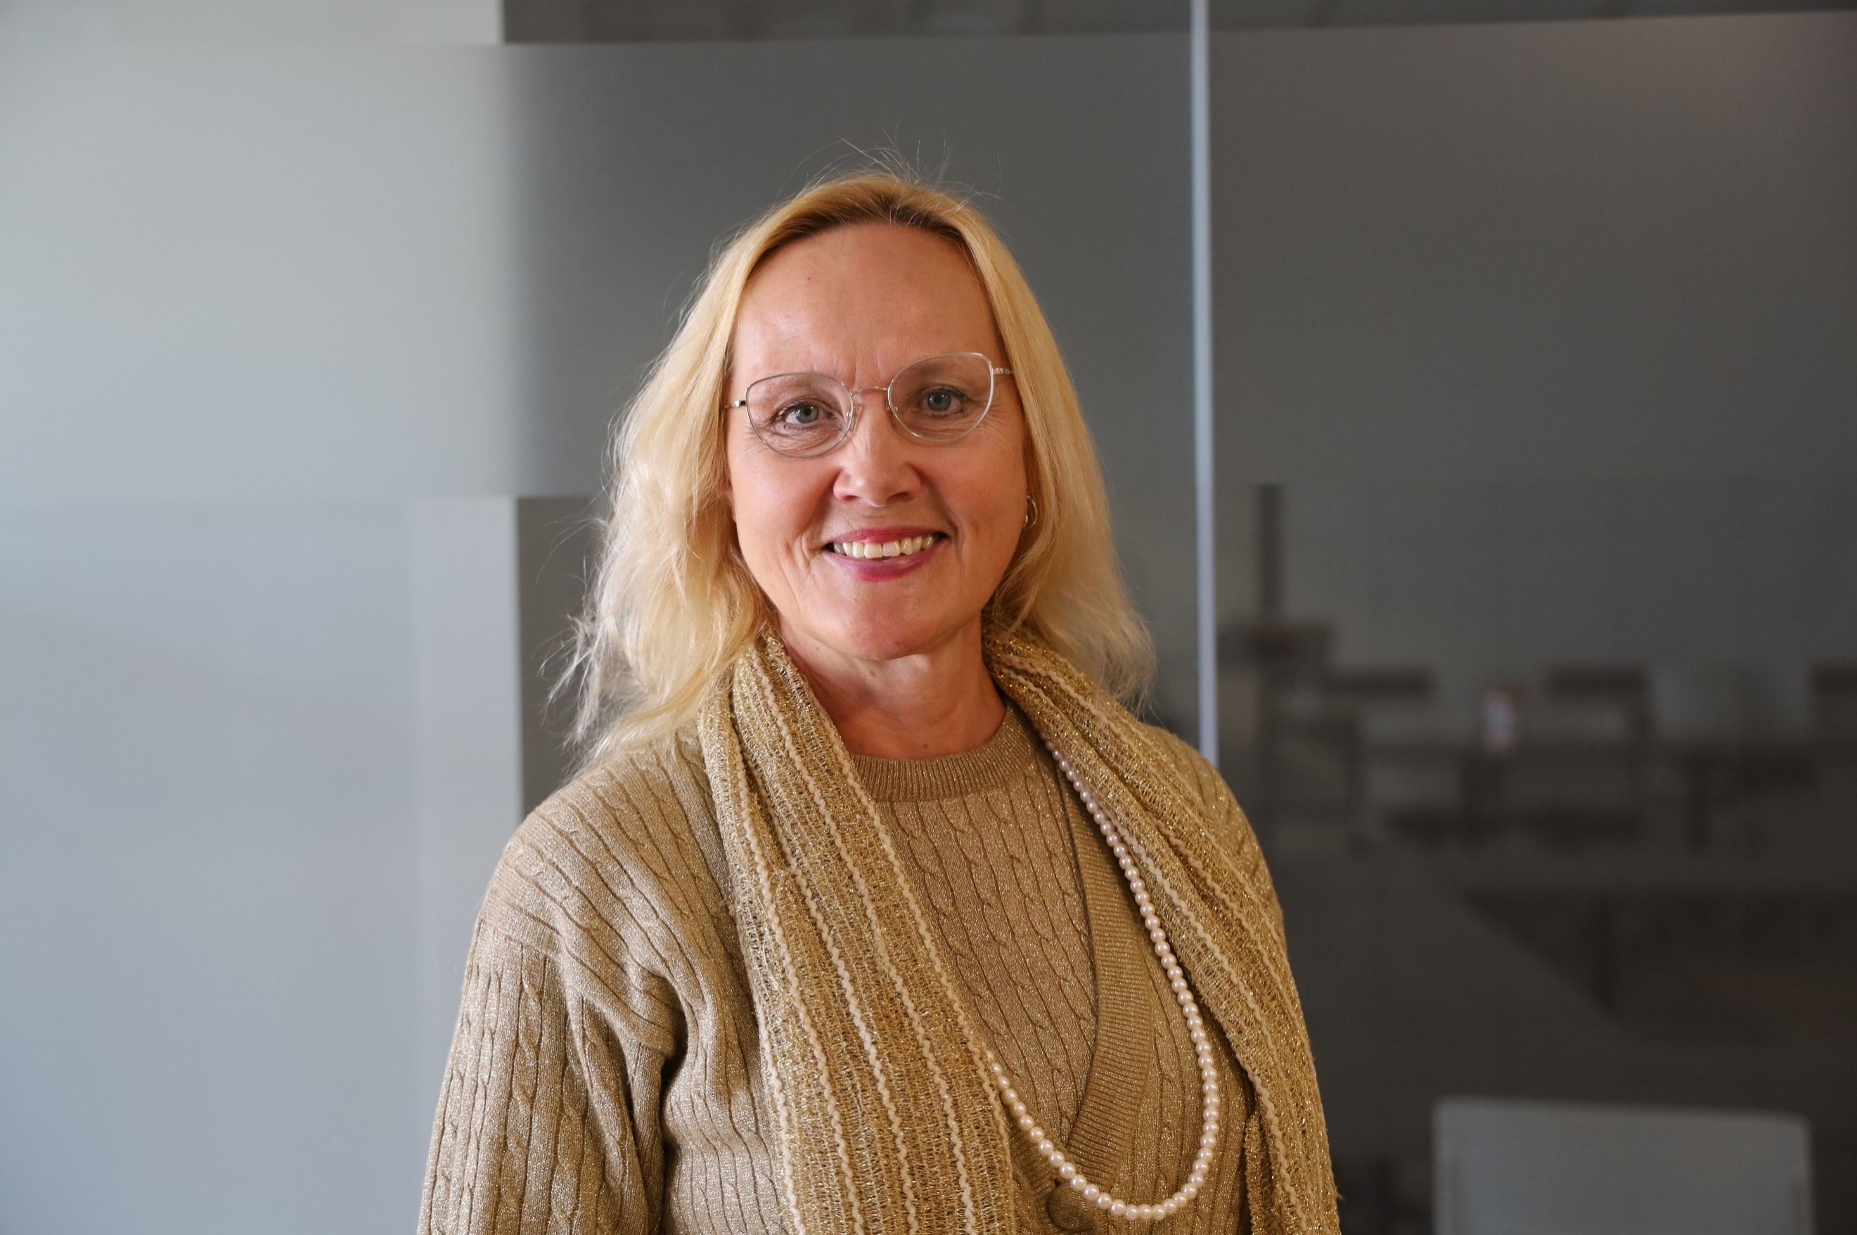
Dr. Erika Simpson (PhD and MA, University of Toronto) is an Associate Professor of International Relations at Western University, London, Canada and the President of the Canadian Peace Research Association (CPRA). Her research interests are in international security and North American foreign and defence policy, particularly arms control, disarmament, nuclear proliferation, nuclear waste, and peacekeeping. She is the author of NATO and the Bomb (McGill-Queen’s University Press, 2001) and her articles have appeared in leading journals including International Journal; In Victus Pax: Journal of Peace Education and Social Justice; Peace Magazine; Peace Research; Peace Review: A Journal of Social Justice; and Policy Options. She is a columnist for the Hill Times, Canada’s foreign policy weekly and the Postmedia Network, and a frequent commentator on al-Jazeera, BBC, CTV, CBC, Sputnik, and Urdu News. She serves as a Director on the Board of the Canadian Pugwash Group and the Board of the Canadian Network to Abolish Nuclear Weapons; a Consultant for the Nuclear Abolition Forum; and a Peer Reviewer for the Canadian Institute for Military and Veteran Health and SSHRC. Formerly she was an Alton Jones Fellow; a Barton Fellow; a Liu Institute Visiting Fellow; a NATO Research Fellow; and the Treasurer and Vice-Chair of the Canadian Pugwash Group. In 2015 the Voice of Women – Canada awarded her the ‘Shirley Farlinger Lifetime Achievement Award for Peace Writings.’ Erika Simpson can be reached at: simpson@uwo.ca.

Sobin, Abigail
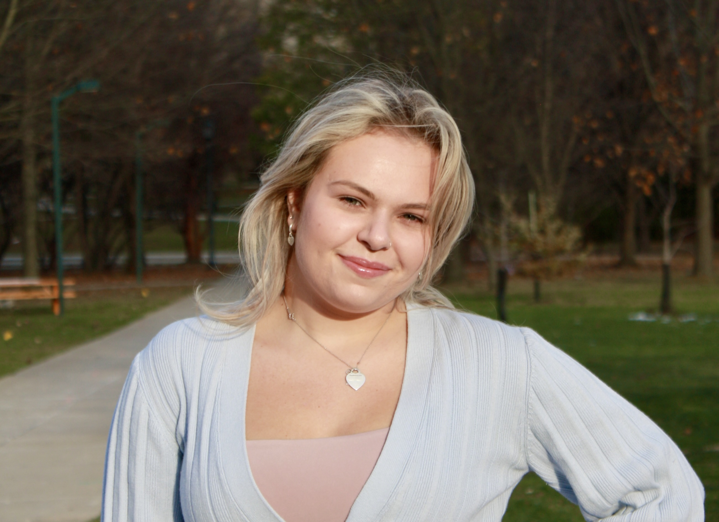
Abigail Sobin is a recent graduate of Western University, where she completed an Honours Specialization in International Relations and a Minor in Transitional Justice and Post-Conflict Reconstruction. Next year, she will attend the University of Waterloo's Master of Public Service program. Ms. Sobin’s research interests include international politics and history, with a focus on Eastern and Central Europe, democracy, social policy and posthumanism. Abigail Sobin can be reached at asobin@uwo.ca

Stevenson, Colton
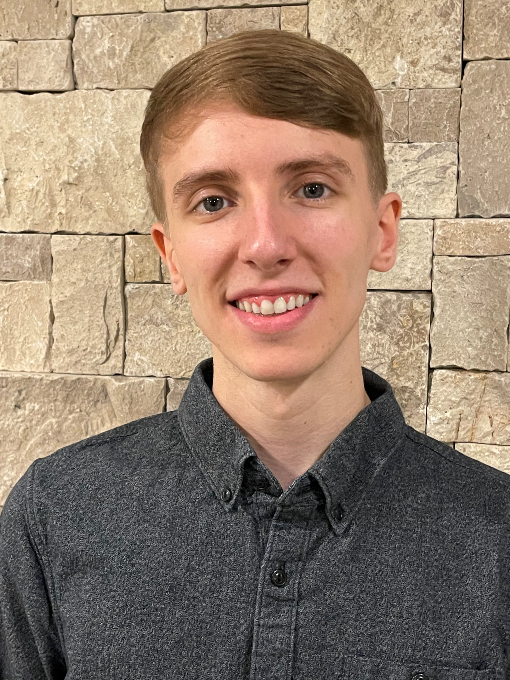
Mr. Colton Stevenson completed the political science undergraduate program at the University of Western Ontario and will pursue a MA at the University of Western Ontario in September 2023. His plans for research focus on sustainability, particularly on our dependence on nuclear weapons and climate change under the field of International Relations. Colton Stevenson can be reached at: csteve59@uwo.ca

Standish, Katerina

Dr. Katerina Standish is an expert on culture and violence and specializes in curricular analysis. Her publications include content on gender, conflict and cultural learning, as well as alternative education (peace education and decolonizing education), violence and self-harm in Indigenous and Non-Indigenous culture, and practical violence transformation. She has published five books and many refereed articles including Suicide Through a Peacebuilding lens: Medical and Instrumental Suicide (Palgrave MacMillan, 2019). Her publications include content on gender, conflict and cultural learning, as well as alternative education (peace education and decolonizing education), violence and self-harm in Indigenous and Non-Indigenous culture, and practical violence transformation. She has published five books and many refereed articles including most recently, Suicide Through a Peacebuilding lens: Medical and Instrumental Suicide (New York: Palgrave MacMillan, 2019). She holds a doctoral degree in Peace and Conflict Studies from the University of Manitoba, a Master's Degree in Human Security and Peacebuilding from Royal Roads University, a post-baccalaureate in Communications from Simon Fraser University and an undergraduate degree in Sociology, Anthropology and Humanities from Simon Fraser University. Dr Standish is a specialist in transformative education, the creator of Yogic Peace Education and the inventor and primary researcher for the Peace Education Curriculum Analysis (PECA) (pecaproject.org). Her peace practices include working in partnership with local communities in Canada and Aotearoa/New Zealand. She has experience in peacebuilding in Uganda, Palestine, Israel and with the Red Cross in Canada and New Zealand. She has been a Yoga, breath and meditation instructor for 15 years. Katerina Standish can be reached at: katerinastandish@gmail.com

Turcotte, Earl
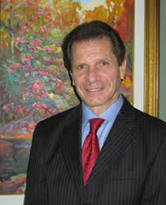
Mr. Turcotte (MA U of Ottawa, MA Carleton University) served variously as a parliamentary assistant, CIDA program manager, First Secretary and Chief of CIDA’s Mine Action Unit. He joined the UNDP on the Mine Action Team and was lead for Canada’s engagement on the Ottawa Convention on Landmines and the chief Canadian negotiator of the Convention on Cluster Munitions. Earl Turcotte can be reached at: earl.turcotte@gmail.com

Venton, Anne
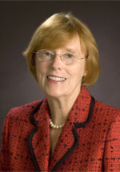
Anne Venton earned a MA (University of Toronto) and was a Media Studies educator with the Toronto District School Board (TDSB). She also served as Head of Library at Northern Secondary School, North Toronto Collegiate, and City Adult Learning Centre. She was a Project Director at the Ontario Institute for Studies in Education (OISE) on projects including the ‘Canadian English Language Achievement Test’ and ‘Sex Stereotyping in Elementary Readers’. With extensive experience on many boards, Ms. Venton served on boards for the Immigration and Refugee Board of Canada; the Council of the Association of Professional Engineers of Ontario; the Greater Toronto Marketing Alliance; and the College of Dental Hygienists of Ontario. She was the Riding President of the Toronto Centre Federal Liberal Association (TCFLA) and President of the Ontario Women's Liberal Commission (OWLC). Currently, she is a VP Community Outreach for TCFLA and she serves on the executive of C-CAVE (Canadians Concerned About Violence in Entertainment) as Director of Communications. She is also the Vice-President of the OISE Alumni Association, which represents one of the largest faculties at the University of Toronto with over 70,000 graduates. Anne Venton can be reached at: a.e.venton@gmail.com.

Venton, Peter
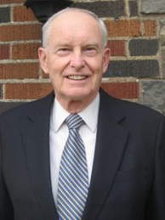
Peter Venton is the Treasurer of the Canadian Peace Research Association (CPRA) (2015-17, 2017-19). He was the Bursar, University of St. Michael’s College in the University of Toronto, Toronto (2001-2009). The modern equivalent of Bursar is Vice President: Administration and Finance, which includes oversight management of Human Resources administration and management’s representative in labor negotiations, as well as oversight management of the University’s physical plant. He is also the former Vice President: Administration and Finance, Wilfrid Laurier University, (1979-1984). Formerly he was an economist and senior policy advisor in the Ontario Government's Ministry of Finance. He holds a MA in Economics from Queen’s University. Venton is currently the President of JPV Associates consulting in economics and public policy in the public interest and public sector management. He has presented papers on economic inequality, environmental sustainability, democracy, globalization and capitalism in Canada, Greece and Taiwan. His publications include, "Radical changes in Canadian democracy: for ecology and the public good,"​ Ecological Systems Integrity: Governance, law and human rights, eds. Laura Westra, Janice Gray and Vasiliki Karagerorgou (New York: Routledge Earthscan, 2015). Currently he serves as the Treasurer of the Canadian Pugwash Group (2017-19), a registered Canadian charitable foundation, and as a Board Member and Director of the Canadian Pugwash Group (2015-2019). Peter Venton can be reached at: peter.venton@bell.net.

Wilmer, Franke

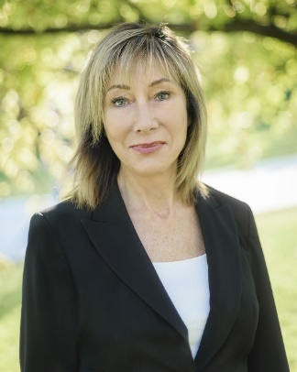
Dr. Franke Wilmer is a Professor, International Relations, Montana State University who specializes in conflict and conflict resolution, international law, public policy, international relations and foreign policy. Dr. Wilmer served four terms in the Montana legislature. She was elected by colleagues from both parties to serve as Speaker Pro Tempore in 2009, chaired the interim committee on State Administration and Veterans' Affairs in 2007-2009, served on House Education; Fish Wildlife and Parks; and State Administration and Veterans' Affairs committees. She received two awards from veteran’s groups for legislative work including Legislator of the Year from the Vietnam Veterans of American Montana Council in 2011. She served on the Council of the American Political Science Association and the Editorial Board of the International Studies Quarterly. She has travelled to over 50 countries as a guest lecturer or researcher, including six times to the former Yugoslavia during wartime. Franke Wilmer can be reached at: frankewilmer1@gmail.com.
Yeung, Bethany
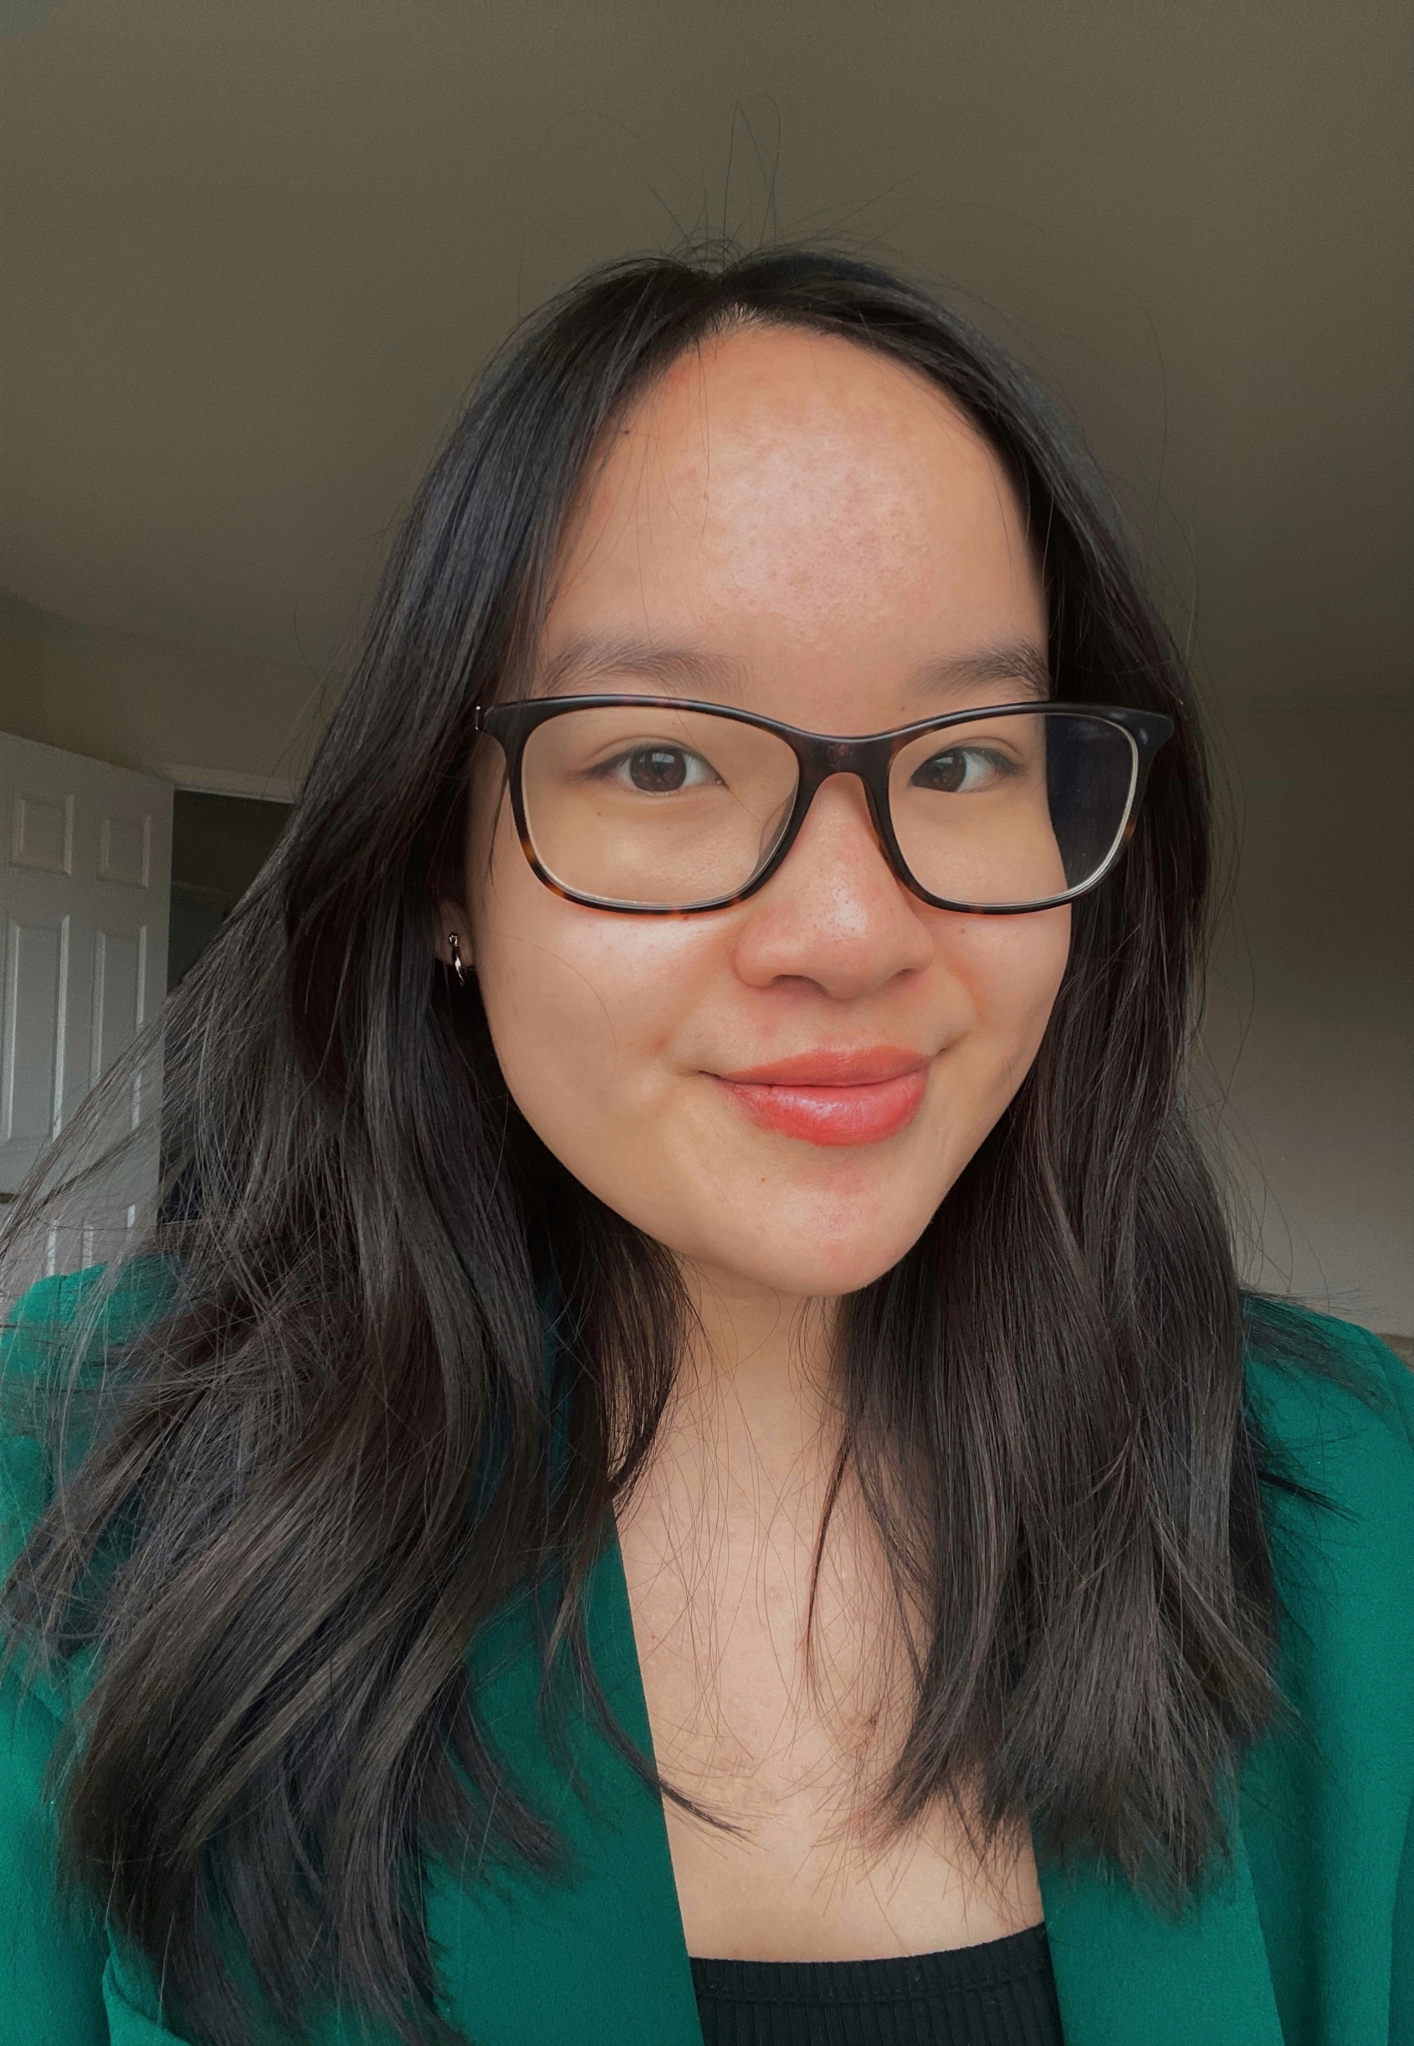
Bethany Yeung is an undergraduate political science student at Western University pursuing an honours specialization degree in international relations. She is currently working as a research intern on a project studying the history of espionage and failures of intelligence over the course of human history. The project is intended to aid in training intelligence officers, policy makers, and strategists about the causes and consequences of intelligence failure. Ms. Bethany Yeung can be reached at: bethanyy167@gmail.com

