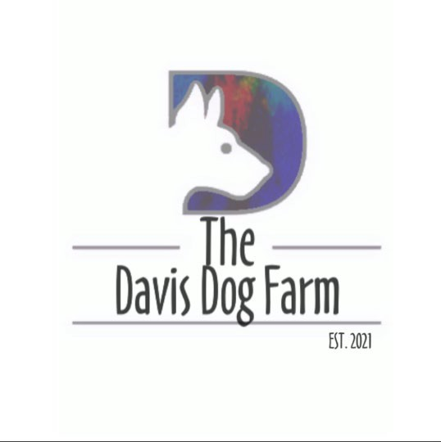

Transfer of Ownership

I, agree and attest that
(dogs name) is my property and I have the legal right to transfer ownership of the above named dog. (Owner initials).

I agree that I have not signed any previous documents stating that if I can no longer keep my dog, that I will return it to another entity such as shelter or rescue.
(Owner initials)

I agree that once this document is signed, that from the date on this document forward, I no longer have any rights to the above named dog as a possession, in name or in title. (Owner Initials)
I agree that I will no longer have a legal right to information about the above named dog including updates or future placement of the dog. This information may be provided at the discretion of The Davis Dog Farm. (Owner Initials)
I agree that I am willingly entering into this contact of my own free will. There has been no coercion, pressure or monetary incentives for the surrender of my dog.
(Owner initials)

I agree that as of today, the date entered on this form, that I have willingly and of my own free will transferred ownership of the above named dog to The Davis Dog
Farm. The Davis Dog Farm will make all decisions on behalf of the dog from this day forward.

Owner Signature & Date

Representative of The Davis Dog Farm

The Davis Dog Form Administrative Only
Copy of Driver’s License
Verified match of DL name and name of Owner

