
2026
Adult Volunteer Form
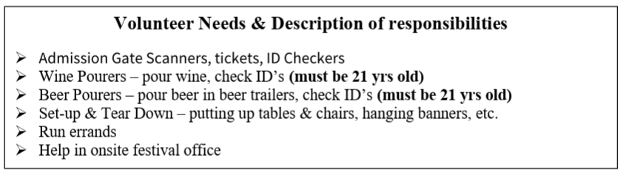
Name:
Email:
Contact Number:

Friday Set Up 5pm-9pm Sunday 9:30am-2:30pm
Saturday 9:30am-2:30pm Sunday 2:00pm-7:00pm
Saturday 2:00pm-7:00pm Sunday Tear Down 6:00pm-9:00pm
Special notes or requests:
