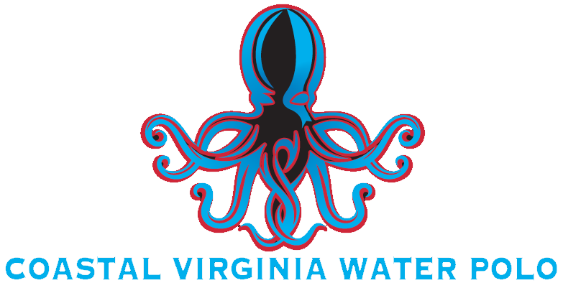 | 
MINOR ATHLETE DUAL RELATIONSHIP CONSENT FORM

This consent form is for the purposes of the Dual Relationship Exception in the Minor Athlete Abuse Prevention Policies. There are times when a Minor Athlete and an Adult Participant have a relationship that exists outside of a sport relationship. Examples of dual relationships include but are not limited to family members, family friends, and teachers. Review the consent and only complete the areas of the form that are necessary by initialing that area and signing the form at the bottom. Not all areas of the form are required to be completed.

Please note depending on the policy, consent could be required:
1 | Every instance,
2 | On an annual basis, or
3 | The parent/guardian can determine if the consent is provided every instance or annually.

If an option is not provided for annual consent, then consent needs to be provided in every instance. Additionally, consent can be withdrawn by a parent/guardian at any time by emailing the Safety Officer (Safety.VBHSWPL@gmail.com).

The undersigned is the parent/guardian of the Minor Athlete identified below, who is a member or participant of Coastal Virginia Water Polo (CoVa WP) (including the Virginia Beach High School Water Polo League (VBHSWPL), CoVa Fall High School Team, and the Kraken Youth Travel Team, and under the age of 18. This consent is provided pursuant to the Adult Behavior Requirements and Expectations (and SafeSport), and I acknowledge that https://covawaterpolo.org/safety contains policies that are intended to prevent abuse and risks of harm. I acknowledge that I have been advised that prior to granting consent, I should complete the training entitled Parent’s Guide to Misconduct in Sport available at www.athletesafety.org.

DUAL-RELATIONSHIP WITH AN ADULT PARTICIPANT
As the parent/guardian of the Minor Athlete identified below, I am advising CoVa WP that name(s) of Minor Athlete, a Minor Athlete under the age of 18, has a Dual Relationship with the following Adult Participant: Adult Participant(s) name. The Dual Relationship is as follows: enter Dual Relationship details.

With my initials below, I am consenting to the Dual Relationship Exception for each area of the Adult Behavior Requirements and Expectations (and SafeSport), for the time period noted. If an area does not have my initial, I do not consent to the exception detailed in that area. I am aware that I can withdraw this consent at any time.

- DUAL RELATIONSHIP CONSENT: ONE-ON-ONE INTERACTIONS
I, as the parent/guardian of the Minor Athlete identified, hereby authorize and consent that the above named Adult Participant, can have In-Program one-on-one interactions where consent is allowed and not otherwise covered by this form with said Minor Athlete at CoVa WP for the time period selected below.
☐ “Annual”: a time period of one year from the date of this consent.
 | Initial: |  | Date:
☐ “Every Instance”: specific dates for the occasions specified below.
Date(s) | Event/Occasion Name | Location | Initial / Date

- DUAL RELATIONSHIP CONSENT: TRANSPORTATION BY AN ADULT PARTICIPANT
I, as the parent/guardian of the Minor Athlete identified, hereby authorize and consent that the above named Adult Participant, can travel one-on-one with said Minor Athlete to and from all In-Program activities related to CoVa WP for the time period selected below.
☐ “Annual”: a time period of one year from the date of this consent.
 | Initial: |  | Date:
☐ “Every Instance”: specific dates for the occasions specified below.
Date(s) | Event/Occasion Name | Location | Initial / Date

Additionally, in either case (annual or specific dates), I acknowledge that the Adult Participant is not providing transportation as a representative of CoVa WP and any transportation provided is not an activity of CoVa WP, but a convenience provided between the families outside of the control and liability of CoVa WP and I agree to hold harmless CoVa WP and its representatives.

- DUAL RELATIONSHIP CONSENT: LODGING - NOT A SHARED ROOM (*shared lodging option follows)
I, as the parent/guardian of the Minor Athlete identified, hereby authorize and consent that the above named Adult Participant, can share a lodging arrangement with said Minor Athlete for all In-Program lodging related to CoVa WP for the time period marked below. I understand that said Adult Participant will NOT share a hotel room or otherwise sleep in the same room with said Minor Athlete and all interactions will be observable and interruptible unless additional consent for In-Program one-on-one interactions is also provided.
☐ “Annual”: a time period of one year from the date of this consent.
 | Initial: |  | Date:
☐ “Every Instance”: specific dates for the occasions specified below.
Date(s) | Event/Occasion Name | Location | Initial / Date

- DUAL RELATIONSHIP CONSENT: LODGING - SHARED ROOM (*not-shared lodging option above)
I, as the parent/guardian of the Minor Athlete identified, hereby authorize and consent that the above named Adult Participant, can share a hotel room or otherwise sleep in the same room with said Minor Athlete for In-Program lodging related to CoVa WP during the time period marked below.
☐ “Annual”: a time period of one year from the date of this consent.
 | Initial: |  | Date:
☐ “Every Instance”: specific dates for the occasions specified below.
Date(s) | Event/Occasion Name | Location | Initial / Date

- DUAL RELATIONSHIP CONSENT: LOCKER ROOMS
I, as the parent/guardian of the Minor Athlete identified, hereby authorize and consent that the above named Adult Participant, can have one-on-one interactions with said Minor Athlete in the Locker Room during In-Program sport activities related to CoVa WP during the time period marked below. I understand this consent does NOT allow said Adult Participant to shower with said Minor Athlete.
☐ “Annual”: a time period of one year from the date of this consent.
 | Initial: |  | Date:
☐ “Every Instance”: specific dates for the occasions specified below.
Date(s) | Event/Occasion Name | Location | Initial / Date

- DUAL RELATIONSHIP CONSENT: ELECTRONIC COMMUNICATIONS
I, as the parent/guardian of the Minor Athlete identified, hereby authorize and consent that the above named Adult Participant, can have one-on-one Electronic Communication with said Minor Athlete during the time period marked below.
☐ “Annual”: a time period of one year from the date of this consent.
 | Initial: |  | Date:
☐ “Every Instance”: specific dates for the occasions specified below.
Date(s) | Event/Occasion Name | Location | Initial / Date

CONSENT
I, parent / guardian name, as parent/guardian of minor athlete name, who is under the age of 18, have read the Adult Behavior Requirements and Expectations (and SafeSport) and acknowledge that the above written permission is valid for the dates identified above. If I am signing and submitting this consent electronically, I acknowledge that my electronic signature shall have the same validity, force, and effect as if I signed this consent by hand.
Parent / Legal Guardian Printed Name:
Parent / Legal Guardian Signature: | (type your signature) |  | Date:

