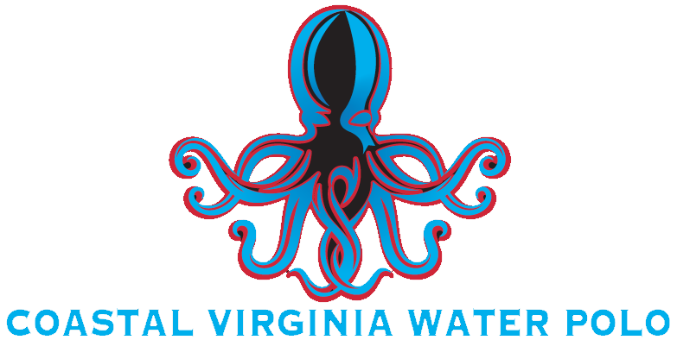 | 
MINOR ATHLETE GENERAL CONSENT FORM
(Includes: Transportation, Lodging, Close-in-Age Exception)

This consent form is a General Consent form to address several In-Program activities that require parental consent as per the Minor Athlete Abuse Prevention Policies. Review the consent and only complete the areas of the form necessary by initialing that area and signing the form at the bottom. Not all areas of the form are required to be completed.

Please note depending on the policy, consent could be required:
1 | Every instance,
2 | On an annual basis, or
3 | The parent/guardian can determine if the consent is provided every instance or annually.

If an option is not provided for annual consent, then consent needs to be provided in every instance. Additionally, consent can be withdrawn by a parent/guardian at any time by emailing the Safety Officer (Safety.VBHSWPL@gmail.com).

The undersigned is the parent/guardian of the Minor Athlete identified below, who is a member or participant of Coastal Virginia Water Polo (CoVa WP) (including the Virginia Beach High School Water Polo League (VBHSWPL), CoVa Fall High School Team, and the Kraken Youth Travel Team), and under the age of 18. This consent is provided pursuant to the Adult Behavior Requirements and Expectations (and SafeSport), and I acknowledge that https://covawaterpolo.org/safety contains policies that are intended to prevent abuse and risks of harm. I acknowledge that I have been advised that prior to granting consent, I should complete the training entitled Parent’s Guide to Misconduct in Sport available at www.athletesafety.org.

- TRANSPORTATION BY AN ADULT PARTICIPANT
I, as the parent/guardian of the Minor Athlete identified below, hereby authorize and consent that Name(s) of Adult Participant(s), an Adult Participant(s), can travel one-on-one with said Minor Athlete to and from all In-Program sport activities related to CoVa WP for the time period selected below. I understand that my Minor Athlete or I can withdraw consent at any time.
☐ “Annual”: a time period of one year from the date of this consent.
 | Initial: |  | Date:
☐ “Every Instance”: specific dates for the occasions specified below.
Date(s) | Event/Occasion Name | Location | Initial / Date

Additionally, in either case (annual or specific occasions), I acknowledge that the Adult Participant is not providing transportation as a representative of CoVa WP and any transportation provided is not an activity of Cova WP, but a convenience provided between the families outside of the control and liability of Cova WP and I agree to hold harmless Cova WP and its representatives.

- LODGING
I, as the parent/guardian of the Minor Athlete identified below, hereby authorize and consent that Name(s) of Adult Participant(s), an Adult Participant(s), can share lodging arrangements with said Minor Athlete for all In-Program lodging related to Cova WP for the time period marked below. I understand that said Adult Participant will NOT share a hotel room or otherwise sleep in the same room with said Minor Athlete and all interactions will be observable and interruptible.
☐ “Annual”: a time period of one year from the date of this consent.
 | Initial: |  | Date:
☐ “Every Instance”: specific dates for the occasions specified below.
Date(s) | Event/Occasion Name | Location | Initial / Date

- CLOSE-IN-AGE EXCEPTION
I, as the parent/guardian of the Minor Athlete identified below, hereby authorize and consent to Name(s) of Adult Participant(s), an Adult Participant(s) that is no more than 4 years older than said Minor Athlete; with NO authority over said Minor Athlete; TO share a hotel room or otherwise sleep in the same room with a Minor Athlete for In-Program lodging related to Cova WP during the following occasions.

Date(s) | Event/Occasion Name | Location | Initial / Date

CONSENT
I, parent / guardian name, as parent/guardian of minor athlete name, who is under the age of 18, have read the Adult Behavior Requirments and Expectations (and SafeSport) and acknowledge that the above written permission is valid for the dates identified above. If I am signing and submitting this consent electronically, I acknowledge that my electronic signature shall have the same validity, force, and effect as if I signed this consent by hand.
Parent / Legal Guardian Printed Name:
Parent / Legal Guardian Signature: | (type your signature) |  | Date:

