**24500 Ford Rd, Dearborn Heights, MI 48127 Suite 20- B  
  
Cardio Dabke Fitness Program**

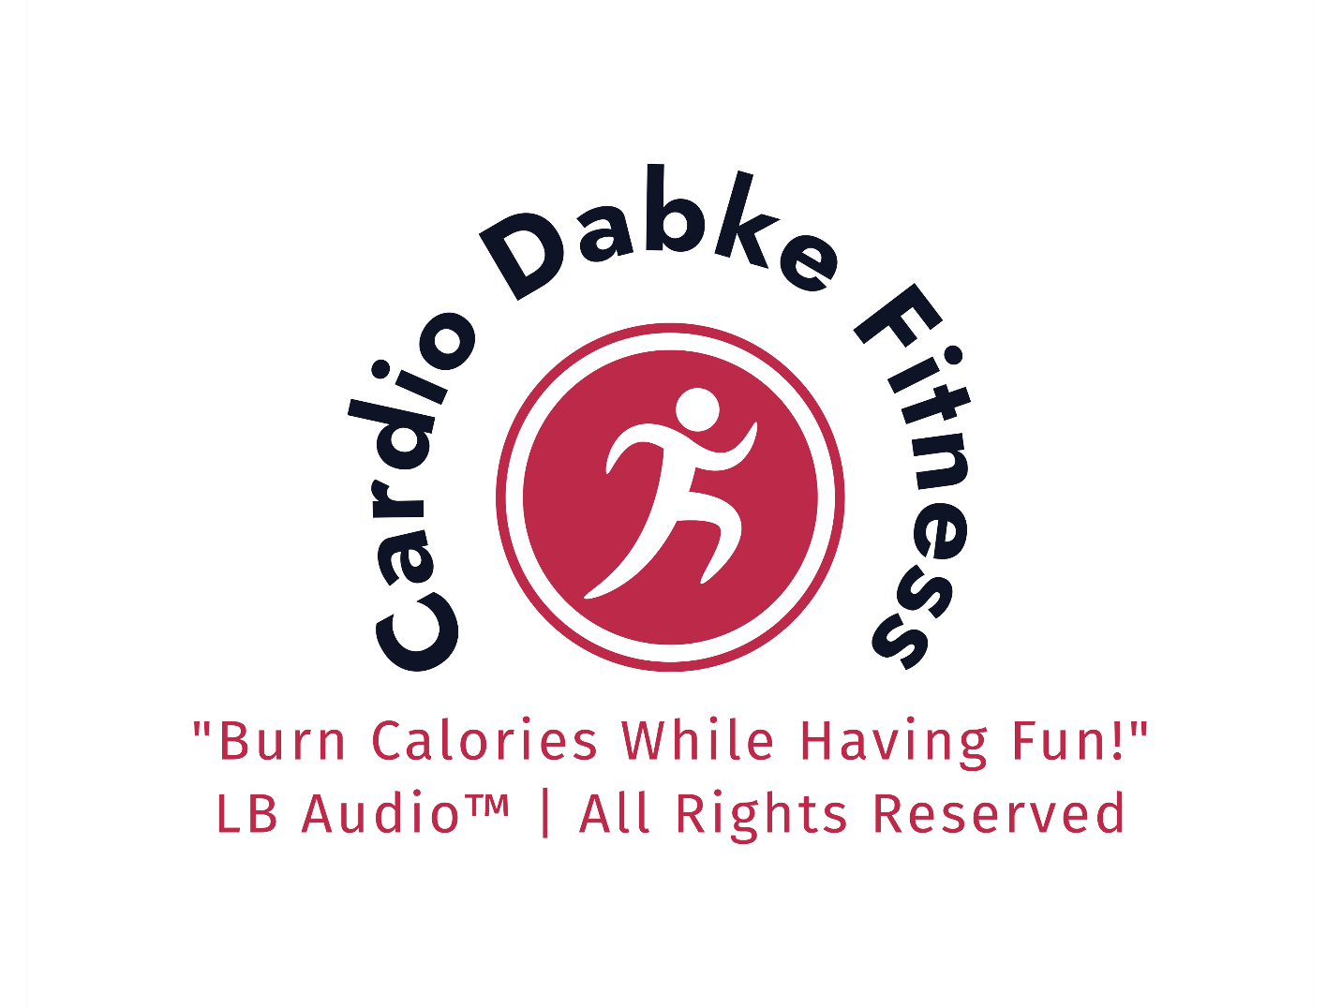

**"Michigan’s First Middle Eastern Fitness Fusion Program!"**  
**Cardio Dabke Fitness** is a unique program proudly presented by **LB Audio**, designed to combine the rich tradition of Dabke with the energy and health benefits of modern exercise. Inspired by popular fitness classes like Zumba, which merges dance and fitness, **Cardio Dabke Fitness** brings the cultural essence of the Middle East into the fitness world for the first time. This program promotes health, culture, and connections while addressing issues such as obesity, depression, and lack of physical activity. Let’s have fun, lose weight, and stay healthy—all while celebrating our heritage.  
 **Our Vision**

**"Honoring Our Culture with Ethical Audio Practices"**

At **LB Audio**, we are committed to creating an enriching and respectful environment that celebrates cultural heritage and promotes health and wellness. Guided by ethical values, we ensure that no inappropriate lyrics or content are included in our sessions. Our goal is to provide a space where participants can honor their culture, stay active, and have fun.

**Program Overview**

**Duration:** 1 Hour Per Week  
**Location:** Suitable for gyms, banquet halls, or community centers  
**Fee:** $25 per person

**Session Structure**

**1. Warm-Up (5 Minutes)**

* **Objective:** Prepare the body for movement and set a welcoming atmosphere.
* **Activities:**
  + Light Dabke steps to soft, rhythmic beats.
  + Mingling and introductions to foster community.
* **Music:** Gentle Dabke beats provided by **LB Audio**.

**2. Moderate Beats (20 Minutes)**

* **Objective:** Build endurance and introduce participants to intermediate Dabke steps.
* **Activities:**
  + Choreographed movements combining traditional Dabke steps with moderate cardio intensity.
  + Group synchrony to encourage teamwork and fun.
* **Music:** Moderate-tempo Dabke tracks curated by **LB Audio**.

**3. Hydration Break (5 Minutes)**

* **Objective:** Ensure participants stay hydrated and energized.
* **Details:**
  + Water and light refreshments provided.
  + Opportunity for a quick chat or rest before the next session segment.

**4. High-Intensity "On Fire" Session (30 Minutes)**

* **Objective:** Maximize calorie burn and elevate heart rates while having fun.
* **Activities:**
  + Fast-paced Dabke choreography.
  + High-energy moves that let participants "let loose."
  + Encouragement to personalize steps to individual fitness levels.
* **Music:** High-energy Dabke beats and motivational audio by **LB Audio**.

**Program Features**

**Participant Guidelines**

To maintain a respectful and welcoming environment, participants are encouraged to dress in comfortable gym attire or pajamas. Please avoid shorts or exposed clothing to ensure cultural sensitivity. Don't forget to bring your towel and a bottle of water to stay refreshed during the session.

* **Professional Audio Support:** The **LB Audio Team** ensures high-quality sound, seamless music transitions, and an immersive experience.
* **Cultural Connection:** Authentic Dabke steps that honor tradition while incorporating modern fitness trends.
* **Inclusive Environment:** Open to all fitness levels, with steps that can be adapted to individual abilities.
* **Refreshments Included:** Participants stay hydrated with refreshments provided during the session.

**Benefits of Cardio Dabke Fitness**

1. **Health and Wellness:** Burn calories, improve cardiovascular health, and enhance coordination.
2. **Community Building:** Connect with others through shared cultural experiences.
3. **Cultural Preservation:** Celebrate and pass down the rich tradition of Dabke in a modern context.
4. **Fun and Motivation:** Enjoy every step with a workout that feels like a celebration.

**Proposed Locations**

This program is ideal for:

* Gyms and fitness centers looking to add culturally unique offerings.
* Banquet halls hosting community events or cultural gatherings.
* Community centers seeking engaging fitness programs for all ages.

**Next Steps**

1. **Proposal Submission:** Present this program to potential venues or sponsors.
2. **Launch Preparation:**
   * Secure a location.
   * Advertise through social media, flyers, and local community channels.
3. **First Session:** Host a launch event to introduce the community to **Cardio Dabke Fitness**.  
     
   **Any hall, gym, or banquet venue interested in hosting this program can do so at a flat rate of [ ].** The rate includes program organization, music, and professional audio services provided by the dedicated team at **LB Audio**. Partner with us to bring this unique cultural fitness experience to your community!

**Contact Us:**  
**LB Audio, USA   
Director: Samah Hamam**Phone: 3135492121  
Email: nabil@lb-edu.com  
Website: https://lbaudio.godaddysites.com/

*"Join us for an experience that honors tradition, promotes fitness, and creates lasting connections!"*