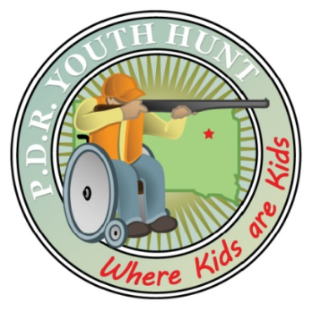**PDR Hunter application**

Please fill out and return the form below.

Call 605-233-0331 for more information.

Mail to: **Dean Rasmussen 300 1st Avenue W. Clark, South Dakota 57225** or email: [fbureau@itctel.com](mailto:fbureau@itctel.com).

**Today’s date ______________**

Entries to be received by August 1, 2019.

Up to ten qualified participants will receive an all-expenses paid hunting adventure September 13 through 15, 2019. Included for both hunter and one parent or guardian are: meals and lodging for two nights; and for the hunter access to: firearms, ammunition, targets, private hunting land, handicap-accessible enclosed deer blinds with hard surface floors to accommodate wheel chairs, individual hunting guides, transportation to/from the field, and venison processing of one White-tail doe.

Name ____________________________________________________________________________

Address ___________________________________________________________________________

Phone ______________________Email _________________________________________________

Date of birth _________________Name of parent/guardian __________________________________

Disability description and any special needs ________________________________________________________________________________________________________________________________________________________________________

Hunting experience? (none, some) _______________________________________________________

Past PDR experience (# years) ____________________ # of PDR animal harvests_________________

SD Game Fish and Parks firearm safety course taken? Yes ___ No ___ Pending ___

Can be accompanied by a parent or guardian? Yes ___ No ___

Distance traveled to Clark, SD (round trip in miles) _________________________________________

The PDR Hunt is a non-profit organization that provides a white-tail deer hunt to disabled youth. The hunt is held annually mid-September near Clark, South Dakota. PDR board members make all hunter selections. Obtaining a South Dakota big game hunting license is the responsibility of each hunter. Forms are available on-line at http://gfp.sd.gov/licenses. Express below why you wish to attend the PDR hunt. ___________________________________________________________________________________________________________________________________________________________________________________________________________________________________________________________________________________________________________________________________________________________________________________________________________________________________________________